CST Reconstruction and Electromagnetic Investigation of a Varactor-Tunable 26 GHz Reflectarray Unit Cell
Working engineering draft
Author | Abdulrahman Ahmad
Programme | Electrical and Computer Engineering
University | Constructor University
Supervisor | [to be completed]
Module | [to be completed]
Date | [to be completed]

Abstract
Abstract to be completed following final electromagnetic characterisation.
This is a working engineering document describing an investigation that is still in progress. The abstract, the discussion and the conclusion will be written after the primary electromagnetic characterisation is complete. Section 10 records the interim status.

Contents
1 Introduction 1
2 Reference design 1
2.1 Operating principle 2
2.2 Published element geometry 2
2.3 Published multilayer architecture 3
2.4 Published target behaviour 4
3 CST reconstruction of the unit cell 4
3.1 Reconstruction approach 4
3.2 Reconstructed model 5
3.3 Layer-by-layer model 5
3.4 Radio-frequency and bias paths 6
4 Design parameters 7
4.1 Principal parameters 7
4.2 Published geometry against the current diagnostic geometry 7
4.3 Stack and material parameters 8
4.4 Reconstruction assumptions 8
5 Electromagnetic simulation methodology 8
5.1 Solver configuration 8
5.2 Varactor model 9
5.3 Adaptive meshing and convergence 9
5.4 Quantities evaluated 10
6 Model verification 10
6.1 Numerical convergence 10
6.2 Lumped-element validation 11
6.3 Geometry and connectivity 11
7 Current electromagnetic results 11
7.1 Endpoint reflection phase 11
7.2 Endpoint reflection magnitude 12
7.3 Preliminary geometry diagnostics 12
7.4 Surface-current distribution 13
8 Current engineering status 14
9 Ongoing work 14
10 Interim project status 15
References 15
Appendix A Complete CST parameter inventory 16
Appendix B Layer stack and derived z coordinates 18
Appendix C Solver settings and convergence records 18
Appendix D Engineering experiment history and rejected diagnostic variants 19
Appendix E Additional electromagnetic plots 21
Appendix F Unresolved source and reconstruction ambiguities 22

List of figures
Figure 1 Published layout of the reference antenna element, showing the unit-cell extent X and Y, the patch width Pw, the coupling slot Sw and Sl, the stripline width Lw and its two resonant lengths Lv and Ls, the blind via, the varactor diode position, and the bias line with the radial stub dimensioned by Bl, Bd, Bw and Bh 3
Figure 2 Published six-layer structure of the reference antenna element 3
Figure 3 Reconstructed unit cell in CST Studio Suite 2023 5
Figure 4 Layer-by-layer view of the reconstruction 6
Figure 5 Representative adaptive tetrahedral mesh convergence for one accepted endpoint run on the current geometry 10
Figure 6 Reflection phase of the co-polarised term SZmax(1),Zmax(1) at the two capacitance endpoints on the current geometry (lineV = 1 12
Figure 7 Surface-current magnitude at 26 13
Figure C.1 Per-branch adaptive-mesh convergence records for the branches in Table C 19
Figure D.1 Bias-T dimensions and port definitions for the 2020 precursor element 20
Figure E.1 Reflection magnitude at the two capacitance endpoints on the current geometry, same runs as Figure 6 12
Figure E.2 Electric-field magnitude at 26 22

List of tables
Table 1 Principal design parameters of the reconstruction 7
Table 2 Parameters temporarily displaced from their published values during the ongoing geometry investigation 7
Table 3 Layer stack and material definition of the reconstruction 8
Table 4 Reconstruction assumptions 7
Table 5 Solver and excitation configuration 9
Table 6 Lumped-element validation 11
Table 7 Single-parameter geometry adjustments carried out as diagnostic checks 13
Table A.1 Complete inventory of named parameters in the CST model 16
Table B.1 Layer stack of the reconstruction with the derived z coordinates 18
Table C.1 Convergence records for the simulated branches 19
Table D.1 Diagnostic branches and their outcomes 20

Nomenclature
CST | CST Studio Suite, the full-wave electromagnetic solver used throughout
PEC | Perfect electric conductor
PCB | Printed circuit board
TE, TM | Transverse electric and transverse magnetic Floquet modes
Floquet port | Modal port used with periodic boundaries to excite a plane wave
L1 to L6 | Conductor layers one to six of the six-layer stack
varC | Model parameter carrying the varactor capacitance in picofarads
fRef | Reference frequency, 26.104 GHz
Delta S | Maximum Delta All S-Parameters, the CST adaptive-mesh convergence measure

1 Introduction
A reflectarray replaces the shaped surface of a conventional reflector antenna with a flat panel carrying many individually controlled scattering elements. Each element receives the field radiated by a feed antenna and re-radiates it with a prescribed phase, so that the collection of element phases synthesises the wavefront a curved reflector would have produced. Because no corporate feed network distributes the signal to the elements, the arrangement avoids the distribution loss that limits conventional arrays at millimetre wavelengths, while keeping a flat geometry that can be manufactured on ordinary printed circuit board.
When the phase of each element is fixed at manufacture, the beam direction is fixed with it. Making the element phase electronically adjustable turns the same panel into a steerable antenna. Reverse-biased varactor diodes are one of the few practical ways to do this in the K-band: they are small enough to fit behind a single element, they draw negligible current, and their capacitance varies continuously with the applied voltage rather than in discrete steps. Continuous control matters because quantised phase, even at one or two bits, raises sidelobe levels and costs gain at boresight [1].
Interest in this frequency range is driven by 5G deployment near 26 GHz and by the measurement problem that follows from it. Characterising steerable millimetre-wave antennas requires reference antennas whose beam can itself be moved in a known way, which is the application that motivated the reference design used here [2].
Placing a tuning element behind a reflecting surface is not free. The varactor has to be reachable by a DC bias network that does not disturb the radio-frequency path, and the radio-frequency path has to couple strongly enough into the tuned resonator for the varactor to control the reflected phase at all. The reference design solves both problems with an aperture-coupled patch over a buried resonant stripline, a blind via, and a bias-T built from a quarter-wavelength transformer and a radial stub.
The objective of this work is to reconstruct that element in CST Studio Suite from the published description, to establish a full-wave periodic unit-cell model whose configuration and numerical behaviour can be defended, and to investigate how its reflection response depends on the varactor capacitance near 26 GHz. The reconstruction is complete and the model solves reliably. The capacitance-dependent phase behaviour reported by the source has not yet been recovered, and locating it is the current focus of the investigation.

2 Reference design
The element reconstructed in this work is the antenna element of Harz and Kleine-Ostmann [2], which develops an earlier element by Harz, Kleine-Ostmann and Schrader [1] and applies the single-varactor concept of Venneri, Costanzo and Di Massa [3]. The two Harz papers describe different elements and their numerical dimensions must not be mixed: the 2020 element uses an 8 mm cell on a Rogers RT5870 substrate, whereas the 2022 element uses a 7 mm cell on Isola Astra MT77. This work reconstructs the 2022 element. The 2020 paper is used for its account of the operating principle and for its dimensioned bias-T figure, which is reproduced in Appendix D.

2.1 Operating principle
An incident plane wave illuminates a square patch on the first conductor layer. The patch is not a resonator terminated in free space; it is aperture-coupled through a rectangular slot in the second layer to a stripline on the third layer. Energy therefore passes from the incident field into the patch, through the aperture, and onto the buried stripline, where it encounters the tuning element.
The stripline is divided by its connection point into two lengths that play different roles. The short stub of length Ls above the junction presents an inductive reactance, and the longer section of length Lv below the junction, terminated by the varactor, presents the capacitive part. Together they form a series resonant circuit whose resonant frequency is set principally by Ls and whose usable phase range is matched to the capacitance range of the diode by choosing Lv [2], [3]. Changing the varactor capacitance moves the resonance, and the phase of the wave returned through the aperture to the patch shifts with it. The patch re-radiates that phase-shifted wave, so the reflection phase of the whole cell becomes a function of the bias voltage.
The aperture-coupled arrangement has a second benefit that motivated its selection. Every active and biasing component sits behind the layer-four ground plane, so the reflecting face stays flat and the backscatter depends only on the patch and the slot, with no parasitic radiation from the bias circuitry [1].

2.2 Published element geometry
Figure 1 reproduces the published layout. It fixes the unit-cell extent, the patch and aperture dimensions, the two resonant stripline lengths, and the position of the blind via and the varactor, together with the four dimensions that define the bias-T. The numerical values are collected in Table 1 of [2] and are carried into Table 1 of this report.
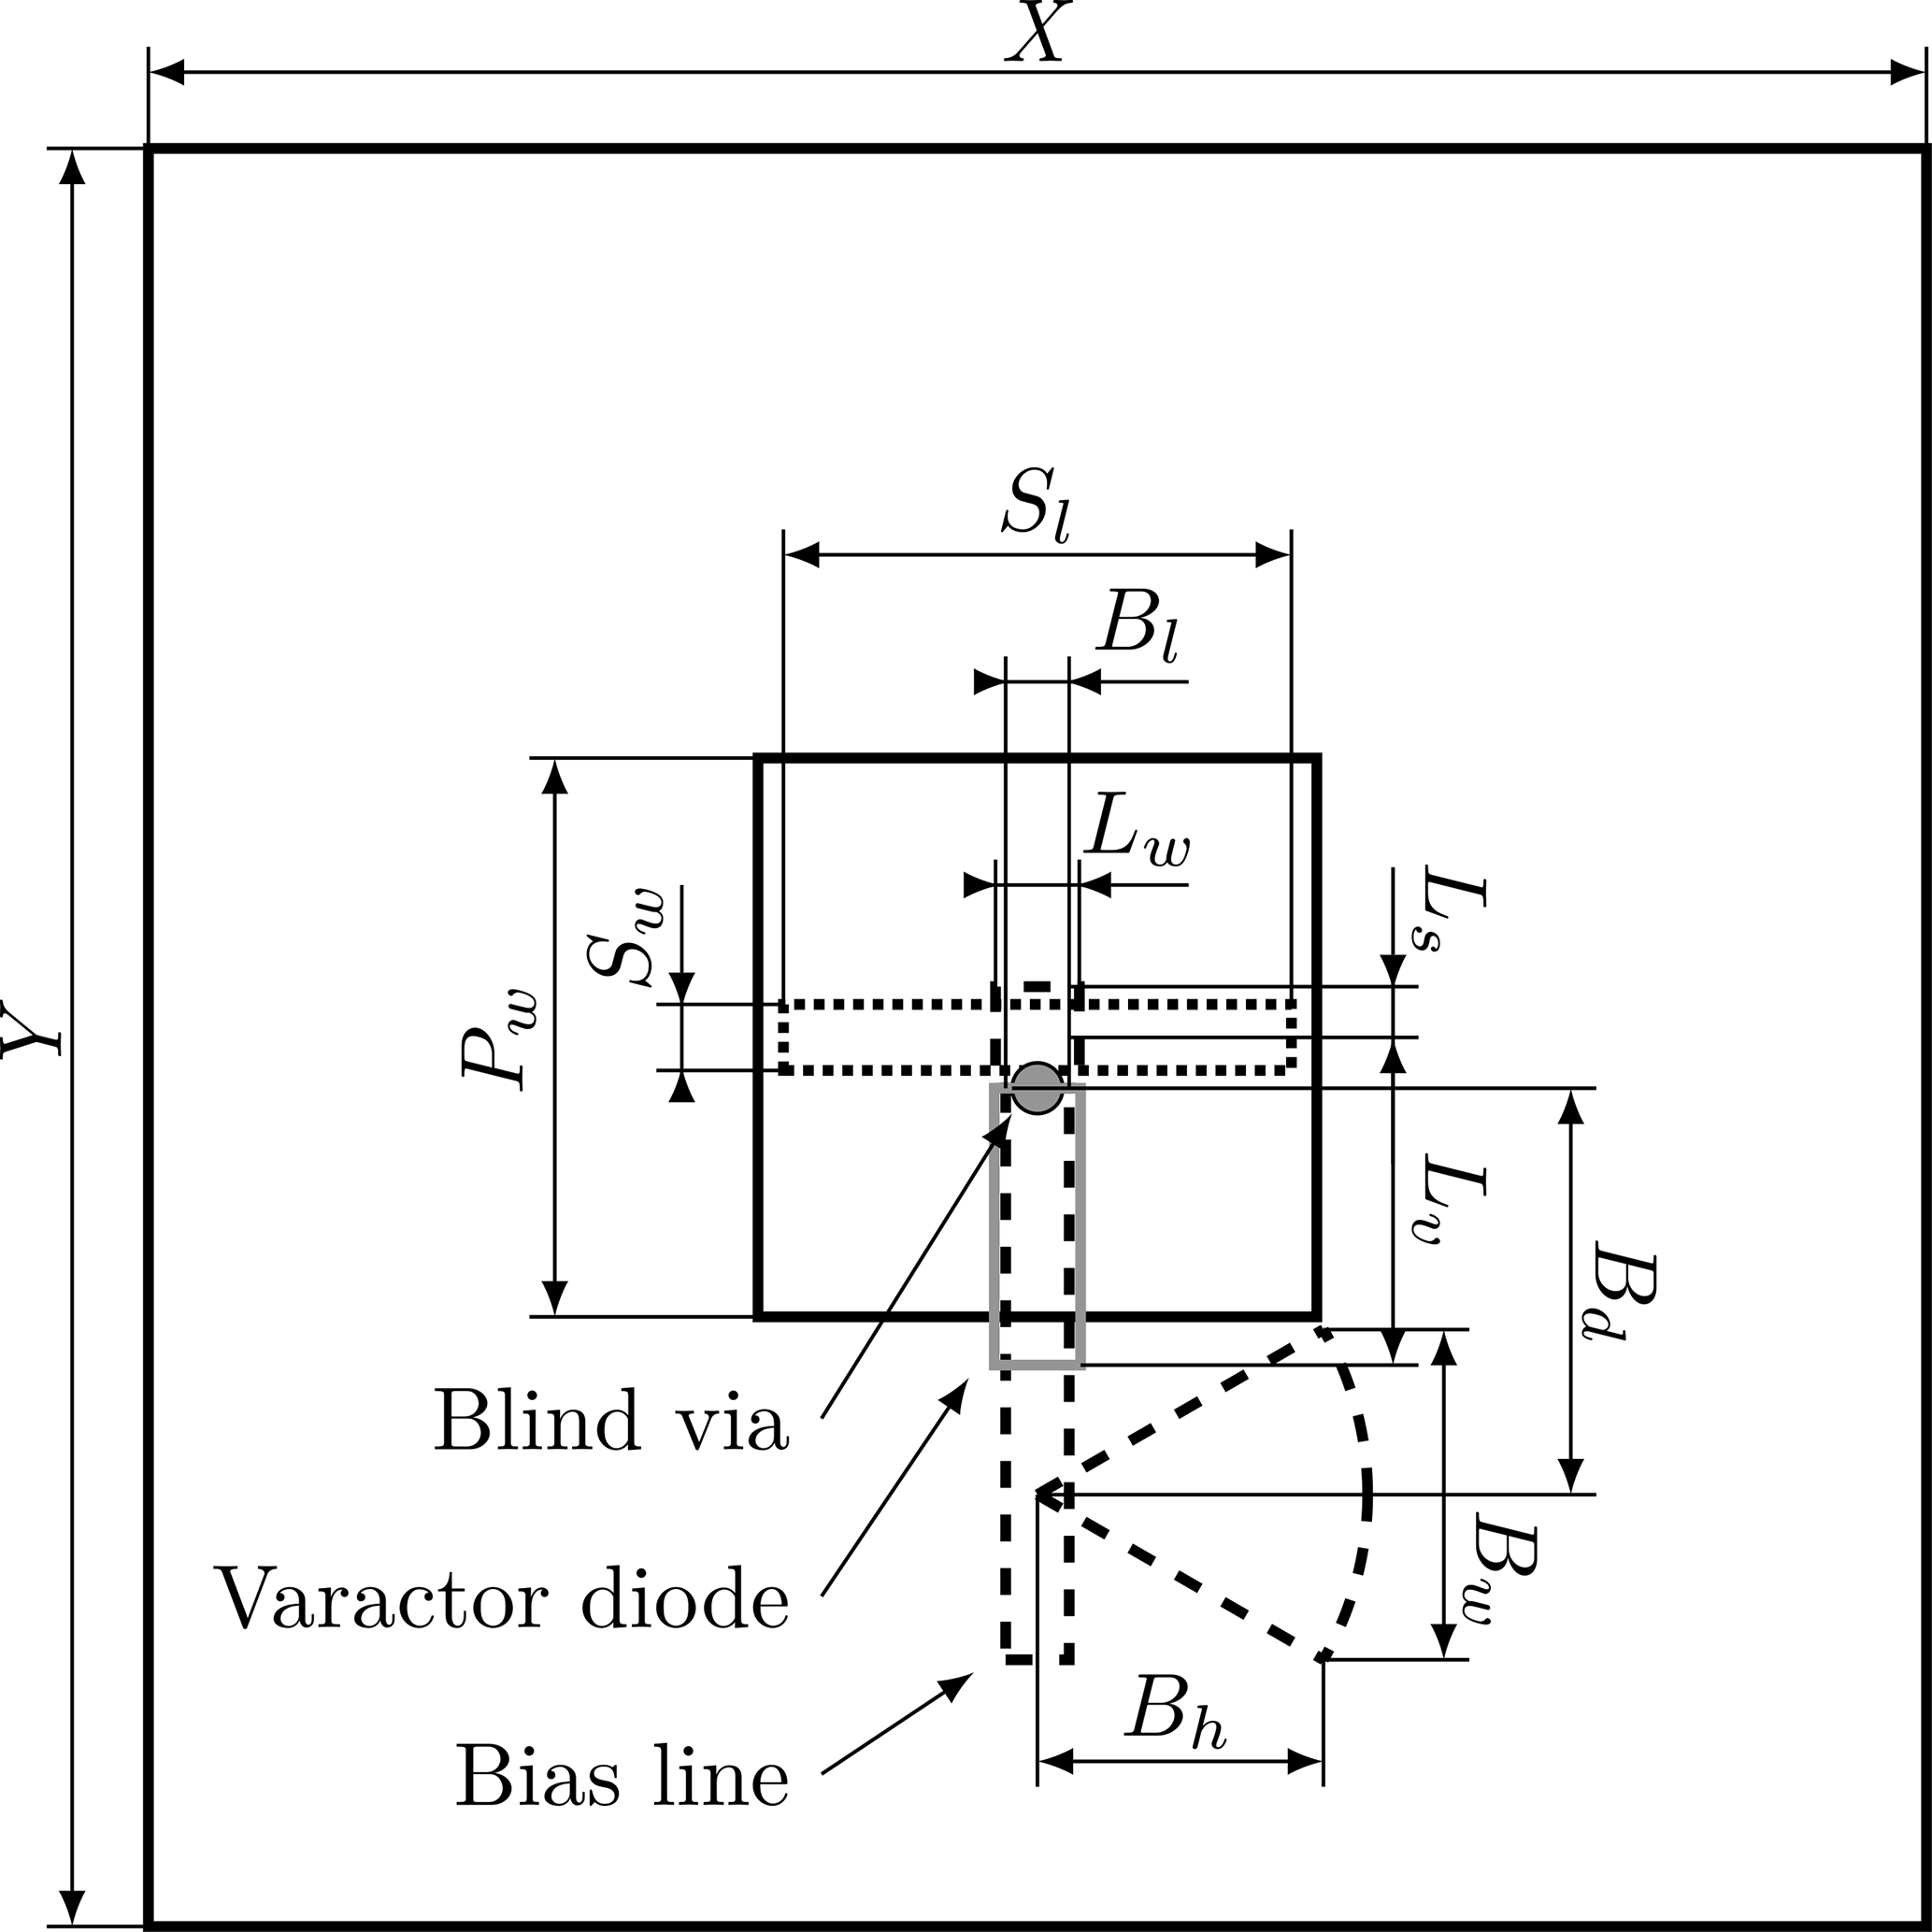
Figure 1. Published layout of the reference antenna element, showing the unit-cell extent X and Y, the patch width Pw, the coupling slot Sw and Sl, the stripline width Lw and its two resonant lengths Lv and Ls, the blind via, the varactor diode position, and the bias line with the radial stub dimensioned by Bl, Bd, Bw and Bh. Reproduced from Harz and Kleine-Ostmann [2], Fig. 1, under the Creative Commons Attribution 4.0 licence.
Two features of the layout govern the reconstruction. The blind via sits at the junction between Ls and Lv, on the stripline axis, so that the via position and the two published lengths are not independent quantities. The bias line continues away from the patch along that axis, and the radial stub branches laterally from it at a distance Bd from the junction rather than continuing along it. Both readings were taken from the figure directly and both differ from earlier interpretations used in this project.

2.3 Published multilayer architecture
The element is built on a six-layer board, reproduced in Figure 2. The first four layers produce the reflection with the intended phase shift; the last two route the bias signals and carry the diode [2].
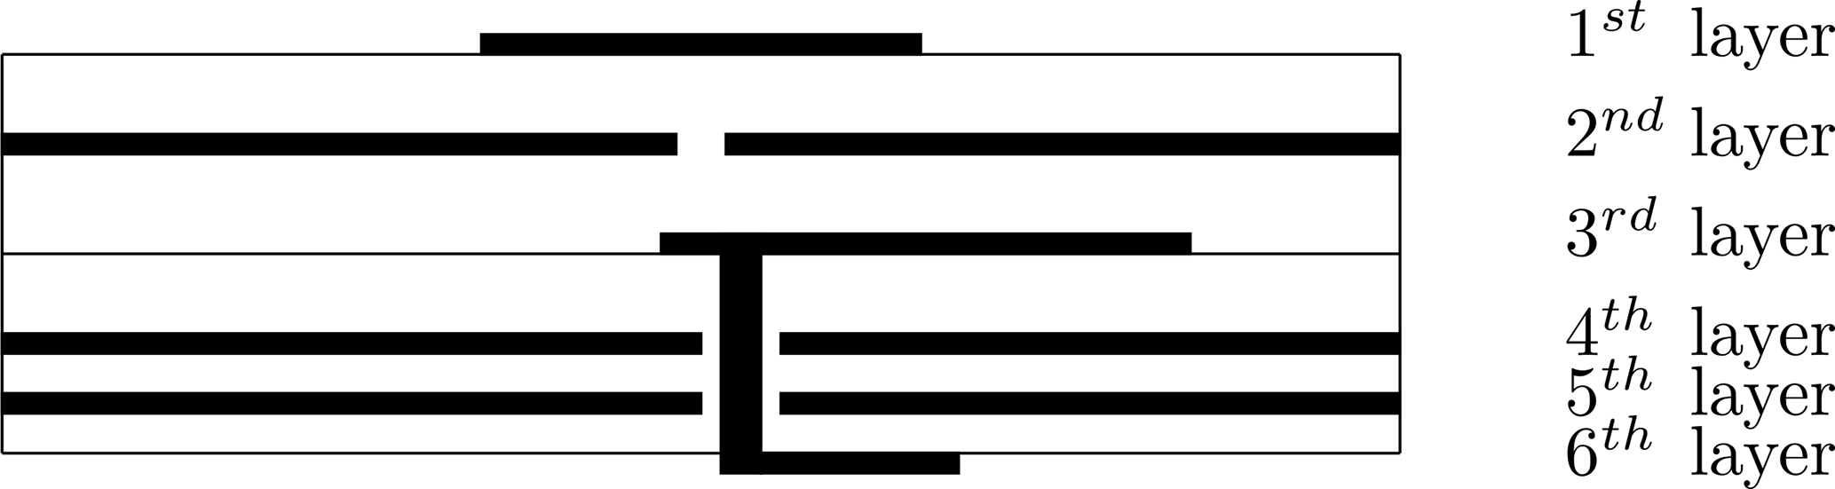
Figure 2. Published six-layer structure of the reference antenna element. The patch sits on layer one, the coupling aperture is the gap in the layer-two conductor, the resonant stripline is on layer three, layer four is the ground plane, and the blind via carries the resonant path down to the varactor on layer six. Reproduced from Harz and Kleine-Ostmann [2], Fig. 2, under the Creative Commons Attribution 4.0 licence.
Layer one carries the patch. Layer two is a conductor sheet interrupted by the coupling aperture, which also serves as the upper ground of the stripline. Layer three carries the resonant stripline and, in the 2022 element, the bias-T. Layer four is the ground plane, which limits radiation from the back of the element. Layers five and six route the control voltage through the array to neighbouring cells and carry the varactor itself. A blind via connects the layer-three resonant path down to the diode, passing through a clearance in the ground plane.
Isola Astra MT77 was chosen for every layer because it supports buried and blind vias and because using one material throughout avoids the mechanical stress that would bow or twist a mixed-material board [2]. One point deserves explicit mention: the published permittivity of 3.0 and loss factor of 0.0017 are specified only up to 20 GHz, and the source applies them at 26 GHz. This reconstruction follows that choice, so the extrapolation is inherited from the source rather than introduced here.
The source does not publish everything the model needs. It gives no via diameter, no ground clearance diameter, no PCB land pattern for the diode, and no dimensions for the layer-five to layer-six interconnect. Section 4.4 records the values adopted in their place.

2.4 Published target behaviour
The quantities in this subsection describe the published system. None of them is a result of the model presented in this report, and no result in Section 7 should be read as reproducing them.
The optimisation goal in [2] was a wide phase-shift range, and the reported outcome is a maximum simulated phase shift of 337 degrees for the element whose dimensions appear in Table 1 of that paper. The precursor element of [1] reports 340 degrees for its own, different geometry.
Fabricated elements were then measured in a waveguide simulator, a technique in which a small number of elements placed in a waveguide reproduces the mutual coupling environment of a large array [4]. The control voltage was swept from 0 to 15 V over 25.6 to 26.6 GHz. Within a 100 MHz bandwidth the maximum measured phase-change range lies between 308 and 336 degrees, and at 26.104 GHz specifically it is 322 degrees [2]. The waveguide simulator imposes a tilted incidence of 21.4 degrees, so these measured figures are not directly comparable with normal-incidence unit-cell simulation.
The reference frequency and the frequency interval used throughout this project are inherited from that measurement rather than chosen independently: 26.104 GHz is the frequency at which the source quotes its phase-change range, and 25.6 to 26.6 GHz is the band over which the source measured.
The tuning element is a MACOM flip-chip varactor with a capacitance range of 0.025 to 0.19 pF over a 0 to 15 V control range, for which the manufacturer supplies no equivalent-circuit parameters [2]. The two papers name slightly different part variants, an ambiguity recorded in Appendix F.

3 CST reconstruction of the unit cell

3.1 Reconstruction approach
The model was rebuilt from the published description rather than adapted from an existing project file, so every dimension in it can be traced to a source value, to a derivation from source values, or to a recorded assumption. Each of the three categories is marked as such in Section 4, and no assumed value is presented as a published one.
The geometry is fully parameterised. Layer positions are expressed as a chain of z-coordinate formulas driven by the substrate and conductor thicknesses, so changing one thickness moves every layer above and below it consistently, and features that must stay aligned are tied to shared parameters rather than to typed coordinates. This matters for the present investigation: the geometry variations in Section 7.3 were applied by editing a single parameter, which keeps the rest of the structure self-consistent and makes each variant reproducible from its parameter list alone.
The element is modelled as one cell of an infinite periodic array rather than in isolation, matching the unit-cell configuration in which the source optimised its own element.

3.2 Reconstructed model
Figure 3 shows the reconstructed unit cell. The cell is 7 mm square in the transverse plane, contains six conductor layers separated by five substrates, and is bounded above and below by open space through which the Floquet excitation enters and leaves.

FIGURE 3
Figure required. Not yet available.
Isometric view of the reconstructed unit cell in CST Studio Suite 2023, with the substrate stack shown semi-transparent so that all six conductor layers, the blind via and the varactor terminal pads are visible. Capture from the current geometry checkpoint (lineV = 1.13 mm, slotW = 0.35 mm, slotL = 2.32 mm).
Figure 3. Reconstructed unit cell in CST Studio Suite 2023. The model is a 7 mm by 7 mm periodic cell containing six perfect-electric-conductor layers separated by five Astra MT77 substrates, with an ideal lumped capacitor across the layer-six terminal pads representing the varactor.

3.3 Layer-by-layer model
Figure 4 separates the six conductor layers so that the reconstruction can be compared directly against the published layout of Figure 1.

FIGURE 4
Figure required. Not yet available.
Layer-by-layer or exploded composite view of the reconstruction, one panel per conductor layer L1 to L6, all at the same scale and camera orientation, so that the reconstruction can be compared panel by panel against Figure 1. Capture from the same checkpoint as Figure 3.
Figure 4. Layer-by-layer view of the reconstruction. L1 carries the square patch, L2 is a conductor sheet interrupted by the rectangular coupling aperture, L3 carries the resonant stripline together with the bias-T branch and radial stub, L4 is the ground plane with a circular clearance around the blind via, L5 carries the DC supply trace, and L6 carries the varactor terminal pads.
The layer-two conductor is built from four rectangular solids rather than as a sheet with a cut, leaving a rectangular aperture of width slotW and length slotL between them. Layer three carries a single stripline solid spanning from -lineV to +lineS in y, so that the blind via at the origin divides it into exactly the two published lengths. Layer four is a full ground plane with a circular clearance centred on the via. Layers five and six carry the DC supply trace and the varactor terminal pads respectively.

3.4 Radio-frequency and bias paths
The radio-frequency path runs from the patch, through the aperture, along the layer-three stripline, down the blind via, and onto the layer-six pad pair that carries the varactor. The via passes through the ground-plane clearance without touching it, so the resonant path reaches the diode without shorting to ground.
The bias path leaves the same layer-three junction as a branch. The quarter-wavelength transformer and the radial stub together present an open circuit at the junction at the operating frequency, which is what keeps the DC feed from loading the resonator; the source reports 36 dB of decoupling for this arrangement [2]. The DC side then continues to the layer-five supply trace through a local interlayer via and reaches the isolated DC pad on layer six.
One aspect of this arrangement remains unresolved. The source establishes that a bias-T exists on layer three, that layer five distributes the control voltage, and that the varactor sits on layer six, but it does not dimension the interlayer route between them. The connection modelled here is a reconstruction that satisfies those constraints rather than a published layout, and Appendix F records it as an open ambiguity.

4 Design parameters
This section gives the parameters needed to understand the model. The complete named-parameter inventory, including derived coordinates, is in Appendix A.

4.1 Principal parameters
Table 1 lists the principal geometry and excitation parameters together with their published counterparts. Every dimension that [2] publishes is reproduced exactly by the reconstruction baseline; the deviations in the current column are the deliberate diagnostic changes described in Section 7.3. The varactor pad dimensions are omitted here and given with the other assumed quantities in Table 4.
Table 1. Principal design parameters of the reconstruction. Published values are taken from Table 1 of [2] and verified directly against the publisher PDF. Where the current model deviates from the published value, both are shown.
Parameter | Description | Published | Current CST | Unit | Origin and status
cellX | Unit-cell extent, x | 7.0 | 7.0 | mm | Published (X)
cellY | Unit-cell extent, y | 7.0 | 7.0 | mm | Published (Y)
patchW | Square patch side, L1 | 2.225 | 2.225 | mm | Published (Pw)
slotW | Coupling aperture width, L2 | 0.26 | 0.35 | mm | Published (Sw); current diagnostic value
slotL | Coupling aperture length, L2 | 2.275 | 2.32 | mm | Published (Sl); current diagnostic value
lineW | Stripline width, L3 | 0.33 | 0.33 | mm | Published (Lw)
lineV | Resonant length below the junction | 1.11 | 1.13 | mm | Published (Lv); current diagnostic value
lineS | Inductive stub above the junction | 0.20 | 0.20 | mm | Published (Ls)
Bl | Bias-line width | 0.25 | 0.25 | mm | Published
Bd | Junction to radial-stub offset | 1.6 | 1.6 | mm | Published
Bw | Radial-stub half-span | 1.3 | 1.3 | mm | Published
Bh | Radial-stub chord offset | 1.13 | 1.13 | mm | Published
viaD | Blind-via diameter | not published | 0.20 | mm | Assumed
viaClearD | L4 clearance diameter | not published | 0.50 | mm | Assumed
Cmin | Lower capacitance endpoint | 0.025 | 0.025 | pF | Published device range
Cmax | Upper capacitance endpoint | 0.19 | 0.19 | pF | Published device range
fRef | Reference frequency | 26.104 | 26.104 | GHz | Published measurement frequency

4.2 Published geometry against the current diagnostic geometry
Three parameters currently sit away from their published values because they were varied during the investigation. Table 2 states both figures for each. The published column remains the reference definition of the element, and the diagnostic values carry no claim of being an improvement.
Table 2. Parameters temporarily displaced from their published values during the ongoing geometry investigation. The published column remains the reference definition of the element.
Parameter | Published value | Current diagnostic value | Change
slotW | 0.26 mm | 0.35 mm | +0.09 mm
slotL | 2.275 mm | 2.32 mm | +0.045 mm
lineV | 1.11 mm | 1.13 mm | +0.02 mm

4.3 Stack and material parameters
Table 3 collects the layer stack and material definition. The substrate thicknesses and the material properties are published; the conductor thicknesses are inferred from the source stack description rather than stated by it.
Table 3. Layer stack and material definition of the reconstruction.
Item | Value | Origin
Substrate material | Isola Astra MT77 | Published [2]
Relative permittivity | 3.0 | Published [2], specified to 20 GHz
Electric loss tangent | 0.0017 | Published [2], specified to 20 GHz
Material reference frequency | 26.104 GHz | Model setting
Material fit range | 25.6 to 26.6 GHz | Model setting
Substrates 1 to 3 thickness | 0.254 mm each | Published [2]
Substrates 4 and 5 thickness | 0.127 mm each | Published [2]
Conductor model | Perfect electric conductor | Modelling simplification
Upper conductor thickness cuOuter | 0.035 mm | Inferred from the source stack
Inner conductor thickness cuInner | 0.018 mm | Inferred from the source stack
L5 and L6 conductor thickness | 0.035 mm | Assumed, carried over from cuOuter

4.4 Reconstruction assumptions
Table 4 lists the quantities the model requires but the source does not publish. These are the values most likely to be responsible for any difference between the reconstruction and the published element, and none of them has yet been sensitivity-tested.
Table 4. Reconstruction assumptions. None of these values is published by the source and none has yet been sensitivity-tested.
Quantity | Value used | Basis
Blind-via diameter | 0.20 mm | Chosen. No published value in the reviewed material.
L4 clearance diameter | 0.50 mm | Chosen to clear the via without shorting the ground plane.
L5 and L6 copper thickness | 0.035 mm | Carried over from the upper-layer interpretation.
Varactor pad geometry | 0.2155 by 0.1905 mm, 0.4185 mm separation | Taken from a MACOM flip-chip package outline in place of an unpublished PCB land pattern. The exact part variant is itself unresolved.
L5 to L6 DC interconnect | diameter, position and route chosen | The source shows that a DC path exists but does not dimension it.
Varactor electrical model | series RLC, R = 0, L = 0 | Deliberate simplification. Package parasitics and the capacitance-versus-bias law are absent.

5 Electromagnetic simulation methodology

5.1 Solver configuration
The frequency-domain solver with a tetrahedral mesh was chosen because the structure is resonant, electrically small, and contains fine features such as the aperture and the via clearance that a conformal tetrahedral mesh resolves efficiently. Table 5 records the configuration.
Table 5. Solver and excitation configuration. All entries were read from the CST dialogs.
Setting | Value
Software | CST Studio Suite 2023, university Teaching Licence
Solver | Frequency domain, general purpose broadband sweep
Mesh | Tetrahedral, with adaptive refinement enabled
Frequency interval | 25.6 to 26.6 GHz
Reference frequency | 26.104 GHz
Boundaries, x and y | Unit cell on Xmin, Xmax, Ymin and Ymax
Boundaries, z | Open, add space, on Zmin and Zmax
Excitation | Floquet port at Zmax
Incidence | theta = 0 degrees, phi = 0 degrees (normal)
Propagating modes | Two: TE(0,0) and TM(0,0). Higher orders evanescent
Monitored term | SZmax(1),Zmax(1), co-polarised reflection
Adaptive passes | Minimum 3, maximum 8
Acceptance criterion | Maximum Delta All S-Parameters of approximately 0.01

Unit-cell boundaries in x and y place the element in an infinite periodic array, and open boundaries with added space in z allow the incident and reflected waves to leave the computational domain. At normal incidence in a 7 mm cell only the two fundamental Floquet modes propagate across the simulated interval; the first higher order would begin to propagate only near 43 GHz, so the two-mode configuration is valid with a wide margin. All phase comparisons use the co-polarised term SZmax(1),Zmax(1), because the orthogonal term was found to be nearly insensitive to capacitance and therefore carries no tuning information.

5.2 Varactor model
The varactor is represented by a series RLC lumped network element placed across the layer-six terminal pads, with the resistance and inductance set to zero and the capacitance driven by the model parameter varC. Its impedance is that of an ideal capacitor,
Z_{C} = 1 / (j2πfC) | (1)
so that at 26.1 GHz the two endpoint capacitances of 0.025 and 0.19 pF correspond to reactance magnitudes of approximately 244 and 32 ohm respectively.
This is deliberately an idealisation. Package parasitics, series resistance, lead inductance and the capacitance-versus-bias characteristic of the real diode are all absent, and the manufacturer publishes no equivalent circuit from which they could be added [2]. The simplification isolates the effect of capacitance alone, which is the quantity under investigation, but it means the model cannot predict the phase-versus-voltage curve of a physical element and does not represent any loss or resonance contributed by the package.

5.3 Adaptive meshing and convergence
Adaptive tetrahedral refinement runs between three and eight passes, refining the mesh where the field solution changes most between passes. The convergence measure is the Maximum Delta All S-Parameters, the largest change in any S-parameter between consecutive passes, and a run is accepted for comparison only when that quantity falls to approximately 0.01 or below. The threshold was tightened to this value after early runs terminated at a looser default and produced results that were not stable enough to compare between capacitance states.

FIGURE 5
Figure required. Not yet available.
Export of the CST adaptive-mesh convergence plot, Maximum Delta All S-Parameters against pass number, for one accepted endpoint run on the current geometry. The horizontal axis must read Pass. State in the caption which capacitance state the run belongs to and the final delta value from the solver log rather than from the plot.
Figure 5. Representative adaptive tetrahedral mesh convergence for one accepted endpoint run on the current geometry. The horizontal axis is the refinement pass number, not frequency. The acceptance criterion used throughout this project is a final Maximum Delta All S-Parameters of approximately 0.01 or below.
Figure 5 shows a representative convergence record. A plot of this kind has the refinement pass number on its horizontal axis and says nothing about the frequency response of the element. Frequency-domain results are presented separately in Section 7.

5.4 Quantities evaluated
Four groups of quantities are extracted from each run. The reflection phase of SZmax(1),Zmax(1) is the primary result, since the design intent is phase control. Its magnitude is monitored as a consistency check on the energy balance rather than as a design target. The lumped-element voltage and current monitors give access to the terminal conditions at the varactor, which is the only direct view of what the tuning element experiences. Field monitors provide surface-current and electric-field distributions at selected frequencies, used qualitatively to see where energy is concentrated.

6 Model verification
Before any electromagnetic result is interpreted, three questions are settled: whether the numerical solution has converged, whether the tuning element is actually participating in the solution, and whether the geometry is connected the way it is supposed to be.

6.1 Numerical convergence
Runs are classified against the criterion defined in Section 5.3. A run that reaches approximately 0.01 or below is accepted for endpoint comparison; a run that does not is either continued with further refinement or discarded. This classification has been applied consistently, and it has excluded results in practice rather than merely in principle: an early baseline that stopped at approximately 0.0119 and a first low-capacitance endpoint that stopped at approximately 0.0138 were both rejected and re-run before use. Both endpoint runs on the current geometry satisfy the criterion. Appendix C holds the per-branch records.

6.2 Lumped-element validation
A converged solution does not by itself show that the lumped element is electrically active. The voltage and current monitors at the varactor terminals provide that check directly: their ratio should match the reactance magnitude of an ideal capacitor at the modelled capacitance. Table 6 gives the comparison.
Table 6. Lumped-element validation. Terminal voltage and current were read from the CST lumped-element monitors and converted from the plotted dBV and dBA values; they are therefore screenshot-derived. The ideal column is the reactance magnitude of a lossless capacitor at 26.1 GHz.
varC | Current | Voltage | Measured |V/I| | Ideal 1/(2*pi*f*C)
0.19 pF | approx. 5.6 mA | approx. 0.184 V | approx. 33 ohm | approx. 32 ohm
0.025 pF | approx. 1.9 mA | approx. 0.46 V | approx. 240 to 245 ohm | approx. 244 ohm

The agreement is close at both endpoints, and the terminal impedance changes by roughly the expected factor between them. The element is therefore excited by the radio-frequency solution and responds to the capacitance parameter as an ideal capacitor would.
The scope of this conclusion is narrow. It establishes that the lumped element is connected, excited and behaving as specified. It does not establish that the resonant structure loading it is correct, nor that the coupling from the aperture into that structure is strong enough for the varactor to control the reflected phase.

6.3 Geometry and connectivity
The model was audited for the connections the topology depends on: that the blind via contacts the layer-three stripline and the layer-six pad, that the ground-plane clearance keeps it isolated from layer four, that the varactor pad gap is not bridged by metal, that the layer-five supply route reaches the isolated DC pad, and that exactly one lumped element is active in the branch. A separate audit confirmed that the layer-three solid is divided by the via into the two published lengths, so that the resonant dimensions in the model are the source's dimensions and not an accidental re-partition of them.

7 Current electromagnetic results
This section reports what the model currently produces. It is deliberately short: the investigation is in progress and the results below are a status, not an outcome.

7.1 Endpoint reflection phase
Figure 6 overlays the reflection phase at the two capacitance endpoints on the current geometry. Both runs satisfy the convergence criterion of Section 5.3, so the comparison is between two numerically settled solutions rather than between two partially converged ones.

FIGURE 6
Figure required. Not yet available.
Overlay of the reflection phase of SZmax(1),Zmax(1) against frequency for varC = 0.025 pF and varC = 0.19 pF on the current geometry over approximately 25.6 to 26.6 GHz, with 26.104 GHz marked. Export the underlying numerical data at the same time so that the separation can be stated in degrees.
Figure 6. Reflection phase of the co-polarised term SZmax(1),Zmax(1) at the two capacitance endpoints on the current geometry (lineV = 1.13 mm, slotW = 0.35 mm, slotL = 2.32 mm), over approximately 25.6 to 26.6 GHz. Both runs satisfy the convergence criterion of Section 5.3. The reference frequency 26.104 GHz is marked.
The two curves remain almost coincident across most of the simulated interval, and in particular at the 26.104 GHz reference frequency. Some additional separation is visually apparent toward the upper end of the interval, near 26.5 to 26.6 GHz. The current reconstruction therefore does not yet exhibit meaningful capacitance-dependent reflection-phase separation at the reference frequency.
No figure is given here for the size of that separation in degrees. The observation is a reading from overlaid plots, and the underlying S-parameter data have not been exported numerically. Quantifying it is one of the immediate tasks in Section 9.

7.2 Endpoint reflection magnitude
The reflection magnitude stays close to 0 dB across the interval in every converged branch, and the two endpoint curves differ by only a few hundredths of a decibel. This is consistent with a structure built from perfect conductors on a low-loss substrate, in which almost all incident power is returned regardless of the capacitance state, and it serves as a check that no unintended loss mechanism has entered the model. It carries no information about whether a resonance is present, since a resonant element with negligible loss can shift phase strongly while its reflection magnitude stays near unity. The magnitude overlay is Figure E.1.

7.3 Preliminary geometry diagnostics
Single-parameter adjustments to the slot width, the resonant stripline length and the slot length were tried in sequence to see whether a nearby geometry would recover endpoint phase separation at the reference frequency. None did. Table 7 summarises them.
Table 7. Single-parameter geometry adjustments carried out as diagnostic checks. Each value was applied in sequence and carried forward, so the three were not varied independently about a common baseline.
Parameter | Reference value | Diagnostic value | Outcome at 26.104 GHz
slotW | 0.26 mm | 0.35 mm | No meaningful endpoint phase separation recovered
lineV | 1.11 mm | 1.13 mm | No meaningful endpoint phase separation recovered
slotL | 2.275 mm | 2.32 mm | No meaningful endpoint phase separation recovered

Because only isolated nearby values were tested, and because each change was carried forward into the next rather than applied about a common baseline, these trials are treated as diagnostic checks rather than as a parametric sensitivity study. They do not establish that these dimensions are unimportant, and they do not bound the response over any wider parameter range. The full record of each branch is in Appendix D and in the repository experiment log.

7.4 Surface-current distribution
A field monitor at the reference frequency was used to see where current concentrates in the structure. Figure 7 shows the surface-current magnitude for the low-capacitance state.

FIGURE 7
Figure required. Not yet available.
Surface-current magnitude plot at 26.104 GHz from the field-audit run at varC = 0.025 pF, rescaled to a fixed 0 to 5 A/m range so that the layer-three resonant path is visible. Use a camera position that can be repeated for the planned 0.19 pF counterpart.
Figure 7. Surface-current magnitude at 26.104 GHz for varC = 0.025 pF, plotted on a fixed 0 to 5 A/m colour scale so that the resonant path is visible. The global maximum reported by the solver for this run is 392.368 A/m, located at approximately (1.138, -0.130, -0.254) mm, which is the layer-two level. The fixed scale saturates the aperture region by construction and the plot is therefore a qualitative distribution, not a calibrated field export.
The global maximum reported by the solver for this run is 392.368 A/m at approximately (1.138, -0.130, -0.254) mm, which places it at the layer-two level near the aperture. On a rescaled plot the current flowing on the layer-three resonant path is of the order of a few amperes per metre, roughly two orders of magnitude below that maximum. The maximum and its position are solver-reported values; the level on the resonant path is an estimate read from a fixed-scale plot.
This observation is not on its own evidence that coupling into the resonator is inadequate. A resonant path can carry modest current and still dominate the reflected phase, and the comparison here is between a current maximum at a field concentration and a distributed current elsewhere in the structure. Interpreting it requires the same monitor at the other capacitance endpoint, which has not yet been run.

8 Current engineering status
Four things are established. The reconstruction reproduces every dimension the source publishes, and it solves as a periodic unit-cell model with a defensible solver configuration. Accepted runs meet a stated convergence criterion that has excluded results in practice. The lumped varactor is electrically active and responds to the capacitance parameter as an ideal capacitor. On the current geometry, the two capacitance endpoints produce almost coincident reflection-phase curves at the reference frequency.
Three things are unresolved. The frequency region in which this element is most sensitive to capacitance has not been located, and the simulated interval so far has been the one inherited from the source measurement rather than one chosen to find that region. The reconstruction still contains unpublished quantities, listed in Table 4, whose influence has not been bounded. And it is not yet known whether the discrepancy originates in the coupling into the resonator, in the placement of the resonance, in one of those assumed quantities, or in some combination of them.
The diagnostic branches tried so far have narrowed the search less than their number suggests. Each rejected a specific hypothesis about the topology or a specific nearby geometry, but none of them establishes that the feature it changed is electrically unimportant, and none of them has been tested outside the original 1 GHz interval.

9 Ongoing work
The immediate task is a wider-frequency endpoint diagnostic on the unchanged current geometry, run at both capacitance endpoints. Widening the sweep before changing the geometry again keeps the comparison against the existing result clean, and it directly addresses the possibility that the capacitance-sensitive region lies outside the interval examined so far. The new bounds have not been selected. Extending the interval also requires re-checking the material fit range, which is currently declared over 25.6 to 26.6 GHz, and the published material specification itself is quoted only to 20 GHz.
Alongside that, the S-parameter results will be exported numerically rather than read from plots, so that endpoint separation can be stated in degrees and tracked between branches instead of being described qualitatively.
Further work depends on what those two steps show. If a capacitance-sensitive region is found, the sequence is to characterise it, then to make targeted geometry changes aimed at moving it toward 26.104 GHz, and only then to run a dense capacitance sweep, which is worth its cost only once an endpoint pair separates meaningfully. If no such region is found, the assumed quantities in Table 4 become the next candidates, starting with a sensitivity test of the via and clearance diameters, together with a field-monitor comparison between the two capacitance states on the same geometry.
None of the work in this section has been carried out. Nothing in this report establishes that a resonance exists above the present upper simulation boundary.

10 Interim project status
A parameterised six-layer reconstruction of the published element now exists in CST and reproduces every dimension the source states. Its solver configuration, convergence behaviour and internal connectivity have been checked, and the lumped varactor has been verified to be electrically active at both capacitance endpoints. The modelling foundation for the investigation is in place.
The behaviour that motivated the work has not been recovered. On the geometry tested so far, changing the varactor capacitance across its full range leaves the reflection phase at 26.104 GHz essentially unchanged, whereas the source reports a simulated phase shift of 337 degrees for its element and a measured phase-change range of 322 degrees at that frequency. Explaining that difference is the open problem, and this report does not claim to have reproduced the published behaviour. No hardware has been fabricated or measured in this project; every result reported here is from simulation.
The next step is the wider-frequency diagnostic described in Section 9, followed by numerical export of the endpoint data. This document is a working engineering report and will be revised as that work produces results. When the investigation reaches a conclusion, this section will be replaced by a proper discussion and conclusion, and the abstract will be written then.

References
[1] T. Harz, T. Kleine-Ostmann, and T. Schrader, “Design of a continuously tunable reflectarray element for 5G metrology in the k-band,” Advances in Radio Science, vol. 18, pp. 1–5, 2020, doi: 10.5194/ars-18-1-2020.
[2] T. Harz and T. Kleine-Ostmann, “Measurement and optimization of a continuously tunable 10 x 10 reflectarray antenna for 5G metrology in the K-band,” Advances in Radio Science, vol. 19, pp. 215–220, 2022, doi: 10.5194/ars-19-215-2022.
[3] F. Venneri, S. Costanzo, and G. Di Massa, “Design and validation of a reconfigurable single varactor-tuned reflectarray,” IEEE Transactions on Antennas and Propagation, vol. 61, no. 2, pp. 635–645, 2013.
[4] P. Hannan and M. Balfour, “Simulation of a phased-array antenna in waveguide,” IEEE Transactions on Antennas and Propagation, vol. 13, pp. 342–353, 1965, doi: 10.1109/TAP.1965.1138428.
[5] Dassault Systèmes, CST Studio Suite 2023. [Computer software]. [TO BE COMPLETED: confirm the vendor string, release designation and build number from Help > About in the installed copy before submission.]
[6] MACOM Technology Solutions, MAVR-011020 series flip-chip varactor diode datasheet. [TO BE COMPLETED: the correct part variant is unresolved, see Appendix F, item 1. Add the datasheet revision and access date once the variant is fixed.]
References [1] to [4] were verified directly against the publisher PDFs. References [5] and [6] are deliberately incomplete rather than filled in from memory.

Appendix A Complete CST parameter inventory
Table A.1 lists every named parameter used by the model, together with its defining expression where it has one. Where a parameter exists in the model history but its current value cannot be established from the available evidence, the origin column says so rather than offering a guess.
Parameters whose expressions depend on lineV re-evaluate when lineV changes. The resolved values given here are those at the reconstruction baseline lineV = 1.11 mm unless the table states otherwise.
Table A.1. Complete inventory of named parameters in the CST model. Resolved values are given at the reconstruction baseline unless stated otherwise. Entries marked as not verified exist in the model history but their current value could not be established from the available evidence.
Parameter | Expression | Resolved | Unit | Purpose | Origin
theta | 0 | 0 | deg | Incidence elevation angle | Model setting
phi | 0 | 0 | deg | Incidence azimuth angle | Model setting
fRef | 26.104 | 26.104 | GHz | Reference and material fit frequency | Published [2]
cellX | 7 | 7 | mm | Unit-cell extent in x | Published (X) [2]
cellY | 7 | 7 | mm | Unit-cell extent in y | Published (Y) [2]
patchW | 2.225 | 2.225 | mm | Square patch side on L1 | Published (Pw) [2]
slotW | 0.26 baseline | 0.35 | mm | Coupling aperture width on L2 | Published (Sw); currently displaced
slotL | 2.275 baseline | 2.32 | mm | Coupling aperture length on L2 | Published (Sl); currently displaced
lineW | 0.33 | 0.33 | mm | Stripline width on L3 | Published (Lw) [2]
lineV | 1.11 baseline | 1.13 | mm | Resonant length below the junction | Published (Lv); currently displaced
lineS | 0.2 | 0.2 | mm | Inductive stub above the junction | Published (Ls) [2]
sub1 | 0.254 | 0.254 | mm | Substrate 1 thickness, L1 to L2 | Published [2]
sub2 | 0.254 | 0.254 | mm | Substrate 2 thickness, L2 to L3 | Published [2]
sub3 | 0.254 | 0.254 | mm | Substrate 3 thickness, L3 to L4 | Published [2]
sub4 | 0.127 | 0.127 | mm | Substrate 4 thickness, L4 to L5 | Published [2]
sub5 | 0.127 | 0.127 | mm | Substrate 5 thickness, L5 to L6 | Published [2]
cuOuter | 0.035 | 0.035 | mm | Outer-layer conductor thickness | Inferred
cuInner | 0.018 | 0.018 | mm | Inner-layer conductor thickness | Inferred
espAstra | 3 | 3 | - | Substrate relative permittivity | Published [2]
tanDAstra | 0.0017 | 0.0017 | - | Substrate electric loss tangent | Published [2]
Bl | 0.25 | 0.25 | mm | Bias-line width on L3 | Published [2]
Bd | 1.6 | 1.6 | mm | Junction to radial-stub offset | Published [2]
Bw | 1.3 | 1.3 | mm | Radial-stub half-span | Published [2]
Bh | 1.13 | 1.13 | mm | Radial-stub chord offset | Published [2]
zPatchBottom | 0 | 0 | mm | L1 lower face, stack datum | Derived
zPatchTop | zPatchBottom + cuOuter | 0.035 | mm | L1 upper face | Derived
zL2Top | -sub1 | -0.254 | mm | L2 upper face | Derived
zL2Bottom | zL2Top - cuOuter | -0.289 | mm | L2 lower face | Derived
zL3Top | zL2Bottom - sub2 | -0.543 | mm | L3 upper face | Derived
zL3Bottom | zL3Top - cuInner | -0.561 | mm | L3 lower face | Derived
zL4Top | zL3Bottom - sub3 | -0.815 | mm | L4 upper face | Derived
zL4Bottom | zL4Top - cuInner | -0.833 | mm | L4 lower face | Derived
zL5Top | zL4Bottom - sub4 | -0.960 | mm | L5 upper face | Derived
zL5Bottom | zL5Top - cuOuter | -0.995 | mm | L5 lower face | Derived
zL6Top | zL5Bottom - sub5 | -1.122 | mm | L6 upper face | Derived
zL6Bottom | zL6Top - cuOuter | -1.157 | mm | L6 lower face | Derived
viaD | 0.20 | 0.20 | mm | Blind-via diameter | Assumed
viaClearD | 0.50 | 0.50 | mm | L4 clearance diameter | Assumed
viaX | capX | 0 | mm | Blind-via centre, x | Derived
viaY | 0 | 0 | mm | Blind-via centre, y; splits L3 into Lv and Ls | Derived, locked
viaZtop | zL3Bottom | -0.561 | mm | Blind-via upper end | Derived
viaZbottom | zL6Top | -1.122 | mm | Blind-via lower end | Derived
capX | 0 | 0 | mm | Tuning-element centre, x | Derived
capY | -lineV + lineW/2 | -0.945 | mm | Tuning-element centre, y; re-evaluates with lineV | Derived
varCenterY | capY | -0.945 | mm | Varactor terminal-pair centre | Derived
varTermSep | 0.4185 | 0.4185 | mm | Separation of the two terminal pads | Assumed from a package outline
varPadW | 0.2155 | 0.2155 | mm | Terminal pad width on L6 | Assumed from a package outline
varPadL | 0.1905 | 0.1905 | mm | Terminal pad length on L6 | Assumed from a package outline
varRFPadY | varCenterY + varTermSep/2 | -0.73575 | mm | Radio-frequency-side pad centre | Derived
varDCPadY | varCenterY - varTermSep/2 | -1.15425 | mm | DC-side pad centre | Derived
varPadXmin | -varPadW/2 | -0.10775 | mm | Pad extent, x minimum | Derived
varPadXmax | +varPadW/2 | +0.10775 | mm | Pad extent, x maximum | Derived
varRFPadYmax | varRFPadY + varPadL/2 | -0.6405 | mm | Radio-frequency pad extent, y maximum | Derived
varRFPadYmin | varRFPadY - varPadL/2 | -0.831 | mm | Radio-frequency pad extent, y minimum | Derived
varDCPadYmax | varDCPadY + varPadL/2 | -1.059 | mm | DC pad extent, y maximum | Derived
varDCPadYmin | varDCPadY - varPadL/2 | -1.2495 | mm | DC pad extent, y minimum | Derived
varElemX | 0 | 0 | mm | Lumped-element position, x | Derived
varElemZ | zL6Top | -1.122 | mm | Lumped-element position, z | Derived
stubR | Sqr(Bh*Bh + Bw*Bw) | 1.7225 | mm | Radial-stub sector radius | Derived from published Bh, Bw
stubHalfAng | atan(Bw/Bh)*180/pi | 48.99 | deg | Radial-stub sector half-angle | Derived from published Bh, Bw
stubCx | viaX | 0 | mm | Sector apex, x | Derived
stubCy | viaY - Bd | -1.6 | mm | Sector apex, y | Derived
stubChordX | Bh | 1.13 | mm | Chord offset from the bias-line axis | Derived
Cmin | 0.025 | 0.025 | pF | Lower capacitance endpoint | Published device range [2]
Cmax | 0.19 | 0.19 | pF | Upper capacitance endpoint | Published device range [2]
varC | swept | 0.025 or 0.19 | pF | Active varactor capacitance | Controlled variable
stubHalfH | Bw/2 | 0.65 | mm | Superseded stub half-height | Superseded, see Appendix D
stubEdgeX | Sqr(stubR^2 - stubHalfH^2) | 0.92434 | mm | Superseded chord construction | Superseded, see Appendix D
stubHalfSpanY | Bw | 1.3 | mm | Superseded span definition | Superseded, see Appendix D
stubApexX | viaX | 0 | mm | Alternative apex naming in the model history | Not verified in current evidence
stubApexY | viaY - Bd | -1.6 | mm | Alternative apex naming in the model history | Not verified in current evidence

Appendix B Layer stack and derived z coordinates
All z coordinates are derived from the substrate and conductor thicknesses by the chain of expressions in Appendix A, with the lower face of the layer-one patch as the datum. Table B.1 gives the resolved stack.
Table B.1. Layer stack of the reconstruction with the derived z coordinates. The datum is the lower face of the layer-one patch.
Layer | Content | Upper face | Lower face | Thickness
L1 | Square patch | +0.035 | 0.000 | 0.035 mm
Substrate 1 | Astra MT77 | 0.000 | -0.254 | 0.254 mm
L2 | Conductor sheet with the coupling aperture | -0.254 | -0.289 | 0.035 mm
Substrate 2 | Astra MT77 | -0.289 | -0.543 | 0.254 mm
L3 | Resonant stripline, bias-T branch, radial stub | -0.543 | -0.561 | 0.018 mm
Substrate 3 | Astra MT77 | -0.561 | -0.815 | 0.254 mm
L4 | Ground plane with the via clearance | -0.815 | -0.833 | 0.018 mm
Substrate 4 | Astra MT77 | -0.833 | -0.960 | 0.127 mm
L5 | DC supply trace | -0.960 | -0.995 | 0.035 mm
Substrate 5 | Astra MT77 | -0.995 | -1.122 | 0.127 mm
L6 | Varactor terminal pads and DC pad | -1.122 | -1.157 | 0.035 mm

Appendix C Solver settings and convergence records
The solver configuration is given in Table 5 of the main text and is not repeated here. Table C.1 records the convergence outcome of each simulated branch.
Table C.1. Convergence records for the simulated branches. Values marked approx. were read from a convergence plot rather than from a solver log. The acceptance criterion is a final Maximum Delta All S-Parameters of approximately 0.01 or below.
Branch | Configuration | Final delta | Accepted
Stage A baseline | varC = 0.10 pF | approx. 0.008 | Yes
Stage B, first solve | varC = 0.10 pF | approx. 0.0119 at pass 3 | No, re-run
Stage B baseline | varC = 0.10 pF | approx. 0.0089 at pass 6 | Yes
Stage B endpoint high | varC = 0.19 pF | approx. 0.009 at pass 6 | Yes
Stage B endpoint low, first attempt | varC = 0.025 pF | approx. 0.0138 at pass 5 | No, re-run
Stage B endpoint low, refined | varC = 0.025 pF | below 0.01 | Yes
L3 termination variant | 0.025 / 0.19 pF | approx. 0.0089 / 0.0093 | Yes
L5 reference-plane variant | 0.025 / 0.19 pF | approx. 0.0098 to 0.010 / 0.0087 | Yes
Source-topology rebuild | 0.025 / 0.19 pF | approx. 0.0094 / 0.007 | Yes
Current geometry | 0.025 / 0.19 pF | Both meet the criterion; the two individual values are not in the record | Yes

Two entries in this table are runs that failed the criterion and were re-run rather than used. They are kept because the acceptance rule is only meaningful if it is shown to have excluded results.

FIGURE C.1
Figure required. Not yet available.
Per-branch adaptive-convergence plots for the accepted Stage-B and diagnostic branches listed in Table C.1, one panel per branch, all with Pass on the horizontal axis.
Figure C.1. Per-branch adaptive-mesh convergence records for the branches in Table C.1.

Appendix D Engineering experiment history and rejected diagnostic variants
The main text summarises only what bears on the current engineering position. This appendix records the diagnostic branches themselves. The complete chronological record, including construction checkpoints that were never simulated, is maintained in docs/experiment_log.md in the project repository.
The work divides into two stages. Stage A modelled the four upper layers with a capacitor placed directly between the stripline and the ground plane. Stage B added layers five and six, the blind via and its clearance, the varactor terminal pads and the bias network, and moved the lumped element onto the layer-six terminal pair. All results in the main text are Stage-B results.
Table D.1. Diagnostic branches and their outcomes. None of these outcomes establishes that the feature changed is electrically unimportant; each rejects one specific hypothesis under one specific set of conditions.
Branch | Hypothesis tested | Outcome
Stage A, simplified stack | A capacitor placed directly between the L3 stripline and the L4 ground reproduces the tuning behaviour | Rejected. Total phase change across the full capacitance range was of the order of a few degrees. Retained as a diagnostic reference branch.
L3 termination at the via | Truncating the stripline so that it ends at the blind via recovers tuning | Rejected. Both endpoints converged and the phase curves stayed almost coincident.
L5 reference plane | A missing reference plane on L5 prevents the radial stub from behaving as a microstrip structure | Rejected. Separation stayed at approximately 1 to 1.5 degrees at the upper band edge. A later source check found L5 to be a bias-supply layer rather than a ground plane, so the plane was removed on source grounds as well.
Bias-T on L6 | The quarter-wave transformer and radial stub belong on L6, in series between the varactor and the DC supply | Rejected on source grounds before simulation. The source describes the bias-T as a branch from the radio-frequency junction on L3.
Stub dimensioning by Bw/2 | The radial stub has radius Bh and half-height Bw/2 | Superseded by a re-reading of the source figure. The corrected sector uses a radius of Sqr(Bh^2 + Bw^2) and a half-angle of approximately 49 degrees.
Stub opening toward -Y | The radial stub continues along the bias line rather than branching from it | Superseded. The source top view shows the stub branching laterally.
Via anchored at capY | Moving the blind via to capY restores the resonant loading | Rejected before simulation. Because capY is the varactor terminal-pair centre, the change drove the via into the varactor gap and produced overlapping solids, so no valid geometry existed to simulate.
Source-topology rebuild | Rebuilding the bias-T on L3 as a branch, removing the L5 plane and routing the DC side through L5 recovers tuning | Rejected as the missing tuning mechanism; separation stayed at approximately 1 degree near the upper band edge. The topology corrections were kept, because they were made for source-fidelity reasons independent of their effect on tuning.
Geometry diagnostics | A nearby value of slotW, lineV or slotL recovers endpoint separation at the reference frequency | Rejected for the values tested. See Section 7.3. Per-run numerical records for the slotW and lineV branches were not archived.

The stub dimensioning and orientation entries above were corrected against the dimensioned bias-T figure of the 2020 precursor paper, reproduced as Figure D.1. That figure shows the radial stub branching laterally from the bias line, with the ports defined so that the transformer length and the stub geometry can be read off directly. Its numerical dimensions belong to the 2020 element and are not the dimensions used in this reconstruction.
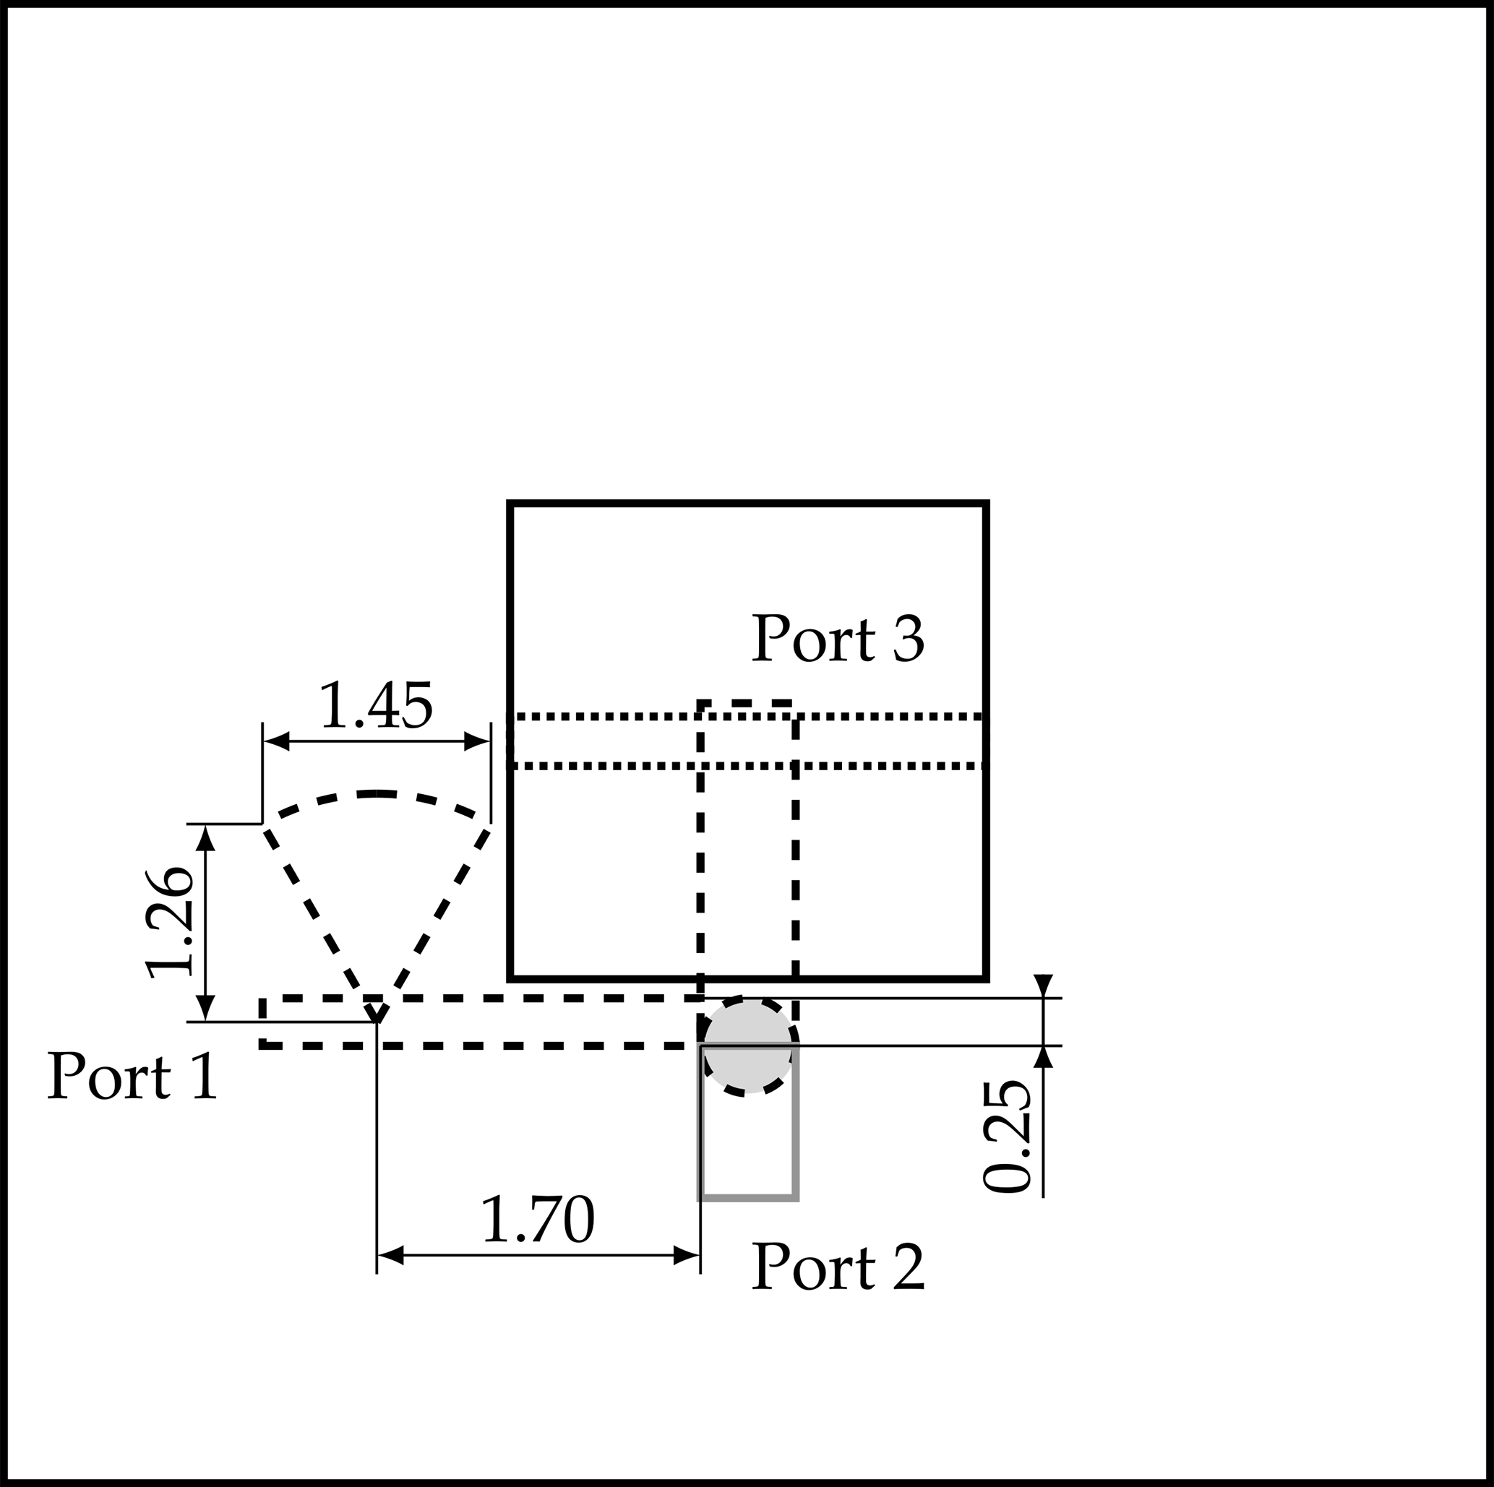
Figure D.1. Bias-T dimensions and port definitions for the 2020 precursor element. The radial stub branches laterally from the bias line rather than continuing along it, which is the reading that corrected the stub orientation and dimensioning in this reconstruction. Note that the numerical dimensions belong to the 2020 element and not to the element reconstructed here. Reproduced from Harz et al. [1], Fig. 5, under the Creative Commons Attribution 4.0 licence.

Appendix E Additional electromagnetic plots
The plots listed here support the main text but are not needed to follow it. None has yet been exported from the solver.

FIGURE E.1
Figure required. Not yet available.
Overlay of the reflection magnitude of SZmax(1),Zmax(1) against frequency at varC = 0.025 pF and 0.19 pF on the current geometry, same runs as Figure 6.
Figure E.1. Reflection magnitude at the two capacitance endpoints on the current geometry, same runs as Figure 6. Discussed in Section 7.2.

FIGURE E.2
Figure required. Not yet available.
Electric-field magnitude at 26.104 GHz on a fixed non-saturating scale, starting near 0 to 10000 V/m, with the same camera position as Figure 7. The existing capture saturates and carries no information, so it must be regenerated before use.
Figure E.2. Electric-field magnitude at 26.104 GHz for varC = 0.025 pF on a fixed non-saturating colour scale.

Appendix F Unresolved source and reconstruction ambiguities
The following points are unsettled. They are recorded here so that they are not mistaken for settled ones, and each is tracked in docs/claims_ledger.md in the project repository.
- The exact varactor part variant. The 2022 paper names MAVR-011020-111 [2], the 2020 paper names MAVR-011020-141 for the same capacitance range [1], and the package outline used for the pad geometry in this model was recorded as MAVR-011020-1411. The difference has not been resolved against a manufacturer datasheet, and it affects the assumed pad geometry in Table 4.
- The incidence angle used in the source's own unit-cell simulation. The source states that the element was optimised in a unit-cell configuration but does not give the angle. This model uses normal incidence. The published measurement, separately, used a waveguide simulator at 21.4 degrees, so the measured phase figures quoted in Section 2.4 are not directly comparable with normal-incidence simulation.
- The interlayer bias route between layers three, five and six. The source establishes that the route exists but does not dimension it. What is modelled satisfies the published constraints without being a published layout.
- The conductor thicknesses. These are inferred from the source stack description rather than published, and the value used for layers five and six is carried over from the upper layers.
- The substrate properties above 20 GHz. The published permittivity and loss factor are specified only to 20 GHz and are applied here at 26 GHz, following the source. Widening the simulated interval will extend this extrapolation further and requires the material fit range to be re-checked.
- Per-run numerical records for the slotW and lineV diagnostic branches. Their parameter values are known and carried forward into the current geometry, but their individual convergence and phase readings were not archived. No numerical value from those two branches is quoted anywhere in this report.
- The endpoint phase separation near the upper band edge. It has been observed from overlaid plots but not quantified, because the S-parameter data have not been exported numerically.

