

sTATISTICS pROGRAM

[Document subtitle]



May 3, 2019

FCis ASU

*DR Mahmoud Mounir   
Second Year*

Abdallah Hossam sec 9

Abdelrahman ghazi sec 9

Abdelrahman khalid sec 9

Rafeek Nehad sec 7

Ahmed Mostafa shihata sec 3

***Program Statistics***

**Description :**

Create the Functionality as like

1. Pie chart
2. Par chart
3. Histogram
4. Measure of center
5. IQR
6. Correlation
7. Population

The goal of that project is to calculate the chosen one and draw it

During his the libraries matplotlib,numpy and Statistics , who is in the Python language and use Qt5 designer in pyqt5

**User Manual :**

when you run the program we allow to you to choose one of this functions

This is the First screen you will show

Step 1 :

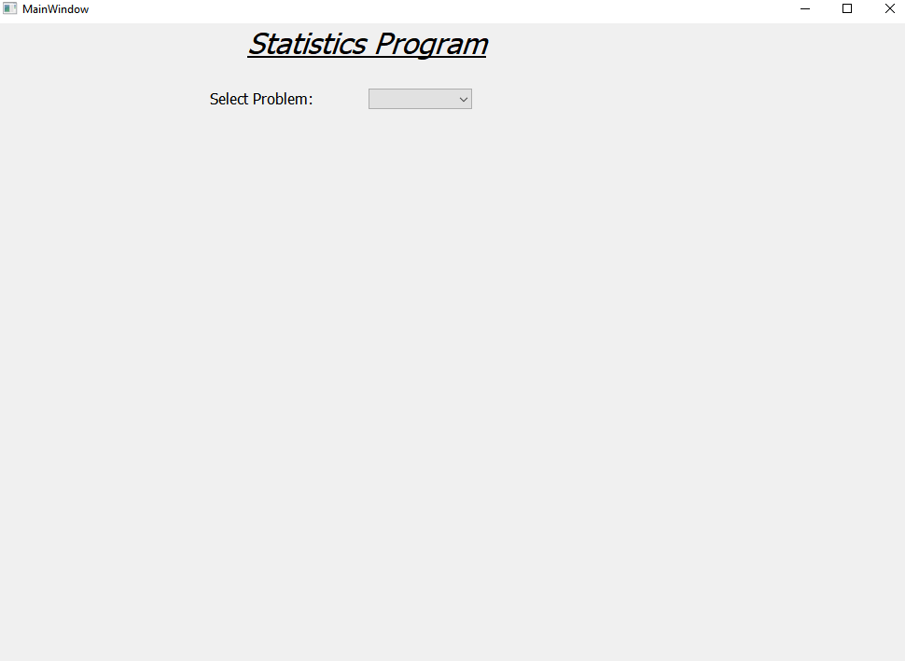

Step 2 :

You can choose one of this functions

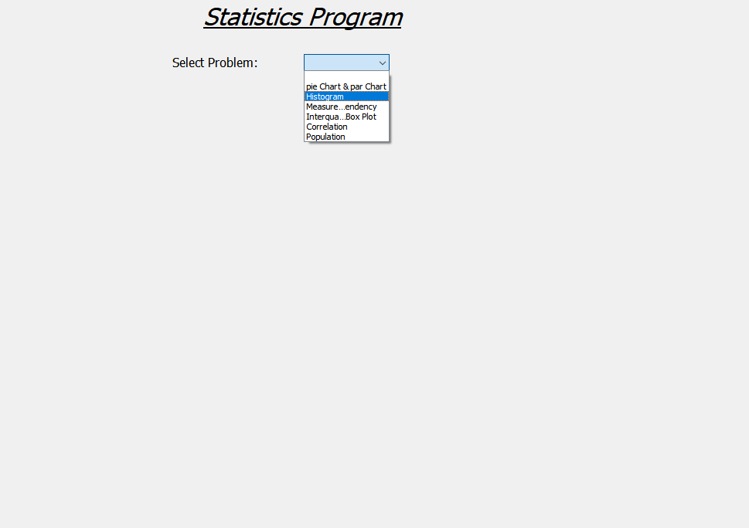

* First Choice

You Selected “ par chart & pie chart “ you will show this :

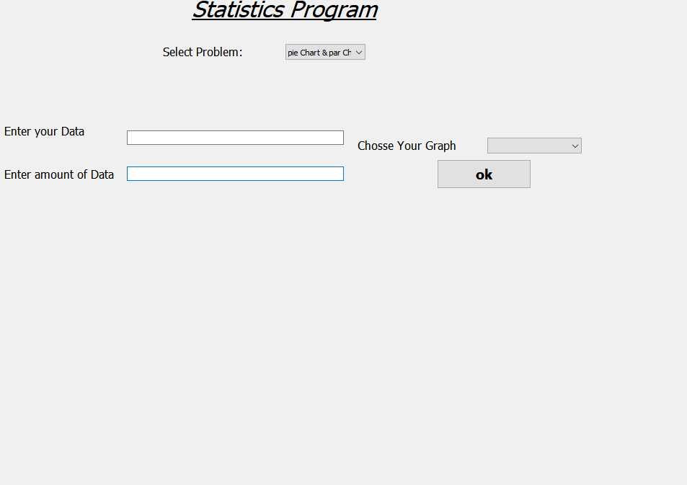

And you can enter your Data but before click ok make sure you chose the type of graph you want from here

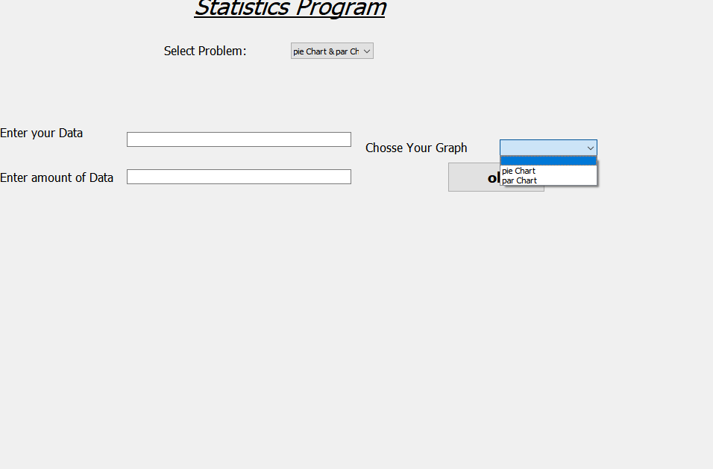

* Second choice

Select the Histogram and you enter your data

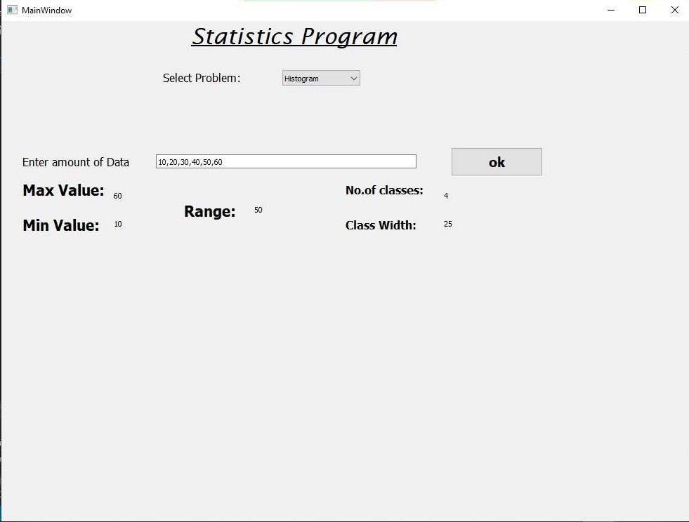

You will see the result and the graph like this :

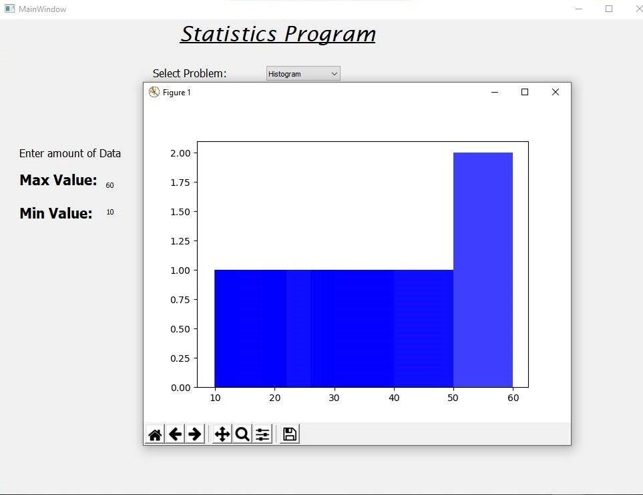

* Third choice

You select Measure of center , you will see this :

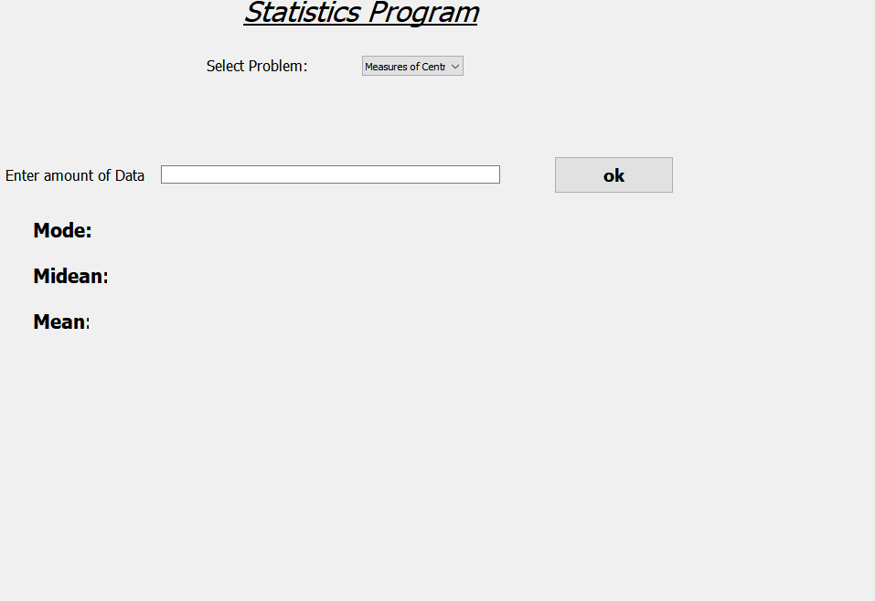

Then enter you data and click ok to get the result.

* Fourth choice :

You select the IQR

If you enter your data here and click ok you will show the results

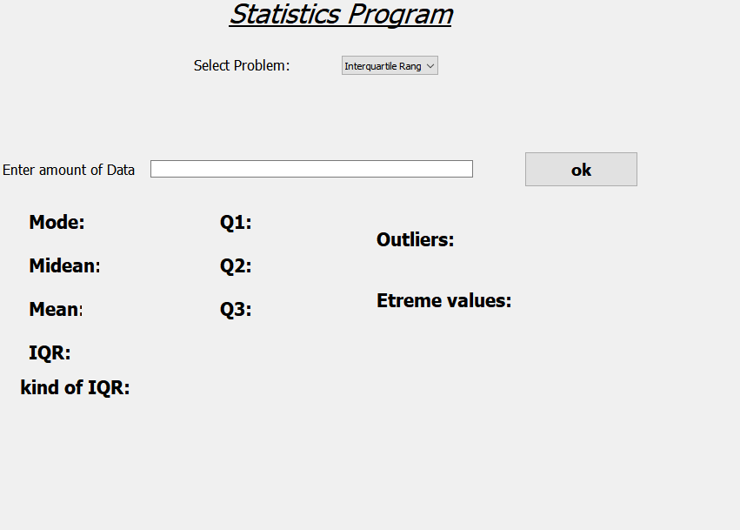

* Fifth choice

You select the Correlation you will see this screen :

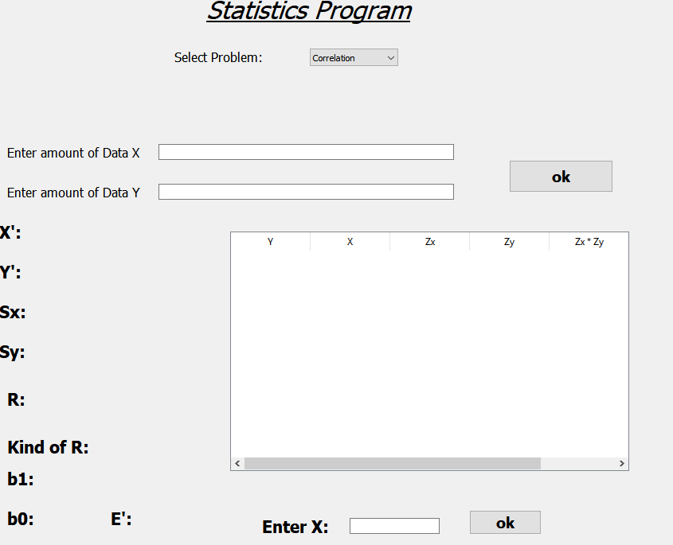

Enter your data and click ok to get the results.

* **Sixth choice**

Select the population you will see this screen :

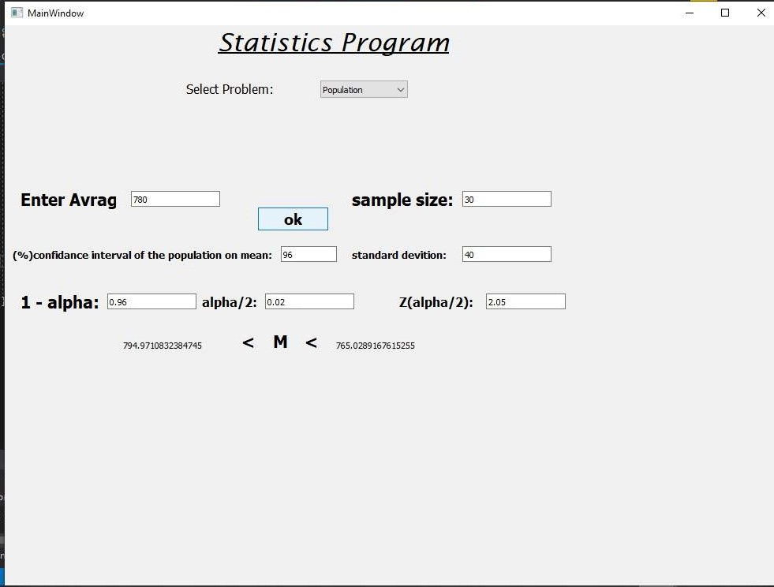

Enter your data and click ok to get your results.