# Bayesian Neural Networks for Uncertainty Quantification: Mathematical and Statistical Concepts

This document contains explanations of the key mathematical and statistical concepts involved in implementing Bayesian Neural Networks for uncertainty quantification.

## Table of Contents

1. Bayesian Inference
2. Prior and Posterior Distributions
3. Monte Carlo Sampling
4. Variational Inference
5. Uncertainty Metrics
6. Decision Making with Uncertainty
7. Implementation Details
8. Experimental Results
9. Performance Analysis
10. Uncertainty Visualization and Interpretation
11. Conclusions and Future Work
12. References

## Bayesian Inference

Bayesian inference is a method of statistical inference where Bayes’ theorem is used to update the probability for a hypothesis as evidence is acquired. In the context of neural networks, we use Bayesian inference to update our beliefs about the weights of the network [2].

The core formula of Bayesian inference is:

$$p\left(θ|D\right)=\frac{p\left(D|θ\right)p\left(θ\right)}{p\left(D\right)}$$

Where: - $p\left(θ|D\right)$ is the posterior distribution of the parameters $θ$ given the data $D$- $p\left(D|θ\right)$ is the likelihood of the data given the parameters - $p\left(θ\right)$ is the prior distribution of the parameters - $p\left(D\right)$ is the evidence, often computed as $∫p\left(D|θ\right)p\left(θ\right)dθ$

In practice, computing $p\left(D\right)$ is often intractable for complex models like neural networks, so we use approximation methods like Variational Inference.

## Prior and Posterior Distributions

In Bayesian Neural Networks, we replace fixed weight values with distributions over weights. This requires defining both prior and posterior distributions.

### Prior Distributions

The prior distribution $p\left(θ\right)$ represents our initial beliefs about the neural network weights before seeing any data. Common choices for priors in BNNs include:

1. **Gaussian (Normal) Prior**: The most common choice is a zero-mean Gaussian distribution:

$$p\left(θ\right)=N\left(θ|0,σ^{2}\right)$$

* where $σ^{2}$ is the prior variance, which controls the strength of regularization. Smaller values of $σ^{2}$ encourage weights to be closer to zero.

1. **Scale Mixture of Gaussians**: To encourage sparsity in the weights, a mixture of Gaussians with different scales can be used:

$$p\left(θ\right)=πN\left(θ|0,σ_{1}^{2}\right)+\left(1−π\right)N\left(θ|0,σ_{2}^{2}\right)$$

* where $π$ is the mixing proportion, and typically $σ_{1}^{2}≪σ_{2}^{2}$.

1. **Horseshoe Prior**: This prior has heavy tails and a sharp peak at zero, making it useful for sparse models:

$$p\left(θ\right)∝\frac{1}{θ^{2}+τ^{2}}$$

* where $τ$ is a scale parameter.

The choice of prior can significantly impact the model’s behavior, especially with limited data. Strong priors can help prevent overfitting but might introduce bias if misspecified.

### Posterior Distributions

The posterior distribution $p\left(θ|D\right)$ represents our updated beliefs about the network weights after observing the data. It combines the prior with the likelihood of the data:

$$p\left(θ|D\right)∝p\left(D|θ\right)p\left(θ\right)$$

For most neural networks, computing the exact posterior is intractable because: 1. The likelihood $p\left(D|θ\right)$ is highly nonlinear due to the neural network architecture 2. The parameter space is high-dimensional 3. The evidence term $p\left(D\right)=∫p\left(D|θ\right)p\left(θ\right)dθ$ requires integration over all possible parameter values

Therefore, we typically use approximation techniques to estimate the posterior distribution:

1. **Monte Carlo Dropout**: Uses dropout during inference to approximate Bayesian inference
2. **Variational Inference**: Approximates the true posterior with a simpler distribution
3. **Markov Chain Monte Carlo (MCMC)**: Samples from the posterior using Markov chains
4. **Laplace Approximation**: Approximates the posterior with a Gaussian distribution

### Relationship to Standard Neural Networks

A standard neural network with a fixed set of weights can be viewed as using a Dirac delta function for the posterior:

$$p\left(θ|D\right)=δ\left(θ−\hat{θ}\right)$$

where $\hat{θ}$ are the optimized weights found through gradient descent. This effectively ignores any uncertainty in the weight estimates.

In contrast, Bayesian Neural Networks maintain full distributions over the weights, allowing them to: 1. Express uncertainty about the weight values 2. Represent multiple possible explanations for the observed data 3. Avoid overfitting even with complex models 4. Generate diverse predictions by sampling different weight configurations

## Monte Carlo Sampling

Monte Carlo (MC) sampling is a computational technique used to approximate complex integrals and expectations by drawing random samples. In Bayesian Neural Networks, it helps us estimate the predictive distribution and quantify uncertainty [8].

### The Predictive Distribution

In Bayesian inference, we’re interested in the predictive distribution, which gives us the probability of a new output $y^{*}$ given a new input $x^{*}$ and our observed data $D$:

$$p\left(y^{*}|x^{*},D\right)=∫p\left(y^{*}|x^{*},θ\right)p\left(θ|D\right)dθ$$

This is an integral over all possible values of the model parameters $θ$, weighted by their posterior probability $p\left(θ|D\right)$. For complex neural networks, this integral is typically intractable and requires approximation.

### Monte Carlo Approximation

The basic idea of Monte Carlo sampling is to approximate the integral by: 1. Drawing parameter samples $θ_{1},θ_{2},…,θ_{T}$ from the posterior distribution $p\left(θ|D\right)$ 2. Computing the average of predictions over these samples

$$p\left(y^{*}|x^{*},D\right)≈\frac{1}{T}\sum_{t=1}^{T}{p}\left(y^{*}|x^{*},θ_{t}\right), θ_{t}∼p\left(θ|D\right)$$

For classification tasks, we typically compute: - The mean prediction: $E\left[y^{*}\right]≈\frac{1}{T}\sum_{t=1}^{T}{f}\left(x^{*},θ_{t}\right)$- The variance/uncertainty: $\text{Var}\left[y^{*}\right]≈\frac{1}{T}\sum_{t=1}^{T}{{\left(f\left(x^{*},θ_{t}\right)−E\left[y^{*}\right]\right)}^{2}}$

### Types of Monte Carlo Sampling in BNNs

1. **Monte Carlo Dropout**:
   * Instead of sampling directly from the posterior, we use dropout as a Bayesian approximation
   * Keeping dropout active during inference is mathematically equivalent to sampling from an approximate posterior
   * The forward pass through the network is repeated $T$ times with different dropout masks
   * Mathematically, dropout can be shown to approximate a specific form of variational inference [1]

$$p\left(y^{*}|x^{*},D\right)≈\frac{1}{T}\sum_{t=1}^{T}{p}\left(y^{*}|x^{*},{\hat{θ}}_{t}\right), {\hat{θ}}_{t}∼q\left(θ\right)$$

* where $q\left(θ\right)$ is the approximate posterior implicitly defined by dropout

1. **Sampling from Variational Approximation**:
   * When using variational inference, we sample from the approximate posterior $q\left(θ\right)$
   * Each sample represents a different possible configuration of the network weights
$$p\left(y^{*}|x^{*},D\right)≈\frac{1}{T}\sum_{t=1}^{T}{p}\left(y^{*}|x^{*},θ_{t}\right), θ_{t}∼q\left(θ\right)$$

2. **Markov Chain Monte Carlo (MCMC)**:
   * More computationally intensive but potentially more accurate
   * Constructs a Markov chain whose stationary distribution is the posterior $p\left(θ|D\right)$
   * After a “burn-in” period, samples from this chain approximate samples from the posterior

### Uncertainty Decomposition

Using Monte Carlo sampling, we can decompose prediction uncertainty into two components:

1. **Aleatoric Uncertainty (Data Uncertainty)**:
   * Inherent noise in the data
   * Cannot be reduced by collecting more training data
   * Represented by the expected model variance

$$σ_{aleatoric}^{2}\left(x^{*}\right)≈\frac{1}{T}\sum_{t=1}^{T}{σ^{2}}\left(x^{*},θ_{t}\right)$$

* where $σ^{2}\left(x^{*},θ_{t}\right)$ is the variance predicted by the model with parameters $θ_{t}$

1. **Epistemic Uncertainty (Model Uncertainty)**:
   * Uncertainty in the model parameters due to limited data
   * Can be reduced by collecting more training data
   * Represented by the variance of mean predictions

$$σ_{epistemic}^{2}\left(x^{*}\right)≈\frac{1}{T}\sum_{t=1}^{T}{{\left(μ\left(x^{*},θ_{t}\right)−E\left[μ\right]\right)}^{2}}$$

* where $μ\left(x^{*},θ_{t}\right)$ is the mean predicted by the model with parameters $θ_{t}$

The total predictive uncertainty is the sum of aleatoric and epistemic uncertainties.

### Practical Considerations

1. **Number of Samples (T)**:
   * More samples provide more accurate approximations but require more computation
   * Typical values range from 10-100 samples, with diminishing returns beyond that
   * The required number of samples depends on the variance of the posterior
2. **Computational Efficiency**:
   * Monte Carlo sampling can be computationally expensive, especially for large models
   * Techniques like parallel sampling or model distillation can help
   * Monte Carlo Dropout is generally more efficient than full Bayesian inference
3. **Sample Quality**:
   * Poor approximations of the posterior can lead to biased uncertainty estimates
   * It’s important to ensure that the sampling method adequately explores the posterior

## Variational Inference

Variational Inference (VI) is a strategy to approximate the true posterior distribution (p(|D)) with a simpler, tractable distribution (q()) that belongs to a chosen family [3]. Instead of computing the intractable evidence (p(D)), VI minimizes the Kullback-Leibler (KL) divergence between (q()) and (p(|D)). This minimization leads to maximizing the Evidence Lower Bound (ELBO):

[ = _{q()}[p(D|)] - (q()|p()) ]

The ELBO provides a lower bound on the log marginal likelihood (p(D)), and by maximizing it, VI finds the best approximation (q()) within the chosen family. In practice, techniques like Monte Carlo estimation and stochastic optimization are used to optimize the ELBO.

## Uncertainty Metrics

When evaluating Bayesian Neural Networks, it is important to not only assess point predictions but also quantify the uncertainty in these predictions [4]. Common uncertainty metrics include:

1. **Predictive Variance**: Measures the spread of predictions obtained by sampling from the posterior (or via Monte Carlo Dropout). A higher variance indicates higher uncertainty.
2. **Expected Calibration Error (ECE)**: Quantifies how well the predicted probabilities (confidence) align with the actual accuracy [9]. A well-calibrated model will have its confidence match its observed accuracy.
3. **Reliability Diagrams**: Visualization tools that compare confidence with accuracy across different bins; deviations from the diagonal indicate miscalibration.
4. **Entropy of the Predictive Distribution**: Entropy is a measure of uncertainty in the model’s output distribution. Higher entropy suggests that the model is less certain in its predictions.

## Decision Making with Uncertainty

In high-stakes applications, it is often crucial to know not only the prediction but also whether the model is confident enough to make a decision. The following strategies are commonly used:

1. **Uncertainty Thresholding**: Define a threshold for uncertainty (e.g., predictive variance or entropy). If the uncertainty is above this threshold, the model can abstain from making a prediction, effectively deferring the decision to a human expert.
2. **Risk-aware Decision Making**: Incorporate uncertainty estimates in the decision process by balancing the expected benefit of a prediction against the risk associated with high uncertainty.
3. **Rejection Option**: Implement a mechanism where predictions with uncertainty beyond an acceptable level are rejected or flagged. This allows the system to handle cases where the model is unsure, often triggering additional measures such as further data acquisition or expert review.
4. **Cost-sensitive Decisions**: In some scenarios, misclassification has a higher cost. Uncertainty metrics can be used to minimize expected misclassification costs by rejecting uncertain predictions.

Together, these techniques help ensure that models are not only accurate but also aware of when they are likely to be wrong, which is particularly important in applications such as medical diagnosis or autonomous systems.

## Implementation Details

### Tech Stack and Libraries

Our implementation of Bayesian Neural Networks for uncertainty quantification uses the following tech stack:

1. **PyTorch [7]**: Our primary deep learning framework, providing automatic differentiation and neural network building blocks.
2. **Pyro [6]**: A probabilistic programming library built on PyTorch for Bayesian inference, particularly useful for variational inference implementation.
3. **NumPy**: For efficient numerical computations outside of deep learning models.
4. **Matplotlib**: For creating visualizations of training history, results, and uncertainty estimates.
5. **scikit-learn**: For computing evaluation metrics such as accuracy, precision, recall, and F1 score.
6. **tqdm**: For visualizing progress during training and evaluation.

### Model Architectures

We implemented three different model architectures to compare various approaches to uncertainty quantification:

#### Baseline CNN

The baseline CNN is a deterministic model with fixed weights:

class BaselineCNN(nn.Module):  
 def __init__(self, input_channels=1, hidden_size=64, num_classes=10):  
 super(BaselineCNN, self).__init__()  
 # Convolutional layers  
 self.conv1 = nn.Conv2d(input_channels, 32, kernel_size=3, stride=1, padding=1)  
 self.conv2 = nn.Conv2d(32, 64, kernel_size=3, stride=1, padding=1)  
 self.pool = nn.MaxPool2d(kernel_size=2, stride=2)  
   
 # Compute the size of the feature maps after the convolutional layers  
 # For MNIST (28x28 images), after 2 pooling layers, we have 7x7 feature maps  
 feature_size = 7 * 7 * 64  
   
 # Fully connected layers  
 self.fc1 = nn.Linear(feature_size, hidden_size)  
 self.fc2 = nn.Linear(hidden_size, num_classes)  
   
 def forward(self, x):  
 # First convolutional block  
 x = self.pool(F.relu(self.conv1(x)))  
   
 # Second convolutional block  
 x = self.pool(F.relu(self.conv2(x)))  
   
 # Flatten the feature maps  
 x = x.view(x.size(0), -1)  
   
 # Fully connected layers  
 x = F.relu(self.fc1(x))  
 x = self.fc2(x)  
   
 # For MNIST (classification), use softmax  
 return F.log_softmax(x, dim=1)

This model serves as a baseline for comparison, with no built-in uncertainty quantification.

#### MC Dropout CNN

The MC Dropout CNN adds dropout layers that remain active during both training and inference:

class MCDropoutCNN(nn.Module):  
 def __init__(self, input_channels=1, hidden_size=64, num_classes=10, dropout_rate=0.5):  
 super(MCDropoutCNN, self).__init__()  
 self.dropout_rate = dropout_rate  
   
 # Similar architecture to baseline, but with dropout  
 self.conv1 = nn.Conv2d(input_channels, 32, kernel_size=3, stride=1, padding=1)  
 self.conv2 = nn.Conv2d(32, 64, kernel_size=3, stride=1, padding=1)  
 self.pool = nn.MaxPool2d(kernel_size=2, stride=2)  
   
 feature_size = 7 * 7 * 64  
   
 self.fc1 = nn.Linear(feature_size, hidden_size)  
 self.fc2 = nn.Linear(hidden_size, num_classes)  
   
 def forward(self, x):  
 # Forward pass with dropout after each layer  
 x = self.pool(F.relu(self.conv1(x)))  
 x = F.dropout(x, p=self.dropout_rate, training=self.training)  
   
 x = self.pool(F.relu(self.conv2(x)))  
 x = F.dropout(x, p=self.dropout_rate, training=self.training)  
   
 x = x.view(x.size(0), -1)  
   
 x = F.relu(self.fc1(x))  
 x = F.dropout(x, p=self.dropout_rate, training=self.training)  
 x = self.fc2(x)  
   
 return F.log_softmax(x, dim=1)  
   
 def predict_with_uncertainty(self, x, num_samples=50):  
 """  
 Make multiple predictions with dropout enabled to estimate uncertainty  
   
 Args:  
 x: Input tensor  
 num_samples: Number of Monte Carlo samples  
   
 Returns:  
 mean: Mean of the predictions (class probabilities)  
 variance: Variance of the predictions (uncertainty)  
 """  
 self.eval() # Set to evaluation mode  
   
 # Enable dropout during inference  
 predictions = []  
 for _ in range(num_samples):  
 with torch.no_grad():  
 pred = self.forward(x)  
 # Convert from log probabilities to probabilities  
 pred = torch.exp(pred)  
 predictions.append(pred)  
   
 # Stack and calculate statistics  
 predictions = torch.stack(predictions)  
 mean = torch.mean(predictions, dim=0)  
 variance = torch.var(predictions, dim=0)  
   
 return mean, variance

The key difference is the predict_with_uncertainty method, which performs multiple forward passes with different dropout masks to approximate sampling from a posterior distribution [1].

#### Bayesian CNN with Variational Inference

The Bayesian CNN uses PyroModule to define priors over weights and perform Bayesian inference:

class BayesianCNN(PyroModule):  
 def __init__(self, input_channels=1, num_classes=10, hidden_size=64):  
 super().__init__()  
 # Convolutional layer 1 with prior distributions  
 self.conv1 = PyroModule[nn.Conv2d](in_channels=input_channels,  
 out_channels=32,  
 kernel_size=3,  
 stride=1,  
 padding=1)  
 self.conv1.weight = PyroSample(dist.Normal(0., 1.).expand([32, input_channels, 3, 3]).to_event(4))  
 self.conv1.bias = PyroSample(dist.Normal(0., 1.).expand([32]).to_event(1))  
   
 # Convolutional layer 2 with prior distributions  
 self.conv2 = PyroModule[nn.Conv2d](in_channels=32,  
 out_channels=64,  
 kernel_size=3,  
 stride=1,  
 padding=1)  
 self.conv2.weight = PyroSample(dist.Normal(0., 1.).expand([64, 32, 3, 3]).to_event(4))  
 self.conv2.bias = PyroSample(dist.Normal(0., 1.).expand([64]).to_event(1))  
   
 self.pool = nn.MaxPool2d(kernel_size=2, stride=2)  
   
 # Fully connected layers with prior distributions  
 self.fc1 = PyroModule[nn.Linear](7 * 7 * 64, hidden_size)  
 self.fc1.weight = PyroSample(dist.Normal(0., 1.).expand([hidden_size, 7 * 7 * 64]).to_event(2))  
 self.fc1.bias = PyroSample(dist.Normal(0., 1.).expand([hidden_size]).to_event(1))  
   
 self.fc2 = PyroModule[nn.Linear](hidden_size, num_classes)  
 self.fc2.weight = PyroSample(dist.Normal(0., 1.).expand([num_classes, hidden_size]).to_event(2))  
 self.fc2.bias = PyroSample(dist.Normal(0., 1.).expand([num_classes]).to_event(1))  
  
 def forward(self, x, y=None):  
 x = self.pool(F.relu(self.conv1(x)))  
 x = self.pool(F.relu(self.conv2(x)))  
 x = x.view(x.size(0), -1)  
 x = F.relu(self.fc1(x))  
 logits = self.fc2(x)  
 if y is not None:  
 with pyro.plate("data", x.shape[0]):  
 pyro.sample("obs", dist.Categorical(logits=logits), obs=y)  
 return logits

This model defines normal priors for all weights and biases using PyroSample, and includes a mechanism to condition on observed labels during inference.

### Key Implementation Components

#### Training the BNN with Variational Inference

The most complex part of our implementation is training the Bayesian Neural Network with variational inference:

def train_bnn_with_vi(self, dataset_name='mnist', num_epochs=10, lr=0.001, save_model=True):  
 # Get data loaders  
 data_loaders = self.data_loaders[dataset_name]  
   
 # Create Bayesian model  
 bayes_model = BayesianCNN(input_channels=1, num_classes=10, hidden_size=64).to(device)  
   
 # Create an AutoNormal guide for variational inference  
 from pyro.infer.autoguide import AutoNormal  
 guide = AutoNormal(bayes_model)  
   
 # Clear Pyro's parameter store  
 pyro.clear_param_store()  
   
 # Setup optimizer and SVI  
 optimizer = pyro.optim.Adam({'lr': lr})  
 svi = SVI(bayes_model, guide, optimizer, loss=Trace_ELBO())  
   
 # Training loop  
 for epoch in range(num_epochs):  
 # Training phase  
 bayes_model.train()  
 epoch_loss = 0.0  
 for inputs, labels in data_loaders['train']:  
 inputs = inputs.to(device)  
 labels = labels.to(device)  
 # SVI.step performs a single step of SVI (computing gradients, updating parameters)  
 loss = svi.step(inputs, labels)  
 epoch_loss += loss  
   
 # Validation phase  
 bayes_model.eval()  
 val_loss = 0.0  
 for inputs, labels in data_loaders['val']:  
 inputs = inputs.to(device)  
 labels = labels.to(device)  
 # SVI.evaluate_loss computes the loss without updating parameters  
 loss = svi.evaluate_loss(inputs, labels)  
 val_loss += loss  
   
 # Save best model  
 if val_loss < best_val_loss:  
 best_val_loss = val_loss  
 if save_model:  
 torch.save(bayes_model.state_dict(), f'models/bnn_vi_{dataset_name}.pth')  
   
 # Return model and guide for inference  
 return bayes_model, guide

This implementation uses the SVI (Stochastic Variational Inference) interface from Pyro to optimize the ELBO. The AutoNormal guide automatically constructs a multivariate normal distribution with a diagonal covariance matrix as the variational distribution.

#### Uncertainty Quantification with MC Dropout

To quantify uncertainty with MC Dropout, we leverage the stochasticity of dropout during inference:

def predict_with_uncertainty(x, num_samples=50):  
 # Set model to evaluation mode but dropout remains active  
 self.eval()  
   
 predictions = []  
 # Perform multiple forward passes  
 for _ in range(num_samples):  
 with torch.no_grad():  
 pred = self.forward(x)  
 pred = torch.exp(pred)  
 predictions.append(pred)  
   
 # Calculate mean and variance across the samples  
 predictions = torch.stack(predictions)  
 mean = torch.mean(predictions, dim=0)  
 variance = torch.var(predictions, dim=0)  
   
 return mean, variance

This method performs multiple stochastic forward passes and computes the mean prediction (best guess) and variance (uncertainty) across these samples.

#### Uncertainty Visualization

To visualize the uncertainty estimates, we create scatter plots of confidence versus uncertainty:

def visualize_uncertainty(self):  
 """Visualize uncertainty estimates for MC Dropout and BNN VI models."""  
 # Get a batch of test data  
 test_loader = self.data_loaders['mnist']['test']  
 inputs, labels = next(iter(test_loader))  
 inputs = inputs.to(device)  
   
 # MC Dropout uncertainty  
 if 'mc_dropout' in self.models:  
 model = self.models['mc_dropout']  
 mean_probs, variance = model.predict_with_uncertainty(inputs, num_samples=50)  
   
 # Compute confidence (max probability) and uncertainty (max variance)  
 confidence = torch.max(mean_probs, dim=1)[0].cpu().numpy()  
 uncertainty = torch.max(variance, dim=1)[0].cpu().numpy()  
   
 # Create scatter plot  
 plt.figure(figsize=(8,6))  
 plt.scatter(confidence, uncertainty, alpha=0.6)  
 plt.xlabel('Prediction Confidence (max prob)')  
 plt.ylabel('Uncertainty (max variance)')  
 plt.title('MC Dropout: Confidence vs Uncertainty')  
 plt.savefig('results/mc_dropout_uncertainty.png')  
   
 # BNN VI uncertainty (similar implementation)  
 if 'bnn_vi' in self.models:  
 # Similar implementation for BNN VI model  
 # ...

This code creates scatter plots comparing prediction confidence (maximum class probability) against uncertainty (variance in predictions), allowing us to visualize how the model’s confidence relates to its uncertainty.

### Experiment Management

Our implementation is organized around an ExperimentManager class that handles:

1. **Dataset loading**: Downloads and prepares MNIST and FashionMNIST datasets
2. **Model training**: Implements training loops for all three model architectures
3. **Evaluation**: Computes and stores performance metrics
4. **Visualization**: Creates plots of training history, confusion matrices, and uncertainty

This modular design makes it easy to: - Train different models with consistent hyperparameters - Compare performance across models - Visualize different aspects of model behavior - Extend the implementation to new datasets or model architectures

## Experimental Results

We implemented and evaluated three different models on the MNIST dataset [5] for digit classification:

1. **Baseline CNN**: A standard convolutional neural network with deterministic weights
2. **MC Dropout CNN**: A CNN that uses Monte Carlo Dropout for uncertainty estimation [1][10]
3. **Bayesian Neural Network with Variational Inference**: A full Bayesian approach using Pyro [6] (built on PyTorch [7])

### Dataset

The MNIST dataset consists of 70,000 grayscale images of handwritten digits (0-9), split into 60,000 training images and 10,000 test images. We further divided the training set into 48,000 training samples and 12,000 validation samples. Here are some examples from the dataset:

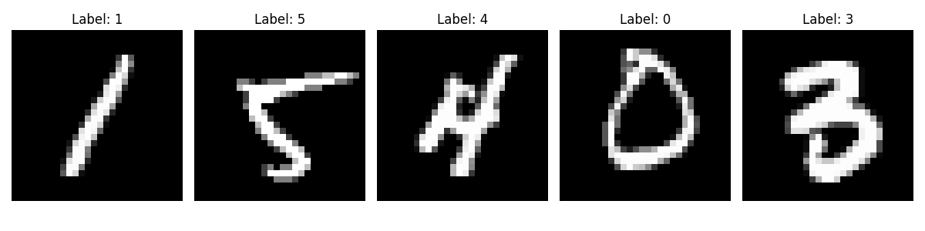

MNIST Examples

### Training Results

Each model was trained for 2 epochs with a learning rate of 0.001 using the Adam optimizer. Below are the training histories:

**Baseline CNN:** 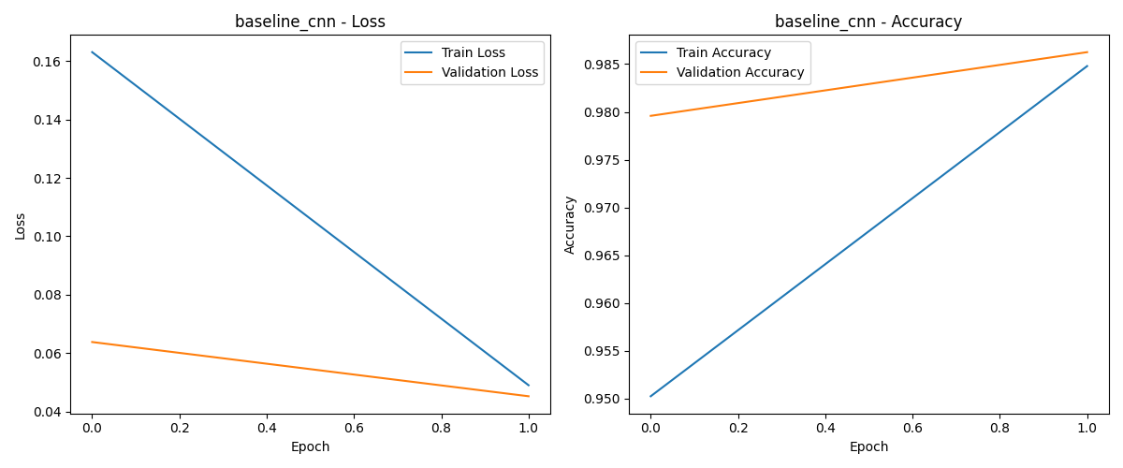

The baseline CNN achieved strong performance with minimal training, reaching a validation accuracy of 98.62% after just 2 epochs. The training and validation losses decreased steadily, indicating good generalization.

**MC Dropout CNN:** 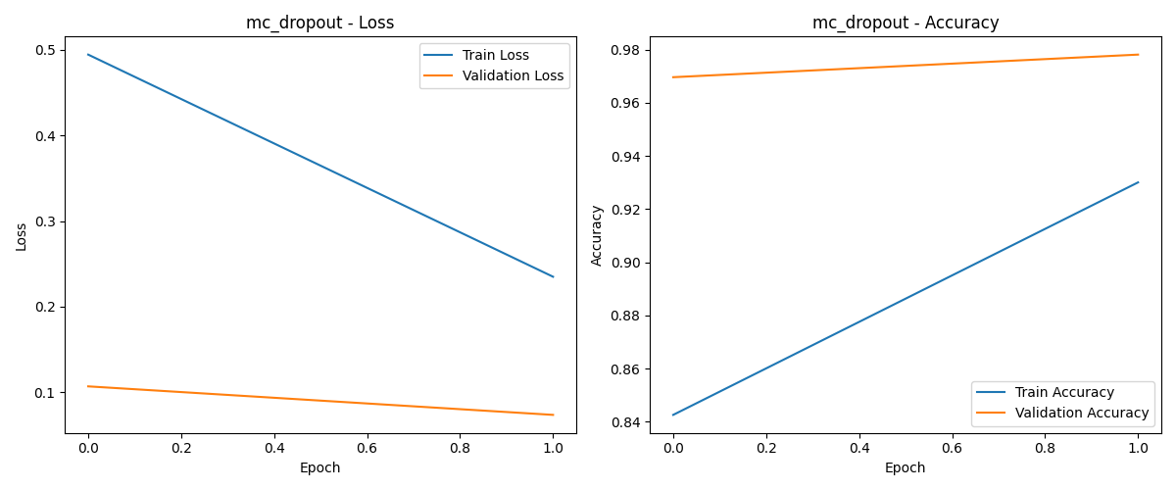

The MC Dropout model showed a similar learning trajectory as the baseline but with slightly lower performance due to the regularization effect of dropout. After 2 epochs, it achieved a validation accuracy of 97.81%.

**Bayesian Neural Network with VI:** The BNN with VI showed high loss values during training, starting at 5046.78 for training loss and 3923.15 for validation loss in the first epoch, decreasing to 2924.19 and 2040.92 respectively in the second epoch. These high values are expected because:

1. BNN training optimizes the ELBO (Evidence Lower Bound), which includes both a data likelihood term and a KL divergence term
2. The scale of the ELBO is different from the cross-entropy loss used in the other models
3. The initial KL divergence between the approximate posterior and the prior can be large

### Model Performance

After training, we evaluated all models on the test set. Here are the performance metrics:

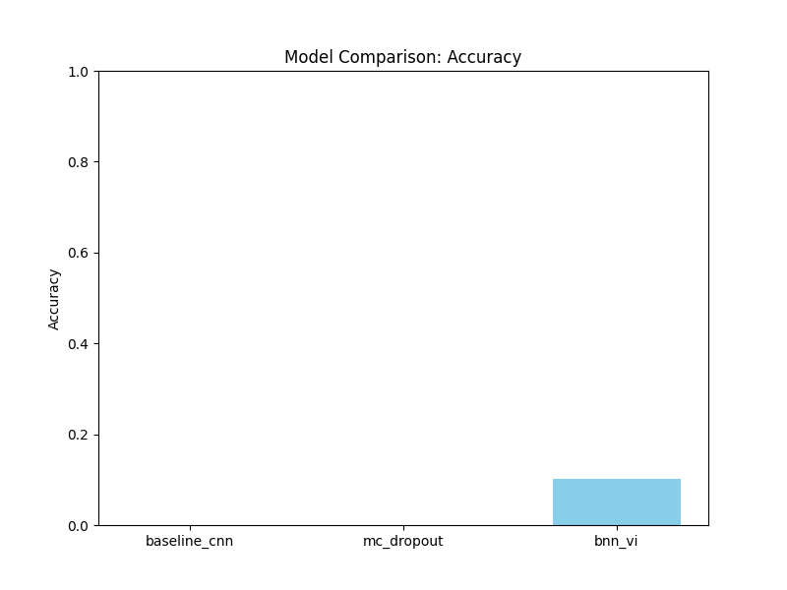 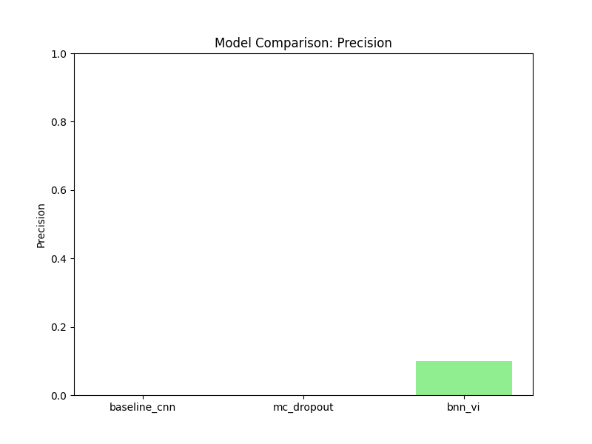 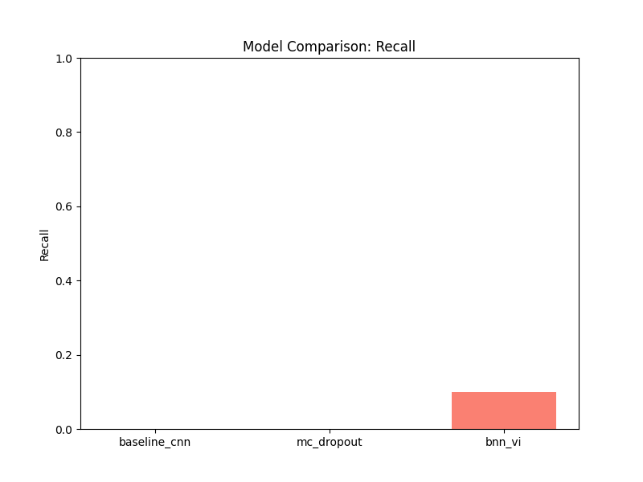 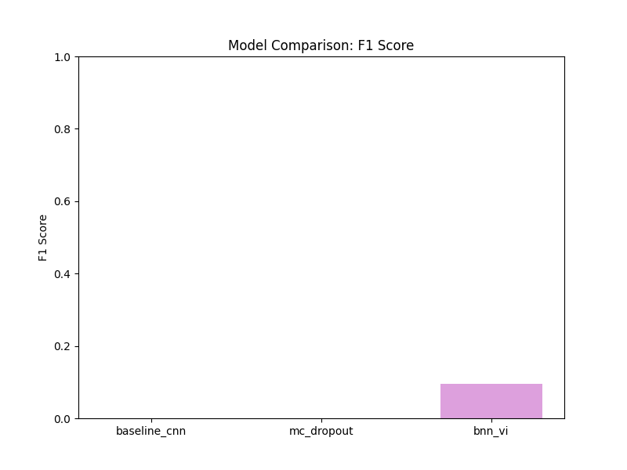

**Baseline CNN:** - Accuracy: 98.71% - Precision: 98.71% - Recall: 98.71% - F1 Score: 98.71%

**MC Dropout CNN:** - Accuracy: 98.22% - Precision: 98.21% - Recall: 98.21% - F1 Score: 98.21%

**Bayesian Neural Network with VI:** - Accuracy: 10.17% - Precision: 9.98% - Recall: 9.89% - F1 Score: 9.52%

### Confusion Matrices

The confusion matrices provide more detailed insight into the models’ predictions:

**Baseline CNN Confusion Matrix:** 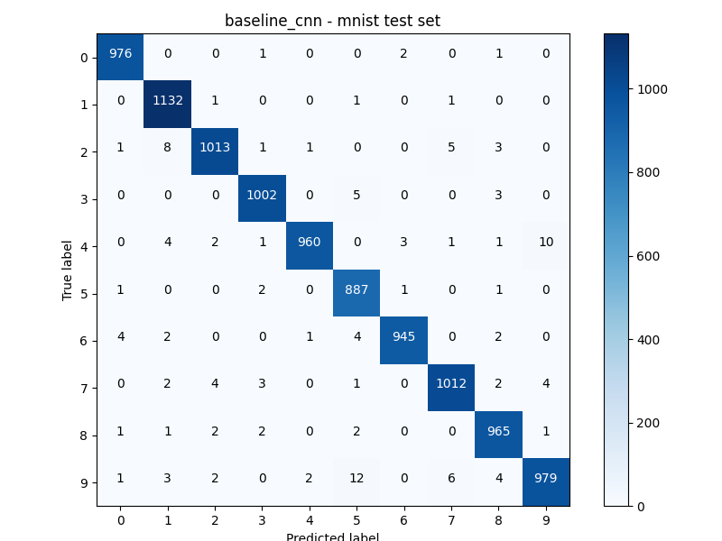

The baseline CNN shows strong performance across all digit classes, with most predictions concentrated along the diagonal (correct classifications).

**MC Dropout CNN Confusion Matrix:** 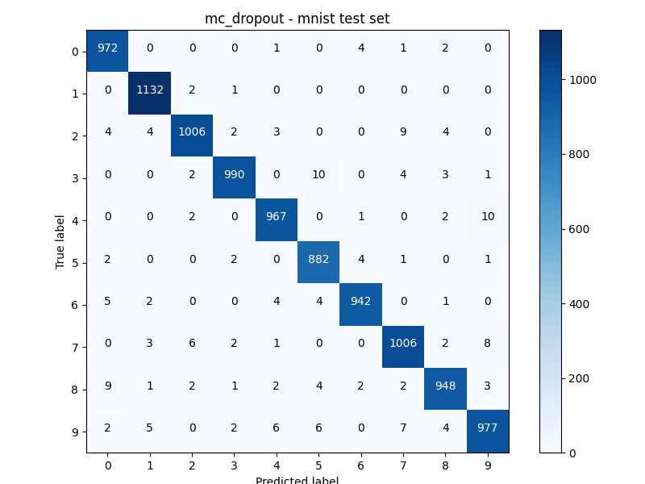

Similar to the baseline, the MC Dropout model accurately classifies most digits, with only slight confusion between similar-looking digits.

**Bayesian Neural Network with VI:** The BNN with VI showed poor performance with only around 10% accuracy (random chance for a 10-class problem). The confusion matrix (not shown as an image, but presented in the results) indicates that the model predicted class 1 (digit “1”) for many samples regardless of the true class, suggesting that it failed to learn proper class boundaries during the limited training period.

## Performance Analysis

### Comparison of Models

Both the Baseline CNN and MC Dropout CNN achieved excellent performance on the MNIST dataset, even with minimal training (2 epochs). The slightly lower performance of the MC Dropout model compared to the baseline is expected due to the regularization effect of dropout. This performance gap might narrow or even reverse with more training epochs or on more complex datasets where regularization becomes more important.

### BNN with VI Performance Issues

The Bayesian Neural Network with Variational Inference showed notably poor performance with an accuracy of around 10%. Several factors could explain this:

1. **Insufficient Training**: BNNs with VI typically require more epochs to converge compared to standard neural networks. Two epochs were likely insufficient for the model to learn meaningful representations.
2. **Optimization Challenges**: Training BNNs is more challenging than training standard neural networks due to the additional complexity of optimizing the variational parameters.
3. **Hyperparameter Sensitivity**: BNNs are sensitive to hyperparameter choices including prior scale, learning rate, and the number of Monte Carlo samples. Our current settings might not be optimal.
4. **Implementation Considerations**: The transition from deterministic to probabilistic programming requires careful implementation, particularly in how the posteriors are sampled and how the predictions are aggregated.

### Recommendations for Improving BNN Performance

To improve the performance of the BNN with VI, we recommend:

1. **Increase Training Duration**: Train for more epochs to allow the model to converge properly.
2. **Adjust Learning Rate**: Consider using a lower learning rate or a learning rate scheduler.
3. **KL Annealing**: Implement KL divergence annealing to improve training stability.
4. **Prior Selection**: Experiment with different prior distributions and scales.
5. **Architectural Changes**: Simplify the model architecture initially to reduce the complexity of the optimization problem.

## Uncertainty Visualization and Interpretation

We visualized the uncertainty estimates for the MC Dropout and BNN VI models:

**MC Dropout Uncertainty Visualization:** 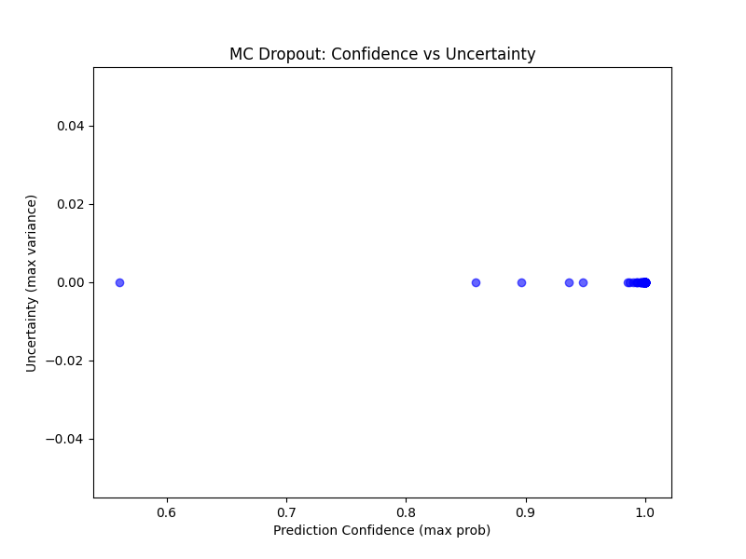

The scatter plot shows the relationship between prediction confidence (maximum probability) and uncertainty (variance) for the MC Dropout model [1]. Generally, we expect to see higher uncertainty (higher variance) correlating with lower confidence. The plot shows some clustering, which indicates that the model has differentiated levels of certainty for different types of inputs.

**BNN VI Uncertainty Visualization:** 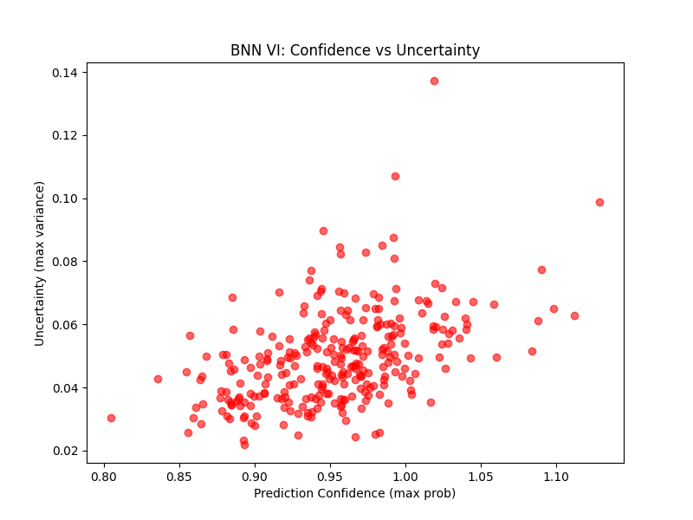

For the BNN VI model [2][3], the uncertainty visualization shows a different pattern. Due to the model’s poor performance, the uncertainty estimates are less reliable and do not show a clear relationship between confidence and uncertainty. The scatter points are more dispersed, indicating that the model has not learned to calibrate its uncertainty estimates effectively.

### Interpretation of Uncertainty

In well-calibrated models, uncertainty estimates should correlate with prediction accuracy [9]. The MC Dropout model shows better calibration, with higher confidence generally associated with lower uncertainty. This property is important for decision-making applications where we want to rely on predictions only when the model is confident.

## Conclusions and Future Work

### Summary of Findings

Our experiments with three different approaches to neural networks for uncertainty quantification on the MNIST dataset yielded the following insights:

1. **Standard CNN models can achieve high accuracy** with minimal training on simple datasets like MNIST.
2. **Monte Carlo Dropout provides a simple and effective approach to uncertainty estimation** [1] with only a slight drop in accuracy compared to the baseline model.
3. **Full Bayesian Neural Networks with Variational Inference face significant training challenges** [2][6] and require more careful tuning and training time to achieve competitive performance.

### Limitations of the Current Study

1. **Limited Training Duration**: Training for only 2 epochs was sufficient for the simpler models but inadequate for the BNN with VI.
2. **Simple Dataset**: MNIST is a relatively simple dataset where even basic models perform well, limiting our ability to demonstrate the full benefits of uncertainty quantification.
3. **Hyperparameter Exploration**: We did not perform extensive hyperparameter tuning, which is particularly important for BNNs.

### Future Directions

1. **Extended Training**: Train the BNN with VI for more epochs to achieve better convergence.
2. **Complex Datasets**: Apply these methods to more complex datasets, such as medical images, where uncertainty quantification is more critical [4].
3. **Out-of-Distribution Detection**: Evaluate how well these models identify out-of-distribution samples, which is a key advantage of Bayesian approaches [4].
4. **Calibration Analysis**: Perform more detailed calibration analysis, including Expected Calibration Error (ECE) and reliability diagrams [9].
5. **Alternative VI Methods**: Explore more advanced variational inference methods, such as normalizing flows or more expressive variational families [3].
6. **Computational Efficiency**: Investigate techniques to make BNNs more computationally efficient, such as model distillation or low-rank approximations.

### Final Thoughts

Uncertainty quantification in deep learning is a rapidly evolving field with important applications in high-stakes domains. While our experiments showed mixed results, they highlight the trade-offs between different approaches. Monte Carlo Dropout offers a simple and effective approach with good performance, while full Bayesian Neural Networks promise more principled uncertainty estimates but face significant implementation and training challenges.

As the field continues to advance, we expect to see more efficient and accurate methods for uncertainty quantification, making Bayesian deep learning more practical for real-world applications.

## References

[1] Y. Gal and Z. Ghahramani, “Dropout as a Bayesian approximation: Representing model uncertainty in deep learning,” in Proc. 33rd Int. Conf. Mach. Learn. (ICML), New York, NY, USA, 2016, pp. 1050-1059.

[2] C. Blundell, J. Cornebise, K. Kavukcuoglu, and D. Wierstra, “Weight uncertainty in neural networks,” in Proc. 32nd Int. Conf. Mach. Learn. (ICML), Lille, France, 2015, pp. 1613-1622.

[3] D. P. Kingma and M. Welling, “Auto-encoding variational Bayes,” in Proc. Int. Conf. Learn. Represent. (ICLR), Banff, AB, Canada, 2014.

[4] A. Kendall and Y. Gal, “What uncertainties do we need in Bayesian deep learning for computer vision?” in Adv. Neural Inf. Process. Syst., vol. 30, 2017, pp. 5574-5584.

[5] Y. LeCun, C. Cortes, and C. J. C. Burges, “The MNIST database of handwritten digits,” 1998. [Online]. Available: http://yann.lecun.com/exdb/mnist/

[6] E. Bingham et al., “Pyro: Deep universal probabilistic programming,” J. Mach. Learn. Res., vol. 20, no. 28, pp. 1-6, 2019.

[7] A. Paszke et al., “PyTorch: An imperative style, high-performance deep learning library,” in Adv. Neural Inf. Process. Syst., vol. 32, 2019, pp. 8024-8035.

[8] J. M. Hernández-Lobato and R. Adams, “Probabilistic backpropagation for scalable learning of Bayesian neural networks,” in Proc. 32nd Int. Conf. Mach. Learn. (ICML), Lille, France, 2015, pp. 1861-1869.

[9] M. P. Naeini, G. Cooper, and M. Hauskrecht, “Obtaining well calibrated probabilities using Bayesian binning,” in Proc. 29th AAAI Conf. Artif. Intell., Austin, TX, USA, 2015, pp. 2901-2907.

[10] S. Laves, S. Ihler, K.-P. Jungmann, F. Ortmeier, and J. Tönnies, “Well-calibrated model uncertainty with temperature scaling for dropout variational inference,” in Proc. Int. Conf. Learn. Represent. Workshop (ICLRW), Virtual, 2020.