**Laboratory work № 1.**

**Designing a database and getting acquainted with the basic operations of the PostgreSQL database**

**Abdulwahed Ibrahim**

**Entity Relationship Diagram**

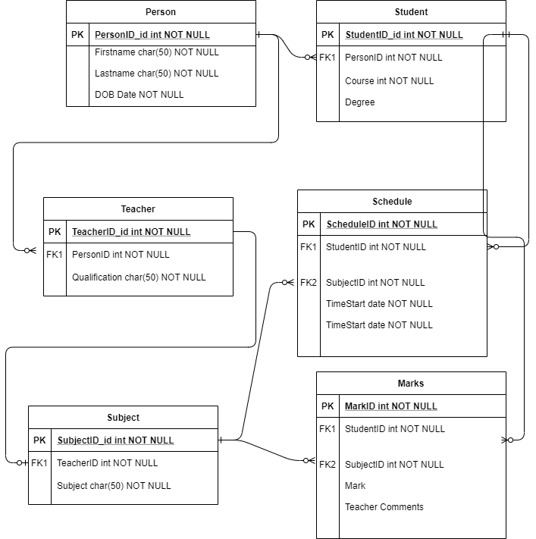

**Data in PGAdmin Database**

**PersonDB**

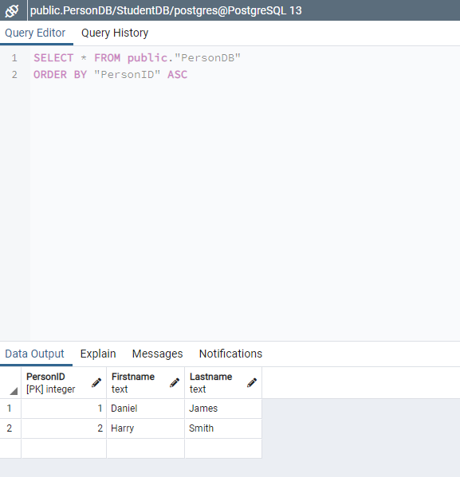

**StudentDB**

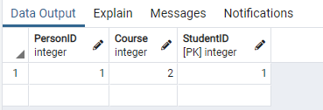

**TeacherDB**

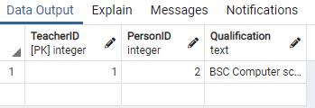

**MarkDB**

