**Laboratory work № 1.**

**Designing a database and getting acquainted with the basic operations of the PostgreSQL database**

**Abdulwahed Ibrahim**

**Entity Relationship Diagram**

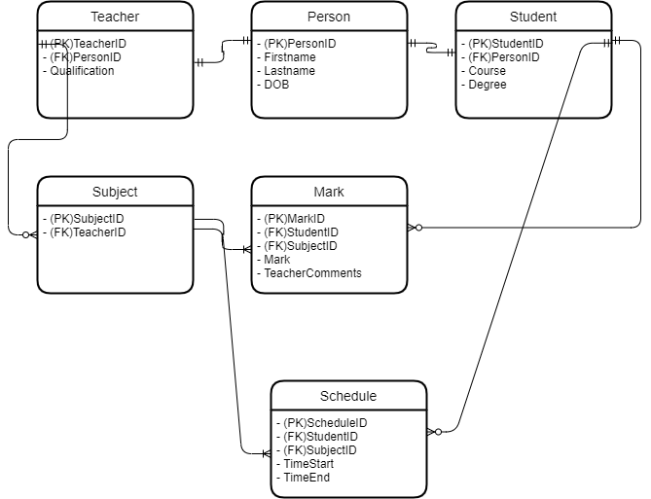

**Relational Database Schema**

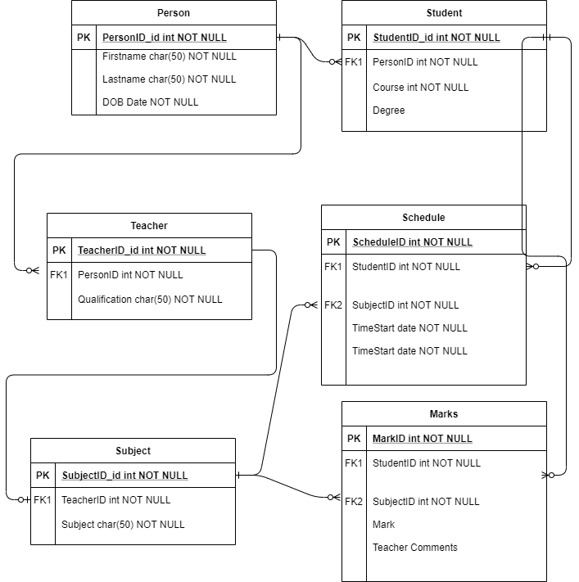

**First Normal Form(1NF)**

This schema satisfies 1NF because

1. Each column holds no more that one data element
2. Data is atomic meaning as fullnames are split into first and lastname to reduce strain and complicated updating queries
3. There are no duplicate rows in my schemas or repeating primary keys

**Second Normal Form(2NF)**

This schema satisfies 2NF because

1. There are no dependencies on any candidate keys for example firstname in the PersonDB , although firstname is unique it can be repeated and therefore can not be dependent on a specific row.
2. Considered creating new tables based on candidate keys of 2NF.

**Third Normal Form(3NF)**

This schema satisfies 3NF because

1. No row is dependent on a candidate key.
2. Each attribute represents an element of the primary key.
3. Composite keys or candidate keys are restricted/limited.
4. No Update Anomalies can occur.
5. Anomaly threat has been reduced.

**Data in PGAdmin Database**

**PersonDB**

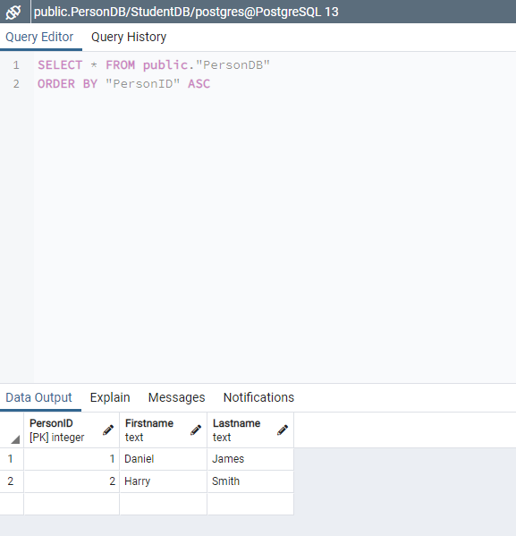

**StudentDB**

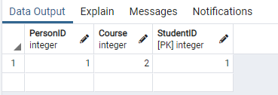

**TeacherDB**



**MarkDB**

