2012 final exam   
<https://www.facebook.com/photo.php?fbid=572701412816642&set=gm.652329328141834&type=1&theater>

Q1 mesh 3aleko dah CH8

Q2:  
=====  
a) Base = start of segment = 1000 0000H  
As the length of the memory segment not given, the max. length allowed is assumed  
(1000 0000H --> FFFF FFFFH)  
20-bit limit = last 5-hex digits of (FFFF FFFFH - 1000 0000H) = EFFFFH   
G-bit = 1

b) 1 GB = 2^30 = 40000000H, then data limit is 40000000H - 1 = 3FFFFFFFH  
End of data = 10000000H + 3FFFFFFFH = 4FFFFFFFH

C) segment's end = FFFFFFFFH

------------------------------------------------------

2012 page(2) :

<https://www.facebook.com/photo.php?fbid=572700692816714&set=gm.652328434808590&type=1&theater>

Q4:  
a)  
opcode = (100010) ==> mov (assumed)  
D = 0 ==> Reg ---> R/M  
W = 1 ==> word (32 bit)  
=============================  
MOD = (11) ==> R/M is a Reg  
Reg = (110) ==> SP (assumed)  
R/M = (011) ==> DX (assumed)  
  
Note: If 67H & 66H prefixes are absent & the uP working in 32-bit instruction mode then the address size is 32 & the register size is 32   
  
The instruction will be MOV EDX , ESP

b) make these assumptions  
opcode of mov = (100010)  
BX = (001)  
DS:[SI] = (111)  
====================  
[SI] ---> BX ==> D = 1  
BX = 16-bit ==> W = 1  
No displacement exist ==> MOD = (00)  
  
The machine code is 67668B0F  
  
67 prefix for 16-bit address  
66 prefix for 16-bit register

----------------------------------------------------------------------------------------------------------------------------------

2011(1) final exam   
<https://www.facebook.com/photo.php?fbid=572700166150100&set=gm.652328358141931&type=1&theater>

Q1:  
==  
a.

then u can explain the real mode & protected mode briefly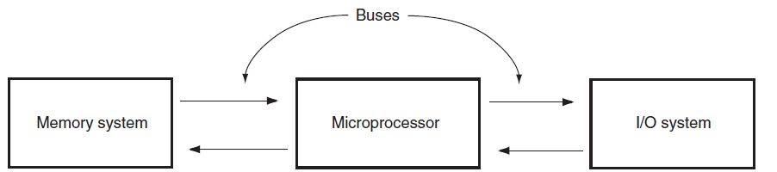 .

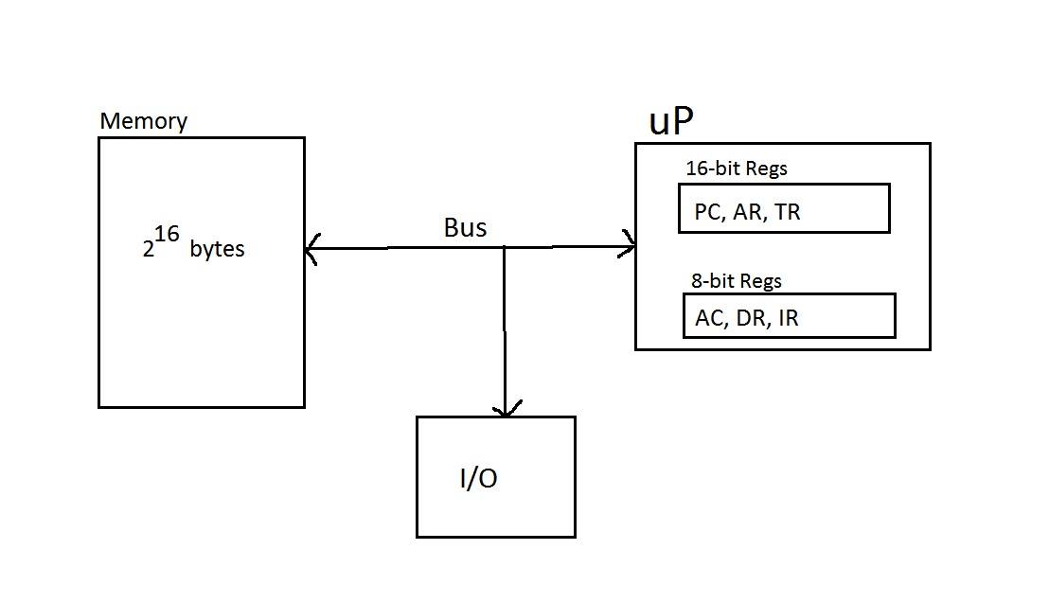b - I)

b-II)

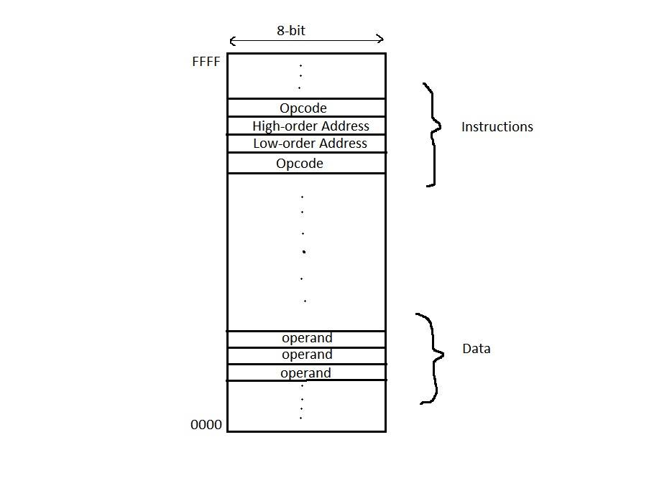

b - III) Microoperations  
Step 1: Fetch the instruction  
1: AR <--- PC  
2: IR <--- M[AR]  
3: PC <--- PC + 3  
Step 2: Decode the instruction & fetch the operand  
4: AR <--- IR[15 - 8] , Decode IR[7 - 0]  
5: DR <--- M[AR]

For Clarification, AR = Address Reg, DR = Data Reg, IR = instruction reg, PC = program counter, AC = Accumulator, TR = mesh 3aref pesara7a

 i mean by (7-0) the opcode &(15-8) the address part

Q2:  
===  
a)  
AX = 0100 , Bx = FCFF

 b)  
To convert from 2's complement to decimal - follow these steps:  
1) represent the hex number in bin format  
2) look for the MSB bit if 0 ==> positive , if 1 ==> negative  
3) if positive, convert the bin number directly to decimal format & skip the next step  
4) if negative, optain the 1's complement of bin number then add 1   
  
let's convert 0100 first  
1) 0100 = 0000000100000000  
2) MSB = 0, then the number is positive & (0000000100000000) = 256  
  
for FCFF number  
1) FCFF = 1111110011111111  
2) MSB = 1, then the number is negative  
3) NOT(1111110011111111) = 0000001100000000 + 1 = 0000001100000001  
& the number = -769

Q3 7aleto fel section

Q4:  
a)  
opcode = (100010) ==> mov (assumed)  
D = 0 ==> Reg ---> R/M  
W = 1 ==> word (32 bit)  
=============================  
MOD = (11) ==> R/M is a Reg  
Reg = (110) ==> SP (assumed)  
R/M = (011) ==> DX (assumed)  
  
Note: If 67H & 66H prefixes are absent & the uP working in 32-bit instruction mode then the address size is 32 & the register size is 32   
  
The instruction will be MOV EDX , ESP

b) make these assumptions  
opcode of mov = (100010)  
BX = (001)  
DS:[SI] = (111)  
====================  
[SI] ---> BX ==> D = 1  
BX = 16-bit ==> W = 1  
No displacement exist ==> MOD = (00)  
  
The machine code is 67668B0F  
  
67 prefix for 16-bit address  
66 prefix for 16-bit register