1-
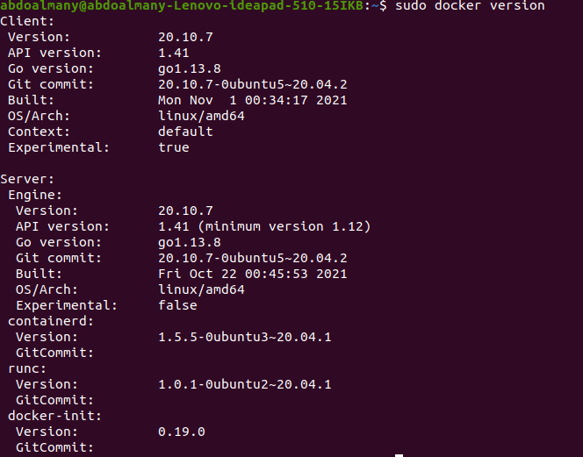
2-

3-

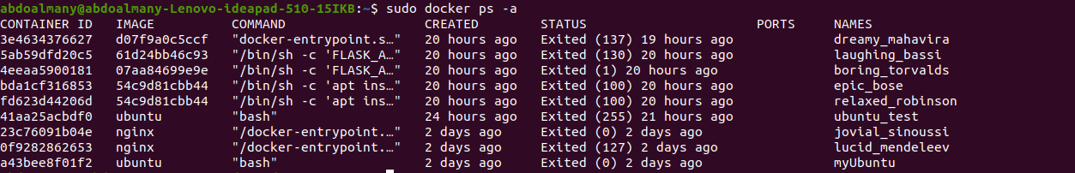
4-
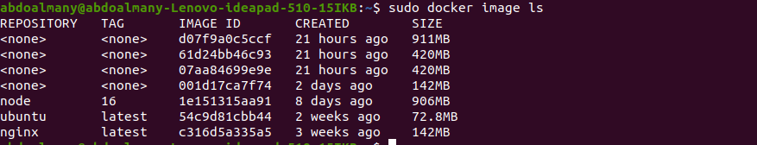

5-
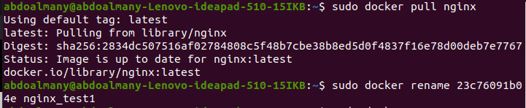
6-
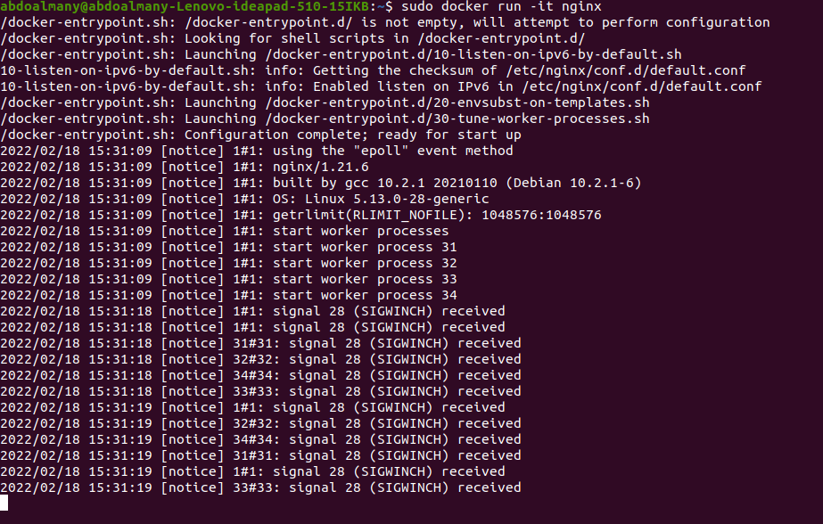
7-
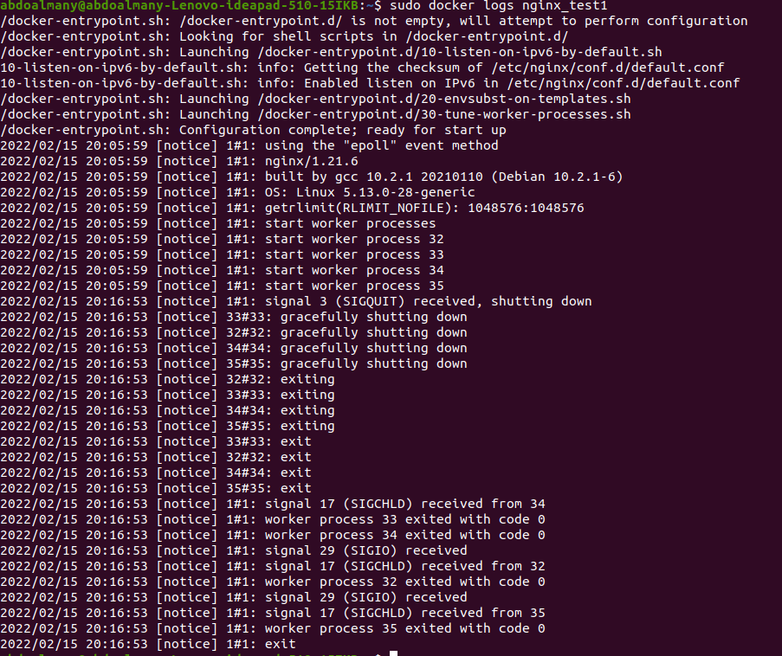
8-
sudo docker inspect nginx_test1

9-
10-
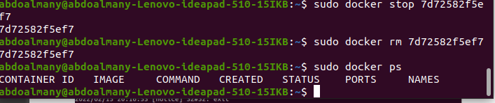
11:14 -
