# Problem 1
### Create bridge network with subnet 192.168.0.0/24.
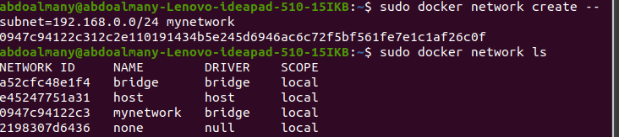
### Run 2 containers and attach containers to this network.

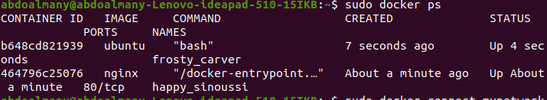
### Create another bridge network with subnet 10.5.0.0/24.

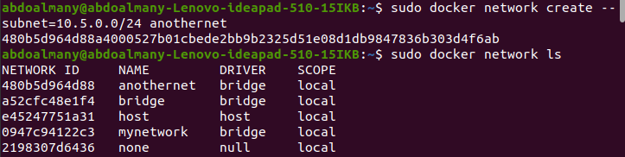
### Run any container and attach it to the new network.

### Make sure that the containers at different networks can’t ping each other

It can ping on the same network
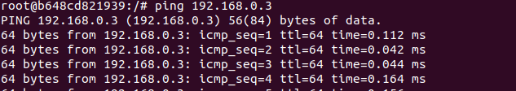
but it can’t on different → 10.5.0.0/24.
