Estimation
Bottom-up Method

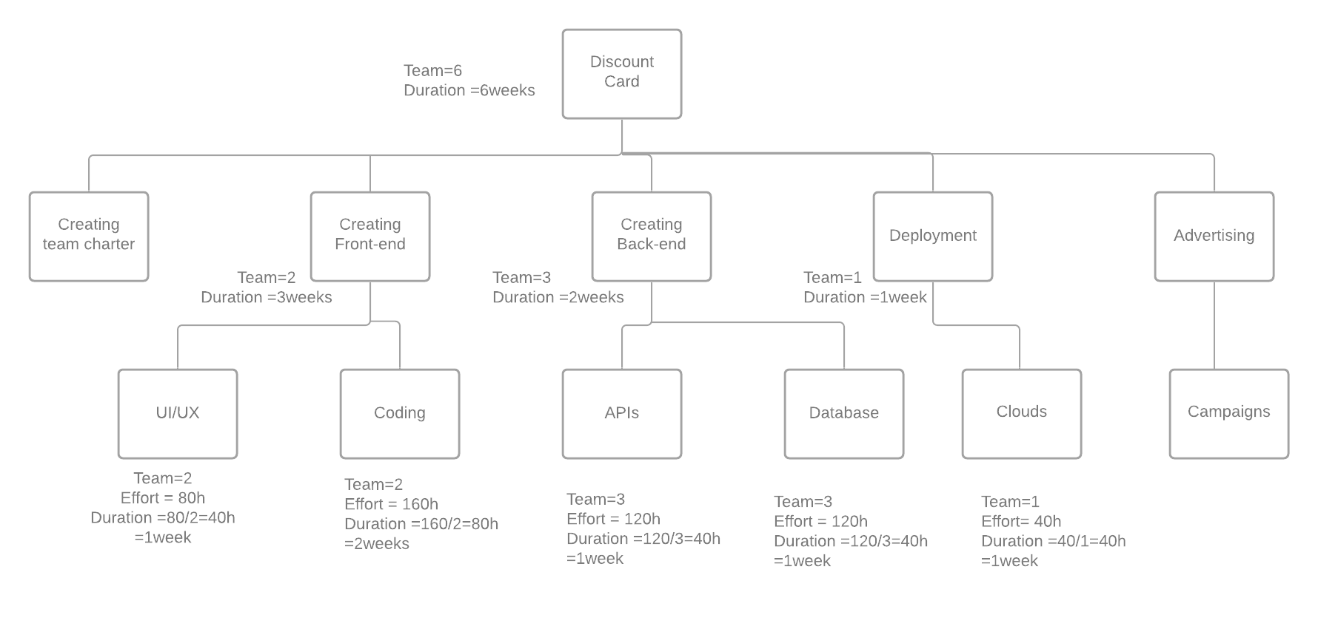
Assumptions
- Tasks completed in specified time .
- Deployment phase included testing .
- Project clouds arrive configured as expected .
- End users will be available to test during the time they agree to .

Cost
Estimated avg salary = 7000
=7000*6*1.5=63000.
Clouds and tools = 18000 per year .
Advertising = 40000.
Maintenance for first year = 20000.
Total Cost = 63000+18000+40000+20000=141000 EGP

