Methods
Data Management and Preparation
The data for this study was collected using a pre-designed questionnaire and subsequently entered into a Microsoft Excel file. The dataset was then imported into IBM SPSS Statistics Version 26 for a comprehensive analysis. Several categorical variables were recoded into numeric formats. This included demographic information such as gender, age, and academic year, as well as institutional and financial factors. This process ensured the data was in a format suitable for quantitative analysis.
For questions where participants could select multiple options (checkboxes), a specific data-handling procedure was implemented. Each unique response was transformed into a separate binary variable, with a value of 1 assigned if the option was selected and 0 if it was not. This method was applied to the variables concerning the main purposes of ChatGPT use, the devices used, and the challenges faced. Additionally, the ten perception items, originally measured on a Likert scale, were recoded into a numerical scale ranging from 1 ("Strongly Disagree") to 5 ("Strongly Agree"). A composite score was then computed as the mean of these ten items to provide a single, continuous measure of a student's overall perception of ChatGPT.
Statistical Methods
The analysis employed a mix of descriptive, bivariate, and multivariable statistical methods to achieve the study's objectives. All analyses were conducted using IBM SPSS Statistics Version 26. The methods were applied systematically to first describe the data, then examine relationships between key variables, and finally, to identify predictors of the outcome of interest.
Descriptive and Reliability Analysis
The analysis began with descriptive statistics to summarize the sample characteristics. This included calculating frequencies for categorical variables like gender and year of study, and means, standard deviations, and ranges for the continuous composite score. The internal consistency of the multi-item perception scale was assessed using Cronbach's Alpha. This measure determined how well the items within the scale were related and consistently measured the same underlying construct.
Bivariate Analysis
To explore the relationships between key variables, several bivariate tests were performed. Chi-square tests of independence were used to examine the associations between categorical variables, such as the relationship between a student's background and their frequency or purpose of ChatGPT use. Independent samples t-tests were used to compare the mean perception scores between two groups, such as males versus females. For comparisons across three or more groups (e.g., different academic years), a one-way ANOVA was performed to identify significant differences in mean perception scores.
Multivariable Analysis
Multivariable Analysis A multiple linear regression model was used to identify factors that predicted a student's perception of how ChatGPT helps them prepare for exams. Additionally, a Binary Logistic Regression was employed to model the likelihood of being a "Frequent User" of ChatGPT based on a set of demographic and institutional predictors. This analysis included the continuous perception score as the dependent variable, and demographic, economic, and usage factors as independent variables. This model helps to understand the strength and direction of the relationships between the predictors and the outcome, while controlling for the effects of other variables in the model.
Results
4.1 Reliability Analysis
The internal consistency of the 10-item Likert-type scale measuring students' perceptions of ChatGPT's effect on their perceived academic benefit was assessed using Cronbach's Alpha (α). The analysis, which included the full sample (N=295), yielded a Cronbach's Alpha coefficient of 0.919. This value indicates excellent internal consistency for the scale, comfortably exceeding the standard threshold of 0.70 and confirming that all ten items are reliably measuring the same underlying latent construct (i.e., the students' overall positive or negative perception of ChatGPT). This high degree of reliability justifies the use of the composite Perceptions Score in subsequent inferential analyses as a robust measure of the perceived effect on perceived academic benefit.
4.2 Descriptive Statistics
This section presents the descriptive analysis, including the demographic and socio-economic profile of the respondents, their ChatGPT usage patterns, and the central tendency of the perception scale items. The analysis included the full sample of N=295 medical students.
4.2.1 Demographic and Socio-Economic Profile
The sample exhibited a near-equal distribution of gender, with 50.5% (n=149) being male and 49.5% (n=146) being female. The vast majority of participants (91.9%, n=271) were aged between 20 and 24 years, which is typical for students in medical school.
The student distribution across medical school years was relatively balanced, with 28.5% in the Third Year (n=84) and 28.5% in the Fifth Year (n=84) representing the largest groups. In terms of residency, the sample exhibited a highly dispersed geographical profile, with a near-even three-way split: 31.9% reside in another city in Sudan, 30.0% live outside Sudan, and 29.2% reside in Omdurman. Only a small minority (8.8%) reside in Khartoum.
Economically, the sample showed low financial constraint, with 85.8% (n=253) reporting a Moderate family income level. A significant majority of respondents (67.1%, n=198) reported facing no financial challenges in maintaining stable internet access for study purposes.
Table 1: Sociodemographic characteristics of participants (N = 295)
Variable | Category | Frequency | Percentage
Gender | Male | 149 | 50.5%
 | Female | 146 | 49.5%
Age | Under 20 | 19 | 6.4%
 | 20 – 24 | 271 | 91.9%
 | ≥ 30 | 5 | 1.7%
Academic Year | Second | 50 | 16.9%
 | Third | 84 | 28.5%
 | Fourth | 77 | 26.1%
 | Fifth | 84 | 28.5%
Residence | Khartoum | 26 | 8.8%
 | Omdurman | 86 | 29.2%
 | Another City | 94 | 31.9%
 | Outside Sudan | 89 | 30.2%
Monthly Income | High | 7 | 2.3%
 | Moderate | 253 | 85.7%
 | Low | 35 | 11.9%

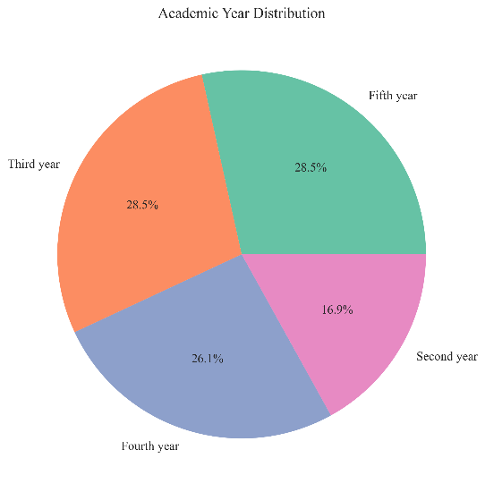
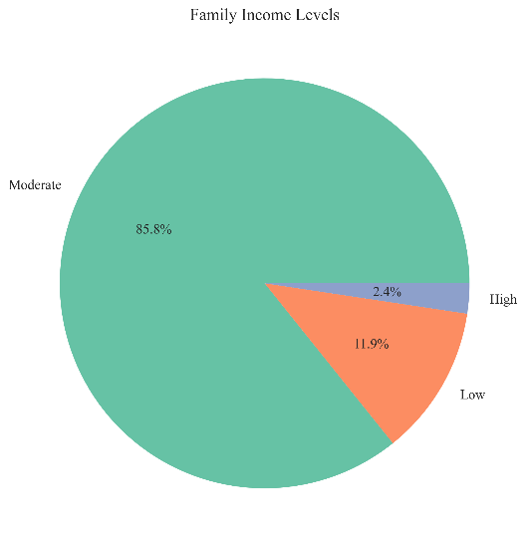
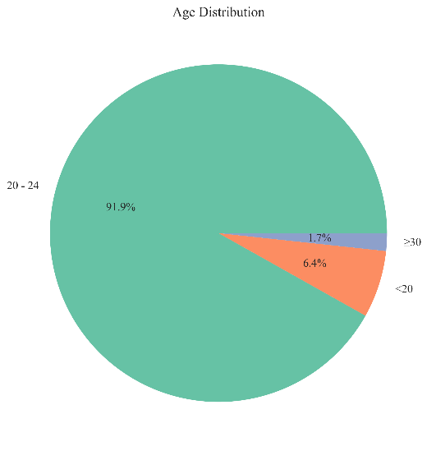
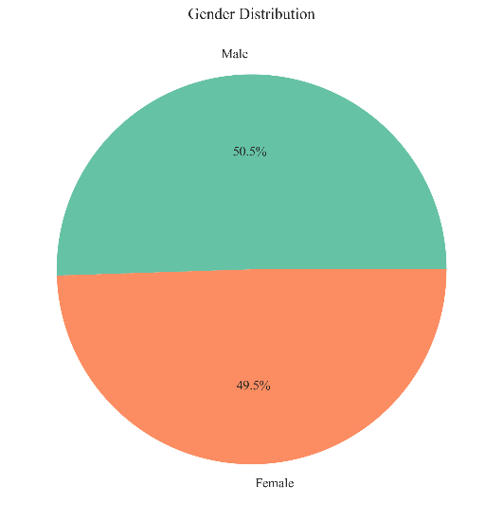
Figure 1: Sociodemographic characteristics of participants (N = 295)
4.2.2 Institutional Factors and Prior Knowledge
The institutional context revealed several key findings. An overwhelming majority of students (93.2%, n=275) reported being "Well Acquainted" with ChatGPT prior to the study, indicating a high baseline familiarity with the tool. However, institutional support appeared limited, as 83.4% (n=246) stated that their universities provided no official guidance on ChatGPT use, while only 4.1% (n=12) reported receiving supportive guidance. Lecturer encouragement was also low, with nearly half of the students (49.2%, n=145) stating that their lecturers "Never" encouraged ChatGPT use and 26.4% (n=78) reporting it was "Rarely" encouraged. Furthermore, institutional training opportunities were almost nonexistent, with 93.2% (n=275) indicating that their institutions offered no training or workshops on AI tools.

Table 2: Institutional Factors & Prior Knowledge (N = 295)
Variable | Category | Frequency | Percentage
Official Guidance | Yes, Supportive | 12 | 4.1%
 | Yes, Discouraging | 37 | 12.5%
 | No official guidance | 246 | 83.4%
lecturers’ encouragement | Always | 10 | 3.4%
 | Sometimes | 62 | 21%
 | Rarely | 78 | 26.4%
 | Never | 145 | 49.2%
Training or Workshops | Yes | 20 | 6.8%
 | No | 275 | 93.2%
4.2.3 ChatGPT Usage Patterns
Usage patterns revealed high regularity and a strong tendency toward independent use. A large majority of students (86.4%, n=255) reported regular internet use for studying, providing the foundation for adopting digital tools such as ChatGPT. Academic use of ChatGPT was particularly frequent, with 45.8% (n=135) using it daily and 34.2% (n=101) several times a week, meaning that 80% of the sample were frequent users. Preference for independent use was also clear, as 82.0% (n=242) reported using ChatGPT alone, compared to only 9.2% (n=27) who preferred group use and 8.8% (n=26) preferred both alone and group usage.
The descriptive analysis of device usage revealed that the majority of participants relied solely on a smartphone for their activities (n = 202, 64.1%), followed by those who used both a smartphone and a tablet (n = 41, 13.0%) or a smartphone and a laptop (n = 28, 8.9%). A smaller proportion of participants used only a tablet (n = 10, 3.2%), all three devices (n = 9, 2.8%), or only a laptop (n = 5, 1.6%). These findings indicate a strong preference for smartphones as the primary device among the sample, with multi-device usage being relatively less common. Table 3 shows the frequency of ChatGPT use, usage preferences, and the types of devices employed by students.

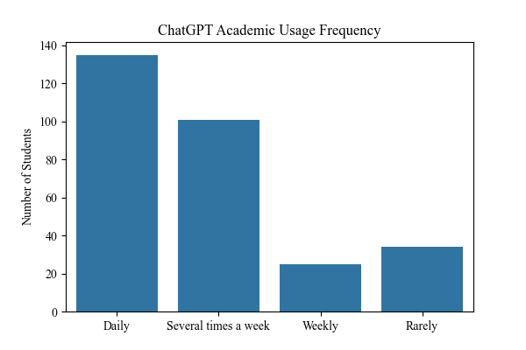
Table 3: ChatGPT Usage Patterns (N = 295)
Variable | Category | Frequency | Percentage
ChatGPT Use for Academic Purposes | Daily | 135 | 45.8%
 | Several Days a week | 101 | 34.2%
 | Weekly | 25 | 8.5%
 | Rarely | 34 | 11.5%
Usage Preferences | Alone | 242 | 82.0%
 | With Group | 27 | 9.2%
 | Both | 26 | 8.8%
Devices Used | Smartphone | 202 | 68.5%
 | Smartphone + Laptop | 41 | 13.9%
 | Smartphone + Tablet | 28 | 9.5%
 | Tablet | 10 | 3.4%
 | All 3 devices | 9 | 3.1%
 | Laptop | 5 | 1.7%
Figure 2: Frequency of ChatGPT use for academic purposes (N = 295).

4.2.4 Purpose of ChatGPT Use
Students reported a range of purposes for using ChatGPT in their academic work. The most commonly cited purposes included explaining difficult concepts (n=251), language support (n=193), and answering clinical questions (n=169). Less frequently mentioned purposes included research assistance (n=145), summarizing lectures (n=110), preparing revision notes (n=88), preparing for exams (n=105), and preparing for OSCEs (n=43). Additionally, a small number of students mentioned other purposes such as creating MCQs, life advice, or trading and analysis, each reported only once.
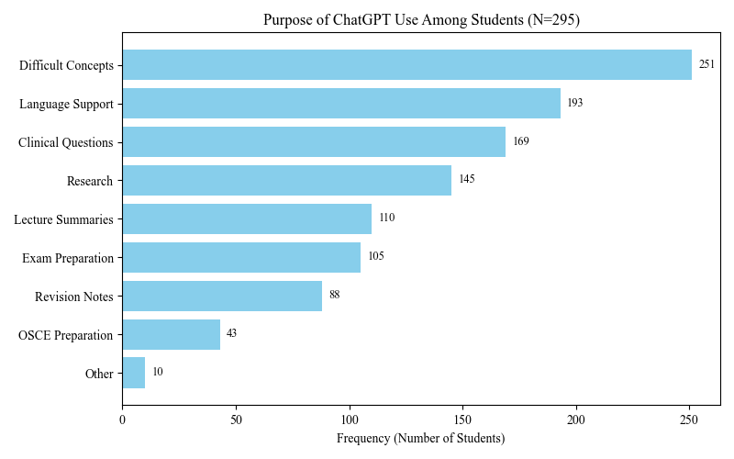
Table 4: Purpose of ChatGPT Use (N = 295)
Purpose | Frequency | Percentage
Explaining difficult concepts | 251 | 85.1%
Language support | 193 | 65.4%
Answering clinical questions | 169 | 57.3%
Research assistance | 145 | 49.2%
Summarizing lectures | 110 | 37.3%
To prepare for exams | 105 | 35.6%
Creating revision notes | 88 | 29.8%
Preparing for OSCE | 43 | 14.6%
Other | 10 | 3.4%
Figure 3: Purposes of ChatGPT use (N = 295)
4.2.5 Perceptions of ChatGPT
The central tendency analysis for the 10 Perception items (on a scale of 1=Strongly Disagree to 5=Strongly Agree) showed that, on average, students agreed with the positive statements about the tool.
Table 5: Perceptions of ChatGPT use (N = 295)
Statement | Strongly Agree | Agree | Neutral | Disagree | Strongly Disagree
ChatGPT improves my understanding of medical topics | 103 (34.9%) | 105 (35.6%) | 46 (15.6%) | 13 (4.4%) | 28 (9.5%)
ChatGPT helps me prepare better for exams | 54 (18.3%) | 110 (37.3%) | 74 (25.1%) | 36 (12.2%) | 21 (7.1%)
ChatGPT provides accurate medical information | 27 (9.2%) | 68 (23.1%) | 125 (42.4%) | 57 (19.3%) | 18 (6.1%)
I verify ChatGPT answers with textbooks | 39 (13.2%) | 90 (30.5%) | 81 (27.5%) | 61 (20.7%) | 24 (8.1%)
ChatGPT boosts my confidence in answering clinical questions | 37 (12.5%) | 93 (31.5%) | 100 (33.9%) | 46 (15.6%) | 19 (6.4%)
ChatGPT saves me study time | 76 (25.8%) | 118 (40.0%) | 55 (18.6%) | 21 (7.1%) | 25 (8.5%)
ChatGPT encourages regular study | 49 (16.6%) | 91 (30.8%) | 100 (33.9%) | 33 (11.2%) | 22 (7.5%)
I replaced some traditional sources with ChatGPT | 47 (15.9%) | 91 (30.8%) | 62 (21.0%) | 63 (21.4%) | 32 (10.8%)
ChatGPT makes learning enjoyable | 75 (25.4%) | 104 (35.3%) | 65 (22.0%) | 33 (11.2%) | 18 (6.1%)
I recommend ChatGPT to peers | 87 (29.5%) | 103 (34.9%) | 50 (16.9%) | 29 (9.8%) | 26 (8.8%)
As shown in the table, students generally showed agreement with positive statements about ChatGPT. The strongest agreement was observed for the statement “ChatGPT improves my understanding of medical topics” (Mean=3.82, SD=1.23). The item “ChatGPT provides accurate medical information” elicited the highest proportion of neutral responses (Mean=3.10, SD=1.01), indicating some caution regarding its reliability. The overall Perceptions Score (Mean=3.44, SD=0.88) supports a generally favorable attitude toward ChatGPT's role in academic life.
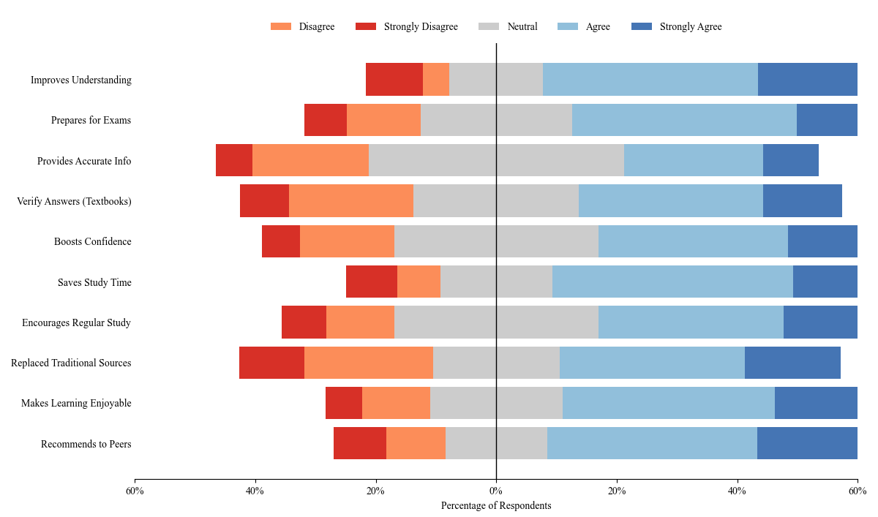
Figure 4.: Student Perception of ChatGPT's Academic Benefit (Likert Scale Distribution).
4.2.6 Challenges with ChatGPT:
Students reported a variety of challenges when using ChatGPT for academic purposes. The most frequently cited challenge was accuracy doubts (n = 218, 73.9%), followed by over-reliance (n = 187, 63.4%). A smaller proportion of students expressed concerns about poor internet connectivity (n = 82, 27.8%) and the risk of plagiarism (n = 54, 18.3%). Only a small minority (n = 15, 5.1%) reported no challenges at all.

Table 6: Reported Challenges with ChatGPT (N = 295)
Challenge | Frequency | Percentage
Accuracy doubts | 218 | 73.9%
Over-reliance | 187 | 63.4%
Poor internet | 82 | 27.8%
Plagiarism risk | 54 | 18.3%
None | 15 | 5.1%
4.3 Correlation Analysis
Correlation analysis examined the relationship between the frequency of ChatGPT use and students' perceptions of its academic impact, as well as inter-item relationships within the 10-item Perceptions Scale. A Pearson correlation between ChatGPT Academic Frequency (1 = Rarely to 4 = Daily) and the Overall Perceptions Score revealed a statistically significant, positive association (p < .001), indicating that students who use ChatGPT more frequently tend to perceive greater academic benefit.

Table 7: Summary of the correlation results between Perceptions Score and ChatGPT academic frequency use
Variable | Perceptions Score | ChatGPT Academic Frequency | P-value
Overall Perceptions Score | 1 | .283 | < 0.0001
ChatGPT Academic Frequency | .283 | 1
Additionally, the inter-item correlation matrix for the 10 perception items showed that all 45 pairwise correlations were statistically significant (p < .05), with most significant at p < .001. Correlation coefficients ranged from a low of 0.117 (between perceived accuracy and verification) to a high of 0.824 (between perceived enjoyment and recommendation), indicating positive associations across all items. In general, the closer a correlation coefficient is to 1, the stronger the linear relationship between the items. These results confirm the homogeneity of the scale items and support the reliability analysis (α = .919). The strongest relationships suggest that students who enjoy using ChatGPT are highly likely to recommend it to peers, and those who believe it improves understanding are also likely to report that it helps them prepare better for exams. The inter-item relationships are visualized in Figure X, where all correlations are positive and statistically significant.
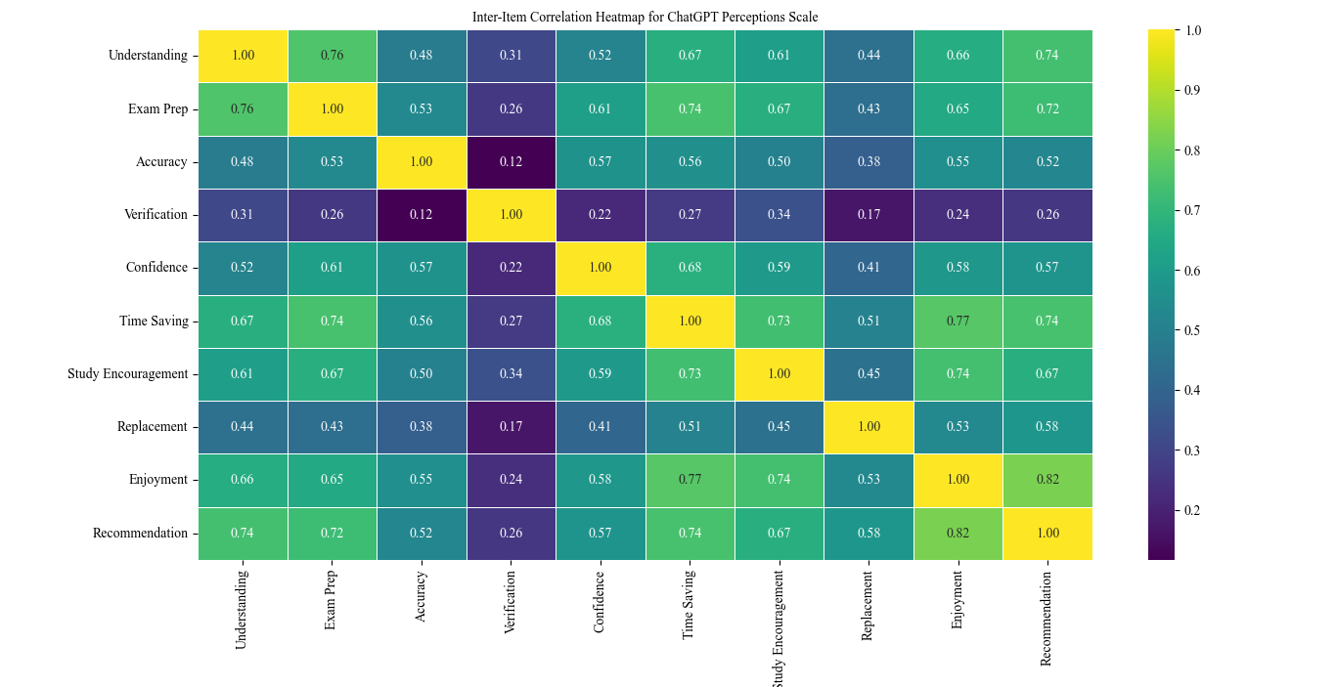
Figure 5: Heatmap of Inter-Item Correlations for the ChatGPT Perceptions Scale
4.4 Bivariate Analysis
4.4.1 Relationship Between Sociodemographic and Academic Factors and Students’ Perceptions of ChatGPT
Independent samples t-tests were conducted to compare the mean overall Perceptions Score between different two-group categories, such as gender and institutional factors. For all t-tests, Levene's Test for Equality of Variances was first assessed.
The analysis revealed that several factors had no statistically significant association with students' overall perceptions of ChatGPT's academic utility. Specifically, there was no significant difference in the mean Perceptions Score based on Gender (p=.831) or Financial Challenges for Internet Access (p=.315). Similarly, the difference between students who preferred using ChatGPT Alone (Mean=3.48, SD=0.88) versus those who used it with a Group (Mean=3.15, SD=0.90) was not statistically significant (p=.067).
In contrast, two factors demonstrated a statistically significant difference in the mean Perceptions Score. First, students who reported Regular Internet Use for Study (Mean=3.52, SD=0.82) had a significantly higher mean Perceptions Score than those who did not (Mean=2.95, SD=1.09; p<.001), suggesting that familiarity with digital study resources is associated with more positive perceptions of ChatGPT’s academic utility. Second, a significant difference was found based on Institution Training on AI (p=.016). Contrary to expectation, students with no training on AI tools (Mean=3.47, SD=0.83) reported higher perceptions than those who received training (Mean=2.99, SD=1.37), indicating that formal training may have emphasized limitations or ethical concerns of AI tools, leading to a more cautious perception among that group.
Table 8: Comparison of Mean Perceptions Scores Across Student Characteristics (N = 295)
Factor | Group Means (SD) | df | p-value
Gender | Male: 3.43 (0.87), Female: 3.45 (0.90) | 293 | 0.831
Financial Challenges | Yes: 3.37 (1.01), No: 3.48 (0.81) | 293 | 0.315
Usage Preference | Alone: 3.48 (0.88), With group: 3.15 (0.90) | 267 | 0.067
Regular Internet Use for Study | Regular: 3.52 (0.82), Not regular: 2.95 (1.09) | 293 | <0.001
Institution Training on AI | No training: 3.47 (0.83), Training: 2.99 (1.37) | 293 | 0.016

4.4.2 Relationship Between Overall Perceptions and Multi-Category Factors
A one-way ANOVA was conducted to examine whether students’ overall perceptions of ChatGPT differed across categorical factors with three or more groups. The analysis revealed that most factors, including Year in Medical School (p=.830), Family Income Level (p=.464), Age Group (p=.724), Current Residency (p=.514), University Guidance (p=.247), and Lecturers Encouragement (p=.451), were not significantly associated with differences in overall perceptions. These results suggest that students’ academic stage, socioeconomic background, age, and institutional environment do not substantially influence how positively they view ChatGPT. In contrast, a statistically significant difference was observed for Prior Knowledge of ChatGPT (p<.001). Students who were “well acquainted” with ChatGPT reported a higher mean perception score (Mean=3.51, SD=0.83) than those who had only “heard about it” (Mean=2.52, SD=0.88) or had no knowledge (Mean=1.00). This indicates that direct engagement with the tool strongly predicts positive perceptions of its academic utility, highlighting the importance of experience and familiarity in shaping students’ attitudes toward ChatGPT.

Table 9: ANOVA Results for Perceptions Score by Prior Knowledge of ChatGPT (N = 295)
Prior Knowledge of ChatGPT | N | Mean Perceptions Score | Std. Deviation
No Knowledge | 1 | 1.00 | N/A
Heard About It | 19 | 2.52 | 0.88
Well Acquainted | 275 | 3.51 | 0.83
4.4.3 Associations Between Demographic/Institutional Factors and ChatGPT Usage
Chi-Square (χ²) tests were conducted to examine associations between categorical variables related to demographics, institutional factors, and ChatGPT usage patterns. A significant association was observed between Year in Medical School and ChatGPT Academic Frequency (p = 0.004), indicating that the year of study significantly affects how often students use ChatGPT. Analysis of the crosstabulation revealed that Second Year students had the highest rate of daily usage (72.0%), whereas Third, Fourth, and Fifth Year students demonstrated lower daily usage, with a larger proportion using ChatGPT several times a week or less frequently. This suggests that early-year medical students are the most intensive daily users of ChatGPT.
The remaining χ² tests showed no statistically significant associations, suggesting independence between these categorical variables and ChatGPT usage or perception. Specifically, there was no association between Gender and ChatGPT Academic Frequency (p = .469), Gender and Prior Knowledge (p = 0.485), Gender and Usage Preference (p = .301), Year in Medical School and Perception of Accuracy (p = 0.185), Current Residency and Academic Frequency (p = 0.348), or University Guidance and Academic Frequency (p = 0.730). These results suggest that factors such as gender, residency, or institutional guidance do not significantly influence ChatGPT usage or perceptions in this sample.
Table 10: Chi-Square Test Results for Associations between Demographic/Institutional Factors and ChatGPT Usage Patterns
Variable Pair Tested | χ² | df | p-value
Year in Medical School * ChatGPT Academic Frequency | 24.315 | 9 | .004
Gender * ChatGPT Academic Frequency | 2.532 | 3 | .469
Gender * Prior Knowledge | 1.447 | 2 | .485
Gender * ChatGPT Usage Preference | 1.071 | 1 | .301
Year in Medical School * Perception of Accuracy | 16.130 | 12 | .185
Current Residency * ChatGPT Academic Frequency | 10.035 | 9 | .348
University Guidance * ChatGPT Academic Frequency | 3.605 | 6 | .730
4.5 Multivariate Analysis
4.5.1 Multiple Linear Regression Predicting Overall Perceptions Score
A Multiple Linear Regression was conducted to assess the combined effect of ChatGPT Academic Frequency, Gender, Year in Medical School, and Regular Internet Use on students’ Overall Perceptions Score. The model was statistically significant(p<0.001), explaining 10.6% of the variance in perceptions (R²=.106; Adjusted R²=.094).
Significant Predictors:
- ChatGPT Academic Frequency (β=.243, t=4.206, p<.001): Each unit increase in usage frequency corresponded to a 0.215-point increase in Overall Perceptions Score.
- Regular Internet Use (β=.164, t=2.867, p=.004): Students who regularly used the internet had perception scores 0.422 points higher than those who did not, controlling for other factors.
Non-significant Predictors: Gender (β=−.018, p=.741) and Year in Medical School (β=−.014, p=.800) were not significant. VIF values were all below 1.1, indicating no multicollinearity issues.
Table 11: Multiple Linear Regression Predicting Overall Perceptions Score
Outcome | R² | Adjusted R² | Predictor | Standardized β | Direction | p-value
Overall Perceptions Score | 0.106 | 0.094 | ChatGPT Academic Frequency | 0.243 | Positive | (p<.001)
 | 0.106 | 0.094 | Regular Internet Use | 0.164 | Positive | (p=.004)
 | 0.106 | 0.094 | Gender | -0.018 | Negative | (p=.746)
 | 0.106 | 0.094 | Year in Medical School | -0.014 | Negative | (p=.853)

4.5.2 Binary Logistic Regression Predicting Frequent ChatGPT Use
A Binary Logistic Regression was conducted to identify predictors of being a Frequent ChatGPT User (n=236) versus an Infrequent User (n=59). The model was significant (χ²(9)=35.915, p<.001), explained 18.1% of variance (Nagelkerke R²), and correctly classified 82.0% of cases.
Significant Predictors:
- Prior Knowledge (p<.001, OR=7.113): More knowledgeable students were over 7 times more likely to be frequent users.
- Age (p=.010, OR=0.140): Older students were less likely to be frequent users.
- Financial Challenges for Internet (p=.014, OR=0.435): Facing financial barriers reduced the odds of frequent use by ~56%.
- Lecturer Encouragement (p=.036, OR=1.516): Higher encouragement increased odds of frequent usage by ~52%.
Gender, Year in Medical School, Family Income, University Guidance, and Institution Training did not significantly predict frequent use.
Table 12: Binary Logistic Regression Predicting Frequent ChatGPT Use
Predictor Variable | p-value | Odds Ratio (Exp(B)) | Interpretation
Prior Knowledge | <.001 | 7.113 | More knowledgeable students are >7× more likely to be frequent users
Age | .010 | 0.140 | Older students are less likely to be frequent users
Financial Challenges for Internet | .014 | 0.435 | Facing financial barriers reduces odds by ~56%
Lecturer Encouragement | .036 | 1.516 | Higher encouragement increases odds by ~52%
Summary of key findings:
The study found that medical students generally view ChatGPT positively and are highly integrated users, with several key factors driving their use and perception.

Student Profile and Usage Patterns
- High Familiarity and Positive View: Students were overwhelmingly familiar with ChatGPT before the study. Their collective opinion was that the tool provides an overall positive benefit to their perceived academic benefit.
- High Frequency of Use: Usage was common and intense: four out of five students reported being a frequent user (using it daily or several times a week).
- Minimal Institutional Support: Despite high student use, universities provided very little guidance. The vast majority of students reported no official guidance on using ChatGPT and received no training or workshops on AI tools.
- Lecturer Engagement: Nearly half of the students reported that their lecturers never encouraged the use of ChatGPT.
- Accuracy Caution: Students' lowest level of agreement was for the statement that ChatGPT provides accurate medical information, suggesting they approach the tool with some caution regarding clinical reliability.
Key Factors Driving Perception and Use
The analysis identified the most powerful drivers of positive perception and frequent use:
- Prior Knowledge is Key to Getting Started: A student's prior knowledge of the tool was the single strongest factor determining if they became a frequent user. Students who were well acquainted with ChatGPT were seven times more likely to use it frequently compared to those with less knowledge.
- Usage Drives Positive Perception: The frequency with which a student used ChatGPT was the strongest predictor of how positively they felt about its academic value. Essentially, the more they use it, the more beneficial they believe it is.
- Digital Readiness: Students who regularly use the internet for studying had significantly more positive perceptions of ChatGPT, highlighting that general digital engagement supports AI adoption.
- Age and Access Matters: Younger students were more likely to be frequent users. Furthermore, having financial challenges in accessing a stable internet connection significantly reduced the likelihood of being a frequent user.
- Instructor Influence: Receiving encouragement from lecturers made a student significantly more likely to be a frequent user.
Notable Non-Intuitive and Non-Significant Findings
- Training Leads to Caution: Students who received institutional training on AI actually reported a lower overall perception score (near the neutral point) compared to those who received none. This suggests formal training may emphasize limitations or ethical issues, leading to a more cautious view.
- Early-Year Dominance: Second-year medical students were the most intensive daily users of ChatGPT compared to their later-year peers.
- No Demographic Impact: A student's gender, income level, or residency location did not significantly affect their perception of ChatGPT's academic benefit.
Limitation:
A key limitation of this study is the absence of direct measures of academic performance, such as GPA or exam results. Instead, we relied on the composite Perceptions Score as a proxy to assess students’ perceived academic benefit from using ChatGPT. While this approach is a common and acceptable practice in social sciences research when objective outcomes are unavailable, it restricts the ability to draw conclusions about the actual impact of ChatGPT on measurable academic achievement. Consequently, the findings should be interpreted as reflecting students’ subjective perceptions rather than confirmed improvements in performance. Future research should incorporate objective academic indicators to validate and extend these results.

