Data Analysis
Data Preparation and Cleaning
All collected responses were first reviewed for completeness and consistency. Incomplete submissions or those containing implausible or contradictory values were excluded from the final dataset. Variables were standardized to ensure uniform formatting across responses. For example, categorical responses such as “Male/Female” and “Single/Married/Divorced/Widowed” were consistently coded using numeric representations to facilitate statistical analysis.
Multiple-response items, such as diabetes-related complications, were separated into distinct binary variables (e.g., Diabetic neuropathy, Diabetic nephropathy, Diabetic retinopathy, Diabetic foot ulcers, cardiovascular disease), coded as “1 = Yes” and “0 = No.” Continuous variables, such as age and duration since diabetes diagnosis, were recoded into categorical groups for certain analyses. Age was classified as Under 20 years, 21–39 years, and 40 years and above. Duration of diabetes was grouped as 0–5 years, 6–15 years, and Over 15 years.
Variable Definition and Coding
Demographic variables included age, gender, marital status, educational level, and employment status.
- Gender was coded as 1 = Male and 2 = Female.
- Marital status was coded as 1 = Single, 2 = Married, 3 = Divorced, and 4 = Widowed.
- Educational level was treated as an ordinal variable with four categories: 1 = No formal education, 2 = Primary School, 3 = Secondary School, and 4 = Higher Education.
- Employment status was coded as 1 = Employed, 2 = Unemployed, 3 = Student, and 4 = Housewife.
Diabetes-related clinical and behavioral variables were similarly standardized:
- Type of current diabetes treatment (1 = Insulin injections only, 2 = Insulin + oral medication, 3 = Diet and exercise only, 4 = Other).
- Medication adherence (1 = Never to 5 = Always).
- Blood sugar monitoring frequency (1 = Never to 5 = Daily).
- Last HbA1c test (1 = Never, 2 = More than 6 months ago, 3 = 3–6 months ago, 4 = Less than 3 months ago).
- Current glycemic control (1 = Poor, 2 = Not sure, 3 = Good).
- Frequency of doctor check-ups (1 = Never to 5 = Every 1–3 months).
Each of these variables was treated as ordinal or nominal based on its conceptual nature.
3.3 Depression Assessment and Scoring
Depression symptoms were evaluated using the 17-item Hamilton Depression Rating Scale (HDRS). Each item measures a specific symptom cluster on a scale from 0 (absent) to 4 (severe or incapacitating), depending on the question type. The individual item scores were summed to yield a total HDRS score ranging from 0 to 52, with higher scores indicating more severe depressive symptoms.
Based on established HDRS cut-off criteria, total scores were categorized as follows:
- 0–7: No depression or remission
- 8–16: Mild depression
- 17–24: Moderate depression
- 25 and above: Severe depression
For additional analyses, a binary outcome variable was created to represent the presence or absence of depression:
- 0 = No Depression (HDRS ≤ 7)
- 1 = Depression (HDRS > 7)
The internal consistency of the HDRS scale was evaluated using Cronbach’s alpha.
Statistical Analyses
Data analyses were performed using descriptive, bivariate, and multivariate statistical methods.
Descriptive statistics were used to summarize demographic, clinical, and behavioral variables. Frequencies and percentages were calculated for categorical variables, while means and standard deviations were reported for continuous variables such as age, duration of diabetes, and total HDRS score.
Bivariate analyses were conducted to examine associations between depression (both continuous and categorical HDRS outcomes) and demographic or clinical factors.
- Chi-square tests were used for associations between categorical variables and the binary depression outcome (e.g., gender, marital status, treatment type, and complications).
- Independent samples t-tests and one-way ANOVA were performed to compare mean HDRS scores across groups (e.g., by age group, education level, and duration of diabetes). Post-hoc comparisons were conducted using the Bonferroni adjustment.
Multivariate analyses were performed to identify independent predictors of depressive symptoms.
- A multiple linear regression model was used with the total HDRS score as the dependent variable to assess predictors of depression severity.
- A binary logistic regression model was then used to predict the likelihood of having depression (Yes/No) based on demographic, treatment-related, and complication variables.
All tests were two-tailed, and statistical significance was set at p < 0.05.
Results
3.1 Reliability Analysis
The internal consistency of the instrument used to assess depressive symptoms was evaluated using the Hamilton Depression Rating Scale (HDRS-17). Reliability testing was conducted on all 17 items of the scale, based on responses from 248 participants with no missing data.
The analysis yielded a Cronbach’s Alpha coefficient of 0.913, indicating excellent internal consistency among the items. This value surpasses the widely accepted minimum threshold of 0.70, confirming that the items are strongly interrelated and measure a single underlying construct of depression.
An examination of the individual item statistics showed that most HDRS items had moderate to strong item-total correlations, ranging from 0.36 to 0.80, suggesting that each item contributed meaningfully to the overall reliability of the scale. Only one item (HDRS_17: Insight) showed a weak correlation with the total score (r = –0.06), implying limited alignment with the other depression items. However, excluding this item would have increased the overall alpha only slightly (from 0.913 to 0.921), so it was retained to preserve the conceptual integrity of the instrument.
In summary, the HDRS-17 demonstrated excellent reliability, supporting its suitability as a consistent and dependable tool for assessing depressive symptoms among individuals with diabetes in this study.

3.2 Descriptive Statistics
3.2.1 Sociodemographic Characteristics
Table 1 summarizes the demographic profile of the participants. The majority were male (54.8%), while 45.2% were female. Most were single (64.1%), followed by married (27.4%), divorced (4.8%), and widowed (3.6%).
In terms of education, 39.1% had completed primary school, 28.6% had secondary education, 16.5% held higher education qualifications, and 15.7% had no formal education. Regarding employment, students formed the largest group (51.2%), followed by the employed (18.5%), unemployed (16.9%), and housewives (13.3%).
Table 1. Sociodemographic characteristics of participants (N = 248)
Variable | Category | Frequency | Percentage (%)
Gender | Male | 136 | 54.8
 | Female | 112 | 45.2
Marital Status | Single | 159 | 64.1
 | Married | 68 | 27.4
 | Divorced | 12 | 4.8
 | Widowed | 9 | 3.6
Educational Level | No formal education | 39 | 15.7
 | Primary School | 97 | 39.1
 | Secondary School | 71 | 28.6
 | Higher Education | 41 | 16.5
Employment Status | Employed | 46 | 18.5
 | Unemployed | 42 | 16.9
 | Student | 127 | 51.2
 | Housewife | 33 | 13.3
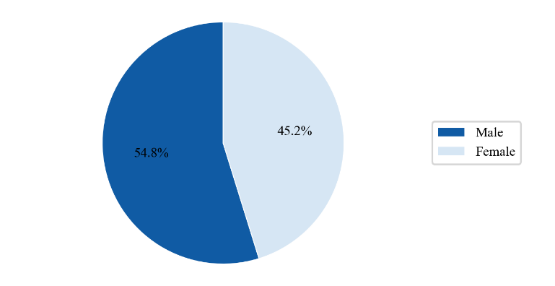
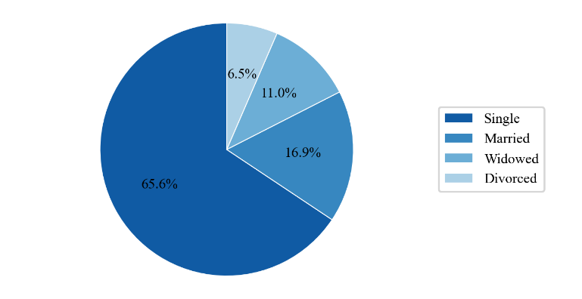
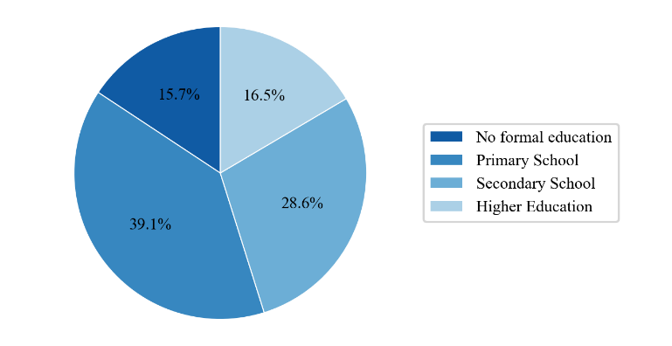
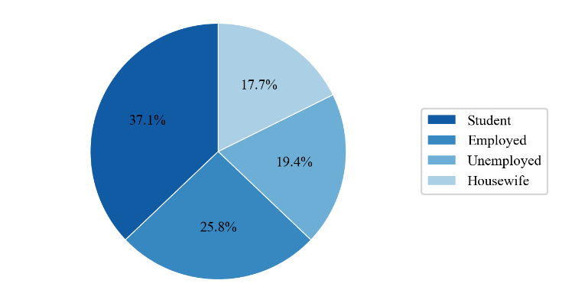
Figure 1. Sociodemographic characteristics of study participants (N = 248)
3.2.2 Clinical Characteristics
Table 2 presents the clinical and treatment-related characteristics. The majority (83.5%) were on insulin injections only, while 16.5% used both insulin and oral medication.
Medication adherence was high, with 60.5% reporting that they always followed their prescribed regimen. Blood sugar monitoring practices varied: 45.6% checked several times per week, 35.5% rarely, and 3.6% daily.
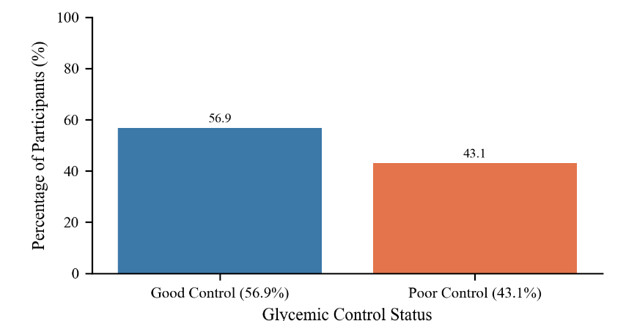
Nearly half of the participants (46.8%) had undergone an HbA1c test within the previous three months, and most (56.9%) rated their glycemic control as good. Regarding medical follow-up, 43.1% reported visiting their doctor every 1–3 months.
Figure 2. Glycemic Control Status of study participants (N = 248)
Table 2. Clinical and treatment characteristics (N = 248)
Variable | Category | Frequency | Percentage
Type of Diabetes Treatment | Insulin injections only | 207 | 83.5
 | Insulin + oral medication | 41 | 16.5
Medication Adherence | Rarely | 11 | 4.4
 | Sometimes | 32 | 12.9
 | Most of the time | 55 | 22.2
 | Always | 150 | 60.5
Blood Sugar Monitoring Frequency | Never | 3 | 1.2
 | Rarely | 88 | 35.5
 | Once a week | 35 | 14.1
 | Several times a week | 113 | 45.6
 | Daily | 9 | 3.6
Last HbA1c Test | Never | 3 | 1.2
 | More than 6 months ago | 68 | 27.4
 | 3–6 months ago | 61 | 24.6
 | Less than 3 months ago | 116 | 46.8
Glycemic Control | Poor | 100 | 40.3
 | Not sure | 7 | 2.8
 | Good | 141 | 56.9
Doctor Visits | Never | 3 | 1.2
 | Only when problems arise | 77 | 31.0
 | Once a year | 5 | 2.0
 | Every 4–6 months | 56 | 22.6
 | Every 1–3 months | 107 | 43.1

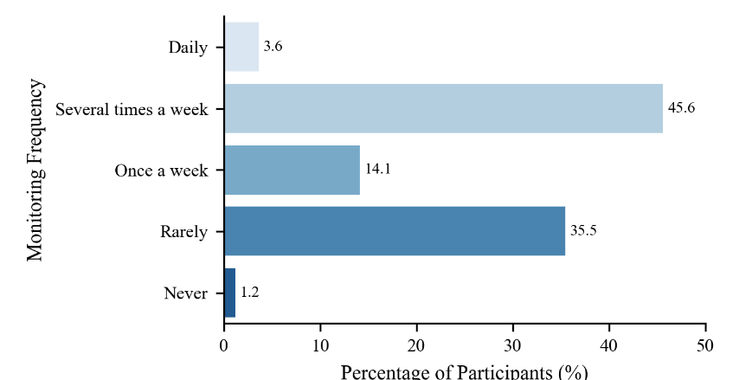
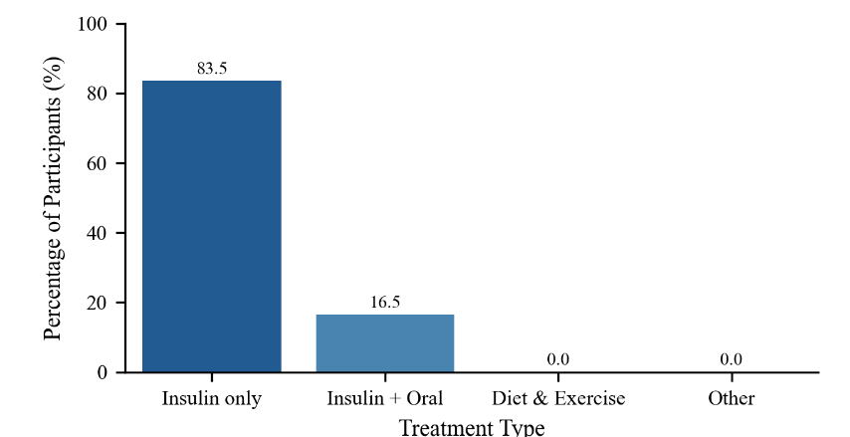
Figure 3. Distribution of Blood Sugar Monitoring frequency (N = 248)
Figure 4. Types of treatments reported by study participants (N = 248)
3.2.3 Diabetes-Related Complications
As shown in Table 3, the most frequently reported complications were foot ulcers (37.5%) and retinopathy (31.9%), followed by neuropathy (19.0%) and nephropathy (19.0%). Cardiovascular disease was present in 12.1% of participants. The majority (85.5%) reported no complications at the time of data collection.
Table 3. Prevalence of diabetes-related complications (N = 248)
Complication | Frequency | Percentage (%)
Neuropathy | 47 | 19.0
Nephropathy | 47 | 19.0
Retinopathy | 79 | 31.9
Foot ulcers | 93 | 37.5
Cardiovascular disease (CVD) | 30 | 12.1
No complications reported | 212 | 85.5

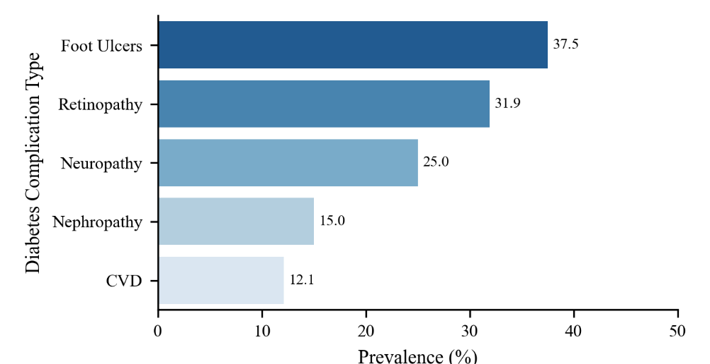
Figure 5. Distribution of complications reported by study population (N = 248)
3.2.4 Continuous Variables: Age, Diabetes Duration, and Depression Scores
Descriptive statistics for continuous variables are presented in Table 4. Participants had a mean age of 23.35 ± 12.84 years, ranging from 3 to 60 years. The mean duration of diabetes was 12.78 ± 9.26 years.
The mean Hamilton Depression Rating Scale (HDRS) score was 15.15 ± 9.88, with scores ranging from 0 to 43, indicating that some participants experienced substantial depressive symptoms.
Table 4. Descriptive statistics for continuous variables (N = 248)
Variable | Minimum | Maximum | Mean | SD
Age (Years) | 3 | 60 | 23.35 | 12.84
Diabetes duration (Years) | 1 | 40 | 12.78 | 9.26
HDRS total score | 0 | 43 | 15.15 | 9.88
3.2.5 Depression Severity
As shown in Table 5, 36.7% of participants had mild depression, 18.1% moderate, and 20.2% severe depression, while 25.0% had no depression. When classified dichotomously, 75.0% met criteria for depression.

Table 5. Distribution of depression severity (N = 248)
Depression Level | Frequency | Percentage (%)
No depression/remission (0–7) | 62 | 25.0
Mild depression (8–16) | 91 | 36.7
Moderate depression (17–24) | 45 | 18.1
Severe depression (≥25) | 50 | 20.2
Total Depression (Yes) | 186 | 75.0
No Depression | 62 | 25.0

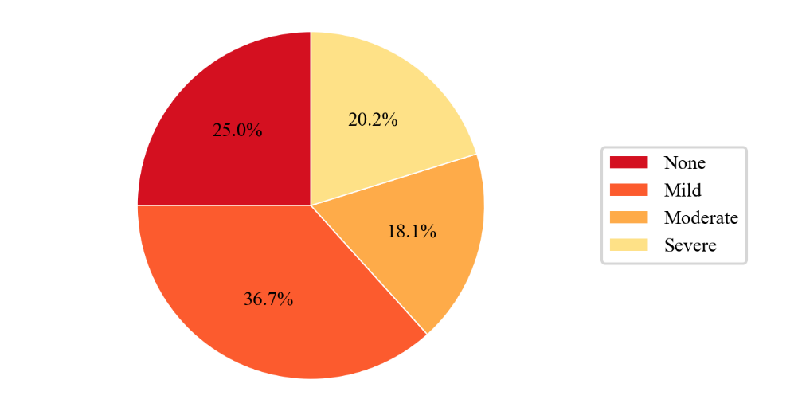
Figure 6. Distribution of Depression Severity
In summary, the study sample was predominantly young, single, and student-aged, with a mean age of 23 years. Most participants were treated with insulin only, showed good adherence, and had regular follow-up visits. Despite reasonable glycemic control, a high prevalence of diabetic complications—notably foot ulcers and retinopathy—was observed.
Importantly, three out of four participants exhibited clinically significant depressive symptoms, underscoring the psychological burden associated with diabetes in this population.
3.3 Correlation Analysis
A Pearson product–moment correlation was conducted to examine the relationships between age, duration of diabetes, and depression severity as measured by the Hamilton Depression Rating Scale (HDRS-17) (Table 6).
The results showed a strong positive correlation between age and duration of diabetes (r = .921, p < .001), indicating that older participants tended to have lived longer with the disease. There was also a moderate positive correlation between age and HDRS total score (r = .315, p < .001), suggesting that depressive symptoms increased with age. Similarly, a moderate positive correlation was found between duration of diabetes and HDRS total score (r = .326, p < .001), implying that participants who had diabetes for a longer time reported higher levels of depression.
These findings suggest that both increasing age and longer disease duration are associated with greater depressive symptomatology among individuals with diabetes in this study.
Table 6. Pearson correlations between age, diabetes duration, and depression severity (N = 248)
Variables | 1 | 2 | 3
1. Age (years) | 1
2. Duration of diabetes (years) | .921 (p<0.001) | 1
3. HDRS total score (0–52) | .315 (p<0.001) | .326 (p<0.001) | 1
3.4 Bivariate Analysis
3.4.1 Association Between Socio-Demographic Factors, Clinical Management, and Depression Status
Chi-square tests of independence were conducted to examine the unadjusted association between the categorical socio-demographic and clinical management variables and the binary depression status (Depression Present vs. No Depression). The results are summarized in Table 7.
Socio-Demographic Factors
Among the core socio-demographic characteristics, only Employment Status demonstrated a statistically significant association with depression status (χ²(3) = 9.632, p = 0.022).
The highest prevalence of depression was observed among respondents classified as Housewife (90.9%), followed closely by the Unemployed group (83.3%). Conversely, students exhibited the lowest depression prevalence (67.7%), while employed individuals showed a prevalence of 76.1%.
Neither Gender (χ²(1) = 0.087, p = 0.768) nor Educational Level (χ²(3) = 1.801, p = 0.615) showed a significant association with depression status.
The prevalence of depression was nearly identical between males (74.3%) and females (75.9%).
The association with Marital Status was marginally non-significant (χ²(3) = 7.688, p = 0.053), although all Widowed participants (100.0%) were classified as having depression, compared to 69.8% of Single participants.
Clinical Management and Control Factors
Associations between depression and several key diabetes management variables were highly significant.
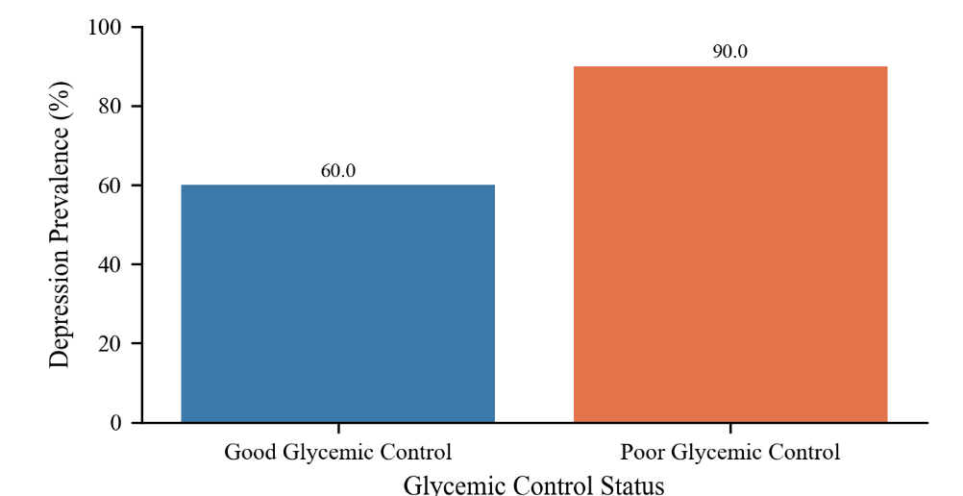
Current Glycemic Control showed the strongest association (χ²(2) = 34.367, p < 0.001).
A striking 93.0% of patients who reported poor glycemic control met the criteria for depression, compared to 61.0% of those reporting good control.
Figure 7. Depression prevalence by glycemic control status
Blood Sugar Monitoring Frequency was also highly significant (χ²(4) = 23.051, p < 0.001).
The prevalence of depression was highest among those who monitor their blood sugar rarely (87.5%) and lowest among those who monitor daily (22.2%), suggesting a clear inverse relationship where more frequent monitoring is associated with a lower rate of depression.
Type of Current Diabetes Treatment was significantly associated with depression (χ²(1) = 8.192, p = 0.004).
Patients on insulin + oral medication had a markedly higher prevalence of depression (92.7%) compared to those on insulin injections only (71.5%).
Medication Adherence was significantly associated with depression (χ²(3) = 10.373, p = 0.016).
The highest prevalence rates were observed in patients reporting adherence most of the time (87.3%) and sometimes (84.4%).
The frequency of the Last HbA1c Test (χ²(3) = 6.320, p = 0.097) and Doctor Check-ups Frequency (χ²(4) = 4.778, p = 0.311) did not show statistically significant associations with depression status.

Diabetes-Related Complications
The presence of diabetes-related complications showed pervasive and strong associations with the likelihood of having depression.
Diabetic Foot Ulcers was the most significantly associated complication (χ²(1) = 21.339, p < 0.001).
A total of 91.4% of patients reporting this complication also met the criteria for depression, compared to 65.2% of those without foot ulcers.
The presence of Cardiovascular Disease (CVD) showed a perfect association, with 100.0% of patients reporting CVD also classified as depressed (χ²(1) = 11.376, p = 0.001).
Both Diabetic Retinopathy (χ²(1) = 9.418, p = 0.002) and Diabetic Nephropathy (χ²(1) = 8.409, p = 0.004) were also significant predictors of depression status, with prevalence rates of 87.3% and 91.5%, respectively, in affected patients. Diabetic Neuropathy showed a marginally non-significant association (χ²(1) = 3.159, p = 0.076), with 85.1% of patients reporting neuropathy classified as depressed.
Table 7. Association Between Categorical Variables and Depression Status (HDRS ≥ 8)
Variable | Category | No Depression | Depression | Total | p-value
Gender | Male | 35 (25.7) | 101 (74.3) | 136 | 0.768
 | Female | 27 (24.1) | 85 (75.9) | 112
Marital Status | Single | 48 (30.2) | 111 (69.8) | 159 | 0.053
 | Married | 12 (17.6) | 56 (82.4) | 68
 | Divorced | 2 (16.7) | 10 (83.3) | 12
 | Widowed | 0 (0.0) | 9 (100.0) | 9
Educational Level | No formal education | 8 (20.5) | 31 (79.5) | 39 | 0.615
 | Primary School | 27 (27.8) | 70 (72.2) | 97
 | Secondary School | 15 (21.1) | 56 (78.9) | 71
 | Higher Education | 12 (29.3) | 29 (70.7) | 41
Employment Status | Employed | 11 (23.9) | 35 (76.1) | 46 | 0.022
 | Unemployed | 7 (16.7) | 35 (83.3) | 42
 | Student | 41 (32.3) | 86 (67.7) | 127
 | Housewife | 3 (9.1) | 30 (90.9) | 33
Type of Current Diabetes Treatment | Insulin injections only | 59 (28.5) | 148 (71.5) | 207 | 0.004
 | Insulin + oral medication | 3 (7.3) | 38 (92.7) | 41
Medication Adherence | Rarely | 5 (45.5) | 6 (54.5) | 11 | 0.016
 | Sometimes | 5 (15.6) | 27 (84.4) | 32
 | Most of the time | 7 (12.7) | 48 (87.3) | 55
 | Always | 45 (30.0) | 105 (70.0) | 150
Blood Sugar Monitoring Frequency | Never | 1 (33.3) | 2 (66.7) | 3 | <0.001
 | Rarely | 11 (12.5) | 77 (87.5) | 88
 | Once a week | 8 (22.9) | 27 (77.1) | 35
 | Several times a week | 35 (31.0) | 78 (69.0) | 113
 | Daily | 7 (77.8) | 2 (22.2) | 9
Last HbA1c Test | Never | 1 (33.3) | 2 (66.7) | 3 | 0.097
 | >6 months ago | 11 (16.2) | 57 (83.8) | 68
 | 3–6 months ago | 13 (21.3) | 48 (78.7) | 61
 | <3 months ago | 37 (31.9) | 79 (68.1) | 116
Current Glycemic Control | Poor | 7 (7.0) | 93 (93.0) | 100 | <0.001
 | Not sure | 0 (0.0) | 7 (100.0) | 7
 | Good | 55 (39.0) | 86 (61.0) | 141
Doctor Check-ups Frequency | Never | 0 (0.0) | 3 (100.0) | 3 | 0.311
 | Only when problems arise | 20 (26.0) | 57 (74.0) | 77
 | Once a year | 3 (60.0) | 2 (40.0) | 5
 | Every 4–6 months | 15 (26.8) | 41 (73.2) | 56
 | Every 1–3 months | 24 (22.4) | 83 (77.6) | 107
Diabetic Neuropathy (nerve damage) | Yes | 7 (14.9) | 40 (85.1) | 47 | 0.076
 | No | 55 (27.4) | 146 (72.6) | 201
Diabetic Nephropathy (kidney disease) | Yes | 4 (8.5) | 43 (91.5) | 47 | 0.004
 | No | 58 (28.9) | 143 (71.1) | 201
Diabetic Retinopathy (eye disease) | Yes | 10 (12.7) | 69 (87.3) | 79 | 0.002
 | No | 52 (30.8) | 117 (69.2) | 169
Diabetic Foot Ulcers | Yes | 8 (8.6) | 85 (91.4) | 93 | <0.001
 | No | 54 (34.8) | 101 (65.2) | 155
Cardiovascular Disease | Yes | 0 (0.0) | 30 (100.0) | 30 | 0.001
 | No | 62 (28.4) | 156 (71.6) | 218
3.4.2 Comparison of Mean Depression Severity Scores Across Gender
An Independent Samples t-test was conducted to compare the mean Total Hamilton Depression Rating Scale Score (HDRS Total Score) between Male and Female participants.
Table 8. Independent Samples t-test Comparing Depression Scores by Gender
Gender | N | Mean (HDRS) | SD | SE Mean
Male | 136 | 15.44 | 10.50 | 0.90
Female | 112 | 14.79 | 9.11 | 0.86
Prior to the t-test, Levene’s test for equality of variances was conducted and yielded a statistically significant result (F=4.664,p=0.032). Since the assumption of equal variances was violated, the results from the "Equal variances not assumed" line of the t-test output were interpreted.
The analysis indicated that there was no statistically significant difference in the mean HDRS Total Score between male and female participants (t(245.31)=0.519,p=0.604). Although males reported a slightly higher mean HDRS Total Score (M = 15.44, SD = 10.50) compared to females (M = 14.79, SD = 9.11), this difference was not large enough to be considered statistically significant.
This finding suggests that Gender does not significantly predict the severity of depressive symptoms (as measured by the continuous HDRS Total Score) in this patient sample.
3.4.3 Comparison of Mean Depression Severity Scores by Age Group, Diabetes Duration, and Educational Level
Three separate One-Way Analyses of Variance (ANOVA) were conducted to compare the mean HDRS Total Score (depression severity) across the different categorical levels of Age Group, Diabetes Duration Group, and Educational Level.
A. Comparison by Age Group
A One-Way ANOVA was conducted to assess differences in mean HDRS Total Scores across three Age Groups: Under 20, 20–39, and 40 and Over.
The analysis revealed a highly statistically significant difference in mean HDRS Total Scores across the three groups (F(2,245) = 10.188, p < 0.001).
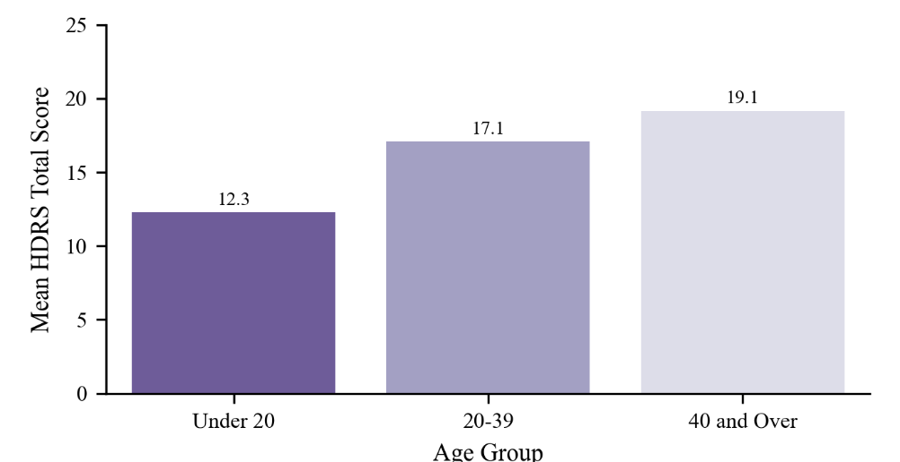
Table 9. Mean HDRS Scores by Age Group
Age Group | N | Mean HDRS Score | Standard Deviation (SD)
Under 20 | 114 | 12.27 | 7.99
20–39 | 101 | 17.09 | 10.71
40 and Over | 33 | 19.15 | 10.60
Figure 8. Mean HDRS Score by Age Group
The mean HDRS Total Score showed a clear trend of increasing depression severity with increasing age, with the highest mean score found in the 40 and Over group (Mean = 19.15).
Bonferroni post-hoc comparisons confirmed that:
- The Under 20 age group had significantly lower depression severity scores than both the 20–39 age group (p = 0.001) and the 40 and Over age group (p = 0.001).
- The difference in mean HDRS Total Score between the 20–39 group (Mean = 17.09) and the 40 and Over group (Mean = 19.15) was not statistically significant (p = 0.845).
B. Comparison by Duration Since Diagnosis with Diabetes
A One-Way ANOVA demonstrated a highly statistically significant difference in mean HDRS Total Scores across the Diabetes Duration Groups (F(2,245) = 11.672, p < 0.001).
Table 10. Mean HDRS Scores by Diabetes Duration Group
Diabetes Duration Group | N | Mean HDRS Score | Standard Deviation (SD)
0–5 Years | 73 | 11.60 | 7.41
6–15 Years | 93 | 14.62 | 10.11
Over 15 Years | 82 | 18.90 | 10.35
The mean HDRS Total Score showed a consistent increase with the duration of the disease. Bonferroni post-hoc comparisons confirmed the following significant differences:
- Patients with Over 15 Years duration had a significantly higher mean HDRS score (Mean = 18.90) than those in the 0–5 Years group (p < 0.001).
- Patients with Over 15 Years duration also had a significantly higher mean HDRS score than those in the 6–15 Years group (p = 0.010).
- The difference between the 0–5 Years and 6–15 Years groups was not statistically significant (p = 0.128).
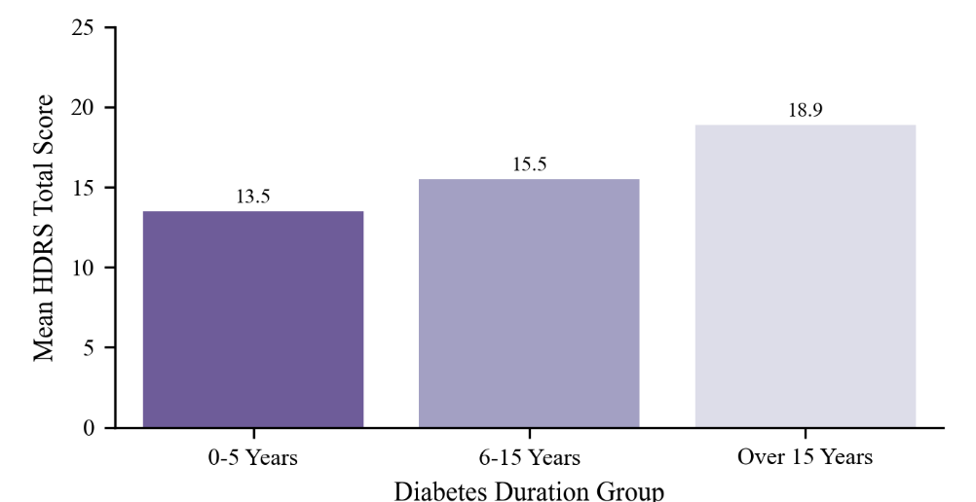
This indicates that longer diabetes duration is associated with significantly higher depression severity.
Figure 9. Mean HDRS Score by duration of diabetes
C. Comparison by Educational Level
A One-Way ANOVA showed a statistically significant difference in mean HDRS Total Scores across the different Educational Levels (F(3,244) = 4.811, p = 0.003).

Table 11. Mean HDRS Scores by Educational Level
Educational Level | N | Mean HDRS Score | Standard Deviation (SD)
No formal education | 39 | 12.46 | 6.58
Primary School | 97 | 13.70 | 9.32
Secondary School | 71 | 18.63 | 10.85
Higher Education | 41 | 15.10 | 10.68
The highest mean HDRS score was found in the Secondary School group (Mean = 18.63). Bonferroni post-hoc tests revealed the following significant pair differences:
- The Secondary School group reported a significantly higher mean HDRS score than the No formal education group (p = 0.009).
- The Secondary School group also reported a significantly higher mean HDRS score than the Primary School group (p = 0.007).
No other pair-wise comparisons (including the difference between Secondary School and Higher Education) were statistically significant.
3.5 Multivariate Analysis of Depression (HDRS Total Score and Binary Diagnosis)
This section presents the results of two multivariate regression models used to identify independent predictors of depression severity (Multiple Linear Regression) and the likelihood of having a depression diagnosis (Binary Logistic Regression).
3.5.1 Multiple Linear Regression Predicting Depression Severity (HDRS Total Score)
A multiple linear regression model was conducted to predict the Total Hamilton Depression Rating Scale (HDRS Total Score) using a set of socio-demographic, clinical management, and complication variables.
Model Fit:
The overall model was statistically significant, F(15, 232) = 19.450, p < .001, and explained a substantial portion of the variance in depression severity, with an Adjusted R² = 0.528 (52.8%), indicating a good fit.
Significant Predictors:
The table below summarizes the independent predictors of higher depression severity after controlling for all other variables.

Table 12. Multiple Linear Regression Predicting HDRS Total Score
Predictor Variable | β (Standardized) | p-value | Interpretation
Foot Ulcers | 0.432 | <0.001 | Foot ulcers associated with an 8.8-point increase in HDRS Total Score
Blood Sugar Monitor Frequency | -0.286 | <0.001 | Each unit increase in monitoring frequency decreases HDRS by 2.9 points
CVD | 0.170 | 0.001 | Presence of CVD associated with a 5.1-point increase in HDRS
Retinopathy | 0.147 | 0.006 | Presence of retinopathy associated with a 3.1-point increase in HDRS
Doctor Check-ups Frequency | 0.098 | 0.046 | Each unit increase in doctor visit frequency increases HDRS by 0.7 points
Note: Standardized coefficients (β) indicate that Foot Ulcers (β = 0.432) is the strongest predictor of depression severity, followed by Blood Sugar Monitor Frequency (β = −0.286) and CVD (β = 0.170). All other variables, including Age and Diabetes Duration, were not significant predictors in this model.
3.5.2 Binary Logistic Regression Predicting Depression Diagnosis
A binary logistic regression was performed to determine independent predictors of a depression diagnosis.
Model Fit and Performance:
The model significantly improved over the null model, χ²(15) = 59.647, p < .001. The Nagelkerke R² was 0.317, indicating that the predictors explained approximately 31.7% of the variance in depression diagnosis. The Hosmer–Lemeshow Test was non-significant, χ²(8) = 5.550, p = .697, confirming good model fit.
The model correctly classified 77.8% of cases, with high sensitivity for depressed patients (93.5%).

Significant Predictors:
The following variables were independent, statistically significant predictors of depression diagnosis:
Table 13. Binary Logistic Regression Predicting Depression Diagnosis
Predictor Variable | p-value | Odds Ratio | Interpretation
Foot Ulcers | 0.007 | 3.355 | Foot ulcers increase odds of depression by 3.36 times
Blood Sugar Monitor Frequency | 0.001 | 0.518 | Each unit increase in monitoring frequency decreases odds by 48.2%
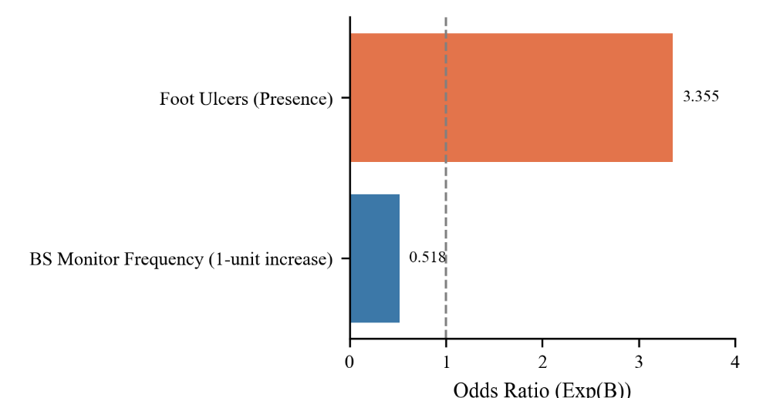
Note: The Complication: CVD variable showed unstable estimates due to quasi-complete separation (0 non-depressed cases among CVD patients), resulting in an unreliable odds ratio and p ≈ 0.998. All other predictors, including Age, Diabetes Duration, and other complications, were not statistically significant.
Figure 10. Independent Predictors of Depression Diagnosis among Type 1 Diabetes Patients
Summary of Key Findings
- The HDRS-17 scale showed excellent reliability (Cronbach’s α = 0.913), confirming internal consistency.
- Participants (N = 248) were mostly young (mean age 23.4 years), male (54.8%), and single (64.1%); over half were students (51.2%).
- Education levels were mostly primary (39.1%) or secondary (28.6%), with a smaller share having higher education (16.5%) or no formal education (15.7%).
- Most participants were on insulin only (83.5%), reported good medication adherence (60.5%), and attended regular doctor visits (43.1% every 1–3 months).
- Glycemic control was generally good (56.9%), though daily blood sugar monitoring was uncommon (3.6%).
- Common diabetes complications included foot ulcers (37.5%) and retinopathy (31.9%); overall, 85.5% reported no active complications.
- The mean depression score was 15.15, and 75% met criteria for depression—mostly mild (36.7%), moderate (18.1%), or severe (20.2%).
- Depression severity increased significantly with both age and diabetes duration (p < .001 for both).
- Employment status was significantly associated with depression (p = .022), highest among housewives and unemployed participants.
- Poor glycemic control, infrequent blood sugar monitoring, and combination insulin + oral treatment were all strongly linked to higher depression rates (p < .01).
- Depression was significantly more common among those with complications, especially foot ulcers, retinopathy, nephropathy, and cardiovascular disease.
- Gender, education, and frequency of doctor visits were not significantly related to depression.
- Regression analyses confirmed foot ulcers, cardiovascular disease, and retinopathy as independent predictors of higher depression scores, while frequent blood sugar monitoring reduced depression risk.
- Overall, depression was highly prevalent and closely tied to poorer diabetes control and complications.

