Chapter 4
Results
4.1 Sociodemographic Characteristics of Participants
A total of 116 participants were surveyed at each time point. The pre-intervention sample and the post-intervention sample were drawn independently from the same internally displaced persons (IDP) community in Marwi Camps, Sudan. Table 1 presents the demographic characteristics of both samples side by side.
The two samples were broadly comparable in composition. The majority of participants at both time points were female (83.6% pre, 81.9% post). Participants ranged in age from 18 to 85 years, with a mean age of 39.16 years (SD = 15.57) before the intervention and 38.99 years (SD = 15.32) after the intervention. Secondary education was the most common educational level in both groups (37.9% pre, 38.8% post). Unemployment was the dominant occupational category, accounting for 55.2% of participants at both time points. The majority of households had four to seven members (54.3% pre, 56.9% post). Household income below 100,000 Sudanese Pounds (SDG) per month was the most common income level (44.8% pre, 47.4% post). Regarding water source, piped water was the most commonly reported primary drinking water source (52.6% pre, 56.0% post), followed by river water (44.0% pre, 37.1% post). A notable difference between the two samples was the rate of prior receipt of diarrheal prevention information: at baseline, only 1 participant (0.9%) had previously received such information, compared to all 116 participants (100.0%) at the post-intervention time point, consistent with the delivery of the educational program between the two surveys.

Table 1. Sociodemographic Characteristics of Participants at Pre- and Post-Intervention
Characteristic | Category | Pre-Intervention (n=116) |  | Post-Intervention (n=116)
 |  | n | % | n | %
Age (years) | Mean (SD) | 39.16 (15.57) | – | 38.99 (15.32) | –
 | Range | 18 - 85 |  | 18 - 85
Gender | Female | 97 | 83.6 | 95 | 81.9
 | Male | 19 | 16.4 | 21 | 18.1
Education | literate | 13 | 11.2 | 14 | 12.1
 | Primary | 36 | 31.0 | 33 | 28.4
 | Secondary | 44 | 37.9 | 45 | 38.8
 | University | 20 | 17.2 | 22 | 19.0
 | Postgraduate | 3 | 2.6 | 2 | 1.7
Family size | 3 or fewer | 28 | 24.1 | 28 | 24.1
 | 4 to 7 | 63 | 54.3 | 66 | 56.9
 | More than 7 | 25 | 21.6 | 22 | 19.0
Monthly income (SDG) | < 100,000 | 52 | 44.8 | 55 | 47.4
 | 100,000 - 250,000 | 47 | 40.5 | 43 | 37.1
 | > 250,000 | 17 | 14.7 | 18 | 15.5
Occupation | Unemployed | 64 | 55.2 | 64 | 55.2
 | Farmer | 5 | 4.3 | 6 | 5.2
 | Trader | 7 | 6.0 | 7 | 6.0
 | Teacher | 8 | 6.9 | 9 | 7.8
 | Employee | 4 | 3.4 | 3 | 2.6
 | Other | 28 | 24.1 | 27 | 23.3
Primary water source | Pipe | 61 | 52.6 | 65 | 56.0
 | River | 51 | 44.0 | 43 | 37.1
 | Pump | 2 | 1.7 | 3 | 2.6
 | Other | 2 | 1.7 | 5 | 4.3
Received prevention info | Yes | 1 | 0.9 | 116 | 100.0
 | No | 115 | 99.1 | 0 | 0.0
4.2 Instrument Reliability
Internal consistency of the three measurement scales was assessed using Cronbach's alpha on the pre-intervention dataset (n = 116). Results are summarized in Table 2. The knowledge scale (13 items) demonstrated acceptable internal consistency (alpha = 0.742). The practice scale (8 self-reported frequency items) yielded a questionable to acceptable alpha of 0.605. The attitude scale (14 items) produced a poor alpha of 0.293. The poor internal consistency of the attitude scale is likely attributable to a ceiling effect in the pre-intervention data. The majority of items were already endorsed positively by a large proportion of participants at baseline, with positive response rates above 90% for several items.
Table 2. Internal Consistency of Measurement Scales (Pre-Intervention Data)
Scale | Number of Items | Pre Cronbach's Alpha
Knowledge scale | 13 | 0.742
Attitude scale | 14 | 0.293
Practice scale | 8 | 0.605
4.3 Knowledge, Attitudes, and Practices at Baseline
This section describes the pre-intervention KAP profile of participants. It provides the reference against which post-intervention findings are compared in Section 4.4.
4.3.1 Knowledge
The mean total knowledge score at baseline was 9.61 out of 13 (SD = 2.54), with scores ranging from 1 to 13. Using the pre-defined classification system, the majority of participants were in the medium knowledge category (63.8%, n = 74), while 20.7% (n = 24) fell into the poor category and only 15.5% (n = 18) into the good category.
At the item level, the highest correct response rates were observed for contaminated water as a risk factor for diarrhea (94.8%) and unwashed hands as a risk factor (94.8%). The two items with the lowest correct response rates were handwashing after using a latrine (28.4%) and knowledge of correct latrine structure (39.7%).
Regarding multi-select knowledge items: 59.5% of participants identified drinking contaminated water as a cause of diarrhea, 48.3% identified unwashed hands, and 31.0% identified insects. Among water treatment methods, 72.4% selected boiling. When asked about the correct times to wash hands, 77.6% selected after defecation, 59.5% before eating, and 51.7% after toilet use. Only 0.9% selected the correct response of handwashing after outdoor activity.
4.3.2 Attitudes
The mean attitude score at baseline was 10.49 out of 14 (SD = 1.77), ranging from 5 to 14. The large majority of participants (89.7%, n = 104) were classified as holding positive attitudes; only 12 participants (10.3%) were classified in the negative category.
Item-level analysis showed that positive responses were near-universal for items such as the importance of clean water containers (94.8%), the role of defective water systems in disease transmission (93.1%), and the importance of safe water for the family (92.2%). The item with the lowest proportion of positive responses at baseline was the view that latrine structure prevents disease (37.9%).
4.3.3 Practices
The mean practice score at baseline was 18.51 out of 27 (SD = 3.91), with scores ranging from 10 to 27. Participants were distributed across the three practice categories as follows: low (37.9%, n = 44), moderate (33.6%, n = 39), and high (28.4%, n = 33).
Observed practice findings indicated that a handwashing facility was present in 59.5% of households, that 77.6% of latrines were used properly, and that 79.3% of households disposed of household waste appropriately. The weakest observed practice at baseline was safe children's feces disposal (63.8%). Self-reported handwashing with soap and water was reported by 58.6% of participants, while 38.8% reported using water only.
4.4 Knowledge, Attitudes, and Practices at Post-Intervention
This section presents the post-intervention KAP findings and contrasts them with baseline values.
4.4.1 Composite KAP Score
The mean composite KAP score increased from 72.48 (SD = 11.92) before the intervention to 88.65 (SD = 5.43) after the intervention. A one-sample t-test comparing the post-intervention mean against the pre-intervention mean as a reference value indicated that this difference was statistically significant (t = 32.10, df = 115, p < .001), with a mean difference of 16.17 points. Table 3 presents the full comparison of all KAP scores.

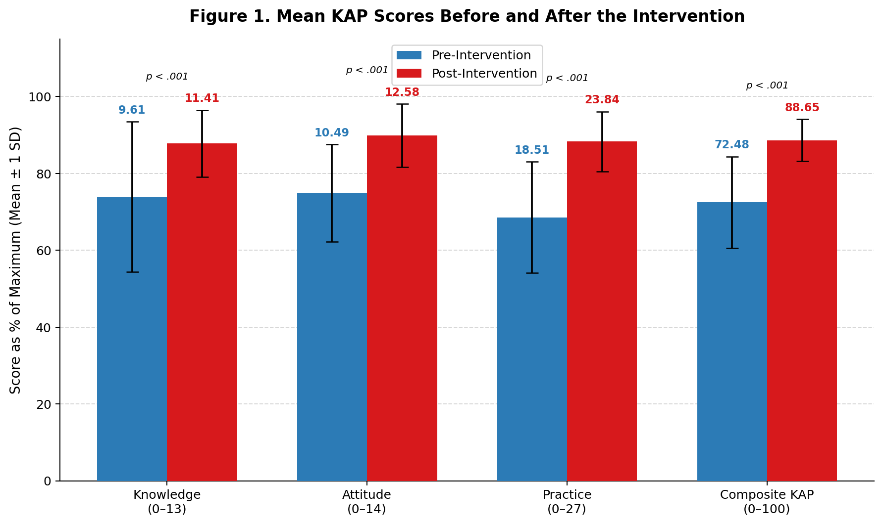
Table 3. Comparison of Mean KAP Scores Before and After the Intervention
Score | Pre Intervention |  | Post Intervention |  | Mean Difference | p-value
 | Mean | SD | Mean | SD
Knowledge (0-13) | 9.61 | 2.54 | 11.41 | 1.13 | 1.80 | < 0.001
Attitude (0-14) | 10.49 | 1.77 | 12.58 | 1.15 | 2.09 | < 0.001
Practice (0-27) | 18.51 | 3.91 | 23.84 | 2.11 | 5.33 | < 0.001
Composite KAP (0-100) | 72.48 | 11.92 | 88.65 | 5.43 | 16.17 | < .001
Figure 1. Mean Knowledge, Attitude, Practice, and Composite KAP scores at pre- and post-intervention time points
4.4.2 Knowledge
The mean knowledge score improved from 9.61 (SD = 2.54) at baseline to 11.41 (SD = 1.13) post-intervention, a statistically significant increase of 1.80 points (t = 17.10, df = 115, p < .001). The proportion of participants in the good knowledge category increased from 15.5% (n = 18) to 45.7% (n = 53), while the proportion in the poor category decreased from 20.7% (n = 24) to 1.7% (n = 2). Table 4 shows the distribution across knowledge categories.

Table 4. Distribution of Participants by Knowledge Category Before and After the Intervention
Knowledge Category | Pre-Intervention |  | Post-Intervention |  | Change
 | n | % | n | %
Poor (score 0-8) | 24 | 20.7 | 2 | 1.7 | -19.0 pp
Medium (score 9-11) | 74 | 63.8 | 61 | 52.6 | -11.2 pp
Good (score 12-13) | 18 | 15.5 | 53 | 45.7 | +30.2 pp
Total | 116 | 100.0 | 116 | 100.0
At the item level, the largest improvements were observed for the correct definition of diarrhea (+28.5 percentage points, from 65.5% to 94.0%) and knowledge of handwashing after using a latrine (+28.5 percentage points, from 28.4% to 56.9%). Knowledge of ORS preparation showed a marked increase from 75.0% to 97.4% (+22.4 pp). The two items that showed the least improvement were knowledge of transmission routes (+1.7 pp) and recognizing feces as a contamination source (+10.3 pp), both of which were already relatively high at baseline. The item on correct latrine structure, which had the second lowest correct response rate at baseline (39.7%), improved to 52.6% post-intervention (+12.9 pp), though it remained among the lower-performing items. Full item-level comparisons are presented in Table 5.

Table 5. Item-Level Knowledge Correct Response Rates Before and After the Intervention
Knowledge Item | Pre Correct n | Pre % | Post Correct n | Post % | Change
Correct definition of diarrhea | 76 | 65.5 | 109 | 94.0 | +28.5
Contaminated water as risk factor | 110 | 94.8 | 115 | 99.1 | +4.3
Unwashed hands as risk factor | 110 | 94.8 | 115 | 99.1 | +4.3
Handwashing after toilet use | 103 | 88.8 | 115 | 99.1 | +10.3
Water alone does not make it safe | 84 | 72.4 | 105 | 90.5 | +18.1
Boiling as water treatment | 92 | 79.3 | 112 | 96.6 | +17.3
Feces as source of contamination | 96 | 82.8 | 108 | 93.1 | +10.3
Flies as transmission vehicle | 104 | 89.7 | 114 | 98.3 | +8.6
Transmission routes | 76 | 65.5 | 78 | 67.2 | +1.7
ORS preparation | 87 | 75.0 | 113 | 97.4 | +22.4
Water purification methods | 98 | 84.5 | 113 | 97.4 | +12.9
Handwashing after using latrine | 33 | 28.4 | 66 | 56.9 | +28.5
Correct latrine structure | 46 | 39.7 | 61 | 52.6 | +12.9

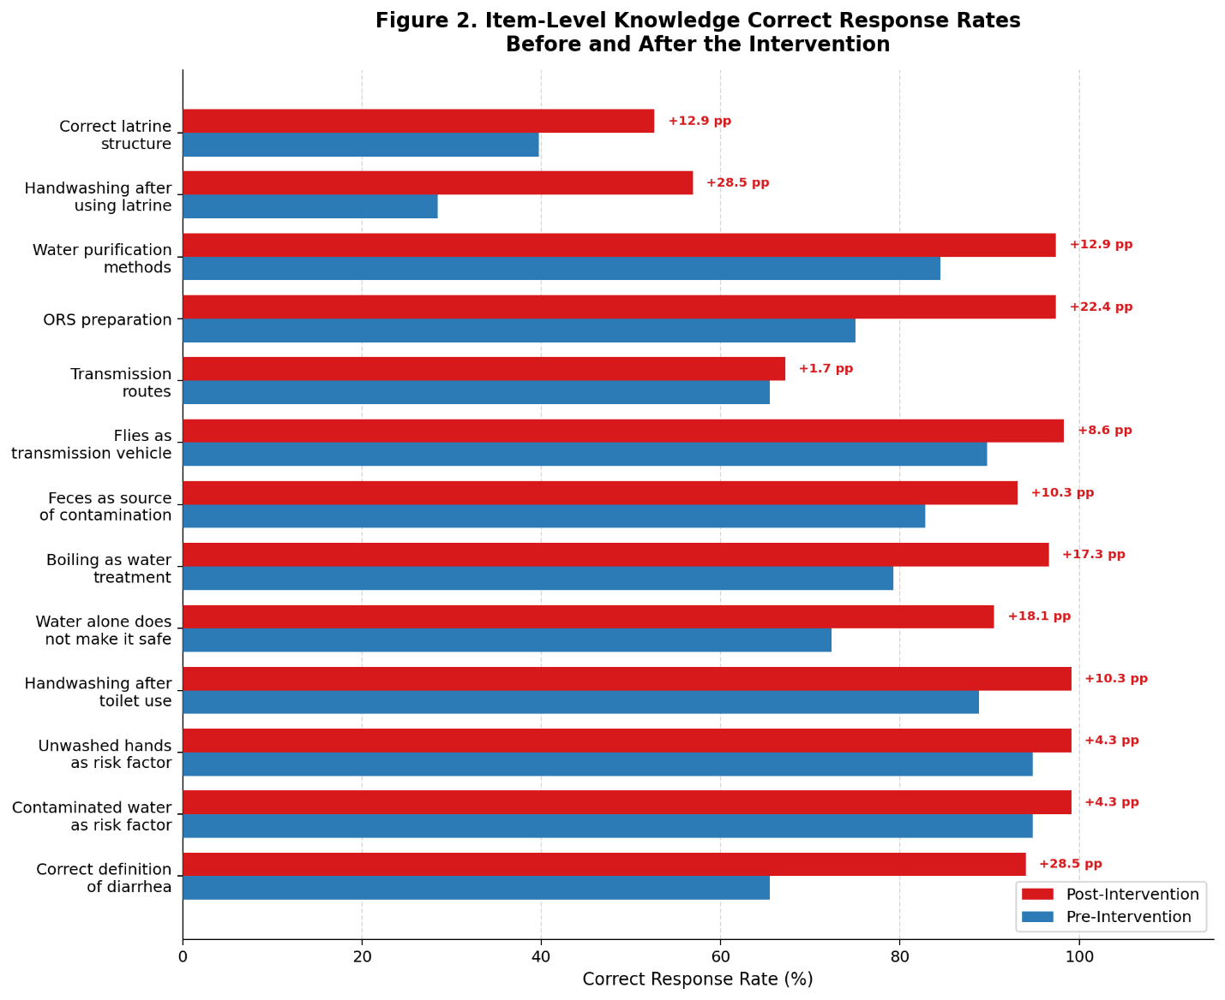
Figure 2. Item-level knowledge correct response rates at pre- and post-intervention
4.4.3 Attitudes
The mean attitude score increased from 10.49 (SD = 1.77) to 12.58 (SD = 1.15), a statistically significant improvement of 2.09 points (t = 19.52, df = 115, p < .001). Post-intervention, all 116 participants (100.0%) were classified in the positive attitude category, compared to 89.7% (n = 104) at baseline, meaning that the 10.3% who had previously held negative attitudes were no longer present in the negative category. Table 6 shows the shift in attitude categories.
The full post-intervention Likert distribution is shown in Table 9. Notably, 'Strongly Agree' responses remained rare post-intervention, with participants largely endorsing the 'Agree' category even after improvement suggesting some conservatism in response style.

Table 6. Distribution of Participants by Attitude Category Before and After the Intervention
Attitude Category | Pre-Intervention |  | Post-Intervention |  | Change
 | n | % | n | %
Negative (score 0-8) | 12 | 10.3 | 0 | 0.0 | -10.3 pp
Positive (score 9-14) | 104 | 89.7 | 116 | 100.0 | +10.3 pp
Total | 116 | 100.0 | 116 | 100.0
The largest item-level improvement was in the belief that latrine structure prevents disease, which rose from 37.9% (n = 44) to 85.3% (n = 99), an increase of 47.4 percentage points. Other substantial improvements were seen in the belief that community members should share a latrine (from 59.5% to 81.9%, +22.4 pp) and the attitude that water should be treated before drinking (from 68.1% to 87.9%, +19.8 pp). Items relating to the importance of clean water containers (94.8% to 100.0%) and the role of defective water systems (93.1% to 97.4%) were already at a high level at baseline and showed marginal further increases. Full item-level comparisons are presented in Table 7.
Full Likert distributions are presented in tables 8 and 9 for pre and post intervention.
Table 7. Item-Level Attitude Positive Response Rates Before and After the Intervention
Attitude Item | Pre n | Pre % | Post n | Post % | Change
Diarrhea is a serious health issue | 65 | 56.0 | 81 | 69.8 | +13.8
Confident in ability to prevent diarrhea | 104 | 89.7 | 110 | 94.8 | +5.1
Safe water important for family | 107 | 92.2 | 115 | 99.1 | +6.9
Water should be treated before drinking | 79 | 68.1 | 102 | 87.9 | +19.8
Handwashing reduces disease exposure | 99 | 85.3 | 114 | 98.3 | +13.0
Soap is effective for handwashing | 96 | 82.8 | 115 | 99.1 | +16.3
Water container cleanliness is important | 110 | 94.8 | 116 | 100.0 | +5.2
Poor hygiene causes diarrhea | 77 | 66.4 | 89 | 76.7 | +10.3
Latrines should provide privacy | 72 | 62.1 | 91 | 78.4 | +16.3
Latrines should be accessible at night | 88 | 75.9 | 105 | 90.5 | +14.6
Latrine structure prevents disease | 44 | 37.9 | 99 | 85.3 | +47.4
Community members should share a latrine | 69 | 59.5 | 95 | 81.9 | +22.4
Defective water systems transmit disease | 108 | 93.1 | 113 | 97.4 | +4.3
Waste near homes attracts disease-carrying flies | 99 | 85.3 | 114 | 98.3 | +13.0
Table 8. Distribution of Attitude Responses – Pre-Intervention (n = 116)
Statement | SD | Disagree | Neutral | Agree | SA
Diarrhea is a serious health issue | 0 (0.0%) | 18 (15.5%) | 33 (28.4%) | 65 (56.0%) | 0 (0.0%)
I am confident in my ability to prevent diarrhea | 0 (0.0%) | 0 (0.0%) | 12 (10.3%) | 68 (58.6%) | 36 (31.0%)
Safe water is important for my family | 0 (0.0%) | 2 (1.7%) | 7 (6.0%) | 77 (66.4%) | 30 (25.9%)
Water should be treated before drinking | 0 (0.0%) | 10 (8.6%) | 27 (23.3%) | 79 (68.1%) | 0 (0.0%)
Handwashing reduces disease exposure | 0 (0.0%) | 2 (1.7%) | 15 (12.9%) | 99 (85.3%) | 0 (0.0%)
Soap is effective for handwashing | 0 (0.0%) | 3 (2.6%) | 17 (14.7%) | 96 (82.8%) | 0 (0.0%)
Water container cleanliness is important | 0 (0.0%) | 5 (4.3%) | 0 (0.0%) | 110 (94.8%) | 0 (0.0%)
Poor hygiene causes diarrhea | 0 (0.0%) | 10 (8.6%) | 29 (25.0%) | 77 (66.4%) | 0 (0.0%)
Latrines should provide privacy | 0 (0.0%) | 28 (24.1%) | 44 (37.9%) | 44 (37.9%) | 0 (0.0%)
Latrines should be accessible at night | 0 (0.0%) | 54 (46.6%) | 34 (29.3%) | 28 (24.1%) | 0 (0.0%)
Latrine structure prevents disease | 0 (0.0%) | 18 (15.5%) | 26 (22.4%) | 72 (62.1%) | 0 (0.0%)
Community members should share a latrine | 0 (0.0%) | 35 (30.2%) | 34 (29.3%) | 47 (40.5%) | 0 (0.0%)
Defective water systems transmit disease | 0 (0.0%) | 1 (0.9%) | 7 (6.0%) | 108 (93.1%) | 0 (0.0%)
Waste near homes attracts disease-carrying flies | 0 (0.0%) | 1 (0.9%) | 16 (13.8%) | 99 (85.3%) | 0 (0.0%)
Table 9. Distribution of Attitude Responses – Post-Intervention (n = 116)
Statement | SD | Disagree | Neutral | Agree | SA
Diarrhea is a serious health issue | 0 (0.0%) | 2 (1.7%) | 31 (26.7%) | 83 (71.6%) | 0 (0.0%)
I am confident in my ability to prevent diarrhea | 0 (0.0%) | 0 (0.0%) | 6 (5.2%) | 110 (94.8%) | 0 (0.0%)
Safe water is important for my family | 0 (0.0%) | 0 (0.0%) | 1 (0.9%) | 114 (98.3%) | 1 (0.9%)
Water should be treated before drinking | 0 (0.0%) | 2 (1.7%) | 12 (10.3%) | 102 (87.9%) | 0 (0.0%)
Handwashing reduces disease exposure | 0 (0.0%) | 0 (0.0%) | 2 (1.7%) | 114 (98.3%) | 0 (0.0%)
Soap is effective for handwashing | 0 (0.0%) | 0 (0.0%) | 1 (0.9%) | 115 (99.1%) | 0 (0.0%)
Water container cleanliness is important | 0 (0.0%) | 0 (0.0%) | 0 (0.0%) | 116 (100.0%) | 0 (0.0%)
Poor hygiene causes diarrhea | 0 (0.0%) | 6 (5.2%) | 21 (18.1%) | 89 (76.7%) | 0 (0.0%)
Latrines should provide privacy | 0 (0.0%) | 82 (70.7%) | 9 (7.8%) | 25 (21.6%) | 0 (0.0%)
Latrines should be accessible at night | 0 (0.0%) | 102 (87.9%) | 3 (2.6%) | 11 (9.5%) | 0 (0.0%)
Latrine structure prevents disease | 0 (0.0%) | 94 (81.0%) | 5 (4.3%) | 17 (14.7%) | 0 (0.0%)
Community members should share a latrine | 0 (0.0%) | 73 (62.9%) | 22 (19.0%) | 21 (18.1%) | 0 (0.0%)
Defective water systems transmit disease | 0 (0.0%) | 3 (2.6%) | 0 (0.0%) | 113 (97.4%) | 0 (0.0%)
Waste near homes attracts disease-carrying flies | 0 (0.0%) | 0 (0.0%) | 2 (1.7%) | 114 (98.3%) | 0 (0.0%)
4.4.4 Practices
The mean practice score improved from 18.51 (SD = 3.91) to 23.84 (SD = 2.11), a statistically significant increase of 5.33 points (t = 27.20, df = 115, p < .001). Table 10 shows the distribution by practice category before and after the intervention.
Table 10. Distribution of Participants by Practice Category Before and After the Intervention
Practice Category | Pre-Intervention |  | Post-Intervention |  | Change
 | n | % | n | %
Low | 44 | 37.9 | 42 | 36.2 | -1.7 pp
Moderate | 39 | 33.6 | 45 | 38.8 | +5.2 pp
High | 33 | 28.4 | 29 | 25.0 | -3.4 pp
Total | 116 | 100.0 | 116 | 100.0
The practice category distribution shows a more modest shift compared to knowledge and attitudes, which is reflected in the post-intervention category distribution remaining spread across all three levels.
4.4.4.1 Observed Practice
Observed (directly assessed) practice findings showed consistent improvements across all seven indicators. The presence of a functioning handwashing facility in the home increased from 59.5% to 88.8% (+29.3 pp). Safe disposal of children's feces improved from 63.8% to 90.5% (+26.7 pp), and the trimming and cleanliness of a child's nails improved from 65.5% to 86.2% (+20.7 pp). Appropriate household waste disposal increased from 79.3% to 92.2% (+12.9 pp). Proper latrine use and latrine cleanliness showed modest but consistent improvements. Full observed practice comparisons are presented in Table 11.
Table 11. Comparison of Observed Practice Indicators Before and After the Intervention
Observed Practice Item | Pre n | Pre % | Post n | Post % | Change
Handwashing facility present | 69 | 59.5 | 103 | 88.8 | +29.3
Waste managed appropriately | 98 | 84.5 | 109 | 94.0 | +9.5
Latrine used properly | 90 | 77.6 | 101 | 87.1 | +9.5
Latrine clean | 91 | 78.4 | 101 | 87.1 | +8.7
Children's feces disposed safely | 74 | 63.8 | 105 | 90.5 | +26.7
Child's nails trimmed / clean | 76 | 65.5 | 100 | 86.2 | +20.7
Household waste disposed appropriately | 92 | 79.3 | 107 | 92.2 | +12.9

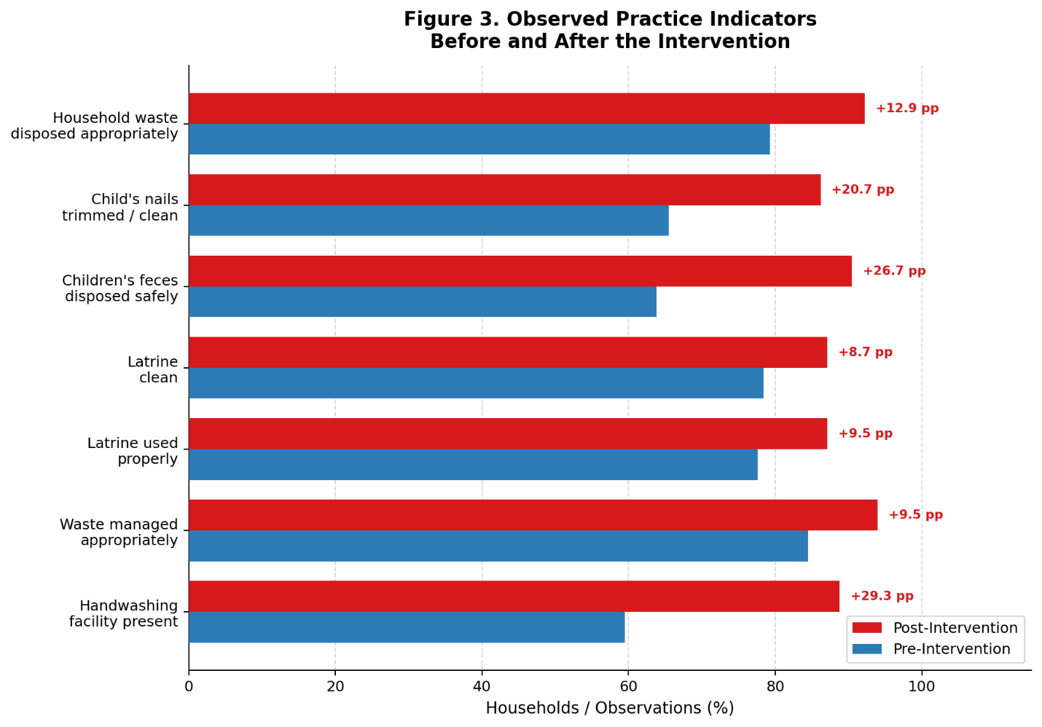
Figure 3. Observed practice indicators at pre- and post-intervention time points
4.4.4.2 Self-Reported Practice
Self-reported practice frequency showed consistent positive shifts across all items. The most notable change was in the use of ORS during diarrhea episodes: the proportion reporting always using ORS increased from 52.6% to 87.1% (+34.5 pp). Safe water storage practices also improved substantially, with the proportion always storing water safely increasing from 70.7% to 96.6% (+25.9 pp). Handwashing with soap and water (as opposed to water only) rose from 58.6% to 87.1% (+28.5 pp). Handwashing always after toilet use improved from 31.9% (at the always level) to 79.3% (+47.4 pp based on the always category alone). Table 12 summarizes the shifts in self-reported practice by item.
Table 12. Comparison of Self-Reported Practice Items Before and After the Intervention
Practice Item | Pre Intervention | Post Intervention | Notable change
Handwashing method | Soap and water: 58.6% | Soap and water: 87.1% | +28.5 pp
Handwashing after outdoor activity | Sometimes (40.5%) | Always (50.0%) | Frequency improved
Handwashing after toilet use | Sometimes (50.0%) | Always (79.3%) | +29.3 pp always
Handwashing before food preparation | Sometimes (51.7%) | Always (78.4%) | +26.7 pp always
Handwashing before eating | Sometimes (50.0%) | Always (56.0%) | +6.0 pp always
Use of safe water for drinking | Sometimes (42.2%) | Always (45.7%) | Modest improvement
Safe water storage | Always (70.7%) | Always (96.6%) | +25.9 pp always
Seeking medical care when ill | Sometimes (46.6%) | Always (54.3%) | Frequency improved
Use of ORS during diarrhea | Always (52.6%) | Always (87.1%) | +34.5 pp always

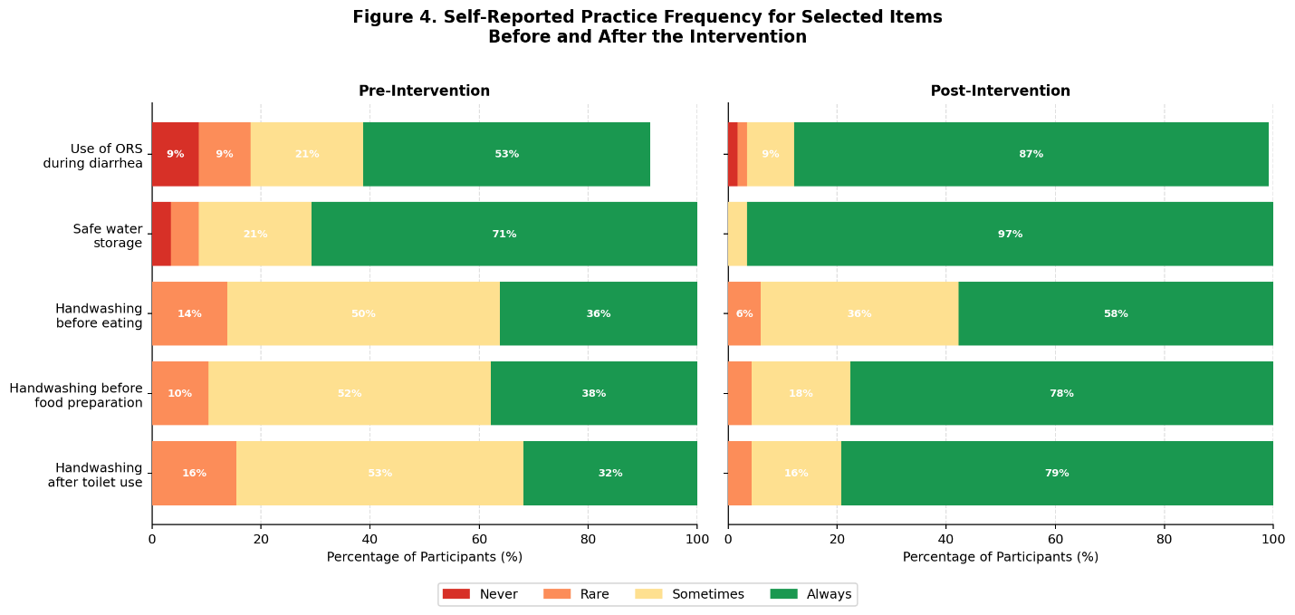
Figure 4. Distribution of response frequencies for selected self-reported practice items at pre- and post-intervention
4.5 Diarrhea Prevalence and Response Behaviour
Table 13 presents a comparison of household diarrhea prevalence and actions taken in response to diarrhea episodes, before and after the intervention.
The proportion of households reporting at least one episode of diarrhea in the previous month decreased from 42.2% (n = 49) at baseline to 33.6% (n = 39) post-intervention, a reduction of 8.6 percentage points. Among affected households, the intensity of illness also appeared to reduce: the proportion of positive households reporting three or more affected members fell from 12.5% to 5.3%.
Table 13. Household Diarrhea Prevalence Before and After the Intervention
Variable | Pre-Intervention |  | Post-Intervention |  | Change
 | n | % | n | %
Household reported diarrhea episode in past month | 49 | 42.2 | 39 | 33.6 | -8.6 pp
1 member affected | 28 | 58.3 | 28 | 73.7 | –
2 members affected | 14 | 29.2 | 8 | 21.1
3 or more members affected | 6 | 12.5 | 2 | 5.3
Regarding actions taken in response to diarrhea (Table 14), the proportion of all participants reporting that they would seek care at a health centre increased from 44.0% to 60.3% (+16.3 pp). The most pronounced change was in ORS administration, which increased from 40.5% to 74.1% (+33.6 pp). In contrast, reliance on home remedies decreased substantially, from 50.9% to 27.6% (-23.3 pp), and the harmful practice of stopping feeding the ill person declined from 8.6% to 1.7% (-6.9 pp).
Table 14. Actions Taken in Response to Diarrhea Before and After the Intervention
Action Taken | Pre-Intervention |  | Post-Intervention |  | Change
 | n | % | n | %
Went to a health center | 51 | 44.0 | 70 | 60.3 | +16.3 pp
Administered ORS | 47 | 40.5 | 86 | 74.1 | +33.6 pp
Used home remedies | 59 | 50.9 | 32 | 27.6 | -23.3 pp
Stopped feeding the ill person | 10 | 8.6 | 2 | 1.7 | -6.9 pp
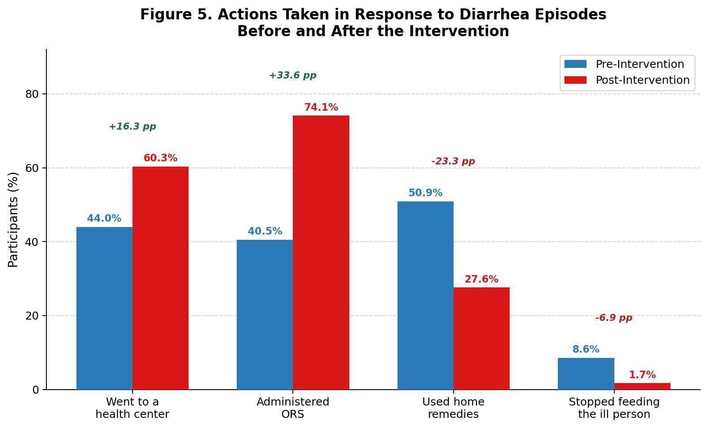

Figure 5. Grouped bar chart comparing actions taken in response to diarrhea episodes before and after the intervention

4.6 Factors Associated with KAP at Baseline
Bivariate and multivariate analyses were conducted on the pre-intervention dataset to identify sociodemographic factors associated with KAP at baseline.
4.6.1 Bivariate Analysis
Table 15 summarizes the results of bivariate tests between sociodemographic variables and KAP category outcomes. Education was the only variable significantly associated with both knowledge category (χ²= 20.69, df = 8, p = .008) and practice category (χ²= 16.52, df = 8, p = .036). Occupation was significantly associated with practice category (χ² = 26.34, df = 10, p = .003) but not with knowledge or attitude categories. No other sociodemographic variable, including gender, family size, income, and age (Spearman rho), was significantly associated with knowledge, attitude, or practice categories. Attitude category was not significantly associated with any of the tested sociodemographic variables.
Spearman rank-order correlations among the three KAP component scores showed that knowledge score was positively correlated with both attitude score (rho = 0.282, p = .002) and practice score (rho = 0.400, p < .001). Attitude score was also positively correlated with practice score (rho = 0.250, p = .007). All three component scores were strongly correlated with the composite KAP score (knowledge: rho = 0.765; attitude: rho = 0.610; practice: rho = 0.760; all p < .001). Age was not significantly correlated with any of the KAP scores (all p > .60).

Table 15. Bivariate Associations Between Sociodemographic Variables and KAP Categories at Baseline
Variable | Test | Statistic | df | p-value
Knowledge Category (Poor / Medium / Good)
Gender | Chi-square | χ²=2.15 | 2 | 0.341
Education | Chi-square | χ²=20.69 | 8 | 0.008
Family size | Chi-square | χ²=5.68 | 4 | 0.225
Monthly income | Chi-square | χ²=3.47 | 4 | 0.482
Occupation | Chi-square | χ²=8.98 | 10 | 0.534
Age | Spearman rho | rho = -0.047 | – | 0.615
Practice Category (Low / Moderate / High)
Gender | Chi-square | χ²=0.93 | 2 | 0.628
Education | Chi-square | χ²=16.52 | 8 | 0.036
Family size | Chi-square | χ²=5.67 | 4 | 0.225
Monthly income | Chi-square | χ²=5.60 | 4 | 0.231
Occupation | Chi-square | χ²=26.34 | 10 | 0.003
Age | Spearman rho | rho = -0.008 | – | 0.935
4.7 Multivariate Regression Analysis
A linear regression model was fitted with composite KAP score as the dependent variable and age, gender, education, family size, income, and occupation as predictors. The model was statistically significant (F = 4.756, df = 6 and 109, p < .001) and explained 20.7% of the variance in composite KAP score (Adjusted R² = 0.164). Education was the only statistically significant predictor in the model (B = 6.00, SE = 1.18, Beta = 0.490, t = 5.08, p < .001), with higher educational level associated with higher composite KAP scores. A parallel model with total knowledge score as the dependent variable also identified education as the sole significant predictor (B = 1.17, SE = 0.26, Beta = 0.447, t = 4.56, p < .001). No other predictor was statistically significant in either model. Full regression coefficients are presented in Table 16.

Table 16. Multiple Linear Regression of Composite KAP Score on Sociodemographic Predictors at Baseline
Predictor | B | SE | Beta | t | df | p-value
Age | 0.09 | 0.07 | .122 | 1.29 | 109 | .198
Gender | -4.45 | 2.98 | -.139 | -1.49 | 109 | .138
Education | 6.00 | 1.18 | .490 | 5.08 | 109 | < .001
Family size | -0.79 | 1.69 | -.045 | -0.47 | 109 | .641
Monthly income | 0.67 | 1.65 | .040 | 0.41 | 109 | .683
Occupation | -0.25 | 0.50 | -.044 | -0.49 | 109 | .622
Dependent variable: Composite KAP score, R² = 0.207, Adjusted R² = 0.164, F(6, 109) = 4.756, p < .001.
4.8 Factors Associated with KAP Post-Intervention
Post-intervention regression models showed a markedly different pattern. The model predicting composite KAP score from the same set of sociodemographic predictors was not statistically significant (F = 0.484, df = 6 and 109, p = .819), and the model explained only 2.6% of variance in post-intervention composite KAP (Adjusted R² = -0.028). A model predicting post-intervention knowledge score was also not significant (F = 1.396, df = 6 and 109, p = .223, R² = 0.071). A model predicting post-intervention practice score showed a marginal, non-significant overall fit (F = 1.436, p = .207, R² = 0.073); within this model, education showed a nominally significant association with post-intervention practice score (B = 0.49, SE = 0.22, Beta = 0.225, t = 2.19, p = .031), though the model as a whole did not reach significance. These findings indicate that the sociodemographic factors that predicted KAP at baseline no longer showed significant predictive power following the intervention.
4.9 Summary of Findings
The results of this study demonstrate statistically significant improvements in all three KAP domains following the diarrheal prevention program in Marwi Camps. The composite KAP score increased by 16.17 points on a 100-point scale (pre: 72.48; post: 88.65; t = 32.10, p < .001). Knowledge scores improved by 1.80 points (t = 17.10, p < .001), attitude scores by 2.09 points (t = 19.52, p < .001), and practice scores by 5.33 points (t = 27.20, p < .001). The proportion of participants in the good knowledge category nearly tripled (from 15.5% to 45.7%), and all participants held positive attitudes post-intervention compared to 89.7% before. Observed practice indicators and self-reported behaviours improved consistently across all items. Household diarrhea prevalence declined from 42.2% to 33.6%, and responses to illness shifted towards evidence-based actions, particularly ORS use and health centre attendance. At baseline, education was the only significant predictor of KAP, an association that was no longer present post-intervention, suggesting that the program may have reduced the influence of educational inequalities on health-related knowledge and practice within this community.

