2.8 Data Analysis
Data analysis was conducted using IBM SPSS Statistics Version 28.0. The dataset consisted of 156 medical students from Omdurman Islamic University. All questionnaires were complete with no missing values, resulting in a 100% response rate for included participants.
2.8.1 Data Cleaning and Preparation
Data cleaning involved converting categorical string variables to numeric format for analysis. Gender was coded as 1=Male and 2=Female. Year of study was coded as 4=4th Year and 5=5th Year. IPC training and awareness variables were coded as binary variables (0=No, 1=Yes). Practice items were coded on a 5-point Likert scale (1=Never to 5=Always).
2.8.2 Computed Scores
Several composite scores were calculated:
Knowledge Score: Sum of correct responses to five questions about the WHO's 5 Moments of Hand Hygiene (range: 0-5).
Total Adherence Score: Sum of six IPC practice items (hand washing before/after patient contact, alcohol rub use, gloves use, mask use, and sharp disposal). Range: 6-30, with higher scores indicating better adherence.
Mean Adherence Score: Total adherence score divided by 6 (range: 1-5).
Barriers Scores: Sum of personal barriers (4 items) and hospital barriers (5 items), with total barriers calculated as their sum.
Adherence Influences Score: Sum of five factors reported to influence IPC adherence (range: 0-5).
2.8.3 Categorical Variables
Knowledge level was categorized as: Poor (0-2 correct), Moderate (3 correct), and Good (4-5 correct). Adherence level was categorized based on mean adherence score as: Poor (<3.0), Moderate (3.0-3.99), and Good (≥4.0).
2.8.4 Statistical Tests
Descriptive statistics included frequencies, percentages, means, and standard deviations. Bivariate analyses employed independent t-tests for comparing means between two groups, one-way ANOVA for comparing means across multiple groups, chi-square tests for associations between categorical variables, and Pearson correlation coefficients for relationships between continuous variables. Multivariate analyses included multiple linear regression to identify predictors of adherence and binary logistic regression for categorical outcomes. Statistical significance was set at p < 0.05.
CHAPTER THREE
RESULTS
3.1 Reliability Analysis
Cronbach's alpha was calculated to assess the internal consistency of the study instruments.
Table 1. Reliability Coefficients for Study Scales
Scale | Number of Items | Cronbach's Alpha | Interpretation
Adherence Scale | 6 | 0.739 | Acceptable
Knowledge (5 Moments) | 5 | 0.849 | Good
The Adherence Scale demonstrated acceptable internal consistency (α=0.739), and the Knowledge scale showed good reliability (α=0.849).
3.2 Descriptive Statistics
3.2.1 Demographic Characteristics
The study included 156 medical students from 4th and 5th year. Table 4.2 presents the demographic distribution.
Table 2. Demographic Characteristics of Participants (N=156)
Characteristic | Category | Frequency | Percentage (%)
Gender | Male | 83 | 53.2
 | Female | 73 | 46.8
Year of Study | 4th Year | 72 | 46.2
 | 5th Year | 84 | 53.8
Age (years) | Mean ± SD | 23.40 ± 1.23
 | Range | 20-27
Males comprised 53.2% of participants while females represented 46.8%. Fifth-year students slightly outnumbered 4th-year students (53.8% vs 46.2%). The mean age was 23.40 years (SD=1.23), ranging from 20 to 27 years.

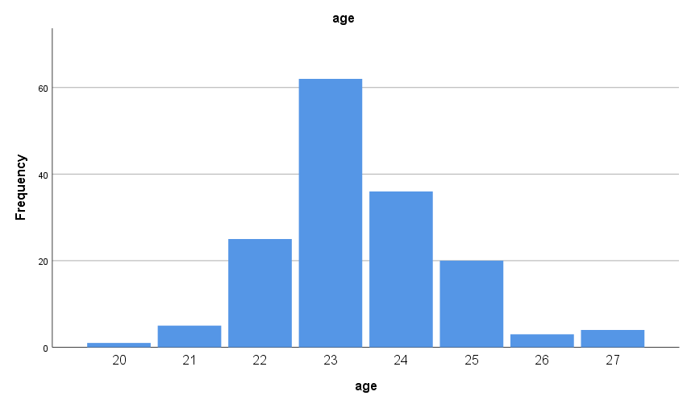
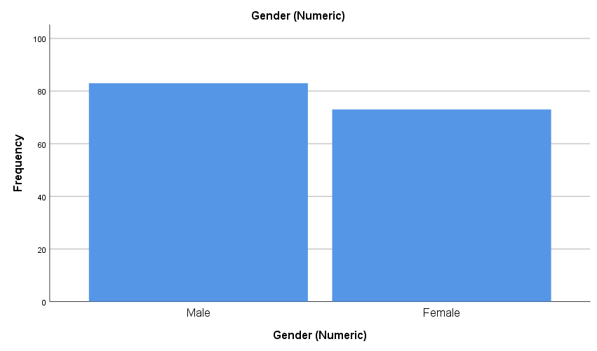
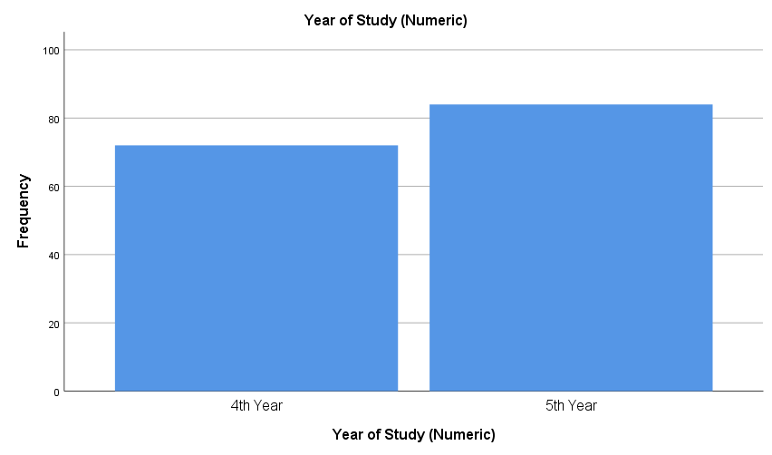
Figure 1. Sociodemographic characteristics of study participants (N=156)
3.2.2 IPC Training and Awareness
Table 3. IPC Training and Awareness (N=156)
Variable | Frequency | Percentage (%)
Previous IPC Training
Yes | 80 | 51.3
No | 76 | 48.7
Heard of 5 Moments
Yes | 102 | 65.4
No | 54 | 34.6
Knows Hand Washing Technique
Yes | 105 | 67.3
No | 51 | 32.7
Aware of Infection Risks
Yes | 130 | 83.3
No | 26 | 16.7
Slightly more than half (51.3%) had received previous IPC training. Nearly two-thirds (65.4%) had heard about the WHO's 5 Moments of Hand Hygiene. The majority knew proper hand-washing technique (67.3%) and were aware of infection risks (83.3%).
Table 4. Types of IPC Training Received (N=156)
Training Type | Frequency | Percentage (%)
Lecture | 61 | 39.1
Workshop | 14 | 9.0
Online Course | 33 | 21.2
Bedside Teaching | 17 | 10.9
Others | 77 | 49.4
Among those who received training, lectures were the most common format (39.1%), followed by 'other' formats (49.4%), online courses (21.2%), bedside teaching (10.9%), and workshops (9.0%).
3.2.3 Knowledge of IPC Practices
Table 5. Knowledge Score Distribution (N=156)
Knowledge Score | Mean ± SD | Minimum | Maximum
Total Score (0-5) | 2.83 ± 1.45 | 0 | 4
Table 6. Knowledge Level Categories (N=156)
Knowledge Level | Frequency | Percentage (%)
Poor (0-2) | 58 | 37.2
Moderate (3) | 9 | 5.8
Good (4-5) | 89 | 57.1
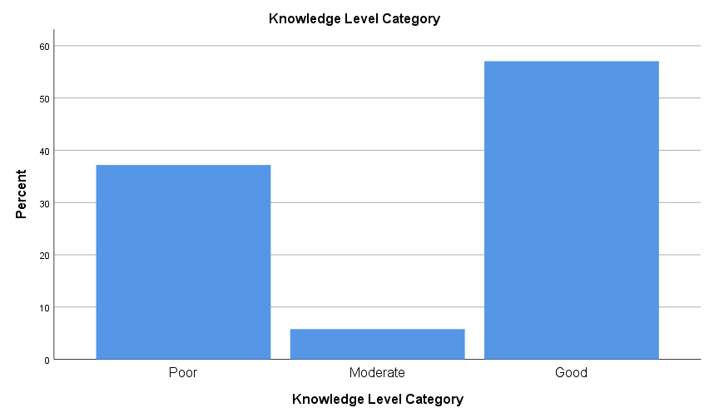
The mean knowledge score was 2.83 out of 5 (SD=1.45). More than half (57.1%) demonstrated good knowledge, while 37.2% had poor knowledge and only 5.8% had moderate knowledge.
Figure 2. Knowledge Level Categories Distribution Among Study Participants (N=156)
Table 7. Correct Identification of WHO's 5 Moments of Hand Hygiene (N=156)
Moment | Correct Responses | Percentage (%)
Before patient contact | 122 | 78.2
Before cleaning/aseptic procedures | 89 | 57.1
After exposure to body fluids | 103 | 66.0
After patient contact | 119 | 76.3
After touching patient surroundings | 97 | 62.2
The highest correct identification rate was for 'before patient contact' (78.2%), followed by 'after patient contact' (76.3%). The lowest was 'before cleaning/aseptic procedures' (57.1%).
3.2.4 IPC Adherence Practices
Table 8. IPC Adherence Scores (N=156)
Adherence Score | Mean ± SD | Minimum | Maximum
Total Adherence Score (6-30) | 22.71 ± 4.80 | 6 | 30
Mean Adherence Score (1-5) | 3.79 ± 0.80 | 1.00 | 5.00

Table 9. Adherence Level Categories (N=156)
Adherence Level | Frequency | Percentage (%)
Poor (<3.0) | 21 | 13.5
Moderate (3.0-3.99) | 54 | 34.6
Good (≥4.0) | 81 | 51.9
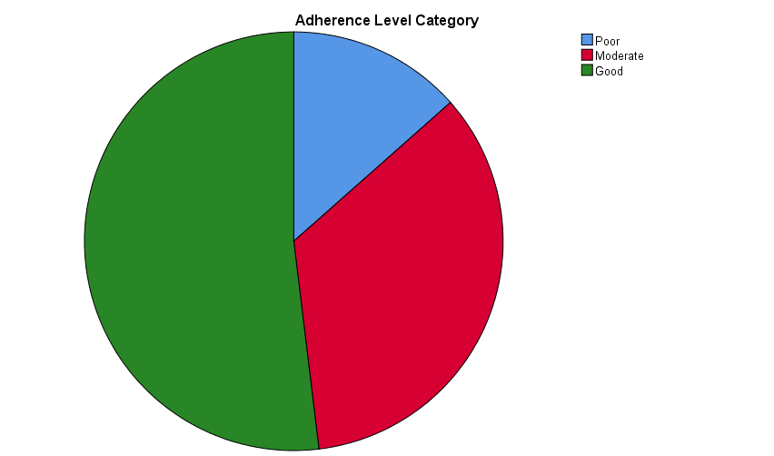
The mean total adherence score was 22.71 out of 30 (SD=4.80), with a mean item score of 3.79 out of 5. More than half of participants (51.9%) demonstrated good adherence, while 34.6% had moderate adherence and 13.5% showed poor adherence.

Figure 3. Adherence Level Categories among study participants (N=156)
Table 10. Individual IPC Practice Items (N=156)
Practice Item | Mean ± SD | Always/Often (%) | Never/Rarely (%)
Hand washing before patient contact | 3.79 ± 1.20 | 62.8 | 12.9
Hand washing after patient contact | 4.16 ± 1.03 | 75.7 | 5.8
Alcohol rub use | 3.72 ± 1.20 | 59.0 | 15.4
Gloves use | 4.06 ± 1.20 | 72.4 | 9.7
Mask use | 3.81 ± 1.14 | 60.9 | 10.2
Proper sharp disposal | 3.16 ± 1.49 | 44.8 | 30.8
Hand washing after patient contact had the highest mean score (4.16), with 75.7% reporting 'always' or 'often.' Proper sharp disposal had the lowest mean score (3.16), with only 44.8% reporting consistent compliance and 30.8% reporting 'never' or 'rarely.'
3.2.5 Barriers to IPC Adherence
Table 11. Summary of Barriers to IPC Adherence (N=156)
Barrier Type | Mean ± SD | Minimum | Maximum
Personal Barriers (0-4) | 2.06 ± 1.11 | 1 | 4
Hospital Barriers (0-5) | 2.60 ± 1.51 | 1 | 5
Total Barriers (0-9) | 4.66 ± 2.36 | 2 | 9
Table 12. Personal Barriers to IPC Adherence (N=156)
Personal Barrier | Frequency | Percentage (%)
Lack of knowledge | 94 | 60.3
Forgetfulness | 81 | 51.9
Poor attitude | 70 | 44.9
Lack of experience | 76 | 48.7
Table 13. Hospital Barriers to IPC Adherence (N=156)
Hospital Barrier | Frequency | Percentage (%)
Overcrowding | 92 | 59.0
Lack of gloves/masks | 77 | 49.4
No alcohol sanitizer | 80 | 51.3
Poor facility hygiene | 92 | 59.0
Inadequate supervision | 65 | 41.7
The most commonly reported personal barrier was lack of knowledge (60.3%), followed by forgetfulness (51.9%). Among hospital barriers, overcrowding and poor facility hygiene were each reported by 59.0% of participants, followed by lack of alcohol sanitizer (51.3%).
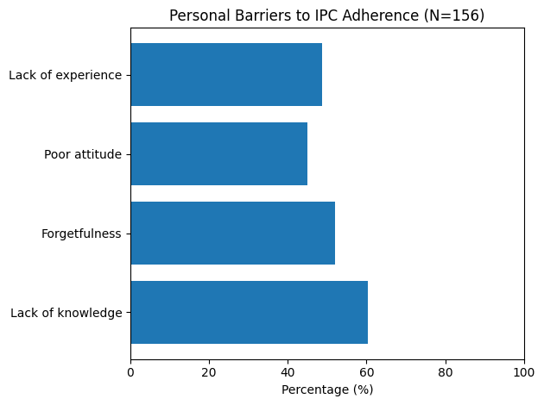
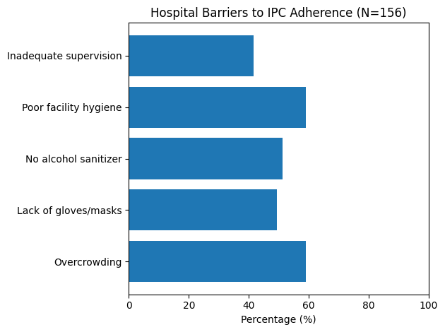
Figure 4. Personal and Hospital Barriers to Adherence
3.2.6 Factors Influencing IPC Adherence
Table 14. Factors Influencing IPC Adherence (N=156)
Influencing Factor | Frequency | Percentage (%)
Training | 79 | 50.6
Role models | 50 | 32.1
Hospital environment | 106 | 67.9
Personal motivation | 64 | 41.0
Supervision | 49 | 31.4
Hospital environment was the most frequently cited influence on adherence (67.9%), followed by training (50.6%) and personal motivation (41.0%). Role models and supervision were least frequently mentioned (32.1% and 31.4%, respectively).
Table 15. Frequency of Senior Staff Following IPC Practices (N=156)
Frequency | n | Percentage (%)
Never | 3 | 1.9
Rarely | 12 | 7.7
Sometimes | 59 | 37.8
Often | 52 | 33.3
Always | 30 | 19.2
More than half of participants (52.5%) reported that senior staff 'often' or 'always' follow IPC practices, while 37.8% observed 'sometimes' compliance. Only 9.6% reported senior staff 'rarely' or 'never' follow IPC practices.
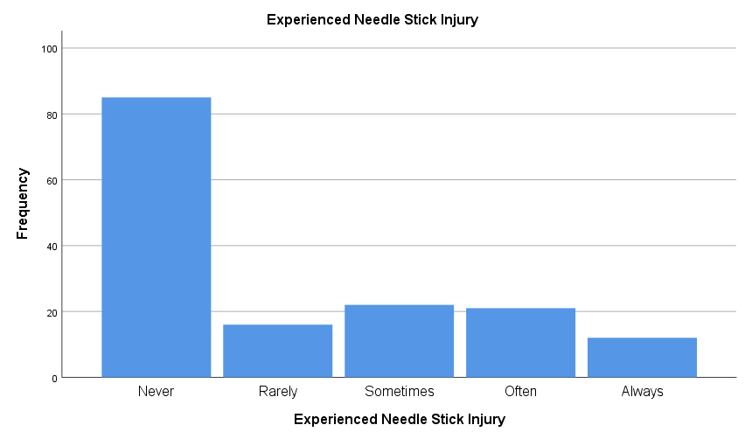
More than half (54.5%) reported never experiencing needle stick injuries, while 10.3% experienced them rarely. However, 35.3% reported experiencing needle stick injuries sometimes, often, or always, indicating a concerning frequency of occupational exposure.
Figure 5. Needle Stick Injure Experience among study participants (N=156)
3.3 Bivariate Analysis
3.3.1 Independent T-Tests
Independent t-tests were conducted to compare means between groups for key variables.
Table 16. Gender Differences in Knowledge and Adherence Scores (N=156)
Variable | Male (n=83) | Female (n=73) | t | p-value
Knowledge Score | 2.60 ± 1.49 | 3.08 ± 1.37 | -2.08 | 0.039
Total Adherence Score | 22.23 ± 4.24 | 23.26 ± 5.34 | -1.34 | 0.182
Total Barriers | 4.46 ± 2.35 | 4.89 ± 2.35 | -1.15 | 0.254
Females demonstrated significantly higher knowledge scores than males (3.08 vs 2.60, p=0.039). There were no significant differences in adherence scores (p=0.182) or total barriers (p=0.254) between genders.
Table 17. Comparison by Previous IPC Training Status (N=156)
Variable | No Training | Training | t | p-value
Knowledge Score | 2.87 ± 1.44 | 2.79 ± 1.47 | 0.35 | 0.729
Total Adherence Score | 22.09 ± 4.78 | 23.30 ± 4.78 | -1.58 | 0.117
Surprisingly, there were no significant differences in knowledge scores (p=0.729) or adherence scores (p=0.117) between students who received previous IPC training and those who did not.

Table 18. Adherence by Knowledge of Hand-Washing Technique (N=156)
Variable | No Knowledge | Has Knowledge | t | p-value
Total Adherence Score | 21.49 ± 5.15 | 23.30 ± 4.53 | -2.24 | 0.026
Students who knew proper hand-washing technique had significantly higher adherence scores (23.30 vs 21.49, p=0.026).
3.3.2 One-Way ANOVA
Table 19. Adherence Scores by Frequency of Senior Staff IPC Compliance
Senior Staff Frequency | Frequency | Mean ± SD | F | p-value
Never | 3 | 11.00 ± 8.66 | 6.63 | < 0.001
Rarely | 12 | 22.08 ± 5.37
Sometimes | 59 | 22.27 ± 5.03
Often | 52 | 22.96 ± 3.65
Always | 30 | 24.57 ± 3.82
There was a significant difference in adherence scores based on how frequently senior staff follow IPC practices (F=6.63, p<0.001). Post-hoc tests revealed that students who observe seniors 'always' following IPC had significantly higher adherence scores than those who observe 'never' or 'rarely.'
3.3.3 Chi-Square Tests
Table 20. Association Between Gender and Adherence Level (N=156)
Gender | Poor | Moderate | Good | χ² | p-value
Male | 11 (13.3) | 36 (43.4) | 36 (43.4) | 6.43 | 0.040
Female | 10 (13.7) | 18 (24.7) | 45 (61.6)
There was a significant association between gender and adherence level (χ²=6.43, p=0.040). A higher proportion of females (61.6%) demonstrated good adherence compared to males (43.4%).
Adherence Level by Knowledge Level
A cross-tabulation analysis was conducted to examine the relationship between participants’ knowledge level and adherence level (N = 156). The distribution of adherence levels across knowledge categories is presented in Table X.
Among participants with poor knowledge (n = 58), the majority demonstrated good adherence (58.6%), while 29.3% had moderate adherence and 12.1% exhibited poor adherence. Participants with moderate knowledge (n = 9) also predominantly showed good adherence (55.6%), with equal proportions reporting poor and moderate adherence (22.2% each). In the good knowledge group (n = 89), nearly half (47.2%) had good adherence, followed by moderate adherence (39.3%) and poor adherence (13.5%).
Overall, good adherence was the most common outcome across all knowledge categories (51.9%), followed by moderate adherence (34.6%) and poor adherence (13.5%).
A Pearson chi-square test indicated no statistically significant association between knowledge level and adherence level (χ² = 2.946, df = 4, p = 0.567). The strength of association was weak, as reflected by Cramer’s V = 0.097. These findings suggest that, within this sample, participants’ level of knowledge was not significantly associated with their adherence behavior.
It should be noted that some cells had expected counts below five, which may reduce the statistical power of the chi-square test and should be considered when interpreting the results.
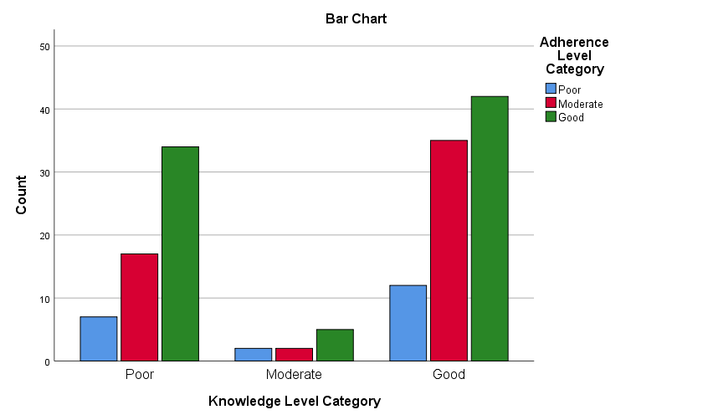
Figure 6. Adherence Level Categories by Knowledge Level
3.3.4 Correlation Analysis
Pearson correlation coefficients were calculated to examine relationships between continuous variables.

Table 21. Correlation Matrix of Key Study Variables (N=156)
Variable | 1 | 2 | 3 | 4 | 5
1. Knowledge Score | 1
2. Total Adherence Score | -0.051 | 1
3. Total Barriers | 0.347** | 0.048 | 1
4. Adherence Influences | 0.328** | 0.116 | 0.575** | 1
5. Age | -0.177* | 0.096 | -0.024 | -0.123 | 1
*p<0.05, **p<0.01
Knowledge score was not significantly correlated with adherence (r=-0.051, p=0.529). However, knowledge showed positive correlations with total barriers (r=0.347, p<0.01) and adherence influences (r=0.328, p<0.01). Age was negatively correlated with knowledge (r=-0.177, p=0.027).
Table 22. Spearman Correlation - Senior Staff Behavior and Adherence (N=156)
Variables | Spearman's ρ | p-value
Senior Staff Follow IPC × Total Adherence Score | 0.211 | 0.008
There was a significant positive correlation between how frequently senior staff follow IPC practices and students' adherence scores (ρ=0.211, p=0.008).
3.4 Multivariate Analysis
3.4.1 Multiple Linear Regression - Predictors of Adherence
Multiple linear regression was conducted to identify predictors of IPC adherence, with total adherence score as the dependent variable.
Table 23. Multiple Regression Model Summary (N=156)
Model | R | R² | Adjusted R² | F | p-value
Full Model | 0.346 | 0.120 | 0.072 | 2.50 | 0.014
Table 24. Multiple Regression Coefficients - Predictors of Adherence
Predictor | B | SE | β | t | p-value
Regression Constant | 8.11 | 8.18 |  | 0.99 | 0.323
Gender (Female) | 1.23 | 0.79 | 0.13 | 1.55 | 0.123
Year (5th) | -0.01 | 0.80 | -0.00 | -0.02 | 0.987
Knowledge Score | -0.30 | 0.28 | -0.09 | -1.06 | 0.292
Training (Yes) | 0.86 | 0.75 | 0.09 | 1.15 | 0.254
Age | 0.34 | 0.33 | 0.09 | 1.01 | 0.313
Total Barriers | 0.05 | 0.20 | 0.02 | 0.22 | 0.825
Senior Staff Follow | 1.23 | 0.41 | 0.24 | 2.97 | 0.004
Adherence Influences | 0.34 | 0.35 | 0.10 | 0.96 | 0.337
The full model explained 12.0% of variance in adherence scores (R²=0.120, F=2.50, p=0.014). Only senior staff IPC compliance was a significant predictor (β=0.24, t=2.97, p=0.004). For each one-unit increase in senior staff compliance frequency, student adherence score increased by 1.23 points. Surprisingly, knowledge score, training status, and barriers were not significant predictors.
3.4.2 Hierarchical Multiple Regression
Table 25. Hierarchical Regression - Building Predictive Model (N=156)
Model | R² | ΔR² | F Change | p-value
1. Demographics only | 0.029 | 0.029 | 1.50 | 0.218
2. + Knowledge | 0.031 | 0.003 | 0.39 | 0.532
3. + Environment & Barriers | 0.120 | 0.089 | 3.70 | 0.007
Hierarchical regression revealed that demographics alone (Model 1) did not significantly predict adherence. Adding knowledge (Model 2) contributed minimally (ΔR²=0.003). However, adding environmental factors and barriers (Model 3) significantly improved the model (ΔR²=0.089, F change=3.70, p=0.007).
3.4.3 Binary Logistic Regression - Predictors of Good Adherence
Table 28. Logistic Regression Coefficients - Predictors of Good Adherence
Predictor | B | SE | Wald | p-value | OR
Gender (Female) | -0.83 | 0.37 | 5.06 | 0.024 | 0.44
Year (5th) | 0.43 | 0.37 | 1.35 | 0.246 | 1.53
Knowledge (Good) | 0.85 | 0.41 | 4.28 | 0.039 | 2.34
Training (Yes) | -0.37 | 0.35 | 1.12 | 0.290 | 0.69
Age | 0.03 | 0.15 | 0.05 | 0.830 | 1.03
Total Barriers | -0.02 | 0.10 | 0.06 | 0.811 | 0.98
Senior Staff Follow | 0.41 | 0.19 | 4.49 | 0.034 | 1.51
*p<0.05, OR = Odds Ratio, CI = Confidence Interval
The model correctly classified 61.5% of cases. Female gender decreased the odds of good adherence (OR=0.44, p=0.024), while good knowledge increased the odds (OR=2.34, p=0.039). Each unit increase in senior staff compliance increased the odds of good adherence by 51% (OR=1.51, p=0.034).
In summary, this chapter presented comprehensive results from 156 medical students at Omdurman Islamic University. The analysis revealed moderate knowledge and good adherence levels overall, with significant gender differences in knowledge and senior staff behavior emerging as the strongest predictor of student IPC adherence. Surprisingly, previous IPC training did not significantly impact knowledge or adherence scores. The next chapter will discuss these findings in detail and compare them with existing literature.

