CHAPTER FOUR
RESULTS
Table 1. Sociodemographic Characteristics of Study Participants (N=184)
Variable | n | %
Age Group
<20 years | 5 | 2.7
20–24 years | 176 | 95.7
25–29 years | 3 | 1.6
Gender
Male | 46 | 25.0
Female | 138 | 75.0
Academic Year
First Year | 1 | 0.5
Third Year | 180 | 97.8
Fourth Year | 2 | 1.1
Sixth Year | 1 | 0.5
Residence
Urban | 129 | 70.1
Rural | 55 | 29.9
Marital Status
Single | 181 | 98.4
Married | 3 | 1.6
Family History of NCDs
Yes | 110 | 59.8
No | 63 | 34.2
Don't Know | 11 | 6.0

Table 2. Sources of Information About NCDs (N=184)
Source of Information | n | %
Medical curriculum | 154 | 83.7
Internet | 100 | 54.3
Social media | 90 | 48.9
Family or friends | 58 | 31.5
Television or radio | 34 | 18.5
Workshops or seminars | 24 | 13.0
Table 3. Frequency Distribution of Responses to Knowledge Items (N=184)
Knowledge Item | Correct n (%) | Incorrect n (%)
Hypertension is a persistent elevation of blood pressure | 154 (83.7) | 30 (16.3)
Obesity increases the risk of hypertension | 183 (99.5) | 1 (0.5)
Hypertension may occur without symptoms | 169 (91.8) | 15 (8.2)
Regular exercise helps prevent hypertension | 183 (99.5) | 1 (0.5)
Diabetes mellitus is characterized by high blood sugar | 182 (98.9) | 2 (1.1)
Physical inactivity is a risk factor for diabetes | 181 (98.4) | 3 (1.6)
Diabetes can affect the kidneys | 181 (98.4) | 3 (1.6)
Healthy diet helps prevent diabetes | 181 (98.4) | 3 (1.6)
Smoking increases the risk of heart disease | 182 (98.9) | 2 (1.1)
High cholesterol contributes to cardiovascular disease | 181 (98.4) | 3 (1.6)
Stress may increase the risk of heart disease | 179 (97.3) | 5 (2.7)
Cardiovascular diseases can be prevented | 183 (99.5) | 1 (0.5)
Smoking is a major cause of chronic lung disease | 178 (96.7) | 6 (3.3)
Asthma is a chronic respiratory disease | 181 (98.4) | 3 (1.6)
Air pollution worsens respiratory diseases | 182 (98.9) | 2 (1.1)
Chronic respiratory diseases can occur in all age groups | 181 (98.4) | 3 (1.6)

Table 4. Knowledge Score, Internal Consistency, and Category Distribution (N=184)
Statistic / Category | Value / n (%)
Mean Knowledge Score (0–16) | 15.55 (SD = 0.91)
Range | 8–16
KR-20 score (16 items) | 0.531
Knowledge Category
Poor (score 0–8) | 1 (0.5%)
Fair (score 9–12) | 1 (0.5%)
Good (score 13–16) | 182 (98.9%)

Table 5. Frequency Distribution of Responses to Attitude Items (N=184)
SD = Strongly Disagree D = Disagree N = Neutral A = Agree SA = Strongly Agree
Attitude Item | SD | D | N | A | SA
NCD prevention should be emphasized in medical education | 0 (0.0) | 0 (0.0) | 8 (4.3) | 58 (31.5) | 118 (64.1)
Medical students should join community awareness campaigns | 0 (0.0) | 0 (0.0) | 7 (3.8) | 37 (20.1) | 140 (76.1)
Lifestyle modification is effective in preventing NCDs | 1 (0.5) | 0 (0.0) | 5 (2.7) | 41 (22.3) | 137 (74.5)
Screening for hypertension and diabetes should be routine | 0 (0.0) | 0 (0.0) | 3 (1.6) | 51 (27.7) | 130 (70.7)
Physicians have an important role in smoking cessation counselling | 3 (1.6) | 0 (0.0) | 22 (12.0) | 159 (86.4) | 0 (0.0)
Chronic diseases place a major burden on the Sudanese healthcare system | 2 (1.1) | 0 (0.0) | 11 (6.0) | 124 (67.4) | 47 (25.5)
I feel confident educating patients about NCD prevention | 3 (1.6) | 0 (0.0) | 29 (15.8) | 67 (36.4) | 85 (46.2)
Early diagnosis of NCDs improves patient outcomes | 0 (0.0) | 0 (0.0) | 6 (3.3) | 32 (17.4) | 146 (79.3)

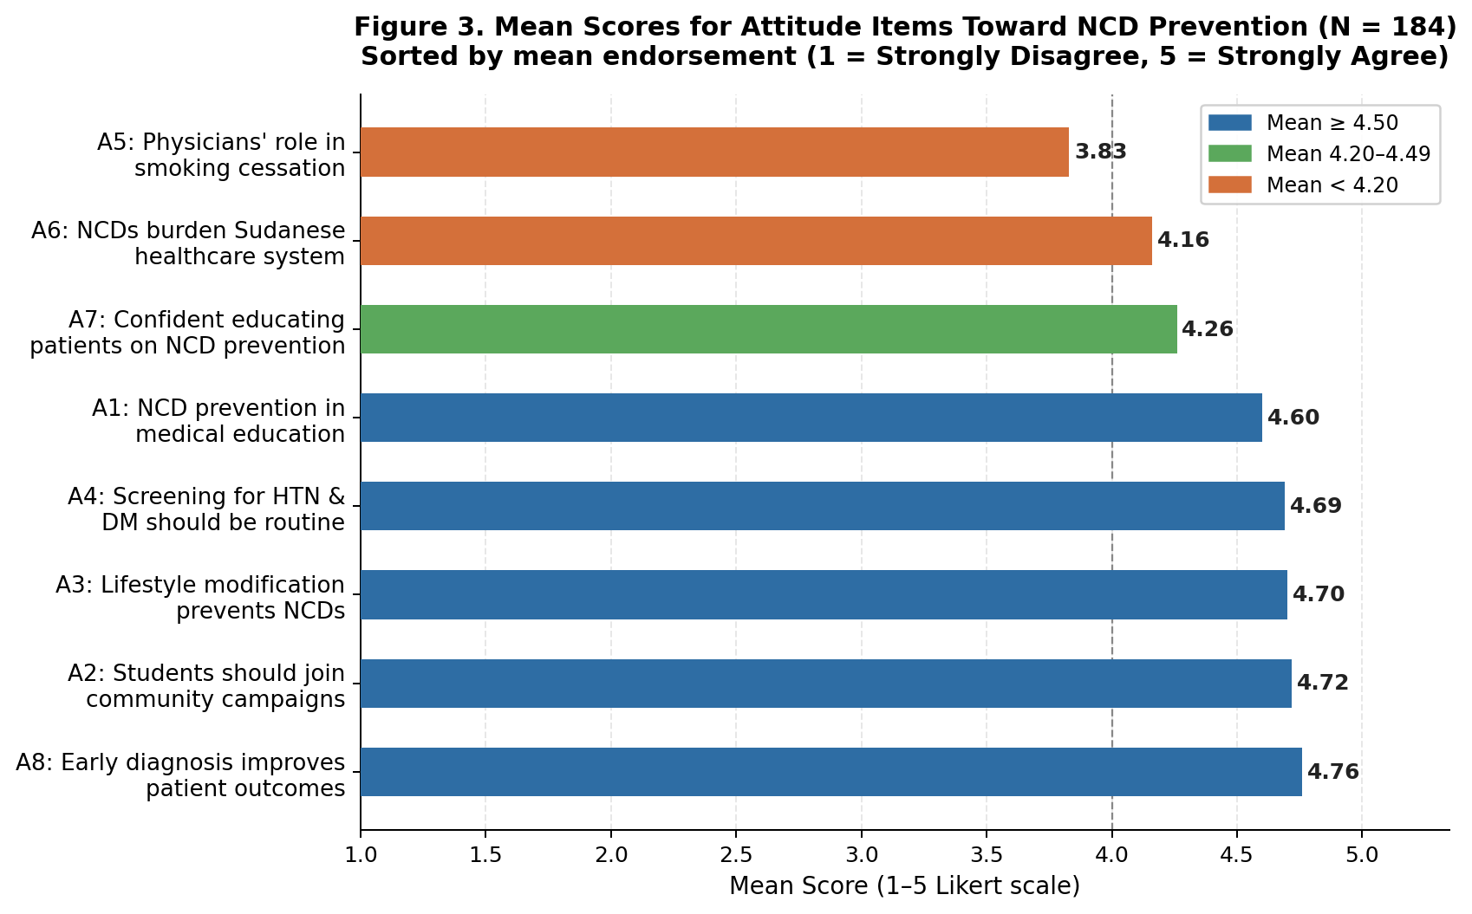
Figure 1. Mean Scores for Attitude Items Toward NCD Prevention (N = 184)
Table 6. Attitude Score, Internal Consistency, and Category Distribution (N=184)
Statistic / Category | Value / n (%)
Mean Attitude Score (8–40) | 35.72 (SD = 2.81)
Range | 22–39
Cronbach's Alpha | 0.743
Attitude Category
Negative/Neutral (score 8–29) | 5 (2.7%)
Positive (score 30–40) | 179 (97.3%)

Table 7. Frequency Distribution of Responses to Practice Items (N=184)
Practice Item | Yes n (%) | No n (%)
Do you exercise regularly? | 83 (45.1) | 101 (54.9)
Do you check your blood pressure regularly? | 26 (14.1) | 158 (85.9)
Do you monitor your blood sugar level periodically? | 17 (9.2) | 167 (90.8)
Do you avoid cigarettes or tobacco products? | 175 (95.1) | 9 (4.9)
Do you consume fruits and vegetables regularly? | 118 (64.1) | 66 (35.9)
Do you avoid excessive salty and fatty foods? | 104 (56.5) | 80 (43.5)
Have you ever participated in NCD awareness activities? | 92 (50.0) | 92 (50.0)
Do you seek medical advice when experiencing symptoms of chronic diseases? | 158 (85.9) | 26 (14.1)
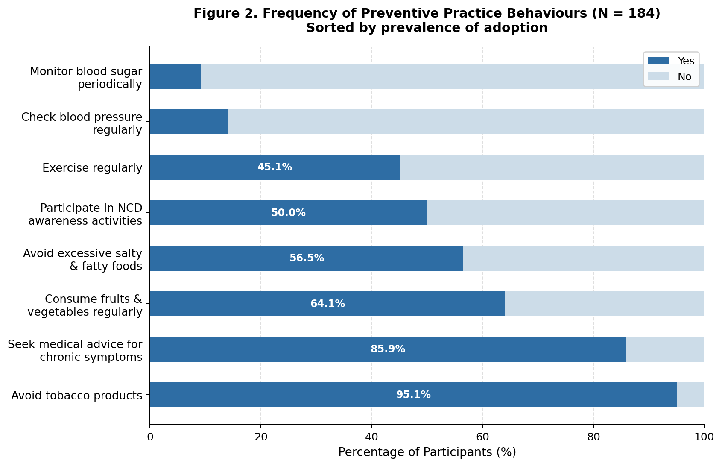
Figure 2. Frequency of Preventive Practive Behaviour (N = 184)

Table 8. Practice Score, Internal Consistency, and Category Distribution (N=184)
Statistic / Category | Value / n (%)
Mean Practice Score (0–8) | 4.20 (SD = 1.58)
Range | 0–8
KR-20 score (8 items) | 0.524
Practice Category
Low (score 0–2) | 23 (12.5%)
Moderate (score 3–5) | 130 (70.7%)
High (score 6–8) | 31 (16.8%)
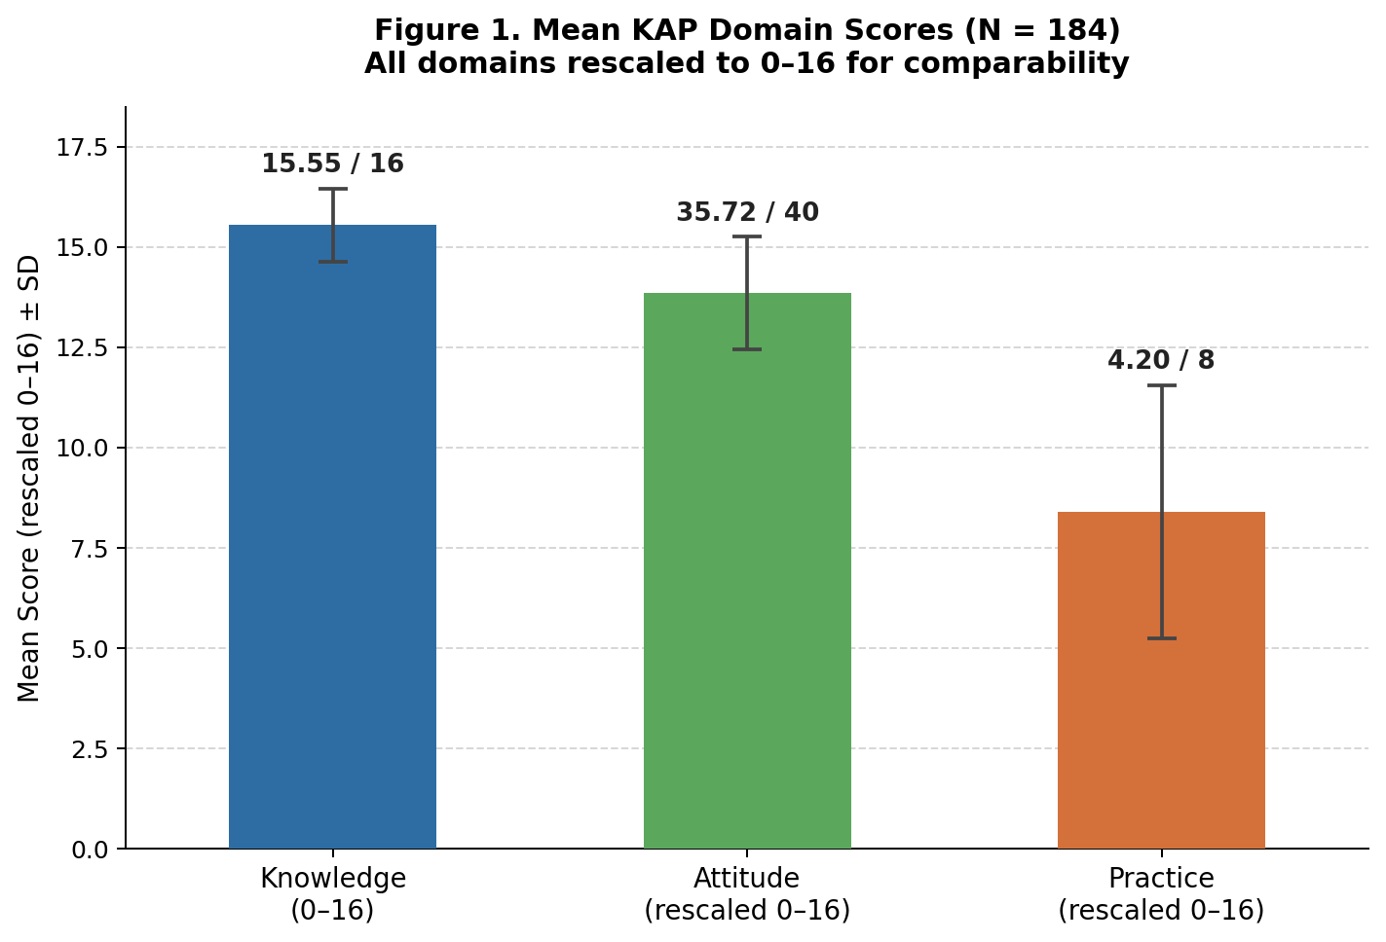

Figure 3. Mean KAP Domain Scores (N = 184)

Table 9. Chi-Square test of sociodemographic Factors Associated with Knowledge Category (N=184)
Variable | Poor/Fair % (n=2) | Good % (n=182) | p-value
Gender |  |  | 0.061
Male | 4.3 | 95.7
Female | 0.0 | 100.0
Age Group |  |  | 0.955
<20 years | 0.0 | 100.0
20–24 years | 1.1 | 98.9
25–29 years | 0.0 | 100.0
Residence |  |  | 1.000
Urban | 1.6 | 98.4
Rural | 0.0 | 100.0
Family History of NCDs |  |  | 0.209
Yes | 0.0 | 100.0
No | 1.6 | 98.4
Don't Know | 9.1 | 90.9
Marital Status |  |  | 1.000
Single | 1.1 | 98.9
Married | 0.0 | 100.0
Source of Information
Medical curriculum | 0.0 | 100.0 | 0.001
Social media | 0.0 | 100.0 | 0.164
Internet | 1.0 | 99.0 | 0.901
Television/radio | 0.0 | 100.0 | 0.498
Family/friends | 1.7 | 98.3 | 0.572
Workshops/seminars | 0.0 | 100.0 | 0.582

Table 10. Chi-Square test of sociodemographic Factors Associated with Attitude Category (N=184)
Variable | Neg./Neutral % (n=5) | Positive % (n=179) | p-value
Gender |  |  | 0.014
Male | 8.7 | 91.3
Female | 0.7 | 99.3
Age Group |  |  | 0.890
<20 years | 0.0 | 100.0
20–24 years | 2.8 | 97.2
25–29 years | 0.0 | 100.0
Residence |  |  | 1.000
Urban | 3.1 | 96.9
Rural | 1.8 | 98.2
Family History of NCDs |  |  | 0.003
Yes | 0.9 | 99.1
No | 3.2 | 96.8
Don't Know | 18.2 | 81.8
Marital Status |  |  | 1.000
Single | 2.8 | 97.2
Married | 0.0 | 100.0

Table 11. Chi-Square test of sociodemographic Factors Associated with Practice Category (N=184)
Variable | Low % (n=23) | Moderate % (n=130) | High % (n=31) | p-value
Gender |  |  |  | 0.420
Male | 15.2 | 63.0 | 21.7
Female | 11.6 | 73.2 | 15.2
Age Group |  |  |  | 0.424
<20 years | 0.0 | 60.0 | 40.0
20–24 years | 12.5 | 71.0 | 16.5
25–29 years | 33.3 | 66.7 | 0.0
Residence |  |  |  | 0.886
Urban | 13.2 | 70.5 | 16.3
Rural | 10.9 | 70.9 | 18.2
Family History of NCDs |  |  |  | 0.911
Yes | 11.8 | 71.8 | 16.4
No | 12.7 | 68.3 | 19.0
Don't Know | 18.2 | 72.7 | 9.1
Marital Status |  |  |  | 0.531
Single | 12.7 | 70.2 | 17.1
Married | 0.0 | 100.0 | 0.0
Source of Information
Medical curriculum | 11.7 | 71.4 | 16.9 | 0.749
Social media | 15.6 | 65.6 | 18.9 | 0.301
Internet | 12.0 | 67.0 | 21.0 | 0.259
Television/radio | 14.7 | 58.8 | 26.5 | 0.194
Family/friends | 15.5 | 69.0 | 15.5 | 0.691
Workshops/seminars | 0.0 | 70.8 | 29.2 | 0.051
.

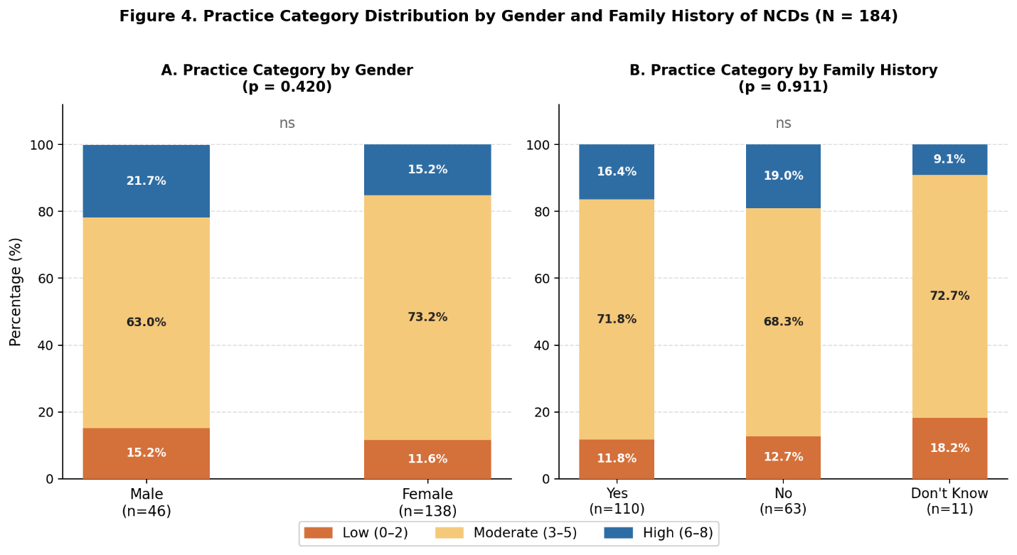
Figure 4. Practice Category Distribution by Gender and Family History of NCDs (N = 184)

Table 12. Chi-Square test of association Between Knowledge, Attitude, and Practice Categories (N=184)
Variable | Low % (n=23) | Moderate % (n=130) | High % (n=31) | p-value
Knowledge Category
Poor/Fair (n=2) | 0.0 | 100.0 | 0.0 | 0.657
Good (n=182) | 12.6 | 70.3 | 17.0
Attitude Category
Negative/Neutral (n=5) | 20.0 | 80.0 | 0.0 | 0.560
Positive (n=179) | 12.3 | 70.4 | 17.3

Table 13. Mean KAP Score Comparisons by Gender and Residence (Independent Samples t-test) (N=184)
 | Male Mean (SD) | Female Mean (SD) | Urban Mean (SD) | Rural Mean (SD) | p-value (Gender / Residence)
Knowledge Score (0–16) | 15.35 (1.45) | 15.62 (0.63) | 15.53 (0.99) | 15.60 (0.68) | 0.229 / 0.567
Attitude Score (8–40) | 35.48 (4.06) | 35.80 (2.26) | 35.61 (3.03) | 35.98 (2.23) | 0.606 / 0.360
Practice Score (0–8) | 4.28 (1.89) | 4.17 (1.47) | 4.17 (1.60) | 4.27 (1.56) | 0.724 / 0.687

Table 14. Mean KAP Scores by Family History of NCDs (One-Way ANOVA) (N=184)
Score | Yes Mean (SD) | No Mean (SD) | DK Mean (SD) | F (df=2,181) | p-value
Knowledge (0–16) | 15.60 (0.72) | 15.54 (1.12) | 15.09 (1.22) | 1.580 | 0.209
Attitude (8–40) | 36.19 (2.18) | 35.27 (2.85) | 33.64 (5.84) | 5.643 | 0.004
Practice (0–8) | 4.25 (1.54) | 4.22 (1.64) | 3.55 (1.70) | 1.014 | 0.365
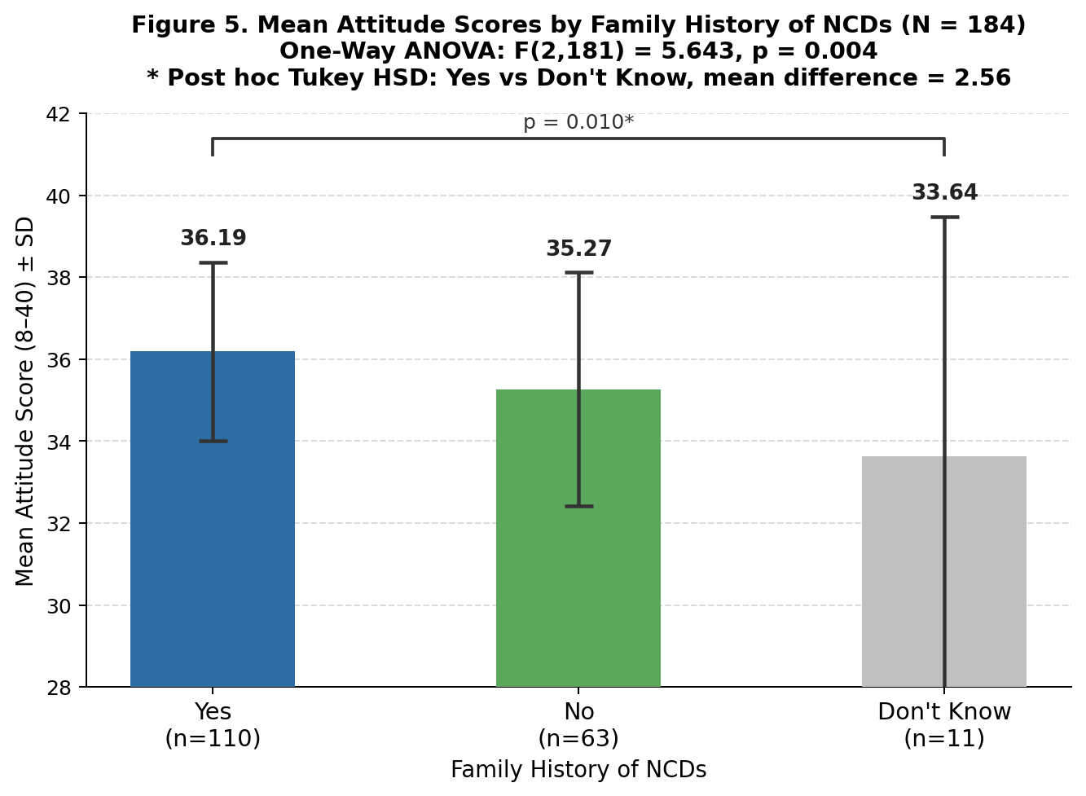
.
Figure 5. Mean Attitude Scores by Family History of NCDs (N = 184)

Table 15. Binary Logistic Regression: Predictors of Adequate Practice (N=184)
Predictor | B | SE | OR (Exp B) | p-value
Gender (Female vs Male) | − 0.548 | 0.440 | 0.578 | 0.212
Age Group (20–24 vs <20) | − 1.254 | 0.977 | 0.285 | 0.199
Residence (Rural vs Urban) | 0.146 | 0.434 | 1.157 | 0.737
Family History (No vs Yes) | 0.184 | 0.420 | 1.202 | 0.662
Family History (DK vs Yes) | − 0.691 | 1.149 | 0.501 | 0.548
Knowledge (Good vs Poor/Fair) | − 0.040 | − | 0.961 | 1.000
Attitude (Positive vs Neg./Neutral) | − | − | 0.000 | 0.999
Model: χ²(8) = 6.718, p = 0.567; Nagelkerke R² = 0.060; Hosmer-Lemeshow p = 0.971.

Interpretations

Sociodemographic Profile
The study enrolled 184 medical students at the University of Gezira, the overwhelming majority of whom were aged 20–24 years (95.7%) and in their third year of study (97.8%), which is consistent with the study's sampling frame of Batches 44 and 45. Three quarters of participants were female (75.0%), and nearly all were single (98.4%). Urban residence was predominant (70.1%). Regarding family history, 59.8% reported having a family history of NCDs, while 6.0% were unsure. The medical curriculum was the most frequently cited source of information about NCDs (83.7%), followed by the internet (54.3%) and social media (48.9%), which together reflect the digitally engaged profile of this population. Formal channels such as workshops and seminars were reported by only 13.0% of participants.

Knowledge of NCDs
The overall level of knowledge among participants was high, with 98.9% classified in the Good category (score 13–16 out of 16) and a mean score of 15.55 (SD = 0.91). Notably, 15 items were answered correctly by more than 90% of participants. The greatest gap was observed for question 1 (hypertension as a persistent elevation of blood pressure), where 16.3% answered incorrectly, suggesting a possible misunderstanding of the clinical definition despite high familiarity with associated risk factors. These findings indicate that third-year medical students possess a strong foundational knowledge base regarding the major NCDs, as would be expected given their stage of clinical training. The knowledge scale demonstrated moderate internal consistency, with a KR-20 coefficient of 0.531.

Attitudes Toward NCD Prevention
Attitudes were overwhelmingly positive, with 97.3% of participants classified in the Positive category and a mean attitude score of 35.72 (SD = 2.81) out of 40. Cronbach's alpha was 0.743, indicating acceptable internal consistency. The highest endorsement was observed for attitude statement 8 (early diagnosis of NCDs improves patient outcomes; mean = 4.76) and attitude statement 2 (medical students should join community awareness campaigns; mean = 4.72). The lowest mean was recorded for attitude statement 5 (physicians have an important role in smoking cessation counselling; mean = 3.83), with 12.0% of participants selecting Neutral, which may reflect uncertainty regarding the counselling role in undergraduate training contexts. Overall, attitudes toward NCD prevention were strongly favorable across all eight items.

Practices Toward NCD Prevention
Preventive practices showed a more variable distribution compared to knowledge and attitudes. The mean practice score was 4.20 (SD = 1.58) out of 8, with 70.7% classified as moderate and only 16.8% classified as high. The most consistently adopted practices were avoiding tobacco (95.1% yes) and seeking medical advice for chronic symptoms (85.9% yes). In contrast, monitoring blood sugar periodically (9.2% yes) and checking blood pressure regularly (14.1% yes) were the least practiced preventive behaviours, suggesting a particular gap in self-screening behaviours despite high knowledge levels. Participation in NCD awareness activities was reported by exactly 50.0% of participants. The practice scale showed moderate internal consistency, with a KR-20 coefficient of 0.524.

Bivariate Analysis
Due to severe ceiling effects in knowledge (98.9% Good) and attitude (97.3% Positive) categories, both variables were collapsed to binary categories for chi-square analysis, and the number of statistically meaningful comparisons was inherently limited.

Regarding knowledge No statistically significant association was found between gender and knowledge category (Fisher's Exact p = 0.061), though male students showed a descriptively higher proportion in the Poor/Fair category (4.3%) compared to females (0.0%). No significant association was found between family history of NCDs and knowledge category. The chi-square statistic (χ² = 7.910, p = 0.019) was not valid for inference due to small expected cell counts (3 of 6 cells < 5); the one-way ANOVA on continuous knowledge scores confirmed the absence of a significant difference across family history groups (Table 14). Selection of the medical curriculum as a source of information was significantly associated with good knowledge (χ² = 10.379, p = 0.026), with 6.7% of those who did not select this source falling in the Poor/Fair category versus 0.0% among those who did. No significant associations were found between knowledge and age, residence, marital status, or any other information source.

Regarding attitude, gender was significantly associated with attitude category (Fisher's Exact p = 0.014), with male students showing a markedly higher proportion in the Negative/Neutral category (8.7%) compared to females (0.7%). Family history of NCDs was significantly associated with attitude scores (F = 5.643, df = 2,181, p = 0.004); students who did not know their family history had the highest proportion in the Negative/Neutral category (18.2%), while those with a confirmed family history had the lowest (0.9%). No significant associations were found between attitude and age, residence, or marital status.

Regarding practice, no sociodemographic variable reached statistical significance. Gender (p = 0.420), age (p = 0.424), residence (p = 0.886), family history (p = 0.911), and marital status (p = 0.531) were all non-significant. Among information sources, workshops or seminars showed the most notable pattern, with none of the students who reported attending workshops falling in the Low practice category, and 29.2% in the High category, compared to 14.4% and 15.0% respectively among those who did not attend (Likelihood Ratio p = 0.014), though the Pearson chi-square p-value of 0.051 was borderline. Knowledge and attitude categories were not significantly associated with practice levels (p = 0.657 and p = 0.560, respectively), confirming the well-documented KAP gap in preventive health behaviour.

Mean Score Comparisons
Independent samples t-tests revealed no statistically significant differences in mean knowledge, attitude, or practice scores by gender or residence (all p > 0.05). One-way ANOVA by family history of NCDs revealed a statistically significant difference in mean attitude scores (F = 5.643, p = 0.004). Post hoc Tukey HSD analysis confirmed that students with a confirmed family history of NCDs had significantly higher attitude scores than those who did not know their family history (mean difference = 2.56, p = 0.010). No significant differences were observed in knowledge or practice scores across family history groups.

Multivariate Analysis
Binary logistic regression was conducted to identify independent predictors of adequate preventive practice (Practice Category = High). The overall model was not statistically significant (χ²(8) = 6.718, p = 0.567) and explained a small proportion of the variance in practice (Nagelkerke R² = 0.060). The model demonstrated acceptable goodness of fit (Hosmer-Lemeshow p = 0.971). No independent predictors of adequate preventive practice were identified in the multivariable analysis.

