RESULTS
Table 1. Sociodemographic Characteristics of Study Participants (N=251)
Variable | n | %
Age Group
20 – 29 years | 38 | 15.1
30 – 39 years | 108 | 43.0
40 – 49 years | 81 | 32.3
50+ years | 24 | 9.6
Gender
Male | 70 | 27.9
Female | 181 | 72.1
Table 2. Professional Characteristics and Telemedicine Training
Qualification | n | %
General Practitioner | 141 | 56.1
Family Medicine Specialist | 67 | 26.7
MD/MS | 42 | 16.7
Other Specialist | 1 | 0.4
Years of Experience
Less than 1 year | Less than 1 year | Less than 1 year
1 – 5 years | 1 – 5 years | 1 – 5 years
6 – 10 years | 6 – 10 years | 6 – 10 years
More than 10 years | More than 10 years | More than 10 years
Telemedicine Training
Yes | 45 | 17.9
No | 206 | 82.1
Years of Experience
Less than 1 year | 27 | 10.8
1 – 5 years | 115 | 45.8
6 – 10 years | 56 | 22.3
More than 10 years | 53 | 21.1
Work Setting
Urban | 166 | 66.1
Peri-urban | 52 | 20.7
Rural | 33 | 13.1
Table 3. Frequency Distribution of Responses to Knowledge Items (N=251)
Knowledge Item | Yes n (%) | No n (%) | DK n (%)
K1: Telemedicine requires informed consent | 239 (97.9) | 4 (1.6) | 8 (3.2)
K2: Written consent is always required | 25 (13.7) | 157 (85.7) | 69 (27.5)
K3: Telemedicine can reduce patient travel | 242 (98.4) | 3 (1.2) | 6 (2.4)
K4: Video link is mandatory for telemedicine | 22 (12.9) | 149 (86.5) | 80 (31.9)
K5: Controlled medications cannot be prescribed | 104 (72.2) | 39 (27.1) | 108 (42.6)
K6: Data privacy laws apply to telemedicine | 219 (96.9) | 6 (2.7) | 26 (10.4)
K7: Telemedicine can replace emergency care | 21 (8.9) | 216 (90.7) | 14 (5.6)
K8: Documentation is required after TM consult | 224 (96.1) | 8 (3.4) | 19 (7.6)
Table 4. Descriptive Statistics for Knowledge Score (N=251)
Variable | N | Mean | SD | Range
Knowledge Score (0–8) | 251 | 5.63 | 1.46 | 0–8
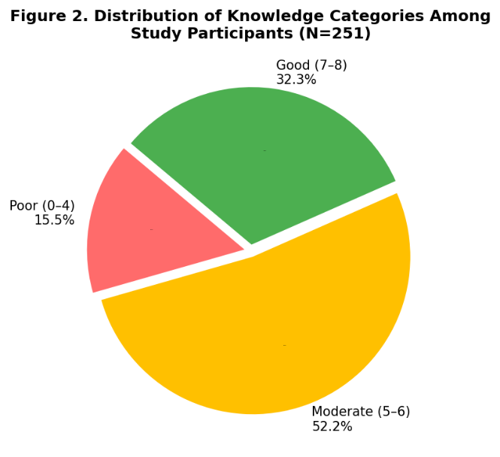

Figure 1. Distribution of Knowledge Categories Among Study Participants (N=251)

Table 5. Descriptive Statistics for Attitude Items and Total Score (N=251)
Attitude Item | SD | Disagree | Neutral | Agree | SA
A1: Telemedicine poses privacy risks | 117  (46.6%) | 71  (28.3%) | 29  (11.6%) | 22  (8.8%) | 12  (4.8%)
A2: Improves rural healthcare access | 11  (4.4%) | 13  (5.2%) | 14  (5.6%) | 62  (24.7%) | 151  (60.2%)
A3: Weakens doctor–patient relationship | 63  (25.1%) | 51  (20.3%) | 80  (31.9%) | 47  (18.7%) | 10  (4.0%)
A4: I feel confident using telemedicine | 11  (4.4%) | 30  (12.0%) | 62  (24.7%) | 68  (27.1%) | 80  (31.9%)
A5: Risk of medical errors | 19  (7.6%) | 21  (8.4%) | 77  (30.7%) | 110  (43.8%) | 24  (9.6%)
A6: Useful as a CME tool | 14  (5.6%) | 40  (15.9%) | 55  (21.9%) | 64  (25.5%) | 78  (31.1%)
A7: Culturally inappropriate | 24  (9.6%) | 42  (16.7%) | 107  (42.6%) | 67  (26.7%) | 11  (4.4%)
A8: Should be integrated into PHC | 13  (5.2%) | 12  (4.8%) | 24  (9.6%) | 57  (22.7%) | 145  (57.8%)
A9: Would recommend to colleagues | 14  (5.6%) | 14  (5.6%) | 48  (19.1%) | 84  (33.5%) | 91  (36.3%)
A10: Reduces physician workload | 13  (5.2%) | 18  (7.2%) | 57  (22.7%) | 69  (27.5%) | 94  (37.5%)

Table 6. Distribution of Telemedicine Practice Indicators (N=251)
Practice Indicator | n | %
Telemedicine Use in Past 6 Months
Yes | 220 | 87.6
No | 31 | 12.4
Consultation Volume (per month)
0–2 consultations | 74 | 29.5
3–5 consultations | 57 | 22.7
6–10 consultations | 60 | 23.9
More than 10 consultations | 60 | 23.9
Documentation Frequency
Never | 47 | 18.7
Rarely | 47 | 18.7
Sometimes | 112 | 44.6
Always | 45 | 17.9
Desire for Further Training
Yes | 209 | 83.3
No | 42 | 16.7
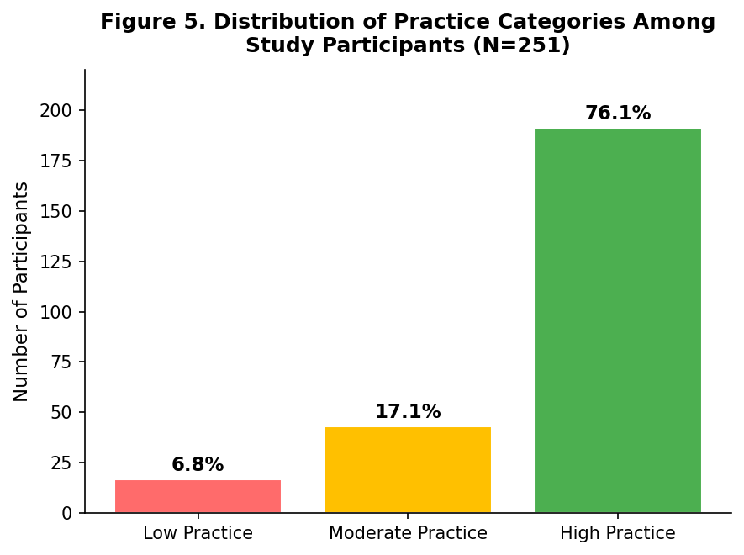
Figure 3. Distribution of Practice Categories Among Study Participants (N=251)

Table 7. Telemedicine Services, Platforms, Barriers, and Support Needs (N=251)
Item | Selected n | Selected %
Services Provided via Telemedicine
Medical consultation / general advice | 240 | 95.6
Prescription management | 189 | 75.3
Chronic disease follow-up | 185 | 73.7
Mental health support | 115 | 45.8
Emergency triage | 13 | 5.2
Platforms Used
Phone call | 217 | 86.5
WhatsApp | 149 | 59.4
Zoom | 63 | 25.1
Sudan HP Platform | 12 | 4.8
Barriers to Telemedicine Practice
Poor internet connectivity | 238 | 94.8
Lack of training | 222 | 88.4
Lack of equipment | 175 | 69.7
Patient resistance | 136 | 54.2
Legal/regulatory concerns | 99 | 39.4
No barriers reported | 5 | 2.0
Support Needed for Implementation
Technical training | 230 | 91.6
Better internet infrastructure | 228 | 90.8
Clinical guidelines | 227 | 90.4
Equipment provision | 196 | 78.1
Financial incentives | 186 | 74.1

Table 8. Bivariate Analysis of Factors Associated with Knowledge Category (N=251)
Variable | Poor (%) | Moderate (%) | Good (%) | χ² (df) | p-value
Age Group |  |  |  | 52.83 (6) | <0.001
20 – 29 years | 47.4 | 44.7 | 7.9
30 – 39 years | 11.1 | 63.0 | 25.9
40 – 49 years | 9.9 | 46.9 | 43.2
50+ years | 4.2 | 33.3 | 62.5
Gender |  |  |  | 3.39 (2) | 0.184
Male | 18.6 | 42.9 | 38.6
Female | 14.4 | 55.8 | 29.8
Work Setting |  |  |  | 5.45 (4) | 0.244
Urban | 17.5 | 50.6 | 31.9
Peri-urban | 7.7 | 51.9 | 40.4
Rural | 18.2 | 60.6 | 21.2
Years of Experience |  |  |  | 50.80 (6) | <0.001
<1 year | 48.1 | 40.7 | 11.1
1 – 5 years | 17.4 | 60.9 | 21.7
6 – 10 years | 5.4 | 55.4 | 39.3
>10 years | 5.7 | 35.8 | 58.5
Highest Qualification |  |  |  | 72.81 (8) | <0.001
General Practitioner | 21.9 | 63.1 | 15
FM Specialist | 3.0 | 47.8 | 49.3
MD/MS | 14.3 | 23.8 | 61.9
Telemedicine Training |  |  |  | 23.15 (2) | <0.001
No | 18.9 | 54.9 | 26.2
Yes | 0.0 | 40.0 | 60.0

Table 9. Bivariate Analysis of Factors Associated with Attitude Category (N=251)
Variable | Negative (%) | Neutral (%) | Positive (%) | χ² (df) | p-value
Age Group |  |  |  | 19.42 (6) | 0.004
20 – 29 years | 15.8 | 65.8 | 18.4
30 – 39 years | 14.8 | 59.3 | 25.9
40 – 49 years | 8.6 | 39.5 | 51.9
50+ years | 8.3 | 50.0 | 41.7
Gender |  |  |  | 2.27 (2) | 0.321
Male | 12.9 | 45.7 | 41.4
Female | 12.2 | 55.8 | 32.0
Work Setting |  |  |  | 5.70 (4) | 0.223
Urban | 11.4 | 54.2 | 34.3
Peri-urban | 7.7 | 55.8 | 36.5
Rural | 24.2 | 42.4 | 33.3
Years of Experience |  |  |  | 18.66 (6) | 0.005
<1 year | 22.2 | 66.7 | 11.1
1 – 5 years | 8.7 | 61.7 | 29.6
6 – 10 years | 14.3 | 41.1 | 44.6
>10 years | 13.2 | 39.6 | 47.2
Highest Qualification |  |  |  | 20.72 (8) | 0.008
General Practitioner | 12.1 | 62.4 | 25.5
FM Specialist | 10.4 | 35.8 | 53.7
MD/MS | 16.7 | 50.0 | 33.3
Telemedicine Training |  |  |  | 49.97 (2) | <0.001
No | 11.2 | 63.1 | 25.7
Yes | 17.8 | 6.7 | 75.6
Knowledge Category |  |  |  | 32.42 (4) | <0.001
Poor | 30.8 | 59.0 | 10.3
Moderate | 11.5 | 58.0 | 30.5
Good | 4.9 | 42.0 | 53.1
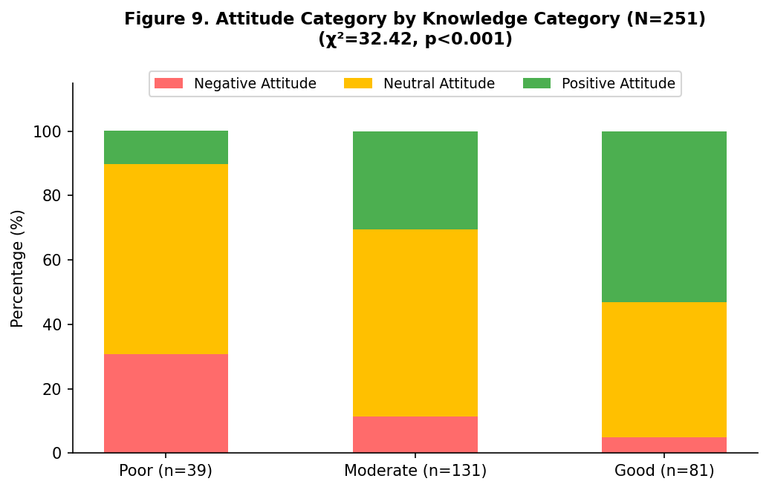

Figure 4. Attitude Category by Knowledge Category (N=251; χ²=32.42, p<0.001)

Table 10. Bivariate Analysis of Factors Associated with Telemedicine Use in the Past Six Months (N=251)
Variable | No (%) | Yes (%) | χ² (df) | p-value
Age Group |  |  | 13.63 (3) | 0.003
20 – 29 years | 28.9 | 71.1
30 – 39 years | 10.2 | 89.8
40 – 49 years | 11.1 | 88.9
50+ years | 0.0 | 100.0
Gender |  |  | 0.50 (1) | 0.481
Work Setting |  |  | 2.88 (2) | 0.237
Years of Experience |  |  | 13.68 (3) | 0.003
<1 year | 33.3 | 66.7
1 – 5 years | 11.3 | 88.7
6 – 10 years | 5.4 | 94.6
>10 years | 11.3 | 88.7
Highest Qualification |  |  | 4.71 (4) | 0.319
Telemedicine Training |  |  | 0.05 (1) | 0.825
Knowledge Category |  |  | 10.30 (2) | 0.006
Poor | 23.1 | 76.9
Moderate | 14.5 | 85.5
Good | 3.7 | 96.3
Attitude Category |  |  | 14.87 (2) | 0.001
Negative | 32.3 | 67.7
Neutral | 12.0 | 88.0
Positive | 5.7 | 94.3

Table 11. Bivariate Analysis of Factors Associated with Telemedicine Practice Category (N=251)
Variable | Low (%) | Moderate (%) | High (%) | χ² (df) | p
Age Group |  |  |  | 63.59 (6) | <0.001
20 – 29 years | 26.3 | 44.7 | 28.9
30 – 39 years | 3.7 | 17.6 | 78.7
40 – 49 years | 3.7 | 7.4 | 88.9
50+ years | 0.0 | 4.2 | 95.8
Gender |  |  |  | 1.34 (2) | 0.511
Work Setting |  |  |  | 10.33 (4) | 0.035
Urban | 6.6 | 15.1 | 78.3
Peri-urban | 7.7 | 11.5 | 80.8
Rural | 6.1 | 36.4 | 57.6
Years of Experience |  |  |  | 34.21 (6) | <0.001
<1 year | 22.2 | 40.7 | 37.0
1 – 5 years | 7.0 | 19.1 | 73.9
6 – 10 years | 0.0 | 10.7 | 89.3
>10 years | 5.7 | 7.5 | 86.8
Highest Qualification |  |  |  | 59.14 (8) | <0.001
General Practitioner | 9.9 | 24.1 | 65.9
FM Specialist | 1.5 | 9.0 | 89.6
MD/MS | 4.8 | 7.1 | 88.1
Telemedicine Training |  |  |  | 6.05 (2) | 0.048
No | 8.3 | 18.4 | 73.3
Yes | 0.0 | 11.1 | 88.9
Knowledge Category |  |  |  | 44.44 (4) | <0.001
Poor | 17.9 | 43.6 | 38.5
Moderate | 6.9 | 16.8 | 76.3
Good | 1.2 | 4.9 | 93.8
Attitude Category |  |  |  | 30.15 (4) | <0.001
Negative | 19.4 | 32.3 | 48.4
Neutral | 7.5 | 21.1 | 71.4
Positive | 1.1 | 5.7 | 93.1
Table 12. Binary Logistic Regression for Telemedicine Use in the Past Six Months (N=251)
Variable | Adjusted OR (95% CI) | p-value
Age Group |  | 0.126
30 – 39 years | 6.32 (1.39–28.73) | 0.017
40 – 49 years | 3.87 (0.67–22.28) | 0.130
50+ years | — | 0.998
Gender |  | 0.879
Female vs Male | 1.09 (0.35–3.47) | 0.879
Work Setting |  | 0.644
Peri-urban | 0.92 (0.28–3.05) | 0.886
Rural | 0.58 (0.19–1.82) | 0.351
Years of Experience |  | 0.121
1–5 years | 2.37 (0.63–8.99) | 0.204
6–10 years | 6.31 (0.91–43.75) | 0.062
>10 years | 1.08 (0.14–8.37) | 0.945
Highest Qualification |  | 0.139
General Practitioner | 11.35 (1.79–72.09) | 0.010
FM Specialist | 1.04 (0.31–3.45) | 0.953
MD/MS | 1.93 (0.35–10.62) | 0.451
Telemedicine Training | 0.53 (0.13–2.23) | 0.388
Knowledge Category |  | 0.131
Moderate | 1.36 (0.40–4.60) | 0.622
Good | 5.34 (0.93–30.78) | 0.061
Attitude Category |  | 0.023
Neutral | 2.82 (0.87–9.18) | 0.085
Positive | 7.26 (1.73–30.41) | 0.007
Interpretations
Sociodemographic Profile
The dominance of females (72.1%) in the sample reflects the feminization trend in Sudan's primary healthcare workforce, which is consistent with regional trends documented in Sudan and the broader MENA region. The concentration of participants in the 30 – 39 age bracket suggests a relatively young physician workforce, which may be relevant when discussing openness to digital technologies. Urban over-representation (66.1%) warrants acknowledgment as a potential limitation affecting generalizability to rural settings.
Knowledge of Telemedicine
The mean knowledge score of 5.63 (SD=1.46) out of 8, with 52.2% classified as moderate and 32.3% as good, suggests a partially informed workforce. Notably, items related to written consent requirements (K2: 27.5% Don’t Know) and mandatory video consultation (K4: 31.9% Don’t Know) and controlled medication prescription (K5: 42.6% Don’t Know) generated the highest "Don't Know" rates, pointing to specific regulatory knowledge gaps. The strong performance on K3 (travel reduction, 98.4% correct) and K6 (data privacy, 96.9% correct) shows awareness of the most visible aspects of telemedicine. These gaps are directly relevant to patient safety and legal accountability and can be linked to the lack of formal telemedicine training reported by 82.1% of participants.
Attitudes Toward Telemedicine
The mean attitude score of 36.67 (SD=6.08) on a 10–50 scale, with 53.0% neutral and 34.7% positive, indicates a moderately favorable disposition overall. The highest-scoring positive items were rural access improvement (A2: 4.31) and PHC integration (A8: 4.23), reflecting awareness of telemedicine's public health value. Conversely, the low score for privacy concerns (A1: 1.97, meaning most disagreed it was a risk) and the relatively high medical error concern (A5: 3.40) are notable. The Cronbach's alpha of 0.729 confirms acceptable scale reliability. The unusually strong shift toward positive attitudes among trained physicians (75.6% positive vs 25.7% among untrained) underscores the attitudinal impact of training.

Telemedicine Practices
The high rate of self-reported telemedicine use (87.6%) is notable in the context of Sudan's infrastructure challenges and may reflect the broad definition of telemedicine adopted (including phone calls). The dominance of phone calls (86.5%) and WhatsApp (59.4%) as platforms suggests that informal, low-cost technologies have enabled widespread but potentially unstructured telemedicine practice. The near-total absence of the Sudan Health Platform (4.8%) is noteworthy, indicating that official national digital health infrastructure has not been adopted. Documentation practices were concerning: only 17.9% documented always, with 18.7% never documenting which is a patient safety and medico-legal issue. The strong desire for training (83.3%) signals readiness to improve practice quality. Overall high practice category prevalence (76.1%) should be interpreted alongside documentation gaps and reliance on informal platforms.
Barriers to Telemedicine
The near-universal reporting of poor internet connectivity (94.8%) and lack of training (88.4%) as barriers positions infrastructure and capacity building as the most critical areas for intervention. Patient resistance (54.2%) and legal/regulatory concerns (39.4%) suggest behavioral and governance dimensions that policy should address. The extremely low "no barriers" response (2.0%) reinforces that challenges are pervasive. Cross-tabulation with work setting did not reveal significant differences in barrier reporting, suggesting that infrastructure problems affect all settings, not just rural areas.
Factors Associated with KAP (Bivariate Findings)
Age, years of experience, qualification, and telemedicine training were consistently significantly associated with knowledge (all p<0.001), while gender and work setting were not. This aligns with evidence from comparable settings where professional seniority and specialty training drive knowledge levels. For attitudes, a similar pattern emerged (age, experience, qualification, training significant), with the additional significant role of knowledge category itself (χ²=32.42, p<0.001), confirming a positive ordinal association between knowledge and attitude. For telemedicine use, age, years of experience, knowledge, and attitude were significant, while gender, work setting, qualification, and formal training were not, suggesting that KAP variables mediate the relationship between demographics and actual use. Practice category showed broader significant associations, with work setting also emerging (χ²=10.33, p=0.035), driven by rural physicians showing lower high-practice prevalence.
Logistic Regression Findings
Positive attitude (OR=7.26, 95% CI 1.73–30.41, p=0.007) emerged as the strongest independent predictor of telemedicine use. Being aged 30 – 39 vs 20 – 29 also independently predicted use (OR=6.32, 95% CI 1.39–28.73, p=0.017). Neither telemedicine training nor knowledge category reached significance in the multivariable model despite being significant in bivariate analysis, suggesting their effects may be mediated through attitude or confounded by other variables.

