**Name : Abdelrahman Ayman Mohamed Abdelhamed Hamza**

**B.N: 442**

**Date : 7\6\2020**

**Topic:** **Artificial Intelligence**

**Github link :**

**Github page :**

**Application brief :** Since computers or machines were invented, their ability to perform various tasks has steadily increased. Humans have developed the power of computer systems in terms of their various fields of work, their increasing speed, and reducing size in terms of time.

A branch of computer science called artificial intelligence seeks to create computers or smart machines like humans.

What is artificial intelligence?

According to the father of artificial intelligence, John McCarthy, "the science and engineering of making smart machines, especially smart computer programs."

Artificial intelligence is a method of making a computer, a computer-controlled robot, or a program that intelligently thinks, in the same way that an intelligent person thinks.

Artificial intelligence is achieved by studying how the human brain thinks, how humans learn, decide, and work while trying to solve a problem, then use the results of this study as a basis for developing smart programs and systems.

What contributes to artificial intelligence?

Artificial intelligence is a science and technology based on disciplines such as computer science, biology, psychology, linguistics, mathematics, and engineering. The main thrust of artificial intelligence is the development of computer functions associated with human intelligence, such as thinking, learning and problem solving.

Among the following areas, one or several regions can contribute to building a smart system.

Programming without and with AI

Programming without AI Programming with AI

A computer program without artificial intelligence can answer specific questions it is intended to solve. Computer software with artificial intelligence can answer the general questions it is intended to solve.

The modification of the program leads to a change in its structure. AI software can accommodate new modifications by putting together pieces of highly independent information together. Thus, you can modify even a portion of the program information without affecting its structure.

Editing is not fast and easy. It may adversely affect the program. Fast and easy program editing.

Artificial intelligence applications

Artificial intelligence has prevailed in various fields such as -

Games - Artificial Intelligence plays a crucial role in strategic games like chess, poker, tic-tac-toe, etc., where a machine can think of a large number of potential situations based on indicative knowledge.

Natural language processing - it is possible to interact with a computer that understands the natural language in which humans speak.

Expert Systems - There are some applications that combine machine, software, and special information to provide logic and advice. They provide explanation and advice to users.

Vision Systems - These systems understand, interpret, and understand visual inputs on a computer. For example,

The spy plane takes pictures that are used to know spatial information or a map of regions.

Doctors use a clinical expert system to diagnose a patient.

The police use computer programs that can recognize the criminal's face with the stored image drawn by the forensic artist.

Speech recognition - some smart systems are able to hear and understand language in terms of sentences and their meanings while a person speaks to them. It can handle different dialects, slang words, background noise, change in human noise due to cold, etc.

Handwriting recognition - The handwriting recognition software reads text written on paper with a pen or on the screen with a pen. It can recognize letter shapes and convert them into editable text.

Smart robots - robots are able to perform the tasks that a human gives. They have sensors to detect physical data from the real world such as light, heat, temperature, movement, sound, bump and pressure. They have powerful processors, multiple sensors and massive memory, to display intelligence. In addition, they are able to learn from their mistakes and can adapt to the new environment.

# Screen shots:

# 

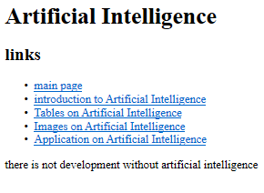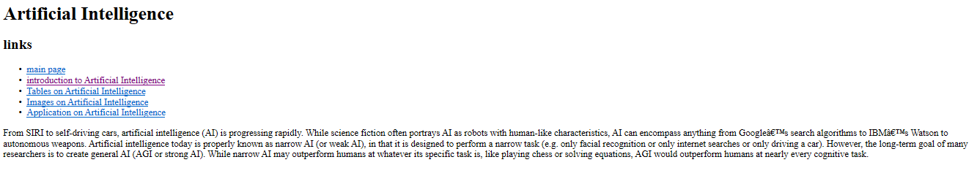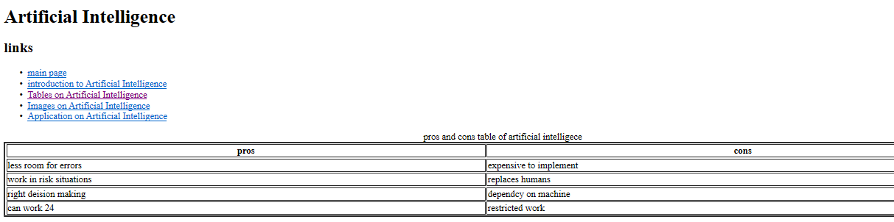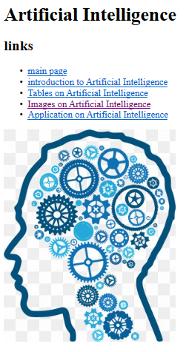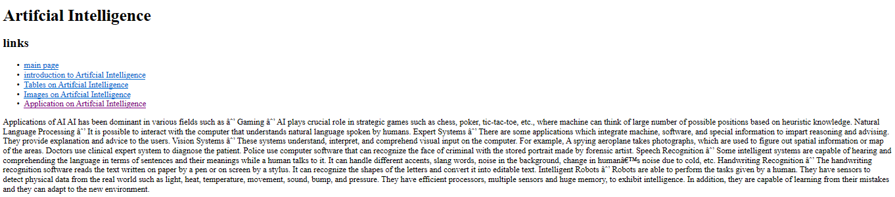

**Source code :**

