PLC STUDY | TELECOM EGYPT
Product Lifecycle Management in Netcracker:
from Idea to Launch-Ready (before CRM integration)
System studied: Netcracker Product Management (Product Catalog + Product Lifecycle Management), part of Netcracker Digital BSS / Digital Commerce & Monetization. Vendor: Netcracker Technology, a wholly owned subsidiary of NEC Corporation.
Prepared by: [Your name] | Version: Draft 1 for review | October 2026
How to read this document. Every statement is tagged with its source: [N] = documented by Netcracker; [S] = defined by the TM Forum TMF620 industry standard, which Netcracker is certified on; [P] = our proposal or an illustrative example, not vendor content. Netcracker's detailed user guides and demos are gated, so screen names in the walkthroughs are illustrative and will differ in a real installation.

1. Scope of this document
This document covers the product journey up to the point where the product is ready to be published to sales channels. It stops before integration with the CRM.
In scope (this document) | Out of scope (later phase)
Ideation / concept (In Study) | Publishing offers to CRM, CPQ and sales channels
Technical product definition | Order capture and order management
Commercial offer definition | Billing / charging activation in production
Pricing | Commercial launch to all customers
Business rules and eligibility | Retirement of old products
Approval gates | Migration of existing customers
Versioning during design
Testing and readiness (In Test, Active)

2. PLC overview
A Product Lifecycle Management (PLC/PLM) system is the single place where an operator turns an idea into a sellable product, governs every change to it, and finally retires it. Its value is that every other system (CRM, ordering, billing, network) reads the same product definition instead of keeping its own copy.

2.1 The industry-standard lifecycle [S]
TM Forum's Product Catalog Management standard (TMF620) defines the statuses every catalog element goes through. Netcracker is certified on TMF620 (TM Forum certification list, June 2024).
Status | Meaning (TMF620) | Gate to enter it | In this document?
In Study | Macro conception of the product has started | Idea registered | Yes
In Design | Conception accepted; product is being designed | Conception approved | Yes
In Test | Design approved; product is being tested | Design approved | Yes
Rejected | Test failed; final status | Test KO | Yes
Active | Validated and tested, but not yet available to customers | Test approved | Yes (end point)
Launched | Start of marketing; customers can buy it | Start of marketing | No (CRM phase)
Retired | No new sales; existing customers keep it | End of marketing | No
Obsolete | No customer holds it; can be removed | No customers left | No

Our scope therefore ends at Active: the product is fully defined, approved and tested, and is waiting to be published to sales channels.

3. Netcracker Product Management: modules used before CRM
Netcracker groups product capabilities under the Product Management domain, with two core components [N]:
- Product Catalog: "a unified holistic view and easy access to up-to-date product information (pricing, discounts, fees, loyalty programs, taxes), supporting sales, ordering and billing processes via industry-standard integration." [N]
- Product Lifecycle Management: "end-to-end lifecycle management from marketing concept development and product configuration to product testing, test launch and subsequent mass production. It also fully supports product versioning, upgrades and retirement." [N]
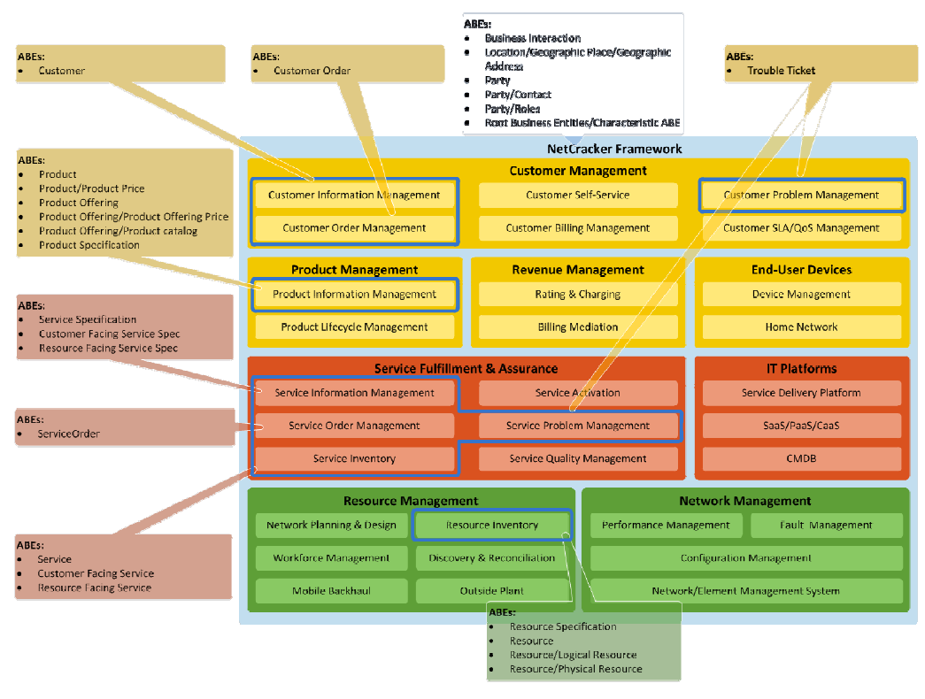
Figure 1. Netcracker module map from TM Forum's certification report. Product Management = Product Information Management (catalog) + Product Lifecycle Management. Source: TM Forum SID certification report, Netcracker TOMS Release 8.2 (2011; historical, shows the module split).

3.1 Module breakdown
Module / capability | What it does before CRM | Source
Product Lifecycle Management | Drives the product through concept, configuration, testing and test launch; manages versions | [N]
Product Offering Catalog (commercial) | Holds offering details, business rules, prices and discounts | [N]
Technical Product Catalog | Holds product/service specifications, provisioning templates and decomposition rules (how an order is split into technical tasks) | [N]
Product templates & reusable components | Pre-defined product definition templates and out-of-the-box components for rapid configuration | [N]
Pricing | Prices, discounts, fees, taxes, loyalty programs | [N]
Business rules | Eligibility by market, distribution channel and customer category; dependencies and constraints | [N]
Catalog federation | Brings third-party partner catalogs into one product management interface | [N]
Analytics | Analyzes product consumption patterns to target offers (input to ideation) | [N]
GenAI assistance | AI-assisted product configuration with reusable templates | [N]

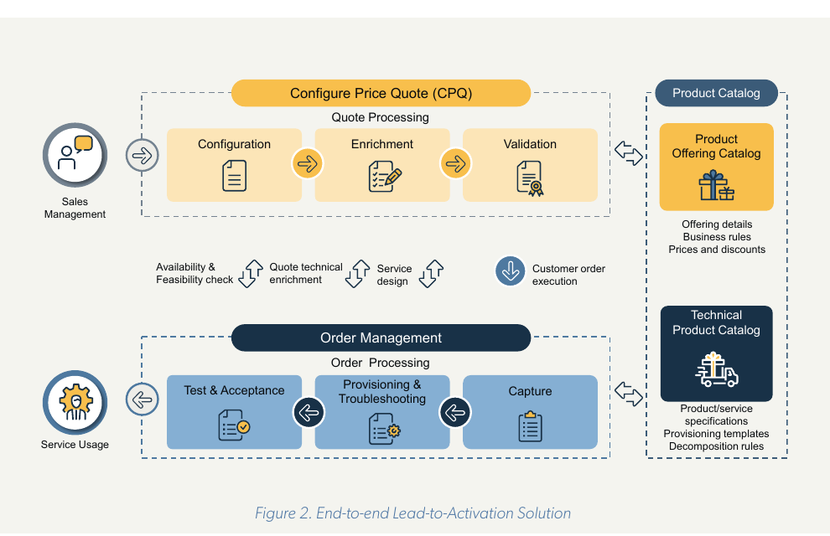
Figure 2. Netcracker's split between the Product Offering Catalog (commercial) and the Technical Product Catalog. The left side (CPQ, Order Management) is the post-CRM phase. Source: Netcracker CPQ whitepaper (2021), Figure 2.

3.2 Core data model [S][N]
Netcracker's product data model was certified by TM Forum against the SID information framework for these entities: Product, Product Price, Product Offering, Product Offering Price, Product Catalog and Product Specification.
Entity | Plain meaning | Example [P]
Product Specification | What the product technically is, with its characteristics | FTTH access, speed = 200 Mbps
Product Offering | What is sold: a single offer or a bundle of offers | "Home Fiber 200" bundle
Product Offering Price | The prices attached to an offering | Monthly fee, installation fee
Product Catalog | A grouping of offerings, e.g. per segment | Residential catalog
Product / Product Price | What a customer actually owns and pays (after sale) | Customer X's subscription

4. Stage-by-stage: how Netcracker applies PLC before CRM
Each stage below lists its purpose, roles, inputs, a walkthrough of what the user does in the system, exit criteria, evidence, and what still needs confirmation. The running example is an illustrative home fiber bundle [P].

4.1 Stage 1: Ideation / marketing concept
Item | Detail
Lifecycle status | In Study [S]
Purpose | Capture a product idea, check its business value, and decide whether it is worth designing.
Who (proposed roles) [P] | Marketing (owner), Product Manager, Finance (business case)
Inputs | Market need, competitor offers, consumption analytics, target segment
Exit criteria / output | Concept approved, so the status moves to In Design; or the concept is dropped.

What you do in the system (walkthrough)
1. Product Manager opens Product Lifecycle Management and registers a new product concept ("Fiber 200 + landline bundle for residential").
2. Attaches the business case: target segment, expected uptake, revenue goal.
3. Reviews product consumption analytics (e.g. heavy-usage ADSL customers) to size the opportunity.
4. Checks the existing catalog for similar products that can be reused instead of creating a new one.
5. Submits the concept for the conception approval gate.

Evidence
- Netcracker PLM starts at "marketing concept development" [N].
- Netcracker analyzes "product consumption patterns to enable better product targeting" [N].
- TMF620: first status is In Study; "conception approved" moves it to In Design [S].

Not publicly documented (confirm in a vendor demo)
- Idea scoring / business-case screens and who signs the conception approval.

4.2 Stage 2: Technical product definition
Item | Detail
Lifecycle status | In Design [S]
Purpose | Define what the product is technically, so the network can deliver it automatically later.
Who (proposed roles) [P] | Product Specialist / network & IT (owner), Product Manager (consulted)
Inputs | Approved concept, network capabilities, existing service specifications
Exit criteria / output | Product specification complete and linked to service and provisioning definitions.

What you do in the system (walkthrough)
1. Product Specialist opens the Technical Product Catalog.
2. Selects an existing Product Specification (or a template) such as "FTTH Access" and sets its characteristics (speed 200 Mbps, technology FTTH).
3. Links the service specification and the provisioning template that will activate the service.
4. Defines decomposition rules: which technical tasks an order for this product creates (e.g. activate port, configure ONT, activate voice line).
5. Saves; the specification is now available for commercial offers.

Evidence
- Technical Product Catalog holds "product/service specifications, provisioning templates, decomposition rules" [N] (Figure 2).
- Product Specification is a TM Forum-certified entity in Netcracker's data model [S][N].
- Template-based configuration "using out-of-the-box product components" [N].

4.3 Stage 3: Commercial offer definition
Item | Detail
Lifecycle status | In Design [S]
Purpose | Package the technical product into something marketing can sell.
Who (proposed roles) [P] | Product Manager / Marketing (owner)
Inputs | Product specifications from Stage 2, concept from Stage 1
Exit criteria / output | Offering structure (single offer or bundle) complete and linked to its specifications.

What you do in the system (walkthrough)
1. Product Manager opens the Product Offering Catalog and creates a new Product Offering from a template.
2. Links it to the "FTTH Access 200" product specification.
3. Builds a bundle: internet 200 Mbps + landline + Wi-Fi router.
4. Adds partner content if needed (e.g. a streaming add-on) through catalog federation.
5. Places the offering in the Residential product catalog / category.

Evidence
- Product Offering Catalog holds "offering details, business rules, prices and discounts" [N].
- "Centralizing the management of products and bundles" [N].
- Federation integrates "third-party partner catalogs into a single product management interface" [N].

4.4 Stage 4: Pricing
Item | Detail
Lifecycle status | In Design [S]
Purpose | Attach all prices and price-related terms to the offering.
Who (proposed roles) [P] | Product Manager (owner), Finance / Pricing (approver)
Inputs | Offering from Stage 3, pricing strategy, tax rules
Exit criteria / output | Complete price set attached to the offering.

What you do in the system (walkthrough)
1. Product Manager opens the offering's pricing section.
2. Adds a recurring monthly fee and a one-time installation fee.
3. Adds a discount (e.g. a launch discount for the first 3 months) and any fees.
4. Applies the correct taxes and, if relevant, loyalty points.
5. Sets different prices per market or customer category if needed.

Evidence
- Catalog covers "pricing, discounts, fees, loyalty programs, taxes" [N].
- Pricing "based on market, customer category, distribution channel" (CPQ whitepaper) [N].
- Product Offering Price is a TM Forum-certified entity [S][N].

Not publicly documented (confirm in a vendor demo)
- The pricing screens themselves and whether price changes need a separate approval.

4.5 Stage 5: Business rules and eligibility
Item | Detail
Lifecycle status | In Design [S]
Purpose | Control who can buy the offer, where, through which channel, and with what.
Who (proposed roles) [P] | Product Manager (owner), Product Specialist (consulted)
Inputs | Offering and prices; coverage areas; channel strategy
Exit criteria / output | Rules defined, so the downstream sales tools will only offer the product to eligible customers.

What you do in the system (walkthrough)
1. Product Manager opens the offering's rules.
2. Sets eligibility: market = fiber-covered areas, distribution channel = shops / call center / app, customer category = residential.
3. Adds dependencies: the bundle requires a compatible router.
4. Adds constraints: cannot be combined with ADSL on the same line.

Evidence
- Validation against "business rules, such as eligibility rules, configured in the Product catalog" to check availability "for the market, distribution channel and customer category" [N].
- Rules cover "product specifications, dependencies, constraints and business rules" [N].
- Figure 3 shows these eligibility fields on a real Netcracker screen.
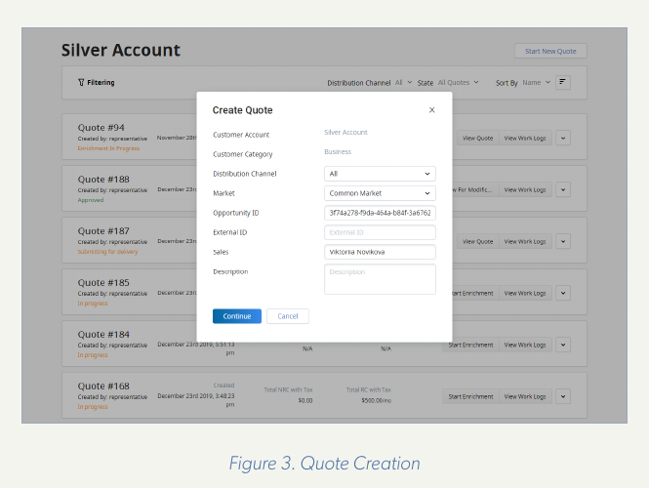
Figure 3. Real Netcracker screen (Create Quote). The fields Customer Category, Distribution Channel and Market are the same eligibility dimensions defined in the catalog. Source: Netcracker CPQ whitepaper (2021), Figure 3.

4.6 Stage 6: Approval gates
Item | Detail
Lifecycle status | In Design to In Test [S]
Purpose | Formally approve the design before testing starts.
Who (proposed roles) [P] | Product Manager (submits); Marketing head, Finance, Legal / Regulatory (NTRA if required), IT/Network (approvers) [P]
Inputs | Complete design from Stages 2 to 5
Exit criteria / output | Design approved and status In Test.

What you do in the system (walkthrough)
1. Product Manager submits the offering for design approval.
2. Approvers review: commercial fit (Marketing), prices and margin (Finance), terms and regulation (Legal), technical feasibility (IT/Network).
3. Each approver approves or rejects with comments.
4. When approved, the status changes to In Test; if rejected, the product stays In Design for rework.

Evidence
- TMF620 defines the gates: "conception approved" to In Design and "design approved" to In Test [S].
- Netcracker's sales tools use approval statuses ("Approved" visible in Figure 3) and "streamline approval workflows" [N].
- PLM provides "automating end-to-end lifecycle management" [N].

Not publicly documented (confirm in a vendor demo)
- The product-approval workflow screens, approver configuration, and sequential vs parallel approval.

4.7 Stage 7: Versioning during design and change
Item | Detail
Lifecycle status | Any status [S]
Purpose | Keep a controlled history of every change to the product.
Who (proposed roles) [P] | Product Manager, Catalog Administrator [P]
Inputs | An existing product or offering that needs to change
Exit criteria / output | New version approved and tested; old version kept in history.

What you do in the system (walkthrough)
1. Instead of editing a tested or approved product directly, the user creates a new version.
2. The new version goes back through design, approval and test.
3. Previous versions remain visible for comparison and audit.

Evidence
- PLM "fully supports product versioning, upgrades" [N].
- TMF620 catalog entities carry a version and a lifecycle status [S].

Not publicly documented (confirm in a vendor demo)
- Version comparison screens and whether parallel versions are allowed.

4.8 Stage 8: Testing and readiness
Item | Detail
Lifecycle status | In Test to Active (or Rejected) [S]
Purpose | Prove the product works end to end before any customer can buy it.
Who (proposed roles) [P] | QA / Test team (owner), IT, Product Manager
Inputs | Approved design
Exit criteria / output | Status Active: validated and tested, ready to be published to CRM and channels. This is the hand-off point where this document ends.

What you do in the system (walkthrough)
1. The approved product is deployed to a test environment.
2. Test team runs test orders to check that pricing, rules, provisioning templates and decomposition rules work.
3. If tests pass, the product moves to Active, ready for a test launch.
4. If tests fail, the product is Rejected (final), or reworked as a new version.
5. Optional test launch to a limited pilot group before mass production.

Evidence
- PLM covers "product testing, test launch and subsequent mass production" [N].
- TMF620: test OK gives Active; test KO gives Rejected, a final status [S].

5. Summary: the journey on one page
# | Stage | Status | Netcracker module | Owner [P] | Output
1 | Ideation | In Study | PLM + analytics | Marketing / PM | Approved concept
2 | Technical definition | In Design | Technical Product Catalog | Product Specialist | Product specification
3 | Commercial definition | In Design | Product Offering Catalog | Product Manager | Offering / bundle
4 | Pricing | In Design | Catalog pricing | PM + Finance | Price set
5 | Rules & eligibility | In Design | Business rules | Product Manager | Eligibility rules
6 | Approval | In Design to In Test | PLM | Approvers | Approved design
7 | Versioning | Any | PLM | PM / Admin | Version history
8 | Testing & readiness | In Test to Active | PLM | QA / IT | Launch-ready product

6. Evidence that this works at real operators
Operator | What was deployed | Published result | Source type
Zain KSA (Saudi Arabia) | Full BSS/OSS including Product Catalog | 50% decrease in product development time; done in under 3 years | Netcracker case study with operator quotes
T-Mobile Netherlands | Product Catalog + Product Lifecycle Management specifically | Manage products "from development to production to retirement"; fewer incorrect offers | Netcracker press release with operator quote
e& UAE | Full BSS including product catalog management | "Groundwork for catalog-driven offers" | Netcracker press release with operator quote
Telecom Egypt | Netcracker BSS/OSS (2013, live 2014) | None published | Third-party database only; unconfirmed

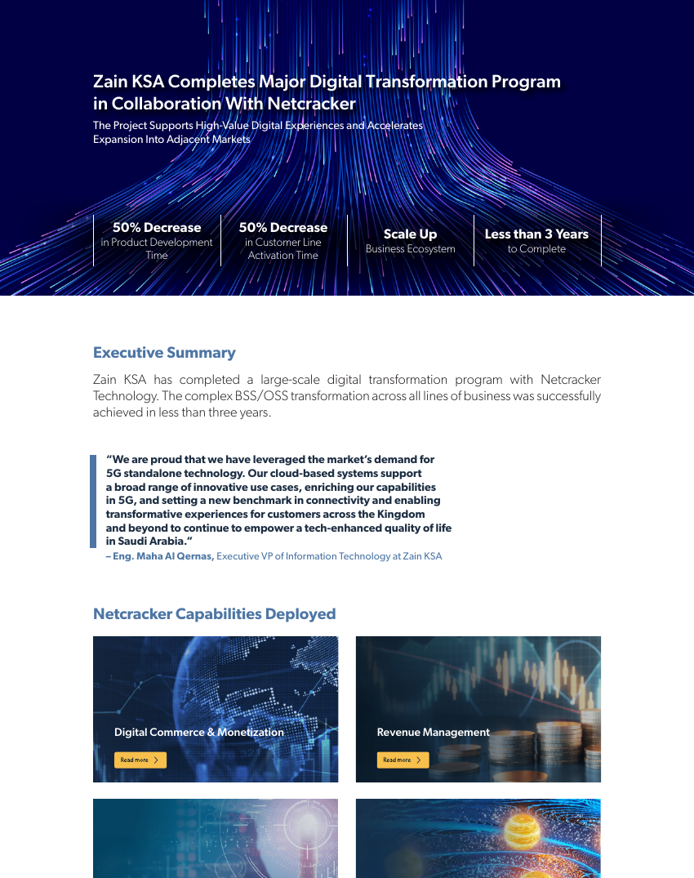
Figure 4. Zain KSA case study: 50% decrease in product development time. Source: Netcracker.

7. Open questions for a Netcracker demo or our IT team
- Does Telecom Egypt still run Netcracker BSS/OSS (2013 contract), and does it include Product Catalog / PLM?
- How are ideas captured and scored before In Study? Is there a business-case approval screen?
- How is the product-approval workflow configured: approvers per stage, sequential or parallel, delegation?
- What roles and permissions exist for catalog users (view, create, edit, approve, publish)?
- Can we add our own lifecycle statuses (e.g. a regulatory approval step)?
- How are versions compared, and can two versions be in design at the same time?
- Which test environments are supported, and how does a product move from test to production?

8. References
1. Netcracker, Product Management (Product Catalog + PLM): https://www.netcracker.com/portfolio/products/digital-bss/product-management
2. Netcracker, Commerce Management: https://netcracker.com/portfolio/products/digital-commerce-monetization/commerce-management
3. Netcracker, Configure-Price-Quote whitepaper (2021), Figures 2 and 3: https://www.netcracker.com/assets/portfolio/solutions/intelligent-sales-automation/netcracker_cpq-whitepaper.pdf
4. Netcracker, Zain KSA case study: https://netcracker.com/documents/pdf/netcracker_zain_case-study_260918.pdf
5. Netcracker, T-Mobile Netherlands press release: https://www.netcracker.com/news/press-releases/t-mobile-netherlands-optimizes-end-to-end-product-management-with-netcracker-bss/
6. Netcracker, e& UAE partnership (Oct 2023): https://netcracker.com/news/press-releases/etisalat-by-e-and-partners-with-netcracker-on-the-largest-full-stack-bss-transformation-project-in-the-middle-east
7. TM Forum, Netcracker SID certification report (Figure 1): https://www.tmforum.org/wp-content/uploads/2015/03/Netcrakcer-Conformance-Cert-NetCracker-TOMS-Suite-Release-8.2-SID-Report.pdf
8. TM Forum, Open API conformance list (Netcracker certified TMF620, June 2024): https://www.tmforum.org/conformance-certification/open-api-conformance/
9. TM Forum, TMF620 Product Catalog Management API (lifecycle statuses): https://www.tmforum.org/open-digital-architecture/open-apis/product-catalog-management-api-TMF620/v5.0
10. AppsRunTheWorld, Telecom Egypt record (unconfirmed): https://www.appsruntheworld.com/customers-database/customers/view/telecom-egypt-egypt

