Invoices & Credit Notes Report
Run months covered: Sep 2025 to Sep 2026 (13 monthly runs). All months are ordered from the latest to the earliest.
Each run covers the billing cycle from the 2nd of the previous month up to the 1st of the run month (e.g. the Sep 2026 run covers 02 Aug 2026 – 01 Sep 2026).

Executive summary
- Overall: 93,594 invoices and 13,308 credit notes were issued across the 13 runs, i.e. 14.2 credit notes for every 100 invoices.
- Peak / low: Nov 2025 had the highest credit-note rate (24.3% of invoices); Apr 2026 had the lowest (5.5%).
- Order types: Over the last 12 months, “New” orders account for 66.9% of credit notes, followed by “Price Change” (10.6%) and “Service Transfer” (10.3%). Together the top 3 are 87.8%.
- Pattern: Invoices spike to ~10.4k–10.8k every third month (Jul 2026, Apr 2026, Jan 2026, Oct 2025), while the other months sit at ~5.4k–6.3k. Credit notes do not follow the same quarterly pattern.

Report 1 – Invoice count vs credit note count by month
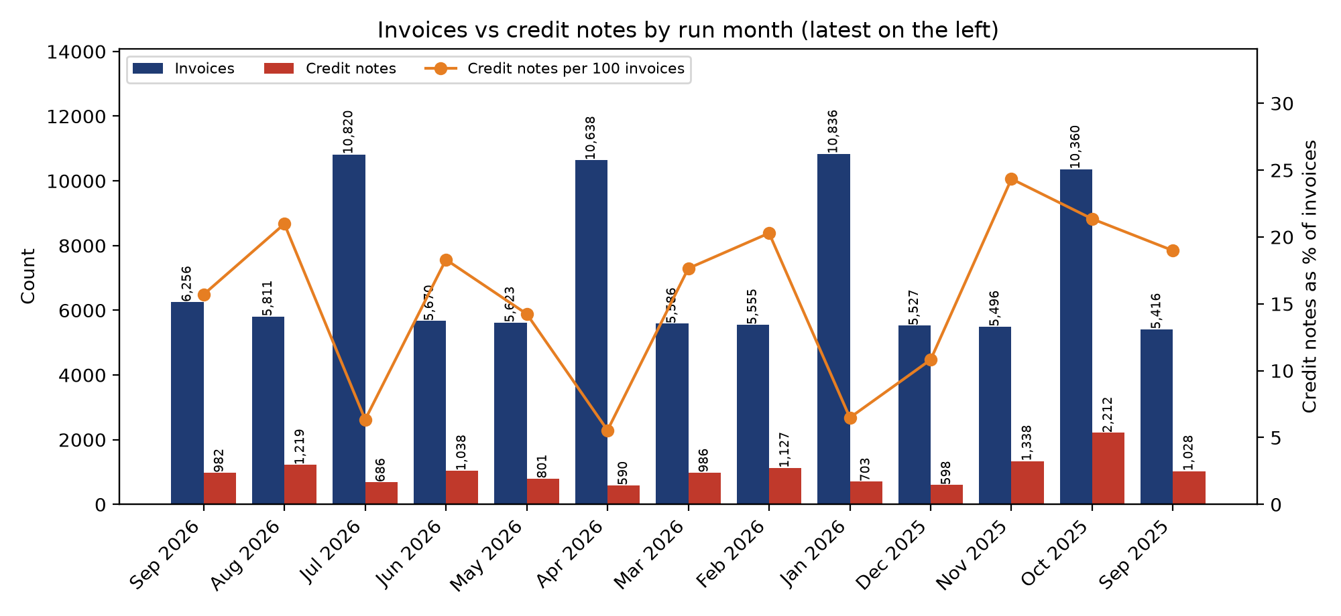
Month | Invoices | Credit notes | Credit notes / invoices | Invoices MoM | Credit notes MoM
Sep 2026 | 6,256 | 982 | 15.7% | +7.7% | -19.4%
Aug 2026 | 5,811 | 1,219 | 21.0% | -46.3% | +77.7%
Jul 2026 | 10,820 | 686 | 6.3% | +90.8% | -33.9%
Jun 2026 | 5,670 | 1,038 | 18.3% | +0.8% | +29.6%
May 2026 | 5,623 | 801 | 14.2% | -47.1% | +35.8%
Apr 2026 | 10,638 | 590 | 5.5% | +90.4% | -40.2%
Mar 2026 | 5,586 | 986 | 17.7% | +0.6% | -12.5%
Feb 2026 | 5,555 | 1,127 | 20.3% | -48.7% | +60.3%
Jan 2026 | 10,836 | 703 | 6.5% | +96.1% | +17.6%
Dec 2025 | 5,527 | 598 | 10.8% | +0.6% | -55.3%
Nov 2025 | 5,496 | 1,338 | 24.3% | -46.9% | -39.5%
Oct 2025 | 10,360 | 2,212 | 21.4% | +91.3% | +115.2%
Sep 2025 | 5,416 | 1,028 | 19.0% | – | –
Total | 93,594 | 13,308 | 14.2%
MoM = change versus the previous (earlier) month.

Brief on each number
- Sep 2026: 6,256 invoices and 982 credit notes, 15.7 credit notes per 100 invoices. Compared with Aug 2026, invoices moved +7.7% and credit notes -19.4%. Credit notes are close to the 1,024 monthly average.
- Aug 2026: 5,811 invoices and 1,219 credit notes, 21.0 credit notes per 100 invoices. Compared with Jul 2026, invoices moved -46.3% and credit notes +77.7%. Credit notes are close to the 1,024 monthly average.
- Jul 2026: 10,820 invoices and 686 credit notes, 6.3 credit notes per 100 invoices. Compared with Jun 2026, invoices moved +90.8% and credit notes -33.9%. Credit notes are well below the 1,024 monthly average.
- Jun 2026: 5,670 invoices and 1,038 credit notes, 18.3 credit notes per 100 invoices. Compared with May 2026, invoices moved +0.8% and credit notes +29.6%. Credit notes are close to the 1,024 monthly average.
- May 2026: 5,623 invoices and 801 credit notes, 14.2 credit notes per 100 invoices. Compared with Apr 2026, invoices moved -47.1% and credit notes +35.8%. Credit notes are close to the 1,024 monthly average.
- Apr 2026: 10,638 invoices and 590 credit notes, 5.5 credit notes per 100 invoices. Compared with Mar 2026, invoices moved +90.4% and credit notes -40.2%. Credit notes are well below the 1,024 monthly average.
- Mar 2026: 5,586 invoices and 986 credit notes, 17.7 credit notes per 100 invoices. Compared with Feb 2026, invoices moved +0.6% and credit notes -12.5%. Credit notes are close to the 1,024 monthly average.
- Feb 2026: 5,555 invoices and 1,127 credit notes, 20.3 credit notes per 100 invoices. Compared with Jan 2026, invoices moved -48.7% and credit notes +60.3%. Credit notes are close to the 1,024 monthly average.
- Jan 2026: 10,836 invoices and 703 credit notes, 6.5 credit notes per 100 invoices. Compared with Dec 2025, invoices moved +96.1% and credit notes +17.6%. Credit notes are well below the 1,024 monthly average.
- Dec 2025: 5,527 invoices and 598 credit notes, 10.8 credit notes per 100 invoices. Compared with Nov 2025, invoices moved +0.6% and credit notes -55.3%. Credit notes are well below the 1,024 monthly average.
- Nov 2025: 5,496 invoices and 1,338 credit notes, 24.3 credit notes per 100 invoices. Compared with Oct 2025, invoices moved -46.9% and credit notes -39.5%. Credit notes are well above the 1,024 monthly average.
- Oct 2025: 10,360 invoices and 2,212 credit notes, 21.4 credit notes per 100 invoices. Compared with Sep 2025, invoices moved +91.3% and credit notes +115.2%. Credit notes are well above the 1,024 monthly average.
- Sep 2025: 5,416 invoices and 1,028 credit notes, 19.0 credit notes per 100 invoices. This is the earliest run in the data, so it has no previous month to compare with. Credit notes are close to the 1,024 monthly average.
- Total: 93,594 invoices (avg 7,200/month) and 13,308 credit notes (avg 1,024/month) over 13 months, an overall rate of 14.2%.

Report 2 – Percentage of credit notes per order type, by run month
Each row shows how that month's credit notes split across order types (every row adds up to 100%). Only percentages are shown. Order types that were zero in every month are left out.
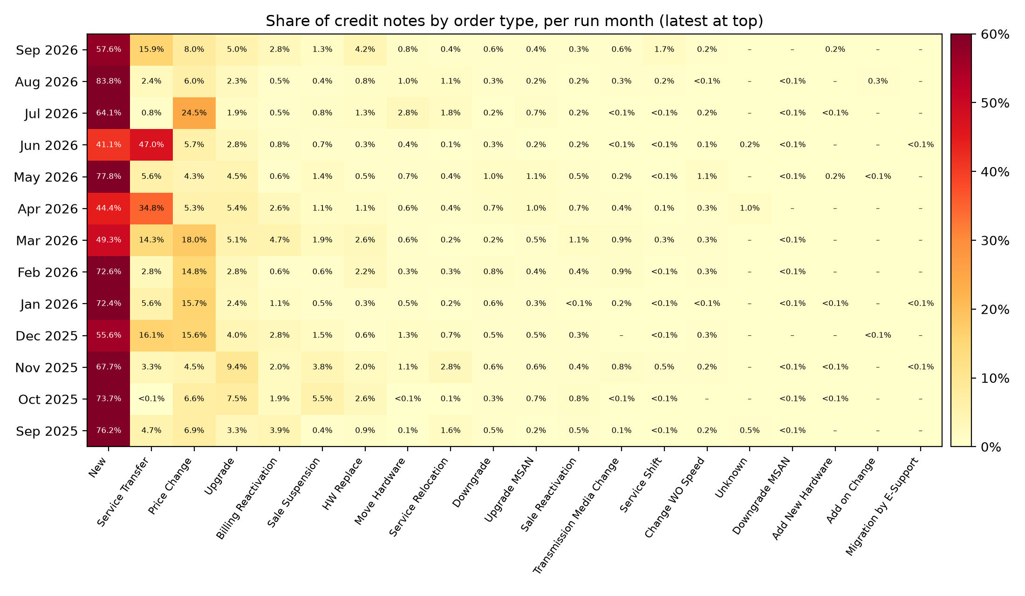
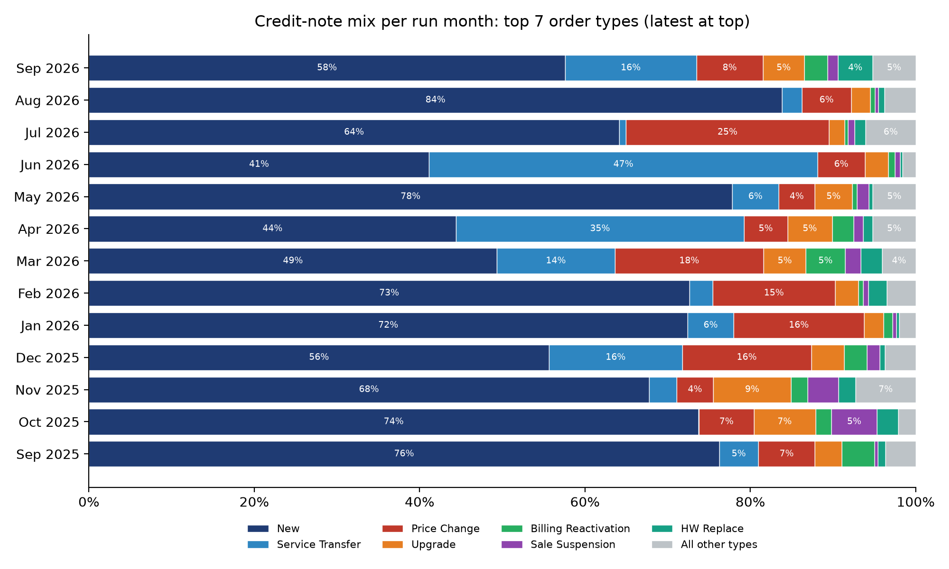

Brief on each month
- Sep 2026: New 57.6%; Service Transfer 15.9%; Price Change 8.0%. The top 3 make up 81.5%. Other order types above 1%: Upgrade 5.0%, HW Replace 4.2%, Billing Reactivation 2.8%, Service Shift 1.7%, Sale Suspension 1.3%. 8 more order types each under 1% (together 3.6%).
- Aug 2026: New 83.8%; Price Change 6.0%; Service Transfer 2.4%. The top 3 make up 92.2%. Other order types above 1%: Upgrade 2.3%, Service Relocation 1.1%. 12 more order types each under 1% (together 4.3%).
- Jul 2026: New 64.1%; Price Change 24.5%; Move Hardware 2.8%. The top 3 make up 91.4%. Other order types above 1%: Upgrade 1.9%, Service Relocation 1.8%, HW Replace 1.3%. 11 more order types each under 1% (together 3.5%).
- Jun 2026: Service Transfer 47.0%; New 41.1%; Price Change 5.7%. The top 3 make up 93.8%. Other order types above 1%: Upgrade 2.8%. 14 more order types each under 1% (together 3.3%).
- May 2026: New 77.8%; Service Transfer 5.6%; Upgrade 4.5%. The top 3 make up 88.0%. Other order types above 1%: Price Change 4.3%, Sale Suspension 1.4%, Change WO Speed 1.1%, Upgrade MSAN 1.1%. 11 more order types each under 1% (together 4.1%).
- Apr 2026: New 44.4%; Service Transfer 34.8%; Upgrade 5.4%. The top 3 make up 84.6%. Other order types above 1%: Price Change 5.3%, Billing Reactivation 2.6%, Sale Suspension 1.1%, HW Replace 1.1%, Unknown 1.0%. 8 more order types each under 1% (together 4.2%).
- Mar 2026: New 49.3%; Price Change 18.0%; Service Transfer 14.3%. The top 3 make up 81.6%. Other order types above 1%: Upgrade 5.1%, Billing Reactivation 4.7%, HW Replace 2.6%, Sale Suspension 1.9%, Sale Reactivation 1.1%. 8 more order types each under 1% (together 3.0%).
- Feb 2026: New 72.6%; Price Change 14.8%; Service Transfer 2.8%. The top 3 make up 90.2%. Other order types above 1%: Upgrade 2.8%, HW Replace 2.2%. 11 more order types each under 1% (together 4.7%).
- Jan 2026: New 72.4%; Price Change 15.7%; Service Transfer 5.6%. The top 3 make up 93.7%. Other order types above 1%: Upgrade 2.4%, Billing Reactivation 1.1%. 13 more order types each under 1% (together 2.8%).
- Dec 2025: New 55.6%; Service Transfer 16.1%; Price Change 15.6%. The top 3 make up 87.4%. Other order types above 1%: Upgrade 4.0%, Billing Reactivation 2.8%, Sale Suspension 1.5%, Move Hardware 1.3%. 8 more order types each under 1% (together 3.0%).
- Nov 2025: New 67.7%; Upgrade 9.4%; Price Change 4.5%. The top 3 make up 81.6%. Other order types above 1%: Sale Suspension 3.8%, Service Transfer 3.3%, Service Relocation 2.8%, HW Replace 2.0%, Billing Reactivation 2.0%, Move Hardware 1.1%. 9 more order types each under 1% (together 3.4%).
- Oct 2025: New 73.7%; Upgrade 7.5%; Price Change 6.6%. The top 3 make up 87.8%. Other order types above 1%: Sale Suspension 5.5%, HW Replace 2.6%, Billing Reactivation 1.9%. 10 more order types each under 1% (together 2.2%).
- Sep 2025: New 76.2%; Price Change 6.9%; Service Transfer 4.7%. The top 3 make up 87.8%. Other order types above 1%: Billing Reactivation 3.9%, Upgrade 3.3%, Service Relocation 1.6%. 11 more order types each under 1% (together 3.4%).

Notable month-to-month shifts
- New: ranges from 41.1% (Jun 2026) to 83.8% (Aug 2026); its average monthly share is 64.3%.
- Service Transfer: ranges from 0.1% (Oct 2025) to 47.0% (Jun 2026); its average monthly share is 11.8%.
- Price Change: ranges from 4.3% (May 2026) to 24.5% (Jul 2026); its average monthly share is 10.5%.
- Sale Suspension: ranges from 0.4% (Aug 2026) to 5.5% (Oct 2025); its average monthly share is 1.5%.
- HW Replace: ranges from 0.3% (Jun 2026) to 4.2% (Sep 2026); its average monthly share is 1.5%.

Report 3 – Percentage of credit notes per order type, last year (Oct 2025 – Sep 2026)
“Last year” means the most recent 12 run months. All credit notes in that window are pooled and split by order type. Only percentages are shown.
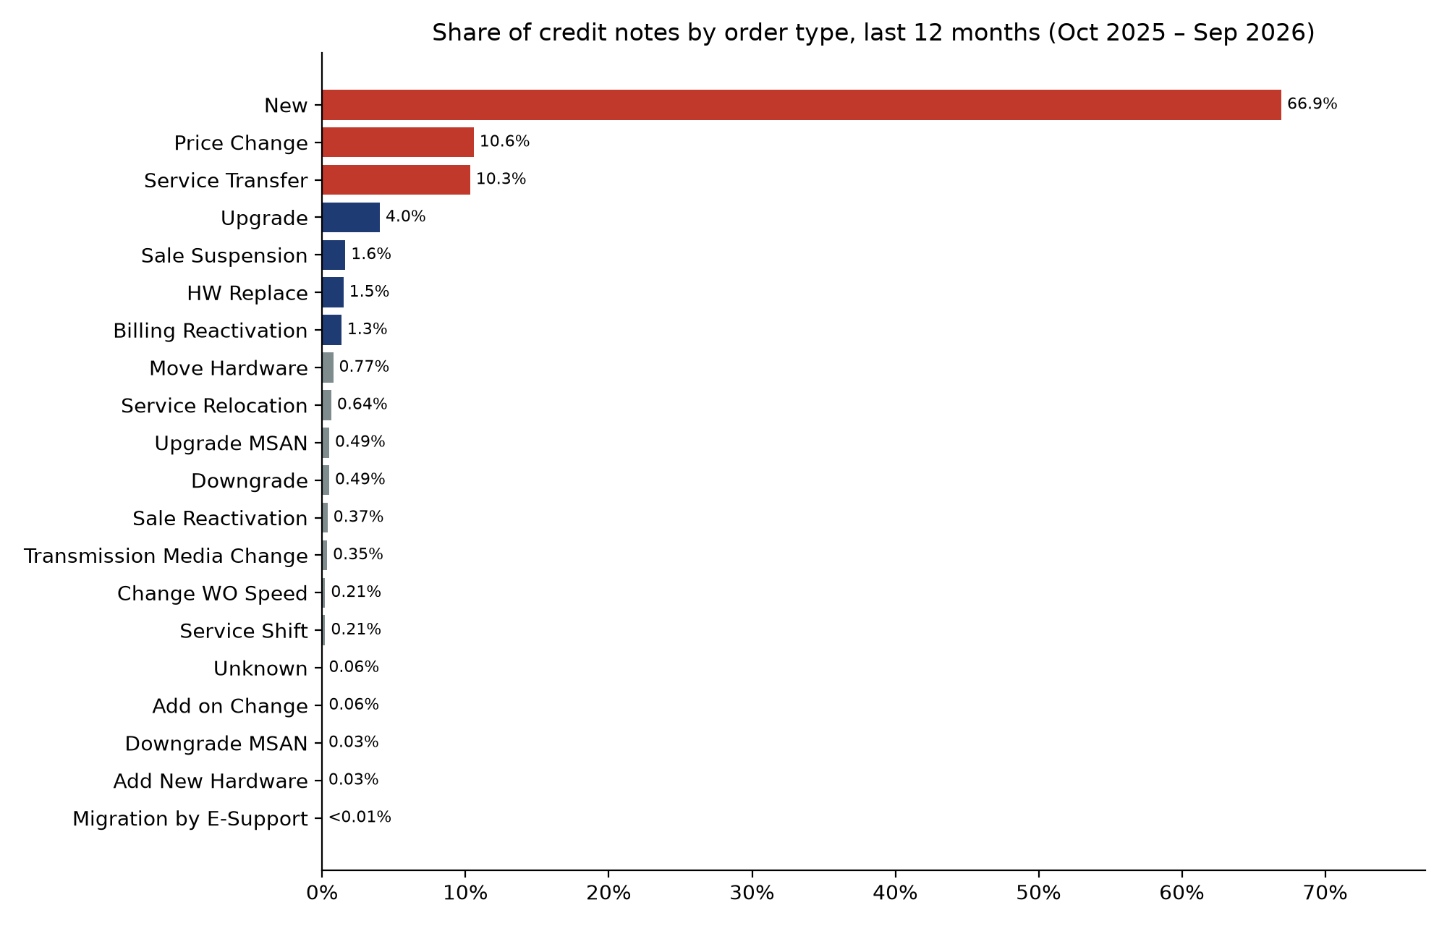
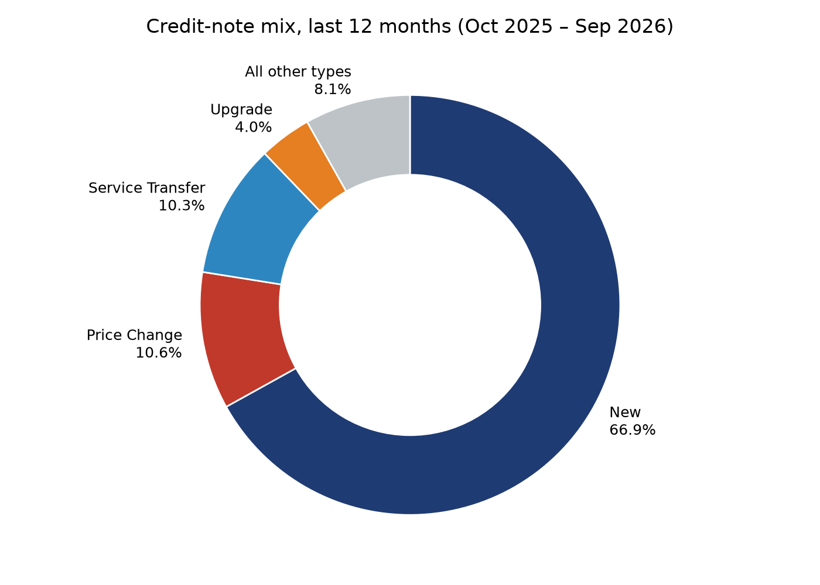

Brief on each order type
- New: 66.9% of last year's credit notes (running total 66.9%). Appeared in 12 of 12 months; its highest monthly share was 83.8% in Aug 2026.
- Price Change: 10.6% of last year's credit notes (running total 77.5%). Appeared in 12 of 12 months; its highest monthly share was 24.5% in Jul 2026.
- Service Transfer: 10.3% of last year's credit notes (running total 87.8%). Appeared in 12 of 12 months; its highest monthly share was 47.0% in Jun 2026.
- Upgrade: 4.0% of last year's credit notes (running total 91.9%). Appeared in 12 of 12 months; its highest monthly share was 9.4% in Nov 2025.
- Sale Suspension: 1.6% of last year's credit notes (running total 93.5%). Appeared in 12 of 12 months; its highest monthly share was 5.5% in Oct 2025.
- HW Replace: 1.5% of last year's credit notes (running total 95.0%). Appeared in 12 of 12 months; its highest monthly share was 4.2% in Sep 2026.
- Billing Reactivation: 1.3% of last year's credit notes (running total 96.3%). Appeared in 12 of 12 months; its highest monthly share was 4.7% in Mar 2026.
- Move Hardware: 0.77% of last year's credit notes (running total 97.1%). Appeared in 12 of 12 months; its highest monthly share was 2.8% in Jul 2026.
- Service Relocation: 0.64% of last year's credit notes (running total 97.7%). Appeared in 12 of 12 months; its highest monthly share was 2.8% in Nov 2025.
- Upgrade MSAN: 0.49% of last year's credit notes (running total 98.2%). Appeared in 12 of 12 months; its highest monthly share was 1.1% in May 2026.
- Downgrade: 0.49% of last year's credit notes (running total 98.7%). Appeared in 12 of 12 months; its highest monthly share was 1.0% in May 2026.
- Sale Reactivation: 0.37% of last year's credit notes (running total 99.1%). Appeared in 12 of 12 months; its highest monthly share was 1.1% in Mar 2026.
- Transmission Media Change: 0.35% of last year's credit notes (running total 99.4%). Appeared in 11 of 12 months; its highest monthly share was 0.9% in Feb 2026.
- Change WO Speed: 0.21% of last year's credit notes (running total 99.6%). Appeared in 11 of 12 months; its highest monthly share was 1.1% in May 2026.
- Service Shift: 0.21% of last year's credit notes (running total 99.8%). Appeared in 12 of 12 months; its highest monthly share was 1.7% in Sep 2026.
- Unknown: 0.06% of last year's credit notes (running total 99.9%). Appeared in 2 of 12 months; its highest monthly share was 1.0% in Apr 2026.
- Add on Change: 0.06% of last year's credit notes (running total 99.9%). Appeared in 3 of 12 months; its highest monthly share was 0.3% in Aug 2026.
- Downgrade MSAN: 0.03% of last year's credit notes (running total 100.0%). Appeared in 9 of 12 months; its highest monthly share was 0.1% in May 2026.
- Add New Hardware: 0.03% of last year's credit notes (running total 100.0%). Appeared in 6 of 12 months; its highest monthly share was 0.2% in Sep 2026.
- Migration by E-Support: 0.00% of last year's credit notes (running total 100.0%). Appeared in 3 of 12 months; its highest monthly share was 0.1% in Nov 2025.

Data notes
- Report 1 uses INVOICES and CREDIT_NOTES from ebu_query_57ad.csv.
- Reports 2 and 3 use the order-type breakdown from the screenshot (credit-note lines per order type). Percentages use each month's order-type total as 100%. This breakdown counts credit-note lines (CREDIT_NOTES_COUNT), which is a different measure from the CSV credit-note count used in Report 1.
- Always-zero order types are not charted: Add New Add on, Billing Suspension, Cancelation, Change Service Parameters, ESales/E-Sales Reactivation, Suspension and Termination, Hardware Change, Hardware Termination, Schedule Auto Termination, Service Change, Termination.
- The screenshot is low resolution. In these months the order types do not add up exactly to the reported CREDIT_NOTES_COUNT: Sep 2026 (6,564 reported vs 4,554 summed), Jul 2026 (7,274 reported vs 7,272 summed), May 2026 (5,494 reported vs 5,496 summed), Mar 2026 (3,601 reported vs 3,401 summed), Oct 2025 (11,795 reported vs 11,815 summed). The Sep 2026 and Mar 2026 totals are most likely 4,564 and 3,401 (a 4 read as a 6). If so, the Sep 2026 gap is 10 lines and the Mar 2026 gap disappears. The remaining gaps of 2 to 20 lines move any share by less than 0.3 percentage points.

