PLC STUDY | WE DATA
Product Lifecycle Management in Amdocs CatalogONE:
from Idea to CRM
System studied: Amdocs CatalogONE, a standalone telecom product catalog and Product Lifecycle Management (PLM) platform. It is BSS-agnostic: it owns the catalog, not the CRM. Amdocs documents that CatalogONE publishes to consuming applications and to "the customer's CRM". The Amdocs–Microsoft Customer Engagement Platform is the product that puts an Amdocs Catalog next to Dynamics 365. Amdocs does not publish a CatalogONE-branded connector named Dynamics 365.
Prepared by: [Your name] | Version: Draft 3 for review | October 2026
How to read this document. Every statement is tagged: [A] = Amdocs public datasheets, whitepapers or the Amdocs–Microsoft Customer Engagement Platform; [P] = Appledore Research solution profile of CatalogONE (2020); [T] = TM Forum case study or Open API conformance list; [S] = TM Forum TMF620 and related Open APIs; [M] = Microsoft documentation; [I] = IDC customer case study on PLDT Unified Case Management (hosted by Amdocs, June 2026); [E] = illustrative example. CatalogONE user guides are not public, so screen names in the walkthroughs are illustrative and will differ in a real installation.

Key takeaways
- Catalog only, not a CRM. CatalogONE is a product catalog and PLM. It is not a CRM. It publishes approved catalog data to consuming applications; Amdocs names "the customer's CRM" as one of those consumers [A].
- One source of truth. Commercial, charging and network-service definitions live in one catalog. Downstream systems consume it instead of keeping their own copies [A][P].
- A governed journey. PLM covers ideation through creation, implementation and end-of-life, with workflow, approvals, simulations, parallel work and versioned change [A]. Statuses follow the TM Forum catalog model [S].
- Business users configure, not IT. A role-based UI, templates and building blocks let product managers create offerings, prices, channels and segments with no code and no deployment overhead [A].
- Publish, do not re-key. CatalogONE Centralized authors once and publishes catalog information to consuming applications. Distribution uses a Kafka bus and TMF APIs, in minutes rather than weeks [A][P]. Dynamics 365 is not named on the CatalogONE datasheet; it is named on the Amdocs–Microsoft CEP [A].
- Proven results. A European quad-play operator moved new-offer time from up to nine months to 1–2 weeks. Sprint / T-Mobile expected a 50% time-to-market cut with CatalogONE. KT launched CatalogONE to accelerate 5G offers [P][T][A].

1. PLC and the TM Forum standard in brief
A Product Lifecycle Management (PLC) system is where an operator turns an idea into a sellable product, controls every change to it, and publishes it to the systems that sell, deliver and bill it.
TM Forum defines this lifecycle in the Product Catalog Management API (TMF620). Each catalog item carries one of these statuses [S]:
Status | Meaning | Gate to enter it
In Study | The idea is being studied | Idea registered
In Design | The product is being designed | Conception approved
In Test | The product is being tested | Design approved
Rejected | Test failed (final status) | Test KO
Active | Ready, but not yet sold | Test approved
Launched | Available to customers through sales channels | Start of marketing
Retired / Obsolete | No new sales / no customers left | End of marketing

CatalogONE is built on the TM Forum data model and exposes TMF Open APIs. Amdocs is listed on the TM Forum Open API conformance register for TMF620 (Product Catalog Management) and related commerce APIs. CatalogONE PLM is described as covering ideation through end-of-life, so the stages below follow the industry model rather than a vendor-only one [A][T][S]. This document covers everything up to Launched: the stages before CRM, how CatalogONE publishes to consuming systems, and how that relates to Dynamics 365 in the Amdocs–Microsoft platform.

2. CatalogONE at a glance
CatalogONE is Amdocs' cloud-native catalog. It is designed as a stand-alone application that can sit on top of existing catalogs and BSS systems, or act as the master catalog. It does not replace the CRM [A][P]. Business users configure products, prices, channels and segments with no code; PLM includes workflow and approval management [A].

2.1 What it is, and what it is not
It is | It is not
A telecom product catalog and PLM | A CRM
BSS-agnostic and API-first [A] | Tied to replacing Dynamics
The authoring and approval system for offers | The quote, order or billing screen
Optional Charging catalog for rated usage [A] | Required for unrated enterprise products

For an operator that already sells unrated enterprise products in Microsoft Dynamics 365, the relevant CatalogONE parts are Commerce (offers and bundles), Centralized (master catalog and publish), Product Lifecycle Management, and the TMF API / event layer. The Charging catalog is an optional module for operators that rate usage; it is not required for this pattern [A][E].

2.2 Modules
CatalogONE is modular. Commerce, Charging, Centralized, Product Lifecycle Management and iCatalog can be adopted one priority at a time [A].
Module | What it does | Source
Product Lifecycle Management | Automation and governance from ideation through creation, implementation and end-of-life; simulations, parallel work, workflow and approvals | [A]
CatalogONE Commerce | Standalone commercial catalog: offerings, bundles, promotions, channels, segments; role-based UI and templates; can sit as a layer on existing catalogs | [A]
CatalogONE Centralized | Master catalog: unified data model, collaborative authoring, testing, A/B testing, auto-release; publishes to consuming applications | [A]
Service / resource catalog | Technical catalog: network and IT capabilities packaged for business users; maps down to service and resource definitions | [P]
Templates and building blocks | Pre-defined product templates (classic telco, infotainment, licensed products, hard goods) and reusable components | [A][P]
Pricing and policy | Prices, promotions, entitlements, channel and segment rules; Charging catalog adds rated usage logic where needed | [A]
Catalog federation | Bring partner and third-party catalogs into one interface via TMF Open APIs | [A]
iCatalog (intelligence) | KPI dashboards, predictive analytics, recommendations, cannibalisation alerts | [A]
Distribution / Open API layer | Kafka bus plus TMF APIs to synchronise approved catalog data to CRM, CPQ, ordering and billing in minutes | [P][A]

2.3 Commercial catalog, technical catalog, master catalog
CatalogONE keeps three views of the same product, then publishes them [A][P]:
- Commercial catalog: what is sold — offerings, bundles, prices, promotions, channels and segments. Owned by the business user [A].
- Service / resource catalog: how it is delivered — network and IT capabilities exposed so marketing can reuse them without changing the network side [P].
- Centralized / master catalog: one data model. Author once, then publish to every consuming application (CRM, billing, charging, order management) [A].
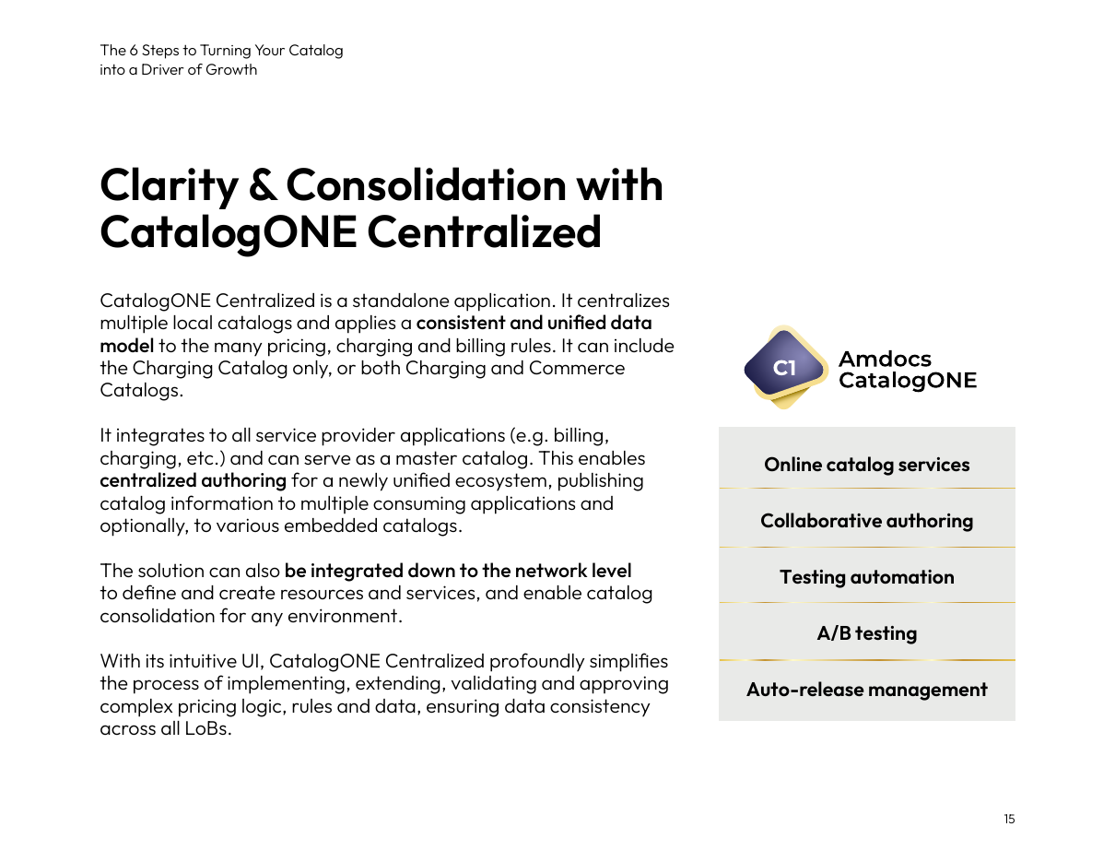
Figure 1. CatalogONE Centralized: collaborative authoring, testing automation, A/B testing and auto-release, then publish catalog information to consuming applications. Source: Amdocs 6 Steps ebook, p.15 [A].

2.4 Core data model [S][A][P]
CatalogONE's APIs are based on the TM Forum data model [A]. The example column uses one illustrative enterprise product that runs through the whole document [E].
Entity | Plain meaning | Example [E]
Product Specification | What the product technically is, with its characteristics | Dedicated Internet Access, bandwidth = 100 Mbps
Product Offering | What is sold: a single offer or a bundle | "Business Internet 100" bundle
Product Offering Price | The prices attached to an offering | Monthly fee, installation fee per site
Product Catalog / Category | A grouping of offerings | Enterprise connectivity catalog
Channel / segment / entitlement | Where and to whom the offer is sold | Enterprise account managers; SME and corporate
Product | What a customer actually owns after the sale | Company X's Business Internet 100 at 3 sites

3. Using the system: from idea to launch-ready
Each stage lists its status, owner, inputs and exit criteria, followed by what the user does in the system. The running example is "Business Internet 100": 100 Mbps dedicated internet, a block of static IP addresses, a managed router, and an availability SLA, sold on 12, 24 or 36-month contracts [E].
Amdocs describes a role-based UI with guided flows: marketing / business users own commercial changes (prices, promotions, bundles); IT, network and product managers work in the same design portal with a different personalised experience [A]. Screen names below are illustrative [E].
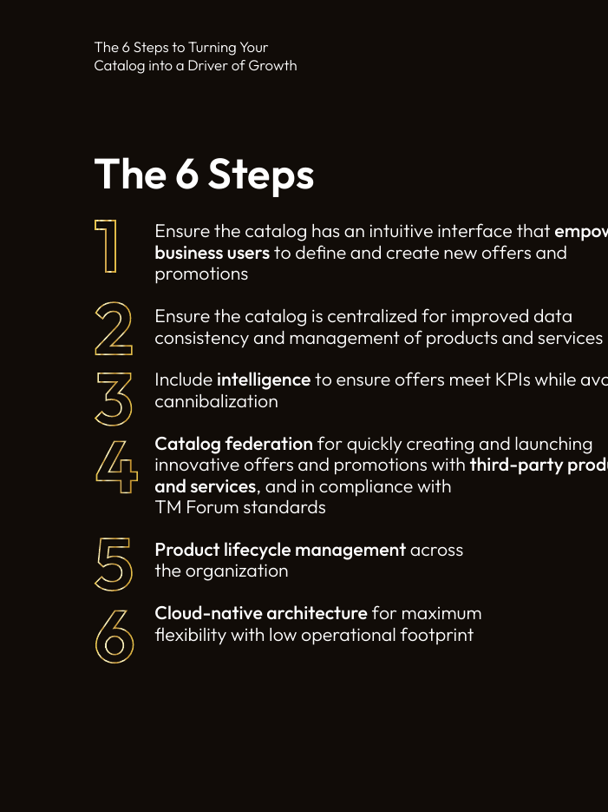
Figure 2. CatalogONE's six catalog capabilities. Step 5 is Product Lifecycle Management across the organisation. Source: Amdocs 6 Steps ebook, p.7 [A].

3.1 Stage 1: Ideation and business case
Item | Detail
Lifecycle status | In Study [S]
Purpose | Capture a product idea, check its business value, and decide whether it is worth designing.
Who (proposed roles) [P] | Product Manager (owner), Marketing, Finance (business case)
Inputs | Market need, competitor offers, iCatalog analytics, target segment
Exit criteria / output | Concept approved, so the status moves to In Design; or the concept is dropped.

What you do in the system (walkthrough)
1. Product Manager opens CatalogONE PLM and registers a new concept: "Business Internet 100 for SMEs".
2. Attaches the business case: target segment, expected number of sites, revenue goal.
3. Reviews iCatalog dashboards: which current offers are under-performing, which segments are growing, whether a 100 Mbps offer would cannibalise 50 Mbps [A].
4. Searches the commercial and technical catalogs for specifications and offers that can be reused or federated.
5. Submits the concept for the conception approval gate.

Evidence
- PLM starts at ideation [A].
- iCatalog "reduces the new offer ideation cycle time, as well as the risk of rolling out sub-optimal offers" [A].
- TMF620: first status is In Study; "conception approved" moves it to In Design [S].

Not publicly documented (confirm in a vendor demo)
- Business-case scoring screens and who signs the conception approval.
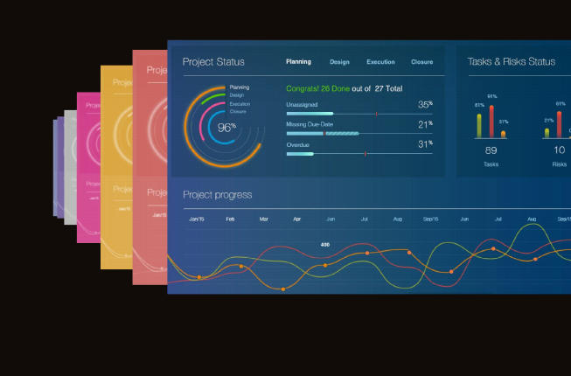
Figure 3. iCatalog: dashboards and analytics used during ideation and after launch to optimise offers. Source: Amdocs 6 Steps ebook, p.16 [A].

3.2 Stage 2: Technical product definition
Item | Detail
Lifecycle status | In Design [S]
Purpose | Define what the product is technically, so it can be delivered consistently.
Who (proposed roles) [P] | Product Specialist / Network & IT (owner), Product Manager (consulted)
Inputs | Approved concept, network capabilities, existing specifications
Exit criteria / output | Product specifications complete and linked to their delivery definitions.

What you do in the system (walkthrough)
1. Network / IT opens the service / resource catalog in the same design portal, on the technical role view [A][P].
2. Selects the "Dedicated Internet Access" specification (or a template) and sets characteristics: bandwidth 100 Mbps, access type fibre, static IP block size.
3. Adds related specifications: managed router, IP address block, SLA monitoring.
4. Exposes those capabilities to the commercial catalog so the Product Manager can bundle them without changing the network side [P].
5. Saves; the specifications are now available for commercial offers.

Evidence
- Role-based UI: "Network can create new services; IT new products; and the business can define new offers and bundles" [P].
- Service / resource catalog packages network and IT capabilities for business owners [P].
- Product Specification is a TM Forum catalog entity [S].

3.3 Stage 3: Commercial offer and bundling
Item | Detail
Lifecycle status | In Design [S]
Purpose | Package the technical product into something sales can sell.
Who (proposed roles) [P] | Product Manager (owner)
Inputs | Specifications from Stage 2, concept from Stage 1
Exit criteria / output | Offering structure complete and linked to its specifications.

What you do in the system (walkthrough)
1. Product Manager opens CatalogONE Commerce and starts the offer wizard from a template [A].
2. Links the offer to the Dedicated Internet Access specification.
3. Builds the bundle: internet 100 Mbps + static IP block + managed router + SLA.
4. Adds optional add-ons (extra IP block, backup link) as separate offerings.
5. Places the offering in the Enterprise Connectivity catalog and selects channels and segments [A].

Evidence
- Commerce is a standalone application with templates and building blocks for promotions and bundles [A].
- Business users "configure new products and services, pricing, channels, segments, and more, without any code" [A].
- Configure once, then launch to all channels (self-service, mobile, B2B portal) [A].

3.4 Stage 4: Pricing
Item | Detail
Lifecycle status | In Design [S]
Purpose | Attach all prices and price-related terms to the offering.
Who (proposed roles) [P] | Product Manager (owner), Finance (approver)
Inputs | Offering from Stage 3, pricing strategy, tax rules
Exit criteria / output | Complete price set attached to the offering.

What you do in the system (walkthrough)
1. Product Manager opens the offering's pricing section in the wizard.
2. Adds a recurring monthly fee and a one-time installation fee per site.
3. Sets prices by contract term (12, 24, 36 months) and by customer segment.
4. Adds discounts (for example a multi-site discount) and validity dates.
5. If the operator later needs rated usage, the Charging catalog can attach rate tables; it is not required for unrated enterprise products [A][E].

Evidence
- Catalog covers "new pricing definition, promotions, rules, entitlements" [A].
- Charging catalog: implement, extend, validate and approve pricing logic and policies with zero coding — optional module [A].
- Product Offering Price is a TM Forum catalog entity [S].

Not publicly documented (confirm in a vendor demo)
- Price-change approval rules and contract-term pricing screens.

3.5 Stage 5: Business rules and eligibility
Item | Detail
Lifecycle status | In Design [S]
Purpose | Control who can buy the offer, where, through which channel, and with what.
Who (proposed roles) [P] | Product Manager (owner), Product Specialist (consulted)
Inputs | Offering and prices; coverage; channel strategy
Exit criteria / output | Rules defined, so the sales channel / CPQ will only offer the product to eligible customers.

What you do in the system (walkthrough)
1. Product Manager opens the offering's rules in the wizard.
2. Sets eligibility: market = fibre-covered areas, channel = enterprise account managers, segment = SME and corporate.
3. Adds dependencies: an extra IP block requires the base offering.
4. Adds constraints: the backup-link add-on is only sold with a 24 or 36-month contract.
5. Sets KPIs for iCatalog to watch after launch [A].

Evidence
- Wizard includes "channel selection, segment selection and setting KPIs" before launch across those channels and segments [A].
- Marketers can "view dependencies in order to understand offering constraints" [A].
- TMF679 Product Offering Qualification is the standard "can this customer get this offer here?" API; Sprint used it with Amdocs DigitalONE [T][S].

3.6 Stage 6: Approval gates and roles
Item | Detail
Lifecycle status | In Design to In Test [S]
Purpose | Formally approve the design before testing starts.
Who (proposed roles) [P] | Product Manager (submits); Marketing head, Finance, Legal / Regulatory, IT/Network (approvers) [E]
Inputs | Complete design from Stages 2 to 5
Exit criteria / output | Design approved and status In Test.

What you do in the system (walkthrough)
1. Product Manager submits the offering for design approval in PLM.
2. Approvers review: commercial fit (Marketing), prices and margin (Finance), terms and regulation (Legal), technical feasibility (IT/Network).
3. Each approver approves or rejects with comments, kept with the product.
4. When all approve, the status changes to In Test; if rejected, it stays In Design for rework.

Evidence
- PLM supports "workflow and approval management" and "effective collaboration both within and outside the organization" [A].
- KT: CatalogONE provides "approvals and notification management capabilities" so business and marketing users manage the offering lifecycle [P].
- TMF620 defines the gates: "conception approved" to In Design and "design approved" to In Test [S].

Not publicly documented (confirm in a vendor demo)
- Approval workflow configuration, role permissions, sequential vs parallel.

3.7 Stage 7: Versioning
Item | Detail
Lifecycle status | Any status [S]
Purpose | Keep a controlled history of every change to the product.
Who (proposed roles) [P] | Product Manager, Catalog Administrator [E]
Inputs | An existing product or offering that needs to change
Exit criteria / output | New version approved and tested; old version kept in history.

What you do in the system (walkthrough)
1. Instead of editing a launched product directly, the user creates a new version.
2. The new version goes back through design, approval and test (short iterative cycles; parallel work is supported) [A].
3. Previous versions stay visible for comparison, audit and existing contracts.
4. On approval, auto-release publishes the new version to consuming systems [A].

Evidence
- PLM manages "all changes that occur during the product lifecycle with short iterative cycles, working in agile mode" [A].
- Governed workflows, approvals, validations and versioning "allow CSPs to manage live offer changes safely" [A].
- TMF620 catalog items carry a version and a lifecycle status [S].

Not publicly documented (confirm in a vendor demo)
- Version comparison screens and whether two versions can be in design at once.

3.8 Stage 8: Testing and readiness
Item | Detail
Lifecycle status | In Test to Active (or Rejected) [S]
Purpose | Prove the product works end to end before any customer can buy it.
Who (proposed roles) [P] | Test team (owner), IT, Product Manager
Inputs | Approved design
Exit criteria / output | Status Active: validated and ready to publish to consuming applications.

What you do in the system (walkthrough)
1. The approved product is released to a test / sandbox environment. CatalogONE distribution supports sandboxes, validation and testing [P].
2. Test team runs test quotes and orders to check pricing, rules and delivery mapping.
3. Centralized catalog supports testing automation and A/B testing [A].
4. If tests pass, the product moves to Active, ready to be published to consuming applications (CRM, CPQ, ordering) [A].
5. If tests fail, the product is Rejected (final) or reworked as a new version.
6. Launch to production is described as "at the touch of a button" once approved [A].

Evidence
- Distribution includes "sandboxes, validation and testing" so a business-owner approval process can replace an IT-testing bottleneck [P].
- Centralized: testing automation, A/B testing, auto-release management [A].
- TMF620: test OK gives Active; test KO gives Rejected, a final status [S].

3.9 The journey on one page
# | Stage | Status | CatalogONE module | Owner | Output
1 | Ideation | In Study | PLM + iCatalog | Product Manager | Approved concept
2 | Technical definition | In Design | Service / resource catalog | Product Specialist | Specifications
3 | Commercial offer | In Design | Commerce | Product Manager | Offering / bundle
4 | Pricing | In Design | Commerce / Charging (optional) | PM + Finance | Price set
5 | Rules & eligibility | In Design | Commerce wizard | Product Manager | Eligibility rules
6 | Approval | In Design to In Test | PLM | Approvers | Approved design
7 | Versioning | Any | PLM | PM / Admin | Version history
8 | Testing | In Test to Active | PLM + Centralized | Test team / IT | Launch-ready product

4. How the catalog reaches CRM — and what Amdocs actually documents
Read this section first. Two facts are documented, and they are not the same sentence. (1) CatalogONE publishes catalog data to consuming applications and to "the customer's CRM" [A]. (2) The Amdocs–Microsoft Customer Engagement Platform puts an Amdocs unified Catalog next to Dynamics 365 Sales [A]. Amdocs does not publish a sentence that says "CatalogONE sends data to Microsoft Dynamics 365 CRM". The mapping table later in this section is an example [E], not a vendor connector spec.

4.1 What CatalogONE documents: publish to consuming systems, including CRM
CatalogONE Centralized "enables centralized authoring … publishing catalog information to multiple consuming applications" [A]. The CatalogONE brochure describes "integration to Amdocs CPQ and the customer's CRM solution" [A]. It does not name Microsoft Dynamics 365 on that page.
How that publish is done, as documented for CatalogONE [A][P][T][S]:
Mechanism | What Amdocs / TM Forum say | Named target
CatalogONE Centralized | Author once; publish to multiple consuming applications [A] | Consuming applications (not named as Dynamics)
Kafka distribution | Synchronise catalog definitions to other systems in minutes [P] | Federated / downstream systems
TMF Open APIs (TMF620 and related) | API-first, TMF data model; Amdocs is certified on TMF620 [A][T] | Any system that consumes TMF620
CPQ + CRM | "integration to Amdocs CPQ and the customer's CRM solution" [A] | The operator's CRM (unnamed)

4.2 What the Amdocs–Microsoft platform documents: Catalog next to Dynamics 365
Separately, Amdocs and Microsoft sell the Customer Engagement Platform. That product "leverages … a unified Catalog, CPQ, Commerce and Order Management, and adds Microsoft's Dynamics 365 modules focused on sales, marketing, and customer service" [A]. AppSource lists it as a Dynamics 365 offering, with "Unified Catalog Serving the Entire Platform" [A].
In CEP papers Amdocs says "Catalog", not "CatalogONE". CatalogONE is Amdocs' catalog/PLM product, so it is the natural catalog in that stack, but that identification is not written as "CatalogONE → Dynamics 365" [A][E].
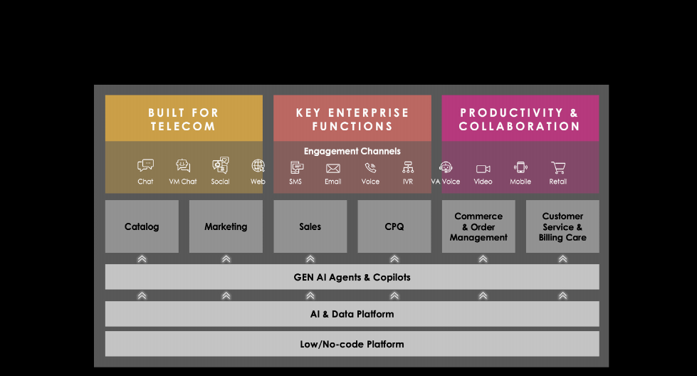
Figure 4. CEP architecture: Catalog is its own module, next to Sales. In this platform Sales is Dynamics 365. Source: Amdocs and Microsoft Customer Engagement Platform paper, p.3 [A].
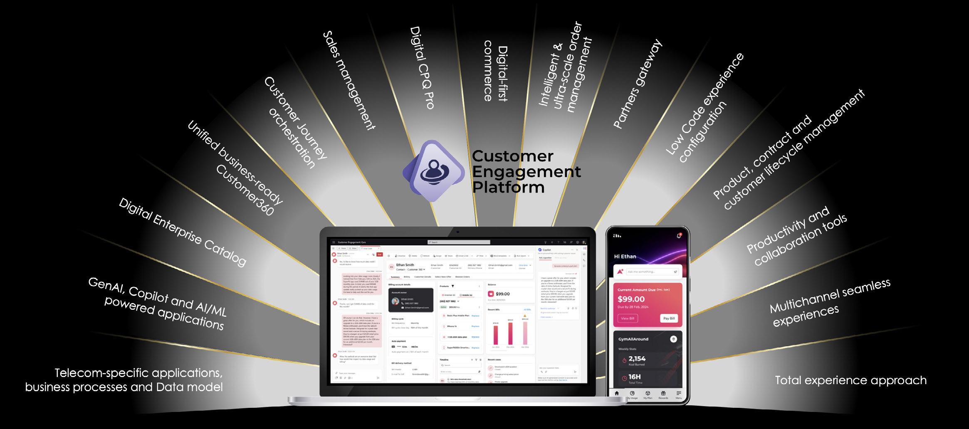
Figure 5. Complementary stack: Digital Enterprise Catalog (Amdocs) and Sales management (Dynamics) on one platform. Source: Amdocs–Microsoft CEP paper, p.4 [A].
CEP also states that agent actions are "captured and updated across all relevant billing, CRM, operations, and product databases" [A]. That is platform-level sync, not a CatalogONE API named in a CatalogONE datasheet.
A live operator on CEP is PLDT (Philippines). Amdocs announced the go-live on 7 May 2025. Agents use Microsoft Copilot and Microsoft Dynamics 365, with network validation and real-time dashboards [A]. In June 2026 IDC published a case study (Christopher Silberberg and Ahmad Latif Ali) on PLDT Unified Case Management on CEP: six weeks after go-live, 48% faster L1 ticket resolution and a 27-point NPS increase on the targeted use cases [A][I].
That IDC paper is customer care: ticketing and case handling on CEP, with Dynamics 365 as the agent workspace. The May 2025 go-live also mentions faster service rollouts at platform level. Neither source describes CatalogONE publishing product-catalog data into Dynamics 365 Sales [A][I].

4.3 What is not publicly documented
- A CatalogONE product page, datasheet or API guide that names Microsoft Dynamics 365 as the destination.
- An AppSource app called CatalogONE for Dynamics.
- A vendor field mapping from CatalogONE / TMF620 entities onto Dataverse Product, Price list item and Bundle.
- Whether CatalogONE can be plugged into an existing Dynamics 365 Sales org (such as WE Data) without buying the full Customer Engagement Platform.
- Any sentence in the IDC PLDT case study that says CatalogONE sends catalog data to Dynamics 365. That paper is Unified Case Management on CEP.

4.4 Example only: how TMF620 items would land in Dynamics 365 Sales [E][M]
If CatalogONE (or the CEP catalog) is the source of truth, and Dynamics 365 Sales is the CRM, the industry mapping is the same pattern used for any TMF620 catalog. The table is an illustration from Microsoft's product-catalog entities plus the TMF model. It is not copied from an Amdocs CatalogONE connector guide [E][M][S].
Catalog / TMF620 item | Dynamics 365 Sales entity [M]
Product Offering | Product
Bundle offering | Product bundle
Product Catalog / Category | Product family
Product Offering Price | Price list item (within a price list)
Discounts / promotions | Discount list
Related offers / add-ons | Product relationships (accessory, cross-sell, up-sell)
Characteristics | Product properties (DynamicProperty)
Lifecycle status: Active / Launched / Retired | Product status: Active / Retired

Dynamics product statuses are Draft, Active, Under Revision and Retired [M]. Study, design, test and approval would stay in CatalogONE; Dynamics would receive only products that are ready to sell [S][M][E].

4.5 Two practical paths, if Dynamics is already the CRM
Path | What it is | Evidence
Buy / adopt CEP | Amdocs Catalog + Dynamics 365 as one pre-integrated platform. PLDT is live on CEP customer service (Unified Case Management) | Amdocs–Microsoft papers [A]; PLDT go-live and IDC case study [A][I]
Keep current Dynamics, add CatalogONE | CatalogONE publishes via TMF620 / Kafka; an integration layer maps into Dataverse. This is how CatalogONE describes any CRM, not a boxed Dynamics connector | CatalogONE: consuming applications + customer's CRM [A]; mapping is [E]

CatalogONE is documented as requiring "no system or catalog replacements" and as able to sit on top of existing catalogs and BSS [A]. That supports keeping Dynamics. It does not, by itself, prove a ready-made CatalogONE-to-Dynamics feed.

5. Evidence from real operators
Operator | What was deployed | Published result | Source type
European quad-play operator | CatalogONE, unifying siloed lines of business | New-offer time from up to 9 months to 1–2 weeks; changes to existing offers in hours; 80% of offer development by configuration (was 70% system integration) | Appledore Research solution profile, 2020 [P]
Sprint / T-Mobile US | CatalogONE (define, implement, test, launch, manage offers) + DigitalONE | Expected 50% time-to-market reduction; business users define offers (3–4 people instead of 20–30); 22 channel catalogs to one | TM Forum Excellence Awards case study [T]
KT Corporation (Korea) | CatalogONE on KT private cloud, migrated charging product catalog | Business-driven UI so teams configure changes directly; foundation to accelerate 5G consumer and enterprise offerings | Amdocs press release, Nov 2020 [A]
Mtel (A1 Bulgaria) | Amdocs Master Enterprise Catalog (CatalogONE predecessor) | Time to market for new offers cut by more than 80%; complex offers from idea to production in under three days (CTO quote) | Operator quote in trade press, 2015
PLDT (Philippines) | Amdocs–Microsoft Customer Engagement Platform: Unified Case Management. Agents use Dynamics 365. Not a CatalogONE catalog-publish case | Six weeks after go-live: 48% faster L1 resolution; +27 NPS on targeted use cases. Press names Dynamics 365 and Copilot as the agent workspace | Amdocs go-live, 7 May 2025 [A]; IDC case study, June 2026 [I]

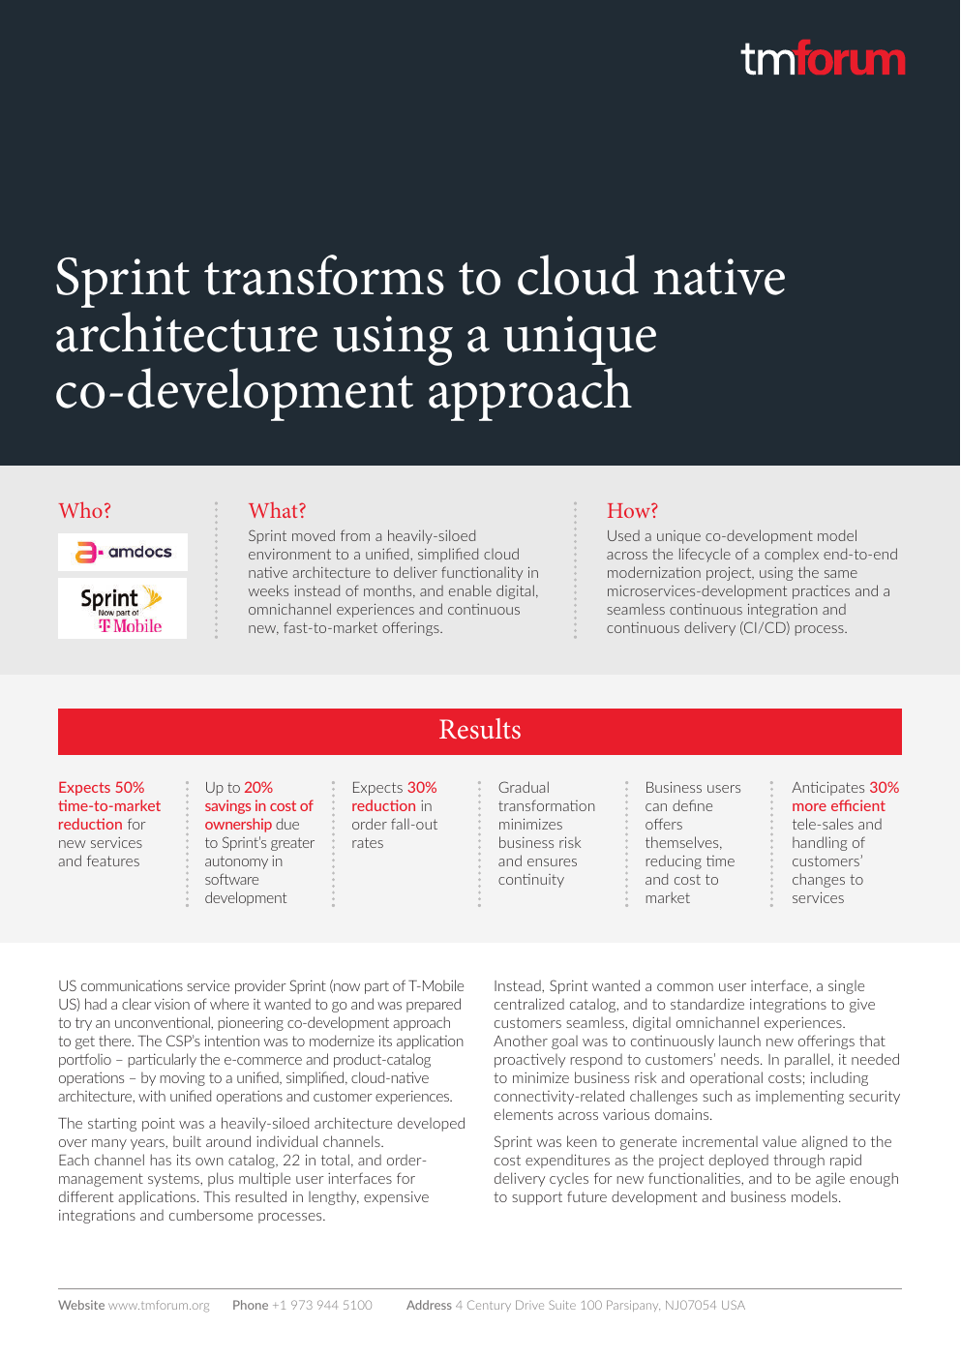
Figure 6. Sprint / T-Mobile US: CatalogONE as the product catalog for a cloud-native commerce transformation. Expected 50% time-to-market reduction; business users define offers. Source: TM Forum Excellence Awards case study [T].

6. Points to explore further
- How ideas and business cases are captured and scored before In Study.
- How the approval workflow is configured: approvers per stage, sequential or parallel, delegation.
- Which roles and permissions exist for catalog users (view, create, edit, approve, publish).
- Whether custom lifecycle statuses can be added (for example a regulatory approval step).
- How versions are compared, and whether two versions can be in design at the same time.
- The exact CEP connector mapping from CatalogONE entities onto Dataverse product, price list and bundle tables.
- How failed synchronisations to Dynamics are retried and audited.
- How contract-term and multi-site pricing for enterprise offers are modelled when the Charging catalog is not in use.

7. References
1. Amdocs, CatalogONE product page: https://www.amdocs.com/products-services/bss-oss/catalog-one
2. Amdocs, CatalogONE – a new catalog paradigm (datasheet, 2025): https://solutions.amdocs.com/rs/647-OJR-802/images/Amdocs-catalog-datasheet-paradigm-02-2025.pdf
3. Amdocs, CatalogONE – your business growth is as easy as the product it can launch (datasheet, 2025): https://solutions.amdocs.com/rs/647-OJR-802/images/Amdocs-catalog-datasheet-02-2025.pdf
4. Amdocs, The 6 Steps to Turning Your Catalog into a Driver of Growth (2025): https://solutions.amdocs.com/rs/647-OJR-802/images/Amdocs-signaturecx-campaign-ebook-catalog-02-2025.pdf
5. Amdocs, CatalogONE whitepaper (role-based UI, TMF APIs, insertion points): http://www.amdocs-marketing.com/CatalogONEwhitepaper/page-1.html
6. Appledore Research, Amdocs CatalogONE Solution Profile (April 2020): https://www.amdocs.com/sites/default/files/2021-07/Amdocs-CatalogONE-Appledore-Solution-Profile.pdf
7. Amdocs and Microsoft, Customer Engagement Platform paper (2025): https://solutions.amdocs.com/rs/647-OJR-802/images/Amdocs-and-microsoft-customer-engagement-platform-01-2025.pdf
8. Amdocs and Microsoft, Customer Engagement Platform datasheet (2024): https://solutions.amdocs.com/rs/647-OJR-802/images/customer-engagement-platform-datasheet-04-11-2024.pdf
9. Microsoft AppSource, Customer Engagement Platform (Amdocs): https://appsource.microsoft.com/en-us/product/dynamics-365/cyprus1676381115144.customerengagementplatform
10. Amdocs, press release, Amdocs and Microsoft introduce Customer Engagement Platform (27 Feb 2023): https://www.amdocs.com/news-press/amdocs-and-microsoft-expand-strategic-partnership-reimagine-telco-experience
11. Amdocs, press release, PLDT Goes Live with the Amdocs Customer Engagement Platform (7 May 2025): https://www.amdocs.com/press-release/pldt-goes-live-amdocs-customer-engagement-platform-redefine-customer
12. IDC (Christopher Silberberg and Ahmad Latif Ali), How PLDT Delivered Customer Experience Gains in Just Six Weeks — Unified Case Management on the Amdocs Customer Engagement Platform (June 2026): https://www.amdocs.com/sites/default/files/2026-06/Amdocs-PLDT-idc-case-study.pdf
13. Amdocs, case-study landing page for the same IDC paper: https://www.amdocs.com/insights/case-study/how-pldt-delivered-customer-experience-gains-just-six-weeks
14. TM Forum, Sprint / T-Mobile cloud-native case study (CatalogONE): https://www.tmforum.org/wp-content/uploads/2021/02/TM-Forum-Excellence-Awards-Case-Study-Cloud_Sprint.pdf
15. Amdocs, KT implements CatalogONE (10 Nov 2020): https://www.globenewswire.com/news-release/2020/11/10/2124219/0/en/KT-Successfully-Implements-Amdocs-CatalogONE-Cloud-Native-Solution-to-Accelerate-Introduction-of-New-5G-Offerings.html
16. TM Forum, Open API conformance list (Amdocs TMF620 and related APIs): https://www.tmforum.org/conformance-certification/open-api-conformance/
17. TM Forum, TMF620 Product Catalog Management API: https://www.tmforum.org/open-digital-architecture/open-apis/product-catalog-management-api-TMF620/v5.0
18. TM Forum, TMF679 Product Offering Qualification API: https://www.tmforum.org/open-digital-architecture/open-apis/product-offering-qualification-api-TMF679
19. Microsoft Learn, Product catalog tables (Dynamics 365 Sales): https://learn.microsoft.com/en-us/dynamics365/sales/developer/product-catalog-entities
20. Microsoft Learn, Publish a product or bundle (Dynamics 365 Sales): https://learn.microsoft.com/en-us/dynamics365/sales/publish-product-bundle-make-available-selling

