|  |
| --- |
| **Website**  **Requirements Document** |

|  |  |
| --- | --- |
| Author | Team members |
| Status | First report |
| team | Software-5 |
| Publication | 22/12/2019 |

Terms

1- abdelrahman mohamed._frontend

2- farida raafat_bakend

3- khaled abdalmoaty_backend.

4- moaz gad_ backend.

5- youmna draz _frontend

**Coordinator:**

- .

**Team leader:**

**-** ABDELRAHMAN MOHAMED .

**MANEGER:**

**-** MOAZ GAD.

# CONTACT PERSON:

- FARIDA RAAFAT.

2. overview

It is a non-profit site.

A brand new website.

There are a lot of people in need of help, whether physical or otherwise, and there are others who can provide that assistance, but there are those ways that harm both sides without achieving the goal, whether by looting or danger,

As he does not recognize any of us by losing his belongings, he is still looking here and there for no use, maybe someone found it and does not know to whom because there is no way to communicate so we thought about that site which we hope to solve those problems.

The site aims to attract different groups of people

2. Website Goals

The idea of our website is based on facilitating the delivery of assistance to the person who really needs help, and our website will provide this process in the easiest and best organized way .The site will contain many sections, such as providing clothes, food, etc. As the user enters the site, the available sections which he can get help are displayed at that time.

3. Phases

Phase 1  _ Social networking sites_current.

Phase 2  _ Add _Crowdfunding section.

4. Content Structure

### Site map

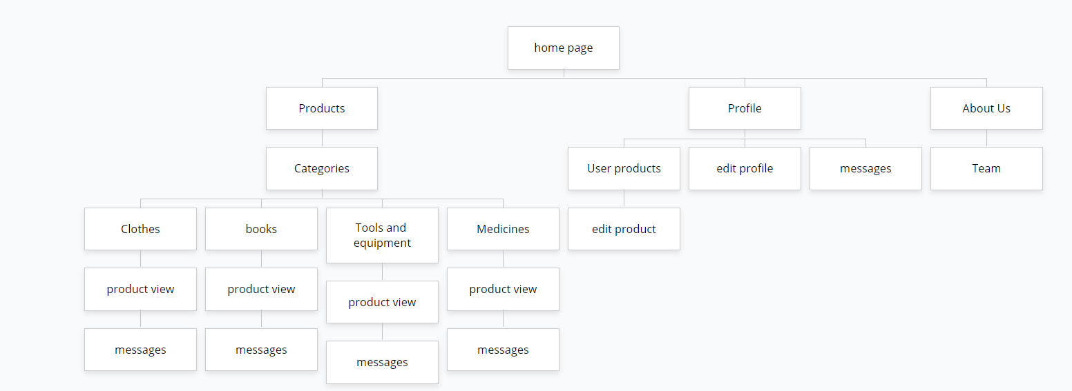

### Content type data and Content types

| Itinerary | For Name |  |
| --- | --- | --- |
| Registration | 1- ACCESSIBILITY: user can visit the home page without registration.   1. user can register new account with following inputs: 2. name 3. Email 4. Phone 5. Password 6. After user registered .he will receive a link in his email to activate his account. |  |
| 2- Authentication & authorization | 1. All types can login. 2. User can user can visit the home page and categories and about us without login . 3. User must login to add product or order it |  |
| 3- Forget password | 1. System should give option to reset his password . 2. User shall enter his email and system shall send a link to reset his password . 3. After user enter to the link direct the user to page can reset his password . |  |
| Edit profile | 1. Any user can edit his profile. 2. Edit profile contain:   - photo  - user name  - phone  - password |  |
| Home page | 1. user can visit the home page without registration. 2. Content the categories and contact us in the footer. |  |
| Contact us | 1. It is in the home page 2. System should receive his message and resend a thankful message to contact. 3. User can give his feedback or his problem by enter his email or user name then write his message and send it. |  |
| Add products | 1. User can add product from the correct part or from his profile . 2. Product require its: 3. Image 4. Name 5. Description 6. part 7. products will order by the latest . 8. user should register to be able to add any product      1. if the user press the add button without registration system will take him to the page of registration . |  |
| 8- Edit product | 1. User can edit his product as long as he registered 2. When user press the button of edit.it will take him to the page of products he published 3. User can choose the product which he want to edit it then edit it 4. User can edit : 5. Image 6. Name 7. Description 8. Part 9. Delete |  |
| 9- Other profiles | 1. User can see information from other accounts: 2. User name 3. Phone 4. Email 5. Posts 6. He can send any message to any other user from his profile. 7. He can rate the publisher from his treatment . |  |
| 10- Categories | 1. They contain 5 main part: 2. Clothes 3. Books 4. Medicine and medical devices 5. Tools and Equipment 6. Others 7. We can search in this page for any part or product 8. We have button to add products in each part 9. When we press any part , it’s product will appear |  |
| 11- Messages | 1. User can send message to any user 2. User can receive messages from other users 3. Messages will appear as a chat 4. User can delete any user 5. User can type a message from the other user profile 6. User can send message to any user 7. User can receive messages from other users 8. Messages will appear as a chat 9. User can delete any user 10. User can type a message from the other user profile |  |
| 15- Sign up | 1. User can sign up when he log in the website if he already registered 2. User should enter: 3. His name or email or phone 4. Password 5. User can reset his password if he forget it from the forget button |  |
| 16- About us | 1- It will contain some information about the website , the idea of it and rates of the using. |  |
| 12-Request a product. | 1. User can request any product he need by send a message to the publisher from his profile 2. User can add rate to the publisher according to his treatment and product |  |
| 13- Delete product | 1. User can delete any product he posted . 2. User can delete from his profile from the button of edit |  |

#### Notes/Additional Items