

Software Requirements Specification
for
Blog
Version 1.0 approved
Prepared by Mohamed Alqblawi &
Mohamed Nagy
Team Error 404!
<1/5/2022>
Table of Contents
Table of Contents ii
Revision History ii
1. Introduction 1
1.1 Purpose 1
1.2 Product Scope 1
2. Overall Description 2
2.1 Product Perspective 2
2.2 Product Functions 2
2.3 User needs 2
2.4 Constrains 2
2.5 Assumptions and Dependencies 3
3. External Interface Requirements 3
3.1 User Interfaces 3
3.2 Hardware Interfaces 3
3.3 Software Interfaces 3
3.4 Communications Interfaces 3
4. System Features 4
4.1 System Feature 1 4
4.2 System Feature 2 (and so on) 4
5. Other Nonfunctional Requirements 4
5.1 Performance Requirements 4
5.2 Safety Requirements 5
5.3 Security Requirements 5
5.4 Software Quality Attributes 5
5.5 Business Rules 5
6. Other Requirements 5
Appendix A: Glossary 5
Appendix B: Analysis Models 5
Appendix C: To Be Determined List 6

Revision History
Name | Date | Reason For Changes | Version

Introduction
The following section provides overview the software requirements Specifications (SRS) for the blog 4All.

Purpose
The purpose of this document is to specify the requirements that must be fulfilled by the blog
aggregation, preservation, management, and dissemination system which will be developed in the
Blog 4All project. Thereby, the requirements describe functional and qualitative necessities of
the system but do not postulate any demands regarding the design of the system.

Product Scope
the description of requirements should help the intended users to express their needs. Therefore, the requirements must be understandable by system users. On the other hand, the specification of requirements facilitates the development of the system by providing measurable demands. It narrows down the number of possible designs. Therefore, the specification must be understandable by developers and the requirements must be formulated in a way that allows the assessment of the fulfilment of requirements.

Overall Description

Product Perspective
The software described this SRS the software for a blog 4All. The system merges various hardware and software elements.

Product Functions
System users will be able to put comments, reacts if he type of plan basic is he is premium he can create post twice a month.
System user and admins will be able to search for any and put comments and reacts.
System admin will be able to create with category, edit, delete posts, view statistics and pages, change format, theme, and sittings.

User needs
USER | USER DESCRIPTION | USER NEEDS
Author (Admin) | Also called ‘admin’; refers to the person with full access of the website’s admin interface. | - The admin should be able to add /remove registered website superusers /admins  - The admin needs to have access to the message’s eft by the visitors through the “Contact Me” form.  - The admin must be able to post and edit content (text, images, videos, links) on the website
Visitor (users basic) | Also called ‘reader’; refers to any person who visits and views the webpage | - The visitor must be able to seamlessly view and navigate all the webpages of the website regardless of browser or device used  - The visitor should be able to contact the author for  inquiries or comments through a “Contact Me” form
Visitor (users premium) | the same as the previous with create post twice a month | the same as the previous

Constraints
The software is constrained by the shared internet connection which should be reliable. Also, the capacity of the database, so it should have a big free space.

Assumptions and Dependencies
- Assumptions:
- express Development. The backend code of the blog will be developed and maintained
using the NodeJS express framework. The system will utilize a relational database to store and manage its data via the built-in sequalize ORM. At the time of development, the express framework version to be used is express 4.18 which features an admin interface.
- react Framework:
React framework will be utilized for the styling and dynamic
features of the website for it to be more responsive and mobile-compatible. At the time of development, react 18 or higher will be utilized for the front-end development of the website.

System features and requirements

Functional requirements
The primary functional requirements of the blog, which are based on the user needs, are as
follows:
a) Viewing and Navigating the Site. Visitors should be able to view the site as intended through
A mobile or desktop browser
b) Contacting the Author. Visitors should be able to contact the author through contact form.
c) Adding, Editing, Removing Posts. The author should be able to add and/or edit blog
posts specifically on the Home.
e) Administrators and users can use the search feature.

Non- Functional requirements

Performance Requirements
The system should be reliable and compatible with all modern browsers.

Safety and security Requirements
- The system must handle safe login and logout through session and hashing technology should be used handle the secure login for users.
- The password must be more than 8 characters.

Reliability
This program should be reliable and provide catching of exceptions so that unintended results do not occur such as system crashes, or data validation failures.

Usability
The system should have user-friendly interface.

System Design

UML Diagram
For this project only 5 diagram of UML diagram will be used. They are Use case, collaboration, sequence, activity, and entity relationship diagram.

High level use case diagram of Blog

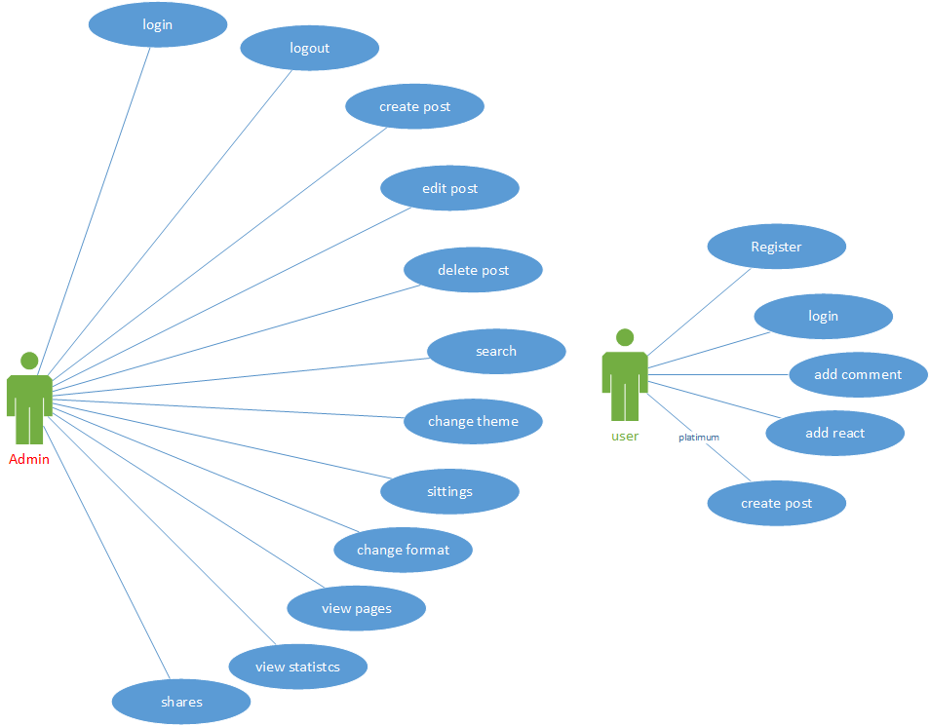

Login dashboard

User case diagram of login

System Feature 2 (and so on)

Other Nonfunctional Requirements

Performance Requirements
<If there are performance requirements for the product under various circumstances, state them here and explain their rationale, to help the developers understand the intent and make suitable design choices. Specify the timing relationships for real time systems. Make such requirements as specific as possible. You may need to state performance requirements for individual functional requirements or features.>

Safety Requirements
<Specify those requirements that are concerned with possible loss, damage, or harm that could result from the use of the product. Define any safeguards or actions that must be taken, as well as actions that must be prevented. Refer to any external policies or regulations that state safety issues that affect the product’s design or use. Define any safety certifications that must be satisfied.>

Security Requirements
<Specify any requirements regarding security or privacy issues surrounding use of the product or protection of the data used or created by the product. Define any user identity authentication requirements. Refer to any external policies or regulations containing security issues that affect the product. Define any security or privacy certifications that must be satisfied.>

Software Quality Attributes
<Specify any additional quality characteristics for the product that will be important to either the customers or the developers. Some to consider are: adaptability, availability, correctness, flexibility, interoperability, maintainability, portability, reliability, reusability, robustness, testability, and usability. Write these to be specific, quantitative, and verifiable when possible. At the least, clarify the relative preferences for various attributes, such as ease of use over ease of learning.>

Business Rules
<List any operating principles about the product, such as which individuals or roles can perform which functions under specific circumstances. These are not functional requirements in themselves, but they may imply certain functional requirements to enforce the rules.>

Other Requirements
<Define any other requirements not covered elsewhere in the SRS. This might include database requirements, internationalization requirements, legal requirements, reuse objectives for the project, and so on. Add any new sections that are pertinent to the project.>
Appendix A: Glossary
<Define all the terms necessary to properly interpret the SRS, including acronyms and abbreviations. You may wish to build a separate glossary that spans multiple projects or the entire organization, and just include terms specific to a single project in each SRS.>
Appendix B: Analysis Models
<Optionally, include any pertinent analysis models, such as data flow diagrams, class diagrams, state-transition diagrams, or entity-relationship diagrams.>
Appendix C: To Be Determined List
<Collect a numbered list of the TBD (to be determined) references that remain in the SRS so they can be tracked to closure.>

