**Report about a health insurance company**

By Team: Error 404!

**Introduction: -**

Designing a database for the health insurance company. This is our project, where it is possible to add new hospitals and types of plans for each hospital, add new customers, display the hospitals of the insurance company in each governorate and city, and other advantages that we review in this report. In this project, we will initially review the relationships of entities and maps between each scheme, and in the end, we will review the project's code.

**ER Diagram: -**

In the beginning, we have a group of entities, and each entity has its attributes.

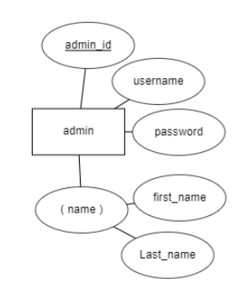The entities are [admins, hospitals, plans, customers, and claims].

1. **Admins:-**   
   the admin has three attributes regular and one composite. The primary key is admin_id because it is possibly more than admin.

The admin has four relationships with other entities.

1. **Plans: -**

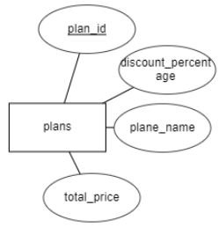the plans have four attributes.

* Plan_id: is the primary key.
* Discount_percentage: The discount that the insured will take from the company after submitting claims.
* Total_price: The price you will pay to buy the plan.
* Plan_name: classic, premium, and gold.

The plans have three relationships with other entities.

1. **Customers: -**

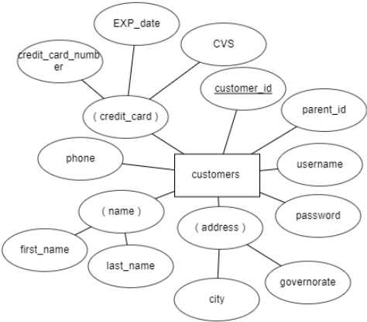the customers have eight attributes three of them are composite.

* Customer_id: primary key.
* Parent_id: Takes a null value if customer_id == Parent_id -> is dependent and if Parent_id takes null, the customer parent there is no dependent his.
* Username and password.
* Address.
* Credit_card and phone.

The Customers have three relationships with other entities.

1. 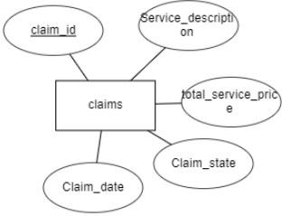**Claims: -**

The claims have five attributes.

* Claim_id: is the primary key.
* Claim_state: accept or reject.
* Claim_date.
* total_service_price: the total amount that the client pays at the hospital.
* Claim_state: A state describes the claim as being accepted or rejected by the administrator.

The claims have three relationships with other entities.

1. **Hospitals: -**

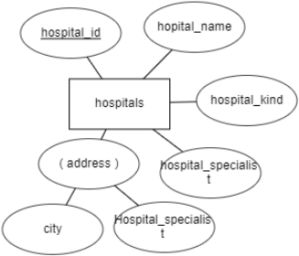the hospitals have five attributes one of them is composite.

* Hospital_id: the primary key.
* Hospital_name.
* Hospital_kind: classic, premium, and gold.
* Hospital_specialist: such that Cardiologists, Colon, and Rectal Surgeons, Dermatologists, Hematologists…. etc.
* Governorate and city: To show all hospitals in the province and city.

The hospitals have three relationships with other entities.

**Relationships with entities: -**

We have five entities with eight relationships.

1. **Admins with plans: -**

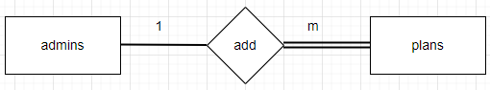one to many from the side admins because that one admin can add more plans and there can be no plan unless the admin adds it. That's why she is total participation from side plans and partial participation from side admins.

1. **Admins with hospitals: -**

one to many from the side admins because that one admin can add more hospitals and there can be no hospital unless the admin adds it. That's why she is total participation from side hospital and partial participation from side admins.

1. **A picture containing shoji

   Description automatically generatedAdmins with customers: -**

One to many from side admins because that one admin can add more customers and can customers add himself. That’s why partial participation from both sides.

1. **Admins with claims: -**

one to many from side admins because that one admin can accept and reject more claims and too partial participation both sides.

1. **Plans with hospitals: -**

many to many from both sides and total participation from the hospital because there is no hospital stored in my database and there is no plan for it and partial participation on the other side and the hospital can have more than one plan and vice versa.

1. **Plans with customers: -**

one to many from side plans and total participation from side customers. There must be at least one customer for the plan. That's why it is total participation.

1. **A screenshot of a computer

   Description automatically generated with low confidenceClaims with customers: -**

Many to one from side claim because that customer can send many claims but claims for one customer, and it is total participation from side claims because there is no claim without customer. That is why total participation and the other side is partial participation.

1. **Claims with hospitals: -**
2. Many to one from side claim because that hospital can send many claims but one claim for hospital, and it is total participation from side claims because there is no claim without the hospital. That is why total participation and the other side is partial participation.A picture containing shoji, clock

   Description automatically generated

**Conclusions: -**

This project is a miniature part of a health insurance company.

We tried to simplify the relationships of entities as much as possible, especially in the customer part.

We did not prefer to put a weak entity in the client part so as not to increase ER.