**Maintenance phase 1**

|  |  |
| --- | --- |
| NAME | ID |
| Ahmed Waleed Mohamed ELsayed | 20206153 |
|  | 20206014 |
|  | 20196031 |
|  | 20175021 |

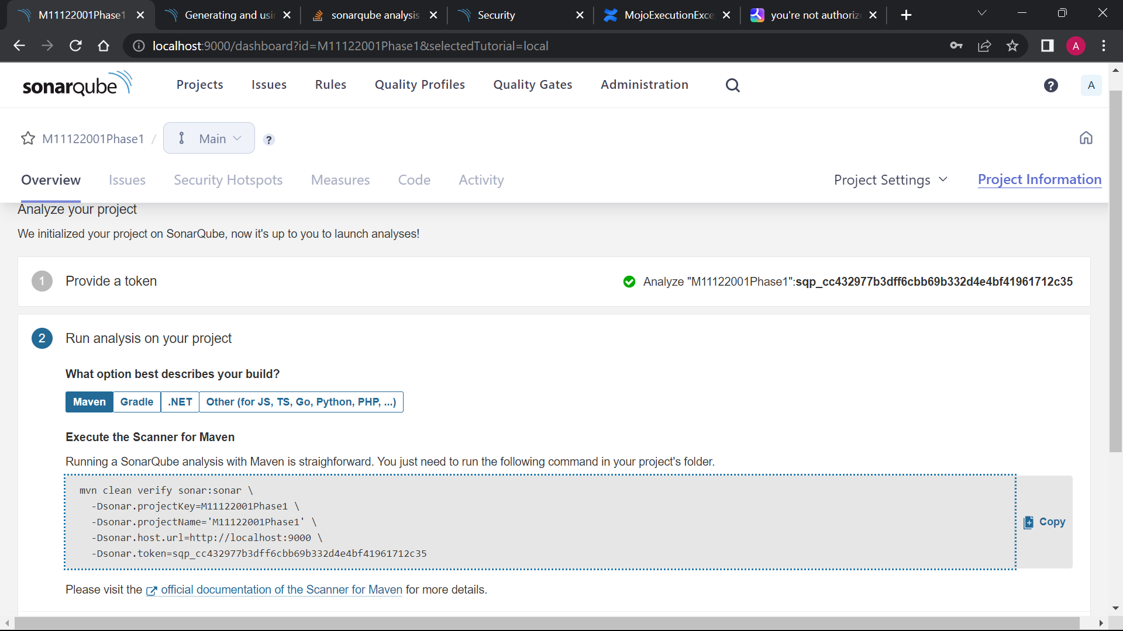**SonarQube Functioning:**

**ERROR MESSAGE:**

