BINARY ADAPTIVE PAGING (BAP)
Power-of-Two Region Decomposition with XOR-Based Address Lookup
Complete Consolidated Technical Research Report | v0–v8.4A

Evidence freeze: 16 October 2026 | GitHub main commit a56b7205f444922528f2e624cf0aa8f9977c3fcc
Status: End-of-phase, evidence-grounded research dossier; NOT a validated kernel/TLB optimization or submission-ready journal paper
Project: https://github.com/abdojat/binary-adaptive-paging

Abstract
Binary Adaptive Paging (BAP) partitions a virtual-memory region into capped power-of-two logical parents and selects a parent from a region-relative address by XOR/MSB arithmetic. This dossier integrates the project's exploratory simulations (v0–v4), native-page feasibility (v5), software translation verification (v6), modeled metadata and record lookup (v7), native C++ software metadata lookup and controlled ablation (v8–v8.1), formal representation audit (v8.2), incremental dynamic-update verification and native timing pilot (v8.3A–v8.3B-2), and a preliminary prior-art novelty audit (v8.4–v8.4A). For a region S=qK+r, 0<=r<K, capped BAP has q+popcount(r) parents; a fixed K-page software grid with a flexible final bucket has q+1[r>0]. BAP therefore refines this grid and cannot require fewer parent-limited maximal PFN/permission run records under equal positive metadata costs. The v8.1 ablation failed to establish general BAP-specific lookup superiority; the v8.3B-1 native pilot likewise found no scenario meeting the prospectively specified improvement-plus-lookup constraints against both optimized overlay baselines, and peak allocation bytes were not measured. Six-model differential verification passed on the recorded abstract traces, without establishing kernel, TLB, or hardware behavior. The sound end-of-phase outcome is a precisely bounded algorithmic construction, independently auditable experiments and negative comparative evidence. Originality and publication suitability are unresolved; any later positive claim requires a new prospective hypothesis, fair baselines, allocation accounting and independent replication.
Keywords: virtual memory; power-of-two partitions; XOR/MSB indexing; bounded range metadata; refinement theorem; native-page feasibility; software translation correctness; controlled ablation; dynamic mapping; sparse exception overlay; negative results; research reproducibility.

Executive synthesis: what was established
VERIFIED WITHIN MODEL: relative XOR/MSB parent location; page-to-PFN and r/w/x semantics on tested traces; a precise structural refinement theorem; an auditable 10-process native pilot record.
NOT ESTABLISHED: a reduction in x86 page tables, TLB misses, hardware address-translation latency, measured native allocator bytes, generic metadata savings over a fair fixed grid, or a BAP-specific dynamic speedup.
RESEARCH DECISION: preserve the negative findings. Do not run another speed benchmark solely to search for a positive result. Priority is reproducibility hardening, manuscript correction, independent proof review and either a defensible comparative study or a genuinely distinct prospective mechanism.

Contents
- 1. Introduction
- 2. Background and Motivation
- 3. Binary Adaptive Paging Design
- 4. Formal Model and Lookup Rule
- 5. Correctness Argument
- 6. Simulation Methodology
- 7. Results
- 8. Discussion
- 9. Limitations and Threats to Validity
- 10. Related Work
- 11. Conclusion
- References
[17] BAP v8.3 research design protocol, `docs/v8_3_design_gate.md`, plus v8.3A and v8.3B-0 source and archival CSVs in the repository [8].
[18] BAP v8.3B-1 C++20 native dynamic benchmark and paired pilot summary, `dynamic_benchmark_v83b1.cpp`, `analyze_v83b1.py`, `results_v83b1/repetitions/run_*.csv`, `results_v83b1/paired_pilot_summary.csv` and `environment.txt`. Repository [8].
[19] BAP v8.3B-2 research decision and decision matrix, `evaluate_v83b1_gate.py`, `docs/v8_3b2_research_decision.md`, `results_v83b1/decision_matrix_v83b2.csv`. Repository [8].
[20] D. Chen et al., FlexPointer: Fast Address Translation Based on Range TLB and Tagged Pointers. ACM Transactions on Architecture and Code Optimization, 2023. https://doi.org/10.1145/3579854
[21] Linux Kernel Documentation. Maple Tree. https://www.kernel.org/doc/html/latest/core-api/maple_tree.html
[22] V. Seshadri et al., Page Overlays: An Enhanced Virtual Memory Framework to Enable Fine-Grained Memory Management. ISCA 2015. https://www.microsoft.com/en-us/research/publication/page-overlays-an-enhanced-virtual-memory-framework-to-enable-fine-grained-memory-management/
[23] BAP v8.4 manuscript reframing and v8.4A preliminary novelty audit, `docs/v8_4_manuscript_reframing.md` and `v8_4a_novelty_audit.md` at frozen commit. Repository [8].
- Appendix A. Reproducibility Notes
- Appendix B. Verification commands and release checklist
- Appendix C. Complete research progression and evidence register (v0–v8.4A)
- Appendix D. Dynamic mapping: differential correctness and incremental pilot (v8.3)
- Appendix E. Literature audit, claim controls and publication position (v8.4A)
- Appendix F. Research decision, corrective work and reproducibility priorities

1. Introduction
Virtual memory is one of the central abstractions in modern operating systems. It allows each process to observe a private address space while the operating system and hardware cooperate to translate virtual addresses into physical locations. The most common practical design is page-based translation with a fixed base page size, such as 4 KB. Fixed-size paging is simple, well supported by hardware, and convenient for protection and demand paging. However, it also means that a large region may require a large number of page-table entries and many small translations in the translation lookaside buffer (TLB).
Large pages, huge pages, and superpages address this problem by allowing one translation entry to cover a larger memory range. This increases TLB coverage and can reduce page-table overhead. However, large pages are not a free solution. They often require suitable alignment and physical contiguity, can amplify page faults when access is sparse, and may interact badly with protection boundaries or copy-on-write. Transparent huge-page mechanisms attempt to make this process automatic, but they still need promotion, demotion, and split policies.
This paper explores a different point in the design space. Binary Adaptive Paging (BAP) organizes each virtual memory region into descending power-of-two logical chunks. A region of 13 base pages is represented as 8 + 4 + 1 pages, and for an address offset a in a region of size S the containing logical chunk is identified by MSB(a XOR S). Variable-size mappings already exist: BAP's candidate contribution is a compact region-relative representation and lookup rule, not the invention of large pages. In particular, a logical BAP chunk is not automatically a hardware-supported page mapping or one TLB entry.
This paper now reports the full sequence of the research: the original logical formulation and synthetic simulators (v0–v4), a virtual/native alignment audit (v5), software translation and access-rights validation (v6), metadata and search-comparison modeling (v7), C++20 lookup benchmarks and repeatability (v8), an ablation separating partition shape from parent selector (v8.1), and a formal dominance/novelty analysis (v8.2). These are explicitly distinct kinds of evidence. None implements a native x86 BAP TLB entry or validates a full operating-system memory manager.
The v6 extension completes virtual-to-physical address semantics in a controlled software model using explicit page-frame and permission metadata. It does not implement BAP in Linux, modify a hardware page walker, or measure TLB performance. The central open question is whether structured XOR/MSB parent lookup outweighs the descriptor, subrecord, and update costs of a generic range representation.
The v7 metadata model found that BAP carries more bytes than generic contiguous ranges in the tested layouts. Although it may reduce parent-local key comparisons, that accounting excludes parent selection. A subsequently strengthened v8 indexed-range comparison and the v8.1 ablation show why the choice of baseline matters: a simple arithmetic fixed-grid parent selector can capture much of the lookup benefit without the additional binary-tail partitions.
The final v8.2 audit makes the comparison precise: in the declared static software-record model, BAP is a refinement of the equally capped fixed grid and is weakly dominated in parent count, minimal physical/permission run count, and modeled metadata bytes. The paper therefore treats the original proposal as a valid logical identity with unproven incremental implementation value, rather than asserting an overall performance improvement.

Contributions
- A region-relative logical chunk representation based on descending power-of-two decomposition.
- A compact XOR/MSB lookup rule for identifying the logical chunk containing an address inside a binary-decomposed region.
- A comparison of logical chunk counts for fixed, huge-page-style, idealized multi-size, aligned multi-size, and limited/unbounded BAP models under stated assumptions.
- A workload-aware synthetic model of whole-chunk activation, split pressure, and permission-boundary refinement (not measured OS page faults).
- A parameter sensitivity study and a v5 audit of virtual alignment and native leaf-page eligibility that identify conditions under which logical BAP chunks cannot be treated as conventional hardware translations.
6. A v6 software-model correctness check for physical-frame translation and protection, with explicit generic-range and native page-leaf comparators across fragmentation and alignment scenarios.
7. A v7 synthetic metadata-budget and instrumented lookup-comparison study, reporting both a negative storage result and the bounded interpretation of reduced child-list key comparisons.
8. A C++20 exploratory lookup microbenchmark (v8) against three generic-range implementations, including a region-relative indexed baseline; it reports workload-dependent rankings and cross-run variability rather than a claim of universal performance superiority.
9. A v8 repeatability study (ten independent processes), v8.1 controlled two-partition/two-selector ablation, and v8.2 formal dominance and targeted novelty audit, preserving negative results and narrowing claims.

2. Background and Motivation

2.1 Fixed-size paging
In fixed-size paging, a process address space is divided into equal-size virtual pages, and physical memory is divided into equal-size frames. For a base page size of 4 KB, the lower 12 address bits are the offset inside the page, and the remaining bits identify the virtual page number. This structure makes translation simple, but a large region requires one mapping entry per base page.
page_number = address >> 12
offset = address & 0xFFF

2.2 Huge pages and superpages
Huge pages and superpages reduce the number of translations by allowing larger mappings. Prior work on superpages notes that one TLB entry can map a large physical memory region into a virtual address space, which increases TLB coverage and may reduce TLB misses [1]. Linux HugeTLB and Transparent Huge Pages are practical examples of large-page mechanisms. Linux documentation describes Transparent Huge Pages as a mechanism for automatically using huge pages as backing for virtual memory, including promotion and demotion of page sizes [2]. Linux HugeTLB documentation also highlights the importance of physically contiguous huge-page allocation, especially when huge pages are allocated early in boot [3].
Large pages can reduce translation-entry counts, but their feasibility is constrained by supported page sizes, alignment, backing, and protection requirements. Whether touching part of a larger range triggers whole-range allocation or loading is operating-system and policy dependent. Accordingly, the synthetic 'fault amplification' measure later in this paper is a modeled whole-chunk-activation ratio, not a universal prediction of hardware page faults.

2.3 Multi-size mappings and region-based designs
Modern processors and operating systems often support multiple page sizes. For example, x86-64 systems commonly support 4 KB, 2 MB, and 1 GB pages, and recent research such as Trident studies how to exploit all page sizes dynamically in Linux [5]. Region-based designs, including Direct Segments, also reduce translation overhead by mapping large contiguous regions using base, limit, and offset-style hardware support [4]. BAP is related to these ideas, but it is region-relative and binary-decomposed. It studies whether a compact bit-level lookup rule can organize variable-size chunks without treating the whole process as one fixed segment.

3. Binary Adaptive Paging Design

3.1 Design overview
Binary Adaptive Paging operates at the level of virtual memory regions rather than whole processes. A process normally contains several regions, such as code, read-only data, heap, mapped files, shared libraries, stack, and guard pages. These regions may have different permissions and backing policies, so the scheme decomposes each region independently. The smallest unit is still the normal base page; all sizes in this paper are measured in base-page units.
For a region of size S, the scheme represents S as a sum of descending powers of two. For example:
S = 13 = 8 + 4 + 1
S = 19 = 16 + 2 + 1
S = 10000 = 8192 + 1024 + 512 + 256 + 16

The chunks are laid out in descending order from the beginning of the region. For S = 13, the layout is [0,8), [8,12), and [12,13). Each chunk has a size that is a power of two, and the number of chunks is equal to the number of set bits in S if the unbounded scheme is used.

3.2 Limited and unbounded variants
The evaluation distinguishes two logical BAP variants. Unbounded BAP represents the region using the set-bit decomposition of S without an imposed maximum. Limited BAP divides any larger logical chunk into subchunks capped at 512 base pages in the main experiments. Although 512 base pages equals 2 MiB for a 4 KiB base page, these are logical region-relative chunks: the cap by itself does not establish native hardware support, virtual/physical alignment, or contiguity. The cap makes logical-size comparisons meaningful; hardware realizability is examined separately in Section 7.3.1.
Table 1. BAP variants used in the paper.
Variant | Meaning | Use in evaluation
binary_adaptive_limited | Caps region-relative logical chunks, e.g., at 512 base pages; not automatically native leaves | Size-capped logical comparison; virtual-alignment eligibility audited in v5
binary_adaptive_unbounded | Allows logical chunks larger than the common 512-base-page comparison cap | Theoretical upper bound

3.3 Adaptive split and merge motivation
A large logical chunk may be economical for a densely accessed uniform region, but a practical mapping design must handle sparse access, copy-on-write, permission boundaries, and updates. The v3 simulator approximates a policy that loads or activates an entire touched chunk and then counts segments produced by a simplified split rule. These figures describe pressure under that policy assumption; they are not measurements of real kernel splitting or hardware page-fault behavior.

4. Formal Model and Lookup Rule

4.1 Region model
A virtual memory region R is represented by a base address B, a size S measured in base pages, and attributes such as permissions and backing type. For a virtual address A inside the region, the normalized address offset is a = A - B. All formulas below use normalized offsets in base-page units.
R = (B, S, permissions, backing)
0 <= a < S
a = A - B

4.2 Binary decomposition
Let S be a positive integer. Its binary representation defines a descending list of powers of two. If bit k is set in S, then the decomposition contains a chunk of size 2^k. Chunks are ordered from larger powers to smaller powers.
decompose(S):
chunks = []
for k from floor(log2(S)) down to 0:
if bit k of S is set:
chunks.append(2^k)
return chunks

4.3 XOR/MSB lookup rule
For an address offset a inside a region of size S, BAP computes x = a XOR S and then k = MSB(x), where MSB returns the index of the most significant set bit. The logical chunk size is then 2^k. The chunk base is obtained by clearing the lower k+1 bits of S:
x = a XOR S
k = MSB_position(x)
chunk_size = 1 << k
chunk_base = S & ~((1 << (k + 1)) - 1)

For example, when S = 13 = 1101b, the decomposition is 8 + 4 + 1. For a = 9, x = 9 XOR 13 = 4, so k = 2 and the address belongs to the 4-page chunk. For a = 12, x = 12 XOR 13 = 1, so k = 0 and the address belongs to the 1-page chunk.

4.4 Translation algorithm
locate_logical_chunk(A, region, max_chunk):
B, S = region.base, region.size # base-page units
if A < B or A >= B + S:
raise RegionMiss
a = A - B
k = MSB_position(a XOR S)
logical_base = S & ~((1 << (k + 1)) - 1)
logical_size = 1 << k
if logical_size <= max_chunk:
chunk_base, chunk_size = logical_base, logical_size
else:
sub_index = (a - logical_base) // max_chunk
chunk_base = logical_base + sub_index * max_chunk
chunk_size = max_chunk
return chunk_base, chunk_size, a - chunk_base
# Logical chunk only; physical mapping handled separately.

The algorithm above locates a logical chunk and an intra-chunk offset; it is not a complete virtual-to-physical translation algorithm. Such a translation additionally needs a region-discovery mechanism, a mapping from each eligible chunk or base page to physical backing, appropriate permissions, and a defined TLB/page-walker interface. Section 7.3.1 tests the necessary virtual prerequisites under selected page-size profiles, while physical prerequisites remain open.

4.5 Physical-frame and permission semantics (v6)
A virtual-to-physical translation requires more than the XOR/MSB parent index. In v6, a region descriptor provides its virtual start and length; a reference map associates each base page with a physical frame number (PFN) and read/write/execute rights. The BAP model first finds the 512-page-capped logical parent using XOR/MSB. Within that parent, it searches subrecords that contain physically consecutive frames and uniform permissions. A selected record yields physical address PA = (start_PFN + (VPN - record_start_VPN)) × 4096 + byte_offset, subject to bounds and permission checks.
The comparator range models encode identical physical and permission runs without BAP parent boundaries: one limits each descriptor to 512 pages and the other allows arbitrary run lengths. An x86-like leaf model permits 4 KiB leaves or 2 MiB leaves only when the starting virtual page and PFN are both multiples of 512, all 512 PFNs are consecutive, and their permissions agree. This construction validates software-model translation semantics; it assumes a hypothetical region-aware lookup path for BAP and generic ranges. It does not establish native hardware support or a TLB-fill mechanism.

4.6 Capped-parent indexing and metadata contract (v7)
The v7 program locates the capped BAP parent with arithmetic in the region-relative coordinate system. Let C = 512 base pages and S be the region length; set full = floor(S/C). For an offset a < full*C, the parent index is floor(a/C). Otherwise let rem = S mod C and k = MSB((a - full*C) XOR rem); the parent index is full + popcount(rem >> (k+1)). The index selects a parent-directory entry containing the start and count of child-run records. The record within that parent is found by binary search, after which the same physical-frame and permission semantics from Section 4.5 apply.
The arithmetic index avoids scanning all parent boundaries, but it adds work beyond the measured child-list comparisons: bit operations, arithmetic, the parent-directory read and bounds/protection checks. It also assumes that the appropriate region descriptor has already been found. Correctness is tested against explicit parent lists for region sizes 1–1,099 and starts 0, 1 and 7; this does not establish latency or TLB integration.

5. Correctness Argument
The central correctness property is that MSB(a XOR S) identifies the power-of-two chunk containing a when the region is decomposed into descending powers of two. The proof is based on the fact that the descending binary chunks correspond to intervals formed by clearing suffixes of S.

5.1 Theorem: correctness of logical XOR/MSB lookup
Let S be a positive integer and let 0 <= a < S. Suppose S is decomposed into descending powers of two according to its set bits, and the resulting chunks are laid out from lower to higher offsets. Let k = MSB(a XOR S). Then a lies in the chunk of size 2^k whose base is S with all bits below and including k cleared.

5.1.1 Proof sketch
Because a < S, the binary strings of a and S must differ at some most significant bit. Let k be the highest bit at which they differ. Since S is larger than a, S has bit k equal to 1 and a has bit k equal to 0 after the common higher prefix. Bits above k are equal in both numbers. Therefore, clearing the lower k+1 bits of S gives the start of the interval whose length is 2^k. The address a shares the higher prefix, has 0 at bit k, and can vary in lower bits, so it falls inside that interval. This interval is exactly the chunk corresponding to bit k in the descending binary decomposition. Since XOR marks exactly the bit positions where a and S differ, MSB(a XOR S) returns this same k.
The simulator also validates this rule exhaustively for all region sizes up to the configured maximum by comparing the XOR/MSB lookup with a naive boundary scan. This validation is not a formal proof by itself, but it is useful as an implementation sanity check.

5.2 Notation and comparison model (v8.2)
Let S >= 1 be the number of base pages in a software-managed virtual region, let K = 2^m (K = 512 in the principal experiments), and write S = qK + r, where q = floor(S/K) and 0 <= r < K. All partition boundaries are region-relative; the absolute starting virtual page B can be unaligned. Limited BAP uses q K-page parents followed by the descending binary decomposition of r. The fixed-grid baseline uses the same q parents followed, if r is nonzero, by one software parent of arbitrary positive length r. That final parent is a software record grouping, NOT a hardware-native huge-page leaf.

5.3 Theorem: parent counts and equality conditions
M_BAP = q + popcount(r); M_GRID = q + 1[r > 0]
M_BAP - M_GRID = popcount(r) - 1[r > 0] >= 0
Proof. The first q full K-page parents are identical in both representations. The fixed grid stores the residual interval in one parent when r > 0; BAP stores one parent for each set bit of r. Since popcount(r) >= 1 when r > 0, the difference is nonnegative. Equality holds exactly when r = 0 or r is a power of two. This proof is independent of the region’s absolute virtual address, since all coordinates are region-relative.

5.4 Theorem: partition refinement and physically valid records
Every fixed-grid boundary (0, K, 2K, ..., qK, S) is also a BAP boundary; BAP introduces possible additional cuts only inside the final residual interval [qK, S). Hence BAP refines the fixed grid. For a fixed PFN and protection array, suppose that every parent is represented by the minimal number of maximal runs with consecutive PFNs and uniform permissions. Adding a parent boundary can never merge two such records, but it may split a record into two. Denote by R_BAP and R_GRID their record counts. Then:
0 <= R_BAP - R_GRID <= popcount(r) - 1[r > 0]
The upper bound follows because each additional cut can create at most one additional record. The difference can be zero when all new BAP cuts coincide with natural PFN discontinuities or permission boundaries. This statement does NOT extend automatically to arbitrarily compressed metadata formats, alternative index layouts, caching, sharing/COW metadata or dynamic update structures.

5.5 Corollary: metadata cost under a shared record layout
Bytes_BAP - Bytes_GRID = c_R (R_BAP - R_GRID) + c_P (M_BAP - M_GRID) >= 0
Both variants receive one common region descriptor of D bytes and identical positive-size records (c_R bytes) and parent-directory slots (c_P bytes). The descriptor term cancels. The v8.1 assumed compact layout uses D = 32, c_R = 24 and c_P = 8 bytes. This is a structural model-specific dominance result: no claim is made about runtime object sizes, page-table allocations, region discovery, cache misses, TLBs, or latency. In particular, metadata bytes need not track lookup time monotonically.

6. Simulation Methodology

6.1 Goals
The evaluation comprises four evidence layers: (i) logical partition structure and synthetic activation (v0–v4); (ii) necessary native-leaf virtual alignment and software translation correctness (v5–v6); (iii) modeled metadata costs and native-code software lookup performance with controls and independent process repetitions (v7–v8.1); and (iv) formal structural dominance and targeted prior-work audit (v8.2). Logical counts, abstract record counts, model-byte budgets, software ns/lookup, and actual TLB/page-walk performance are not interchangeable observables.

6.2 Baselines
Table 2. Mapping strategies evaluated by the simulator.
Strategy | Description | Purpose
fixed | One mapping per base page | Standard page-based baseline
huge_mixed | 512-page mappings plus base-page remainder | Simple huge-page-style baseline
multi_size_unaligned | Greedy use of multiple sizes without alignment constraints | Strong idealized baseline
multi_size_aligned | Greedy multi-size mapping with virtual alignment constraints | More realistic multi-size baseline
binary_adaptive_limited | BAP with maximum chunk cap | Fair BAP comparison
binary_adaptive_unbounded | BAP without maximum chunk cap | Theoretical upper bound

6.3 Metrics
Table 3. Main simulation metrics.
Metric | Meaning
logical_mapping_count | Number of region-relative logical chunks (not necessarily hardware leaf entries)
estimated_tlb_reach_pages | Optimistic largest-chunk coverage proxy; not simulated TLB hit rate
alignment_penalty_entries | Difference in logical counts when absolute virtual alignment is imposed
fault_amplification | Modeled loaded/touched ratio under whole-chunk-activation assumption
adaptive_split_added_entries | Extra entries introduced by adaptive split
permission_refined_mapping_count | Mapping count after splitting at permission boundaries

6.4 Workloads
Table 4. Synthetic workloads in Simulator v3.
Workload | Description
dense_sequential | Every page in the region is touched
sparse_random | About 2% of pages are touched randomly
very_sparse_random | About 0.2% of pages are touched randomly
hot_cold_clustered | One hot cluster plus a small number of cold random touches
boundary_sparse | Pages near chunk boundaries are touched
cow_burst | A small contiguous write burst approximates COW pressure
mixed_permissions | Synthetic permission boundaries force mapping refinement

6.5 Experimental settings
Unless stated otherwise, one base page is the simulation unit and the principal cap is 512 base pages. The v2–v4 experiments use a 64-slot optimistic largest-chunk coverage proxy (not a TLB simulator); structural region sizes include 1–10,000 pages, and workload-aware runs focus on 1,000, 4,096, and 10,000 pages. Sensitivity runs vary BAP's cap among 128, 256, 512, 1,024, and 2,048 pages and the density threshold among 0.05, 0.10, 0.25, and 0.50, over five seeds. In v5, the cap is 512 pages, region sizes are 13, 19, 513, 1,000, 4,096, and 10,000, and starts are 0, 1, 7, 13, 64, and 255, for two leaf-size profiles (72 cases). v5 tests only virtual alignment and page-size membership, not physical backing or actual TLB behavior.

6.6 v6 translation-correctness protocol
The v6 experiment uses a 4 KiB base page and considers three region sizes (1,000, 4,096, and 10,000 pages), three starting VPNs (0, 1, and 7), and five deterministic backing layouts: contiguous, contiguous_phase_matched, fragmented_32, mixed_permissions, and fragmented_permissions. The Cartesian product contains 45 cases. Each strategy receives the same page-to-PFN map and permissions. Every base page is checked at byte offsets 0, 17, and 4,095 for read, write, and execute access, including expected protection faults; out-of-region accesses are also rejected by validation. The code reports structural parent, subrecord, range, and x86-like leaf counts, not allocation costs or runtime metrics.
In the contiguous layout, physical frames begin at an aligned PFN independently of the region start, which can mismatch the virtual 2 MiB alignment phase. The contiguous_phase_matched layout aligns the virtual and physical phases; fragmented_32 adds a deterministic discontinuity every 32 pages. Mixed-permission cases divide the region into RX, R, and RW thirds. Validation was reproduced using python translation_v6.py --validate, with 45 rows identical to the supplied v6 CSV. The numerical comparison refers exclusively to the specified software model and its assumptions.

6.7 v7 modeled metadata and lookup-comparison protocol
v7 reuses the same per-base-page PFN and permission reference from v6 and the same three representations: capped BAP parents with child runs, generic uniform-permission contiguous ranges capped at 512 pages, and unbounded contiguous ranges. Native x86 page-table storage is not included because a fair byte comparison would require a separate page-table allocation model. The representation study assigns 32 bytes to a region descriptor for all models, 24 bytes to each permission-uniform physical run record for all models, and an additional 8 bytes for each BAP parent-directory slot. These sizes are declared packing assumptions, not measured memory usage.
The resulting budget is BAP_bytes = 32 + 24*BAP_child_records + 8*BAP_parents; capped_range_bytes = 32 + 24*capped_records; and unbounded_range_bytes = 32 + 24*unbounded_records. Region discovery and its index, allocator overhead, page-table pages, cache-line occupation, shootdowns, and physical TLB storage are outside this byte model. Comparisons count only binary-search tests on the start-VPN key of a child/run record; BAP XOR/MSB and parent indexing are not charged as comparisons.
The factorial design includes region lengths 1,000, 4,096 and 10,000 pages; starting VPNs 0, 1 and 7; five backing/permission layouts; uniform-random, sequential, hot/cold and boundary-stress address patterns; and seeds 1, 2 and 3. Thus, 3*3*5*4*3 = 540 scenario/trace rows are recorded, with 1,024 lookups per row by default. Every modeled translation is checked against the reference PFN and permissions. Results include mean, 95th-percentile and maximum search-key comparisons; the next section reports mean values for three representative layouts with uniform-random accesses.
Table 4a. Assumed compact layout for v7 (abstract software representations).
Object | Bytes | Coverage / qualification
Region descriptor | 32 | Charged to all representations; descriptor discovery excluded
Physical contiguous-run record | 24 | Same run-record structure for BAP and generic ranges
BAP parent-directory slot | 8 | Child start-index + child count; additional BAP cost
Note. The run record comprises start VPN (8 bytes), length (4), start PFN (8), permissions (1), and padding/reserved bytes (3). A parent slot uses two 4-byte indices. Byte totals are layout assumptions, not Python object sizes or real kernel allocations.

6.8 Native-code software lookup microbenchmark protocol (v8)
To test whether reduced child-list comparisons translate into lower software lookup time, v8 implements four translation-record search variants in a compiled C++20 microbenchmark: (1) BAP arithmetic parent selection plus a local binary search of child runs; (2) a global binary search of capped (512-page) contiguous-range records; (3) a global binary search of unbounded contiguous-range records; and (4) a stronger indexed-range scheme using the same capped-range records but an 8-byte directory entry per 512-page region-relative bucket, followed by a bucket-local binary search. Each method returns the same VPN-to-PFN and protection information. All cases undergo exhaustive page-wise semantic validation before timing; the timed path incorporates a translation-dependent checksum to discourage unused-result elimination.
The test grid includes region sizes 1,000, 4,096 and 10,000 pages; initial VPNs 0, 1 and 7; five deterministic physical/permission layouts; four address-access patterns (uniform random, sequential, hot/cold and boundary stress); and trace seeds 1, 2 and 3, totaling 540 case/trace rows per program execution. Each row is timed using 4,096 lookups and five repeated measurement passes with rotated method order. The per-method median ns/lookup is recorded. Two separate executions of the supplied pilot on a virtualized x86_64 host yielded 540 rows each. Boundary-stress traces are deterministic and the nominal seeds are not independent samples for that pattern. These are *in-process software-record lookups*, not kernel page-table translation or TLB timing.
The pilot host was a virtualized Intel Xeon Platinum 8573C system (KVM, five allocated vCPUs), using GCC 14.2.0 with -O3 -std=c++20. Metadata byte estimates retain v7 assumptions: a shared 32-byte region descriptor, 24 bytes per run record, and 8 bytes per BAP-parent or indexed-range directory slot. They exclude container/allocator overhead and region-discovery indexes. Timing excludes mapping creation and updates, OS page walks, TLB activity, shootdowns, and whole-application behavior. Microsecond and nanosecond-scale numbers from virtualized execution must not be generalized beyond this pilot.
Table 4b. Lookup schemes and what is actually timed (v8).
Scheme | Search interface | Extra directory
BAP | Parent arithmetic + parent-local binary search | 8 B per BAP parent
Range cap512 | Global binary search in capped run list | None
Range unbounded | Global binary search in unrestricted run list | None
Range indexed | 512-page bucket directory + local binary search | 8 B per bucket
Note. Every variant is a software metadata lookup over synthetic layouts, not a supported x86 leaf mapping. The common region descriptor is treated as already selected; discovery among many VMAs is excluded.

6.9 Repeated-process analysis and four-way ablation (v8 and v8.1)
The user repeated v8 in ten independent process launches on the same machine, with 540 scenario/seed rows per process, 4,096 lookup queries per row, and five within-process measurement passes. The v8 repeatability tool groups the three fixed seeds within each process and uses a paired percentile bootstrap across ten process-level differences; seeds or 540 rows are NOT treated as independent processor replicates. Results are exploratory, and the 180 scenario groups constitute multiple comparisons.
The v8.1 controlled ablation fixes the underlying region, virtual-to-physical mapping, protection array, query trace, record format, common bounds checks and translation-dependent checksum. It varies two parent partitions (BAP capped dyadic parents or fixed-size K-page buckets with one residual bucket) and two parent selection methods (direct arithmetic indexing or binary search of parent starts). Each selected parent uses the same child-record binary search. The four measured variants are BAP arithmetic, BAP binary, fixed-grid arithmetic and fixed-grid binary. The experiment uses the same factorial grid: three region sizes, three starts, five physical/permission layouts, four access patterns, and three seeds (540 rows per process, 10 processes).
The machine reported an Intel Core i5-12500H (x86-64) under a Microsoft hypervisor, GCC 13.3.0, Python 3.12.3; compilation used g++ -O3 -std=c++20. The ablation analyzer produces 720 aggregated contrast rows (180 scenario groups x four contrasts). As in v8, the reported nanoseconds are only user-space metadata lookup timings and remain sensitive to branch prediction, cache state, compiler decisions and host scheduling.

6.10 Independent formal checker and prior-work audit (v8.2)
The independent Python standard-library program formal_audit_v82.py tests the capped-parent formula and boundary refinement for 10,000 region sizes; it also tests record-count and packed-byte inequalities on 633 deterministic physical-frame and permission configurations. These checks corroborate the mathematical proof but do not replace it. The targeted novelty review compares the model with Direct Segments [4], Redundant Memory Mappings (RMM) [12], CoLT [13], Trident [5] and the general dyadic/CIDR interval-decomposition tradition [14]. The review is not an exhaustive systematic priority search for the precise XOR/MSB expression.

7. Results

7.1 Structural mapping-count results
The original structural experiment compares logical chunk counts when regions start at page 0. The BAP limited and idealized multi-size strategies share the same maximum logical block size. This controls the logical decomposition comparison, but does not establish equivalent native page-table support or TLB representation.
Table 5. Fair structural comparison for aligned region start.
Region size | Fixed | Huge mixed | Multi-size unaligned | Multi-size aligned | BAP limited | BAP reduction vs fixed (%)
13 | 13 | 13 | 3 | 3 | 3 | 76.92
19 | 19 | 19 | 3 | 3 | 3 | 84.21
512 | 512 | 1 | 1 | 1 | 1 | 99.80
513 | 513 | 2 | 2 | 2 | 2 | 99.61
1000 | 1000 | 489 | 6 | 6 | 6 | 99.40
4096 | 4096 | 8 | 8 | 8 | 8 | 99.80
10000 | 10000 | 291 | 21 | 21 | 21 | 99.79
Note. Counts are logical chunk counts; a 512-page cap alone does not imply that every resulting block is a native 2 MiB translation.

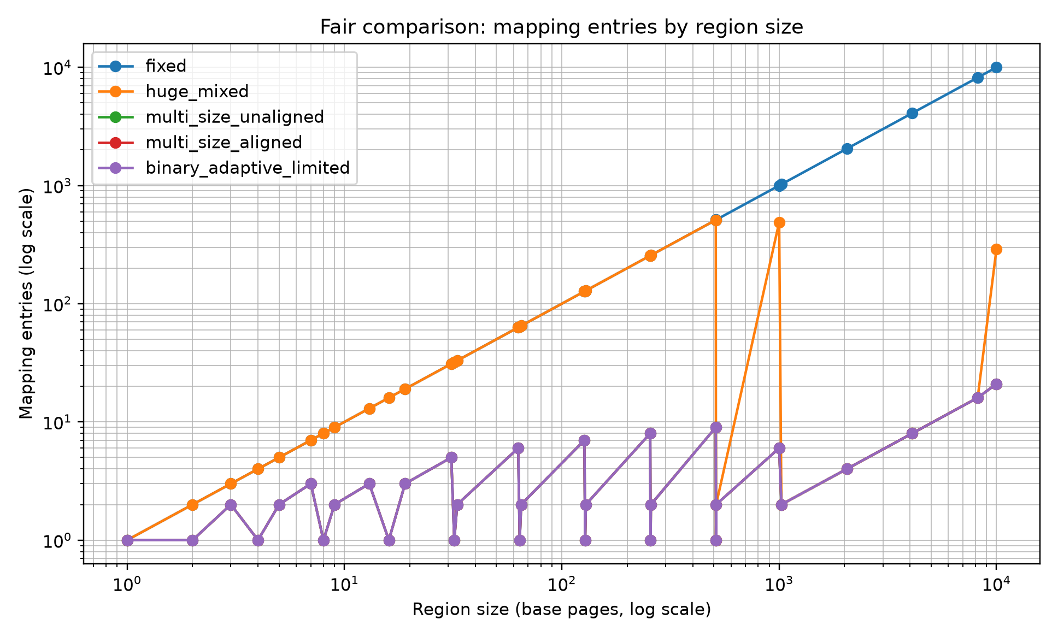
Figure 1. Fair comparison: mapping entries by region size.

In the logical decomposition model, a 10,000-page region uses 10,000 fixed-size chunks or 21 BAP limited chunks. For aligned starts and the same maximum chunk size, BAP limited matches the strong idealized multi-size models rather than improving their count. These counts should not be interpreted as actual page-table entries or hardware TLB entries without an implementation model and page-size/alignment eligibility checks.

7.2 Upper-bound behavior
Table 6. Upper-bound comparison with unbounded BAP.
Region size | Fixed | Huge mixed | BAP limited | BAP unbounded | Unbounded reduction vs fixed (%)
13 | 13 | 13 | 3 | 3 | 76.92
19 | 19 | 19 | 3 | 3 | 84.21
512 | 512 | 1 | 1 | 1 | 99.80
513 | 513 | 2 | 2 | 2 | 99.61
1000 | 1000 | 489 | 6 | 6 | 99.40
4096 | 4096 | 8 | 8 | 1 | 99.98
10000 | 10000 | 291 | 21 | 5 | 99.95
Note. Unbounded BAP is a logical decomposition upper bound, not a claim of support for an arbitrary hardware page size.

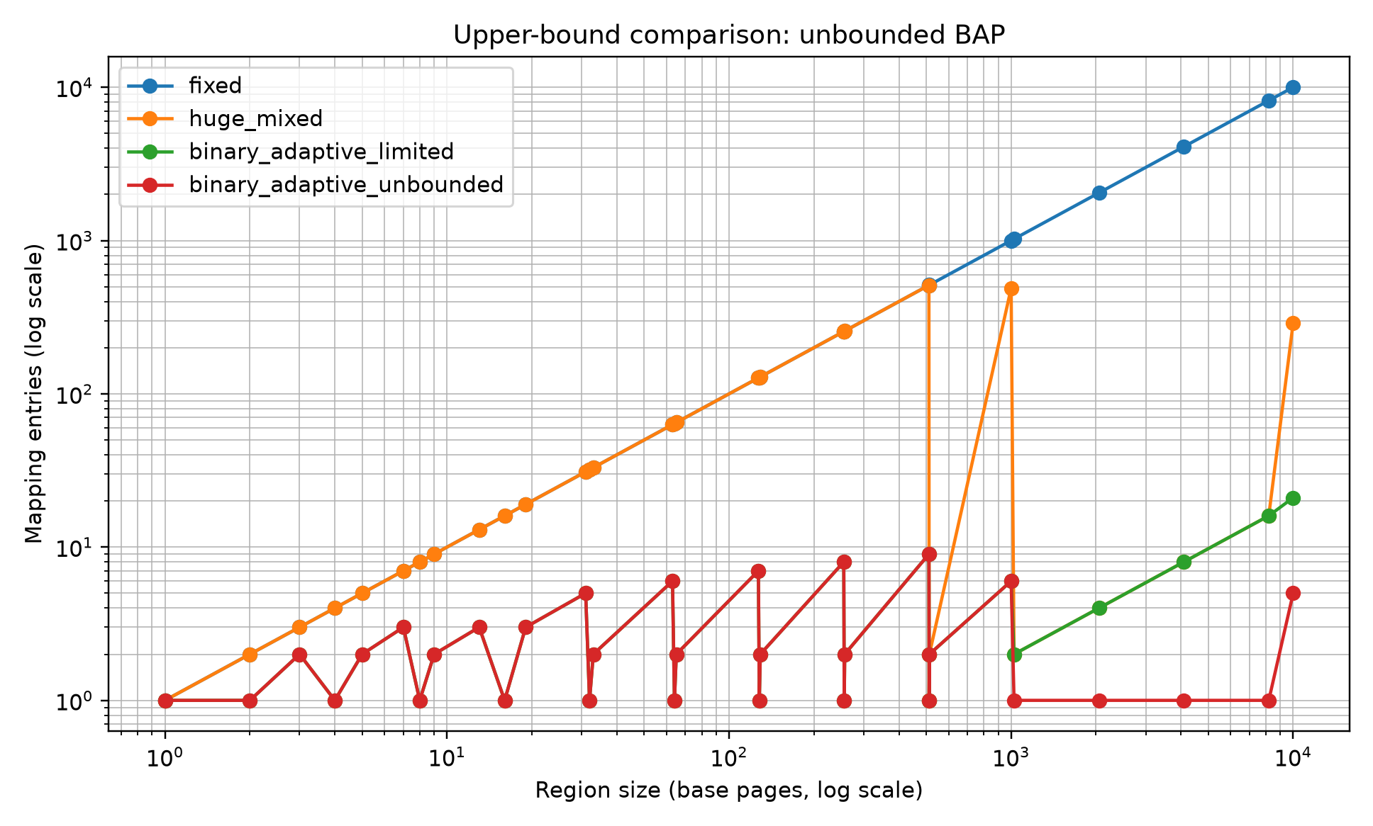
Figure 2. Upper-bound comparison: unbounded BAP.

Unbounded BAP decomposes 4,096 pages into one logical chunk and 10,000 pages into five logical chunks (8,192 + 1,024 + 512 + 256 + 16). This is an upper bound on logical representation size only; it does not assume existing hardware can implement each chunk as an independent translation leaf.

7.3 Alignment sensitivity
Table 7. Logical chunk counts under region-start offsets (abstract v2 model).
Region start | Multi-size unaligned | Multi-size aligned | BAP limited | BAP unbounded | Alignment penalty
0 | 21 | 21 | 21 | 5 | 0
1 | 21 | 30 | 21 | 5 | 9
7 | 21 | 30 | 21 | 5 | 9
13 | 21 | 30 | 21 | 5 | 9
64 | 21 | 24 | 21 | 5 | 3
255 | 21 | 25 | 21 | 5 | 4
Note. BAP chunks are relative to the region base and are NOT necessarily legal native hardware page mappings. Section 7.3.1 audits the prerequisite alignment and size support.

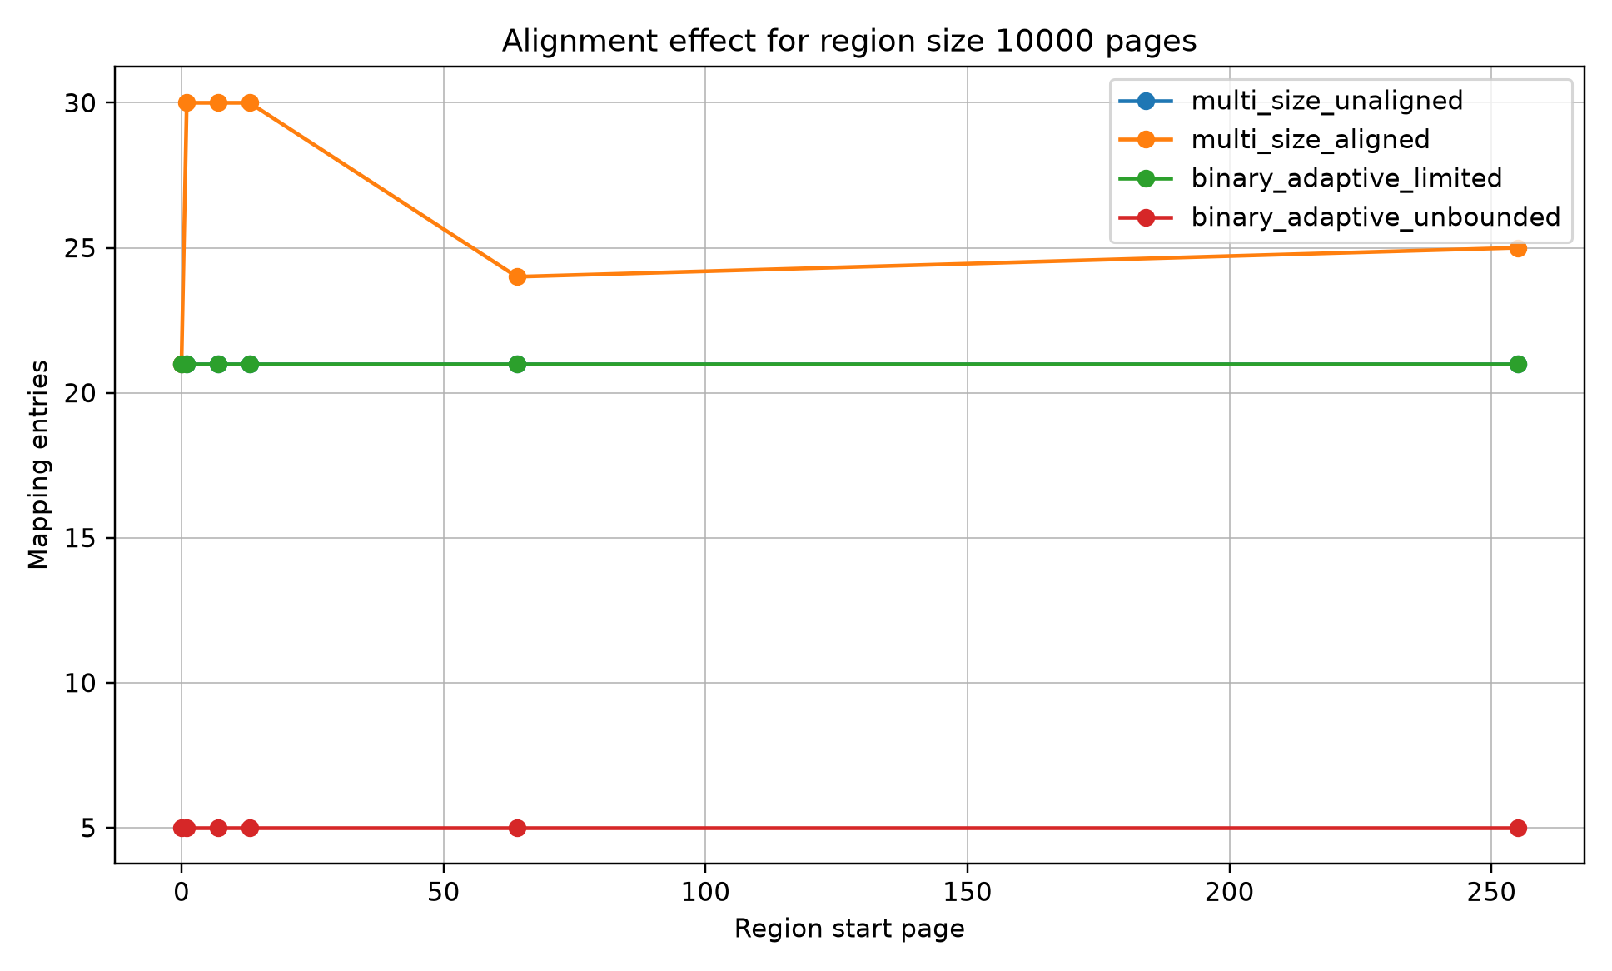
Figure 3. Logical region-relative chunk counts versus aligned multi-size counts (not TLB results).

The original v2 model counts 21 BAP limited logical chunks for a 10,000-page region regardless of whether the region starts at page 0, 1, 7, or 13; the alignment-constrained multi-size model counts 21 for start 0 and 30 for starts 1, 7, or 13. This demonstrates an assumption of the region-relative representation, not 21 immediately realizable hardware translation leaves. A native large-page entry requires an allowed size and virtual alignment, with further physical and protection constraints. The feasibility check below tests these necessary virtual conditions rather than assuming them away.

7.3.1 Virtual-alignment and page-size feasibility (v5)
The v5 structural audit examines whether each original BAP limited block has an allowed native leaf size and begins at an absolutely aligned virtual address. It reports (i) original logical blocks, (ii) blocks individually eligible for a native leaf, (iii) legal aligned leaves obtained by splitting within original BAP block boundaries, and (iv) leaves obtained by realigning/retiling the entire region. Two explicit profiles are considered: 'ideal powers of two' (every native size 1, 2, 4, ..., 512 base pages, hypothetical) and 'x86 4 KiB/2 MiB' (native leaf sizes 1 and 512 base pages only; 1 GiB leaves are excluded by this 512-page cap). All counts assume adequate physical backing and do not model TLB operation.
Table 7a. Virtual eligibility and aligned retiling, S = 10,000 base pages (v5).
Profile | Start page | BAP logical chunks | Directly eligible chunks | Split only: legal leaves | Retile: aligned leaves
Ideal powers of two | 0 | 21 | 21 | 21 | 21
Ideal powers of two | 1 | 21 | 0 | 204 | 30
Ideal powers of two | 64 | 21 | 1 | 80 | 24
x86 4 KiB/2 MiB | 0 | 21 | 19 | 291 | 291
x86 4 KiB/2 MiB | 1 | 21 | 0 | 10000 | 802
x86 4 KiB/2 MiB | 64 | 21 | 0 | 10000 | 802
Note. Direct eligibility tests only allowed size and virtual alignment, not physical feasibility. Split-only keeps BAP boundaries and is not optimized. Retiling may change them. The all-powers-of-two profile is hypothetical.
Interpretation. The apparent 21-versus-30 advantage in Table 7 is a logical representation comparison, not a native hardware paging advantage. Under the hypothetical all-powers-of-two profile, legal retiling at start page 1 needs the same 30 aligned leaves as the aligned multi-size baseline. Under the limited x86 4 KiB/2 MiB profile, it needs 802 legal leaves; the original 21 BAP chunks cannot serve as native page-table leaves. These findings do not rule out a newly designed region-relative translation mechanism, but such a mechanism must specify its region lookup, physical mapping, metadata costs, protection semantics, and TLB interface. No end-to-end speedup is implied.

7.3.2 End-to-end translation semantics and physical-layout checks (v6)
Unlike v5, which checked necessary virtual leaf prerequisites, v6 builds byte-address translations from specific physical frame sequences and permission maps. BAP uses a two-stage software lookup: a region-relative XOR/MSB parent plus a search among contiguous, permission-uniform child subrecords. Two generic range representations and an x86-like page-leaf construction act as comparators. All four models must return the same physical address for permitted accesses and reject disallowed accesses. A region-aware hardware translation interface for BAP is assumed, not demonstrated.
Table 7b. Structural translation representation counts under five backing layouts (v6; region S = 10,000 pages, starting VPN = 1).
Physical backing | BAP parents | BAP subrecords | Generic range ≤512 | Generic range unlimited | x86-like leaves
Contiguous; phase differs | 21 | 21 | 20 | 1 | 10000
Contiguous; phase matched | 21 | 21 | 20 | 1 | 802
Fragmented every 32 pages | 21 | 313 | 313 | 313 | 10000
Three permission zones | 21 | 23 | 21 | 3 | 10000
Fragmented + permissions | 21 | 315 | 315 | 315 | 10000
Note. BAP subrecords exclude parent-index and region-descriptor storage; range records are not TLB entries. The x86-like leaf count reflects eligibility under virtual/physical alignment and uniform-permission constraints only. Generic ranges and BAP use hypothetical lookup support. No memory-byte or time cost is measured.
With contiguous uniform backing, 21 BAP parent chunks correspond to 21 physical/permission subrecords, while a capped generic-range partition needs 20 records and an unbounded range needs only one. Therefore, the structural results do not show that BAP is inherently more compact than generic range metadata. When physical continuity is broken every 32 pages, both BAP and generic range representations require 313 subrecords or records. Under three protection zones, BAP needs 23 subrecords versus 21 capped or 3 unbounded generic-range records. The parent boundaries do not eliminate extra fragmentation and protection metadata.
The x86-like outcome depends sharply on *both* virtual and physical alignment. At starting VPN 1, contiguous frames beginning at a 2 MiB-aligned PFN have a different phase from the virtual start; no 2 MiB leaf is eligible, so the model needs 10,000 base-page leaves. When phases are matched, 18 2 MiB leaves become eligible and the total falls to 802 leaves. The latter matches the best-case virtual-alignment count from v5, but only under the added physical assumptions. Across all 45 scenarios, translation and permission validation succeeded in the local reference-model rerun; no TLB latency, metadata byte budget, allocation dynamics, or operating-system integration was evaluated.

7.4 Workload-aware fault amplification
The workload-aware v3 simulation models a deliberate whole-chunk-activation rule: if a chunk is touched, all base pages in that chunk are counted as loaded until a split rule is applied. The ratio (modeled loaded pages)/(unique touched pages) is labeled 'fault amplification' in the original plots. It is not a measured OS page-fault rate, nor a necessary consequence of an abstract translation chunk. In this synthetic model, dense access gives a ratio of 1.0.
Table 8. Selected workload-aware stress results for a 10,000-page region.
Strategy | Workload | Mappings | Touched | Loaded no split | Amplification no split | Adaptive mappings | Loaded after split | Amplification after split
fixed | sparse_random | 10000 | 200 | 200 | 1 | 10000 | 200 | 1
binary_adaptive_limited | sparse_random | 21 | 200 | 9984 | 49.92 | 416 | 200 | 1
binary_adaptive_unbounded | sparse_random | 5 | 200 | 9984 | 49.92 | 402 | 200 | 1
binary_adaptive_limited | hot_cold_clustered | 21 | 550 | 9216 | 16.76 | 113 | 1070 | 1.95
binary_adaptive_unbounded | hot_cold_clustered | 5 | 550 | 9728 | 17.69 | 606 | 550 | 1
fixed | cow_burst | 10000 | 100 | 100 | 1 | 10000 | 100 | 1
binary_adaptive_limited | cow_burst | 21 | 100 | 512 | 5.12 | 122 | 100 | 1
binary_adaptive_unbounded | cow_burst | 5 | 100 | 8192 | 81.92 | 106 | 100 | 1
Note. All loaded-page/amplification results are from the synthetic whole-chunk-activation assumption; split costs, actual allocation behavior, and TLB invalidations are not modeled.

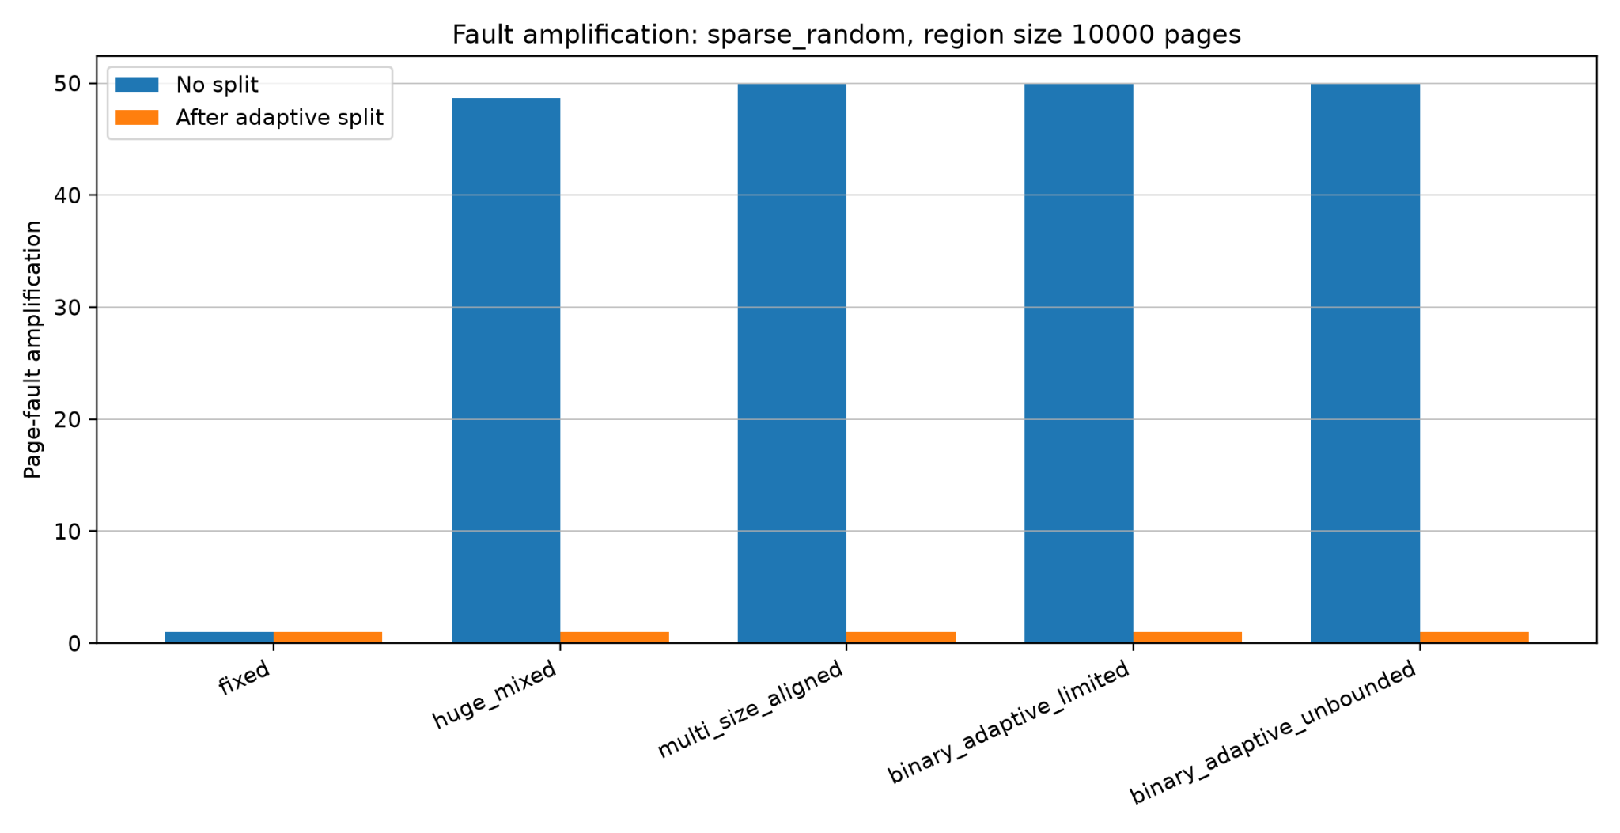
Figure 4. Fault amplification under sparse random access.

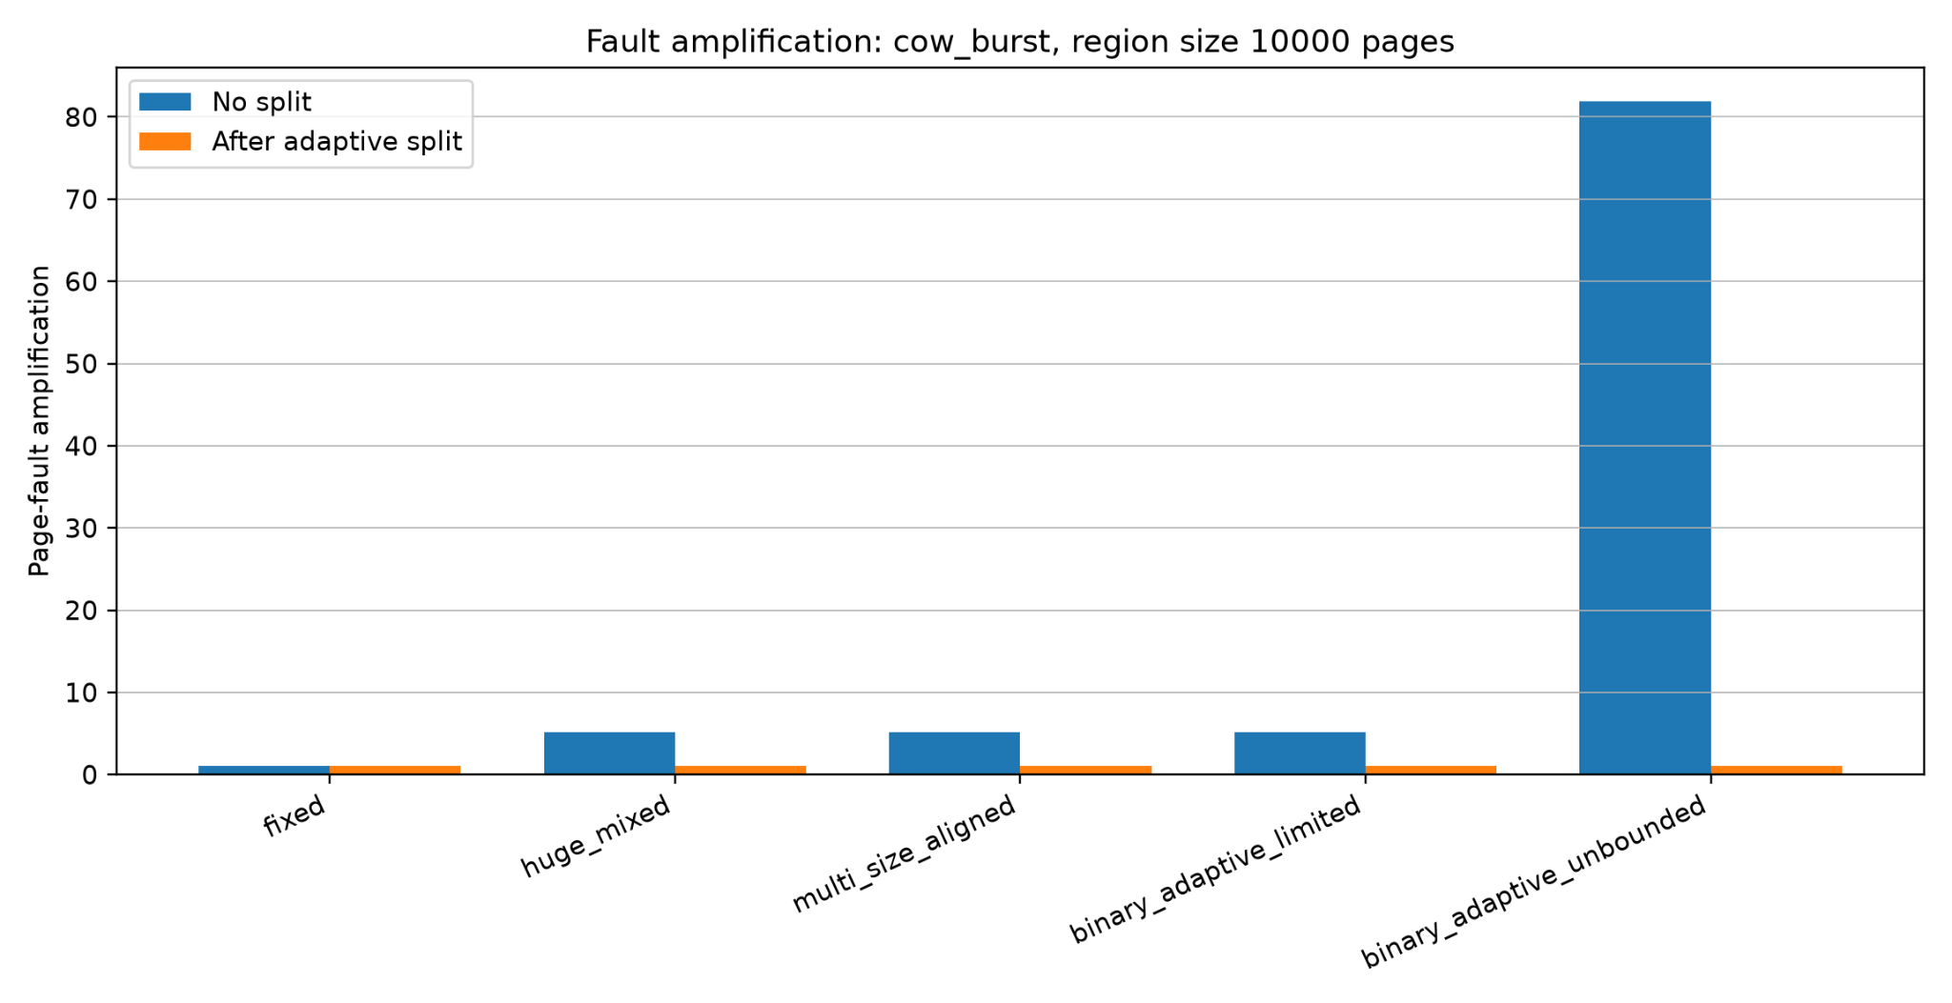
Figure 5. Fault amplification under COW-like burst access.

For the 10,000-page synthetic region, the sparse workload touches 200 distinct pages. The whole-chunk-activation model counts 9,984 pages before splitting for BAP limited, giving a modeled ratio of 49.92; the fixed-page model counts 200 pages (ratio 1.0). For the COW-like burst, the modeled BAP limited ratio is 5.12 and unbounded BAP is 81.92. These observations identify a sensitivity of the chosen activation policy to chunk size. They do not independently establish page-fault behavior or a special BAP advantage over conventional aligned multi-size mappings.
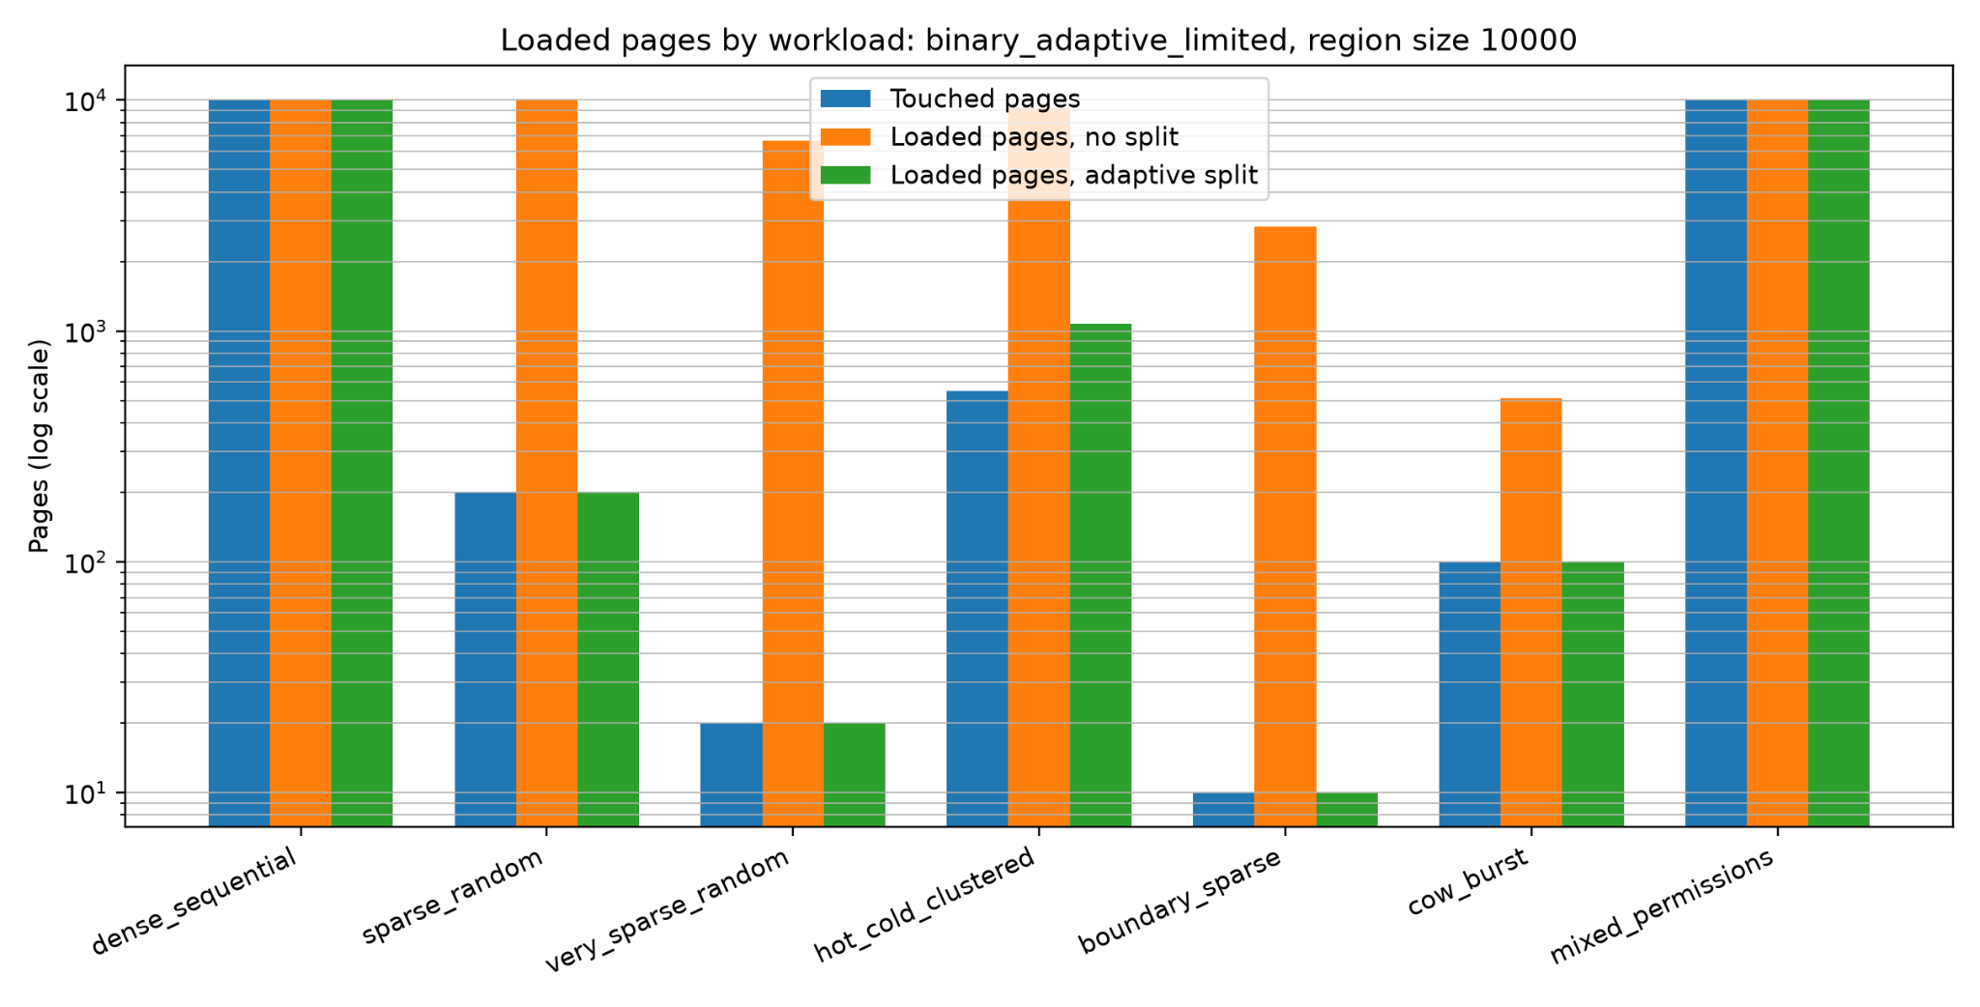
Figure 6. Loaded pages by workload for BAP limited.

7.5 Permission-boundary refinement
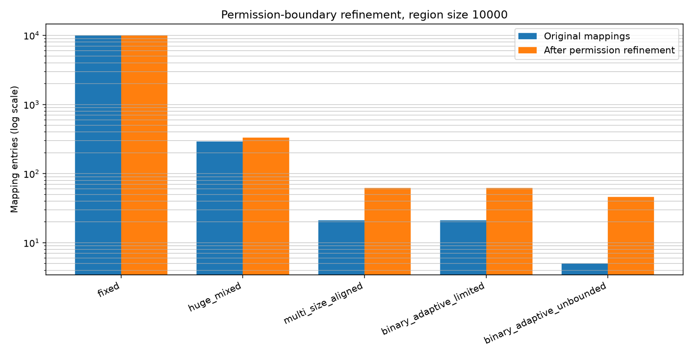
Figure 7. Mapping refinement after synthetic permission boundaries.

Under synthetic permission-boundary refinement, the 10,000-page example increases BAP limited from 21 to 62 logical segments and unbounded BAP from 5 to 46. This models segmentation pressure, not a validated hardware page-table construction; the resulting segments must still satisfy page-size, virtual/physical alignment, and protection requirements for native mappings.

7.6 Sensitivity analysis
Table 9. Mapping-count sensitivity for BAP limited.
Max BAP chunk | Mean mappings
128 | 79
256 | 40
512 | 21
1024 | 12
2048 | 8
Note. Increasing the logical BAP cap reduces chunk count in this sweep; the comparator cap was not co-varied, so cross-strategy trends at different caps are not a controlled native-hardware comparison.

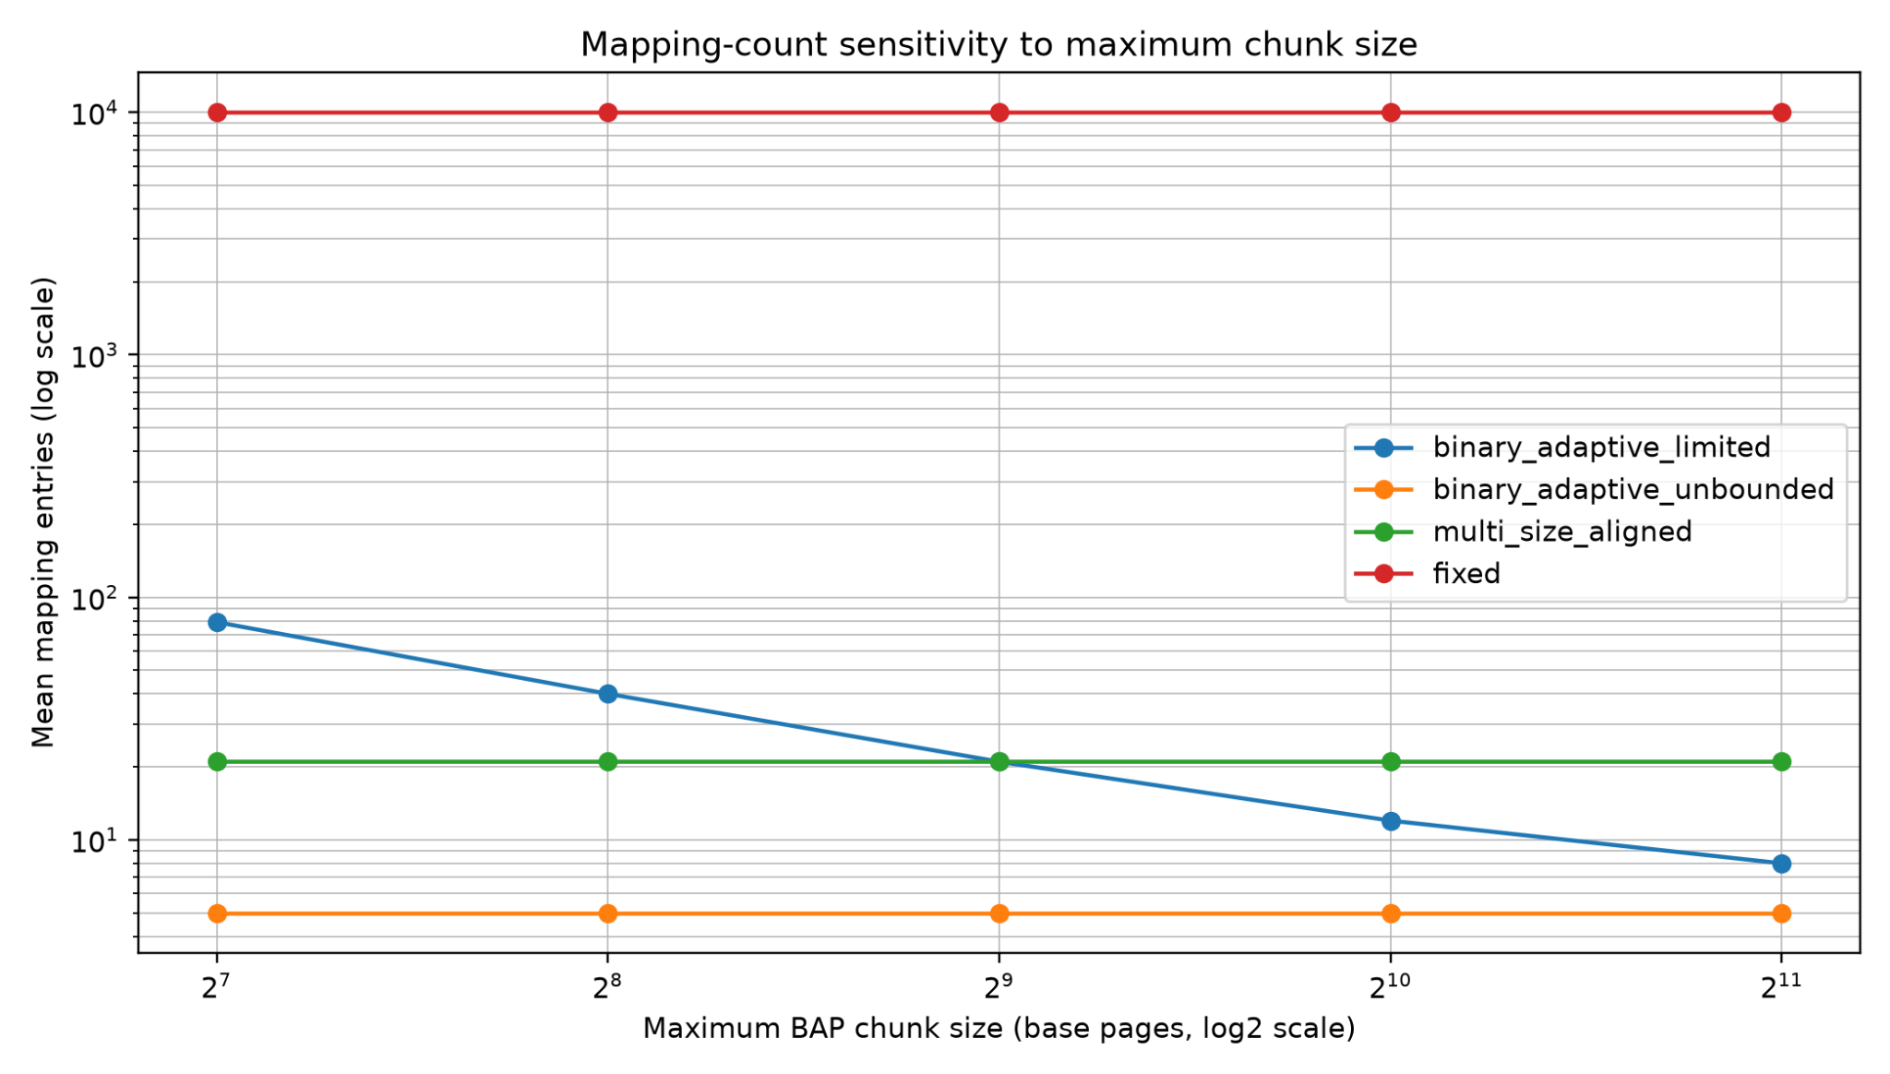
Figure 8. Mapping-count sensitivity to maximum chunk size.

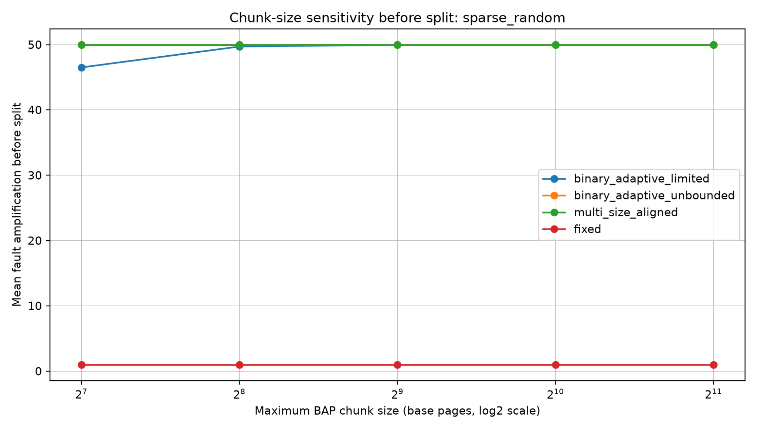
Figure 9. Chunk-size sensitivity before split under sparse random access.

Table 10. Split-threshold tradeoff for BAP limited under hot/cold workload.
Split threshold | Mean amplification after split | Mean added entries
0.05 | 1.95 | 93
0.10 | 1.95 | 93
0.25 | 1.95 | 93
0.50 | 1 | 599.40
Note. Higher split thresholds reduce amplification but can add many mappings.

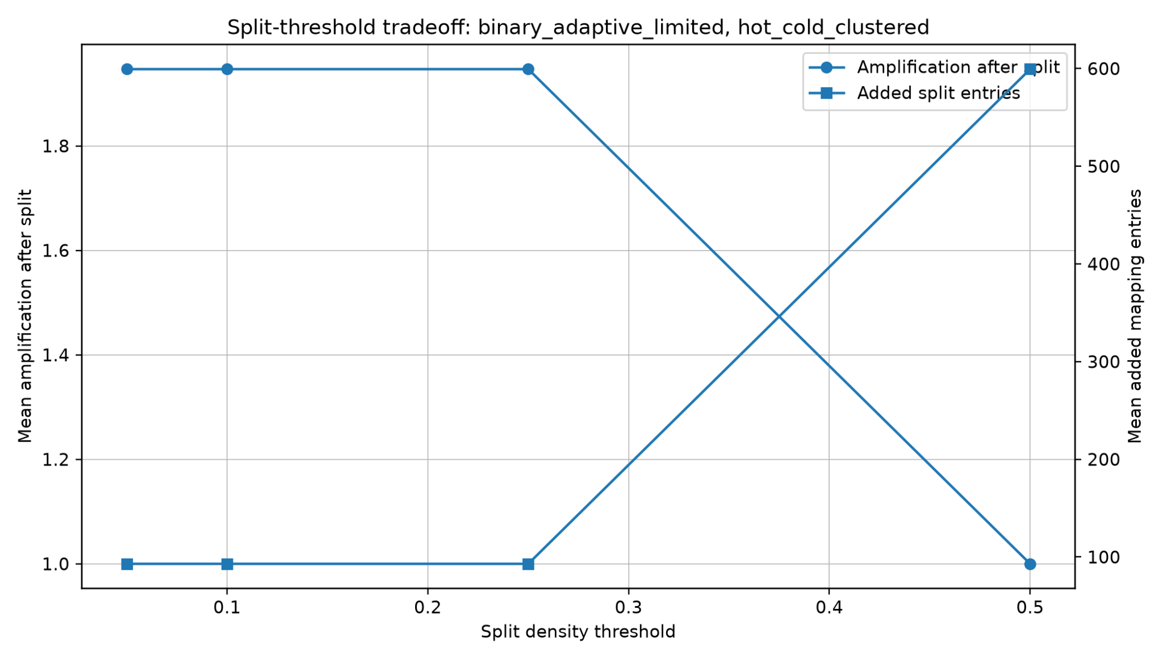
Figure 10. Split-threshold tradeoff for BAP limited.

Sensitivity runs show that increasing the logical BAP cap from 128 to 2,048 pages reduces its chunk count from about 79 to 8 for the 10,000-page region. More aggressive synthetic splitting can reduce the modeled whole-chunk-activation ratio, but at the expense of extra segments. These trends are within-model parameter effects; native leaf-size eligibility, physical backing, and runtime costs were not included. In particular, Figure 8 varies BAP's cap while the comparison baseline's cap is fixed, so it should not be read as a fair hardware mapping advantage.

7.7 Metadata-budget and key-comparison results (v7)
For comparability with the v6 examples, the tables below select a 10,000-page region starting at VPN 1. All byte totals are derived from the declared v7 model; they are invariant across access patterns and random seeds for a given physical/permission layout. The search-key means are averaged across three seeds of the uniform-random pattern (1,024 lookups per seed).
Table 11. Modeled metadata bytes at S = 10,000, starting VPN = 1 (v7).
Physical / permission layout | BAP parents / child records | BAP bytes | Range <=512 bytes | Range unbounded bytes
Contiguous | 21 / 21 | 704 | 512 | 56
Fragmented every 32 pages | 21 / 313 | 7,712 | 7,544 | 7,544
Three permission zones | 21 / 23 | 752 | 536 | 104
Fragmented + permissions | 21 / 315 | 7,760 | 7,592 | 7,592
Note. All three representations include the same 32-byte descriptor; BAP additionally carries one 8-byte slot per parent. Bytes are modeled assumptions, not hardware or process-memory measurements.
In the 540 reported rows, BAP never has a lower model-byte total than either generic-range representation. With contiguous backing, BAP uses 704 bytes, capped ranges 512, and unbounded ranges 56; with 32-page physical fragmentation the respective amounts are 7,712, 7,544 and 7,544 bytes. Thus, v7 provides no support for an unconditional BAP metadata-compression claim under the tested layout. Different encodings remain an open design question and cannot be credited without implementation.
Table 12. Mean run-start binary-search key comparisons (uniform random, three seeds; v7).
Physical / permission layout | BAP child-list | Range <=512 global | Range unbounded global
Contiguous | 1.000 | 4.464 | 1.000
Fragmented every 32 pages | 4.039 | 8.377 | 8.377
Three permission zones | 1.024 | 4.512 | 2.000
Note. Counted operations are search-key comparisons only. BAP parent selection, XOR/MSB, popcount, integer arithmetic, parent-directory loads, and all cache or memory-latency effects are excluded.
For fragmented backing, BAP averages 4.039 child-list key comparisons versus 8.377 global range comparisons in both range baselines. With a single contiguous range, BAP and the unbounded-range baseline each use one record-key comparison, while BAP additionally needs a parent lookup. The instrumented reduction in key comparisons does not establish a lower complete instruction count, fewer cache misses, lower translation latency, or better performance on actual processors.

7.8 Exploratory software lookup latency and indexed-range baseline (v8)
The following descriptive tables summarize the supplied v8 pilot results only. For each layout, S = 10,000 base pages, initial VPN = 1, and uniform-random access, the figures are medians across three trace seeds in each of two separate program executions (six case-level observations). The complete dataset consists of two 540-row CSV files. The table is not a latency claim for a production memory-management system.
Table 13. Pilot software lookup ns/access (S = 10,000; initial VPN = 1; uniform random; v8).
Physical / permission layout | BAP | Range cap512 | Range unbounded | Range indexed
Contiguous | 3.36 | 24.43 | 3.50 | 2.33
Contiguous, phase matched | 3.36 | 24.42 | 3.36 | 2.33
Fragmented every 32 pages | 27.66 | 51.50 | 56.45 | 31.53
Fragmented + permissions | 29.35 | 50.76 | 57.32 | 29.28
Mixed permissions | 3.76 | 24.85 | 10.30 | 5.46
Note. Values are descriptive case medians from two independent pilot program executions on a virtualized host. They are not confidence bounds, p-values, hardware translation latencies, or measurements from the user's local CSV.
The ranked outcome changes by layout. Indexed ranges were faster with contiguous backing (2.33 vs. 3.36 ns/access for BAP); BAP had a lower reported pilot median under 32-page fragmentation (27.66 vs. 31.53 ns/access); and the two were close under combined fragmentation and permission changes (29.35 vs. 29.28 ns/access). BAP generally outpaced a naive global binary search of many records, but such a comparison alone is not adequate evidence of novelty or overall superiority. The indexed-range control is essential because it can exploit the same locality used by BAP parent search.
Table 14. Hypothetical model metadata bytes for v8 compared schemes (same scenario subset).
Physical / permission layout | BAP (B) | Range cap512 (B) | Range unbounded (B) | Range indexed (B)
Contiguous | 704 | 512 | 56 | 672
Contiguous, phase matched | 704 | 512 | 56 | 672
Fragmented every 32 pages | 7,712 | 7,544 | 7,544 | 7,704
Fragmented + permissions | 7,760 | 7,592 | 7,592 | 7,752
Mixed permissions | 752 | 536 | 104 | 696
Note. Bytes are assumed packed representation sizes, not measured process RSS, allocator footprint, CPU-cache traffic, or actual page-table memory. The indexed control adds an 8-byte slot per 512-page bucket.
The modeled storage cost does not favor BAP in this illustrative subset. For contiguous backing it requires 704 bytes against 672 for indexed ranges, 512 for globally searched capped ranges and 56 for unbounded ranges; with 32-page fragmentation the BAP/indexed totals are 7,712/7,704 bytes. The pilot therefore offers no evidence that BAP is more compact than a comparable indexed contiguous-range organization.
The initial v8 pilot host exhibited appreciable inter-run variation, motivating a ten-process repeatability study on the user’s virtualized Intel host. The latter CSVs now exist in results_v8/repetitions and were checked for matching workloads, per-case metadata counts and deterministic checksums. The new local repeated-process data are discussed below and should not be pooled directly with the older pilot machine measurements as if they came from a controlled homogeneous experiment.

7.8.1 Independent local validation status
The local C++20 benchmark passed complete modeled address/permission validation and generated 540 timing rows (checksum diagnostic 176). The full results_v8/local_run.csv and ten complete repetition files were later committed. Their analysis is now available in results_v8/repeatability_summary.csv. Thus the original local PASS screenshot is no longer the only evidence; the observed timings can be reported as repeated user-space lookups but must not be confused with hardware TLB performance.

7.8.2 Ten-process repeatability of the v8 indexed-range comparison
Ten matching independent process launches yielded 5,400 scenario-seed rows. A checksum/configuration consistency check found no mismatches across all files. Comparing BAP to indexed ranges by mean time within 180 scenario groups, BAP was faster in 20 groups; 17 of those had wholly positive exploratory bootstrap intervals. The indexed baseline was faster in most other groups. Performance differences are small enough that virtualized-host interference and multiple testing remain important considerations.
Table 15. Ten-process software lookup means for v8: S = 10,000, VPN start = 1, uniform random.
PFN / permission layout | BAP (ns) | Indexed range (ns) | Indexed − BAP (ns)
Contiguous | 2.8498 | 2.2014 | −0.6484
Contiguous, phase matched | 2.8794 | 2.1642 | −0.7152
Fragmented every 32 pages | 26.2529 | 25.7994 | −0.4535
Fragmented and permissions | 26.7942 | 25.7767 | −1.0175
Mixed permissions | 3.3661 | 5.4476 | +2.0815
Note. Positive delta means BAP was faster. Each entry is a mean over ten independently launched processes, with the three deterministic trace seeds averaged within each process. Not equivalent to ten independent hardware platforms.
The mixed-permissions random-access subset favored BAP consistently in these v8 process runs (paired mean indexed minus BAP = +2.0815 ns; exploratory 95% percentile-bootstrap interval +2.0163 to +2.1561 ns). However, this comparison held the metadata representation and indexing schemes unequal and therefore did not isolate the contribution of the XOR/MSB rule. That uncertainty motivated v8.1.

7.9 Controlled partition/selector ablation (v8.1)
The ablation separates the parent selection algorithm from the parent partition itself. Arithmetic selection decisively reduced measured time relative to binary parent search under both partition shapes. But this effect was shared with the simple fixed grid and therefore cannot be credited exclusively to BAP. The global counts below characterize the direction of each ten-process scenario-group mean; they are descriptive and not a multiple-comparison-corrected discovery rate.
Table 16. Direction of v8.1 mean differences across 180 scenario groups (ten process runs each).
Method A compared with method B | A faster groups | Groups with positive exploratory 95% CI
BAP arithmetic vs BAP binary | 180 / 180 | 179 / 180
Fixed arithmetic vs fixed binary | 180 / 180 | 180 / 180
BAP arithmetic vs fixed arithmetic | 75 / 180 | 45 / 180
BAP binary vs fixed binary | 55 / 180 | 30 / 180
Note. Confidence bounds are within-scenario exploratory process-level percentile bootstraps with no correction for the four contrasts and 180 scenario groups. These comparisons do not measure OS TLB translation.
Table 17. v8.1 preselected focused case, S = 10,000, start VPN = 1, mixed permissions and uniform random.
Variant | Mean software ns/lookup | Modeled metadata
BAP arithmetic | 4.7460 | 752 B
BAP binary parent | 24.6301 | 752 B
Fixed-grid arithmetic | 4.3345 | 720 B
Fixed-grid binary parent | 24.6137 | 720 B
Note. The byte budget is a fixed 32-byte descriptor + 24 bytes per minimal run + 8 bytes per parent. The measured Python or C++ runtime allocation and parent-start arrays are excluded.
For the focused case, BAP arithmetic was slower than fixed-grid arithmetic by 0.4115 ns/lookup on average; the difference (fixed minus BAP) was −0.4115 ns with exploratory bootstrap 95% interval [−0.4390, −0.3840] ns. Fixed-grid arithmetic used 720 modeled bytes compared with 752 for BAP. In fragmented-32 backing, the arithmetic means were much closer (BAP 26.3996 versus fixed-grid 26.3565 ns), showing that the performance impact varies with trace and PFN layout. The evidence supports arithmetic indexing as a general optimization but not BAP-specific superiority.
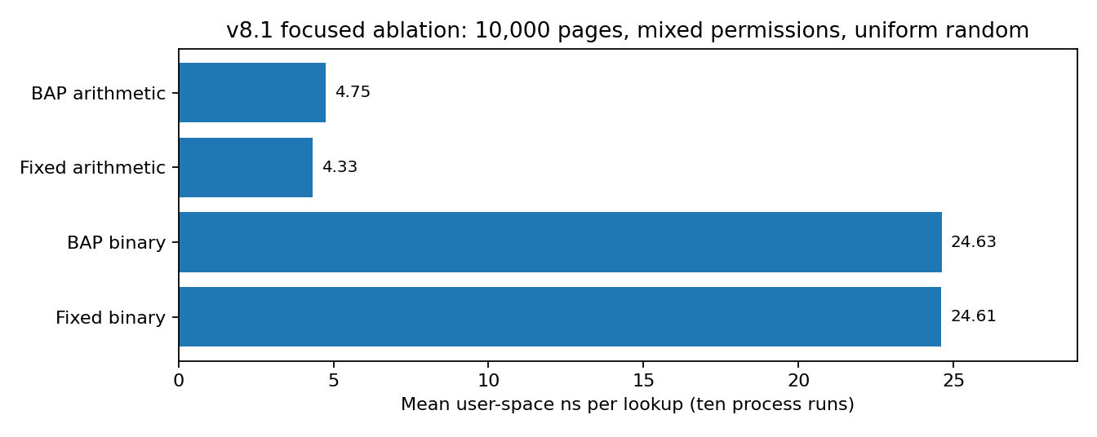
Figure 11. Controlled v8.1 partition-selector comparison for the preselected mixed-permission case.
Values are mean software lookup latencies; changing the parent selection method has a much larger effect here than changing BAP versus fixed-grid partitioning.

7.10 Formal dominance and independent validation (v8.2)
The proof in Section 5 clarifies the unexpected results. The fixed grid retains the same full K-page prefix as limited BAP and merges all of BAP’s dyadic residual parents into at most one final software bucket. Thus the number of BAP parents cannot be smaller. Because every BAP boundary is either an existing fixed-grid boundary or an additional internal cut, physically contiguous permission-uniform run records cannot be fewer under this minimal-run storage policy. With positive per-record and per-parent costs, the modeled BAP byte budget is not smaller.
Table 18. Formal comparison at S = 10,000, K = 512 (q = 19, r = 272 = 256 + 16).
Layout | BAP parents | Fixed parents | BAP bytes | Fixed bytes
Contiguous, uniform permissions | 21 | 20 | 704 | 672
Fragmented every 32 pages | 21 | 20 | 7,712 | 7,704
Contiguous, mixed permissions | 21 | 20 | 752 | 720
The independent v8.2 checker validated 10,000 region sizes and 633 physical/permission cases, with no reported counterexample to the parent, subrecord or byte inequalities. This is a stronger, but narrower, result than informal observations from selected simulations: the static software-metadata representation is provably weakly dominated in size by an equally capped fixed grid. The theorem does not address the possibility of a future dynamic-update advantage, nor does it imply that a non-power-of-two residual software bucket is legal as a native hardware translation.

8. Discussion

8.1 What the results support
- BAP's descending power-of-two region decomposition has a compact mathematical representation and an XOR/MSB rule for locating the containing logical chunk.
- For the aligned starts and shared maximum logical chunk size in v2, BAP limited matches the strong idealized multi-size baseline rather than reducing its logical count.
- Virtual-alignment feasibility is not automatic: v5 shows that region-relative BAP chunks at unaligned starts cannot generally be inserted unchanged as native aligned leaves.
- Unbounded BAP provides a lower bound on *logical* chunk count, but is not an established implementation or TLB-reach upper bound on current hardware.
- Synthetic whole-chunk activation may induce a high loaded/touched ratio in sparse workloads; simplified splitting can reduce this ratio while adding entries.
- v6 defines and checks consistent byte-address translations across four software representation models while respecting page permissions and explicit PFN layouts; correctness is conditional on its reference region descriptors and idealized access path.
- Generic range baselines can equal or beat BAP in record count for contiguous regions, so XOR/MSB-based parent partitioning is not yet shown to improve total metadata space or lookup work.
- v7 demonstrates a negative metadata-space result for the declared packed layout: BAP is not smaller than either generic-range baseline in the tested cases. Fragmented layouts show fewer BAP child-list key comparisons, but this is not a complete lookup-cost or speed measurement.
- The v8 C++ pilot measures software-record lookup time and supplies a competitive indexed generic-range control. Its rankings differ by layout, and its modeled storage bytes remain no better for BAP in the examples reported; this is not a universal speedup or storage benefit.
- v8 repeatability verified the matching run inputs and showed that BAP beats indexed ranges by mean lookup time in just 20/180 tested scenario groups. This is a narrow, workload-dependent software result, not a robust universal performance improvement.
- v8.1 shows that arithmetic parent selection is much faster than binary search under BOTH BAP and fixed-grid partitioning. This does not demonstrate an incremental benefit of the XOR/MSB scheme over fixed arithmetic indexing.
- v8.2 proves a weakly nonnegative BAP parent, maximal-run record and modeled-byte overhead relative to an equally capped fixed grid under the declared static software representation assumptions.

8.2 What the results do not support
- The reported 21 region-relative BAP chunks at unaligned starts are not 21 legal native translations in either v5 page-size profile; conventional leaf support cannot realize the claimed difference without changes or fallback retiling.
- No experiment demonstrates that BAP reduces real TLB misses, page walks, translation latency, resident memory, or program runtime compared with existing hardware paging.
- The v3 split model does not include optimal legal buddy splitting, runtime split/merge costs, TLB shootdowns, allocator effects, or actual demand-paging/COW behavior.
- The feasibility audit checks necessary virtual eligibility only. It does not certify physical frame continuity, protection correctness, software integration, or novelty relative to other region/range translation designs.
- v6 does not establish hardware realizability, lower page-walk or TLB costs, compact total metadata, efficient invalidation, or a runtime speedup, despite passing software-model translation tests.
- The lower v7 BAP comparison count cannot be interpreted as a faster end-to-end translator because the measured operation excludes parent arithmetic and memory accesses, and region discovery is common but not instrumented.
- The archived v8 local CSV was subsequently analyzed together with ten independently recorded process-run CSVs. The later v8.1 ablation and v8.2 formal audit supersede interpretation of isolated favorable v8 timings; local command success by itself does not establish an operating-system or hardware speedup.

8.3 Design implication
The combined v6–v8.2 evidence rules out the original broad claim that logical BAP chunks automatically provide more efficient physical translation or lower static software metadata than strong comparators. The correct practical interpretation is narrower: XOR/MSB is a valid bit-level parent-selection identity, but it has not yet shown a unique software or hardware advantage over a simple arithmetic grid. The next research gate must specify an actual non-dominated task and corresponding algorithm before new benchmarking: e.g., page-level permission and copy-on-write changes where an explicit update strategy might trade time, write amplification, fragmentation and resident metadata differently. Such a strategy must be evaluated against both fixed grid and a dynamic interval/range data structure, while preserving exact access and PFN semantics. If no incremental benefit survives these comparisons, publication should present a comparative/negative study or pivot to a redesigned mechanism rather than imply an optimization unsupported by evidence.

8.4 Research-claim decision after v8.2
Table 19. Claim audit: current status at v8.2.
Proposed statement | Decision
XOR/MSB identifies the correct logical BAP chunk | KEEP: proved for the logical scheme
BAP reduces chunks vs 4 KiB fixed pages | QUALIFY: logical comparison only
BAP saves static metadata vs equally capped grid | REJECT under the declared model
BAP avoids native huge-page alignment requirements | REJECT without new hardware and backing semantics
BAP is generally faster than simple arithmetic grid lookup | NOT SUPPORTED by v8.1
BAP offers cheaper dynamic updates / COW splits | OPEN: no algorithm or cost measurements yet

9. Limitations and Threats to Validity
- No OS or hardware implementation: v6 constructs and validates virtual-to-physical translations inside a software reference model, but it does not modify kernel paging, install BAP leaves in commodity hardware, or measure a page walker or TLB.
- Optimistic TLB proxy: summing the largest logical mappings is not a TLB miss-rate simulation and ignores replacement, associativity and native leaf eligibility.
- Virtual vs physical constraints: v5 audits virtual eligibility; v6 additionally tests fixed, synthetic PFN continuity, alignment phases and permission patterns, but not physical allocator behavior, NUMA, compaction, migration or aliasing.
- Synthetic activation and splitting: whole-chunk loading is an assumed policy, not a necessary property of conventional page translation; estimated splitting omits implementation cost and legal page-tree structure.
- Synthetic traces and reproducibility: workloads record unique touched pages rather than full address-access sequences; v3 also mixes a randomized Python string hash into its RNG seed, which can affect cross-process reproducibility unless fixed.
- Hardware and novelty: the region-relative lookup cannot be interpreted as a native huge-page mapping without new support or legal retiling. Costs of metadata, region discovery and translation must be compared against prior region/range-based methods.
- Representation and cost comparability: parent chunks, range records and native page-table leaves are not the same architectural objects. v6 counts omit descriptor and index bytes, cache locality, region discovery cost, update frequency and actual ISA/hardware integration.
- v7 byte layout is hypothetical: fixed 32/24/8-byte records omit real pointer and allocator costs, global region indexes, address-width constraints and cache placement. Comparisons do not measure CPU cycles, page walks, or TLB operations; v7 does not include a kernel page-table byte baseline.
- v8 is a preliminary C++20 software metadata-search microbenchmark. Host virtualization and CPU frequency, cache state, allocation layout, compiler optimizations, and process scheduling may influence nanosecond-scale timings; neither CPU performance counters nor stable non-virtualized runs have yet been reported. The pilot excludes region discovery, dynamic map/protect/unmap/split/merge operations, TLB and page walks.
- The local v8 and v8.1 raw CSVs are available and ten process repetitions have been checked for consistent scenario keys and checksums. However, the experiments ran in a virtualized environment; the bootstrap intervals are exploratory, multiple scenarios/contrasts were inspected, and no independent bare-metal replication, CPU pinning, cache-counter analysis or practical OS integration has been established. Ten process launches on one laptop are not equivalent to ten independent machine samples.
- The v8.1 partition ablation measures C++ user-space child-record lookup with shared record format and access semantics, but not dynamic map/unmap/protection transitions or total system costs. The fixed-grid residual parent is legal only as a software metadata grouping, not necessarily as a page-table leaf.
- The v8.2 dominance theorem depends on positive uniform per-record and per-parent costs and maximal physically contiguous permission-uniform run decomposition. Alternate compressed formats, multi-region discovery structures and update algorithms are not covered by its inequality.

10. Related Work

10.1 Superpages and huge pages
Superpages and huge pages are the closest practical relatives of BAP. They increase TLB reach by allowing one translation entry to map a larger memory region [1]. Linux HugeTLB provides explicit huge-page support and emphasizes the role of physically contiguous allocation [3]. Transparent Huge Pages attempt to automate huge-page use and include promotion/demotion behavior [2]. BAP differs by decomposing each region into binary chunks and using an XOR/MSB lookup rule instead of relying only on conventional fixed large-page sizes.

10.2 Multi-size page management
Multi-size page management attempts to use several page sizes dynamically. Trident, for example, studies transparent use of 1 GB, 2 MB, and 4 KB pages in Linux [5]. BAP limited is similar in spirit to multi-size management when the maximum chunk size is capped. The difference is that BAP defines the decomposition directly from the binary representation of the region size and uses a region-relative lookup rule.

10.3 Region-based address translation
Direct Segments reduce virtual memory overhead by mapping large contiguous virtual regions directly to contiguous physical memory using base, limit, and offset registers [4]. BAP is less aggressive: it remains page-compatible at the base-page unit and decomposes regions into multiple chunks rather than replacing page mapping with one segment.

10.4 TLB coalescing and contiguity-aware translation
Other work improves address translation by exploiting contiguity in memory mappings, including coalesced TLBs and subregion-contiguity approaches [6]. These approaches are related because they also try to increase the coverage of translation entries. BAP approaches the problem from the virtual-region layout side by using binary decomposition and explicit chunk metadata.

10.5 Generic range representations as strong baselines
The v6 capped and unlimited generic range models encode contiguous, permission-uniform VA-to-PA runs without imposing BAP binary parent boundaries. They are deliberately abstract comparators: neither is presented as an implementation of an existing range-TLB architecture, Direct Segments [4], or the coalescing mechanisms discussed in [6]. The comparison indicates that BAP needs an explicit lookup/metadata-cost argument rather than an inference from parent-chunk count alone. Direct quantitative comparisons against published hardware range-translation methods remain future work.
The v7 results strengthen the case for generic contiguous ranges as a control rather than only comparing against fixed paging: their absence of forced binary-parent boundaries yields fewer record bytes in all tested layouts. The measured number of binary-search key comparisons is an implementation-dependent surrogate and must be compared against equally engineered indexing structures; v7 is not an empirical benchmark of Direct Segments, range TLBs or any published hardware scheme.

10.5.1 Relationship to indexed-range and range-translation work
v8 adds an indexed generic-range baseline to avoid attributing a speed benefit solely to BAP when bucketing can also reduce a global binary-search workload. This is a comparison with a modeled software representation, not an implementation or replication of published Range TLB or Redundant Memory Mappings (RMM) hardware. A rigorous originality assessment must compare full mechanism and costs against such prior range-translation schemes as well as against native paging.

10.5.2 Direct Segments, RMM, CoLT and dyadic range schemes
Direct Segments [4] demonstrate hardware mapping of contiguous virtual/physical memory via explicit range information. Redundant Memory Mappings (RMM) [12] provides a prominent range-translation mechanism, so a BAP design must be compared against strong range hardware and software metadata costs rather than only an unindexed range scan. CoLT [13] addresses coalesced TLB entries and reinforces that contiguity exploitation is a mature research direction. Trident [5] addresses hardware-supported multiscale page management, whereas general dyadic/CIDR covers [14] make binary decomposition a familiar algorithmic building block. Neither the targeted audit nor the current data proves that the exact XOR/MSB expression was previously published; it also does not establish that expression as a practically novel memory-translation architecture.

10.6 Buddy allocation
Buddy allocation also uses power-of-two blocks and supports efficient split and merge. BAP is related to the buddy idea, but it applies power-of-two decomposition to virtual memory region mappings and address translation, not only physical memory allocation. The XOR/MSB lookup rule is the specific mechanism that gives BAP its distinct identity.

11. Conclusion of the v0–v8.2 Core Evaluation
The core evaluation has traced Binary Adaptive Paging from its original conceptual scheme through v8.2. The core XOR/MSB identity correctly selects a power-of-two logical chunk from a region-relative address. v0–v4 established the logical decomposition and explored synthetic activation/splitting; v5 exposed native alignment and page-size restrictions; v6 checked PFN translation and access permissions in a controlled software model; and v7 found that modeled BAP metadata does not beat generic range representations in its scenarios.
The C++20 v8 study and its ten-process repeatability extension compared BAP with stronger indexed ranges and observed workload-dependent behavior rather than overall leadership. The v8.1 four-way ablation isolated the selector and partition variables: arithmetic selection beat binary search for both BAP and fixed-grid partitions, but BAP arithmetic beat fixed-grid arithmetic in only 75/180 scenario-group means. For the preselected mixed-permission uniform-random case, the fixed arithmetic grid was faster (4.3345 versus 4.7460 ns/lookup) and smaller in the declared model (720 versus 752 bytes). The final v8.2 theorem proved that limited BAP refines the equally capped fixed-grid software representation and cannot use fewer parents, maximal physical/permission run records, or modeled metadata bytes under shared positive storage costs.
The v0–v8.2 core result is a correct logical construction and a bounded, reproducible comparative study rather than a demonstrated improvement in a hardware page walker, TLB reach, or whole-system performance. Appendices C–F extend the evidence through v8.4A and provide the end-of-phase research verdict. A claim of novelty or journal readiness is not established.

References
[1] J. Navarro, S. Iyer, P. Druschel, and A. Cox. Practical, Transparent Operating System Support for Superpages. OSDI 2002. https://www.usenix.org/conference/osdi-02/practical-transparent-operating-system-support-superpages
[2] Linux Kernel Documentation. Transparent Hugepage Support. https://docs.kernel.org/admin-guide/mm/transhuge.html
[3] Linux Kernel Documentation. HugeTLB Pages. https://docs.kernel.org/admin-guide/mm/hugetlbpage.html
[4] A. Basu et al. Efficient Virtual Memory for Big Memory Servers. ISCA 2013. https://research.cs.wisc.edu/multifacet/papers/isca13_direct_segment.pdf
[5] V. S. S. Ram, A. Panwar, and A. Basu. Trident: Harnessing Architectural Resources for All Page Sizes in x86 Systems. MICRO 2021. https://www.csa.iisc.ac.in/~arkapravab/papers/MICRO21_Trident.pdf
[6] C. Yu, Y. Bai, and R. Wang. Enabling Large-Reach TLBs for High-Throughput Processors by Exploiting Memory Subregion Contiguity. arXiv:2110.08613, 2021. https://arxiv.org/abs/2110.08613
[7] A. Silberschatz, P. B. Galvin, and G. Gagne. Operating System Concepts. Wiley. Standard textbook reference for paging, segmentation, virtual memory, and memory-management background.
[8] Binary Adaptive Paging project repository, including simulators v2–v4, feasibility_v5.py and results_v5/feasibility_summary_v5.csv: https://github.com/abdojat/binary-adaptive-paging (repository state accessed 16 October 2026).
[9] BAP v6 experiment artifacts: translation_v6.py and results_v6/translation_semantics_v6.csv (software-model translation verification). See project repository [8].
[10] BAP v7 supplementary experiment artifacts: metadata_lookup_v7.py and results_v7/metadata_lookup_v7.csv (synthetic modeled metadata bytes and lookup-key comparisons; not measured memory usage or translation time).
[11] BAP v8 pilot artifacts: lookup_benchmark_v8.cpp, results_v8/lookup_latency_v8.csv, results_v8/replication_b.csv, results_v8/summary_s10000_start1_v8.csv and BAP_v8_Pilot_Research_Note.md (pilot native-code software metadata-lookup timing, not journal-ready data).
[12] V. Karakostas et al. Redundant Memory Mappings for Fast Access to Large Memories. ISCA 2015. https://www.microsoft.com/en-us/research/publication/redundant-memory-mappings-for-fast-access-to-large-memories/
[13] B. Pham et al. CoLT: Coalesced Large-Reach TLBs. MICRO 2012. https://doi.org/10.1109/MICRO.2012.32
[14] IETF. RFC 4632: Classless Inter-domain Routing (CIDR): The Internet Address Assignment and Aggregation Plan. 2006. https://www.rfc-editor.org/rfc/rfc4632
[15] BAP v8.1 artifacts: lookup_ablation_v81.cpp, analyze_v81.py, results_v81/repetitions/run_1.csv through run_10.csv, results_v81/ablation_summary_v81.csv, and results_v81/environment.txt. Repository [8].
[16] BAP v8.2 formal audit: formal_audit_v82.py, results_v82/formal_checks_v82.csv, and Binary Adaptive Paging: v8.2 Formal Dominance and Novelty Audit. Independent project research note (2026).

Appendix A. Reproducibility Notes
The full work comprises v0–v4 exploratory simulations, v5 72-case structural eligibility, v6 45-case translation semantics, v7 540-row modeled-byte/lookup-comparison evaluation, v8 540 scenario-seed lookup rows per run including ten local independent process executions, v8.1 540 rows per process over ten processes yielding 720 aggregated contrasts, and v8.2 10,000 structural-region sizes with 633 PFN/permission validation cases. These experiments use synthetic inputs and must not be treated as TLB or OS benchmarks. Archive sources, result tables, commands, exact revisions, CPU/compiler versions and raw run files to enable independent verification. The v3 use of process-randomized Python hash for workload seeds remains a documented reproducibility issue.
python simulator_v2.py --validate --tlb-entries 64
python simulator_v3_workloads.py --validate --tlb-entries 64
python sensitivity_v4.py --simulator-path simulator_v3_workloads.py
python feasibility_v5.py --validate --out results_v5/feasibility_summary_v5.csv
python translation_v6.py --validate --out results_v6/translation_semantics_v6.csv
python metadata_lookup_v7.py --validate --out results_v7/metadata_lookup_v7.csv
g++ -O3 -std=c++20 -Wall -Wextra -pedantic lookup_benchmark_v8.cpp -o lookup_benchmark_v8
./lookup_benchmark_v8 --out results_v8/local_run.csv --queries 4096 --repeats 5

The most important generated files were:
- fair_comparison_start0_v2.csv
- upper_bound_comparison_start0_v2.csv
- alignment_effect_v2.csv
- selected_workload_comparison_v3.csv
- sensitivity_aggregated_v4.csv
- fair_mapping_entries_v2.png
- upper_bound_mapping_entries_v2.png
- fault_amplification_sparse_random_v3.png
- fault_amplification_cow_burst_v3.png
- max_chunk_mapping_count_v4.png
- threshold_split_tradeoff_v4.png
- feasibility_summary_v5.csv
- translation_v6.py
- translation_semantics_v6.csv
- metadata_lookup_v7.py
- results_v7/metadata_lookup_v7.csv
- lookup_benchmark_v8.cpp
- results_v8/lookup_latency_v8.csv
- results_v8/replication_b.csv
- results_v8/summary_s10000_start1_v8.csv
- results_v8/local_run.csv (local measurement file analyzed; see also repetitions/)
The repository contains the cumulative BAP scripts and archives through v8.1, including the complete locally generated repetition files and their summaries. The independent v8.2 checker and audit report should be archived alongside this consolidated manuscript under a pinned commit before a public scientific submission. This manuscript is an integrated research record, not a claim that every version is an independent published experiment. The v8 and v8.1 checksums are execution diagnostics, not cryptographic provenance receipts.

Appendix B. Verification commands and release checklist
python3 simulator_v2.py --validate --tlb-entries 64
python3 simulator_v3_workloads.py --validate --tlb-entries 64
python3 sensitivity_v4.py --simulator-path simulator_v3_workloads.py
python3 feasibility_v5.py --validate --out results_v5/feasibility_summary_v5.csv
python3 translation_v6.py --validate --out results_v6/translation_semantics_v6.csv
python3 metadata_lookup_v7.py --validate --out results_v7/metadata_lookup_v7.csv
g++ -O3 -std=c++20 lookup_benchmark_v8.cpp -o lookup_benchmark_v8
python3 bap_v8_repeatability_gate.py results_v8/repetitions/run_*.csv --out results_v8/repeatability_summary.csv
RUNS=10 QUERIES=4096 REPEATS=5 bash run_v81.sh
python3 formal_audit_v82.py --cap 512 --sizes-exhaustive 10000 --random-cases 600 --out results_v82/formal_checks_v82.csv
Before external submission: pin a source-control commit; record operating-system/kernel and CPU environment; archive compiler and Python versions; correct v3 randomized-hash seeding; archive raw trace/config files; run a software sanitizer suite; verify all table numbers; declare exploratory/multiple-testing status; and ensure explicit permission to distribute any data used. No implementation of BAP in a kernel, page walker or TLB is available in these artifacts.

Appendix C. Complete research progression and evidence register (v0–v8.4A)
This appendix is a backward-compatible extension of the v0–v8.2 integrated manuscript. The historical core chapters and original figures remain preserved. All dynamic and novelty-stage numerical statements below are grounded in committed scripts/CSVs at the stated source-control freeze, not inferred from filenames or presented as full systems results.

C.1 Research progression and experimental meaning
Stage | Question or contribution | Evidence / qualification
v0–v2 | Logical binary decomposition; selected mapping-count comparisons; alignment and fixed/huge-page alternatives. | Synthetic analytical/simulation outputs; TLB reach at this stage is an estimate, not measured TLB behavior.
v3–v4 | Fault amplification, permission refinement, workload effects and sensitivity to chunk caps / split thresholds. | Simulated workloads and parameter sweeps; original v3 seed uses randomized Python hash and requires a future versioned reproducibility fix.
v5 | Native x86 leaf eligibility for 4 KiB and 2 MiB candidate sizes; explicit virtual/physical alignment constraints. | 72 recorded feasibility cases; logical chunks do not equate to legal hardware leaves.
v6 | Software virtual-to-physical translation and permission checking under contiguous/fragmented layouts. | 45 recorded cases; not a page-table walker.
v7 | Modeled parent descriptors, per-parent PFN/permission run records, and lookup comparison counts. | 540 synthetic rows; modeled bytes, not measured allocator bytes or time.
v8 | C++20 native software metadata lookup versus strong indexed-range baseline. | 540 scenario-seed rows per run and archived 10-run replication; workload-dependent results, not a general BAP win.
v8.1 | Controlled 2x2 ablation: partition {BAP,fixed} x selector {binary,arithmetic}. | 10 independent process files, 720 summary contrast rows; arithmetic beats binary selector in all 180 case-group comparisons for each partition.
v8.2 | Formal audit of capped BAP refinement of K-page fixed grid with a flexible final software bucket. | 10,000 sizes exhaustively checked, plus 633 mapping cases recorded; structural theorem, not hardware or latency theorem.
v8.3A | Reference oracle and six-model dynamic semantic correctness (eager/overlay x BAP/fixed/ranges). | 96 configurations x six methods = 576 rows, plus six large-region spot checks; zero recorded mismatches.
v8.3B-0 | Local incremental split/merge/exception updates; equivalence to v8.3A. | 576 matched scenario/model states, independent state SHA and record/exception/compaction checks; no latency estimates.
v8.3B-1 | Native C++20 pilot update, lookup, combined time; std::map baseline and shared sparse overlay. | 10 processes x 288 rows = 2,880 timing rows; no peak native allocation instrumentation, single WSL/Intel machine.
v8.3B-2 | Predeclared two-baseline screening criteria and negative research decision. | 16 setting decision rows, 192 contrasts; no setting met 10%/5% two-baseline latency conditions.
v8.4–v8.4A | Reframe manuscript as a bounded comparison and audit prior-art novelty. | Documentation/research decisions, not new experiments; full systematic literature review remains incomplete.

C.2 Interpretive boundaries
- The fixed-grid comparator is a software metadata grid with an arbitrary-length residual parent. It is not an x86 2 MiB leaf at every boundary.
- A smaller modeled parent/record count does not imply measured bytes allocated, fewer TLB entries, fewer page walks or improved application runtime.
- Successful oracle verification on finite traces demonstrates correctness only for those abstract states and explicitly supported operations. It does not establish concurrency, swapping, device mapping, shared PFNs, actual COW copying, kernel protection handling or hardware address translation.
- Native C++ lookup/update numbers are CPU software metadata operations; they do not measure native MMU/TLB translation cycles.
- Benchmark replication was by separate benchmark process on one Intel i5-12500H under Microsoft hypervisor/WSL; it is not independent-hardware validation.

C.3 Evidence integrity and immutable outputs
Freeze source commit: a56b7205f444922528f2e624cf0aa8f9977c3fcc. Historical results must remain byte-stable during repository cleanup. Summaries should point to raw runs, scenario identities, environment files and separately identified model versions. Re-running a simulator after changing its seed is a new experimental series; never replace original CSVs under the same release name.

Appendix D. Dynamic mapping verification, native pilot and the v8.3 research gate

D.1 Formal operational contract and fair comparison
The dynamic test domain is a flat virtual region containing base-page mappings (PFN, permission set) or unmapped holes. The operations are map into unmapped pages, unmap previously mapped pages, protect mapped pages without changing PFNs, and a one-page COW-like PFN reassignment. Every method processes identical deterministic sequences, with alias constraints on active PFNs. The six methods are BAP-eager, BAP-overlay, fixed-eager, fixed-overlay, ranges-eager and ranges-overlay. Every overlay method uses the same exception and compaction policy. A generic range comparator uses the same balanced `std::map` record container in the native pilot, not a straw-man linear Python scan.
The software overlay is a mapping-metadata exception dictionary: lookup checks exceptions before the base. It is not the fine-grained physical-page cache-line Page Overlays mechanism [22], and use of a dictionary should not be labeled a new BAP-exclusive concept.

D.2 Correctness gates and model scope
Evidence | Experimental observations | Meaning
v8.3A | 96 configurations x 6 methods; 576 recorded rows; 0 recorded semantic mismatches. | Exhaustive small-region or sampled large-region checks against an independent per-page oracle.
10,000-page spot check | One large-region scenario x 6 methods; equal final state SHA and 0 recorded mismatches. | Spot check only; does not cover exhaustive long sequences or realistic kernel events.
v8.3B-0 | 576 scenario/model states match v8.3A SHA, record counts, remaining overlay exceptions and compaction counts. | Evidence of local-update model equivalence, not timing or memory efficiency.
v8.3B-1 | 10 x 288 native timing rows, with matched scenario checksum and structural controls. | Measured native user-space software lookup/update costs, not MMU/TLB latency.

D.3 Quantitative native dynamic-pilot screening
For each of the 16 distinct setting groups (two region lengths, two virtual starts, two layouts and two update mixes), the analysis aggregates three seeds inside each of ten separate process runs. Each run is the unit of replication. A positive baseline-minus-BAP timing difference means BAP was faster. The reported 95% bootstrap intervals are exploratory and uncorrected for multiple comparisons.
BAP + overlay metric | Faster mean vs fixed + same overlay | Faster mean vs ranges + same overlay | Positive exploratory lower CI: fixed / ranges
Update latency per operation | 7 / 16 | 11 / 16 | 0 / 16 / 3 / 16
Lookup latency per query | 2 / 16 | 12 / 16 | 0 / 16 / 4 / 16
Combined cost per query | 6 / 16 | 13 / 16 | 0 / 16 / 4 / 16

The comparison that matters is not whether BAP sometimes beats globally coalesced ranges, but whether a BAP-specific benefit survives both equally optimized alternatives. In 0/16 groups did the update-time exploratory lower CI favor BAP against both fixed+overlay and ranges+overlay. In 0/16 groups did it satisfy the prespecified update improvement >=10% and lookup slowdown <=5% constraints versus both. Peak native allocation bytes were not measured; accordingly the full G2 threshold cannot be evaluated even though the measurable latency component fails. G3 cross-machine/compiler reproducibility was not tested.

D.4 Research-gate verdict
Gate | Verdict | Reason
G0 — correctness | PASS on tested software traces | Reference oracle checks, matching structural signatures and six models; excludes actual OS behavior.
G1 — specific attribution | NOT DEMONSTRATED | No scenario passes two-comparator exploratory CI criterion for update advantage.
G2 — practicality | NOT DEMONSTRATED; full gate unassessable | Zero latency-only 10%/5% qualifying settings; measured live allocation missing.
G3 — portability | UNTESTED | One Intel/WSL hypervisor host, one compiler setup.
Current speedup hypothesis | STOP / ARCHIVE | A negative pilot result is not universal impossibility; new prospective mechanism required for restart.

The interpretation is limited: the pilot does not prove BAP is always slower, nor a mathematical impossibility for any workload. Method order repeats across processes, traces are short (128 operations in the archived benchmark), some effects are nanosecond-scale, and allocator/cache/runtime confounds are material. A claim of production-quality performance is unjustified.

Appendix E. Prior-art positioning, allowed claims and research novelty

E.1 Credible novel contribution versus previously studied mechanisms
Prior work | Documented relation to BAP | Claim boundary
Direct Segments (ISCA 2013) | Direct translation for contiguous virtual and physical segments with hardware support. | Generic range translation was already explored; BAP is not a demonstrated replacement.
CoLT (MICRO 2012) | Contiguity-aware TLB entry coalescing. | Software partition counts cannot justify TLB reach claims.
RMM (ISCA 2015) | Arbitrary-length contiguous virtual/physical range translation using software tables and a proposed range TLB. | Must compare against arbitrary range representations; BAP chunks alone are not new range translation.
FlexPointer (TACO 2023) | Tagged pointers address indexing of arbitrarily bounded memory ranges. | Overlaps the problem statement; full-text novelty follow-up is required.
Linux Maple Tree | Cache-conscious balanced indexing/update of nonoverlapping ranges in VMAs. | Naive sorted-list dynamic comparison cannot establish BAP superiority.
Page Overlays (ISCA 2015) | Fine-grained cache-line overlays over physical pages. | Different mechanism but overlay terminology must be disambiguated.
Dyadic decomposition / buddy allocation | Power-of-two interval decomposition and split/merge are longstanding ideas. | Descending-bit decomposition alone is not a credible novelty assertion.

E.2 Structural theorem and proof assumptions
Let K=2^k denote the page-count parent cap and S=qK+r where 0<=r<K. The fixed grid has P_fixed=q+1[r>0] groups, whereas capped BAP has P_BAP=q+popcount(r). Their difference is popcount(r)-1[r>0]>=0. Both share all full-K prefixes. The remainder parent of fixed is split by BAP into powers of two, so BAP is a refinement. Refining a parent with the same notion of maximal consecutive PFN, permission-uniform run cannot decrease record count. With strictly nonnegative, otherwise equal per-record and per-parent costs, modeled storage cannot be smaller for BAP in this software contract.
Equality of parent counts occurs when r=0 or popcount(r)=1, but equality of modeled bytes in a nonzero multi-bit tail is not possible if additional BAP parents have strictly positive byte cost. This is a representation theorem, not a complexity dominance proof for lookup, updates, allocation, native huge pages or TLB coverage. A fixed-grid residual parent is allowed to have any positive length solely as a metadata container; that assumption is essential.

E.3 Claims-to-evidence policy
Proposed statement | Status | Source / limitation
Relative XOR/MSB identifies prescribed BAP parent | Supported within construction | v6, v8.1 checks; need exact conditions in main text.
Capped BAP has no fewer modeled parents than flexible-tail fixed grid | Proved under defined assumptions | v8.2 argument and checker; originality itself unsettled.
BAP improves metadata over fair fixed baseline | Contradicted in defined model | Refinement theorem and v8.2.
BAP universally speeds lookup or updates | Not supported | v8.1 ablation and v8.3B-2 gate.
Six models correctly implement tested operations | Supported only for tested traces | v8.3A/B-0/B-1 verification.
BAP reduces actual TLB miss rate or OS latency | Not measured | No hardware/kernel/TLB validation.
Negative-comparison paper is novel and journal ready | Unresolved | Need gap-specific full related-work assessment and stronger evaluation.

The strongest presently defensible paper framing is a bounded comparison and methodological characterization of a concrete capped dyadic region representation. Its publishability is conditional on finding a nontrivial gap beyond elementary arithmetic and standard baselines, expanding evidence where needed, and passing independent technical review. No Scopus quartile or editorial outcome is guaranteed.

Appendix F. Final end-of-phase verdict, repair list and extension without restart

F.1 End-of-phase answer
At the evidence freeze, the BAP research pipeline is technically substantive: logical construction, workload simulations, native-feasibility restrictions, exact software translation, structural metadata audit, lookup and dynamic native pilot measurements, controlled ablations and a falsifiable stopping decision. It does not currently justify a claim that BAP is a novel generally faster paging implementation. The current central result is instead a bounded representation theorem plus reproducible negative/heterogeneous evidence that controls changed the headline.

F.2 Repairs and evidence discipline (no new algorithms required)
- Repository cleanup: add root README, results index, data provenance and verification smoke tests; stop tracking compiled executables without rewriting Git history; move root v8.4A audit to docs and keep results immutable.
- Historical reproducibility: the v3 Python hash(workload_name) seed causes process-specific randomization. Correct only as a new labeled generator/experiment release, and mark historical outcomes accordingly.
- Manuscript editorial audit: remove placeholders, reconcile obsolete statements about v8 local CSV analysis, align source paths and claims with v8.3B-2, and ensure references are factually verified.
- Independent formal review: ask a second reviewer to check the precise parent-refinement proof, equivalence cases, PFN/permission run restriction, cost model and the flexible fixed-tail assumption.
- Publish evidence provenance: record source commit, target hardware/hypervisor/compiler flags, raw repetition hashes, methods/order, workload seeds, missing allocator metric and all exploratory comparisons.

F.3 Best new work that reuses the project
Possible next action | Reuses existing artifacts | Scientific value and decision
A. Replication and artifact hardening — FIRST | All scripts, tests and archived outputs | Highest immediate value and low cost; improves trust without claiming novelty.
B. Proof-strengthening / equality-case audit | v8.2 source, exhaustive checker, v5 legality cases | Low computational cost; formal clarity and counterexamples. Alone may not clear novelty threshold.
C. Balanced workload/method-order sensitivity extension | Existing v8.3B-1 C++ code and analysis | Genuinely tests a known validity threat. Only do prospectively if a precise research question warrants reruns.
D. Native allocation metering for six methods | Same benchmark and state schema | Addresses missing G2 storage evidence, but by itself cannot rescue failed two-baseline latency criterion.
E. Workload trace export and replay | Existing simulators and update generators | Makes experiments independently auditable and enables real trace comparisons; trace collection requirements may be nontrivial.
F. Reframed comparison manuscript | Entire v0–v8.4A evidence archive | Strongest no-restart paper path if a real related-work gap is verified and review standards met.

Priority recommendation: (1) execute reversible Codex cleanup and source/CSV checksum preservation; (2) produce a claims-to-evidence manuscript revision and independent proof audit; (3) only if an explicit remaining research question survives prior-art review, select one narrow prospective supplementary experiment. Do not manufacture a novel speedup by swapping baselines, changing thresholds after observing the outcomes, or repeatedly screening scenarios until a favorable case appears.

F.4 Deliverable and publication status
This document is a consolidated technical research report suitable for project review and evidence audit, not an automatically submission-ready journal manuscript. It preserves the historical v0–v8.2 analysis and adds an explicitly scoped review through v8.4A. For external submission, the author list/affiliations and permissions, abstract length, figure citation checks, publication-quality plots, bibliographic metadata, DOI verification, exact experimental parameters and formal originality claim must be audited under the intended journal’s instructions. A formal scientific statement of the comparison contribution should precede journal targeting.
Source: https://github.com/abdojat/binary-adaptive-paging
Frozen reference commit: a56b7205f444922528f2e624cf0aa8f9977c3fcc
Research conclusion: current performance superiority NOT DEMONSTRATED; safe follow-up is artifact hardening and constrained comparative research.

