**An exploration of descriptive machine learning approaches for antimicrobial resistance: multidrug resistance patterns in *Salmonella* *enterica***

Abdolreza Mosaddegh1, Claudia Cobo Angel1, Maya Craig2, Kevin J. Cummings2, Casey L. Cazer1,2 *

1Department of Clinical Sciences, College of Veterinary Medicine, Cornell University, Ithaca, NY

2Department of Public and Ecosystem Health, College of Veterinary Medicine, Cornell University, Ithaca, NY

* Corresponding author: casey.cazer@cornell.edu

**Abstract**

Salmonellosis is one of the most common foodborne diseases worldwide, with the ability to infect humans and animals. Antimicrobial resistance (AMR) and, particularly, multidrug resistance (MDR) among *Salmonella enterica* poses a risk to human health. Antimicrobial use (AMU) regulations in livestock have been implemented to reduce AMR and MDR in foodborne pathogens. In this study, we used an integrated machine learning approach to investigate *Salmonella* AMR and MDR patterns before and after the implementation of AMU restrictions in agriculture in the United States. For this purpose, *Salmonella* isolates from cattle in the National Antimicrobial Resistance Monitoring System (NARMS) dataset were analysed using three descriptive models consisting of hierarchical clustering, network analysis, and association rule mining. The analysis showed impact of the antimicrobial regulations on AMR trends and revealed a distinctive MDR pattern in the Dublin serotype. The results also indicated that each descriptive model provides insights on a specific aspect of resistance patterns and, therefore, combining these approaches make it possible to gain a deeper understanding of AMR.

**Introduction**

*Antimicrobial resistance in Salmonella*

The Centers for Disease Control and Prevention (CDC) estimates that each year in the United States, *Salmonella* *enterica* causes 1.2 million infections, 24,000 hospitalizations, and 450 deaths (CDC, 2019). *Salmonella enterica* serotype Dublin, (i.e., *Salmonella* Dublin) infections in humans are an emerging public health concernbecause of this serotype’s propensity to cause septicemia, with higher risk of hospitalization and death compared to other *Salmonella* serotypes (Holschbach and Peek, 2018). Its incidence has increased almost 8-fold in the last 50 years, unlike other *Salmonella* serotypes which have maintained a stable incidence in the same period (Harvey et al., 2017). The greater severity of *Salmonella* Dublin infections compared to other *Salmonella* infections is hypothesized to be associated with increasing antimicrobial resistance (AMR) and multidrug resistance (MDR) (Srednik et al., 2021). A retrospective analysis of National Antimicrobial Resistance Monitoring System (NARMS) and regional laboratory data showed that the prevalence of resistance to most antimicrobial agents among bovine *Salmonella* isolates decreased significantly over time (Cummings et al., 2013). However, MDR *Salmonella* Dublin has been emerging in the last decade in the United States (STARR, 2018). *Salmonella* Dublin frequently displays AMR, with a reported prevalence higher than 50% for resistance to tetracycline, ceftiofur, and sulfonamides in the United States (Valenzuela et al., 2017). A recent analysis of MDR in food animals found an association between *Salmonella* Dublin and resistance to quinolones and 3rd-generation cephalosporins mediated by AMR genetic determinants (Pires et al., 2021). A recent analysis of 140 *Salmonella* Dublin isolates from the National Veterinary Services Laboratories found that 98% of isolates were resistant to at least one antimicrobial and reported a prevalence of 85% for resistance to β-lactams, including the third-generation cephalosporin ceftriaxone, which is used to treat pediatric *Salmonella* Dublin infections (Harvey et al., 2017).

Although *Salmonella* Dublin is a cattle-adapted serotype, it has been isolated from other host species, such as pigs, sheep, dogs and mice (Mangat et al., 2019). In cattle, *Salmonella* Dublin can cause coughing, dyspnea, diarrhea, and fever in calves, as well as abortion in pregnant animals (Holschbach and Peek, 2018). *Salmonella* Dublin infections can result in subclinical carriers that periodically shed bacteria into the environment, leading to long-term bacterial persistence within farms and promoting zoonotic transmission through direct contact or consumption of contaminated products (Nielsen et al., 2004). The incidence of *Salmonella* Dublin infection in dairy cattle has been increasing over the last several years (Cummings et al., 2018). The Animal Health Diagnostic Center at Cornell University isolates approximately 100 *Salmonella* Dublin isolates per year (24% of total *Salmonella* isolates and 27% of bovine isolates) (STARR, 2018). A retrospective study of *Salmonella enterica* isolated from bovine samples submitted to the Wisconsin Veterinary Diagnostic Laboratory from 2006 to 2015 found that *Salmonella* Dublin was the most common serotype identified, accounting for the 23% of total *Salmonella* isolates (Valenzuela et al., 2017).

Considering that antimicrobial use (AMU) is recognized as the main modifiable driver of AMR (World Health Organization, 2021), there is increased pressure to reduce AMU in food-producing animals, especially the critically important antimicrobials for human medicine (World Health Organization, 2021). In 2012, the U.S. Food and Drug Administration (FDA) prohibited extra-label uses of cephalosporins and established a framework for voluntarily ending the use of medically important antimicrobials in livestock for production purposes (e.g., growth promoters) (FDA, 2012). In 2017, the FDA transitioned medically important antimicrobials used in food-producing animals from over-the-counter status to prescription status requiring veterinary oversight, and it eliminated production uses, which represented a significant change in the way that antimicrobials could be used in food animals (FDA, 2017). The impact of these restrictions has been assessed in terms of antimicrobials sales (Jacobs et al., 2019), but there is limited information regarding their effects on antimicrobial resistance among zoonotic pathogens (Deb et al., 2023).

*Applications of AI in antimicrobial resistance*

In recent years, there has been a growing interest in using artificial intelligence (AI) techniques to combat antimicrobial resistance. The new technologies of AI in the big-data era create new opportunities to discover complex patterns and relations. Some scholars (Ferguson, 2012) believe that this new paradigm of research makes it possible to find black swans, unpredictable and hidden patterns which cannot be investigated by the classic approaches. Machine learning models, such as support vector machine, decision trees, random forests, and gradient boosting approaches can be used to forecast antimicrobial susceptibility from phenotypic and genotypic antimicrobial profiles and predict which interventions are most likely to be effective (Coelho et al., 2013; Pascual-Sánchez et al., 2021; Nguyen et al., 2021). Support Vector Machine (SVM) models are also popular in the literature due to their ability to perform a non-linear classification by mapping their inputs into high-dimensional feature spaces (Mather et al., 2016). Recently, more advanced ML approaches such as deep neural networks (DNNs) were used in a few AMR studies (Lee et al., 2021) and outperformed simple ML techniques. Although high accuracy rates are reported for SVM and DNN models (Mather et al., 2016), their black-box nature limits the interpretability of results. Black-box machine learning refers to methods that produce results without showing how the output was reached. These statistical methods do not enable us to obtain a clear picture of the relationships between the factors with impacts on antimicrobial resistance.

Other machine learning approaches can provide more interpretable results. Association rule mining models provide interpretability of complex correlations between resistance patterns (Cazer et al., 2012). Association rule mining aims to transform raw data into actionable insights that can inform real-world decisions; it can reveal complex patterns within large datasets that may not be immediately apparent (Telikani et al., 2020). Another analytical method providing interpretable patterns is network analysis, which is a part of graph theory, and defines networks as graphs where the nodes or edges possess attributes. Network analysis techniques such as centrality measures and community detection algorithms make it possible to identify important nodes or subgroups within the network. For example, Zhang et al. (2020) investigated wastewater bacterial community shifts and co-occurrence of resistome and microbial taxa on a network of AMR gene types and genera. A few studies in the literature focused on agglomerative hierarchical clustering methods to identify similarities between AMR clusters (Jahne et al., 2015). Agglomerative hierarchical clustering is an unsupervised machine learning algorithm using a bottom-up approach that starts with the individual data points and builds up the hierarchy of clusters based on distances between clusters. Jahne et al. (2015) studied MDR bacteria isolated from a cattle feedlot wastewater treatment system using agglomerative hierarchical clustering and found a closely associated resistance cluster among drug-resistant *E. coli* isolates that included cephalosporin, aminoglycoside, and quinolone resistance.

We aimed to explore the types of analysis that can be made using AI on antimicrobial resistance phenotypic data. In this regard, we investigated MDR among bovine *Salmonella* isolates using three descriptive models consisting of hierarchical clustering, network analysis, and association rule mining to assess the impact of the 2012 restriction on cephalosporin use in livestock on the burden of *Salmonella* AMR.

**Methods**

*Data*

The original dataset consisted of 30,135 bacterial isolates from 2006 to 2014 extracted from the Hazard Analysis and Critical Control Point (HACCP) dataset of National Antimicrobial Resistance Monitoring System (NARMS), downloaded from the NARMS portal on 09/04/2023. The data were transferred to a data-warehouse in Microsoft SQL Server and pre-processed during a data cleaning phase. We identified 2,648 *Salmonella* isolates from cattle; a subset of 1,177 isolates from 2010 to 2013 was used in this analysis. The data was divided into two equal intervals (2010-2011 and 2012-2013) before and after implementation of AMU restrictions in 2012. Complementary data including NARMS AMR breakpoints and class of antimicrobials were added to the data-warehouse (Supplementary Table 1). Minimum inhibitory concentration (MIC) values from eleven antimicrobials were included in the analysis: amoxicillin-clavulanic acid, ampicillin, cefoxitin, ceftriaxone, chloramphenicol, ciprofloxacin, gentamicin, nalidixic acid, sulfisoxazole, tetracycline, and trimethoprim-sulfamethoxazole. To assure data consistency, all MICs were checked to be valid MIC values. Lastly, the MICs were interpreted as resistant, intermediate, or susceptible according to the NARMS breakpoints. Any isolate resistant to three or more classes of antimicrobials was considered multidrug resistant.

*Association Mining*

To reveal relationships between antimicrobial resistance patterns, we used a Parallel FP-Growth (Li et al., 2008) on PySpark (Python library over the SPARK platform) for extracting association rules. An association rule in the form X→Y (X∩Y=ϕ) represents a co-occurrence between antecedent antimicrobial resistances (X) and consequent antimicrobial resistances (Y) in the dataset. Three measures (interestingness measures) were used to determine the relevance of associations between the resistances:

• Support (supp) of an association rule X → Y is the proportion of transactions containing both itemsets X and Y out of the total number of transactions and implies the frequency of a specific rule in the dataset. Support can be defined as:

Support (X → Y) = P (X U Y)

Since some bacterial isolates were not tested against all antimicrobials, we used a Robust Association Rules (RAR) approach (Ragel and Cremilleux, 1999). RAR disregards the null values in item-sets and applies the support threshold on non-null values. For this analysis, we extracted frequent rules that had at least 0.05 support and 0.1 RAR support.

• Confidence (conf) of an association rule X → Y represents the proportion of transactions containing itemset X which also contains Y and implies the reliability of a rule.

Confidence (X → Y) = Support (X U Y) / Support (X)

For this analysis, a confidence threshold of 0.8 was used to determine reliability of the rules.

• Lift (lift) of an association rule X → Y represents the increase in probability of occurrence of Y because of presence of X and implies the strength of correlation between antecedent and consequent.

Lift (X → Y) = P (X U Y) / P (X) P (Y)

Any lift value greater than 1 indicates a meaningful correlation between the antecedent and the consequent. To test the strength of correlations, a lift threshold of 1.5 was used in this study.

Associations rules of each interval were extracted separately and associations between antimicrobial resistance and *Salmonella* serotypes were visualized using Chord diagrams. In Chord diagrams, associations between antimicrobial resistances were represented by arcs proportional to the strength of associations. For this purpose, the number of arcs between each antecedent-consequent pair of antimicrobial resistances was proportional to the sum of lift values of all association rules containing that pair. Therefore, more arcs imply a higher total lift between two antimicrobial resistances.

Moreover, association rules of the two study periods (before and after cephalosporin regulations were imposed) were extracted separately and compared by changes in support, confidence, and lift. As a typical practice in association rule mining, there are not pre-determined thresholds for interestingness of the rules; in this study, changes by 25% or more in support or lift, and 10% or more changes in confidence were considered major differences. Association rules that met the support, confidence, and lift thresholds in at least one study period were selected.

*Network analysis*

We developed two bipartite AMR networks of serotypes and corresponding antimicrobial resistances for both intervals of 2010–2011 and 2012–2013. A bipartite network is a graph whose nodes are divided into two independent sets without internal connections (Burgos, 2008). In this case, the node sets were antimicrobial resistances and serotypes; associations (edges) were identified between antimicrobial resistances and serotypes. Degree centrality was used to illustrate the role of each node in the overall network structure. Degree centrality measures the number of connections that a node has to other nodes in the network. Community detection was also applied to identify similar patterns of antimicrobial resistances. A community is a group of nodes within a network that are more densely connected to each other than to nodes in other parts of the network. In other words, a community is a subset of nodes that share common characteristics.

Let v, w be two vertices in network G, be the corresponding value in the adjacency matrix of the network, and , be the community of v, w respectively. The degree of the vertex v () is defined as:

And modularity of the network (Q) is defined as:

Modularity measures the distinction between communities of a network and higher degree of modularity implies more differences in characteristics of communities. If the ratio of intra-community edges to all edges in network is random, modularity will be zero. Clauset-Newman-Moore greedy modularity maximization (Clauset et al., 2004) was used for detection of communities in this analysis. Greedy modularity maximization assigns one community to each node and repeatedly joins the pair of communities that lead to the largest modularity. The process ends when no further increase in modularity is possible.

*Clustering*

For detection of similar AMR clusters, an agglomerative hierarchical clustering was employed in this study. Isolates tested against antimicrobials are represented by nodes. The algorithm clusters each node as a single group, and then iteratively merges the closest pairs of clusters until a cut-off factor of ten clusters is reached. We used *average linkage* to quantify similarities between clusters. Average linkage calculates the distance between two clusters by average distances between their nodes. For this analysis, the Euclidean distance (d) is used.

Where *n* is number of antimicrobials and is the result of antimicrobial *x* on isolate v as follows:

Shifts in AMR clusters resulting from agglomerative hierarchical clustering on two intervals of 2010-2011 and 2012-2013 were compared and analysed.

# **Results**

Montevideo, Dublin, and Typhimurium were the most common serotypes in both time periods (2010–2011 and 2012–2013). Dublin isolates had the highest proportion of AMR (53.27% before 2012 and 57.75% after 2012) and MDR (92.41% before 2012 and 88.23% after 2012), which are significantly higher than the average proportion of AMR (8.89% before 2012 and 7.45% after 2012) and MDR (11.22% before 2012 and 11.13% after 2012) of other serotypes. Among Dublin isolates, out of eight classes of antimicrobials, none of them showed significant declines in prevalence of AMR after 2012 and two classes showed significant increases (Supplementary Table 2 and Fig 1). In contrast, patterns of AMR were mostly decremental in other serotypes (Supplementary Table 2 and Fig 2).

In the first phase of study, we investigated association rules among resistances in *Salmonella* . Seven out of 11 antimicrobials and one serotype met the interestingness thresholds and thus appeared in the association rules. These associations are visualized using Chord graphs (Figure 1).

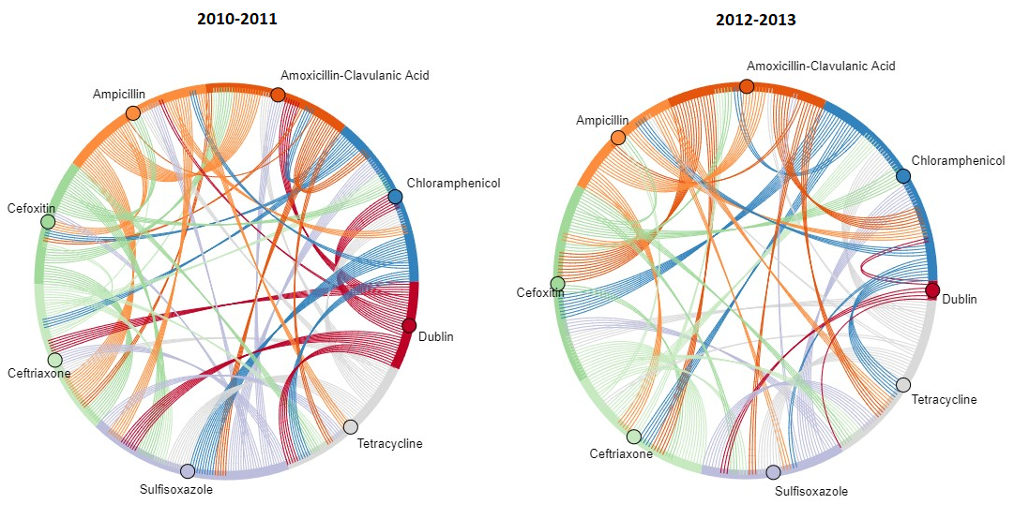

Figure 1 – Association rules of antimicrobial resistance. Antimicrobials are colored and ordered by class. The arc is colored by the antecedent in the antecedent-consequent pair. The number of arcs is proportional to the total lift of the antecedent-consequent pair.

Overall, patterns of associations in both intervals were consistent. The Chord diagrams illustrate strong correlations between resistances in phenicols, beta-lactams, cephalosporins, sulfonamide, and tetracycline. Cephalosporins and beta-lactams were highly connected to other classes in both intervals. There were also strong intra-class connections within beta-lactam antimicrobials, as expected for within-class resistances. The largest ten aggregated lifts of antimicrobial pairs in the 2010–2011 and 2012–2013 intervals are presented in Table 1 and Table 2, respectively, and all antimicrobial pairs are in Supplementary Table 3.

Dublin is the only serotype that appears in the association rules that met the interestingness thresholds, indicating that there are resistance patterns specific to this serotype. However, as shown in Figure 1, after 2012 there was a decrease in number of rules containing the Dublin serotype, suggesting that AMR patterns were more consistent across all serotypes after 2012.

Table 1- Top ten aggregated lifts of association rules 2010-2011. Lift was summed across all association rules that contained the antecedent-consequent pair.

|  |  |  |
| --- | --- | --- |
| Association Antecedent | Association Consequent | Aggregated Lift |
| Ampicillin | Amoxicillin-Clavulanic Acid | 50.49 |
| Ampicillin | Ceftriaxone | 50.31 |
| Chloramphenicol | Sulfisoxazole | 47.41 |
| Tetracycline | Sulfisoxazole | 38.78 |
| Cefoxitin | Ceftriaxone | 34.47 |
| Dublin | Chloramphenicol | 31.27 |
| Sulfisoxazole | Chloramphenicol | 31.23 |
| Dublin | Sulfisoxazole | 29.49 |
| Cefoxitin | Sulfisoxazole | 29.39 |
| Cefoxitin | Amoxicillin-Clavulanic Acid | 28.44 |

Table 2- Top ten aggregated lifts of association rules 2012-2013. Lift was summed across all association rules that contained the antecedent-consequent pair.

|  |  |  |
| --- | --- | --- |
| Association Antecedent | Association Consequent | Aggregated Lift |
| Ceftriaxone | Cefoxitin | 31.34 |
| Amoxicillin-Clavulanic Acid | Cefoxitin | 30.58 |
| Ampicillin | Amoxicillin-Clavulanic Acid | 25.55 |
| Tetracycline | Chloramphenicol | 24.33 |
| Sulfisoxazole | Chloramphenicol | 24.24 |
| Tetracycline | Sulfisoxazole | 24.03 |
| Chloramphenicol | Cefoxitin | 22.73 |
| Cefoxitin | Chloramphenicol | 18.57 |
| Ceftriaxone | Chloramphenicol | 18.50 |
| Chloramphenicol | Tetracycline | 18.38 |

To investigate changes after 2012, the association rules meet thresholds in at least one period were compared by differences in support, confidence, and lift (Table 3). The comparison indicated significant changes in proportion of sulfisoxazole and tetracycline resistance after 2012 for Dublin since the supports are decreased more than 37%; however, this pattern was not seen among other serotypes.

Table 3- Significant changes among resistances meeting thresholds of 0.05 support, 0.10 RAR support, 0.8 confidence and 1.5 lift in at least one time period. * major difference of 25% or more in support or lift, or 10% or more in confidence

|  |  |  |  |  |  |  |  |  |  |
| --- | --- | --- | --- | --- | --- | --- | --- | --- | --- |
| Association | Support | | | Confidence | | | Lift | | |
| 2010-2011 | 2012-2013 | Change | 2010-2011 | 2012-2013 | Change | 2010-2011 | 2012-2013 | Change |
| [SEROTYPE:Dublin, Tetracycline] -> [Sulfisoxazole] | 0.12 | 0.07 | * -39 % | 0.99 | 0.95 | -3% | 4.35 | 4.73 | 8% |
| [SEROTYPE:Dublin] -> [Sulfisoxazole] | 0.12 | 0.07 | * -38 % | 0.90 | 0.86 | -4% | 3.97 | 4.28 | 7% |
| [SEROTYPE:Dublin] -> [Tetracycline] | 0.12 | 0.07 | * -37 % | 0.89 | 0.86 | -2% | 2.78 | 3.22 | 15% |

In the second phase of the study, a Clauset-Newman-Moore greedy community detection approach was employed over a bipartite network of resistances for both intervals (Figures 2, 3). The degree centrality of each node and modularity of the network were calculated. The modularity of the network was stable before and after 2012 (0.156 for 2010–2011 and 0.158 for 2012–2013) demonstrating that strength of community structure didn’t change significantly after 2012.

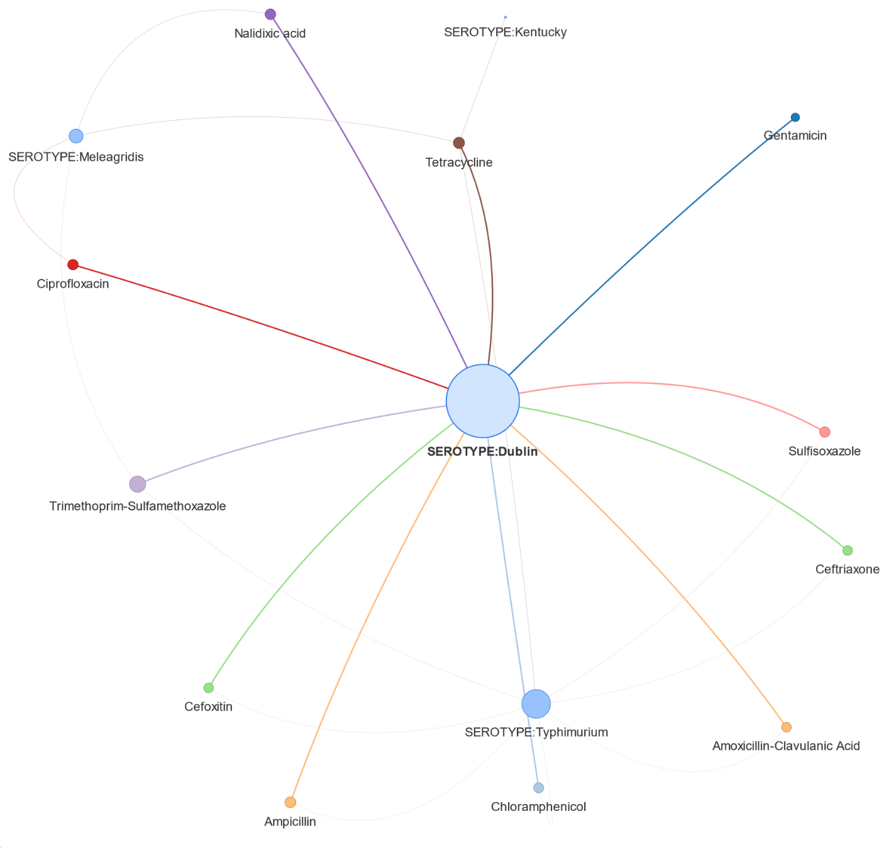

Figure 2 – Bipartite network of resistances and corresponding serotypes from 2010 to 2011

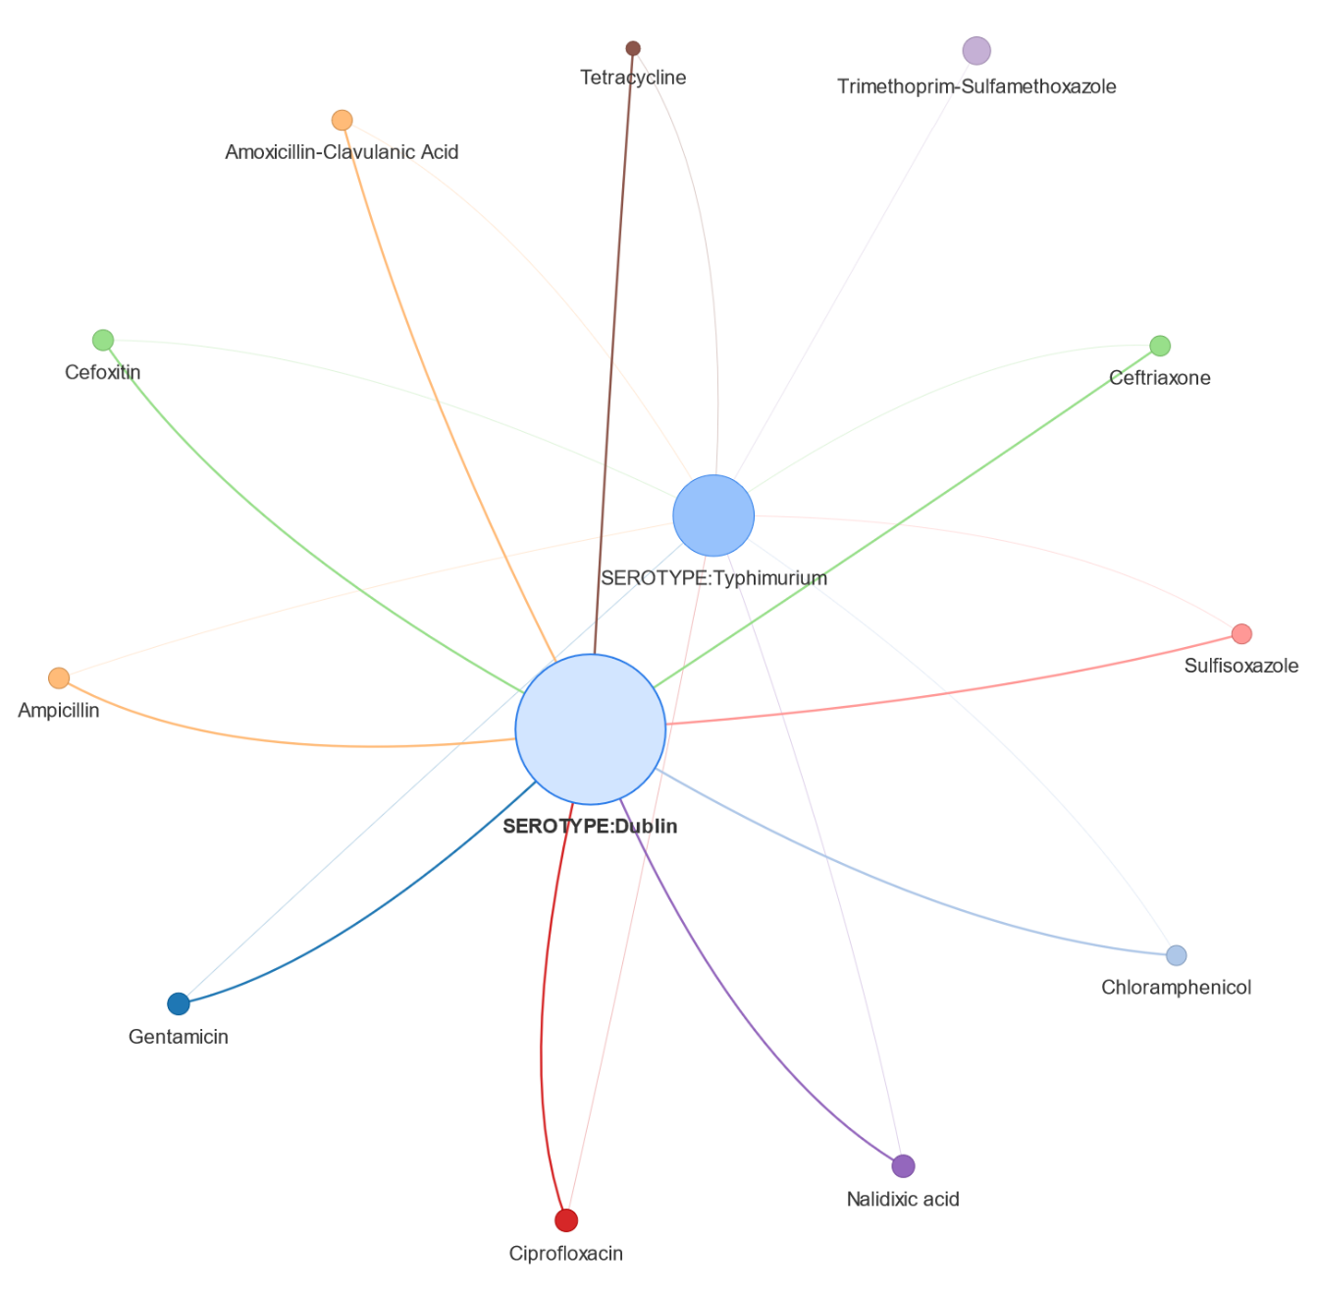

Figure 3 – Bipartite network of resistances and corresponding serotypes from 2012 to 2013

We compared the communities produced by the greedy community detector algorithm over AMR bipartite networks in 2010–2011 and 2012–2013 intervals (Table 4).

Table 4 – Community and degree centrality in the bipartite AMR networks. Community of Dublin serotype is shaded in orange and Typhimurium serotype is shaded in blue.

|  |  |  |  |  |
| --- | --- | --- | --- | --- |
|  | Community Membership | | Degree Centrality | |
| Node | 2010-2011 | 2012-2013 | 2010-2011 | 2012-2013 |
| Amoxicillin-Clavulanic Acid | 1 | 1 | 0.14 | 0.17 |
| Cefoxitin | 1 | 1 | 0.14 | 0.17 |
| Ceftriaxone | 1 | 1 | 0.14 | 0.17 |
| Ciprofloxacin | 1 | 1 | 0.14 | 0.17 |
| Gentamicin | 1 | 1 | 0.07 | 0.17 |
| Nalidixic acid | 1 | 1 | 0.14 | 0.17 |
| SEROTYPE:Dublin | 1 | 1 | 0.79 | 0.83 |
| Ampicillin | 2 | 1 | 0.14 | 0.17 |
| Chloramphenicol | 2 | 1 | 0.14 | 0.17 |
| Sulfisoxazole | 2 | 2 | 0.14 | 0.17 |
| SEROTYPE:Typhimurium | 2 | 2 | 0.57 | 0.92 |
| Tetracycline | 3 | 2 | 0.29 | 0.17 |
| Trimethoprim-Sulfamethoxazole | 3 | 2 | 0.21 | 0.08 |
| SEROTYPE:Kentucky | 3 |  | 0.07 |  |
| SEROTYPE:Meleagridis | 3 |  | 0.29 |  |

The Dublin community gained more members after 2012 and contained 8 out of 11 antimicrobials. There were two important cluster shifts in this community after 2012. Ampicillin and chloramphenicol shifted from the Typhimurium to the Dublin community. On the other hand, tetracycline and trimethoprim-sulfamethoxazole moved to the Typhimurium community. Network analysis also indicated a similarity between Dublin and Typhimurium resistance patterns. Both serotypes showed diverse AMR patterns represented by edges between them and most antimicrobials in network graphs (Figure 4, 5).

Lastly, we applied an agglomerative hierarchical clustering algorithm to cluster antimicrobial resistances by phenotypic characteristics using average linkage and Euclidean distance with cut-off factor of ten clusters for each interval (Supplementary Tables 4, 5). The Dublin serotype showed a specific resistance pattern before 2012 since the isolates in two clusters are more than 90% of Dublin serotype (Figure 4, Cluster 3 and Cluster 6); however, no cluster consists of more than 60% Dublin isolates after 2012 (Figure 5).

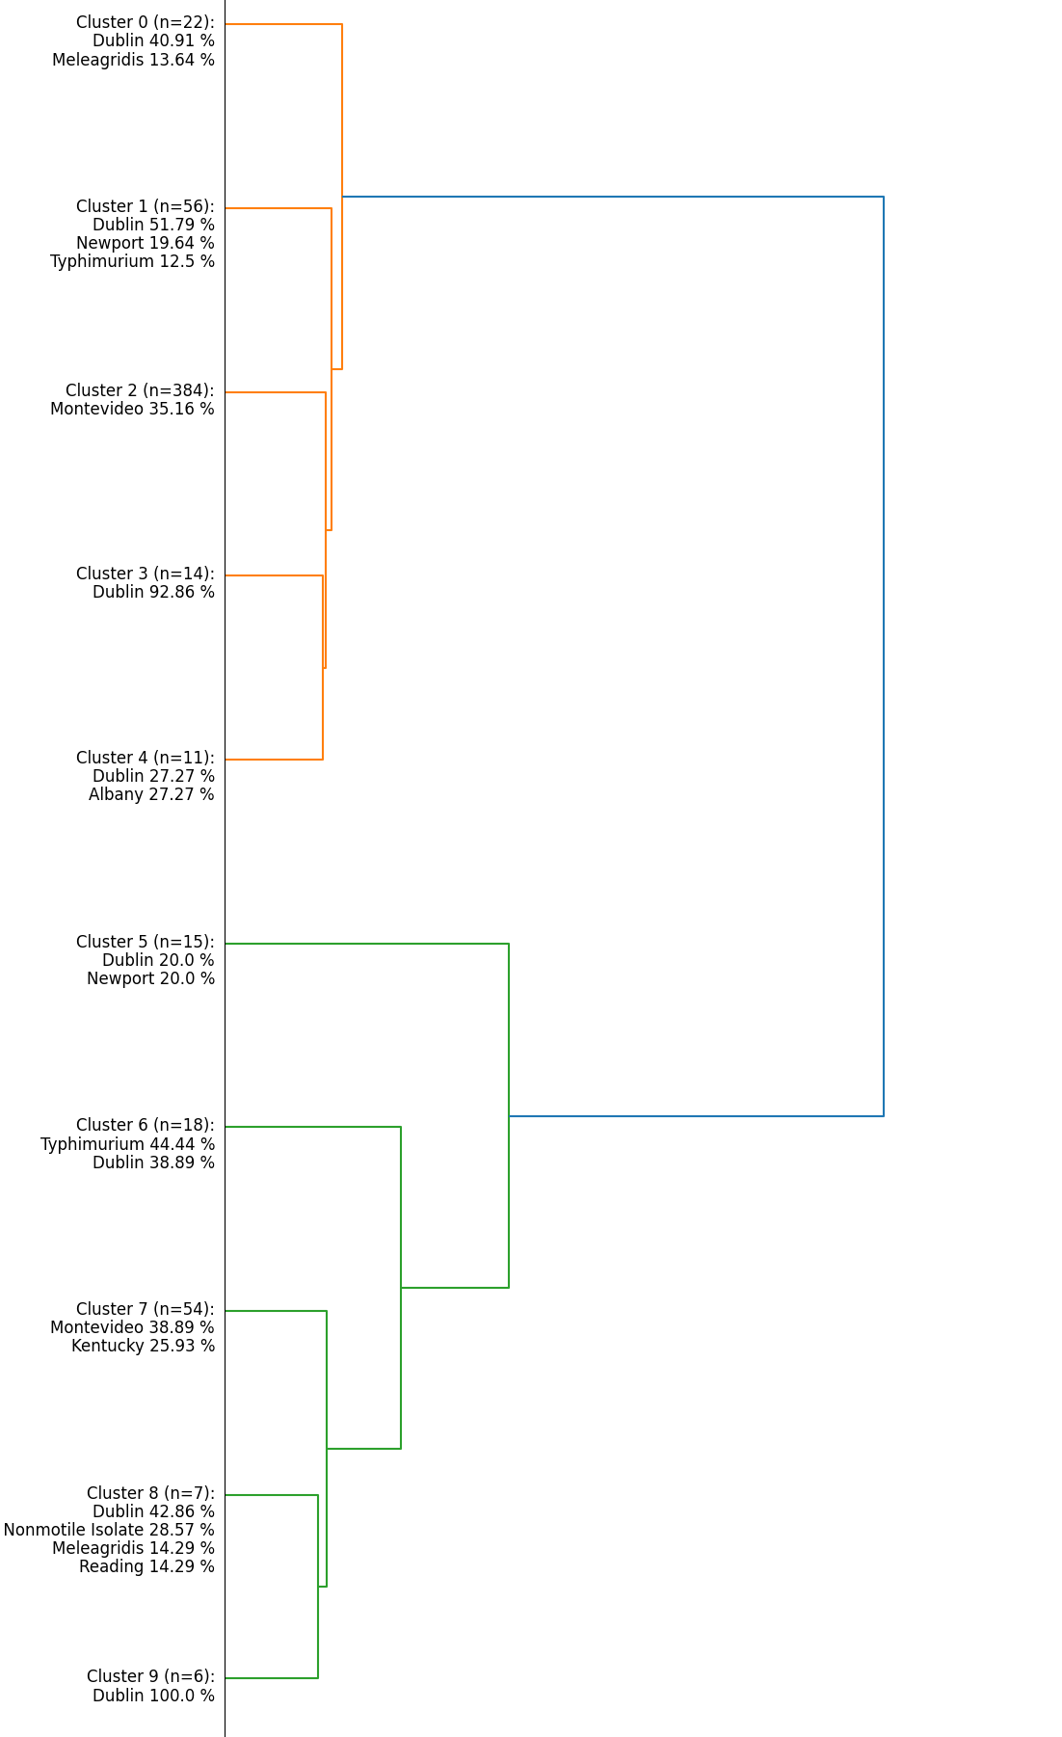

Figure 4 – Hierarchical clustering of resistance profiles among isolates from 2010 to 2011

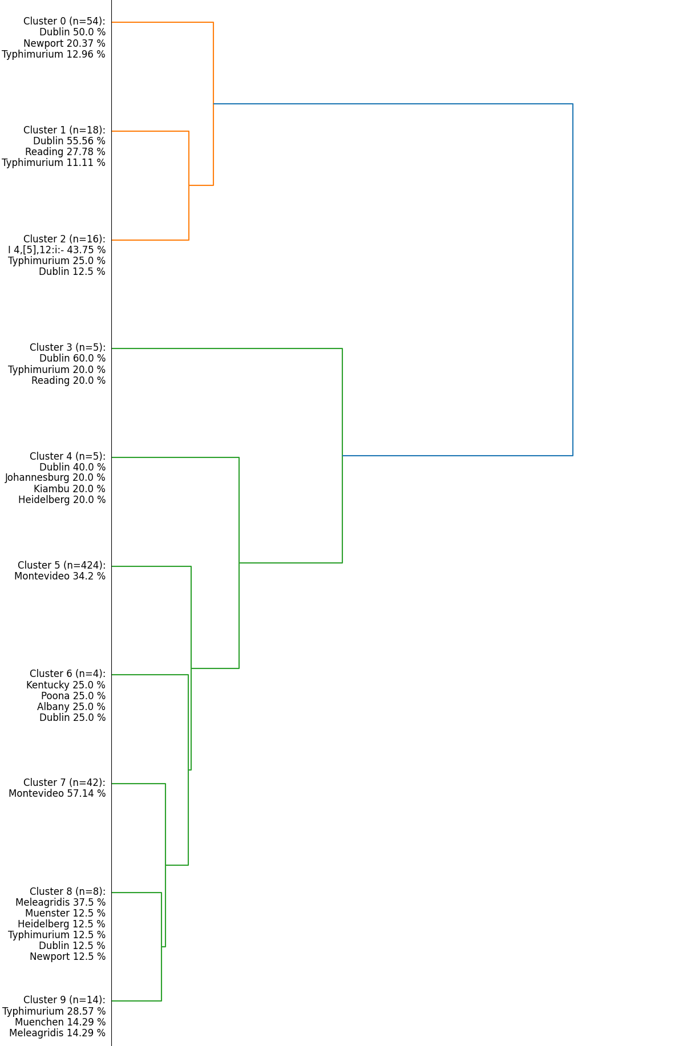

Figure 5 – Hierarchical clustering of resistance profiles among isolates from 2012 to 2013

**Discussion**

International authorities have called for the One Health approach to study AMR and develop strategies to mitigate the development and spread of AMR. In this study, we used an integrated AI approach to analyse *Salmonella* AMR and MDR patterns before and after the implementation of AMU restrictions in agriculture intended to reduce the burden of bacterial AMR. We investigated patterns of antimicrobial resistance using descriptive analytics consisting of association rule mining, hierarchical clustering, and network analysis.

Association rules with chloramphenicol, tetracycline, and sulfisoxazole resistances have high lift values, indicating that those resistances occur together much more often than would be expected by random chance in both intervals. Cephalosporin resistance have been found to be associated with cross-resistance to other antimicrobials and MDR (Jeon et al., 2019). Cephalosporins (ceftriaxone and cefoxitin) mostly appeared with lower lifts in rules consisting of other antimicrobial classes after 2012 (Supplementary Table 3). The result is consistent with previous findings on downward phenotypic resistance trends after implementing Food and Drug Administration (FDA) guidance on antimicrobial use (Deb et al., 2023) and significant associations between lower presence of resistances and restrictions of antimicrobials in food-producing animals (Nobrega et al., 2021; Tang et al., 2017).

Regarding resistance patterns of serotypes, network analysis revealed a similarity between *S.* Dublin and *S.* Typhimurium. The result supports a previous study (Holschbach and Peek, 2018) which suggested that these two serotypes are closely related and share the host predilection for cattle. Typhimurium serotype showed the largest increase in degree centrality after 2012, which indicates that it diversified its resistance pattern. Despite the increase in diversity, the number of community members (intensity) remained stable. However, the Typhimurium community showed more dynamicity in membership changes than the Dublin community. In both intervals, the community that included the Dublin serotype was the largest community. In other words, for most antimicrobials in this study, there were more interconnections (intensity) with the Dublin serotype than any other serotype. The community grew after 2012 which implies increase in interconnections between Dublin serotype and various antimicrobial resistances after 2012. The results are consistent with prevalence of resistance in Dublin serotype which shows more significant increases after 2012 comparing non-Dublin serotypes.

The only serotype that appeared in the association rules was Dublin indicating that this serotype has a specific antimicrobial resistance pattern. However, this pattern weakened in association rules after 2012. The specific pattern of Dublin serotype before 2012 was also aligned with clustering results in which two clusters contained only Dublin serotype before 2012 and a same trend is presented in the clusters after 2012 where specific clusters of Dublin serotype disappeared.

There was a limitation on availability of isolates’ meta data in this study. Additional metadata of the isolates make it possible to include new types of analysis and models. Moreover, additional descriptive ML models can be deployed to provide a better understanding of other aspects of multidrug resistance.

**Conclusions**

Most studies in the existing literature employed ML techniques focused on black-box models. Although most of such black-box models achieved high accuracy rates, especially in prediction and classification tasks but they don’t provide deep understanding of AMR patterns. The results of various descriptive models in our study show potentials of white-box ML approaches to reveal different aspects of anti-microbial resistances. Hierarchical clustering provided characteristics of similar AMR profiles. Due to its hierarchical structure, the resulting clusters are more interpretable than clusters by flat segmentation methods since they provide insights into the underlying subclusters. By cutting the hierarchical structure, it provided a flexible way to explore similarities between AMR profiles at different levels of granularity. Network analysis revealed dynamism of changes in antimicrobial communities. It illustrated key nodes having significant impacts on the structure within the network of antimicrobials and serotypes also AMR communities, where antimicrobials and corresponding serotypes are densely connected internally which are crucial for understanding the dynamics of resistances. Finally, association rule mining presented the patterns and rules of antimicrobial resistances which are interpretable and aiding in decision-making in clinical practices. This approach is well-suited for AMR data where each isolate contains a single transaction of AMR profiles, and provided valuable insights into AMR patterns by uncovering complex rules and interesting relationships in AMR profiles that cannot be detected using analytical methods investigating one-to-one or first-order associations. Although each of these methods revealed valuable information on AMR patterns in our study; however, none of them was capable to cover all aspects of resistance patterns that identifies a need for integrating various descriptive ML approaches in AMR studies. Further work needed to integrate white-box and black-box ML approaches in this field of research and employ AI-driven models in clinical practices.

**Acknowledgements**

This work was supported by a Hatch award under 7000403 from the USDA National Institute of Food and Agriculture.

**References**

1. Burgos, E., Ceva, H., Hernández, L., Perazzo, R.P., Devoto, M. and Medan, D., 2008. Two classes of bipartite networks: nested biological and social systems. Physical Review E, 78(4), p.046113.
2. Cazer, C. L., Westblade, L. F., Simon, M. S., Magleby, R., Castanheira, M., Booth, J. G., ... & Gröhn, Y. T., 2021. Analysis of Multidrug Resistance in Staphylococcus aureus with a Machine Learning-Generated Antibiogram. Antimicrobial Agents and Chemotherapy, 65(4), e02132-20.
3. CDC. Salmonella Infection Questions and Answers. Edited by Centers for Disease Control and Prevention. Atlanta, GA: U.S. Department of Health and Human Services, CDC; 2019.
4. Clauset, A., Newman, M.E. and Moore, C., 2004. Finding community structure in very large networks. Physical review E, 70(6), p.066111.
5. Coelho JR, Carriço JA, Knight D, Martínez J-L, Morrissey I, Oggioni MR, et al., 2013. The Use of Machine Learning Methodologies to Analyse Antibiotic and Biocide Susceptibility in Staphylococcus aureus. PLoS ONE 8(2): e55582.
6. Cummings, K.J., Perkins, G.A., Khatibzadeh, S.M., Warnick, L.D. and Altier, C., 2013. Antimicrobial resistance trends among Salmonella isolates obtained from dairy cattle in the northeastern United States, 2004–2011. Foodborne pathogens and disease, 10(4), pp.353-361.
7. Cummings, K.J., Virkler, P.D., Wagner, B., Lussier, E.A. and Thompson, B.S., 2018. Herd‐level prevalence of Salmonella Dublin among New York dairy farms based on antibody testing of bulk tank milk. Zoonoses and public health, 65(8), pp.1003-1007.
8. Deb, L. C., Jara, M., & Lanzas, C., 2023. Early evaluation of the Food and Drug Administration (FDA) guidance on antibiotic use in food animals on antimicrobial resistance trends reported by the National Antimicrobial Resistance Monitoring System (2012–2019). One Health, 100580.
9. FDA. New Animal Drugs; Cephalosporin Drugs; Extralabel Animal Drug Use; Order of Prohibition (FDA-2008-N-0326). Washington D.C: U.S. Food and Drug Administration. 2012.
10. FDA. Guidance for Industry on Revising Approved Conditions of Use for New Animal Drugs and New Animal Drug Combination Products Administered in or on Medicated Feed or Drinking Water of Food-Producing Animals to Align with GFI #209. Washington D.C: U.S. Food and Drug Administration. 2017.
11. Ferguson, R. B., 2012. Risky business: How data analytics and behavioral science can help. MIT Sloan Management Review, 54, 1–5.
12. Harvey, R.R., Friedman, C.R., Crim, S.M., Judd, M., Barrett, K.A., Tolar, B., Folster, J.P., Griffin, P.M. and Brown, A.C., 2017. Epidemiology of Salmonella enterica serotype Dublin infections among humans, United States, 1968–2013. Emerging infectious diseases, 23(9), p.1493.
13. Holschbach, C. L., and S. F. Peek. 2018. Salmonella in Dairy Cattle, Vet Clin North Am Food Anim Pract, 34: 133-54.
14. Jacobs, T.G., Robertson, J., van den Ham, H.A., Iwamoto, K., Bak Pedersen, H. and Mantel-Teeuwisse, A.K., 2019. Assessing the impact of law enforcement to reduce over-the-counter (OTC) sales of antibiotics in low-and middle-income countries; a systematic literature review. BMC health services research, 19(1), pp.1-15.
15. Jahne MA, Rogers SW, Ramler IP, Holder E, Hayes G. Hierarchal clustering yields insight into multidrug-resistant bacteria isolated from a cattle feedlot wastewater treatment system. Environ Monit Assess. 2015 Jan;187(1):4168.
16. Jeon HY, Kim YB, Lim SK, Lee YJ, Seo KW. Characteristics of cephalosporin-resistant Salmonella isolates from poultry in Korea, 2010-2017. Poult Sci. 2019 Feb 1;98(2):957-965.
17. Lee, A.L.H.; To, C.C.K.; Lee, A.L.S.; Chan, R.C.K.; Wong, J.S.H.; Wong, C.W.; Chow, V.C.Y.; Lai, R.W.M. Deep learning model for prediction of extended-spectrum beta-lactamase (ESBL) production in community-onset Enterobacteriaceae bacteraemia from a high ESBL prevalence multi-centre cohort. Eur. J. Clin. Microbil. Infect. Dis. 2021, 40, 1049–1061.
18. Li, H., Wang, Y., Zhang, D., Zhang, M., & Chang, E., 2008. PFP: Parallel FP-growth for query recommendation. In Proceedings of the 2008 ACM conference on Recommender systems (pp. 107–114).
19. Mangat, C.S., Bekal, S., Avery, B.P., Côté, G., Daignault, D., Doualla-Bell, F., Finley, R., Lefebvre, B., Bharat, A., Parmley, E.J. and Reid-Smith, R.J., 2019. Genomic investigation of the emergence of invasive multidrug-resistant Salmonella enterica serovar Dublin in humans and animals in Canada. Antimicrobial Agents and Chemotherapy, 63(6), pp.10-1128.
20. Mather CA, Werth BJ, Sivagnanam S, et al. Rapid detection of vancomycin intermediate staphylococcus aureus by matrix-assisted laser desorption ionization–time of flight mass spectrometry. J Clin Microbiol 2016; 54:883–890.
21. Nguyen, M., Long, S.W., McDermott, P.F., Olsen, R.J., Olson, R., Stevens, R.L., Tyson, G.H., Zhao, S. and Davis, J.J., 2019. Using machine learning to predict antimicrobial MICs and associated genomic features for nontyphoidal Salmonella. Journal of clinical microbiology, 57(2), pp.10-1128.
22. Nielsen, L. R., Y. H. Schukken, Y. T. Gröhn, and A. K. Ersbøll. 2004. Salmonella Dublin infection in dairy cattle: risk factors for becoming a carrier, Prev Vet Med, 65: 47-62.
23. Nobrega, D. B., Tang, K. L., Caffrey, N. P., De Buck, J., Cork, S. C., Ronksley, P. E., ... & Barkema, H. W., 2021. Prevalence of antimicrobial resistance genes and its association with restricted antimicrobial use in food-producing animals: a systematic review and meta-analysis. Journal of Antimicrobial Chemotherapy, 76(3), 561-575.
24. Pascual-Sánchez, L.; Mora-Jiménez, I.; Martínez-Agüero, S.; Álvarez-Rodríguez, J.; Soguero-Ruiz, C. Predicting multidrug resistance using temporal clinical data and machine learning methods. In Proceedings of the IEEE International Conference on Bioinformatics and Biomedicine (BIBM), Houston, TX, USA, 9–12 December 2021; pp. 2826–2833
25. Pires, João, Jana S. Huisman, Sebastian Bonhoeffer, and Thomas P. Van Boeckel. 2021. 'Multidrug Resistance Dynamics in Salmonella in Food Animals in the United States: An Analysis of Genomes from Public Databases', Microbiology Spectrum, 9: e00495-21.
26. Ragel A., Cremilleux, B., 1999. MVC – a preprocessing method to deal with missing values. Knowledge-Based Systems, Vol. 12, No. 5.
27. Srednik, Mariela E., Kristina Lantz, Jessica A. Hicks, Brenda R. Morningstar-Shaw, Tonya A. Mackie, and Linda K. Schlater. 2021. 'Antimicrobial resistance and genomic characterization of Salmonella Dublin isolates in cattle from the United States', PLOS ONE, 16: e0249617.
28. STARR. Preserve Antibiotics Protect the Future. New York, NY: U.S. NYS Antimicrobial Resistance Prevention and Control Task Force (2018).
29. Tang, K. L., Caffrey, N. P., Nóbrega, D. B., Cork, S. C., Ronksley, P. E., Barkema, H. W., ... & Ghali, W. A., 2017. Restricting the use of antibiotics in food-producing animals and its associations with antibiotic resistance in food-producing animals and human beings: a systematic review and meta-analysis. The Lancet Planetary Health, 1(8), e316-e327.
30. Telikani, A., Gandomi, A. H., & Shahbahrami, A., 2020. A survey of evolutionary computation for association rule mining. Information Sciences, 524, 318-352.
31. Valenzuela, J. R., A. K. Sethi, N. A. Aulik, and K. P. Poulsen. 2017. Antimicrobial resistance patterns of bovine Salmonella enterica isolates submitted to the Wisconsin Veterinary Diagnostic Laboratory: 2006-2015, J Dairy Sci, 100: 1319-30.
32. World Health Organization. 2021. Antimicrobial Resistance Key Facts. Available at: <https://www.who.int/news-room/fact-sheets/detail/antimicrobial-resistance> [accessed 27 July 2023]
33. Zhang G, Guan Y, Zhao R, Feng J, Huang J, Ma L, Li B. Metagenomic and network analyses decipher profiles and co-occurrence patterns of antibiotic resistome and bacterial taxa in the reclaimed wastewater distribution system. J Hazard Mater. 2020 Dec 5; 400:123170

**Supplementary Content**

Table 1 – List of antimicrobials in this study

|  |  |  |  |  |
| --- | --- | --- | --- | --- |
| Antimicrobial | Antimicrobial Class | Breakpoints for *Salmonella* bacteria (Cattle) | | |
| Susceptible | Intermediate | Resistant |
| Amoxicillin-Clavulanic Acid | Beta lactam | ≤ 8 | 16 | ≥ 32 |
| Ampicillin | Penicillins | ≤ 8 | 16 | ≥ 32 |
| Cefoxitin | Cephems | ≤ 8 | 16 | ≥ 32 |
| Ceftriaxone | Cephems | ≤ 1 | 2 | ≥ 4 |
| Chloramphenicol | Phenicols | ≤ 8 | 16 | ≥ 32 |
| Ciprofloxacin | Quinolones | ≤ 0.06 | ≥ 0.12 | ≥ 0.12 |
| Gentamicin | Aminoglycosides | ≤ 4 | 8 | `≥ 16 |
| Nalidixic acid | Quinolones | ≤ 16 |  | ≥ 32 |
| Sulfisoxazole | Folate pathway inhibitors | ≤ 256 |  | ≥ 512 |
| Tetracycline | Tetracyclines | ≤ 4 | 8 | ≥ 16 |
| Trimethoprim-Sulfamethoxazole | Folate pathway inhibitors | ≤ 2 |  | ≥ 4 |

Table 2 – Prevalence of resistance by antimicrobial classes. Significant decreases in resistance over time are shaded in green and significant increases in resistance are shaded in orange (significance level of 95% confidence).

|  |  |  |  |  |  |  |
| --- | --- | --- | --- | --- | --- | --- |
| Antimicrobial Class | Dublin | | | Non-Dublin | | |
| 2010-2011 | 2012-2013 | P-value | 2010-2011 | 2012-2013 | P-value |
| Aminoglycosides | 18.99 | 15.69 | 0.63 | 1.18 | 0.93 | 0.69 |
| Beta lactam | 68.35 | 78.43 | 0.21 | 11.81 | 8.16 | 0.05 |
| Cephems | 63.29 | 76.47 | 0.03 | 10.83 | 7.05 | 0.00 |
| Folate pathway inhibitors | 46.84 | 43.14 | 0.56 | 7.48 | 7.61 | 0.91 |
| Penicillins | 75.95 | 80.39 | 0.55 | 12.60 | 10.20 | 0.22 |
| Phenicols | 87.34 | 84.31 | 0.63 | 10.63 | 9.09 | 0.40 |
| Quinolones | 13.29 | 25.49 | 0.01 | 0.69 | 1.39 | 0.12 |
| Tetracyclines | 88.61 | 86.27 | 0.69 | 23.62 | 21.52 | 0.42 |

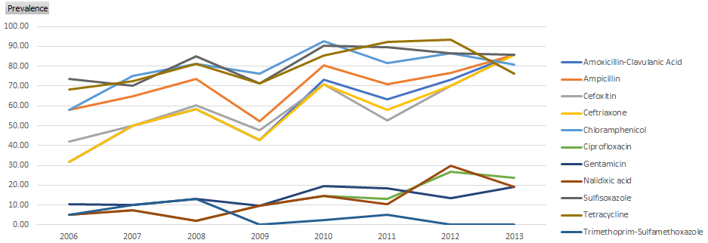

Figure 1- Trends of prevalence in Dublin serotype

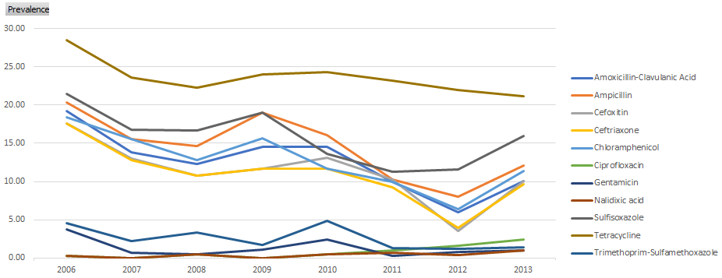

Figure 2- Trends of prevalence in non-Dublin serotypes

Table 3– Aggregated lifts of association rules. Associations between cephalosporins and other classes of antimicrobials are shaded in blue.

|  |  |  |  |
| --- | --- | --- | --- |
| Association Antecedent | Association Consequent | Aggregated Lift Before 2012 | Aggregated Lift After 2012 |
| Ampicillin | Amoxicillin-Clavulanic Acid | 50.49 | 25.55 |
| Ampicillin | Ceftriaxone | 50.31 | 13.31 |
| Chloramphenicol | Sulfisoxazole | 47.41 | 4.85 |
| Tetracycline | Sulfisoxazole | 38.78 | 24.03 |
| Cefoxitin | Ceftriaxone | 34.47 | 7.76 |
| Dublin | Chloramphenicol | 31.27 | 5.53 |
| Sulfisoxazole | Chloramphenicol | 31.23 | 24.24 |
| Dublin | Sulfisoxazole | 29.49 | 9.01 |
| Cefoxitin | Sulfisoxazole | 29.39 | 9.44 |
| Cefoxitin | Amoxicillin-Clavulanic Acid | 28.44 | 7.56 |
| Tetracycline | Chloramphenicol | 26.58 | 24.33 |
| Dublin | Amoxicillin-Clavulanic Acid | 25.77 | - |
| Dublin | Ceftriaxone | 25.61 | - |
| Ampicillin | Sulfisoxazole | 24.88 | 9.39 |
| Sulfisoxazole | Tetracycline | 21.61 | 18.3 |
| Chloramphenicol | Tetracycline | 21.33 | 18.38 |
| Amoxicillin-Clavulanic Acid | Sulfisoxazole | 21.23 | 9.39 |
| Ceftriaxone | Sulfisoxazole | 21.22 | 9.38 |
| Dublin | Tetracycline | 20.85 | 3.22 |
| Sulfisoxazole | Amoxicillin-Clavulanic Acid | 20.74 | 6.18 |
| Sulfisoxazole | Ceftriaxone | 20.73 | - |
| Cefoxitin | Ampicillin | 19.04 | 6.15 |
| Amoxicillin-Clavulanic Acid | Chloramphenicol | 18.04 | 18.25 |
| Ceftriaxone | Chloramphenicol | 18.03 | 18.5 |
| Cefoxitin | Chloramphenicol | 17.97 | 18.57 |
| Ampicillin | Chloramphenicol | 17.1 | 11.1 |
| Sulfisoxazole | Ampicillin | 16.8 | - |
| Tetracycline | Ampicillin | 16.75 | 5.24 |
| Tetracycline | Amoxicillin-Clavulanic Acid | 15.48 | 6.27 |
| Tetracycline | Ceftriaxone | 15.48 | 6.26 |
| Chloramphenicol | Amoxicillin-Clavulanic Acid | 15.4 | 6.96 |
| Chloramphenicol | Ceftriaxone | 15.33 | 14.7 |
| Ampicillin | Tetracycline | 14.99 | 10.76 |
| Cefoxitin | Tetracycline | 14.93 | 10.89 |
| Ampicillin | Cefoxitin | 14.89 | 7.13 |
| Chloramphenicol | Ampicillin | 12.32 | 10.43 |
| Amoxicillin-Clavulanic Acid | Tetracycline | 12.12 | 10.85 |
| Ceftriaxone | Tetracycline | 12.11 | 10.85 |
| Amoxicillin-Clavulanic Acid | Ceftriaxone | 11.45 | 15.21 |
| Chloramphenicol | Cefoxitin | 10.05 | 22.73 |
| Sulfisoxazole | Cefoxitin | 9.88 | 15.5 |
| Dublin | Ampicillin | 8.59 | - |
| Ceftriaxone | Amoxicillin-Clavulanic Acid | 5.7 | 7.56 |
| Ceftriaxone | Cefoxitin | 5.7 | 31.34 |
| Amoxicillin-Clavulanic Acid | Cefoxitin | 5.64 | 30.58 |
| Amoxicillin-Clavulanic Acid | Ampicillin | 4.77 | 6.15 |
| Ceftriaxone | Ampicillin | 4.77 | 6.15 |
| Tetracycline | Cefoxitin | - | 15.5 |

Table 4- Clusters of antimicrobial resistances by phenotypic characteristics among isolates from 2010 to 2011

Cluster No: 0

Cluster Size: 22

Cluster Analysis:

SEROTYPE: Dublin: 40.91 %, Meleagridis: 13.64 %

AMR Phenotypes:

[Cefoxitin, Chloramphenicol]

[Amoxicillin-Clavulanic Acid, Ampicillin, Gentamicin]

[Gentamicin, Sulfisoxazole, Tetracycline]

[Ampicillin, Chloramphenicol, Gentamicin, Sulfisoxazole, Tetracycline]

[Chloramphenicol, Gentamicin, Sulfisoxazole, Tetracycline]

[Chloramphenicol, Tetracycline]

[Sulfisoxazole, Tetracycline, Trimethoprim-Sulfamethoxazole]

[Cefoxitin, Chloramphenicol, Sulfisoxazole, Tetracycline]

[Gentamicin, Sulfisoxazole]

[Cefoxitin, Chloramphenicol, Sulfisoxazole]

[Sulfisoxazole]

[Chloramphenicol, Sulfisoxazole, Tetracycline]

[Sulfisoxazole, Tetracycline]

----------------------------------------------------------------------------------------------------------------------------------------------

Cluster No: 1

Cluster Size: 56

Cluster Analysis:

SEROTYPE: Dublin: 51.79 %, Typhimurium: 12.5 %, Newport: 19.64 %

AMR Phenotypes:

[Amoxicillin-Clavulanic Acid, Ampicillin, Cefoxitin, Ceftriaxone, Chloramphenicol, Sulfisoxazole, Tetracycline]

[Amoxicillin-Clavulanic Acid, Ampicillin, Ceftriaxone, Chloramphenicol, Sulfisoxazole, Tetracycline]

----------------------------------------------------------------------------------------------------------------------------------------------

Cluster No: 2

Cluster Size: 384

Cluster Analysis:

SEROTYPE: Montevideo: 35.16 %

AMR Phenotypes:

[Cefoxitin]

[All susceptible]

[Ciprofloxacin, Nalidixic acid]

[Ampicillin, Ciprofloxacin, Nalidixic acid]

----------------------------------------------------------------------------------------------------------------------------------------------

Cluster No: 3

Cluster Size: 14

Cluster Analysis:

SEROTYPE: Dublin: 92.86 %

AMR Phenotypes:

[Amoxicillin-Clavulanic Acid, Ampicillin, Cefoxitin, Ceftriaxone, Chloramphenicol, Gentamicin]

[Amoxicillin-Clavulanic Acid, Ampicillin, Cefoxitin, Ceftriaxone, Chloramphenicol, Gentamicin, Sulfisoxazole]

[Amoxicillin-Clavulanic Acid, Ampicillin, Cefoxitin, Ceftriaxone, Chloramphenicol, Gentamicin, Sulfisoxazole, Tetracycline]

----------------------------------------------------------------------------------------------------------------------------------------------

Cluster No: 4

Cluster Size: 11

Cluster Analysis:

SEROTYPE: Dublin: 27.27 %, Albany: 27.27 %

AMR Phenotypes:

[Amoxicillin-Clavulanic Acid, Ampicillin, Cefoxitin, Ceftriaxone, Sulfisoxazole, Tetracycline]

[Amoxicillin-Clavulanic Acid, Ampicillin, Cefoxitin, Ceftriaxone]

[Amoxicillin-Clavulanic Acid, Ampicillin, Cefoxitin, Ceftriaxone, Chloramphenicol, Tetracycline]

[Amoxicillin-Clavulanic Acid, Ampicillin, Cefoxitin, Ceftriaxone, Gentamicin, Sulfisoxazole, Tetracycline]

[Amoxicillin-Clavulanic Acid, Ampicillin, Cefoxitin, Ceftriaxone, Tetracycline]

----------------------------------------------------------------------------------------------------------------------------------------------

Cluster No: 5

Cluster Size: 15

Cluster Analysis:

SEROTYPE: Dublin: 20.0 %, Newport: 20.0 %

AMR Phenotypes:

[Amoxicillin-Clavulanic Acid, Ampicillin, Cefoxitin, Ceftriaxone, Chloramphenicol, Sulfisoxazole, Tetracycline, Trimethoprim-Sulfamethoxazole]

[Amoxicillin-Clavulanic Acid, Ampicillin, Cefoxitin, Ceftriaxone, Chloramphenicol, Gentamicin, Sulfisoxazole, Tetracycline, Trimethoprim-Sulfamethoxazole]

----------------------------------------------------------------------------------------------------------------------------------------------

Cluster No: 6

Cluster Size: 18

Cluster Analysis:

SEROTYPE: Typhimurium: 44.44 %, Dublin: 38.89 %

AMR Phenotypes:

[Ampicillin, Sulfisoxazole, Tetracycline]

[Amoxicillin-Clavulanic Acid, Ampicillin, Sulfisoxazole, Tetracycline]

[Ampicillin, Chloramphenicol, Tetracycline]

[Ampicillin, Chloramphenicol, Sulfisoxazole, Tetracycline]

[Amoxicillin-Clavulanic Acid, Ampicillin, Chloramphenicol, Sulfisoxazole, Tetracycline]

[Amoxicillin-Clavulanic Acid, Ampicillin, Tetracycline]

[Ampicillin, Tetracycline]

----------------------------------------------------------------------------------------------------------------------------------------------

Cluster No: 7

Cluster Size: 54

Cluster Analysis:

SEROTYPE: Kentucky: 25.93 %, Montevideo: 38.89 %

AMR Phenotypes:

[Cefoxitin, Tetracycline]

[Tetracycline]

----------------------------------------------------------------------------------------------------------------------------------------------

Cluster No: 8

Cluster Size: 7

Cluster Analysis:

SEROTYPE: Dublin: 42.86 %, Rough/ Nonmotile Isolate: 28.57 %, Reading: 14.29 %, Meleagridis: 14.29 %

AMR Phenotypes:

[Amoxicillin-Clavulanic Acid, Ampicillin, Cefoxitin, Ceftriaxone, Chloramphenicol, Ciprofloxacin, Nalidixic acid, Sulfisoxazole, Tetracycline]

[Amoxicillin-Clavulanic Acid, Ampicillin, Cefoxitin, Ceftriaxone, Chloramphenicol, Ciprofloxacin, Sulfisoxazole, Tetracycline]

[Amoxicillin-Clavulanic Acid, Ampicillin, Cefoxitin, Ceftriaxone, Chloramphenicol, Ciprofloxacin, Nalidixic acid, Sulfisoxazole, Tetracycline, Trimethoprim-Sulfamethoxazole]

----------------------------------------------------------------------------------------------------------------------------------------------

Cluster No: 9

Cluster Size: 6

Cluster Analysis:

SEROTYPE: Dublin: 100.0 %

AMR Phenotypes:

[Chloramphenicol, Ciprofloxacin, Sulfisoxazole, Tetracycline]

[Chloramphenicol, Ciprofloxacin, Nalidixic acid, Sulfisoxazole, Tetracycline]

Table 5- Clusters of antimicrobial resistances by phenotypic characteristics among isolates from 2012 to 2013

Cluster No: 0

Cluster Size: 54

Cluster Analysis:

SEROTYPE: Dublin: 50.0 %, Newport: 20.37 %, Typhimurium: 12.96 %

AMR Phenotypes:

[Amoxicillin-Clavulanic Acid, Ampicillin, Cefoxitin, Ceftriaxone, Chloramphenicol, Gentamicin, Sulfisoxazole, Tetracycline]

[Amoxicillin-Clavulanic Acid, Ampicillin, Cefoxitin, Ceftriaxone, Sulfisoxazole, Tetracycline]

[Amoxicillin-Clavulanic Acid, Ampicillin, Cefoxitin, Ceftriaxone, Chloramphenicol, Tetracycline]

[Amoxicillin-Clavulanic Acid, Ampicillin, Cefoxitin, Ceftriaxone, Chloramphenicol, Sulfisoxazole, Tetracycline, Trimethoprim-Sulfamethoxazole]

[Amoxicillin-Clavulanic Acid, Ampicillin, Cefoxitin, Ceftriaxone, Chloramphenicol, Sulfisoxazole, Tetracycline]

----------------------------------------------------------------------------------------------------------------------------------------------

Cluster No: 1

Cluster Size: 18

Cluster Analysis:

SEROTYPE: Reading: 27.78 %, Dublin: 55.56 %, Typhimurium: 11.11 %

AMR Phenotypes:

[Amoxicillin-Clavulanic Acid, Ampicillin, Cefoxitin, Ceftriaxone, Chloramphenicol, Ciprofloxacin, Sulfisoxazole, Tetracycline]

[Amoxicillin-Clavulanic Acid, Ampicillin, Cefoxitin, Ceftriaxone, Chloramphenicol, Ciprofloxacin, Nalidixic acid, Sulfisoxazole, Tetracycline]

[Amoxicillin-Clavulanic Acid, Ampicillin, Cefoxitin, Ceftriaxone, Chloramphenicol, Ciprofloxacin, Gentamicin, Nalidixic acid, Sulfisoxazole]

[Amoxicillin-Clavulanic Acid, Ampicillin, Cefoxitin, Ceftriaxone, Chloramphenicol, Ciprofloxacin, Nalidixic acid, Tetracycline]

----------------------------------------------------------------------------------------------------------------------------------------------

Cluster No: 2

Cluster Size: 16

Cluster Analysis:

SEROTYPE: I 4,[5],12:i:-: 43.75 %, Dublin: 12.5 %, Typhimurium: 25.0 %

AMR Phenotypes:

[Ampicillin, Chloramphenicol, Sulfisoxazole, Tetracycline]

[Amoxicillin-Clavulanic Acid, Ampicillin, Sulfisoxazole, Tetracycline]

[Amoxicillin-Clavulanic Acid, Ampicillin, Ceftriaxone, Chloramphenicol, Nalidixic acid, Sulfisoxazole, Tetracycline]

[Ampicillin, Sulfisoxazole, Tetracycline]

[Amoxicillin-Clavulanic Acid, Ampicillin, Chloramphenicol, Sulfisoxazole, Tetracycline]

----------------------------------------------------------------------------------------------------------------------------------------------

Cluster No: 3

Cluster Size: 5

Cluster Analysis:

SEROTYPE: Reading: 20.0 %, Typhimurium: 20.0 %, Dublin: 60.0 %

AMR Phenotypes:

[Chloramphenicol, Ciprofloxacin, Nalidixic acid, Sulfisoxazole, Tetracycline, Trimethoprim-Sulfamethoxazole]

[Amoxicillin-Clavulanic Acid, Ampicillin, Chloramphenicol, Ciprofloxacin, Gentamicin, Nalidixic acid, Sulfisoxazole, Tetracycline, Trimethoprim-Sulfamethoxazole]

[Chloramphenicol, Ciprofloxacin, Nalidixic acid, Sulfisoxazole, Tetracycline]

[Cefoxitin, Chloramphenicol, Ciprofloxacin, Nalidixic acid, Sulfisoxazole, Tetracycline]

----------------------------------------------------------------------------------------------------------------------------------------------

Cluster No: 4

Cluster Size: 5

Cluster Analysis:

SEROTYPE: Dublin: 40.0 %, Heidelberg: 20.0 %, Johannesburg: 20.0 %, Kiambu: 20.0 %

AMR Phenotypes:

[Chloramphenicol, Gentamicin, Sulfisoxazole]

[Gentamicin, Tetracycline]

[Chloramphenicol, Gentamicin, Sulfisoxazole, Tetracycline]

[Gentamicin, Sulfisoxazole, Tetracycline]

----------------------------------------------------------------------------------------------------------------------------------------------

Cluster No: 5

Cluster Size: 424

Cluster Analysis:

SEROTYPE: Montevideo: 34.2 %

AMR Phenotypes:

[Ciprofloxacin]

[Chloramphenicol]

[All susceptible]

[Ampicillin]

[Cefoxitin, Chloramphenicol]

[Sulfisoxazole]

----------------------------------------------------------------------------------------------------------------------------------------------

Cluster No: 6

Cluster Size: 4

Cluster Analysis:

SEROTYPE: Poona: 25.0 %, Albany: 25.0 %, Dublin: 25.0 %, Kentucky: 25.0 %

AMR Phenotypes:

[Amoxicillin-Clavulanic Acid, Ampicillin, Cefoxitin, Ceftriaxone]

[Amoxicillin-Clavulanic Acid, Ampicillin, Ceftriaxone]

[Amoxicillin-Clavulanic Acid, Ampicillin, Sulfisoxazole]

----------------------------------------------------------------------------------------------------------------------------------------------

Cluster No: 7

Cluster Size: 42

Cluster Analysis:

SEROTYPE: Montevideo: 57.14 %

AMR Phenotypes:

[Tetracycline]

----------------------------------------------------------------------------------------------------------------------------------------------

Cluster No: 8

Cluster Size: 8

Cluster Analysis:

SEROTYPE: Muenster: 12.5 %, Heidelberg: 12.5 %, Typhimurium: 12.5 %, Dublin: 12.5 %, Newport: 12.5 %, Meleagridis: 37.5 %

AMR Phenotypes:

[Chloramphenicol, Sulfisoxazole, Tetracycline, Trimethoprim-Sulfamethoxazole]

[Chloramphenicol, Sulfisoxazole, Tetracycline]

----------------------------------------------------------------------------------------------------------------------------------------------

Cluster No: 9

Cluster Size: 14

Cluster Analysis:

SEROTYPE: Typhimurium: 28.57 %, Muenchen: 14.29 %, Meleagridis: 14.29 %

AMR Phenotypes:

[Sulfisoxazole, Tetracycline]