**Part 1:** Is the Marble a Sphere?

**Method**: We are testing whether or not the Blue, Green, and big clear marbles are spheres. When we measured the blue marble using the tape measure, we found that 3 different diameters were all .55 +/- .05 inches, which are identical, so we predict that it and the other marbles are indeed spheres. We will measure the diameters using a caliper, and if the diameter is the same for many different orientations (marked with a marker), we will conclude it is a sphere. The uncertainty in our measurement comes from the precision of the caliper, and we will conclude the measurements are “the same” if they are within these uncertainties.

**Data**: We measured 5 different orientations for each marble. See the table:

Table 1: Marble Diameters

|  |  |  |  |  |  |  |
| --- | --- | --- | --- | --- | --- | --- |
|  | Blue Marble | | Green Marble | | Clear Marble | |
| Trial | Diameter (In) | Uncertainty (In) | Diameter (In) | Uncertainty (In) | Diameter (In) | Uncertainty (In) |
| 1 | 0.5540 | 0.0005 | 0.5580 | 0.0005 | 0.9740 | 0.0005 |
| 2 | 0.5550 | 0.0005 | 0.5570 | 0.0005 | 0.9710 | 0.0005 |
| 3 | 0.5540 | 0.0005 | 0.5590 | 0.0005 | 0.9720 | 0.0005 |
| 4 | 0.5580 | 0.0005 | 0.5550 | 0.0005 | 0.9750 | 0.0005 |
| 5 | 0.5600 | 0.0005 | 0.5560 | 0.0005 | 0.9730 | 0.0005 |

When repeated measurements along the exact same diameter, we got the exact same result, so the statistical uncertainty is negligible.

For the Blue Marble, Trials 1 and 3 agreed within the uncertainty. The rest did not. For the other marbles, none agreed within the uncertainty.

**Conclusion**: Measured to the new precision of +/-.0005 inches, the Blue, Green, and Clear marbles are not spheres. For example, the blue marble had diameters ranging over .006 inches, which is over 10 times the uncertainty (for the green marble and clear marbles it was a range of .004 inches). Our prediction was falsified. Our prediction was initially based on visual inspection with a tape measure, which has much less precision than the caliper, so it makes sense that we didn’t notice this initially. There is no discrepancy with the tape measure measurements since they agree with the caliper measurements within the tape measure uncertainty. For a next iteration, we could:

* Measure more diameters
* Measure all diameters multiple times to better ensure we are consistent in our measurements
* Use the micrometer, which is even more precise than the caliper

Should we sue the manufacturer? We don’t think so, because the disagreement is at most .006 inches out of a diameter of .55 inches, so less than 1%.

**Part 2:** Does Color Influence Rolling Time?

**Method**: We will test if the color of a marble influences the time it takes to fall down the ramp. The influences on the marble as it rolls down the ramp include:

* Gravitational force
* Friction with the ramp and/or the air
* Wobbling of marble within the track
* Rolling vs. slipping of the marble
* Angle of the incline

Because none of these influences depend on color, we predict that the rolling times will not be different for the two marbles. We will measure times using the stopwatch. We will keep the length and angle of the ramp the same each time and will only vary the color of the marble. We will start with 10 measurements of the time it takes for a marble to roll down the ramp, and compute an average and standard deviation of the mean. If this is a sufficient number to reduce the random uncertainty below the systematic uncertainty, we will stop, if not we will collect more data. If the measurements agree within the uncertainties, we’ll conclude they are the same, otherwise we will conclude they aren’t.

**Data**: See below for our data, which was collected for a ramp of length .48 meters at an angle of 4 degrees. (Individual data points are in the appendix)

Figure 1: Rolling times for Marbles

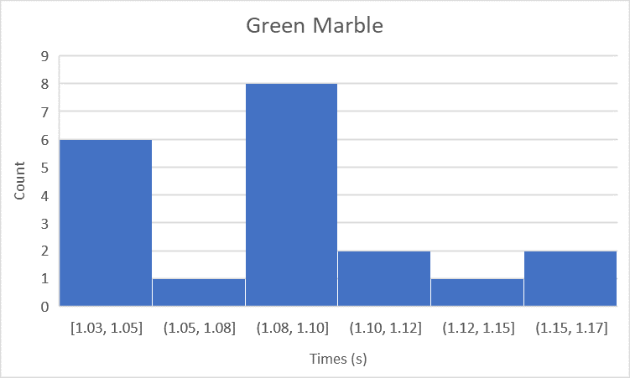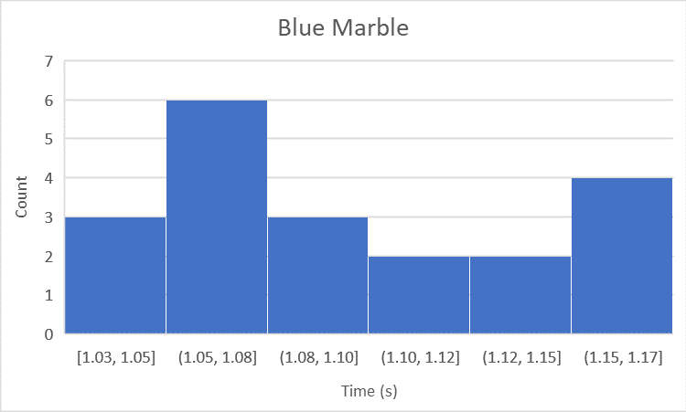

Mean: 1.09s STD: .05s STDM: .01s Mean: 1.10s STD: .05s STDM: .01s

The difference between the two marble’s mean times to roll down the ramp is .01s. Each has an uncertainty of .01s so the two results overlap. Our standard deviation of the mean is as small as the measurement precision of a digital stopwatch, so there is no use in collecting more data.

**Conclusion**: We do not find any influence of color on the time it takes for the ball to roll down the ramp at least to the precision of .02 seconds for the ramp we specified. Our prediction is not falsified. However, we only tested this for a specific ramp configuration. For a next iteration:

* We could use a more precise time measuring device, like a photogate
* We could vary the orientation or length of the ramp and see if the model still works
* We could compare marbles with different diameters or masses

Appendix

|  |  |  |  |  |  |  |
| --- | --- | --- | --- | --- | --- | --- |
| Green Marble |  |  |  | Blue Marble |  |  |
| Trial | Time (s) | Uncertainty (s) |  | Trial | Time (s) | Uncertainty (s) |
| 1 | 1.16 | 0.01 |  | 1 | 1.16 | 0.01 |
| 2 | 1.07 | 0.01 |  | 2 | 1.15 | 0.01 |
| 3 | 1.10 | 0.01 |  | 3 | 1.04 | 0.01 |
| 4 | 1.03 | 0.01 |  | 4 | 1.10 | 0.01 |
| 5 | 1.04 | 0.01 |  | 5 | 1.15 | 0.01 |
| 6 | 1.17 | 0.01 |  | 6 | 1.07 | 0.01 |
| 7 | 1.10 | 0.01 |  | 7 | 1.08 | 0.01 |
| 8 | 1.11 | 0.01 |  | 8 | 1.05 | 0.01 |
| 9 | 1.10 | 0.01 |  | 9 | 1.06 | 0.01 |
| 10 | 1.03 | 0.01 |  | 10 | 1.13 | 0.01 |
| 11 | 1.03 | 0.01 |  | 11 | 1.12 | 0.01 |
| 12 | 1.04 | 0.01 |  | 12 | 1.06 | 0.01 |
| 13 | 1.08 | 0.01 |  | 13 | 1.17 | 0.01 |
| 14 | 1.12 | 0.01 |  | 14 | 1.06 | 0.01 |
| 15 | 1.08 | 0.01 |  | 15 | 1.12 | 0.01 |
| 16 | 1.14 | 0.01 |  | 16 | 1.14 | 0.01 |
| 17 | 1.09 | 0.01 |  | 17 | 1.07 | 0.01 |
| 18 | 1.08 | 0.01 |  | 18 | 1.10 | 0.01 |
| 19 | 1.10 | 0.01 |  | 19 | 1.07 | 0.01 |
| 20 | 1.05 | 0.01 |  | 20 | 1.03 | 0.01 |
| Mean | 1.09 | 0.01 |  | Mean | 1.10 | 0.01 |
| STD | 0.05 |  |  | STD | 0.05 |  |