

**Smart Solar Tracker**

Version 1.0

Prepared by:

* Dina Mohamed
* Rania El-Sayed
* Abdallah Ayman
* Abeer Arafa
* Nahla Hussien

Under Supervision of:

* Dr/ Amr El-Sayed

Contents

List of Figures 4

1. Preface 5

1.1 Document Purpose 5

1.2 Target Users 5

1.3 Revision History 5

2. Introduction 5

2.1 Purpose 5

2.2 Scope 6

2.3 Overview 6

3. Glossary 6

3.1 Acronyms, definitions, and abbreviations. 6

4. System Users 6

4.1 System stakeholders 6

4.2 Users objectives 7

5. User Requirements definitions 7

5.1 System Functions 7

5.2 Constraints 7

6. System Architecture 7

7. System Functional requirements 8

7.1 Add a new student 8

7.2 Edit Student 8

7.3 View student 8

7.4 Search for a student 8

7.5 Generate Reports for the student 9

7.6 View Student Payments 9

7.7 Add Payment 9

7.8 Add departments’ desires 9

7.9 Edit student’s department desires 9

7.10 Add Employee 9

7.11 Edit Employee 9

7.12 Edit Employee’s Job description 9

7.13 Delete Employee 9

8. Interface requirements 9

8.1 User interfaces: 9

8.2 Software Interfaces 9

8.3 Communications Interfaces 9

9. Non-functional requirements 10

9.1 Availability: 10

9.2 Security: 10

9.3 Safety: 10

10. System Models and Diagrams 10

11. System Evolution 10

12. Time Plan 10

12.1 Work Breakdown Structure 10

12.2 Gantt chart 10

# List of Figures

Figure 1: System Functions hierarchy 6

Figure 2 System Architecture 9

Figure 3: Page Layout 13

Figure 4: Main Page 14

Figure 5: Student Page 14

Figure 6: Search Result Page 15

Figure 7: Add and Edit Form 15

# Preface

## Document Purpose

## Target Users

## Revision History

|  |  |  |  |
| --- | --- | --- | --- |
| Version | Author | Description | Date |
|  |  |  |  |
|  |  |  |  |

# Introduction

## Purpose

## Scope

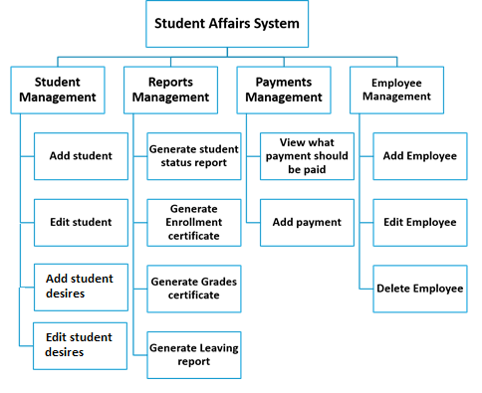

Figure : System Functions hierarchy

## Overview

# Glossary

## Acronyms, definitions, and abbreviations.

# System Users

## System stakeholders

## Users objectives

# User Requirements definitions

## System Functions

## Constraints

# System Architecture

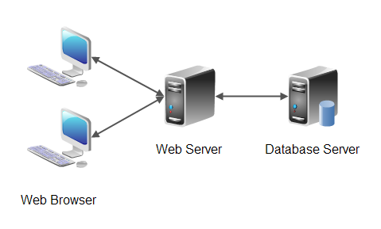

Figure System Architecture

# System Functional requirements

## Add a new student

## Edit Student

## View student

## Search for a student

## Generate Reports for the student

## View Student Payments

## Add Payment

## Add departments’ desires

## Edit student’s department desires

## Add Employee

## Edit Employee

## Edit Employee’s Job description

## Delete Employee

# Interface requirements

## User interfaces:

Figure :

Figure :

Figure :

Figure :

Figure :

## Software Interfaces

## Communications Interfaces

# Non-functional requirements

## Availability:

## Security:

## Safety:

# System Models and Diagrams

# System Evolution

# Time Plan

## Work Breakdown Structure

## Gantt chart