

MedFlow
Empowering Your Wellness Journey

Project Report
Mobile Computing — Spring 2026

FEHU · Faculty of Engineering

Team Members
Abdelrahman Housam
Khalid Abd El-Naser Mohamed
Khaled Ayman Farouk
Mohammed Saber Labib
Omar Akram

Course Supervisor
Ahmad Hussain

Contribution
Eng. Rania

TABLE OF CONTENTS

Project Introduction 3
Section 01: UX Phase 4
Stage I — Research (Empathy Map & Personas) 4
Stage II — Define (Problem Statements) 5
Stage III — Ideate (Goal Statements & Solution) 6
Stage IV — Wireframes & Site Map 7
Section 02: Frontend 9
Design Colors & Typography 9
Custom Components & Buttons 10
UI Design Screenshots 12
Responsiveness 16
Section 03: Backend 17

Project Introduction

MedFlow is a healthcare appointment-management platform designed to bridge the gap between patients and doctors through a seamless, digital-first experience. Built as a responsive Angular web application backed by a Spring Boot REST API and PostgreSQL database, MedFlow empowers patients to book, manage, and track their medical appointments online — eliminating the friction of phone queues, repeated paperwork, and missed reminders.
For healthcare providers, MedFlow delivers a unified doctor dashboard that consolidates schedules, patient profiles, and appointment history into a single, intuitive interface — reducing administrative overhead and preventing double-bookings.
The platform supports two distinct user roles — Patient and Doctor — each with a tailored portal experience. Key capabilities include: Google OAuth authentication, a calendar-based slot picker, real-time notifications, doctor discovery with specialty filtering, patient profile management, and fully responsive layouts that adapt seamlessly between mobile and desktop viewports.
MedFlow was developed as the Mobile Computing course project for Spring 2026 at the Faculty of Engineering, Helwan University (FEHU), following a rigorous UX-driven process from research and empathy mapping through wireframing, design system definition, and full-stack implementation.

SECTION 01

UX Phase

The UX phase covers research, problem definition, solution ideation, and wireframing. MedFlow is a healthcare appointment-management platform connecting patients with doctors through a clean, mobile-first Angular web app backed by a REST API.

Stage I — Research

Empathy Map
Two personas were mapped: Ahmed Hassan (Patient, 32) and Dr. Karim Nour (Doctor, 45). The empathy map surfaces what each user thinks, feels, sees, hears, says and does, plus their core pains and gains.
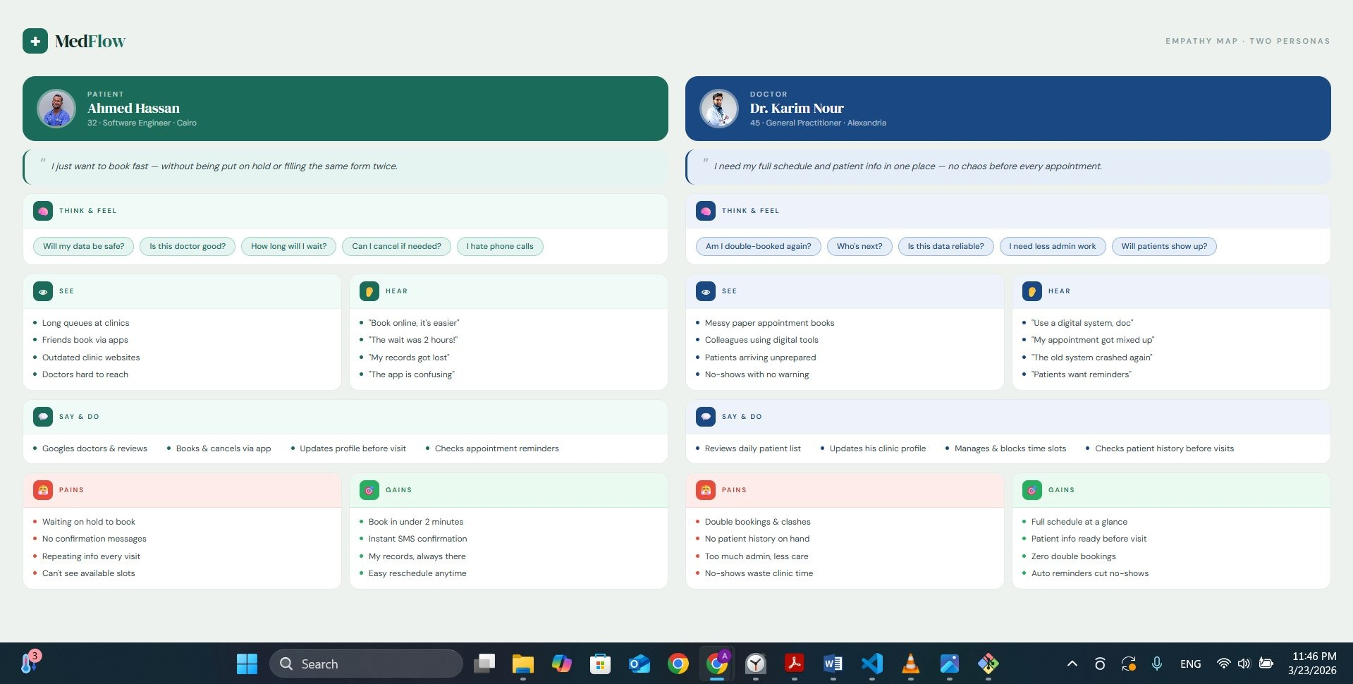
Figure — Empathy Map: Patient (left) & Doctor (right)

User Personas
Detailed personas were created to keep design decisions grounded in real user needs.
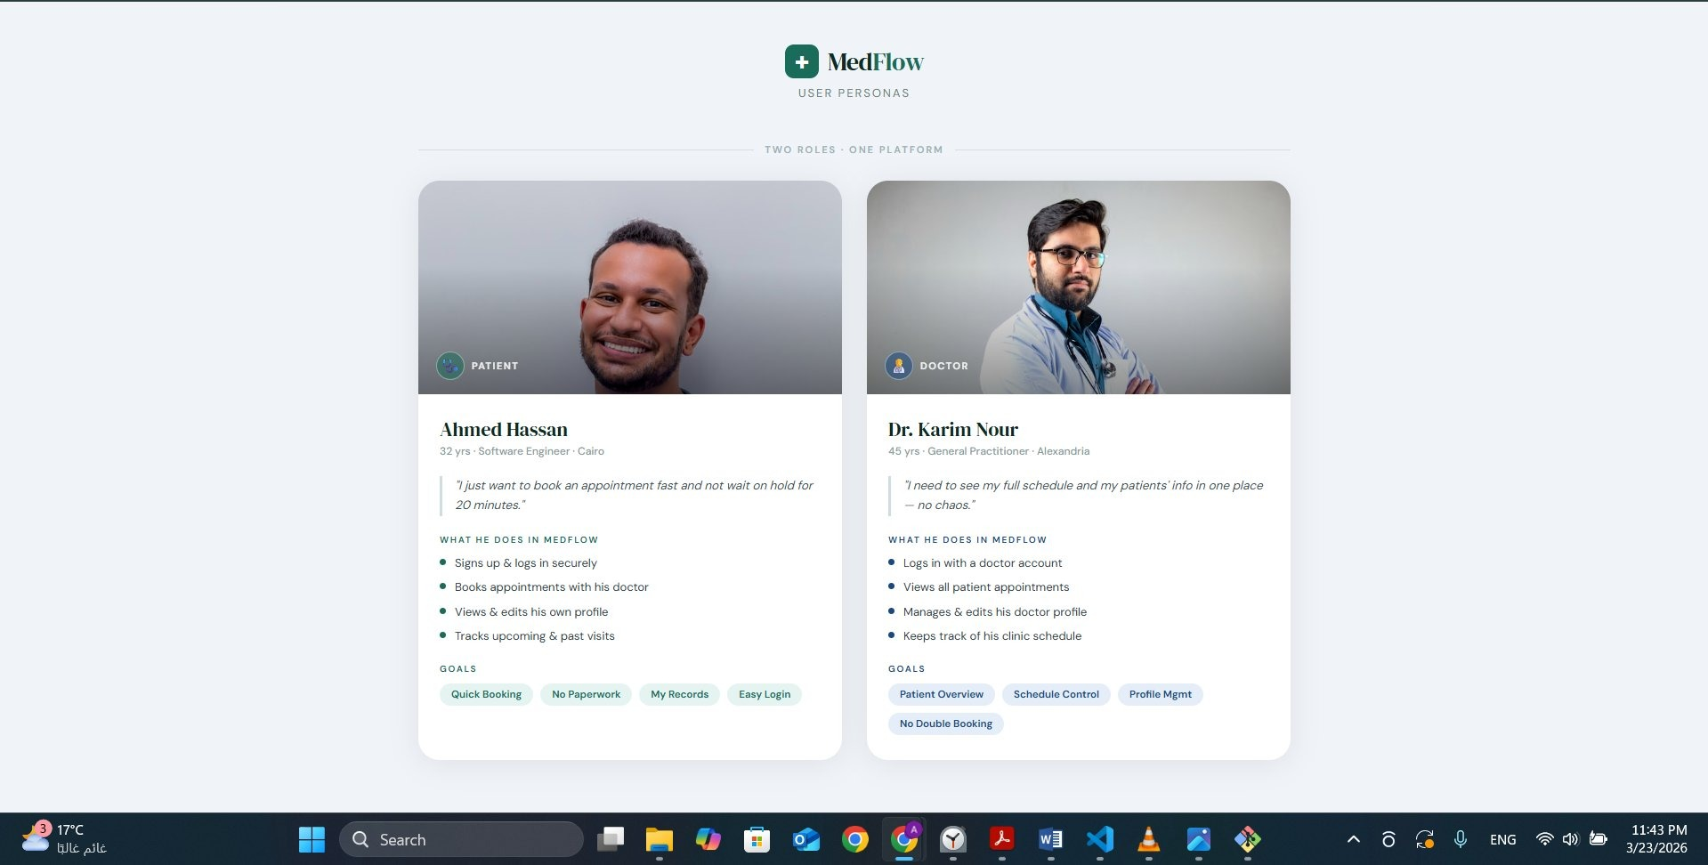
Figure — User Personas: Ahmed Hassan (Patient) & Dr. Karim Nour (Doctor)
Attribute | Ahmed Hassan — Patient | Dr. Karim Nour — Doctor
Age / Role | 32 · Software Engineer · Cairo | 45 · General Practitioner · Alexandria
Quote | "Book fast, no hold time." | "Full schedule in one place — no chaos."
Goals | Quick booking, no paperwork, easy login | Patient overview, schedule control, no double-booking
Pains | Waiting on hold, no confirmation, repeating info | Double bookings, no patient history, admin overload
Gains | Book in 2 min, instant SMS, easy reschedule | Full schedule glance, patient info ready, auto reminders

Stage II — Define

Problem Statements
Four pain-point categories were identified from research and mapped to concrete problem statements.
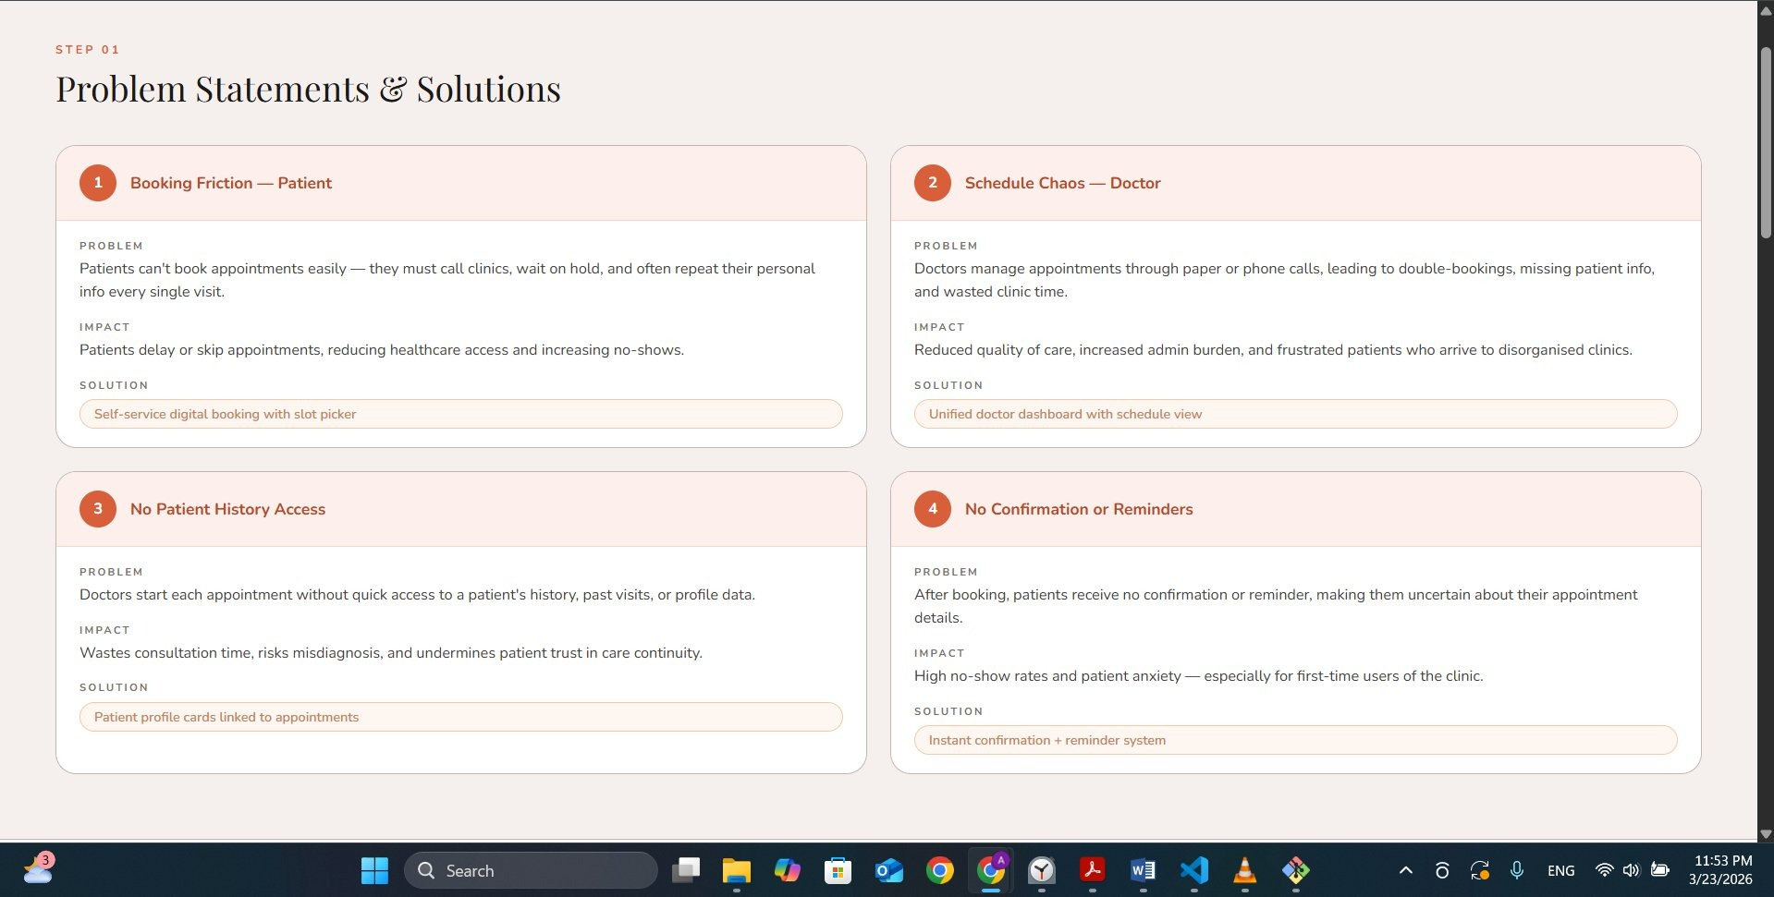
Figure — Problem Statements & Solutions
1 Booking Friction — Patient
PROBLEM
Patients must call clinics, wait on hold, and repeat personal info every visit.
IMPACT
Patients delay or skip care, increasing no-shows.
SOLUTION
Self-service digital booking with slot picker
2 Schedule Chaos — Doctor
PROBLEM
Doctors manage appointments via paper or phone, causing double-bookings and missing patient info.
IMPACT
Reduced care quality and high admin burden.
SOLUTION
Unified doctor dashboard with schedule view
3 No Patient History Access
PROBLEM
Doctors start each appointment without quick access to patient history or profile data.
IMPACT
Wasted consultation time and risk of misdiagnosis.
SOLUTION
Patient profile cards linked to appointments
4 No Confirmation or Reminders
PROBLEM
After booking, patients receive no confirmation or reminder.
IMPACT
High no-show rates and patient anxiety.
SOLUTION
Instant confirmation + reminder notification system

Stage III — Ideate

Goal Statements
G1 Reduce patient booking time to under 2 minutes by providing a self-service digital slot picker with instant confirmation.
G2 Give doctors a unified dashboard so they can view all appointments, patient info, and schedule without double-bookings.
G3 Ensure patients receive instant booking confirmation and pre-appointment reminders to reduce no-show rates.
G4 Allow patients to maintain a persistent profile so they never repeat personal information across visits.

Selected Solution & Feature List
Selected Solution: A responsive Angular web app (MedFlow) with a Spring Boot REST backend and PostgreSQL database, providing separate patient and doctor portals within a single unified platform.
Why this approach? Existing solutions (Zocdoc, Vezeeta) are either region-locked, expensive, or lack a real-time doctor dashboard. MedFlow is open, self-hosted, and combines both patient booking and doctor management in one codebase with a consistent design system.
Feature | Description
Authentication | Sign In / Sign Up with Patient or Doctor role selection, Google OAuth
Patient Portal | Dashboard, upcoming & past appointments, quick actions, online doctors list
Doctor Portal | Doctor dashboard with today's patients, stats (patients, reviews, rating, experience)
Appointment Booking | Calendar-based slot picker, confirmation, cancel action
My Appointments | Tabbed view — Today / Upcoming / History for both roles
Notifications | Bell icon with badge count, slide-in notification panel, clear all
Doctor Discovery | Filter by specialty & search, doctor profile with working hours & fee
Patient List | Doctor-side patient registry with search, total count, patient profiles
Profile Management | Edit profile for both roles, medical baseline (age, blood, gender) for patients
Navigation | Responsive sidebar (desktop) + bottom navbar (mobile) for both roles

Stage IV — Wireframes & Site Map
High-fidelity wireframes were produced for all 12 screens before development. The site map below reflects the navigation structure implemented in the final app.
Screens covered: Login, Register, Home, Profile, Find Doctor, Doctor Profile, Book Appointment, My Appointments, Doctor Dashboard, Doctor Appointments, Doctor Profile (edit), Patients List.
(Wireframe link: see project GitHub repository)
---------------------------------------------------------------------------------------------------------------------------------------
SECTION 02

Frontend

MedFlow is built with Angular 17 (standalone components), TypeScript, and a custom design system inspired by warm, earthy healthcare tones. The app is fully responsive, adapting between a mobile bottom-navbar layout and a desktop sidebar layout.

Technologies Used
Layer | Technology | Purpose
Frontend Framework | Angular 17 (Standalone) | Component-based SPA
Language | TypeScript 5 | Type-safe frontend code
Styling | CSS3 + CSS Variables | Design tokens, responsive layout
Icons | Font Awesome 6 | UI icons throughout the app
HTTP | Angular HttpClient | REST API communication
Routing | Angular Router | Client-side navigation & guards
State / Auth | SessionStorage + AuthService | User session management
Backend | Spring Boot (Java) | REST API server
Database | PostgreSQL | Persistent data storage
Build Tool | Angular CLI / Vite | Dev server & production builds

Design Colors
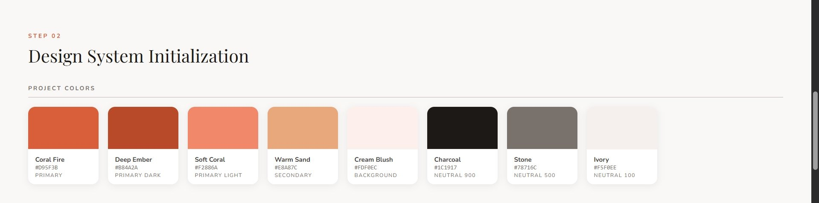
Figure — MedFlow Design System Colors
Token | Name | Hex | Role
--primary | Coral Fire | #D95F3B | Primary action, CTAs, headers
--primary-dark | Deep Ember | #B84A2A | Hover states, active elements
--primary-light | Soft Coral | #F2886A | Highlights, badges
--secondary | Warm Sand | #E8A87C | Secondary accents
--bg | Cream Blush | #FDF0EC | Page background
--neutral-900 | Charcoal | #1C1917 | Primary text
--neutral-500 | Stone | #78716C | Secondary text, labels
--neutral-100 | Ivory | #F5F0EE | Card backgrounds, table rows

Typography
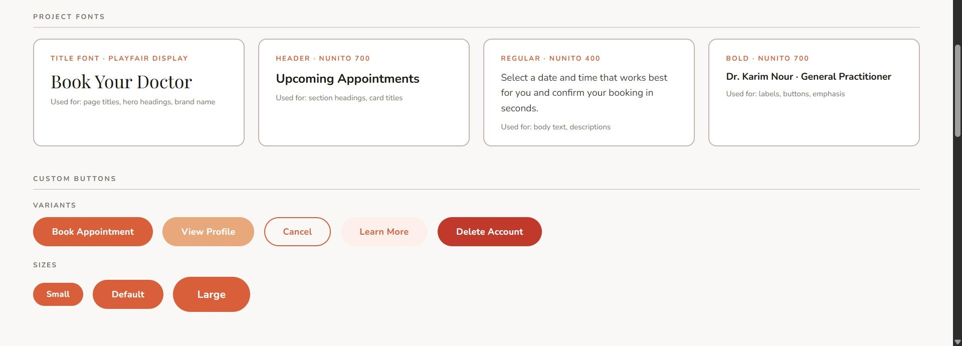
Figure — Project Fonts & Custom Buttons
Role | Font | Size | Weight | Usage
Display / Logo | Playfair Display | 28–36px | Bold 700 | App name, hero headings
Section Titles | Nunito 700 | 20–26px | SemiBold 600 | Page titles, card headers
Body Text | Nunito 400 | 13–15px | Regular 400 | Paragraphs, descriptions
Labels & Badges | Nunito 700 | 10–12px | Bold 700 | Status chips, meta info
Form Inputs | Nunito | 14px | Regular 400 | Input fields, placeholders

Custom Components
The following reusable Angular standalone components are shared across the app. Each is encapsulated with its own HTML template and scoped CSS.
Component | Style / Description | Used In
Sidebar | Fixed left panel on desktop (≥1024px); hidden on mobile. Shows logo, nav links with active highlight, and user role. Width: 240px, background white, primary-colored active states. | Home, Doctor Dashboard, Appointments, Doctors, Patients, Profile (all desktop views)
Navbar | Sticky bottom bar on mobile (<1024px); hidden on desktop. Contains 4–5 icon+label tab items. Active tab highlighted in primary color. Accepts [isDoctor] and [activePage] inputs. | All pages — patient and doctor portals
Notification Panel | Full-height slide-in panel from the right. Semi-transparent overlay. Displays notification cards (unread highlighted in primary tint). Emits (close) event. Bell icon shows red badge. | Home, Doctor Dashboard
Alert / Toast | Inline alert with icon, message, and optional dismiss button. Variants: success (green), error (red/coral), info (blue). Auto-dismisses after 4s or on user click. | Booking confirmation, form validation, profile update success

Custom Buttons
Name | CSS Class | Style | Used In
Primary Button | .btn-primary | Background: Coral Fire #D95F3B; text white; border-radius 999px; hover darkens to Deep Ember. | Sign In, Book Appointment, Confirm, Edit Profile
Outline Button | .btn-outline | Transparent background; 1px border in primary color; text primary; hover fills with primary. | Cancel, secondary actions in forms
Icon Button | .icon-btn | Circular 42px; white background; primary-colored icon; box-shadow; badge position. | Notification bell, profile nav, back arrow
Quick Action Btn | .quick-action-btn | Square card shape; bg-muted fill; column flex (icon + label); hover lifts with translateY(-2px). | Home quick actions grid
Tab Button | .tab-btn | Pill-shaped; inactive = muted bg; active = primary bg white text; groups of 2–3. | Login role selector, Appointments tabs
Status Badge | .appointment-status | Pill shape; UPCOMING=blue tint, COMPLETED=green tint, CANCELLED=red tint. | Appointment cards throughout the app

UI Design Screenshots
All screens below are captured from the live MedFlow application, showing the mobile-first responsive layout.
Patient Screens
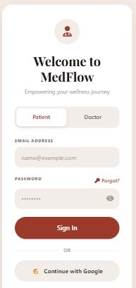 | 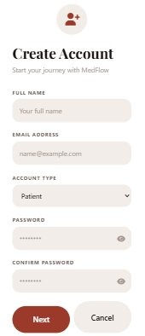 | 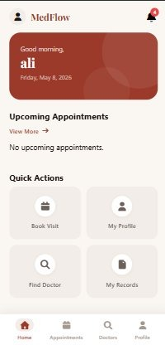 | 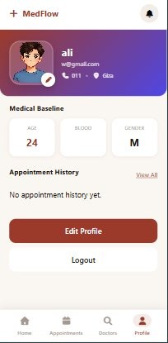
Login | Register | Home | Patient Profile

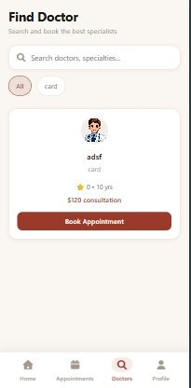 | 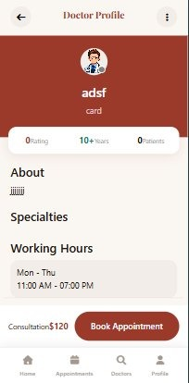 | 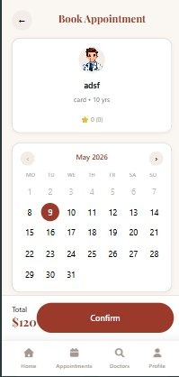 | 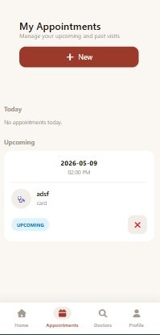
Find Doctor | Doctor Profile | Book Appointment | My Appointments

Doctor Screens
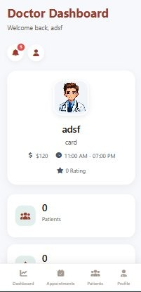 | 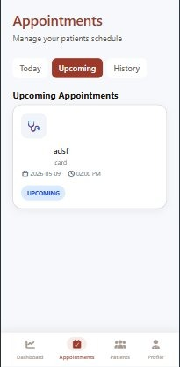 | 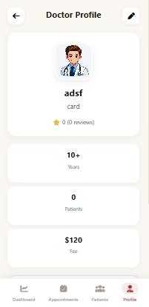 | 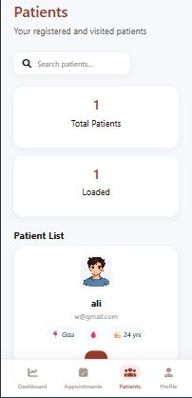
Doctor Dashboard | Doctor Appointments | Doctor Profile (edit) | Patients List

Responsiveness
MedFlow uses CSS media queries and flexible layouts to adapt between mobile (< 768px), tablet (768–1023px), and desktop (≥ 1024px) viewports.
Element | Behaviour
Bottom Navbar ↔ Sidebar | On mobile, renders a sticky bottom tab bar. On desktop (≥1024px), it is hidden and replaced by a fixed sidebar on the left.
Hero Banner | Padding and font sizes increase on desktop. The home content-wrap switches to a 2-column CSS Grid layout.
Stats Grid | Doctor dashboard stats display as 4 columns on desktop, 2 on tablet, 1 on mobile.
Doctor Cards Grid | "Top Specialists" section uses 1 column on mobile and 3 columns on desktop.
Appointment Cards | Flex direction switches from row (desktop) to column (mobile) so status badges align correctly.
Forms | All form inputs are full-width; the role toggle tabs shrink gracefully on small screens.

SECTION 03

Backend

MedFlow's backend is built with Spring Boot (Java) and a PostgreSQL relational database, exposed as a RESTful API consumed by the Angular frontend via Angular HttpClient.

Database Records
Representative snippets of database records from different parts of the application, illustrating how data is persisted across the key entities.
Users / Patients Table
Stores patient accounts including personal details and medical baseline (age, blood type, gender, location). The role field differentiates between PATIENT and DOCTOR accounts.
Doctors Table
Extends user records with doctor-specific fields: specialty, about text, working hours, consultation fee, years of experience, and aggregate stats (rating, patient count, review count).
Appointments Table
Records each booking with foreign keys to both patient and doctor, appointment date/time, and a status enum (UPCOMING, COMPLETED, CANCELLED). This table drives all appointment views for both portals.
Notifications Table
Stores per-user notification entries with a read flag, message body, and timestamp. The notification panel queries this table on load and marks entries as read on dismiss.

Dynamic Content
All displayed data in MedFlow is fetched dynamically from the PostgreSQL database via REST API calls. Key dynamic content flows:
- Patient Home: upcoming appointments and quick stats are fetched on login and refreshed on navigation.
- Doctor Discovery: doctor cards are retrieved from /api/doctors with optional specialty filter and search query parameters.
- Appointment Booking: available time slots are fetched per doctor and date, preventing double-booking at the database constraint level.
- Notifications: unread notification count drives the badge on the bell icon; the panel list is fetched and marked read via PATCH requests.
- Doctor Dashboard: today's patient count, total appointments, rating, and experience are computed server-side and returned as a stats DTO.
- Patient List (Doctor view): paginated patient registry is fetched with a search parameter for real-time filtering.

Database Screenshots
The following screenshots are taken directly from pgAdmin 4 connected to the live PostgreSQL 18 instance (medical_db). They confirm the structure and sample data stored across the five core tables that power the MedFlow application.

Figure 1 — Patients Table
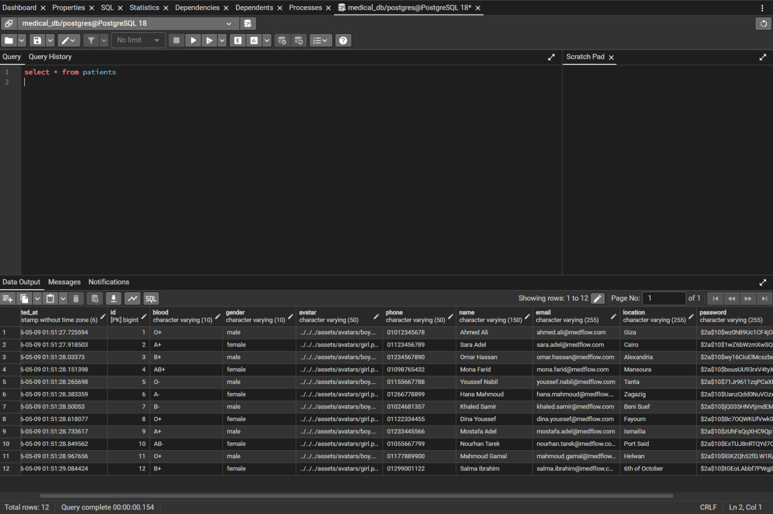
The patients table stores 12 patient accounts with personal details (name, email, phone, location, blood type, gender) and bcrypt-hashed passwords. Avatar paths reference local asset files.

Figure 2 — Appointments Table
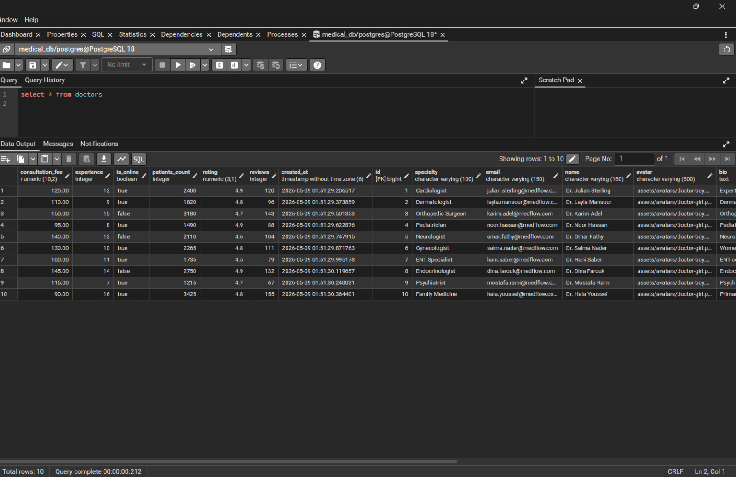
The appointments table holds 9 booking records linking patients and doctors via foreign keys. Each row captures the appointment date, time slot (e.g., 10:00 AM), duration in minutes, specialty, doctor name, and a status enum (UPCOMING / COMPLETED / CANCELLED). Icon and icon_bg columns supply the card visual in the frontend.

Figure 3 — Doctors Table
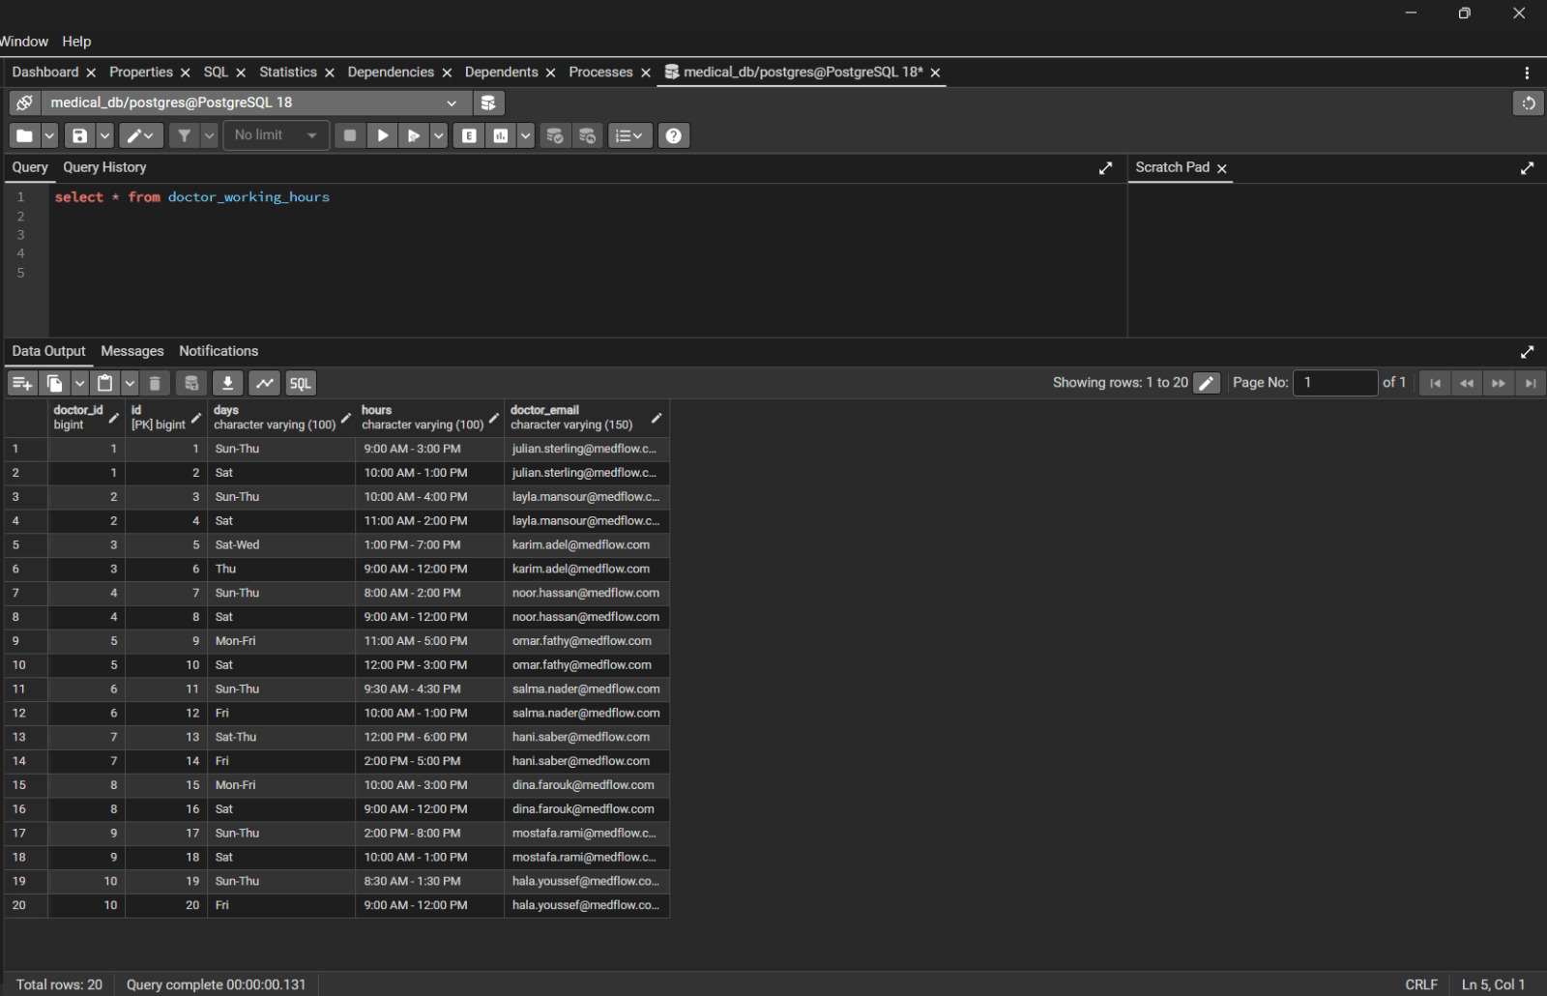
The doctors table stores 10 doctor profiles. Aggregate fields (rating, reviews, patients_count, experience) are updated server-side. The consultation_fee (numeric) and is_online flag drive the doctor discovery cards. Each record links to an avatar asset path and a bio text column (truncated in view).

Figure 4 — Notifications Table
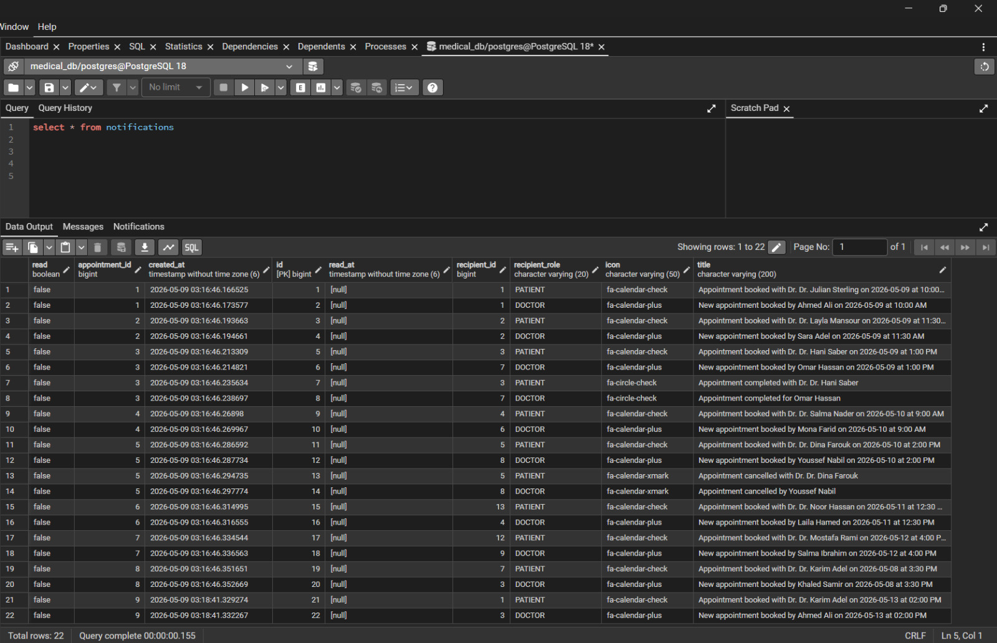
The notifications table contains 22 entries (2 per appointment — one for the patient, one for the doctor). The read boolean defaults to false and is flipped to true when the user dismisses the panel. The recipient_role column (PATIENT / DOCTOR) allows the API to scope queries per user type. The title column holds the human-readable notification message shown in the slide-in panel.

Figure 5 — Doctor Working Hours Table
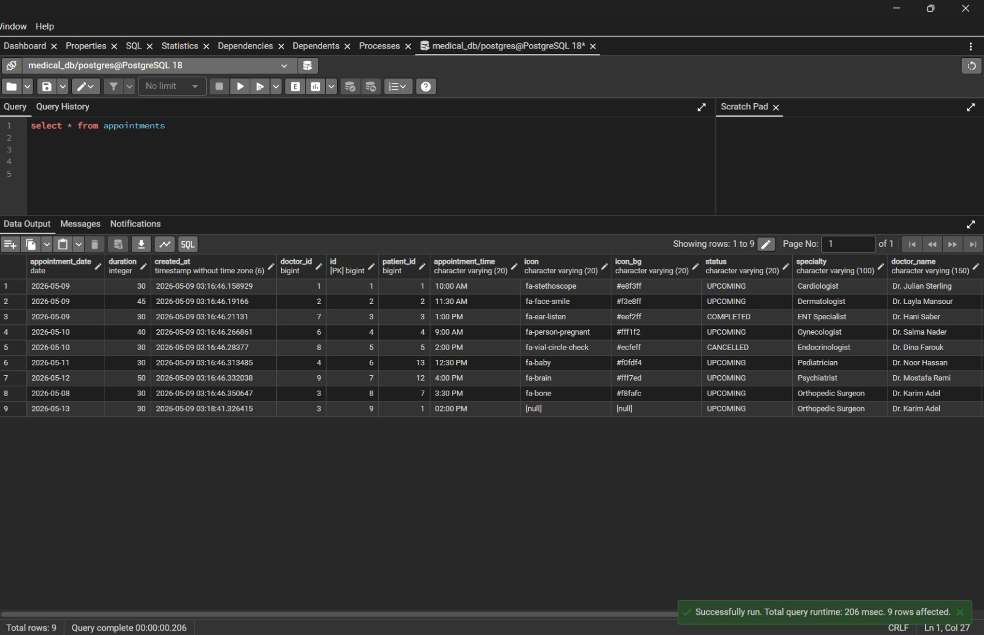
The doctor_working_hours table holds 20 rows (2 schedule slots per doctor). Each row stores the working days (e.g., Sun–Thu, Sat) and the corresponding time range (e.g., 9:00 AM – 3:00 PM). This data is consumed by the doctor profile page and the appointment booking slot picker to display availability and prevent out-of-hours bookings.

