**

**FACE MASK DETECTOR PROJECT**

**GENE 4300**

**KULLIYYAH OF ENGINEERING**

## FACEMASK DETECTOR

# project portfolio

### 18th DECEMBER 2020

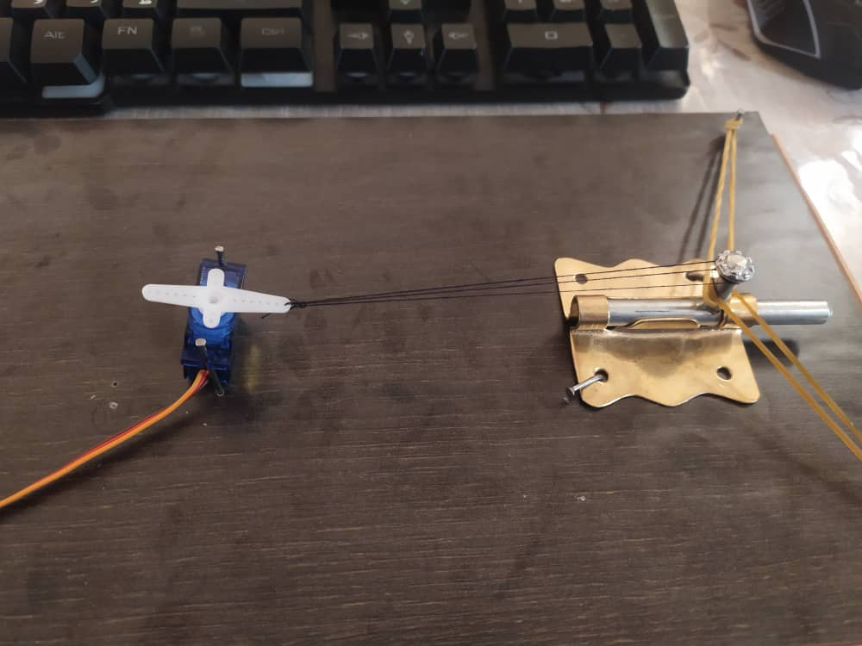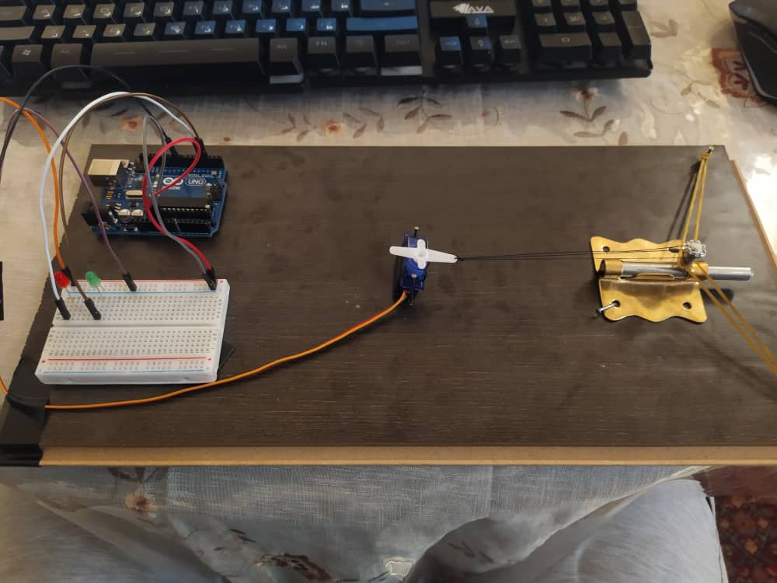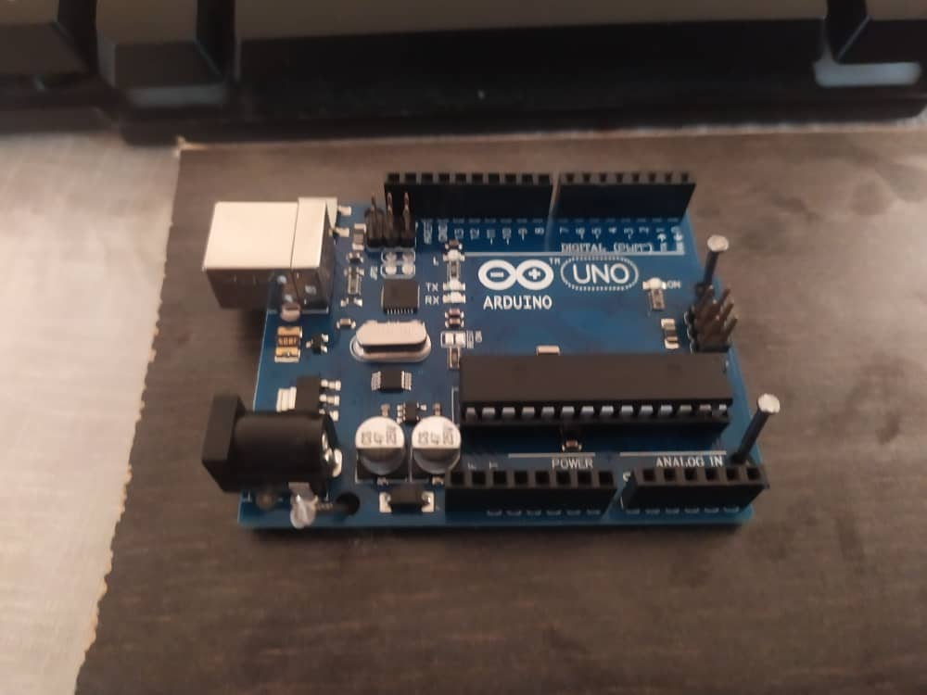

|  |  |  |  |
| --- | --- | --- | --- |
| **Project Name** | FACE MASK DETECTOR | | |
| **Project/Programme Manager** | Yousef Ghanem (1522909) | | |
| **Assistant Program Manager** | AbdelRahman Tamer (1724925) | | |
| **Secretary** | Yousra (1727478) | | |
| **Financial Controller** | Galib (1724359) | | |
| **Special Task** | Liqwan Shah Nasution Bin Lindung Saputra (1719469)  Mohamed Abdulkadir (1522909) | | |
| **Start Date** | 1st November 2020 | **Completion Date** | 18th December 2020 |

# Part 1: Project Closure

## Purpose of the project

In the present scenario due to Covid-19, the face mask detection application is a high demand for transportation means, densely populated areas, residential districts, large-scale manufacturers, and other enterprises to ensure safety. If the application is deployed correctly, the face mask detector could potentially be used to help ensure the safety and wellbeing of the people. The primary objective of this approach is to trigger an alert only for people who do not wear a mask, by minimizing as many false-positive face detections as possible, without missing any mask detections. This is an application that utilizes a camera to detect if a person is wearing a mask and if the mask is being used correctly. The data will be transferred and stored automatically in the system to enable reports whenever wanted.

## Objectives achieved/not achieved

Based on the objective of the project, Face Mask Detector is successfully carried out within this semester. By using specific software for the coding to detect the human faces that isn’t wearing mask and faces that wearing a mask. Also, by using the specific material that need for the project work, component such as Arduino components that will act as the coding changer to operate the coding system. If will activate the lock by detecting the faces of peoples as we inserted in the coding. The lock will unlock when it detected the person who wear a mask while it will be locked when the person did not wear mask. This face mask detector could potentially be used to help ensure the safety and wellbeing of the people. Here is the link about our project and how we explored the coding and how the project worked.

https://youtu.be/zeNlwFsNcdA

## ACTIVITIES

|  |  |
| --- | --- |
| **DATE** | **ACTIVITY** |
| **17th Novermber 2020** | **Research on machine learning and deep learning:**  In order to develop a program that can detect if a person wearing a mask or not we needed to use Artificial Inelegance. Which we needed to make research one to have a better understanding. |
| **19th November 2020** | **Start to develop the code:** |
| **1st December 2020** | **Collecting the Arduino parts for the project:** |
| **3rd December 2020** | **Constructing the circuit :** |
| **8th December 2020** | **Training the program:** in order for the program to be able to do the detection process, it needed a lot of data to so the program would read and learn what is false condition (no mask) and what is a correct condition (mask on) so we had to collect around 1,000 pictures as data for that process. |
| **8th December 2020** | **Testing:** |

## Changes incorporated

At the beginning we used a program called "Cascade training gui", which is a software used to train a XML file to detect a specific file. So we provide the software with almost 2000 pictures of human faces that isn't wearing mask and nearly the same amount of pictures but with either mask only or a human face wearing a mask. But then the process was too long and wasn't that accurate so we decided to use 2 cascade files and combine them together. The best thing regarding these cascade files is it was trained using haarcascade which is an accurate cascade and at the same time it doesn't take much time to detect the object (nearly real-time). So by combining 2 files together it became more accurate So we used the first cascade to detect the face then in each face it detect if there is a mouth in this face or not.

## Outstanding Risks and Issues

The system allowed people to enter who covered their face with hand or something else, from time to time. If the lens is not clean, it might affect the accuracy of the product. By Applying the principle of facial or mask recognition, it is possible that the machine learning models could pick up on other “background” features, such as race and gender that would cause it to make mistakes about whether someone is wearing a mask. Besides that, videos have their own set of challenges like motion blur, dynamic focus, transitioning between frames, etc. In order to ensure that the detections remain stable and to avoid jitter between frames. Lastly, if it more complex classifiers did not work as well as expected due to the lack of large databases for training.

## Post project review

Combining all the components of our architecture, we thus get a quite accurate Face Mask Detection System. It was observed that the model showed good results on images taken from a very short distance. It can detect as many faces as it can fit within the range of the camera. The proposed system operates in an automated way and helps to automatically perform the face mask inspection process. Once the model is trained with the custom data set and the pre-trained weights given, we check the accuracy of the model on the test dataset by showing the red or green bounding squared box. The system first detects all persons in the range of cameras and shows a green bounding box around each person who is wearing a mask. If a person is breaching social distancing rules by not wearing a mask, the bounding box colour changes to red for that person and simultaneously face mask detection is achieved by showing bounding boxes on the identified person's face. The person who is wearing a mask, gets a green light and is allowed to enter. On the contrary, if the mask is not visible in the face, it gets a red light and instantly locks the door so that the person may not enter the premises. The system detects the masks with a precision score of 90%. Until now, we have seen that our system shows high performance over images, overcoming most of the issues commonly faced in object detection in images. For real-world scenarios, it is beneficial to extend such a detection system to work over video feeds as well.

Therefore, this proposed system will operate in an efficient manner in the current situation and help to track public places easily in an automated manner. We have addressed in depth the identification of face masks that help to ensure human health. The solution has the potential to significantly reduce violations by real-time interventions, so the proposed system would improve public safety through saving time and helping to reduce the spread of coronavirus.

# Part 2: Review of the effectiveness of project management

## Governance

The organisation of the project was done quickly, and while it had a few bumps in the beginning, it was easier after the major decisions and roles were determined. Abel Rahman, being the one most knowledgeable about the coding language and processes required, was designated as the leader of the team as well as the lead programmer for the code of the project. The remaining people were then assigned to support the leader in the project, or to help in gathering resources and make more decisions regarding the face mask detector as a whole. Not everyone had all the right skills, but they were willing to learn and understand what was needed in order to keep the pace of the project going, and those were able to fulfill their responsibilities regarding the project. The stakeholders were all the members of the group, so they were able to manage everything accordingly and efficiently. The communication strategy was effective as everyone participated in several meetings via online to discuss and plan the steps for each phase of the project.

## Planning and control

The plans and estimates for the resources were rough and uncertain at the beginning of the project, but as time passed and plans were discussed properly and executed it became more efficient, and resource management became easier to handle. The estimates of effort, time and cost are varied. The estimates for effort were very accurate, but estimates for time and cost were slightly off as we had to take into account the delays in time, caused by errors in the code, as well as the budget for all the equipment, such as camera, electronic components, etc. The monitoring and control mechanisms were highly effective, with the group members taking care to properly keep track of the project, thus it was completed in time and the project itself shows promising results. The governance and control were thus at the right level for the group, though some improvements could have been made for more efficiency.

## [Stakeholder management](https://www.stakeholdermap.com/stakeholder-management.html)

The project will affect so many shops and offices if they chose to implement in on their gates. The product is clear and need some modification depending on the gate of the shop/office that wants to implement it. Even with the pandemic, some people keep ignoring the rules and walks into public places not wearing the mas, so this program will help to minimize these case.

We engaged with few shops owners and we got a great feedback. They were really interested about the idea. But no shop actually accepted to support us financially to implement the program at their gate. All the shop owners informed us that they are trying to minimize the expenses because they are not making much profit with the current situation.

We believe that if we get the support, we will be able to come up with a marketing strategy to get more shops and even malls to implement this program at their gates.

# Part 3: Sharing lessons learned

## Recommended Good Practices

Firstly is teamwork. We managed to complete this project due to the excellent teamwork between members, like the saying teamwork makes the dream work. We communicated with each other and discussed everything together and executed our work accordingly. Secondly, planning and time management. We successfully finished our project on time without having any trouble because of our good planning and time management skills. We ensured that our project and any submissions required were done as soon as possible to meet the deadlines. Then is commitment. All members were committed to this project and this helped in ensuring that all works were being done from the start till the end smoothly. After that, fair work distribution. Each member has their own work to do and this ensures fairness and the members will get to focus on a specific task better which will result in excellent outcomes. Lastly, Project that has a great impact to the society can help promoting not only ourselves, but also the institution. Project that has a great impact to the society can help promoting not only ourselves, but also the institution.

## Lessons Learned

This project is beneficial which help to protect our self from Covid 19. In order for this project to work successfully, we need to have a great team management. As an engineer it is important to have a great team to make sure the project we are running will work as what we expected. As a future engineer, this project is one the platforms for us to practice in managing projects. We have learned a lot of lessons that will benefit us in the future. This is a valuable experience to all of us. All of us are clear that the role of an engineer is to tackle some of the world’s biggest problems; helping to save lives and create fantastic new technological advancements that can improve the way we live. This project made all of the members learn the importance of ethics in engineering. As the future engineers we have to implement the ethics that we have learned from this subject during our work time. Due to the pandemic, we could not contribute our project to society directly as we lived far from each other and could not carelessly go out to shops and malls. If the situation in our country got better, we could contribute our final product to shops and mall.

---------------------------------------------------------------------------------------------------------------------------------

**Prepared by Approved by**

**________________________ ______________________**

**Name: Yousra Name: Yousef Ghanem**

**Designation: Secretary Designation: Program Manager**