**Abdoul Akhad Top**

**Online Bank System Project**

1. **Introduction**

In this project, we’ve been asked to create an online banking system that is going to mainly have three functionalities:

* Withdraw Money
* Check Balance
* Make a Deposit

1. **The Mockup with Paint Expert** 🖌

In this section, we are going to make a visual representation using tools such as Adobe or Paint Expert…

The reason for that is that it will facilitate our Work by providing a design to what our project would approximately look like.

Hence below, we provide screenshots that show the outcome of the design.

* **Paint Expert Mockup**

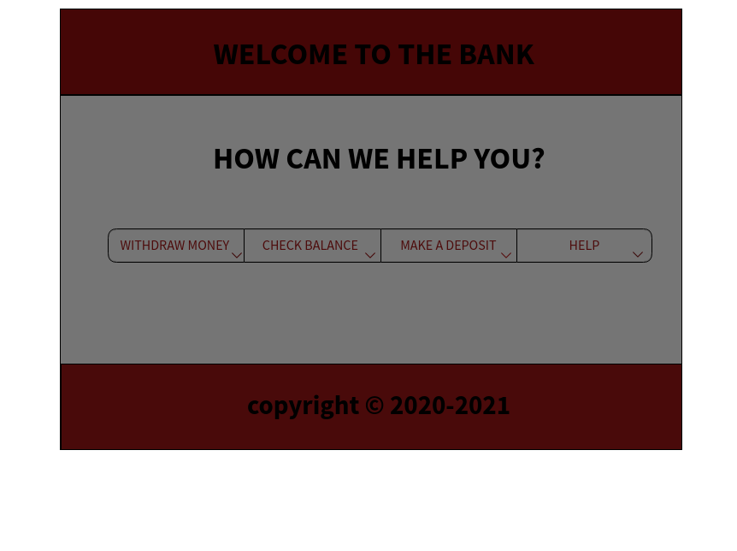

1. **The Interface with JAVA**

Once the mockup was done, we were pretty much half way done in doing it with JAVA. We use the java GUI (Graphical User Interface) and elements such as J**Panel, JButton, JLabel** coming from mainly packages like **java.awt** and **javax.swing** to almost have the same representation as our mockup above.

* **The Java Code**

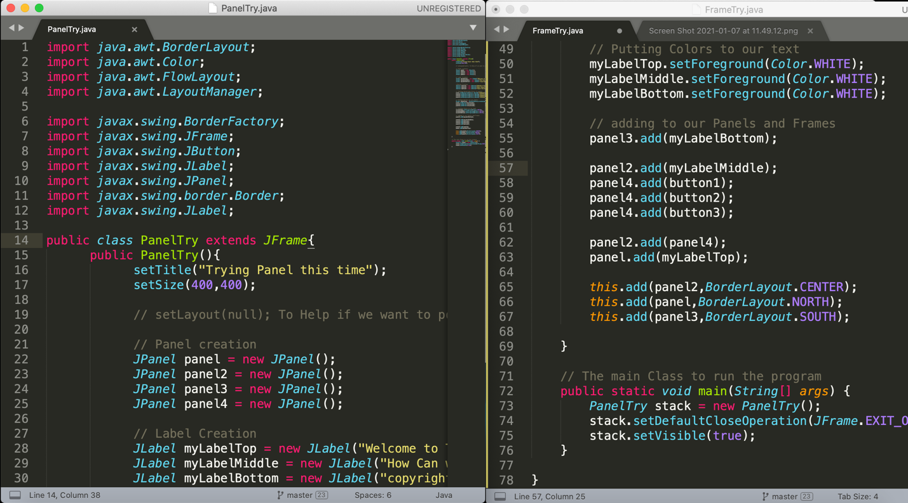

* **The Terminal Output**

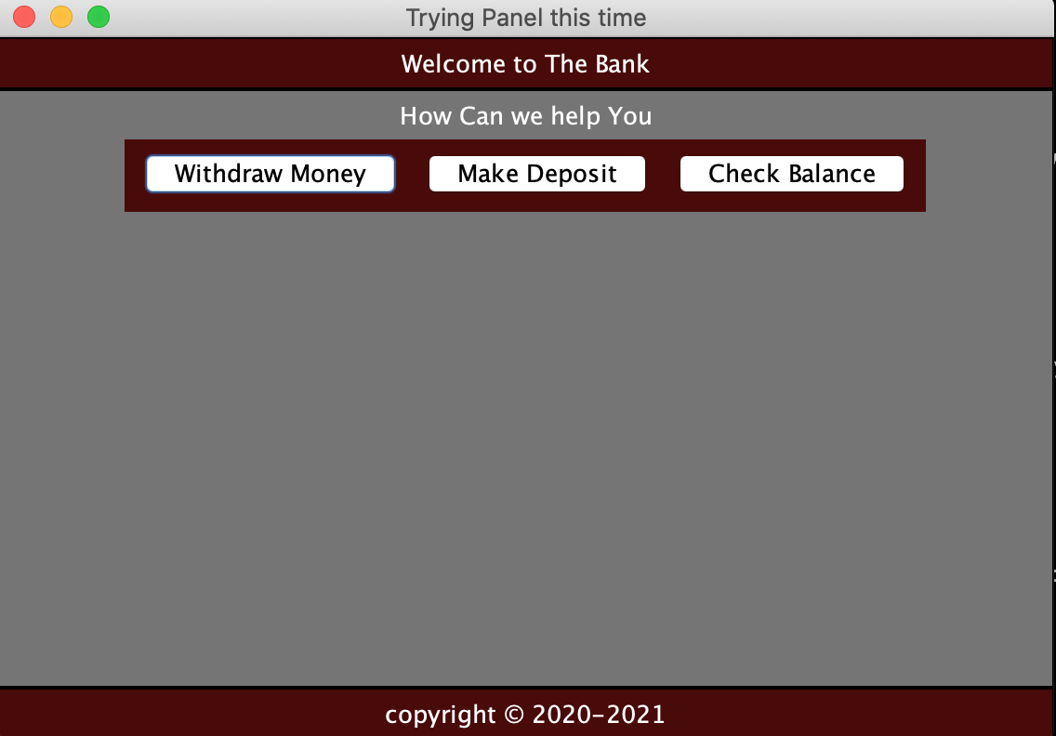

**Class Diagram**

Before Starting, we are going to make a representation of our system using classes to showcase the requirement of our system.

|  |  |
| --- | --- |
| BankAccount | customers |
| -float balance;  -int account-num;  -float interest; | -str fName;  -str lName;  -date bDate;  -int accountNum |
| + void withdraw;  + void deposit;  + void checkBalance; |  |