CFD and structural simulations report

Structural analysis of fins
During high-speed flight, rocket fins are subjected to significant bending moments caused by the aerodynamic forces acting on their surfaces. In the design process, the mechanical resistance of the fins to bending and flutter was carefully considered to ensure structural integrity. The goal of this simulation is to validate the fin design by assessing their ability to withstand these aerodynamic loads without excessive deformation or failure.

Geometry and material selection

The rocket fins were modeled using a thin shell approach to simplify the structural analysis while capturing the essential bending behavior. The geometry was created by extracting the midplanes of the fin faces and the root using SolidWorks, effectively representing the composite layers as single surfaces. This method reduces computational complexity while maintaining accuracy for evaluating bending moments and flutter resistance under aerodynamic loads.
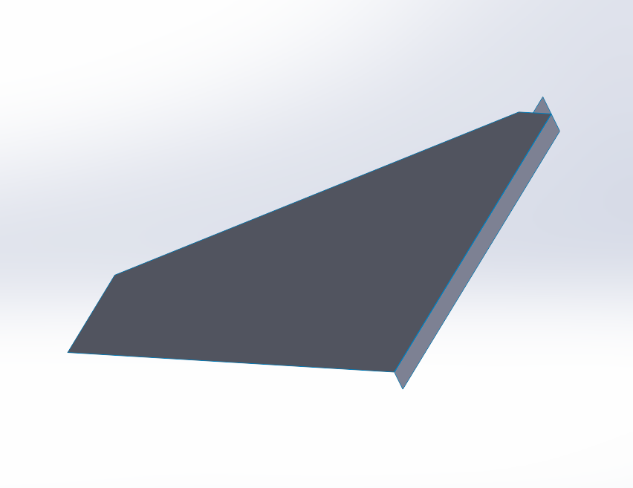
Figure 1 midsurface of the rocket fin as a thin shell
The fins are constructed as a composite stack-up consisting of:
- A 3 mm wood core for stiffness and support.
- Three layers of glass fiber on each side, oriented at 0°, 45°, and 90° to optimize strength in multiple directions.
- The first two layers use 500 g/m² glass fiber for maximum load-bearing capacity.
- The third layer uses 240 g/m² glass fiber to provide surface finishing and additional reinforcement.
The goal of this simulation is to validate the fin design by assessing their ability to withstand aerodynamic loads without excessive deformation or risk of structural failure.

Simulation
The structural performance of the fins was evaluated using ANSYS Workbench. The simulation workflow consisted of the following steps:

Material Modeling
• The glass fiber layers were defined in the Engineering Data section of ANSYS Workbench.
• The material definitions were copied directly from the technical datasheets of the fibers used in the composite stack-up

Meshing
The thin shell geometry was discretized using an appropriate shell element mesh, refined in areas of expected high stress, such as the fin root and edges.
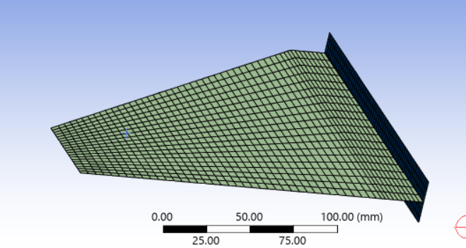

Figure 2 Mesh, using ansys mechanical

Material Assignment

Each composite layer and the core were assigned their corresponding material properties in ACP Mechanical, ensuring correct stacking sequence and fibre orientation.
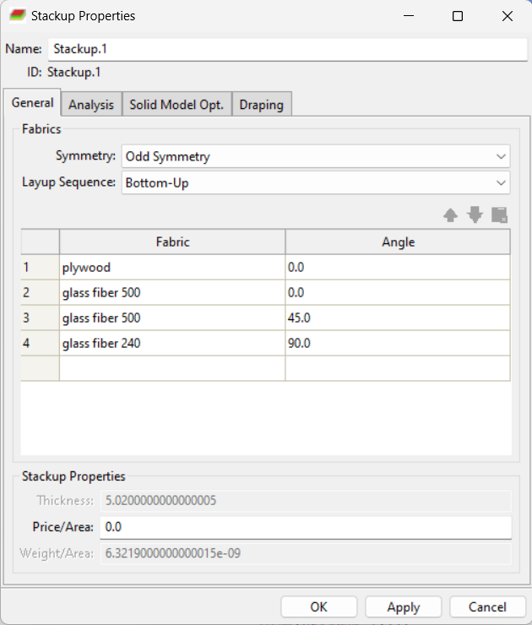
Figure 3 Composite stackup creation
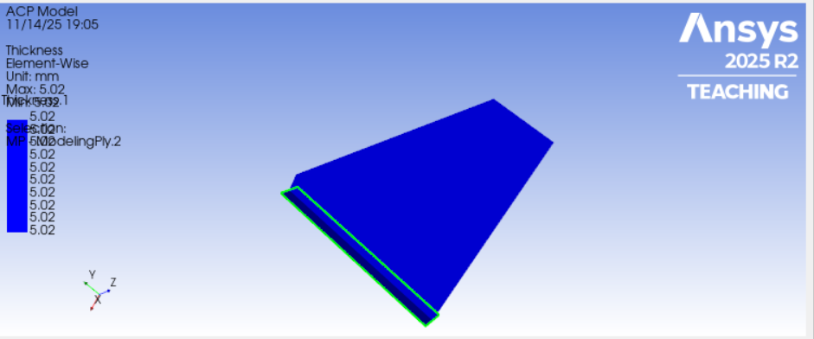
Figure 4 fully modelled fin+root : uniform thickness

Solving

A static structural analysis was performed to compute bending stresses and strains under aerodynamic load conditions. Boundary conditions were applied at the fin root to simulate attachment to the rocket body, while aerodynamic loads were applied on the fin surfaces. The force applied was calculated by the flight dynamics team:
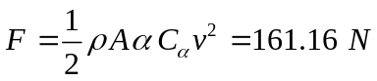

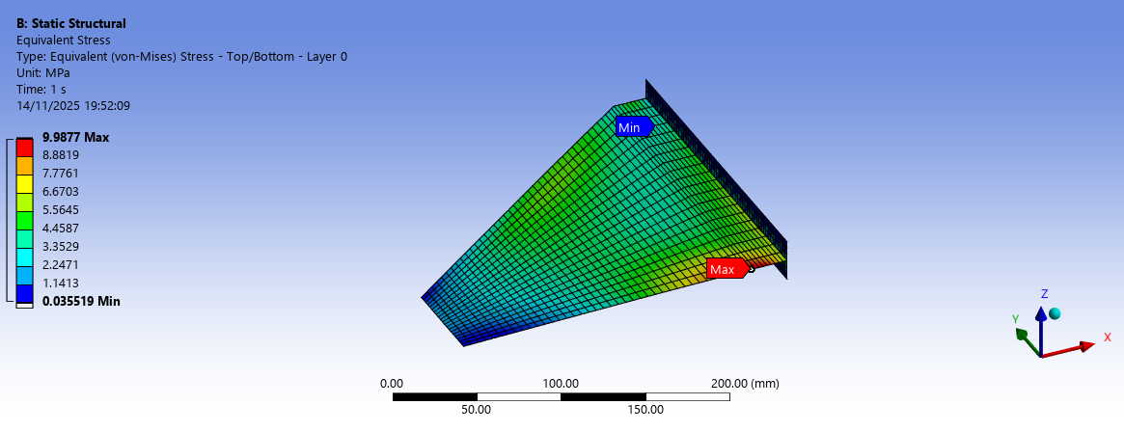

RESULTS DISCUSSION

The results of the static structural simulation show that the maximum equivalent Von Mises stress in the fin reaches 9.98 MPa. This value remains below the maximum allowable stress for the composite fin which was estimated at about 13.4 MPa, indicating that the current layup and geometry provide sufficient mechanical resistance under the applied aerodynamic loading.
The stress distribution also confirms that the highest stresses occur near the fin root, as expected due to the bending moment transmitted from the aerodynamic force. Since the maximum stress remains within safe limits, the fin design can be considered structurally adequate for the intended flight conditions.

Flight simulation of the rocket

introduction
The CFD simulation was carried out under the flight conditions corresponding to the maximum velocity reached by the rocket during its ascent. This point in the trajectory represents the moment of highest aerodynamic loading on the fins and body, making it the most critical for both structural integrity and flight stability.

Geometry Setup

3.1 Rocket Body Inclusion
A full 3D model of the rocket was imported into the CFD workflow, including:
- the nose cone
- the cylindrical body
- the fin assembly
To improve numerical robustness and avoid excessively sharp mesh elements, the rocket tip was slightly rounded. This modification does not significantly affect the aerodynamic behavior at the operating Mach number but improves mesh quality and solver stability during convergence.

Creation of the Flow Enclosure
A large external flow enclosure was constructed around the rocket to capture all relevant aerodynamic features. Its size was chosen to:
- ensure that pressure waves or shock structures dissipate before reaching the boundaries,
- allow proper wake development behind the rocket.

Subtraction to Obtain the Fluid Domain

This Boolean subtraction guarantees clean contact surfaces and avoids meshing gaps between solid and fluid regions.
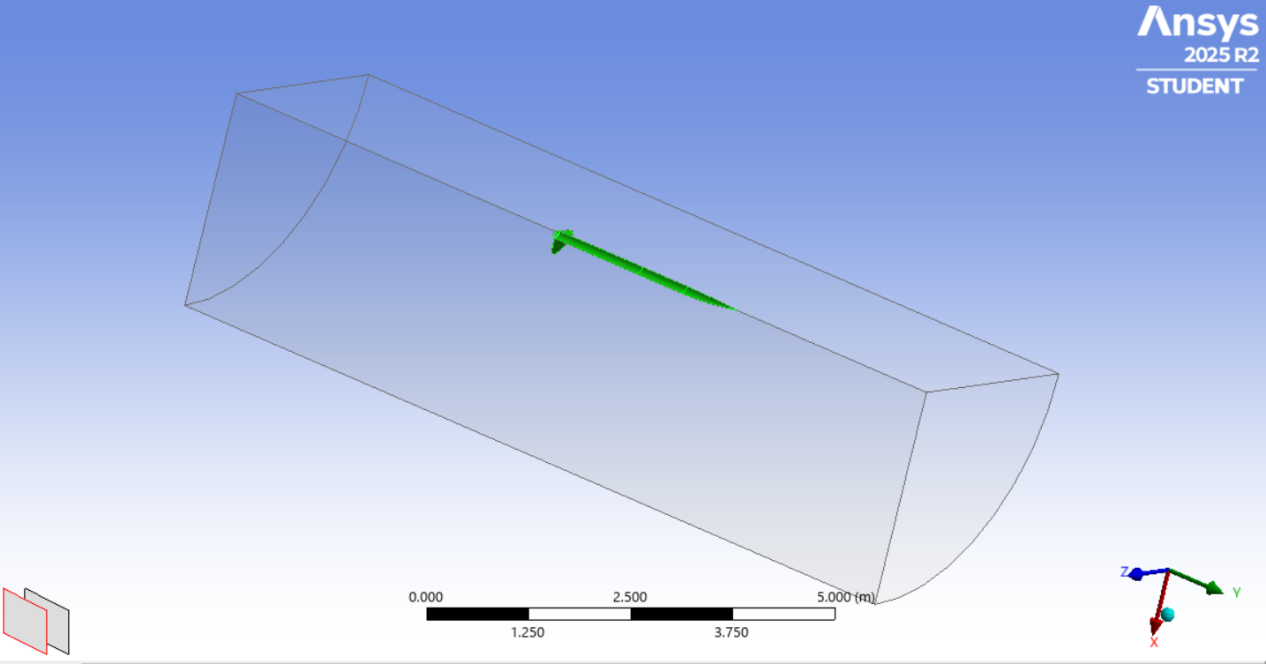
Figure 5 Computational domain and boundaries
To reduce computational cost, I exploited the geometric symmetry of the rocket and simulated only one quarter of the full domain. Symmetry boundary conditions were applied on the corresponding planes.

Flow Definition Using Far-Field Boundary Condition
To correctly model the external aerodynamics around the rocket at maximum speed, the simulation used a Far-Field (Pressure Far-Field) boundary condition. This type of boundary is specifically designed for compressible flows and allows Fluent to automatically interpret the freestream as a function of the Mach number, static pressure, and static temperature.
- The freestream Mach number corresponding to the rocket’s maximum velocity was specified directly in the far-field boundary

- 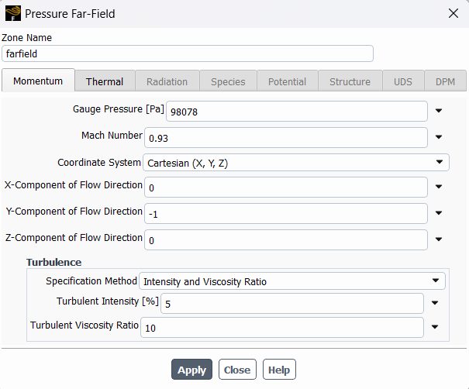
Figure 6 farfield boundary conditiion setup
Static temperature and static pressure were set using standard atmospheric values at the chosen flight altitude.
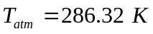

Solution setup
The simulation employed a density-based solver suitable for compressible, high-speed external aerodynamics. The k–ω SST turbulence model was selected for its accuracy in predicting near-wall behavior and flow separation. Additionally, the energy model was activated to account for compressibility effects and temperature variations around the rocket during flight.

Solving and Convergence Strategy
The solution was advanced using a strict convergence approach to ensure numerical stability and accuracy of the aerodynamic loads. A residual convergence criterion of 1×10⁻⁵ was imposed on the continuity and energy equations, ensuring sufficient reduction of imbalance in mass and thermal transport.
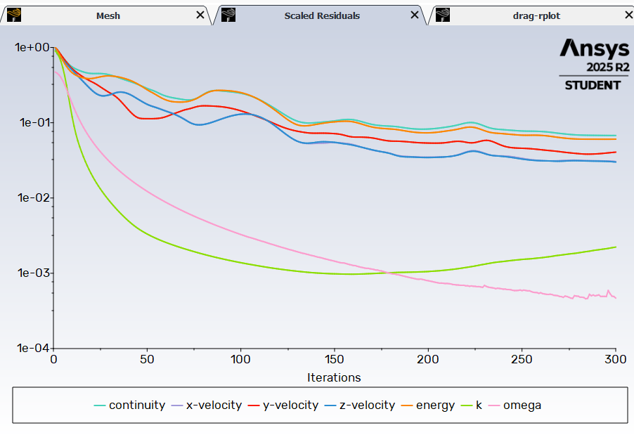
Figure 7 Residuals plot
To complement residual monitoring, a predefined drag report was created on the rocket body. The solution was considered converged only when the drag coefficient reached a stable plateau with negligible oscillations, ensuring that both residual-based and physics-based convergence conditions were satisfied.

Results and post processing

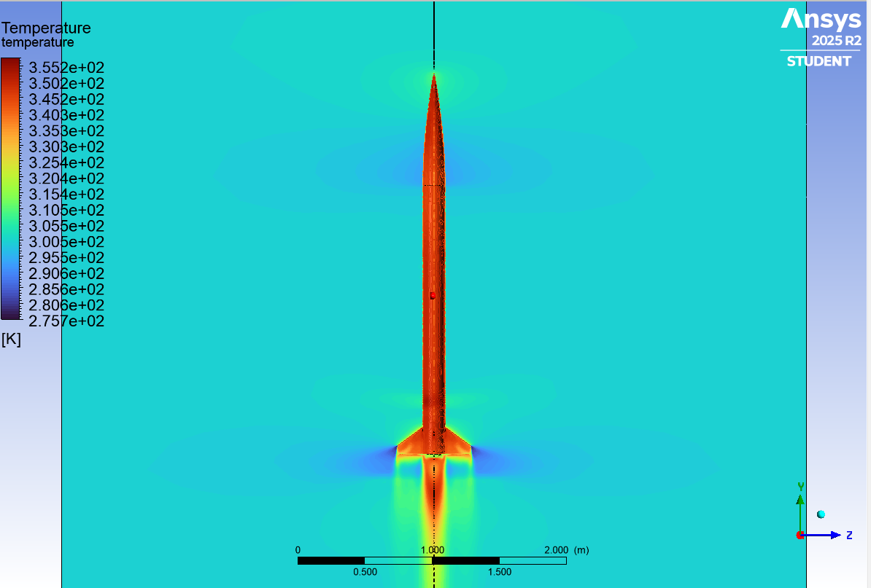
Figure 8 pressure based results
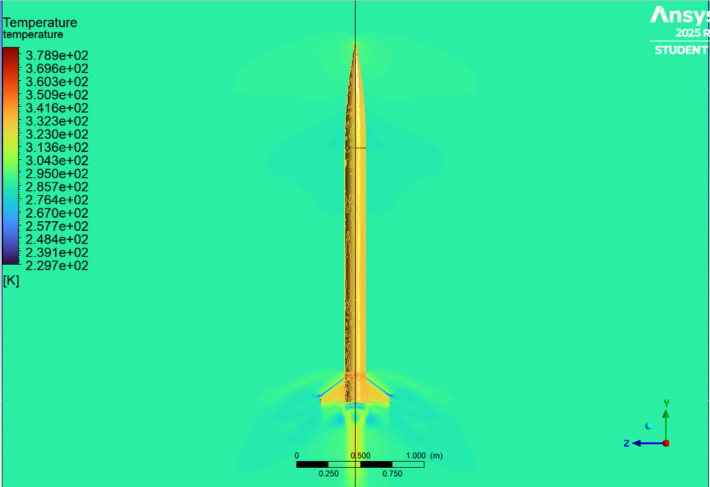
Figure 9 density-based solver results
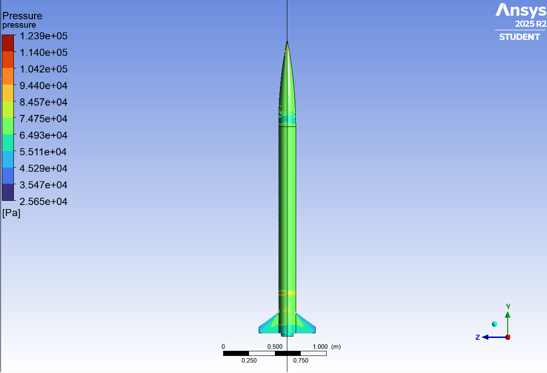
Figure 10 pressure based results
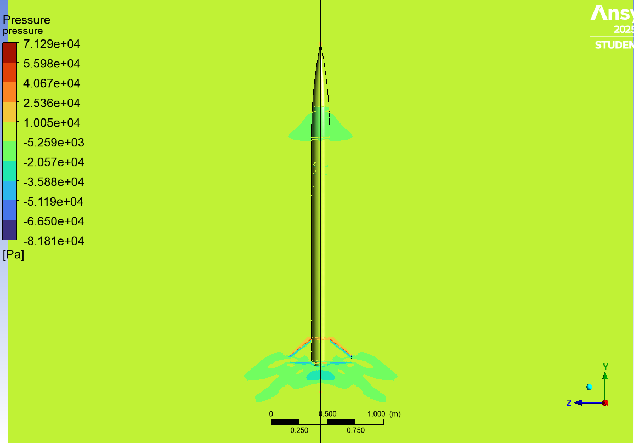
Figure 11 density based

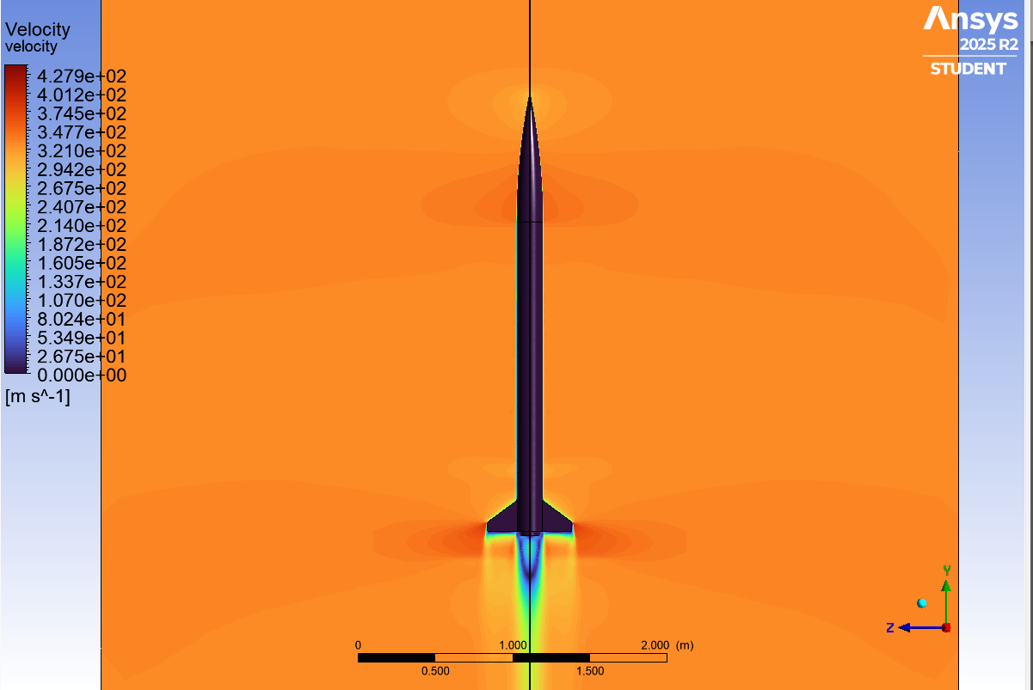
Figure 12 pressure based
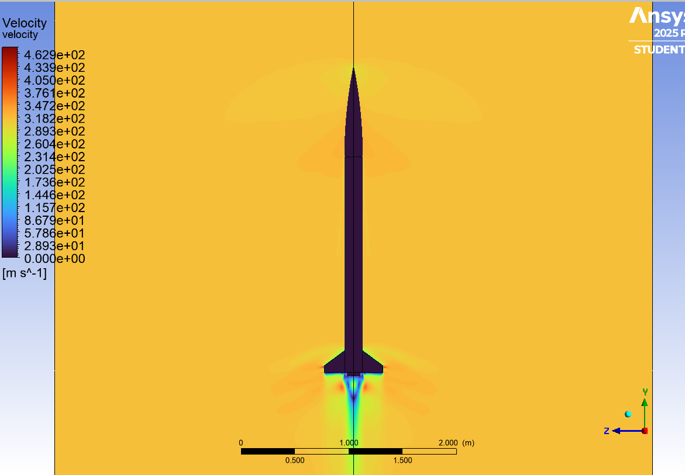
Figure 13 density based

