Thermodynamic Model for Molecular Glue Design: Evaluation of De Novo Designed Ligands

Introduction
In the realm of drug discovery, molecular glues are emerging as a powerful tool for stabilizing protein-protein interactions (PPIs), offering a novel approach to target specific protein complexes. This document outlines the thermodynamic model used to evaluate the efficacy of de novo designed molecular glues, presents the computational methods employed, and discusses the results obtained from the res.csv data file.

Thermodynamic Model for PPI Stabilization
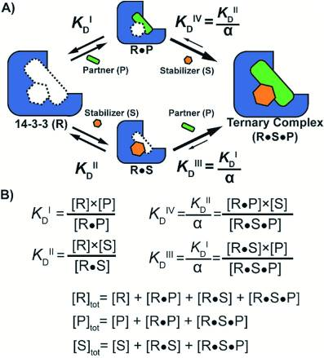

Concept of Molecular Glues
Molecular glues are small molecules that stabilize PPIs, acting as a "glue" to hold proteins together. This stabilization is crucial in drug development for targeting specific protein interactions involved in various diseases.

Cooperativity Framework
The thermodynamic model, as described in the research paper PMC6429609 , introduces a cooperativity framework to quantify the stabilization effect of small molecules on PPIs. Key parameters include:
- Cooperativity Factor (α): Measures the mutual enhancement between the stabilizer and the binding partners, indicating the effectiveness of stabilization.
- Intrinsic Affinity (KDII): Represents the affinity of the stabilizer for one of the proteins in the complex.
These parameters are crucial for understanding the stability of the protein complex and the potency of the molecular glue.

Computational Methods

Forcefield Calculations and KD Determination
The free energy change (ΔG) was computed using forcefields, and the intrinsic affinity (KD1) was determined using the formula:
KD1=exp⁡(ΔGR⋅T)KD1=exp(R⋅TΔG​)
Where:
- RR is the gas constant.
- TT is the temperature in Kelvin.

Data Evaluation
The res.csv file contains the computed KD (KD2) and α values for various ligands, including generated ligands and known compounds like thalidomide. These values were used to evaluate the efficacy of the designed molecular glues.

Results and Discussion

Data Presentation
The res.csv data includes multiple entries for some ligands, likely representing different conformations or variants. A scatter plot of KD versus α for these ligands would provide a visual summary of their relative efficacies.

Implications of KD and α Values
- Lower KD: Indicates higher affinity of the ligand for the protein.
- Higher α: Suggests stronger cooperativity in stabilizing the PPI.
These values help in understanding the structure-activity relationships (SAR) of the ligands, guiding the design of more effective molecular glues.

Validation and Comparison
Comparison of the computed KD and α values with those of known molecular glues, such as thalidomide, validates the computational approach and provides insights into the relative efficacy of the designed ligands.

Limitations and Considerations

Potential Sources of Error
- Forcefield Accuracy: Empirical models may have limitations in predicting ΔG.
- Protein Flexibility: Not fully accounted for in the model.
- Approximations: Simplifications made in the thermodynamic model.

