

BADJI MOKHTAR ANNABA UNIVERSITY
FACULTY OF MEDICINE
DEPARTMENT OF MEDICINE
MODULE: GENERAL HUMAN EMBRYOLOGY
Report on the first practical session: Introduction to histology techniques

First and Last Name:
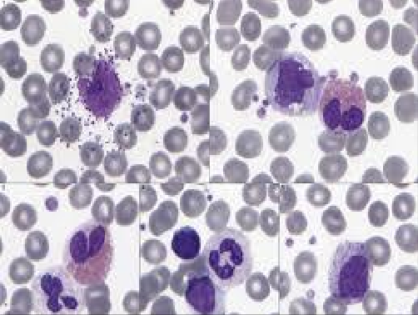
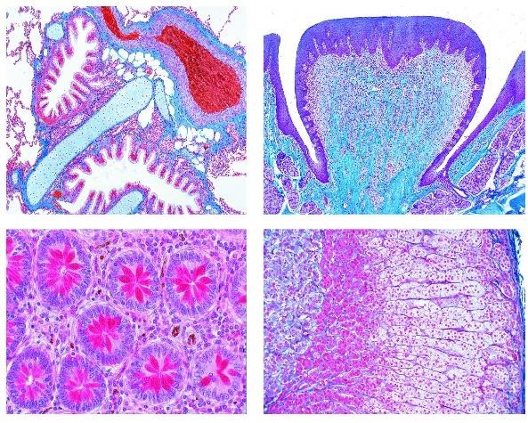
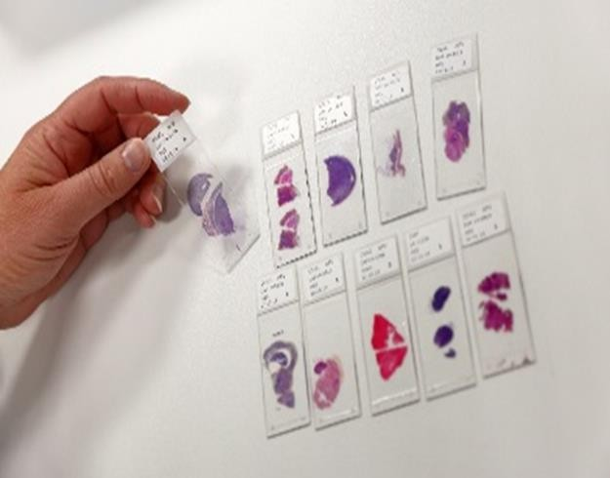

Group:
Academic year: 2025/2026

Instructions to follow:
1. Font: Times New Roman (size 12 for text, size 14 for titles), adjust your paragraphs by clicking on (Justify), line spacing is 1.5.
2. Try to type your names and the group before printing (this will look more presentable)
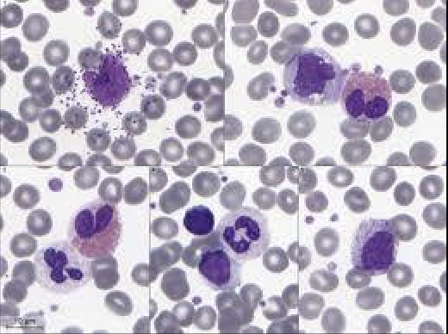
3. Figure title at the bottom, centered and numbered. Example

Figure 01. Histological section of blood cells.

4. Table title at the top, centered and numbered. Example
Table 01………………………………………………..

5. Please number the pages (bottom right), excluding the cover page.
6. Please bring the paper version to the next session.

Good luck!
Dr. ARROUSSI R.

