CAMPUSCONNECT AUS
System Architecture Document
Multi-Environment Mobile Infrastructure Design Blueprint
Course Requirement: Academic Software Engineering Project
Assignment Group: Group 11
Campus Code: CAM-AUS-11
Prepared By: Abdullahi Abba Ahmad
Matriculation Number: FCP/CIT/22/1000
Date: June 2026
Version: 1.0.0

1. Architecture Overview
The architecture of CampusConnect AUS is engineered around the core principles of Clean Architecture and the Repository Pattern, using Riverpod as the reactive state management and dependency injection framework. The system is split into isolated layers with unidirectional dependency flows, ensuring that core business logic remains completely independent of third-party frameworks, database drivers, and user interfaces.
A central structural driver of this architecture is the Environment Switching Strategy, which completely decouples the application interface from concrete data services. This enables the mobile client to switch transparently between a cloud-native production pipeline powered by Google Firebase and a completely self-contained development or testing pipeline driven by a local Mockoon mock server or in-memory mock datasets.
2. Technology Stack
Flutter & Dart
Serves as the cross-platform frontend compilation target and runtime language. It compiles directly into native ARM machine code for both Android and iOS devices from a shared single codebase, ensuring high-performance UI rendering (targeting a baseline of 60 FPS) through a declarative widget layout pipeline.
Firebase Cloud Infrastructure
- Firebase Authentication: Handles secure student authentication, remote user creation, and session security token emission.
- Cloud Firestore: A NoSQL cloud document database providing out-of-the-box, low-latency WebSocket stream synchronized listeners required to meet real-time message exchange objectives.
- Firebase Cloud Messaging (FCM): Manages resource-optimized, lifecycle-aware push notification payload dispatches directly to operating system routing backbones.
SQLite Embedded Database Engine
Acts as the robust relational local cache layer embedded inside the mobile device storage sandbox. It holds offline mirrors of crucial system data definitions, answers queries during total network drops, and handles atomic queuing for outbound transactional mutation playbacks.
Riverpod State Engine
Provides type-safe state management controls and a clean compile-safe Dependency Injection (DI) matrix registry. It removes unstable global state tracking mechanisms and handles structural lifecycle containment for operational objects.
OpenStreetMap (flutter_map)
Acts as the open-source geographic information layer (GIS). By eliminating third-party API key licensing constraints, it allows localized tile segment pre-fetching and cache policies so that campus location lookup maps remain functional during poor network access cycles.
3. Architectural Style
The codebase is split into three strictly isolated software layers to achieve long-term code maintainability, isolation of concerns, and clean testing vectors.
Domain Layer (Core Business Rules)
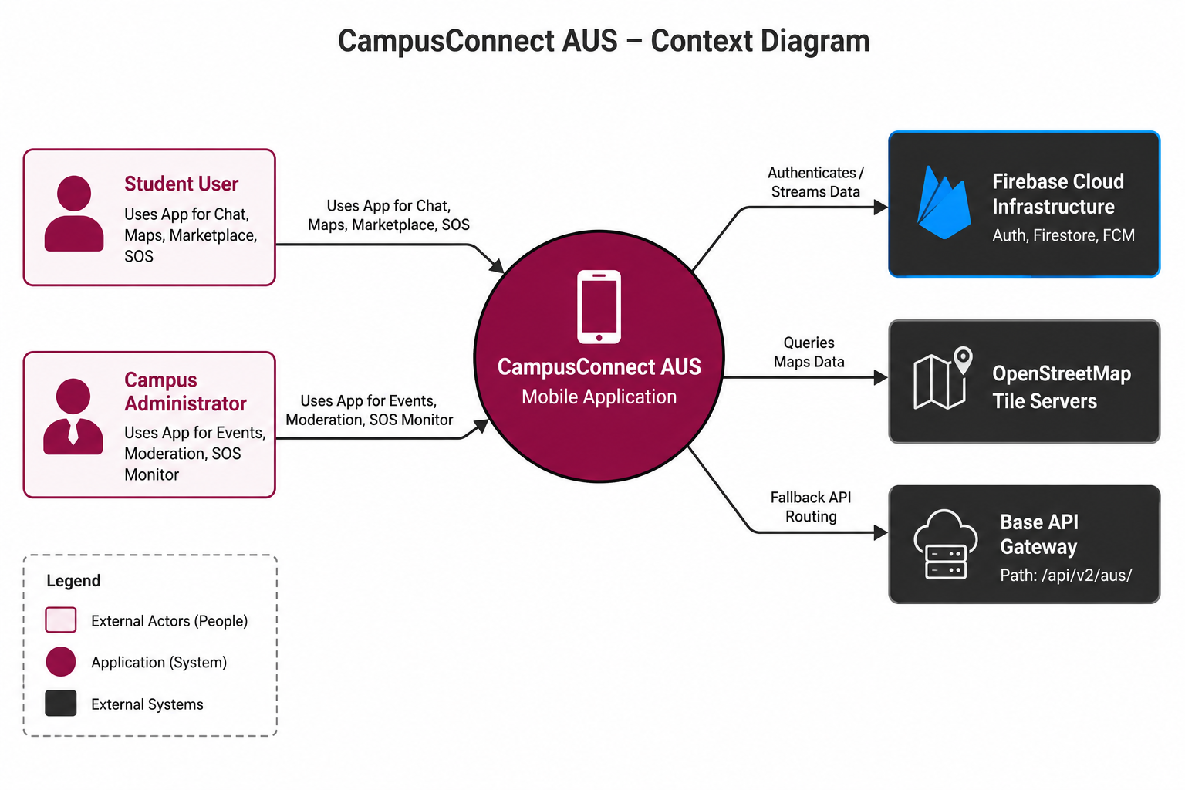
- Contains structural application abstractions, state definitions, core validations, entities, use cases, and abstract repository layout matrices.
- Maintains zero third-party dependencies. It has no references to Flutter, Firebase, SQLite packages, or network frameworks.
- Dependencies flow strictly inward; it remains completely unaware of databases or UI layers.
Data Layer (Infrastructure Details)
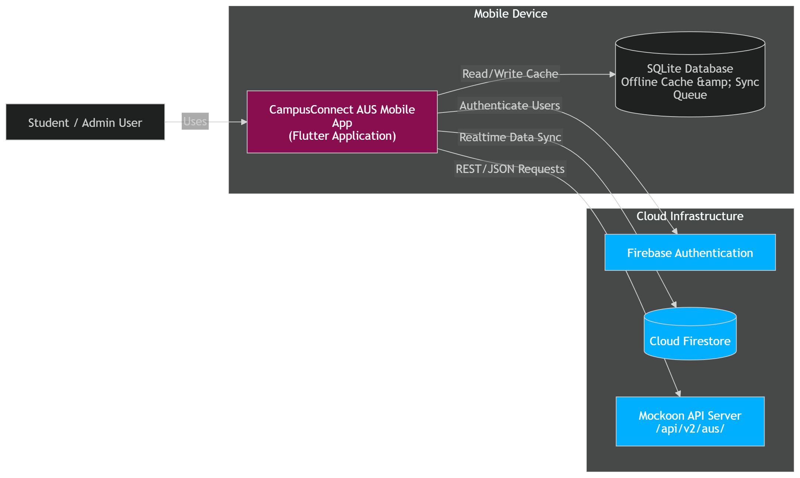
- Implements the boundary specifications mapped out by the abstract domain layer contracts.
- Handles parsing configurations, network request processing, local SQLite transaction execution, and remote data synchronization logic.
- Encapsulates the Firebase client SDK and handles local SQLite entity mapping behaviors.
Presentation Layer (User Interface & Control State)
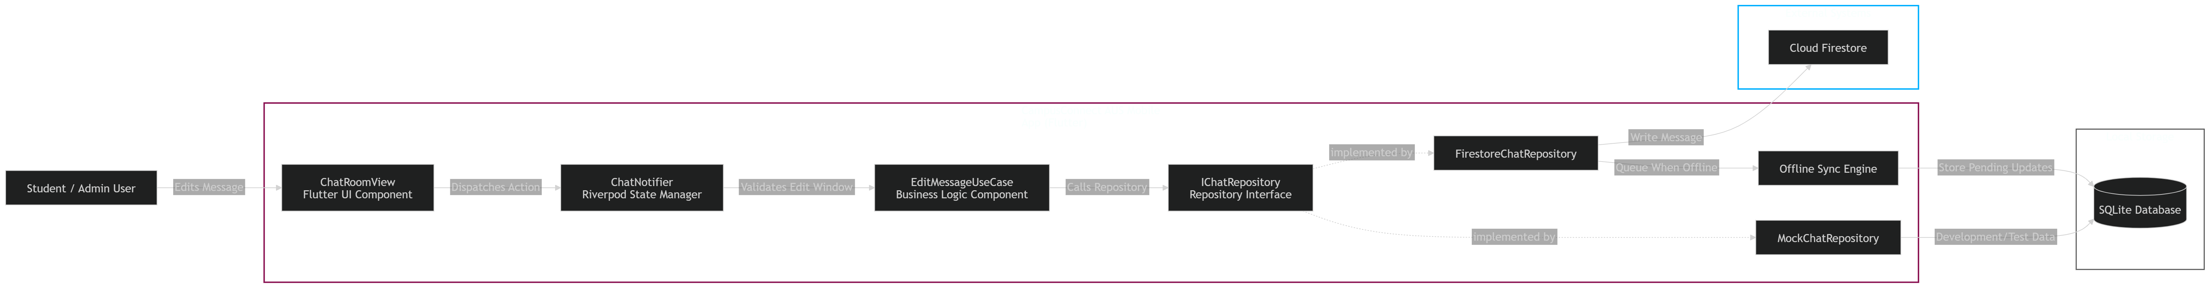
- Composed of Flutter layout widgets and Riverpod state management controllers (Notifiers).
- Views listen to explicit slices of UI state variables and forward user actions down to corresponding domain use cases.
The Repository Pattern Abstraction Barrier
The Repository Pattern acts as an explicit abstraction barrier separating business rules from actual infrastructure logic. Core use cases communicate only with the abstract contract interfaces. Swapping data configurations—such as shifting from remote live data streams down to local mock frameworks—requires zero structural code adjustments inside the core business module.
4. Environment Switching Strategy
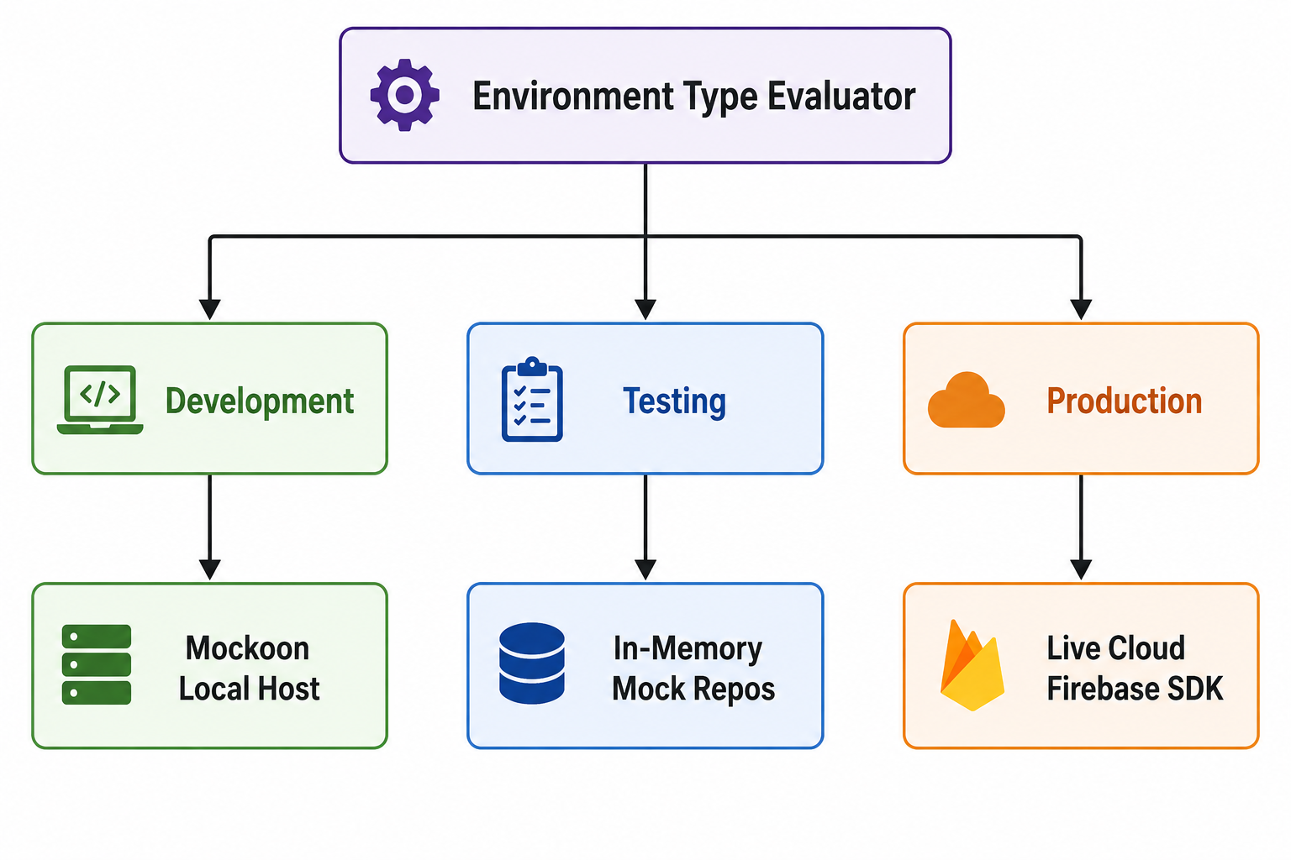
To enable seamless operation across different development phases without modifying codebase source layers, the system utilizes an explicit compilation build state matrix:
Development Environment
- Points application infrastructure channels to a localized host machine endpoint running a structural Mockoon footed layout matrix.
- Configures remote connections to bind smoothly to local addresses: http://10.0.2.2:3000/api/v2/aus/ (resolving standard Android/iOS emulator routing blocks).
Testing Environment
- Features zero platform or external network route dependencies.
- Uses pure in-memory Mock Repositories that simulate operations using structured test arrays, isolated from background transport frameworks.
Production Environment
- Binds system dependencies natively to the secure, real-time Google Cloud Firebase services network infrastructure.
- Enables secure cloud synchronization routines, live messaging listeners, and real-time push bulletins.
5. Dependency Injection Strategy
Dependency configuration is resolved explicitly at startup using Riverpod's compile-safe registry override capability. Contract wrappers throw error instances by default, preventing uninitialized code runtime errors.
Abstract Domain Contract Interface
abstract class IChatRepository {
Stream<List<Message>> streamMessages(String chatId);
Future<void> sendMessage(String chatId, Message message);
Future<void> editMessage(String chatId, String messageId, String newContent);
}

Base Contract Provider Slot Registry
import 'package:riverpod/riverpod.dart';
final chatRepositoryProvider = Provider<IChatRepository>((ref) {
throw UnimplementedError('Environment override must be executed at startup.');
});

Startup System Blueprint Resolution (main.dart)
void main() async {
WidgetsFlutterBinding.ensureInitialized();
// Resolve environment config (e.g., via --dart-define=ENV=prod)
const environment = String.fromEnvironment('ENV', defaultValue: 'dev');
late IChatRepository resolvedChatRepo;
if (environment == 'prod') {
resolvedChatRepo = FirestoreChatRepository(firestoreInstance: FirebaseFirestore.instance);
} else if (environment == 'test') {
resolvedChatRepo = MockChatRepository();
} else {
resolvedChatRepo = MockoonChatRepository(httpClient: Dio(BaseOptions(baseUrl: 'http://10.0.2.2:3000/api/v2/aus/')));
}
runApp(
ProviderScope(
overrides: [
chatRepositoryProvider.overrideWithValue(resolvedChatRepo),
],
child: const CampusConnectApp(),
),
);
}

6. Security Architecture
Local Data Protection via Sandboxed Encryption
Local transactional elements, message tables, and user state matrices saved inside SQLite fields are encrypted using an AES-256 layer. Database connections unlock dynamically using page-level validation sequences driven by cryptographic master key configurations stored inside the host hardware's native keychain container (Android Keystore / iOS Keychain).
Network Integrity Guardrails
All network transport packets routing under the `/api/v2/aus/` base gateway are restricted to a minimum deployment of TLS 1.3 tunnels. Outward HTTP interceptors validate request structures, injecting signed authorization bearer tokens to authenticate requests.
Server-Side Validation: Firebase Security Rules
To defend the system data boundaries, access permissions are verified programmatically at the cloud layer. Firestore rules restrict chat manipulation solely to validated participant arrays. Crucially, message creation timestamps are verified as immutable, and updates are structurally blocked if they exceed Group 11's 120-second edit window constraint:
match /chats/{chatId}/messages/{messageId} {
allow create: if request.auth != null && request.resource.data.sender_id == request.auth.uid;
allow update: if request.auth != null
&& resource.data.sender_id == request.auth.uid
&& request.resource.data.created_at == resource.data.created_at
&& (request.time - resource.data.created_at) < duration.value(2, 'm');
}

7. Deployment Architecture & CI/CD Pipeline
Code modifications follow an automated software verification path using GitHub Actions workflows to ensure system stability before deployment:
- Code Validation Track: Scans styling parameters and checks code syntax formatting using the strict 'flutter analyze' ruleset.
- Automated Test Phase: Executes standard unit testing runs alongside individual repository validation operations to verify entity modeling logic.
- Integration Analysis Track: Provisions localized Mockoon application mocks to evaluate operational flow scenarios under automated interface testing metrics.
- Distribution Pipeline: Upon successfully clear runs, release branches compile production binaries (.aab for Android, .ipa for iOS) which are pushed out directly to the Google Play Console Internal Tracks and Apple TestFlight environments respectively.

