

Shoubra Faculty of Engineering

Benha University

Student Name: Abdoulah Hmdy Abd El-Rahman

Group: 4

Section: 21

ID: 475

GitHub Link: <https://abdoulahhmdy.github.io/ece001/>

Course Name: Computer

Course Code: ECE001

**Computer Engineering Role in COVID-19 Pandemic**

*Under Supervision of:*

*Dr. Ahmed Bayoumi.*

**Introduction**

This website is build using Visual studio Code, HTML Language and Css.

The website contains 5 pages:

* الصفحة الرئيسية
* إرشادات لتجنب تفشى كوفيد
* أهم ما تم اختراعه لمواجهة تفشى كوفيد
* مجهودات العلماء والمطورين
* علوم البيانات وكوفيد

The main page contains some information about the COVID 19. Then, the second page, we move to some guides and tips to avoid the virus. After that some inventions used to overcome COVID. Then, what did scientists do to overcome covid. Finally, Big Data and COVID.

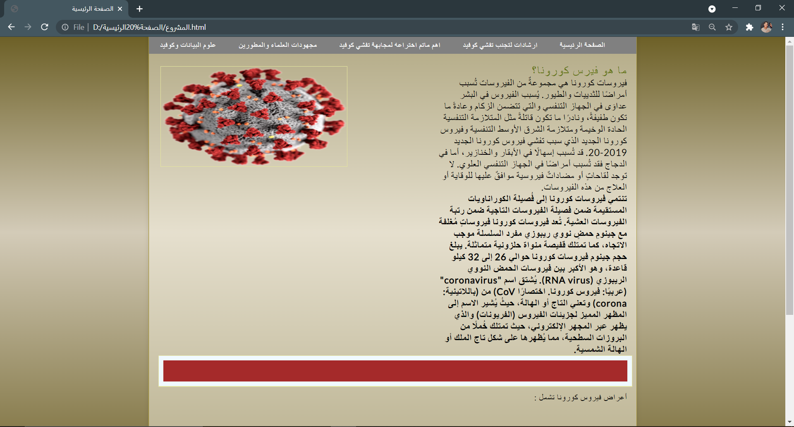**Screenshots representing the website:**

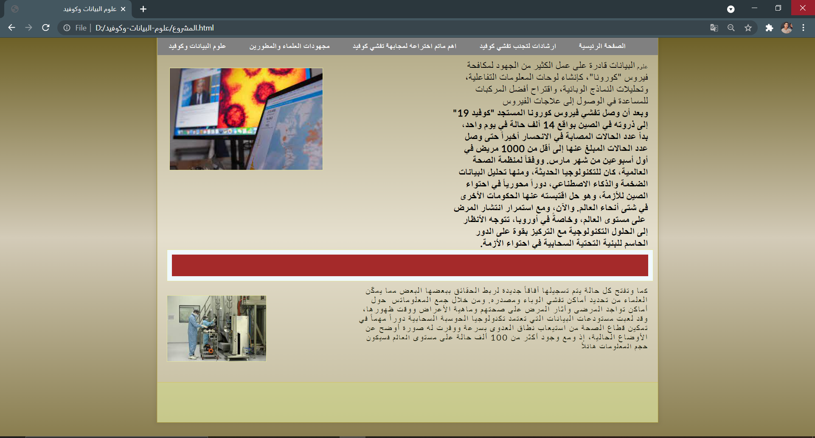

**These are some screenshots representing the code:**

