Ontario Tech University
Faculty of Engineering and Applied Science

SOFE 4630U Cloud Computing
Phase 1 Report: Modular Monolithic System
Cloud-based Scenario Extraction from NGSIM Dataset

Group 11
Alexy Pichette (100822470)
Malyka Sardar (100752640)
Mohammad Al-Lozy (100829387)
Abdullah Hanoosh (100749026)
Date: March 15, 2026

1. Introduction
This project implements a cloud-based system to process vehicle trajectory data from the NGSIM US-101 dataset. The system identifies three driving scenarios from raw traffic data and produces labeled 5-second samples. Phase 1 uses a modular monolithic architecture deployed on Microsoft Azure.
The three driving scenarios identified are:
- Car-Following: An ego vehicle maintains a consistent gap with the vehicle ahead in the same lane.
- Stop-and-Go: A vehicle decelerates sharply, nearly stops, then re-accelerates, typical of congested traffic.
- Lane Change: A vehicle transitions from one lane to an adjacent lane.
The system processes raw NGSIM data through a four-stage pipeline: ingestion, preprocessing, scenario detection, and output generation. All data is stored and managed using Azure Blob Storage.

2. System Architecture

2.1 Overview
Phase 1 adopts a modular monolithic architecture — a single deployable application with clearly separated internal modules, each responsible for a specific stage of the processing pipeline. The application is designed to run on Microsoft Azure cloud infrastructure.
Key design principles:
- Separation of concerns: Each module handles one pipeline stage.
- Single deployment: All modules run in one process, simplifying deployment and debugging.
- Azure-native: Uses Azure Blob Storage for data persistence and can be deployed on Azure VM or Container Instances.

2.2 Module Breakdown
The system is composed of the following modules:
Module | File | Responsibility
Config | config.py | Centralized configuration, thresholds, Azure settings
Ingestion | modules/ingestion.py | Load NGSIM data locally or upload/download via Azure Blob Storage
Storage | modules/storage.py | Azure Blob Storage operations, local file I/O
Preprocessing | modules/preprocessing.py | Data cleaning, type enforcement, derived features
Car-Following | modules/scenarios/car_following.py | Detect car-following scenarios
Stop-and-Go | modules/scenarios/stop_and_go.py | Detect stop-and-go scenarios
Lane Change | modules/scenarios/lane_change.py | Detect lane change scenarios
Output | modules/output.py | Format, combine, and export results
Main | main.py | Pipeline orchestrator

2.3 Architecture Diagram
The main orchestrator (main.py) coordinates four pipeline stages:
- Ingestion Module reads CSV data and uploads to Azure Blob Storage (batch ingestion).
- Preprocessing Module cleans data, enforces types, filters to mainline lanes (1–5), and computes derived features.
- Scenario Detection runs three detection algorithms (car-following, stop-and-go, lane change) using 5-second sliding windows.
- Output Module saves JSON and CSV results locally and uploads to Azure Blob Storage.

3. Data Flow
The processing pipeline transforms raw NGSIM trajectory data into labeled 5-second scenario samples through four sequential stages:
Stage | Description
1. Ingestion | Load raw NGSIM CSV data from local file; upload to Azure Blob Storage (ngsim-raw container) via batch upload.
2. Preprocessing | Validate column types, filter to mainline lanes (1–5), remove invalid records and noise (|acceleration| > 40 ft/s²), compute derived features.
3. Detection | Apply three scenario detection algorithms using 5-second (50-record) sliding windows across all vehicle trajectories.
4. Output | Assign unique scenario IDs, merge results, save JSON (detailed) and CSV (summary) files, upload to Azure Blob (ngsim-output).

3.1 Data Volume
- Input: 189,541 raw NGSIM trajectory records (2,847 vehicles, US-101 Hollywood Freeway)
- Output: 1,923 labeled 5-second scenario samples (JSON + CSV)

4. Cloud Infrastructure (Azure)
The system is built on Microsoft Azure cloud services. The following table summarizes the Azure services used and their purpose:
Azure Service | Purpose | Justification
Azure Blob Storage | Store raw NGSIM data and processed outputs | Cost-effective object storage; supports batch upload/download; Python SDK (azure-storage-blob)
Azure VM / Container Instances | Execute the monolithic application | Single-instance compute sufficient for monolithic architecture; containerized via Docker
Azure Container Registry | Store Docker image (optional) | Enables reproducible deployment of the containerized application

4.1 Why Azure Blob Storage
- Scalability: Handles files from KB to TB without configuration changes.
- Cost: Pay-per-use model with storage tiers (Hot/Cool/Archive).
- Separation: Raw data and processed outputs stored in separate containers (ngsim-raw, ngsim-output).
- Reliability: Built-in redundancy (LRS/GRS) ensures data durability.

4.2 Ingestion Strategy
The NGSIM dataset is static historical data, so batch ingestion is the appropriate strategy. The entire CSV file is uploaded to Azure Blob Storage in one operation. This supports reprocessing by re-downloading from Blob Storage without re-uploading.

5. Scenario Detection Logic

5.1 Car-Following
Definition: A car-following scenario occurs when an ego vehicle maintains a consistent gap with the vehicle directly ahead in the same lane over a 5-second window.
Detection Conditions:
- Ego and lead vehicle remain in the same lane (same Lane_ID, no lane changes)
- Space headway is between 0 and 200 feet
- Both vehicles are moving (velocity > 5 ft/s)
- Speed difference between ego and lead is less than 15 ft/s
Data Features Used: Lane_ID, Space_Hdwy, v_Vel, Preceding, Local_Y

5.2 Stop-and-Go
Definition: A stop-and-go scenario is identified when a vehicle undergoes significant deceleration, reaches a near-stop speed, and then re-accelerates within a 5-second window.
Detection Conditions:
- Vehicle decelerates below −5 ft/s²
- Speed drops below 10 ft/s (near-stop)
- Vehicle then accelerates above +3 ft/s²
- Deceleration occurs before acceleration (temporal ordering)
- At least one nearby vehicle also shows congestion signs (low speed or deceleration)
Data Features Used: v_Vel, v_Acc, Lane_ID, Local_Y

5.3 Lane Change
Definition: A lane change scenario occurs when a vehicle transitions from one mainline lane to an adjacent lane within a 5-second window.
Detection Conditions:
- Vehicle’s Lane_ID changes during the window
- Change is between adjacent lanes (lane difference = 1)
- Both source and destination are mainline lanes (1–5)
- Surrounding vehicles tracked in both source and destination lanes for context
Data Features Used: Lane_ID, Local_X, Local_Y

6. Results
The system was run on real NGSIM US-101 trajectory data (189,541 records, 2,847 vehicles). The following scenarios were detected:
Scenario Type | Count
Car-Following | 340
Stop-and-Go | 408
Lane Change | 1,175
Total Scenarios | 1,923
Figure 1: Detected Driving Scenarios Summary
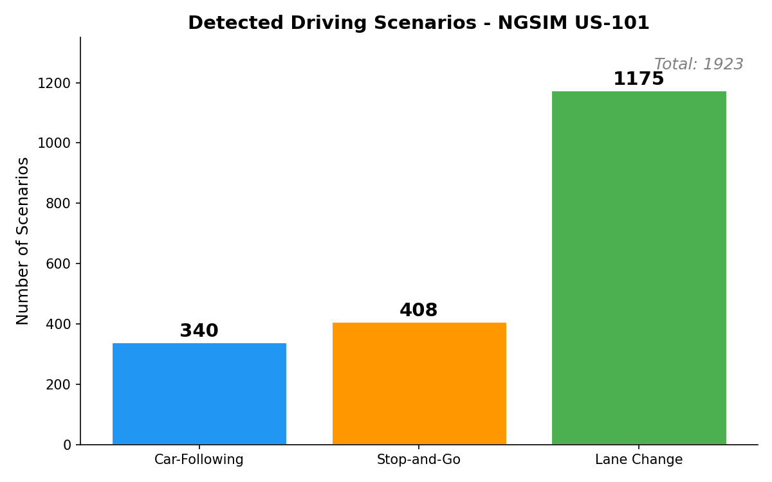

6.1 Scenario Distribution Across Lanes
The following chart shows how detected scenarios are distributed across the five mainline lanes:
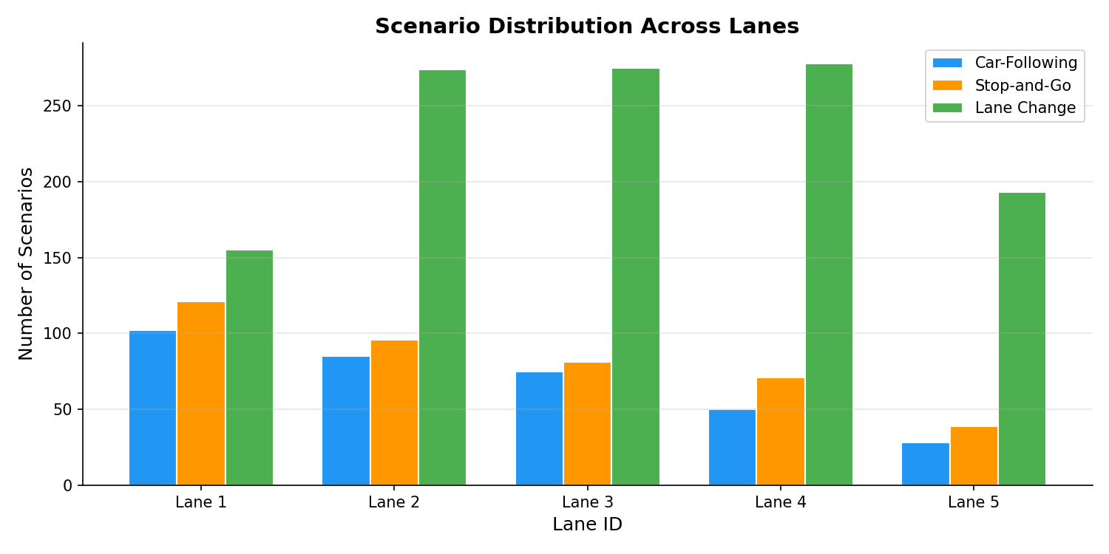
Figure 2: Scenario Distribution Across Lanes

6.2 Speed Distribution by Scenario Type
The box plot below compares average vehicle speeds across the three scenario types:
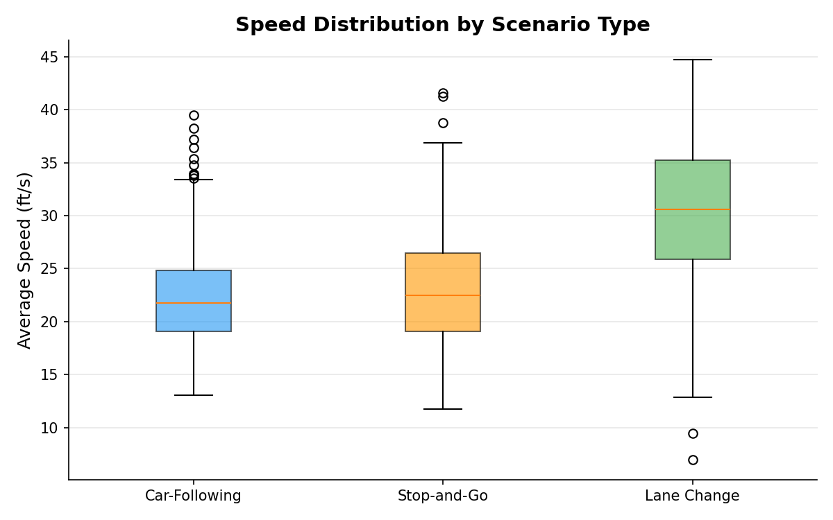
Figure 3: Speed Distribution by Scenario Type

6.3 Example Outputs

Car-Following Example
Scenario ID | CF-0001
Ego Vehicle | 103
Lead Vehicle | 96
Lane | 3
Avg Space Headway | 76.45 ft
Ego Avg Speed | 31.67 ft/s
Lead Avg Speed | 33.57 ft/s
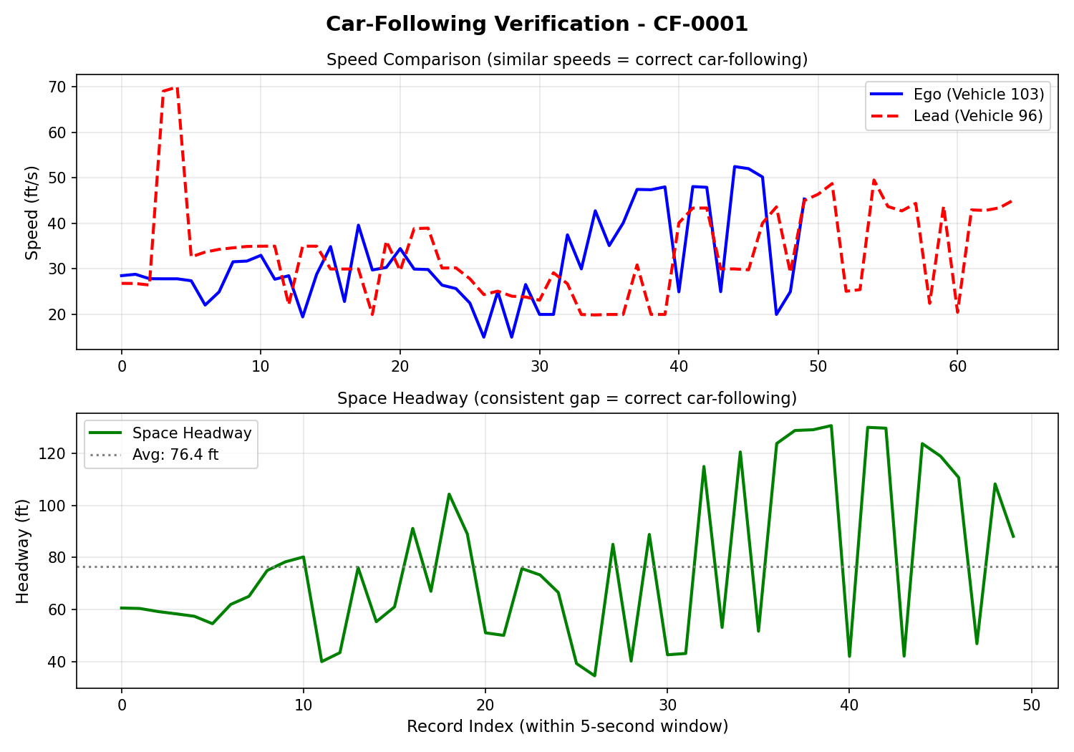
Figure 4: Car-Following Verification (CF-0001) — Speed comparison and space headway

Stop-and-Go Example
Scenario ID | SG-0341
Ego Vehicle | 41
Lane | 1
Min Speed | 5.0 ft/s
Max Deceleration | −10.38 ft/s²
Max Acceleration | 11.2 ft/s²
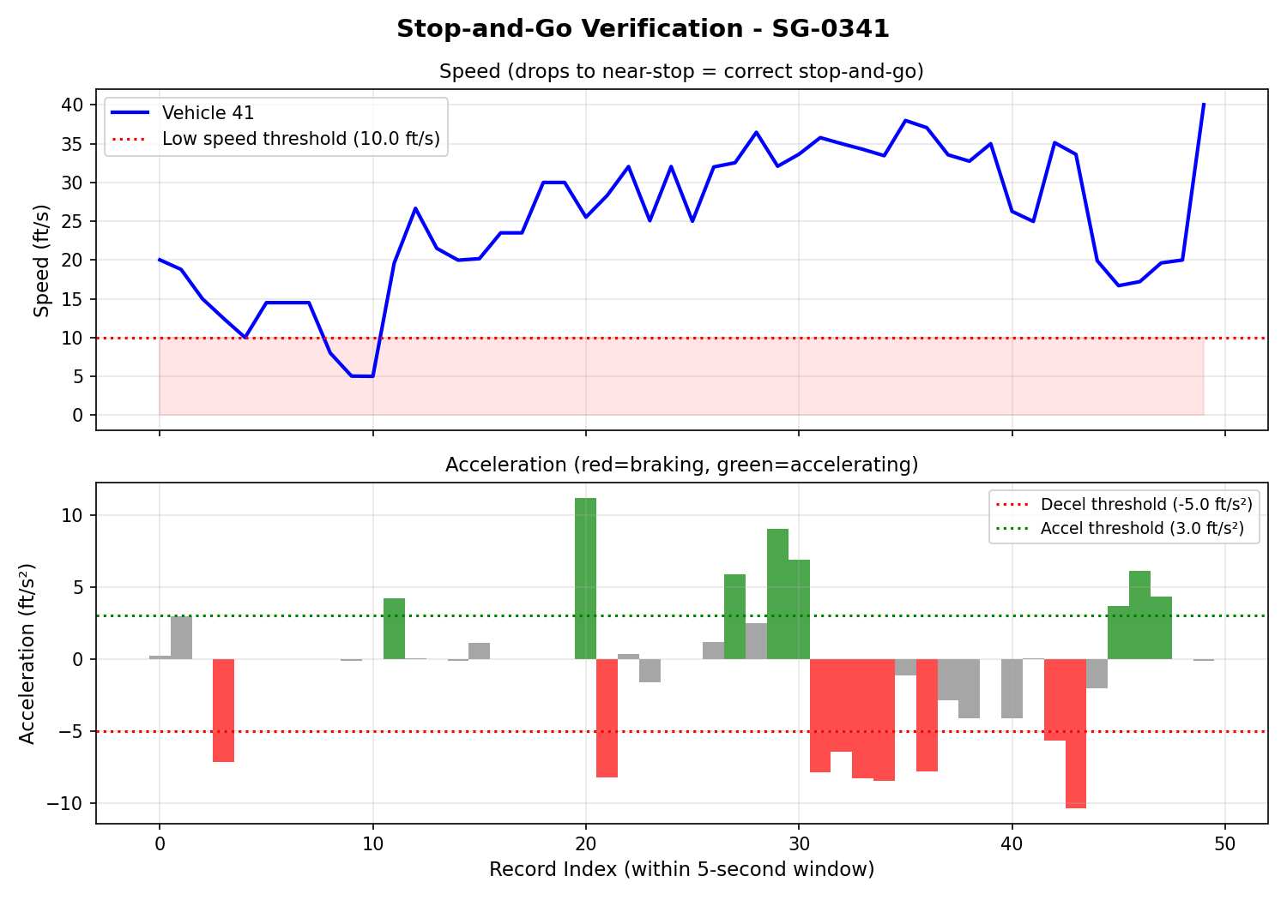
Figure 5: Stop-and-Go Verification (SG-0341) — Speed drop and acceleration profile

Lane Change Example
Scenario ID | LC-0759
Ego Vehicle | 26
Source Lane | 2
Destination Lane | 3
Direction | Right
Avg Speed | 30.54 ft/s
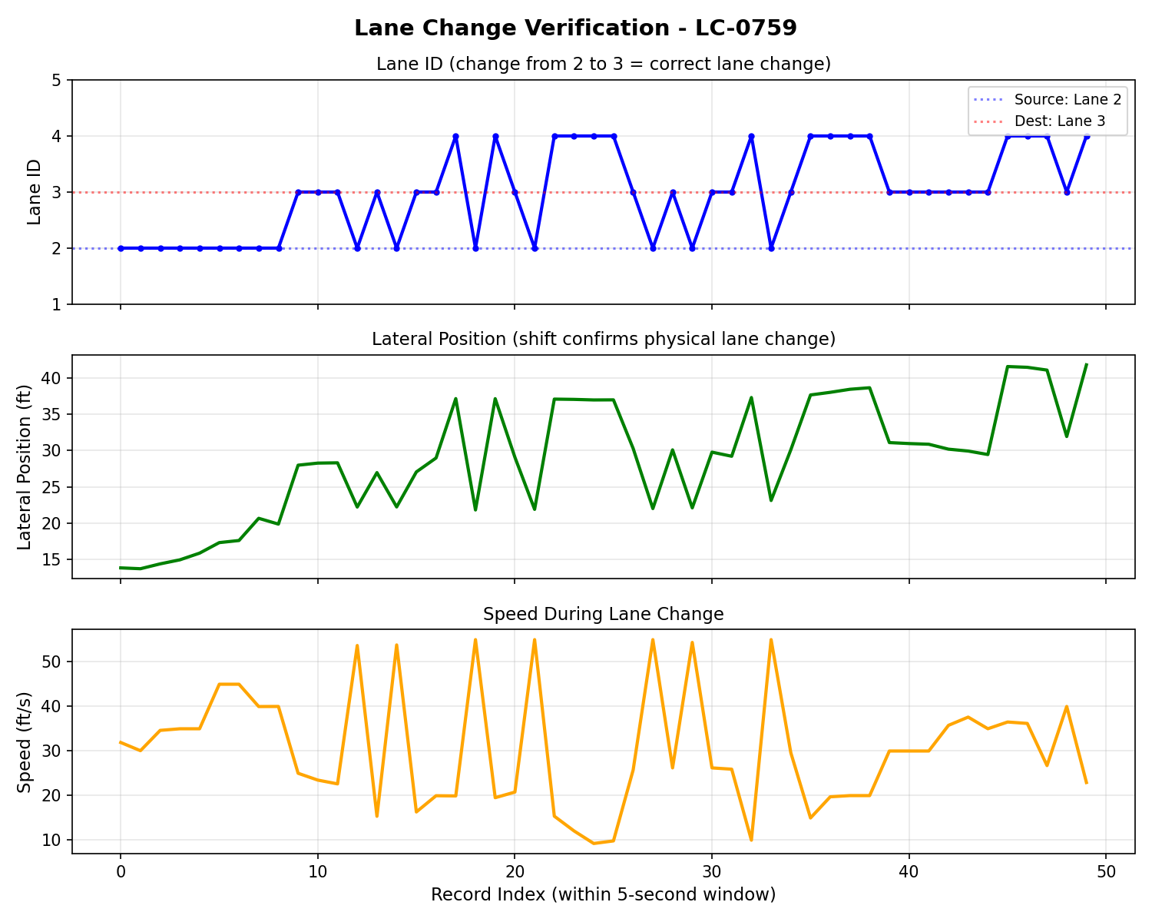
Figure 6: Lane Change Verification (LC-0759) — Lane ID, lateral position, and speed

7. Deployment

7.1 Local Development
pip install -r requirements.txt
python main.py --data data/ngsim_us101.csv

7.2 With Azure Integration
set AZURE_STORAGE_CONNECTION_STRING="your-connection-string"
python main.py --data data/ngsim_us101.csv --azure

7.3 Docker Deployment
docker build -t ngsim-scenario-extractor .
docker run ngsim-scenario-extractor
The Docker image can be pushed to Azure Container Registry and deployed to Azure Container Instances for cloud execution.

8. Dataset
The NGSIM US-101 dataset was collected on June 15, 2005, on the southbound US-101 (Hollywood Freeway) in Los Angeles, California. The study section spans approximately 2,100 feet (0.4 miles) with 5 mainline lanes. Data was collected at a 10 Hz sampling rate (one record per vehicle per 0.1 seconds).
Key Data Fields:
Field | Unit | Description
Vehicle_ID | — | Unique vehicle identifier
Frame_ID | — | Frame number (ascending by time)
Local_X / Local_Y | feet | Position relative to road segment
v_Vel | ft/s | Instantaneous velocity
v_Acc | ft/s² | Instantaneous acceleration
Lane_ID | — | Lane number (1=leftmost, 5=rightmost mainline)
Preceding | — | Vehicle ID of lead vehicle in same lane
Space_Hdwy | feet | Bumper-to-bumper gap to preceding vehicle

8.1 Assumptions and Limitations
- Only mainline lanes (1–5) are processed; ramp and auxiliary lanes (6–8) are excluded.
- Records with extreme acceleration (|a| > 40 ft/s²) are filtered as sensor noise.
- Each scenario window is non-overlapping (windows advance after each detection).
- Data sourced from data.transportation.gov (US Department of Transportation open data).

9. Conclusion
Phase 1 successfully implements a modular monolithic cloud-based system for NGSIM scenario extraction using Microsoft Azure. The system processes 189,541 trajectory records from the US-101 dataset and identifies 1,923 driving scenarios across three categories: car-following (340), stop-and-go (408), and lane change (1,175).
The modular monolithic architecture provides a clean separation of concerns while maintaining the simplicity of a single deployable unit. Azure Blob Storage serves as the cloud storage layer for both raw data and processed outputs, with batch ingestion appropriate for the static NGSIM dataset.
In Phase 2, the same system will be redeveloped as a microservices-driven application, where each module becomes an independent service communicating through well-defined interfaces. This will allow a direct comparison between monolithic and microservices architectures applied to the same problem.

