Inspiration:
https://www.wix.com/website-template/view/html/2954?originUrl=https%3A%2F%2Fwww.wix.com%2Fwebsite%2Ftemplates%2Fhtml%2Findustrial%2Fconstruction&tpClick=view_button&esi=217bb1d3-888b-43ca-83db-1c9b2122c61b

https://www.wix.com/website-template/view/html/1734?originUrl=https%3A%2F%2Fwww.wix.com%2Fwebsite%2Ftemplates%2Fhtml%2Findustrial%2Fconstruction&tpClick=view_button&esi=5ddfd73f-acec-445d-934e-c8a446e87e64

HOME PAGE
Top Left Mays group Logo Top Right Tabs: Home, Our Story, Services, Careers

Video in Background with caption “One Canadian Group. Every Service, Delivered with Excellence.”

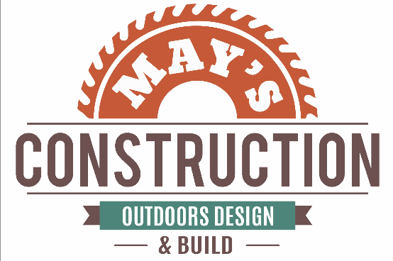
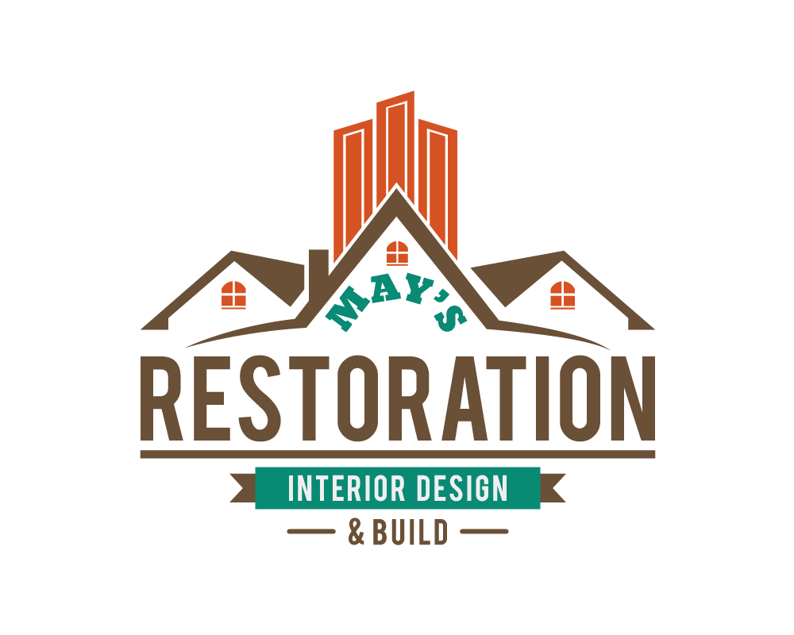
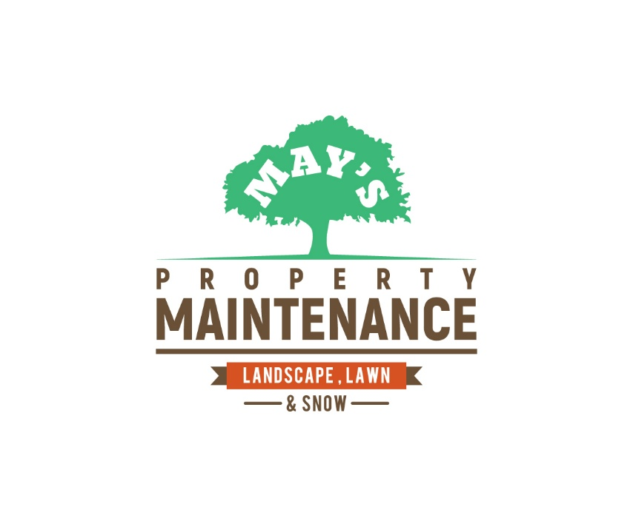
Our divisions:

year-round commercial property services, including snow removal and landscaping
Meticulous interior renovation and restoration services for commercial and high-rise residential properties.
exterior construction services, from concrete works, fencing systems, and infrastructures.

About Us
Canadian family-owned business, May's Group serves as the dedicated parent company for our three specialized subsidiaries. Operating from our headquarters in Toronto, we take a hands-on approach to leadership, directly overseeing every aspect of our day-to-day operations to ensure our high standards are never compromised. We are committed to enforcing strict quality control, paramount safety protocols, and responsive customer service across the entire group. By applying disciplined management principles and leveraging modern technology like real-time GPS tracking, we provide a unified and transparent experience for all our partners, from local residents to the many municipalities we serve.

Why Choose May’s Group
As a local, Canadian family-owned business based in Toronto, May’s Group provides more than just a service, we provide a partnership. We personally oversee all day-to-day operations of our subsidiaries to ensure that the standards of quality and safety that built this company are present on every job site.
- Canadian & Local Expertise: Based in Ontario, we have a deep understanding of local property standards and the harsh realities of Canadian winters, allowing us to plan properly and respond with urgency.
- A Focus on Customer Service: We believe every interaction is an opportunity to exceed expectations. We prioritize long-term relationships through fast response times and professional follow-through.
- One Group, All-Season Solutions: With specialized divisions in Property Maintenance, Construction, and Restoration, we provide consistent quality across every scope and season.
- Safety-Driven Operations: Safety is paramount in everything we do. Our comprehensive reporting and regular staff training are designed to protect the public and minimize risks, especially during winter conditions.
- Proactive & Transparent Communication: We eliminate the guesswork for our clients by providing real-time project updates and time-stamped photo documentation for every service visit.
- Ownership Mentality: We foster a culture of pride and commitment; eligible team members can earn shares in the company after five years, ensuring they treat your property with the same care as their own.
- A Proven Track Record: From maintaining 30+ commercial sites to constructing 300+ municipal bus stops, we are trusted across Ontario for delivering excellence on projects of any scale.

Featured Projects:
Squares of pictures
Will provide details
Clients and partners
Will send logos of companies

Contact Us:
Location on map and our contact info

OUR STORY
Our Story
May’s Group began in 2014 as a small, family-run operation cutting grass and maintaining properties with a simple focus: show up, do the work properly, and treat clients with respect. That consistency led to growth, year after year, as customers trusted us with larger responsibilities and higher standards.
The founder, Mustafa Tawfiq, studied aviation and is a former pilot. The discipline of aviation, planning, safety, documentation, and precision became the foundation of how May’s Group operates. As demand expanded, we grew from seasonal maintenance into year-round property services, then into larger commercial and municipal work. In 2018, May’s Group was formally incorporated and evolved into a diversified Canadian group with three divisions: Property Maintenance, Construction, and Restoration.
Today, we service over 40 commercial properties and have successfully completed major projects across Ontario, including over 300 bus stops, parks, and specialized builds such as medical and lab construction.
What makes May’s Group different is that we invest in people and standards. We consistently train our staff to deliver reliable, safe, high-quality work and we reward long-term commitment.
May’s Group remains hands-on and personal. The founder is still heavily involved in day-to-day operations and stays personally in touch with every client, ensuring accountability, quick decisions, and the same high standard on every site season after season.

