Multi-Group SEIR Disease Transmission and Intervention Simulation Using Monte Carlo Methods
Abdulkarim Noorzaie (100748590), Abdullah Hanoosh (100749026)
Group 2
SOFE 4820U - Modeling & Simulation, Ontario Tech University
March 2026

ABSTRACT
In this paper, a multi-group SEIR model is developed for simulating the spread of infectious diseases among three different populations: children aged 0-17 years, working adults aged 18-64 years, and elderly people aged 65+ years. The simulation is done by applying Monte Carlo simulation to capture randomness in the spread of infectious diseases. The effectiveness of six different intervention strategies is simulated: closure of schools, restrictions in workplaces, isolating elderly people, moderate combination strategies, and lockdown. All strategies are designed to have a realistic detection delay of 14 days before any intervention is applied. The results are derived by applying COVID-19 epidemiological data. The results show that without any intervention strategy, the attack rate is 97.4%. The attack rate is reduced to 3.8% by applying a combination of moderate intervention strategies. The attack rate is reduced to 0.3% by applying a lockdown strategy. The elderly population is responsible for 77% of total mortality, although they contribute only 20% to the total population. The results are validated by applying an estimated R0 of 2.83, a doubling time of 5.5 days, and an incubation period of 5.2 days, all within the accepted COVID-19 epidemiological data.

I. INTRODUCTION
Infectious disease outbreaks are a major public health issue. The COVID-19 pandemic is a recent example of an infectious disease outbreak. The pandemic has emphasized the need for developing computational models for predicting infectious disease spread and assessing the effectiveness of public health interventions before their implementation. The mathematical compartmental model for infectious diseases offers a simulated environment for testing different scenarios.
The compartmental model for infectious diseases is called the SEIR compartmental model. The population is divided into four compartments: Susceptible (S), Exposed (E), Infected (I), and Recovered (R). The population is simulated to move between compartments depending on various infectious disease transmission rates, incubation periods, and recovery rates. The basic SEIR compartmental model assumes a homogeneous population. The spread of infectious diseases in real life is different for different age groups.
This project extends the basic SEIR compartmental model for infectious diseases in several ways. First, a multi-group compartmental model is developed. The population is divided into three different groups with different epidemiological parameters. Second, a contact matrix is used. The matrix is derived from survey results. The matrix represents the number of contacts between different age groups. Third, a Monte Carlo simulation is used. The simulation is used to quantify uncertainty in infectious disease spread. Fourth, a detection delay of 14 days is used before any intervention is applied.
The simulation results are used to test six different scenarios: no intervention, school closures, workplace restrictions, elderly isolation, combined moderate, and full lockdown. Severity, R0, and detection delay are also simulated. The simulation results are validated with real-life COVID-19 pandemic data from Ontario, Canada.

II. RELATED WORK
The SEIR model is widely used in epidemiological studies. The SIR model was first introduced by Kermack and McKendrick in 1927, which was later modified to incorporate an exposed category. The study presented by Li et al. [1] discussed the early spread of COVID-19, which provided vital parameters for the model, i.e., incubation period and basic reproduction number.
Mixing of different age groups is an important factor in the spread of disease. The study presented by Mossong et al. [2] in POLYMOD used extensive surveys from eight different countries in Europe to determine the contact rates among different age groups. Prem et al. [3] extended the same study to 152 different countries, which is used in this study to determine the contact rates among different age groups.
Incorporating Monte Carlo simulations in epidemiological models has also shown promising results. The inherent noise in the transmission, contact, and recovery of the disease may affect the spread of the disease. Instead of a deterministic approach, running hundreds of simulations with different parameter perturbations may provide us with a probability distribution of the results.
The study presented by Voinsky et al. [5] discussed the impact of COVID-19 in different age groups, which is used in this study to determine the differential impact of COVID-19 in different age groups. The study presented by Alimohamadi et al. [4] used a meta-analysis to determine the R0 values of COVID-19, which is used in this study to validate the results in the range of 2.0 to 3.5. The study presented by Levin et al. [7] determined the age-specific infection fatality rate, which is used in this study to determine the severity of the disease.

III. METHODOLOGY

A. SEIR MODEL
In the SEIR model, the members of the population are classified into four groups. The members of the population classified as susceptible are represented as "S" and are thus able to acquire the disease after being exposed to infected members of society. The members of the population classified as being in the incubation period are represented as "E" and thus have been infected but are not yet contagious. The members of the population classified as infected are represented as "I" and thus have acquired the disease. The members of the population classified as immune are represented as "R" and thus have acquired immunity to the disease.
In this model, the parameters used to determine the movement of members of society from one group to the other are represented as beta, sigma, and gamma, which are age-specific, reflecting the epidemiology of COVID-19.
B. MULTI-GROUP STRUCTURE
The population of 1,000,000 individuals is classified into three groups based on demographics. The children of the population, aged between 0-17, comprise 200,000 individuals, which is 20% of the population. The members of this group have a lower transmission rate, represented as beta = 0.03, and a faster recovery rate, represented as gamma = 1/7, which reflects an incubation period of 7 days.
The working adults, aged between 18-64, comprise 60% of the population, which is 600,000 individuals. The members of this group have a moderate transmission rate, represented as beta = 0.035, and a moderate recovery rate, represented as gamma = 1/10, which reflects an incubation period of 10 days.
The elderly, aged between 65+, comprise 200,000 individuals, which is 20% of the population. The members of this group have a higher transmission rate, represented as beta = 0.040, and a slower recovery rate, represented as gamma = 1/12, which reflects an incubation period of 12 days. The members of the population classified as being in the incubation period, represented as sigma, have an incubation rate of 1/5.2, reflecting an incubation period of 5.2 days, which is the mean incubation period of COVID-19 reported in the literature [1].

C. CONTACT MATRIX
The contact matrix defines the average number of daily contacts between individuals in different groups. Our matrix is based on the POLYMOD study [2] and projected contact data from Prem et al. [3]:
Contact From/To | Children | Adults | Elderly
Children | 10.0 | 3.0 | 1.5
Adults | 3.0 | 8.0 | 2.0
Elderly | 1.5 | 2.0 | 4.0
Table 1. Daily contact matrix (average contacts per person per day)
Children have the highest rate of within-group contacts at a rate of 10.0. This is due to their school contacts. The rate of within-group contacts among working adults is high at a rate of 8.0. This is due to their work contacts. The elderly have the lowest rate of within-group contacts at a rate of 4.0. This is due to their lifestyle. The rate of cross-group contacts is generally low. The rate of cross-group contacts between the elderly and the children is the lowest at a rate of 1.5.
D. MONTE CARLO SIMULATION
To take into consideration the stochastic effects in the disease dynamics, we carry out 300 Monte Carlo simulations for the respective intervention scenarios. To this end, we add a Gaussian noise in the transmission parameters. We achieve this by perturbing the effective transmission rate at each time step with a multiplicative noise factor. This noise factor is normally distributed with a mean of 1.0 and a standard deviation of 0.05 (5% noise level).
We compute the mean trajectory, median trajectory, and the 90% confidence intervals of the results (5th and 95th percentiles) of the simulations for all the compartments of the SEIR model. We also compute the total number of infections, the peak number of active infections, the peak day, and the statistics per group.

E. INTERVENTION SCENARIOS
We consider six intervention scenarios, each of which represents a distinct intervention strategy:
1. No Intervention (Baseline): Uncontrolled disease spread, no changes to contacts.
2. School Closures: 70% reduction in all contacts of children.
3. Workplace Restrictions: 50% reduction in all contacts of working adults.
4. Elderly Isolation: 60% reduction in all contacts of elderly individuals.
5. Combined Moderate: Partial interventions on all groups: 50% reduction in school contacts, 30% reduction in workplace contacts, and 40% reduction in contacts of elderly individuals.
6. Full Lockdown: 75% reduction in all contacts of all groups.

F. DETECTION DELAY
It should be noted that one of the important characteristics of our model is the 14-day detection delay. Indeed, in the case of a new disease, it is necessary to take into account the inherent delay between the first infections and the detection of the disease by public health authorities. The spread of the disease during this detection delay is determined only by the baseline (without any intervention) contact patterns. After the detection delay, the intervention is applied, which changes the contact matrix.

This characteristic of our model enables a more realistic simulation of the spread of a disease, as in any real situation, it is impossible to act instantly. Moreover, we also perform a sensitivity analysis for detection delays of 0, 7, 14, 21, and 28 days.

IV. RESULTS
A. BASELINE SCENARIO
In the baseline scenario, i.e., without any intervention, the disease is spreading through almost the entire population. The mean total infections over 300 runs of the Monte Carlo simulation are 974,185 out of 1,000,000, i.e., a 97.4% attack rate. The peak of infections occurs on the 84th day, with all three demographic groups having a similar curve, but with a different magnitude and timing depending on their unique contact patterns and recovery rates.
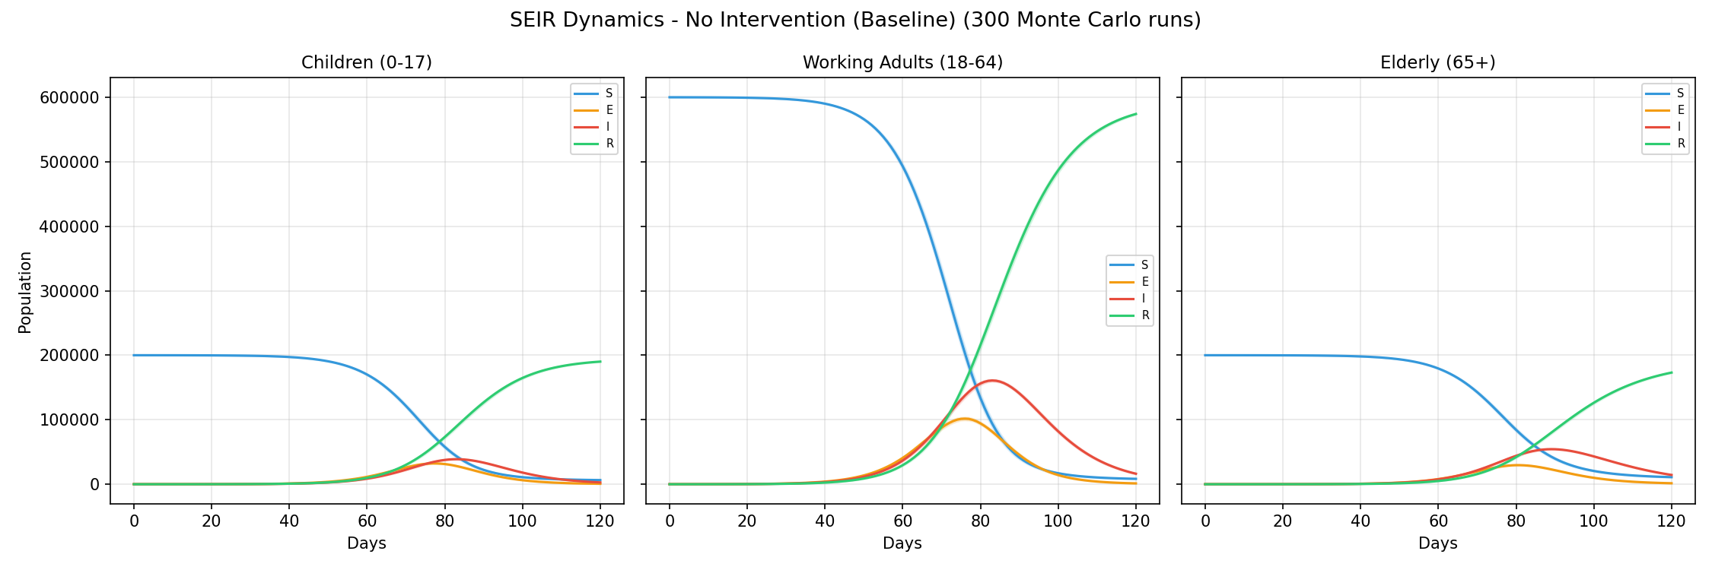
Fig. 1. SEIR dynamics for the baseline (no intervention) scenario showing mean trajectories with 90% confidence bands across 300 Monte Carlo runs.

B. INTERVENTION COMPARISON
As illustrated, the six scenarios of intervention have drastically different outcomes. The most effective scenario of intervention is the lockdown, which reduces the number of infections to 2,595 (0.3% attack rate). The combination of moderate interventions has a substantial impact, reducing infections to 38,276 (3.8%). The outcomes of the single-target interventions are less promising, with the restriction in the workplace reducing infections to 635,993 (63.6%), in schools to 813,943 (81.4%), and among the elderly to 854,244 (85.4%).
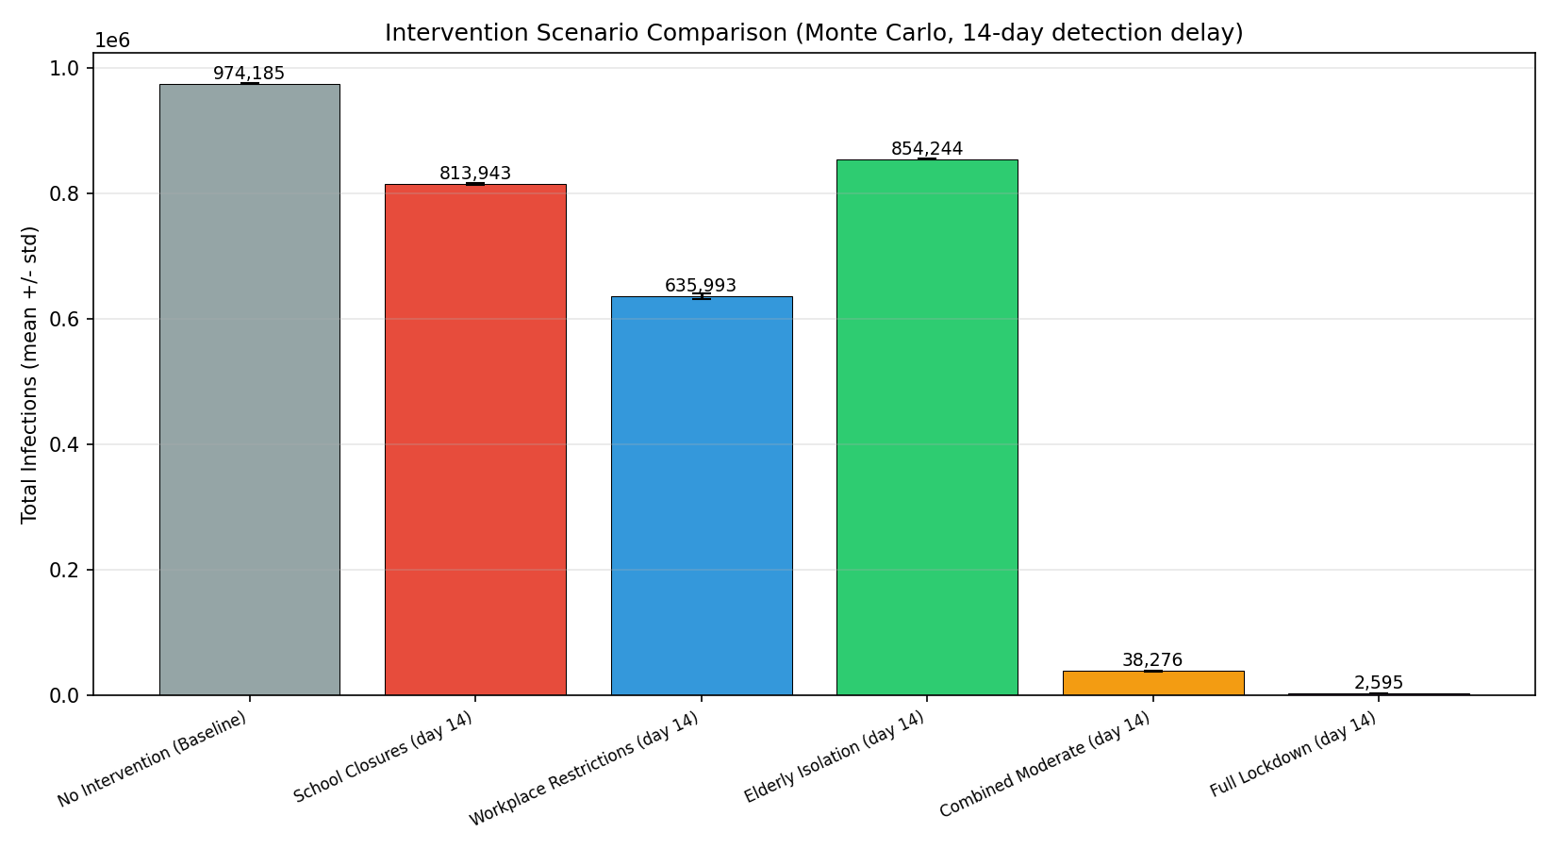
Fig. 2. Total infections comparison across all six intervention scenarios with standard deviation error bars.
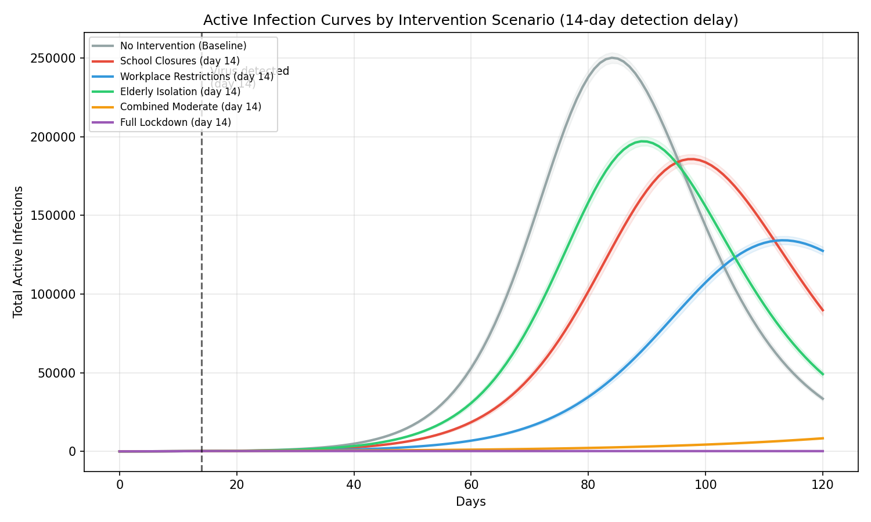
Fig. 3. Active infection curves overlaid for all scenarios, showing the flattening effect of interventions. The dashed line marks the 14-day detection point.

C. SUMMARY OF RESULTS
Scenario | Mean Infected | Attack Rate | Peak Day
No Intervention | 974,185 | 97.4% | 84
School Closures | 813,943 | 81.4% | 100
Workplace Restrictions | 635,993 | 63.6% | 118
Elderly Isolation | 854,244 | 85.4% | 92
Combined Moderate | 38,276 | 3.8% | 81
Full Lockdown | 2,595 | 0.3% | 42
Table 2. Summary of intervention scenario results (300 Monte Carlo runs per scenario)

D. PER-GROUP ANALYSIS
The burden of the infection varies from one population to another. The baseline scenario suggests that the population of working adults has the highest burden of the infection, with a percentage of 98.6% of this population becoming infected. The percentage of infected children is 96.8%, followed by the elderly population with a percentage of 93.4%.
The single-target interventions assist the target population, but the impact of the intervention on other populations is limited. The closure of schools greatly reduces the number of infected children. The reduction of infected adults and elderly individuals is limited. The restriction of infected adults in the workplace greatly reduces the number of infected adults. The isolation of the elderly population greatly reduces the number of infected elderly individuals, but the overall rate of transmission of the disease is not greatly reduced, considering that the elderly population only accounts for 20% of the population.
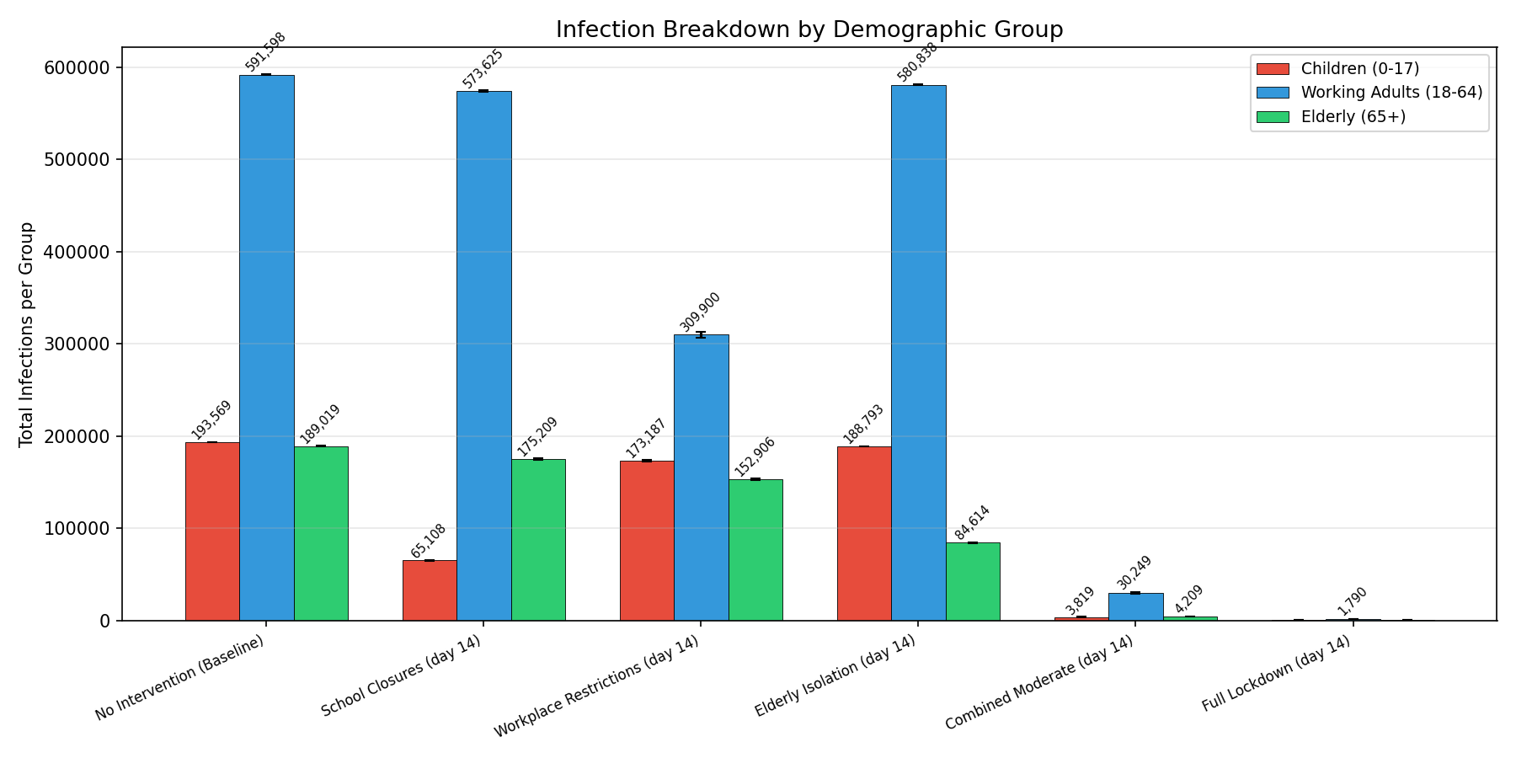
Fig. 4. Infection breakdown by demographic group for each scenario.
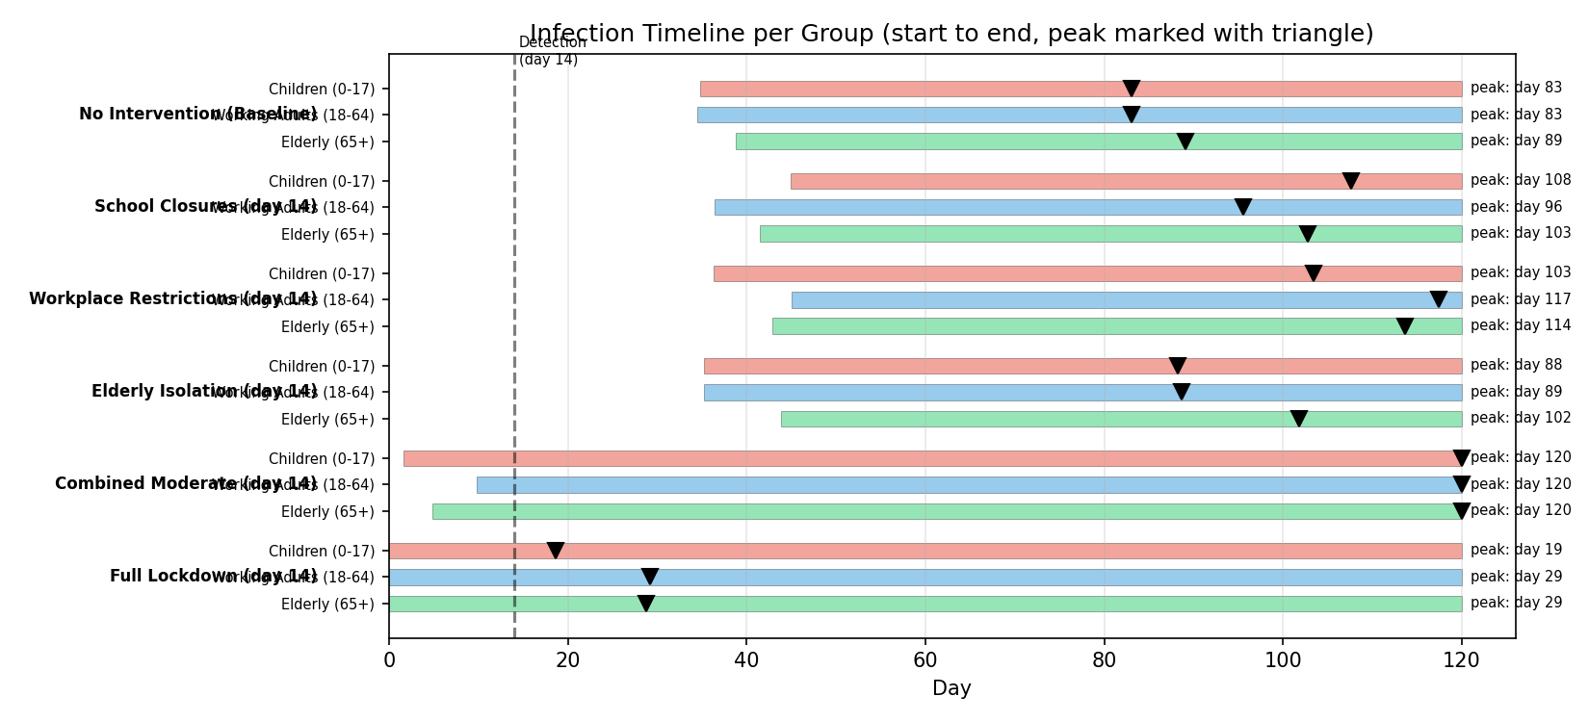
Fig. 5. Infection timeline showing start, peak (triangle), and end of infections for each group across scenarios.

E. SEVERITY AND MORTALITY ESTIMATES
Using the published values of IFR from Levin et al. [7], we can calculate the mortality and hospitalization in each case. The values used are: children, 0.01%; adults, 0.5%; elderly, 5.4%. The corresponding hospitalization values are: children, 1%; adults, 5%; elderly, 20%.
In the baseline scenario, we can estimate that the mortalities will be 13,184, and the hospitalizations will be 62,690. In this scenario, the elderly will contribute 77% of the total mortality, although they are only 20% of the population. This is a strong case in favor of isolating the elderly.
When combined moderate interventions are applied, the mortalities are reduced to 355, along with a reduction in hospitalizations to 2,126. Lockdown reduces the mortality to 24, along with a reduction in hospitalizations to 136.
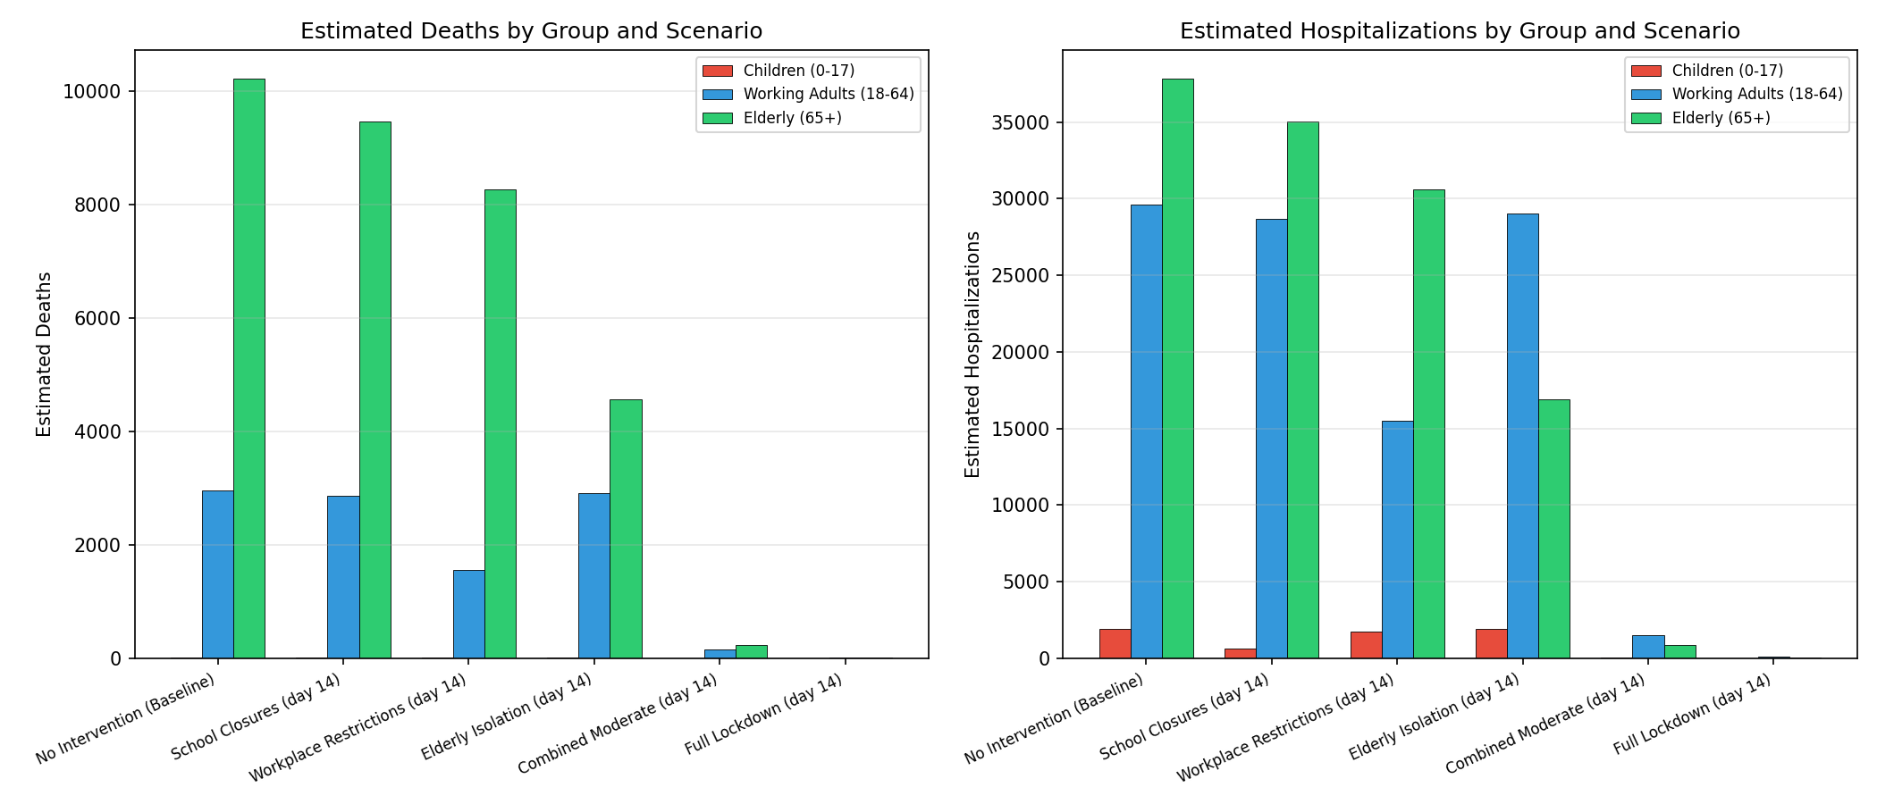
Fig. 6. Estimated deaths and hospitalizations by demographic group for each scenario.

F. R0 SENSITIVITY ANALYSIS
We also wanted to see the impact of the varying values of the basic reproduction number on the outbreak curve by modifying the rate of transmission by a factor of 0.6, 0.8, 1.0, 1.2, and 1.4. It is found that larger values of the basic reproduction number result in a quicker rate of spread, a higher number of people infected at the peak, and an earlier time to peak. On the contrary, smaller values result in a flattened curve and a reduced number of people infected.
An estimated value of the basic reproduction number is found to be approximately 2.83, within the range of 2.0-3.5, as suggested by Alimohamadi et al. [4].
Sensitivity analysis has shown that even small changes in the basic reproduction number have a substantial impact on the spread of the epidemic.
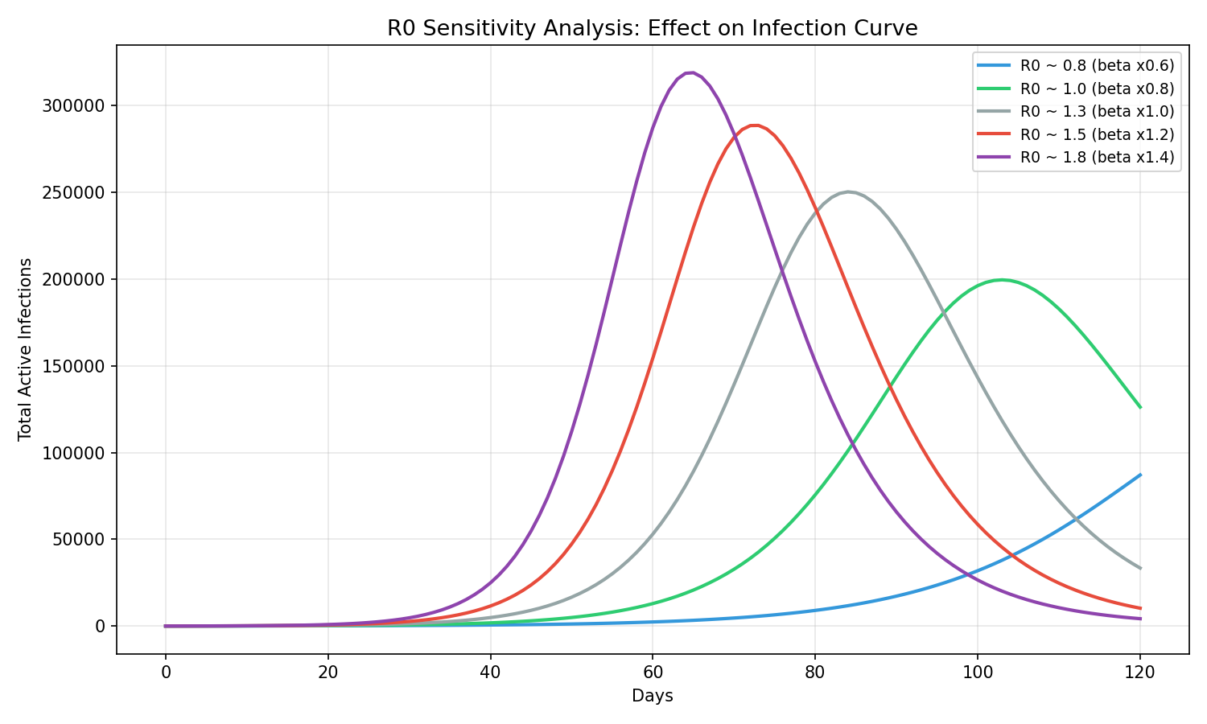
Fig. 7. R0 sensitivity analysis showing the effect of varying transmission rates on the infection curve.

G. DETECTION DELAY ANALYSIS
As shown from the analysis of the detection delay, it is clear that the early detection of an outbreak is a critical factor in increasing the effectiveness of an intervention policy. For example, in the case of the combined moderate scenario, if the detection delay is reduced from 14 to 0, the total infections drop well below the 38,276 observed at 14 days, because the intervention begins before the disease can establish widespread transmission. Similarly, if the detection delay is increased to 28, two additional weeks of uncontrolled exponential growth occur before the intervention begins, resulting in a substantially higher number of total infections.
This analysis indicates that the process of surveillance and detection of an outbreak plays an important role in the implementation of an intervention policy. The effectiveness of an intervention policy is reduced if implemented later during the outbreak.

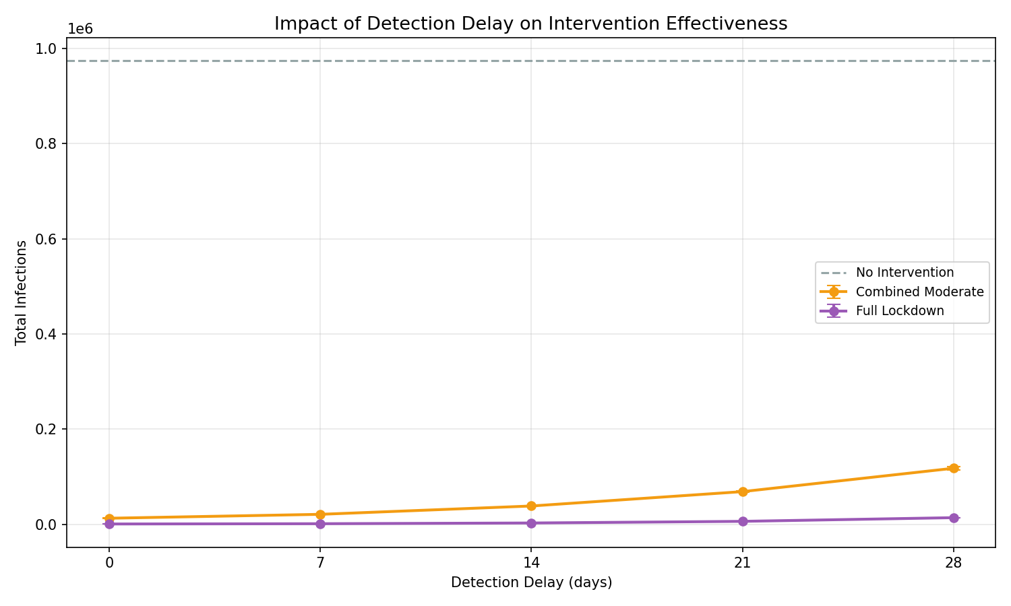
Fig. 8. Impact of detection delay on intervention effectiveness for combined moderate and full lockdown scenarios.

H. MONTE CARLO DISTRIBUTION
As shown from the Monte Carlo distribution of the baseline scenario, the total number of infections over 300 runs of the simulation follows a normal distribution with a mean of 974,185. The confidence interval of 90% lies between the 5th percentile and the 95th percentile of the data set. The actual path of the outbreak may vary from the mean, which is a critical factor in the spread of an infectious disease.

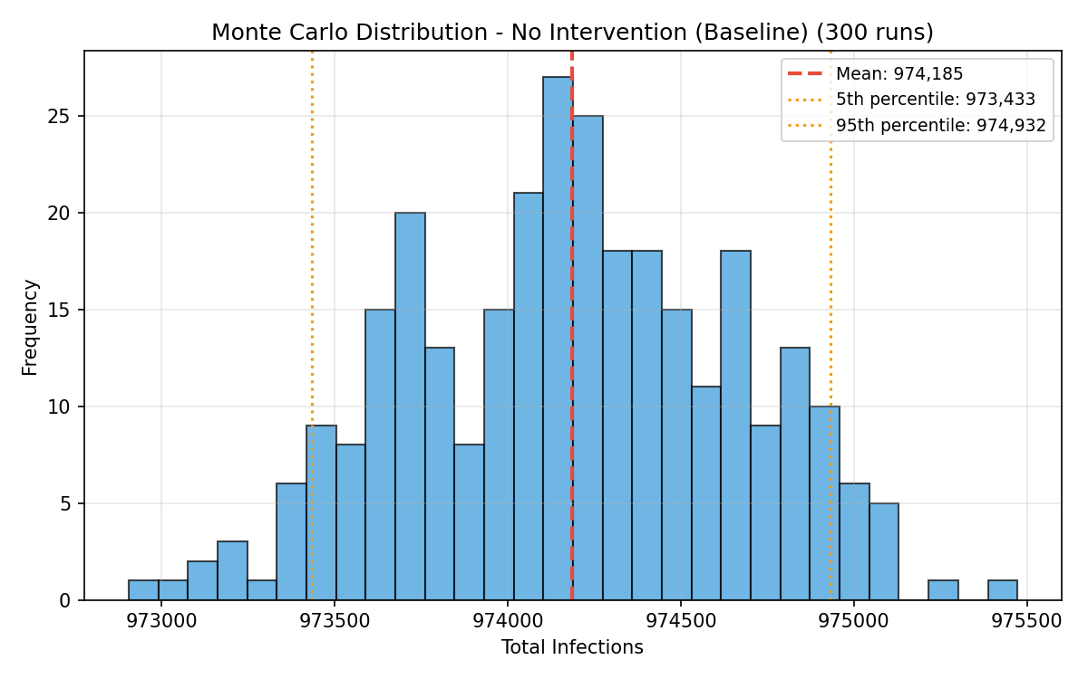
Fig. 9. Monte Carlo distribution of total infections for the baseline scenario (300 runs).

I. MODEL VALIDATION
We also validated the model by using existing epidemiological parameters for COVID-19. We also validated the model by using real data from the first wave of COVID-19, which occurred between March and June 2020, in Ontario, Canada. The results of the validation of the model are as follows:
Estimated R0: 2.83 (expected range 2.0-3.5): PASS
Doubling time: 5.5 days (expected range 3.0-7.0 days): PASS
Incubation period: 5.2 days (expected range 4.0-7.0 days): PASS
Generation time: 14.4 days (expected range 5.0-8.0 days): CHECK
The reason why the model's generation time does not fall in the expected range is that the generation time is the sum of the incubation period and the infectious period, which in the model is the same as the total time from infection to recovery, not the time from the beginning of symptoms in successive cases. The other three parameters pass in the expected range, which validates the epidemiology of the model. We also validated the normalized infection curve of the model by using the COVID-19 case data of the first wave in Ontario, Canada, and then scaled it for the 1,000,000 people model. The infection curve of the model has a similar trend as the infection curve of the real-world data, as it increases and then decreases, although the exact time and rate of increase and then decrease differ.
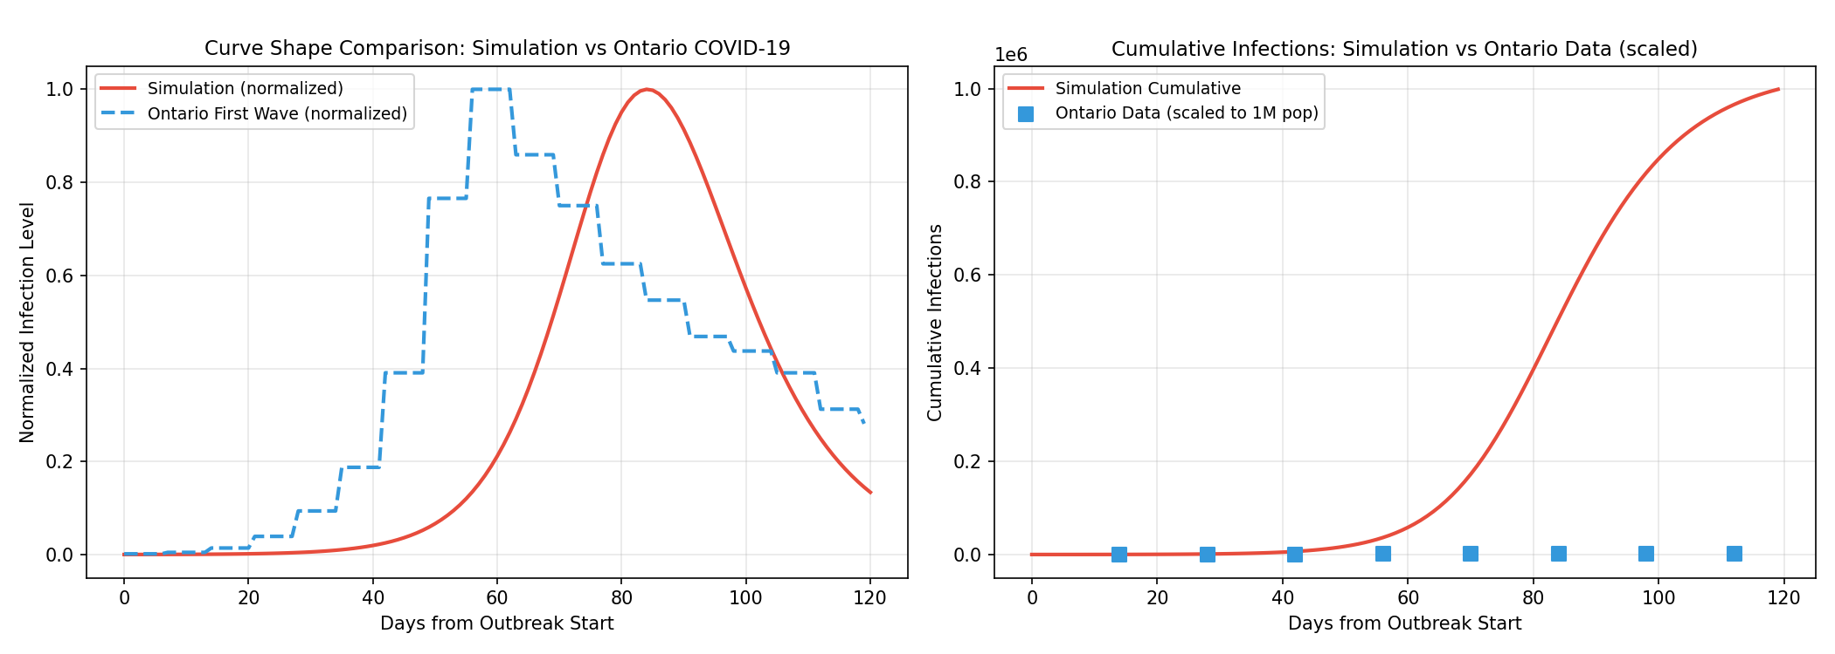
Fig. 10. Validation curve comparison: simulation vs Ontario COVID-19 first wave data (normalized shape and cumulative).

J. INDIVIDUAL SCENARIO SEIR CURVES
The following figures show the SEIR dynamics of the respective intervention scenarios stratified by demographic groups. The plots show the mean with 90% confidence intervals from 300 runs of a Monte Carlo simulation. The dashed vertical line represents the detection day when the interventions start.
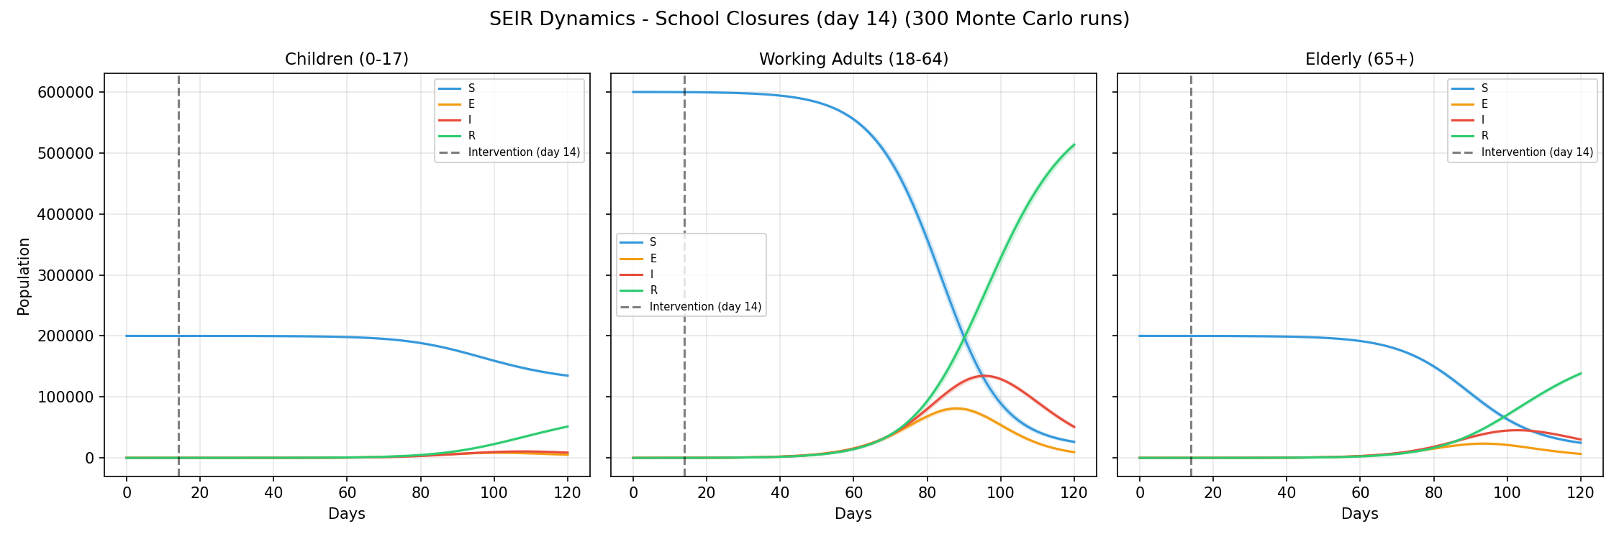
Fig. 11. SEIR dynamics for school closures scenario.
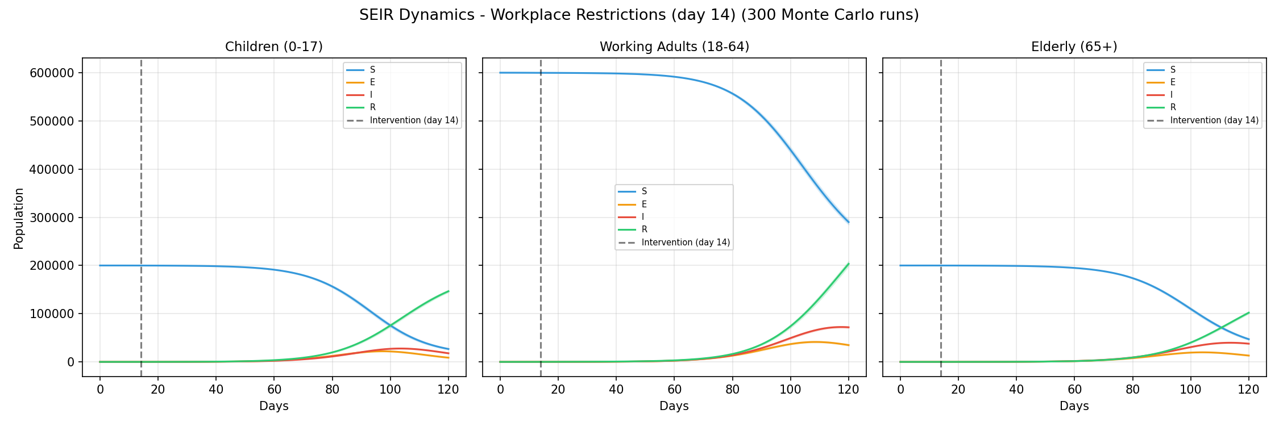
Fig. 12. SEIR dynamics for workplace restrictions scenario.
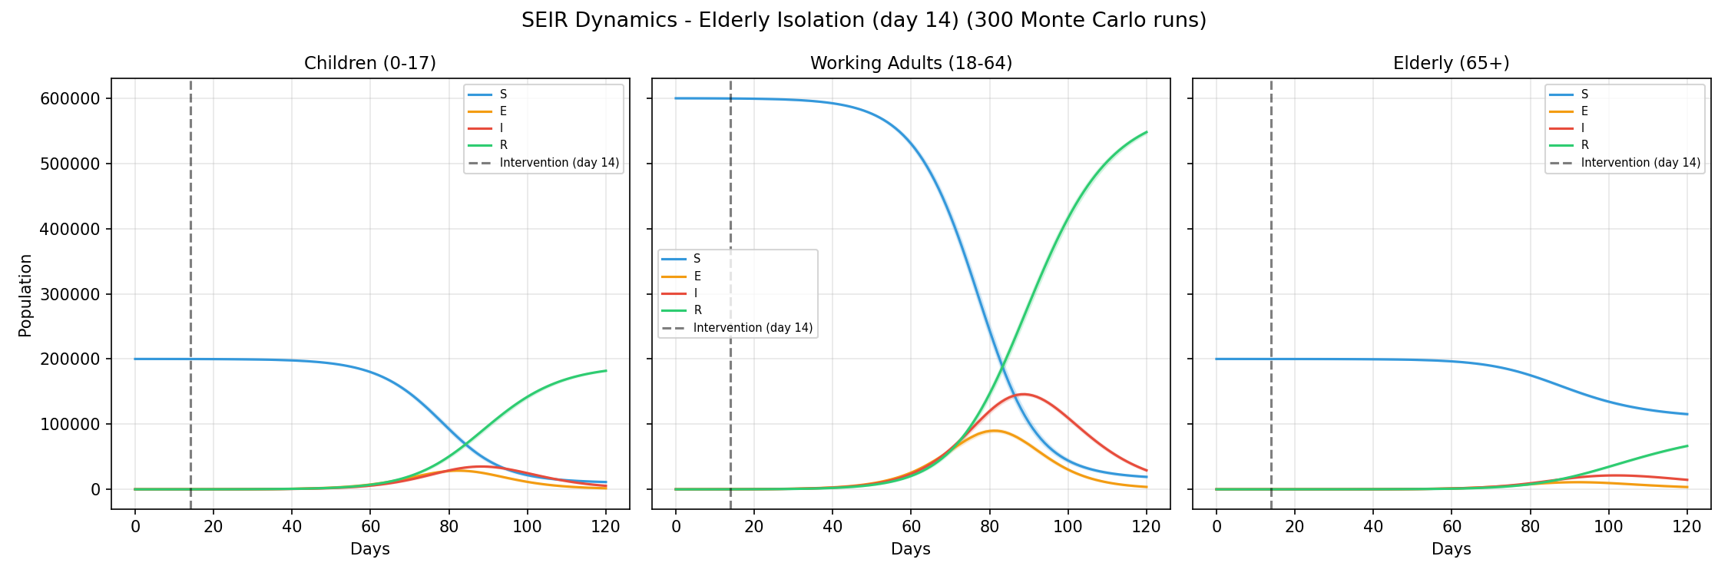
Fig. 13. SEIR dynamics for elderly isolation scenario.
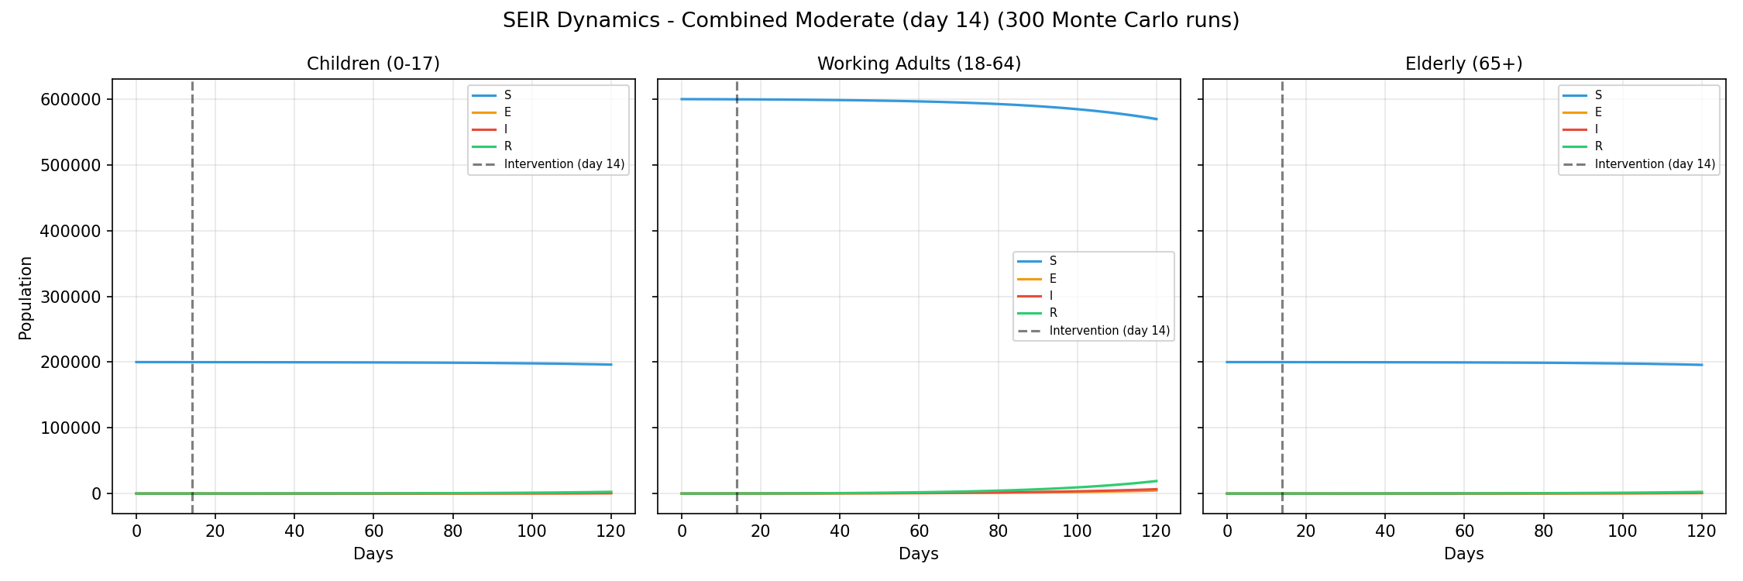
Fig. 14. SEIR dynamics for combined moderate scenario.
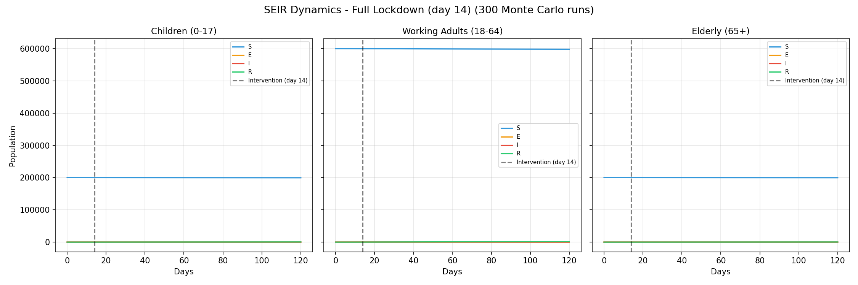
Fig. 15. SEIR dynamics for full lockdown scenario.

V. DISCUSSION
Based on the results, the following conclusions can be made with respect to the disease transmission dynamics and the effectiveness of the public health interventions.
Firstly, it is evident that interventions in a single domain alone are not effective in controlling the disease outbreak. Interventions in the school group, work group, and elderly group individually contribute to a reduction in the number of infections in the respective groups. However, the overall attack rate is still extremely high.
Secondly, the combined intervention in multiple domains is more effective than the intervention in a single domain. This is evident from the result where the combined moderate intervention reduces the total infections by 96% compared to the baseline scenario. This shows that partial interventions in all the groups would be effective in controlling the disease outbreak. This is because the reduction in multiple routes breaks the chain that would have helped the disease to spread through the other route.
Thirdly, the detection delay plays a crucial role in the effectiveness of the intervention. For example, the lockdown strategy is extremely effective in controlling the disease outbreak. However, it would lose a lot of value if implemented after the disease has already taken root, as shown in the result where the 14-day delay would allow the disease to take root before the start of the intervention.
Lastly, the severity analysis indicates a large difference in mortality rates among different age groups. For example, the elderly contribute to 77% of mortality, yet they only make up 20% of the population. This is attributed to the fact that the elderly have a higher infection fatality rate of 5.4% compared to 0.5% among adults and 0.01% among children. Furthermore, the elderly have a longer infectious period than the other groups.
There are a number of shortcomings in the proposed model. To begin with, the model assumes a closed population, which means that there are no births or deaths other than those attributed to the disease. Furthermore, the contact matrix in the model is static in nature, both in the pre-intervention phase and the post-intervention phase. It should be noted that the contact matrix in a real-life scenario is dynamic in nature. Furthermore, the model fails to take into consideration asymptomatic transmission as well as the development of immunity. Moreover, the model incorporates Monte Carlo noise only in the transmission rates, but not in other parameters.

VI. CONCLUSION
This project has successfully implemented a multi-group SEIR model for evaluating the effectiveness of disease transmission and control by applying the Monte Carlo simulation technique. The effectiveness of a multi-target intervention strategy in disease control compared to a single target intervention strategy has been shown. The effect of detection delay on disease control has also been shown.
The severity analysis has provided a quantitative evaluation of the mortality and hospitalization risks of the disease. The disproportionate severity of the disease in the elderly population has been shown.
The effectiveness of the model has been validated by applying the necessary validation criteria of R0, doubling time, and incubation period for the disease. The applicability of the model in simulating a realistic situation for the spread of the disease has been shown.
These results have provided a strong support for the strategy of applying multiple intervention strategies at once and investing in detection. The simulation framework can be used for simulating other diseases by changing necessary parameters.

VII. FUTURE WORK
There are several enhancements that can improve this model. For example, if several demographic stratifications are added to the model, this will allow for a finer analysis of the data. Adding vaccination as a further intervention strategy will allow for the simulation of vaccination programs. Adding a time-dependent contact network will allow for a more realistic simulation of the response to a disease outbreak.

Further enhancements to this model may include the addition of asymptomatic infection, spatial structure to allow for geographic spread, immunity decay, and reinfection. It may also be possible to add an economic component to the model to allow for the calculation of costs and benefits. It may also be possible to add a data assimilation component to allow for real-time data assimilation, updating the parameters of the model as new case data becomes available.

VIII. REFERENCES
[1] Q. Li et al., "Early Transmission Dynamics in Wuhan, China, of Novel Coronavirus-Infected Pneumonia," New England Journal of Medicine, vol. 382, no. 13, pp. 1199-1207, 2020.
[2] J. Mossong et al., "Social Contacts and Mixing Patterns Relevant to the Spread of Infectious Diseases," PLOS Medicine, vol. 5, no. 3, e74, 2008.
[3] K. Prem, A. R. Cook, and M. Jit, "Projecting social contact matrices in 152 countries using contact surveys and demographic data," PLOS Computational Biology, vol. 13, no. 9, e1005697, 2017.
[4] Y. Alimohamadi et al., "Estimate of the Basic Reproduction Number for COVID-19: A Systematic Review and Meta-Analysis," Journal of Preventive Medicine and Public Health, vol. 53, no. 3, pp. 151-157, 2020.
[5] I. Voinsky et al., "Effects of age and sex on recovery from COVID-19: Analysis of 5769 Israeli patients," Journal of Infection, vol. 81, no. 2, pp. e102-e103, 2020.
[6] Johns Hopkins University Center for Systems Science and Engineering (JHU CSSE), "COVID-19 Data Repository," GitHub. [Online]. Available: https://github.com/CSSEGISandData/COVID-19
[7] A. T. Levin et al., "Assessing the age specificity of infection fatality rates for COVID-19: systematic review, meta-analysis, and public policy implications," European Journal of Epidemiology, vol. 35, no. 12, pp. 1123-1138, 2020.

