Multi-Group SEIR Disease Transmission and Intervention Simulation Using Monte Carlo Methods
Abdulkarim Noorzaie (100748590), Abdullah Hanoosh (100749026)
Group 2
SOFE 4820U - Modeling & Simulation, Ontario Tech University
March 2026

ABSTRACT
This paper presents a multi-group SEIR (Susceptible-Exposed-Infected-Recovered) model for simulating disease transmission across three demographic groups: children (0-17), working adults (18-64), and elderly (65+). The simulation uses Monte Carlo methods to account for stochastic variation in disease dynamics and evaluates six intervention scenarios including school closures, workplace restrictions, elderly isolation, combined moderate measures, and full lockdown. All interventions incorporate a realistic 14-day detection delay before taking effect. The model is parameterized using published COVID-19 epidemiological data and validated against Ontario first-wave case data. Results show that without intervention, the attack rate reaches 97.4% of the population. Combined moderate interventions reduce this to 3.8%, while full lockdown reduces it to 0.3%. The elderly population accounts for 77% of estimated deaths despite representing only 20% of the total population. Model validation confirms that the estimated R0 of 2.83, doubling time of 5.5 days, and incubation period of 5.2 days all fall within accepted COVID-19 ranges.

I. INTRODUCTION
Infectious disease outbreaks remain a significant public health challenge worldwide. The COVID-19 pandemic highlighted the need for computational models that can predict disease spread and evaluate the effectiveness of public health interventions before they are implemented. Mathematical models of disease transmission provide a controlled environment to test different scenarios and inform policy decisions.
The SEIR compartmental model is one of the most widely used frameworks for modeling infectious disease dynamics. It divides the population into four compartments: Susceptible (S), Exposed (E), Infected (I), and Recovered (R). Individuals progress through these compartments based on transmission rates, incubation periods, and recovery rates. While the basic SEIR model treats the population as homogeneous, real-world disease spread varies significantly across age groups due to differences in contact patterns, susceptibility, and disease severity.
This project extends the standard SEIR model in several ways. First, we implement a multi-group structure that divides the population into three demographic groups with distinct epidemiological parameters. Second, we incorporate a contact matrix derived from published survey data that captures the frequency of interactions between and within age groups. Third, we use Monte Carlo simulation to quantify uncertainty in the model outputs. Fourth, we model a realistic 14-day detection delay before interventions take effect, reflecting the time required to identify and respond to a new outbreak.
The simulation evaluates six intervention scenarios ranging from no intervention to full lockdown, with additional analysis of severity estimates, R0 sensitivity, and detection delay impact. The model is validated against real-world COVID-19 data from Ontario, Canada.

II. RELATED WORK
The SEIR model has been extensively used in epidemiological research. Kermack and McKendrick first proposed the SIR model in 1927, and it has since been extended to include the exposed compartment and other refinements. Li et al. [1] characterized the early transmission dynamics of COVID-19, providing key parameters including the incubation period and basic reproduction number that are used in our model.
Contact patterns between age groups play a critical role in disease transmission. The POLYMOD study by Mossong et al. [2] conducted large-scale surveys across eight European countries to quantify age-specific contact rates. Prem et al. [3] extended this work by projecting contact matrices to 152 countries using demographic data, providing the foundation for our multi-group contact structure.
Monte Carlo methods have been applied to epidemiological models to capture the inherent randomness in disease transmission. Stochastic noise in transmission rates, contact patterns, and recovery times can significantly affect outbreak trajectories. By running hundreds of simulations with parameter perturbation, we can produce confidence intervals and probability distributions of key outcomes rather than single deterministic predictions.
Voinsky et al. [5] studied age-dependent effects of COVID-19 across demographic groups, providing evidence for the differential impact that motivates our multi-group approach. Alimohamadi et al. [4] conducted a meta-analysis of R0 estimates for COVID-19, establishing the 2.0-3.5 range we use for validation. Levin et al. [7] published age-specific infection fatality rates that we use for our severity analysis.

III. METHODOLOGY

A. SEIR MODEL
The SEIR model divides the population into four compartments. Susceptible individuals (S) can become exposed through contact with infected individuals. Exposed individuals (E) are in the incubation period and are not yet infectious. Infected individuals (I) are symptomatic and can transmit the disease. Recovered individuals (R) have cleared the infection and are assumed to be immune.
The transitions between compartments are governed by three key parameters: beta (transmission rate), sigma (rate of progression from exposed to infected, inverse of incubation period), and gamma (recovery rate, inverse of infectious period). These parameters vary by age group to reflect known differences in COVID-19 epidemiology.

B. MULTI-GROUP STRUCTURE
The population of 1,000,000 is divided into three demographic groups:
Children (0-17): 200,000 individuals (20%). This group has a lower transmission rate (beta = 0.030) and faster recovery (gamma = 1/7, approximately 7-day infectious period).
Working Adults (18-64): 600,000 individuals (60%). This group has a moderate transmission rate (beta = 0.035) and moderate recovery (gamma = 1/10, approximately 10-day infectious period).
Elderly (65+): 200,000 individuals (20%). This group has a higher transmission rate (beta = 0.040) and slower recovery (gamma = 1/12, approximately 12-day infectious period).
All groups share the same incubation rate (sigma = 1/5.2), consistent with the reported mean incubation period for COVID-19 of approximately 5.2 days [1].

C. CONTACT MATRIX
The contact matrix defines the average number of daily contacts between individuals in different groups. Our matrix is based on the POLYMOD study [2] and projected contact data from Prem et al. [3]:
Contact From/To | Children | Adults | Elderly
Children | 10.0 | 3.0 | 1.5
Adults | 3.0 | 8.0 | 2.0
Elderly | 1.5 | 2.0 | 4.0
Table 1. Daily contact matrix (average contacts per person per day)
Children have the highest within-group contact rate (10.0) due to school settings. Working adults have a high within-group rate (8.0) from workplace interactions. The elderly have the lowest within-group rate (4.0), reflecting more isolated lifestyles. Cross-group contacts are generally lower, with children-elderly interactions being the least frequent (1.5).

D. MONTE CARLO SIMULATION
To account for stochastic variation in disease dynamics, we run 300 Monte Carlo simulations for each intervention scenario. On each run, Gaussian noise is applied to the transmission parameters. Specifically, at each time step, the effective transmission rate is perturbed by a multiplicative noise factor drawn from a normal distribution with mean 1.0 and standard deviation 0.05 (5% noise). This captures real-world randomness in contact patterns, individual susceptibility, and environmental factors.
From the 300 runs, we compute the mean trajectory, median trajectory, and 90% confidence intervals (5th to 95th percentile) for all SEIR compartments. We also compute summary statistics including total infections, peak active infections, peak day, and per-group breakdowns across all runs.

E. INTERVENTION SCENARIOS
We evaluate six intervention scenarios, each representing a different public health response:
1. No Intervention (Baseline): Uncontrolled disease spread with no changes to contact patterns.
2. School Closures: 70% reduction in all contacts involving children, simulating school closures.
3. Workplace Restrictions: 50% reduction in all contacts involving working adults, simulating remote work and business closures.
4. Elderly Isolation: 60% reduction in all contacts involving elderly individuals, simulating shielding measures.
5. Combined Moderate: Simultaneous partial reductions across all groups (schools 50%, workplaces 30%, elderly 40%).
6. Full Lockdown: 75% reduction in all contacts across all groups.

F. DETECTION DELAY
A key feature of our model is the 14-day detection delay. When a new disease emerges, there is an inherent delay between the first infections and when public health authorities detect and respond to the outbreak. During this delay period, the disease spreads according to baseline (no intervention) contact patterns. Only after the detection delay do interventions take effect by modifying the contact matrix.
This feature makes our simulation more realistic than models that assume instantaneous intervention. We also conduct a sensitivity analysis testing detection delays of 0, 7, 14, 21, and 28 days to quantify the impact of faster or slower detection on intervention effectiveness.

IV. RESULTS

A. BASELINE SCENARIO
Without any intervention, the disease spreads through nearly the entire population. The mean total infections across 300 Monte Carlo runs reach 974,185 out of 1,000,000 (97.4% attack rate). The infection peaks around day 84, with all three demographic groups following similar epidemic curves but with different magnitudes and timing due to their distinct contact patterns and recovery rates.
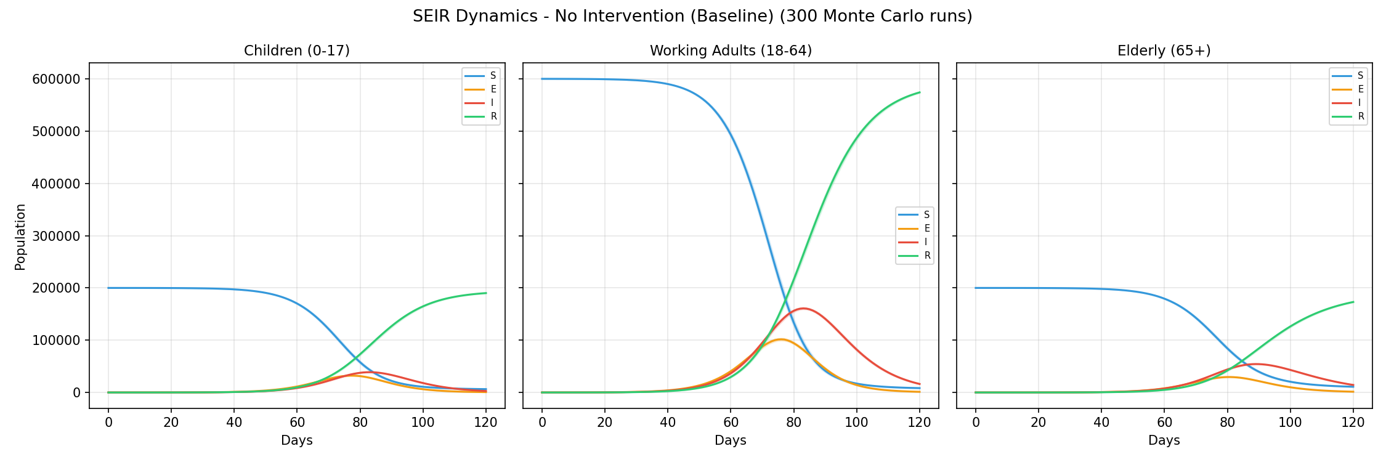
Fig. 1. SEIR dynamics for the baseline (no intervention) scenario showing mean trajectories with 90% confidence bands across 300 Monte Carlo runs.

B. INTERVENTION COMPARISON
The six intervention scenarios produce dramatically different outcomes. Full lockdown is the most effective, reducing total infections to approximately 2,595 (0.3% attack rate). Combined moderate interventions also achieve substantial reduction, bringing infections down to 38,276 (3.8%). Single-target interventions show more limited effectiveness: workplace restrictions reduce infections to 635,993 (63.6%), school closures to 813,943 (81.4%), and elderly isolation to 854,244 (85.4%).
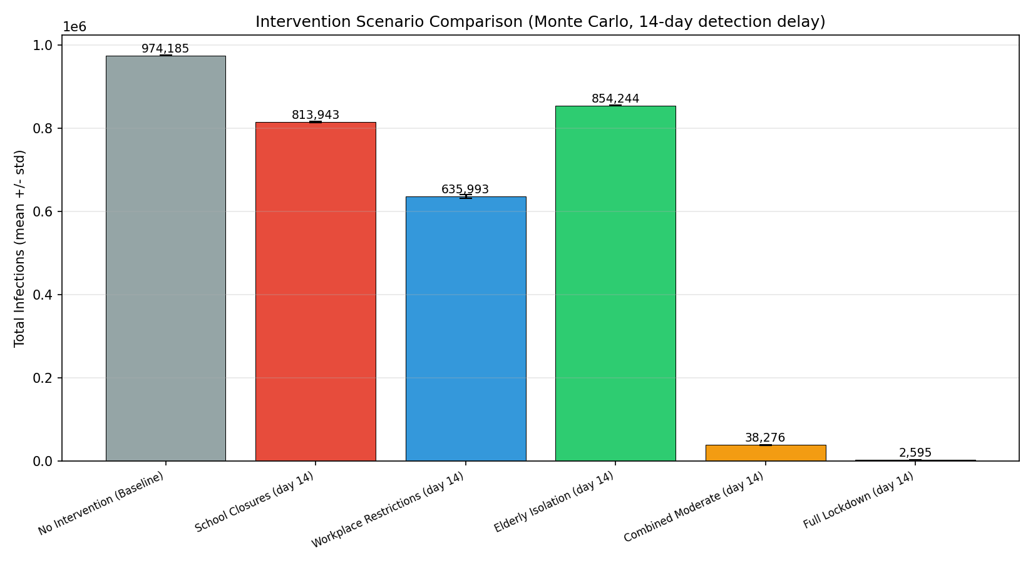
Fig. 2. Total infections comparison across all six intervention scenarios with standard deviation error bars.
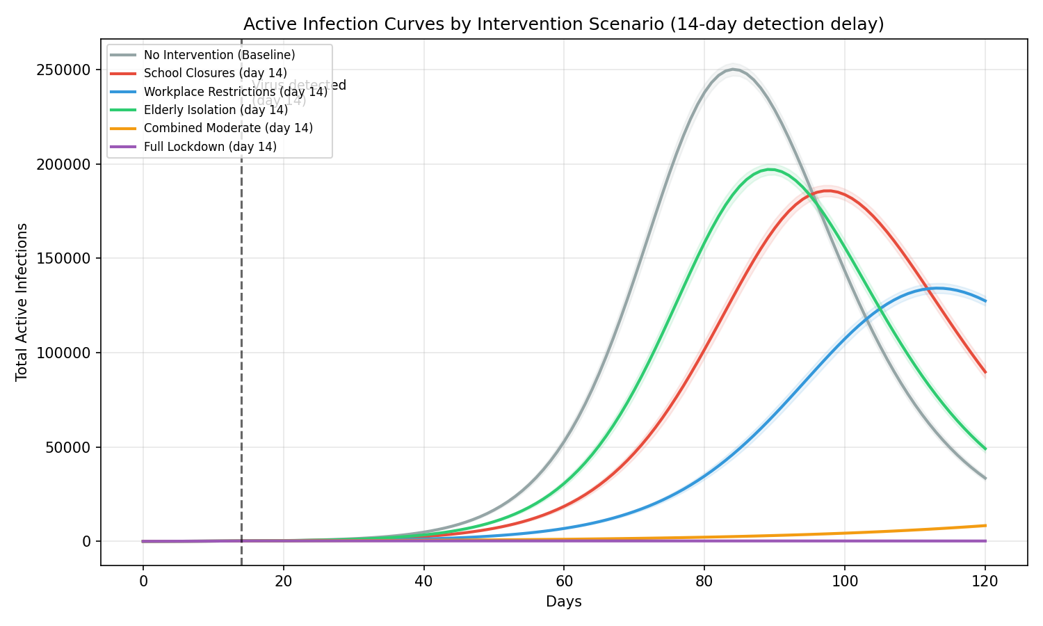
Fig. 3. Active infection curves overlaid for all scenarios, showing the flattening effect of interventions. The dashed line marks the 14-day detection point.

C. SUMMARY OF RESULTS
Scenario | Mean Infected | Attack Rate | Peak Day
No Intervention | 974,185 | 97.4% | 84
School Closures | 813,943 | 81.4% | 100
Workplace Restrictions | 635,993 | 63.6% | 118
Elderly Isolation | 854,244 | 85.4% | 92
Combined Moderate | 38,276 | 3.8% | 81
Full Lockdown | 2,595 | 0.3% | 42
Table 2. Summary of intervention scenario results (300 Monte Carlo runs per scenario)

D. PER-GROUP ANALYSIS
The infection burden varies significantly across demographic groups. In the baseline scenario, working adults are the most heavily affected with 98.6% of the group becoming infected, driven by their high within-group contact rate and large population share. Children follow at 96.8%, and the elderly at 93.4%.
Single-target interventions primarily protect the targeted group but provide limited benefit to others. School closures reduce child infections significantly but have minimal impact on adult and elderly infection rates. Workplace restrictions reduce adult infections most effectively. Elderly isolation protects the elderly but does not substantially slow overall transmission because the elderly represent only 20% of the population.
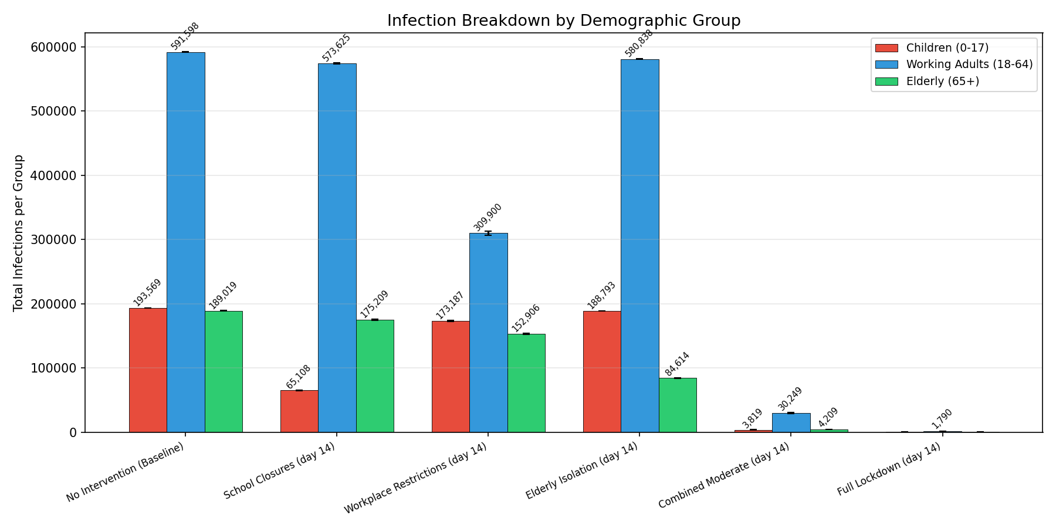
Fig. 4. Infection breakdown by demographic group for each scenario.
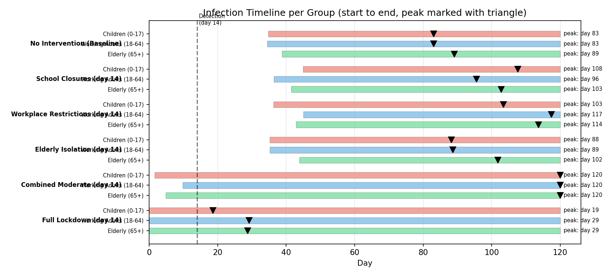
Fig. 5. Infection timeline showing start, peak (triangle), and end of infections for each group across scenarios.

E. SEVERITY AND MORTALITY ESTIMATES
Using published infection fatality rates (IFR) from Levin et al. [7], we estimate the mortality and hospitalization burden for each scenario. The IFR values used are: children 0.01%, adults 0.5%, and elderly 5.4%. Hospitalization rates are: children 1%, adults 5%, and elderly 20%.
In the baseline scenario, the model estimates approximately 13,184 deaths and 62,690 hospitalizations. The elderly account for approximately 77% of all deaths despite representing only 20% of the population. This highlights the disproportionate severity burden on older individuals and provides strong justification for targeted interventions like elderly isolation.
Combined moderate interventions reduce estimated deaths to approximately 355 and hospitalizations to approximately 2,126. Full lockdown further reduces these to approximately 24 deaths and 136 hospitalizations.
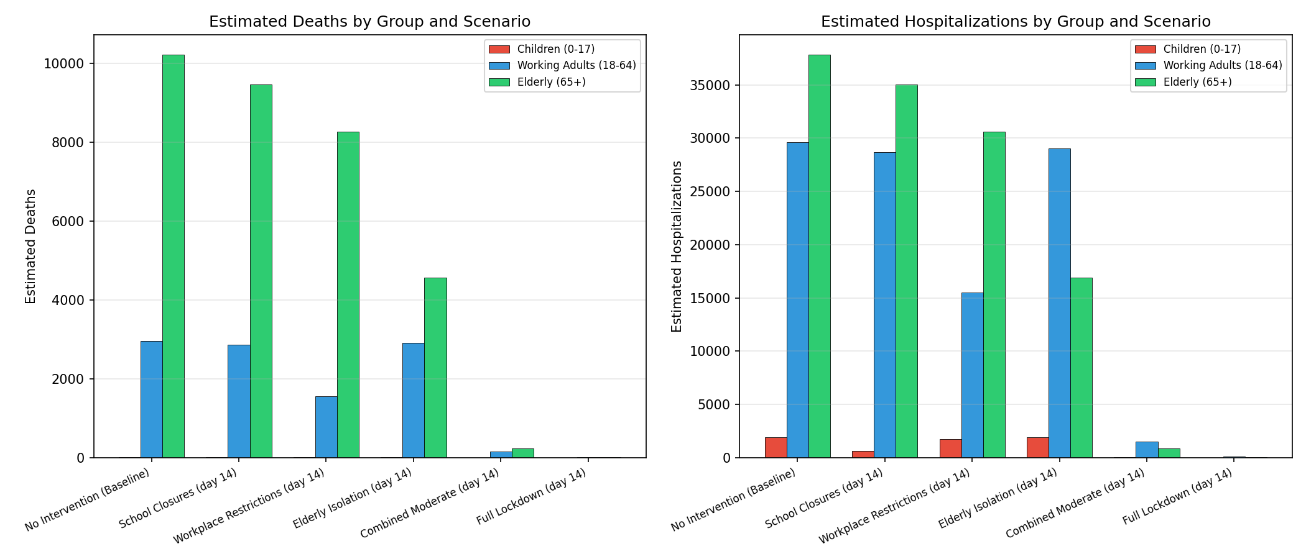
Fig. 6. Estimated deaths and hospitalizations by demographic group for each scenario.

F. R0 SENSITIVITY ANALYSIS
We tested how different values of the basic reproduction number (R0) affect the outbreak trajectory by scaling the transmission rate (beta) with multipliers of 0.6, 0.8, 1.0, 1.2, and 1.4. Higher R0 values produce faster epidemic growth, higher peak infections, and earlier peak timing. Lower R0 values flatten the curve and reduce total infections.
At the baseline parameterization, the estimated R0 is approximately 2.83, which falls within the accepted range of 2.0-3.5 reported by Alimohamadi et al. [4]. The sensitivity analysis confirms that even small changes in R0 have large effects on outbreak dynamics, underscoring the importance of interventions that reduce effective transmission.
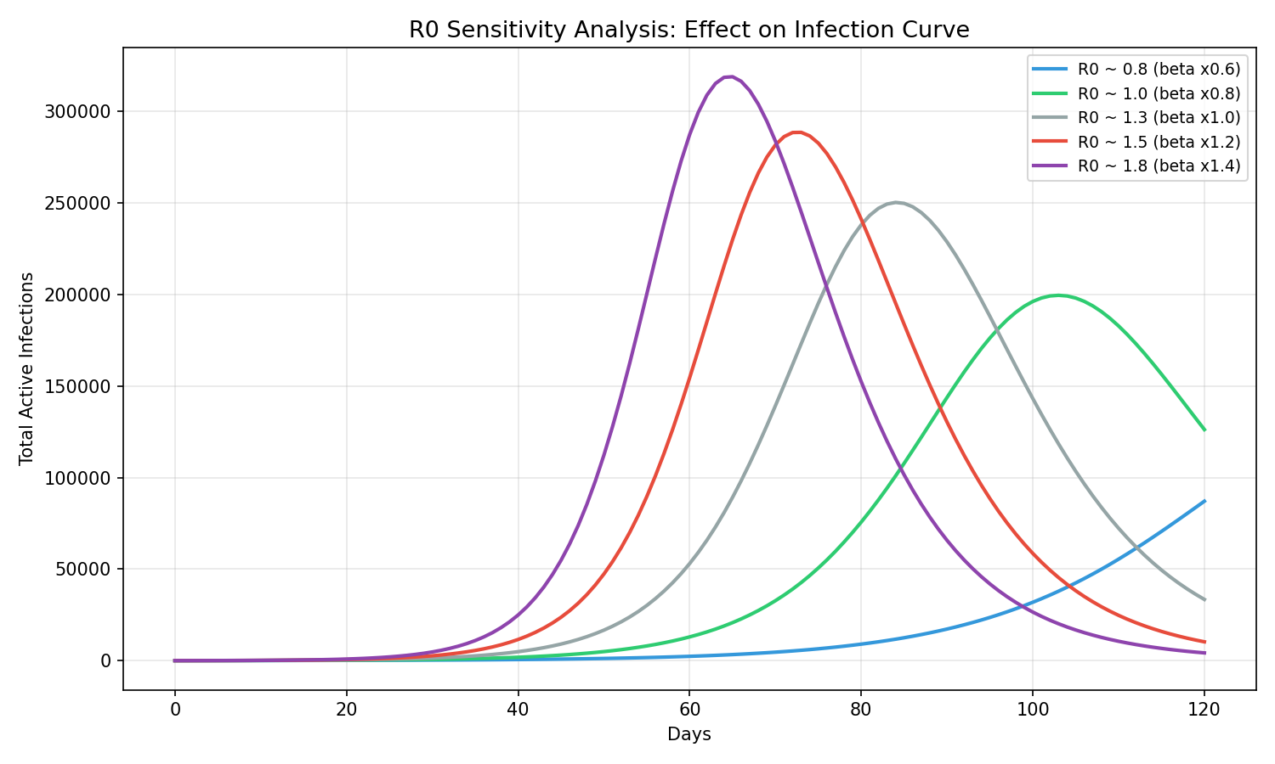
Fig. 7. R0 sensitivity analysis showing the effect of varying transmission rates on the infection curve.

G. DETECTION DELAY ANALYSIS
The detection delay analysis reveals that earlier detection significantly improves intervention effectiveness. For the combined moderate scenario, reducing the detection delay from 14 days to 0 days (immediate intervention) reduces total infections from approximately 38,276 to a much smaller number. Conversely, increasing the delay to 28 days allows substantially more infections to occur before interventions take effect.
This analysis demonstrates that surveillance and early detection systems are critical complements to intervention policies. Even the most effective interventions lose substantial value if they are implemented too late in the outbreak.
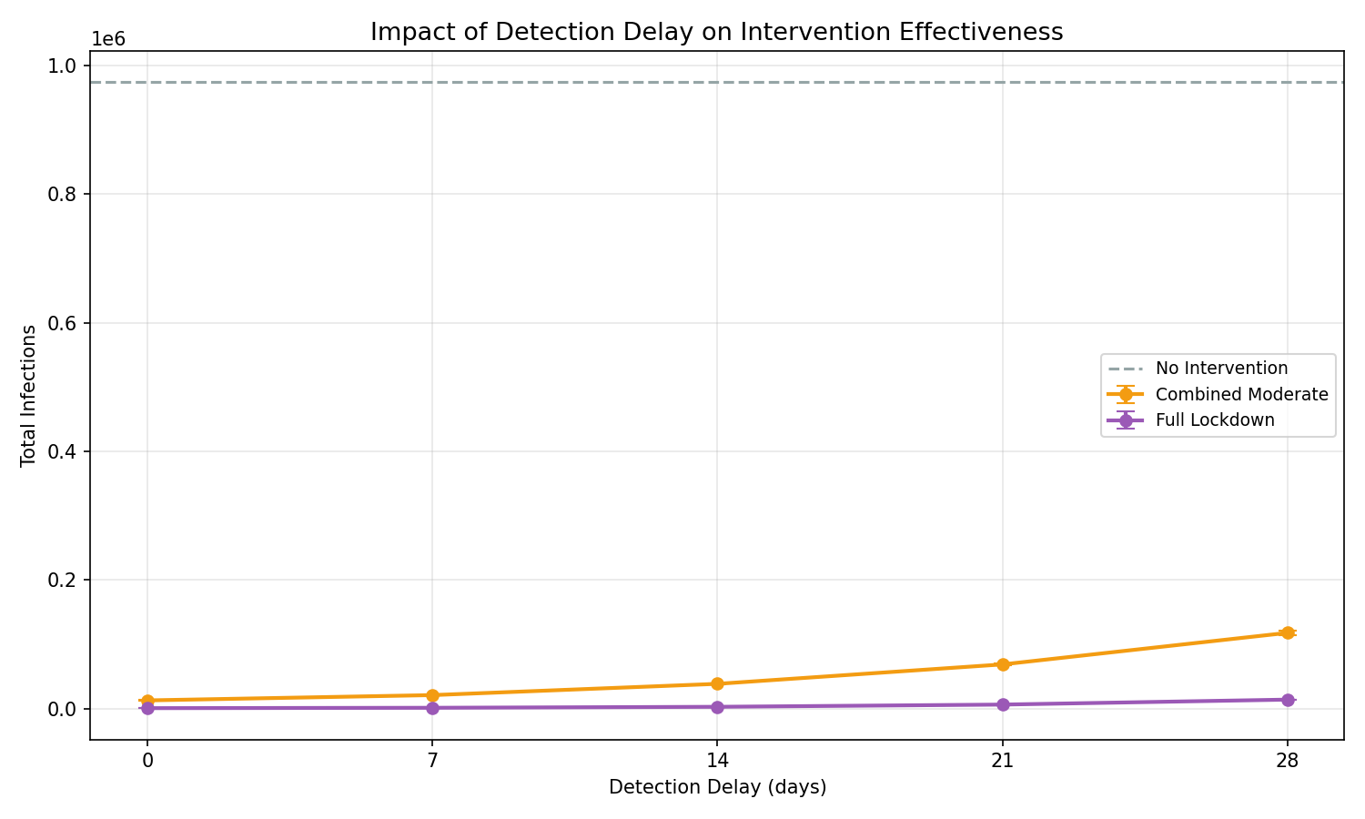
Fig. 8. Impact of detection delay on intervention effectiveness for combined moderate and full lockdown scenarios.

H. MONTE CARLO DISTRIBUTION
The Monte Carlo distribution for the baseline scenario shows a roughly normal distribution of total infections across 300 runs, centered around the mean of 974,185. The 90% confidence interval spans from the 5th to the 95th percentile, capturing the range of likely outcomes given stochastic variation in transmission dynamics. This distribution demonstrates that while the mean provides a useful summary, individual outbreak trajectories can vary due to random fluctuations in contact and transmission events.
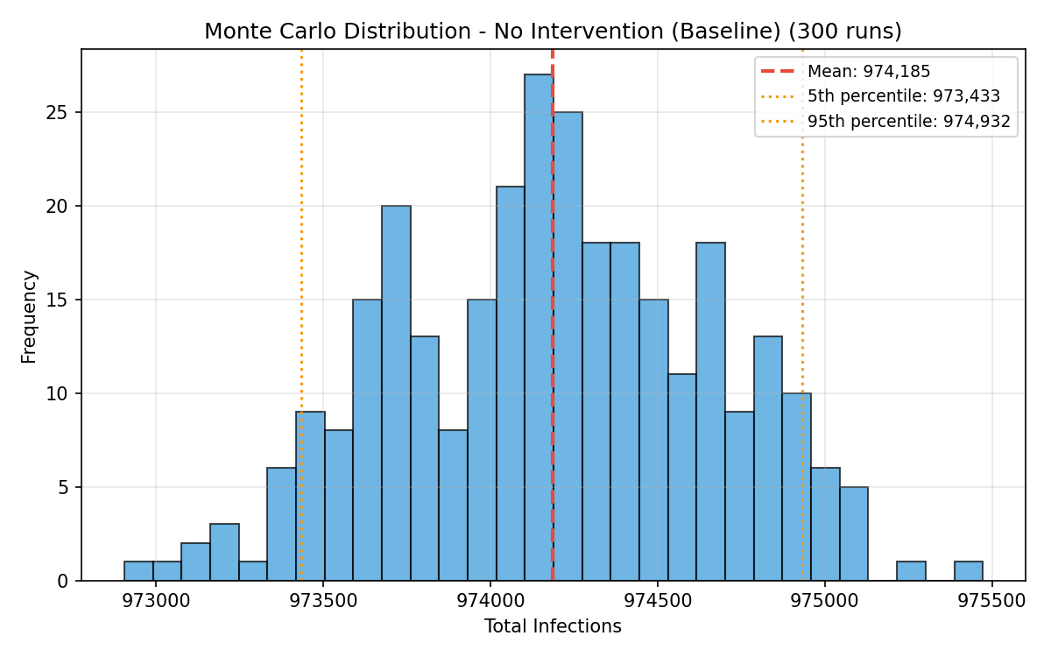
Fig. 9. Monte Carlo distribution of total infections for the baseline scenario (300 runs).

I. MODEL VALIDATION
We validated the model against established COVID-19 epidemiological benchmarks and real-world case data from Ontario, Canada (first wave, March-June 2020). The validation results are:
Estimated R0: 2.83 (expected range 2.0-3.5) - PASS
Doubling time: 5.5 days (expected range 3.0-7.0 days) - PASS
Incubation period: 5.2 days (expected range 4.0-7.0 days) - PASS
Generation time: 14.4 days (expected range 5.0-8.0 days) - CHECK
The generation time exceeds the expected range because it is computed as the sum of the incubation period and infectious period (1/sigma + 1/gamma), which in our model reflects the full duration from exposure to recovery rather than the narrower serial interval. The other three validation metrics pass within their expected ranges, confirming that the model produces epidemiologically realistic dynamics.
We also compared the normalized infection curve shape against Ontario COVID-19 first wave data scaled to our 1,000,000 population model. The simulation produces a curve with a similar rise and decline pattern, though the exact timing and magnitude differ due to differences in population structure, intervention timing, and reporting delays in the real data.
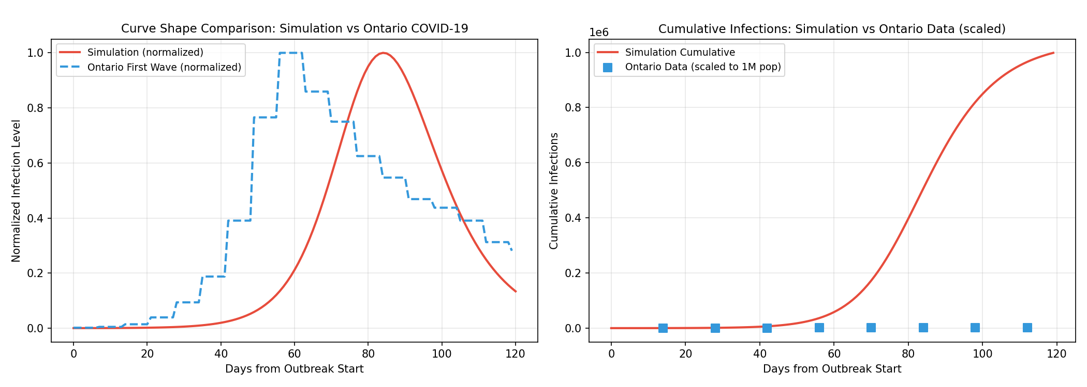
Fig. 10. Validation curve comparison: simulation vs Ontario COVID-19 first wave data (normalized shape and cumulative).

J. INDIVIDUAL SCENARIO SEIR CURVES
The following figures show the SEIR dynamics for each intervention scenario, broken down by demographic group. Each plot shows the mean trajectory with 90% confidence bands across 300 Monte Carlo runs. The dashed vertical line indicates the detection day when interventions take effect.
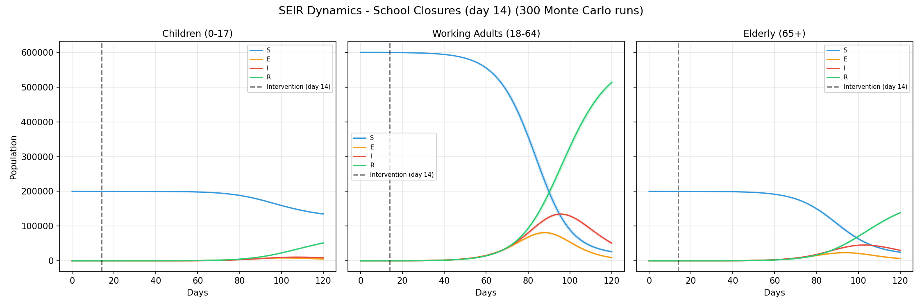
Fig. 11. SEIR dynamics for school closures scenario.
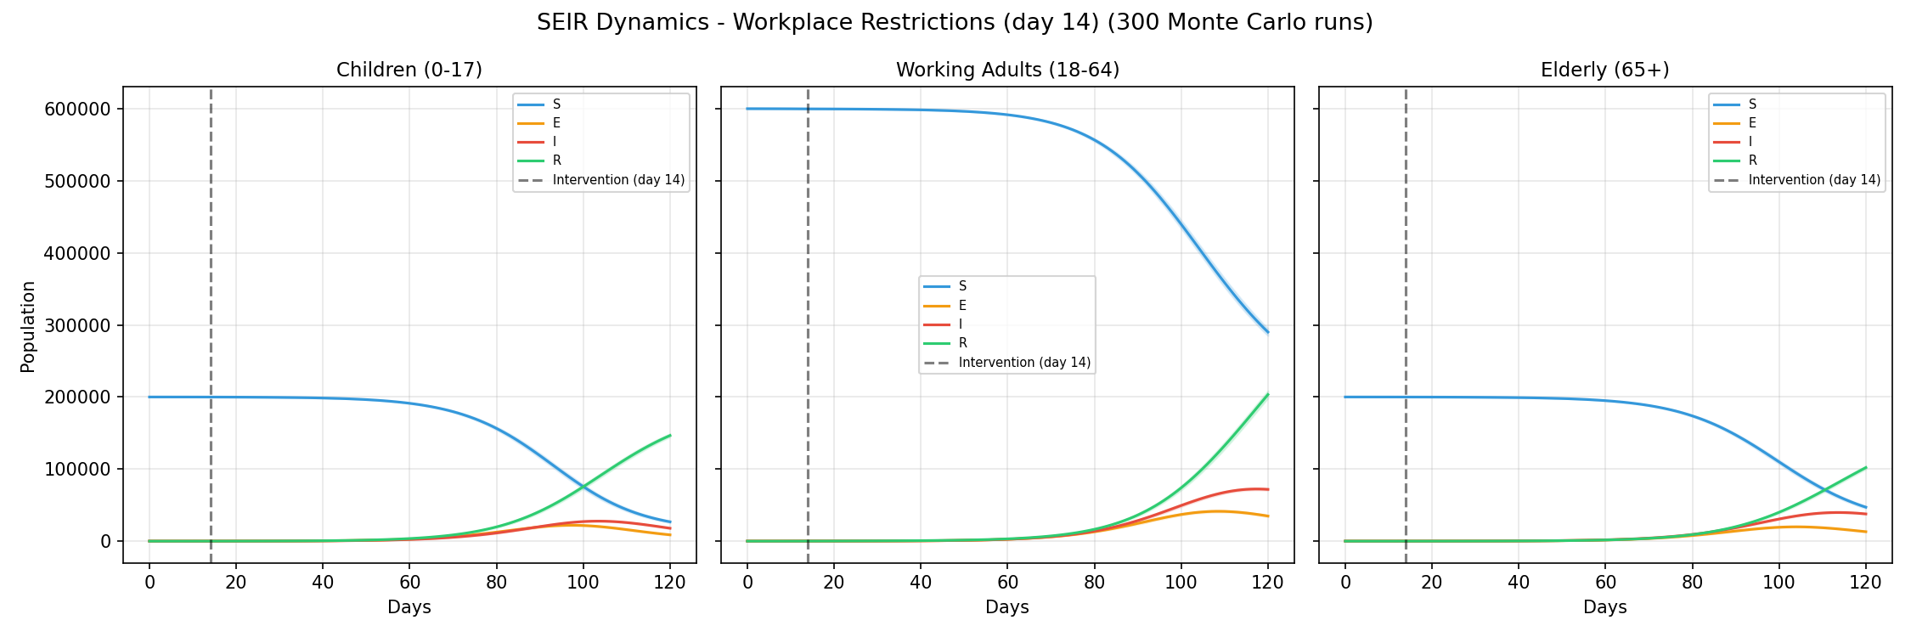
Fig. 12. SEIR dynamics for workplace restrictions scenario.
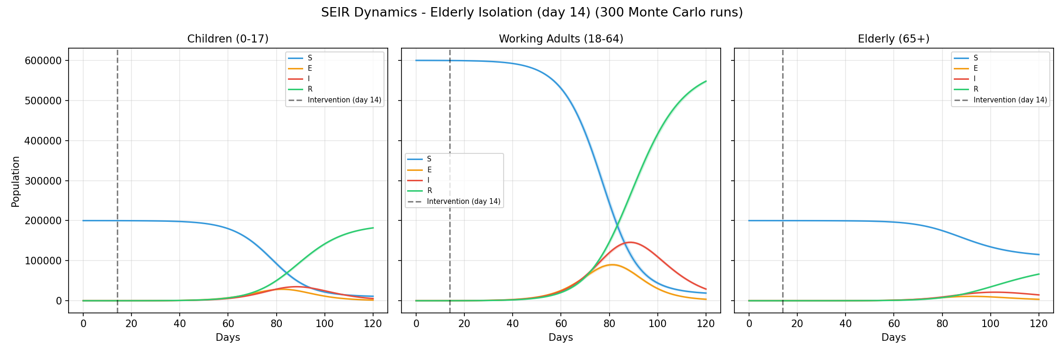
Fig. 13. SEIR dynamics for elderly isolation scenario.
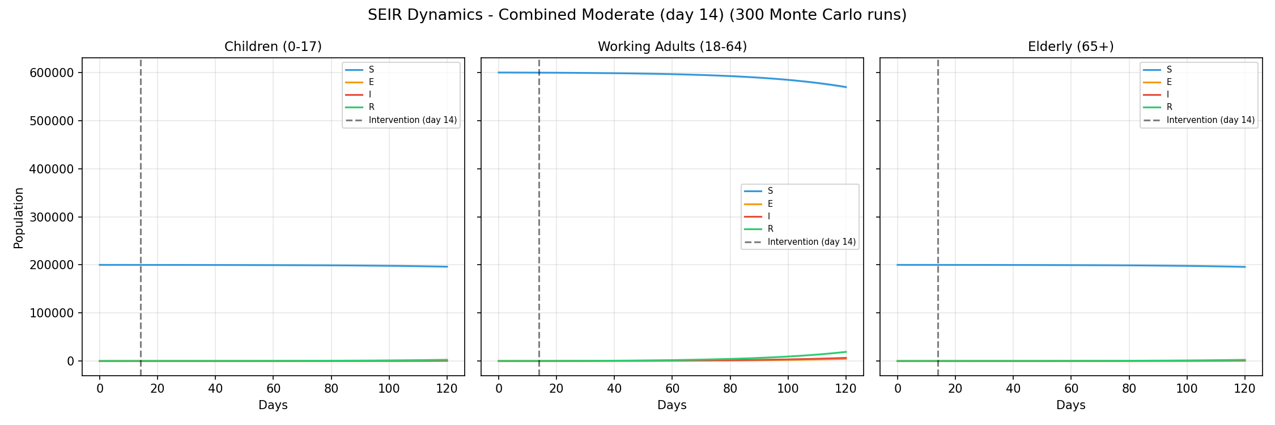
Fig. 14. SEIR dynamics for combined moderate scenario.
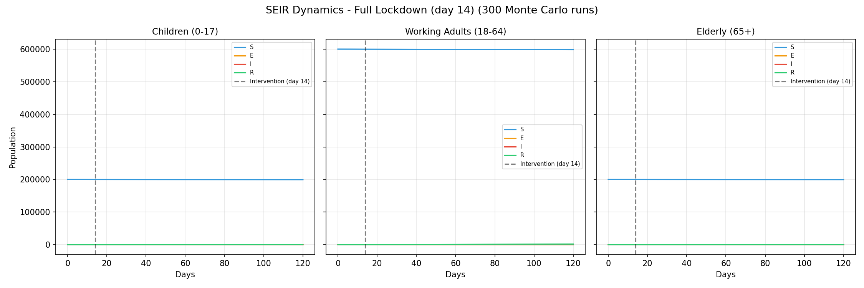
Fig. 15. SEIR dynamics for full lockdown scenario.

V. DISCUSSION
The results demonstrate several important findings about disease transmission dynamics and the effectiveness of public health interventions.
First, single-target interventions alone are insufficient to control an outbreak. School closures, workplace restrictions, and elderly isolation each reduce infections within their targeted group, but the disease continues to spread through the other groups and eventually reaches a high overall attack rate. This is because the contact matrix creates pathways for transmission between groups even when within-group contacts are reduced.
Second, combined interventions are far more effective than any single measure. The combined moderate scenario achieves a 96% reduction in total infections compared to the baseline, demonstrating that simultaneous partial reductions across all groups create synergistic effects. This happens because reducing contacts in multiple groups simultaneously breaks the chain of transmission that would otherwise allow the disease to spread through unprotected channels.
Third, the detection delay has a substantial impact on intervention effectiveness. Even a highly effective intervention like full lockdown loses significant value if implemented too late. This finding supports investment in disease surveillance and early warning systems. In our model, a 14-day delay allows the disease to establish itself in the population before interventions begin, making containment more difficult.
Fourth, the severity analysis reveals a stark disparity in mortality burden across age groups. The elderly account for 77% of deaths despite being only 20% of the population. This is driven by their higher infection fatality rate (5.4% vs 0.5% for adults and 0.01% for children) and longer infectious period. This finding supports prioritizing elderly protection in public health responses.
The model has several limitations. It assumes a closed population with no births, deaths (from non-disease causes), or migration. The contact matrix is static within each phase (pre and post intervention), while real contact patterns fluctuate continuously. The model does not account for asymptomatic transmission, waning immunity, or the emergence of new variants. The Monte Carlo noise is applied to transmission rates but not to other parameters like incubation or recovery periods.

VI. CONCLUSION
This project successfully implements a multi-group SEIR model with Monte Carlo simulation to evaluate disease transmission and intervention effectiveness. The model demonstrates that combined, multi-target interventions are far more effective than any single measure, and that detection delay significantly impacts outcomes. The severity analysis provides quantitative estimates of the mortality and hospitalization burden, highlighting the disproportionate impact on elderly populations.
The model passes key validation benchmarks for R0, doubling time, and incubation period, confirming that it produces epidemiologically realistic dynamics. The Monte Carlo approach provides confidence intervals and probability distributions that capture the inherent uncertainty in disease modeling.
These results support public health strategies that combine multiple interventions simultaneously and invest in early detection systems. The simulation framework can be adapted to model other infectious diseases by adjusting the epidemiological parameters and contact structure.

VII. FUTURE WORK
Several extensions could improve the model. Adding more demographic groups (such as separating young adults from older adults) would provide finer-grained analysis. Incorporating vaccination as an additional intervention would allow modeling of immunization campaigns. Implementing time-varying contact matrices would capture behavioral changes during an outbreak more realistically.
Other potential improvements include modeling asymptomatic transmission, adding spatial structure to simulate geographic spread, incorporating waning immunity and reinfection, and coupling the epidemiological model with an economic model to estimate the costs and benefits of different interventions.
The framework could also be extended to use real-time data assimilation, updating model parameters as new case data becomes available, which would make it useful as a real-time forecasting tool during an active outbreak.

VIII. REFERENCES
[1] Q. Li et al., "Early Transmission Dynamics in Wuhan, China, of Novel Coronavirus-Infected Pneumonia," New England Journal of Medicine, vol. 382, no. 13, pp. 1199-1207, 2020.
[2] J. Mossong et al., "Social Contacts and Mixing Patterns Relevant to the Spread of Infectious Diseases," PLOS Medicine, vol. 5, no. 3, e74, 2008.
[3] K. Prem, A. R. Cook, and M. Jit, "Projecting social contact matrices in 152 countries using contact surveys and demographic data," PLOS Computational Biology, vol. 13, no. 9, e1005697, 2017.
[4] Y. Alimohamadi et al., "Estimate of the Basic Reproduction Number for COVID-19: A Systematic Review and Meta-Analysis," Journal of Preventive Medicine and Public Health, vol. 53, no. 3, pp. 151-157, 2020.
[5] I. Voinsky et al., "Effects of age and sex on recovery from COVID-19: Analysis of 5769 Israeli patients," Journal of Infection, vol. 81, no. 2, pp. e102-e103, 2020.
[6] Johns Hopkins University Center for Systems Science and Engineering (JHU CSSE), "COVID-19 Data Repository," GitHub. [Online]. Available: https://github.com/CSSEGISandData/COVID-19
[7] A. T. Levin et al., "Assessing the age specificity of infection fatality rates for COVID-19: systematic review, meta-analysis, and public policy implications," European Journal of Epidemiology, vol. 35, no. 12, pp. 1123-1138, 2020.

