**UOIT**

# Group 04

Lab 1

Software Project Management (Laboratory)

CRN: 74667

* Abdullah Hanoosh (100749026)

* Malyka Sardar (100752640)

* Okiki Ojo (100790236)

GitHub Link: [https://github.com/abduh3131/SoftwareProjectMngmnt-Group-6](https://github.com/abduh3131/SoftwareProjectMngmnt-Group-6/tree/main)

Git status check

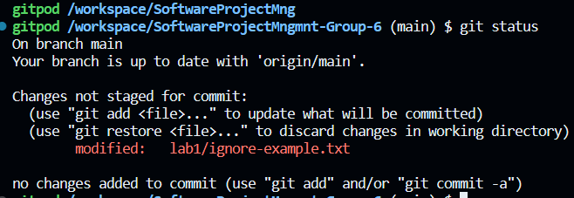

Push to origin after creating the files

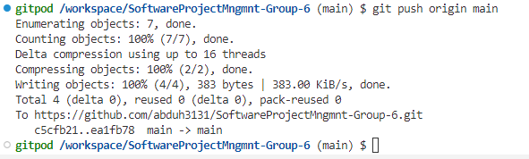

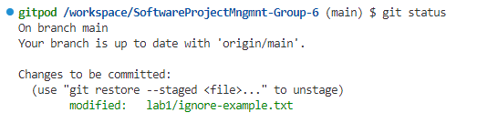

We had issues with our .gitignore where out git wasn’t ignoring the files listed, we used the resources listed here <https://gist.github.com/pavankjadda/2bb6fbdd8786e1f57fd7bcbcc666b51d>

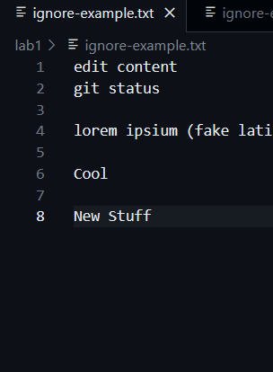

Check git status again

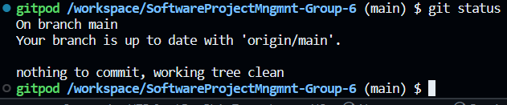

Create new branch

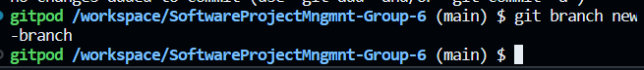

Switch to new-branch

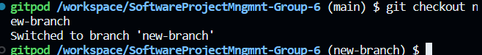

Create BranchExample.txt file in `lab1/` on the `new-branch` branch

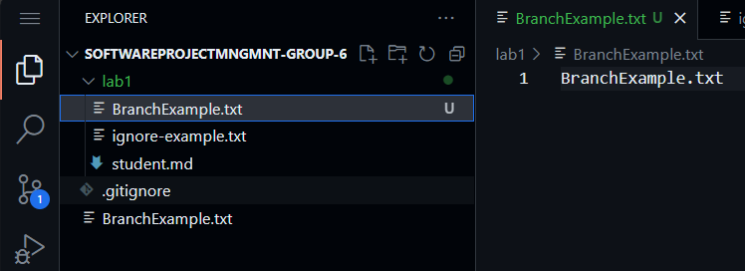

Add and commit BranchExample.txt file to the `new-branch` branch

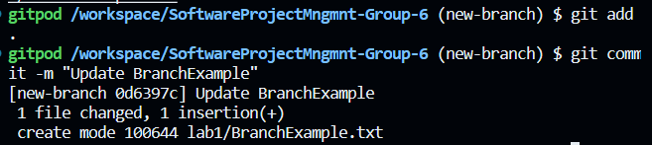

Use notepad command again???

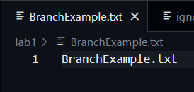

Switch back to the main branch

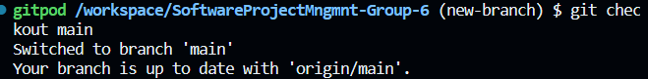

Use the same notepad command again

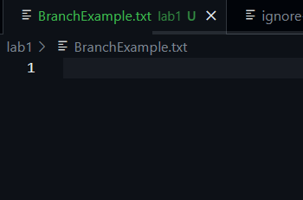

Remove RemoveExample.txt on the main branch after creating it first

Also, check git status

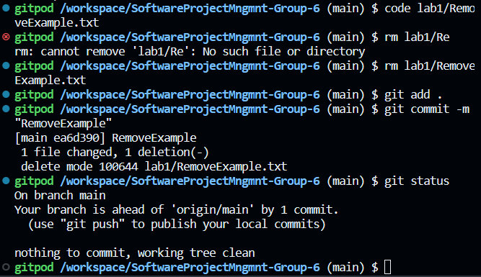

Use git clean to remove file completely

