**REPORT FOR THE WEEK 1 TASK OF DATA VISUALIZATION INTERNSHIP**

To achieve success in any advertisement campaign, there are key social media metrics that we need to track such as cost per reach (CPR), reach, impression, amount spent on ads, unique link clicks (ULC) ,cost per click (CPC) And Cost Per Result(CPR).

**Objective:**

Project deliverables is to analyze the Marketing Team's data from Facebook Super U ad campaign in order to identify underperforming ads that should be discontinued so as to cut the company's marketing expenses.

**The Analytics Team :**

* Yatharth Gupta (270805@duck.com)
* Vyshnavi Rao Ponnamaneni (vyshnavirao.ponnamaneni@slu.edu)
* Kailash Singh (robinjyala1234@gmail.com)
* Shreevathsan (shreevat12@gmail.com)
* Vinay Kattirapalli (vkattirapalli@gmail.com)
* Ansuman Pal (ansumanpal96@gmail.com)
* Lalitha Chandra Mythily Manogna Koduri (lalithachandra57@gmail.com)
* Poorna Chandra (motepallipoorna13@gmail.com)
* Mohommad Abdul Gafoor(gafoor.mngr@gmail.com)
* Collins Acheampong Ofori (chectar@gmail.com)
* Jethin reddy gorla(jethinreddy17@gmail.com)
* Cynthia Ehikioya (osekimmie@gmail.com)

**Team Project Lead Process :**

We have approached some technical steps to tackle this problem:

**1. Data understanding -** The key to success on any data project is to understand the data in detail. So, we took the time to understand the data model and domain of your business.

**2. Data extraction -** After understanding the main topic, we architected what an ideal dataset should look like for this problem and extracted it from the relevant data sources.

**3.** After extracting the raw data, we needed to process and model this data into a dataset that can precisely answer the business questions and produce analytics.In our case, we achieved this by grouping the Campaign IDs by the important metrics such as Reach, Impressions, Amount spent and CPR.

**4.** With the new dataset, we used our analytical expertise to uncover insights from this dataset and to produce visualizations to describe the insights.

**5. Data-informed Decision making -** And finally we used these insights to unlock business decisions and to make recommendations on next step.

**Tools for Data Analysis:** Once we have data ready, we may try analyzing it using different tools like excel or R programming or Python or Tableau or Power BI.

However, we have used Power BI for the visualization of the dataset in order to reach an outcome. Power BI is no doubt a very helpful tool to work with Data.

**Work:**

When we started working with the data we did a number of visualizations and plotted some graphs. Below we are attaching some screenshots.

Please go through the attached [link](https://drive.google.com/file/d/1T2phQDOcjeiBgzXF_pQtKFfGh75enHdd/view?usp=sharing) in order to see the real work or click here-

[Week 1 task report (Best Work in Power BI)](https://drive.google.com/file/d/1T2phQDOcjeiBgzXF_pQtKFfGh75enHdd/view?usp=sharing)

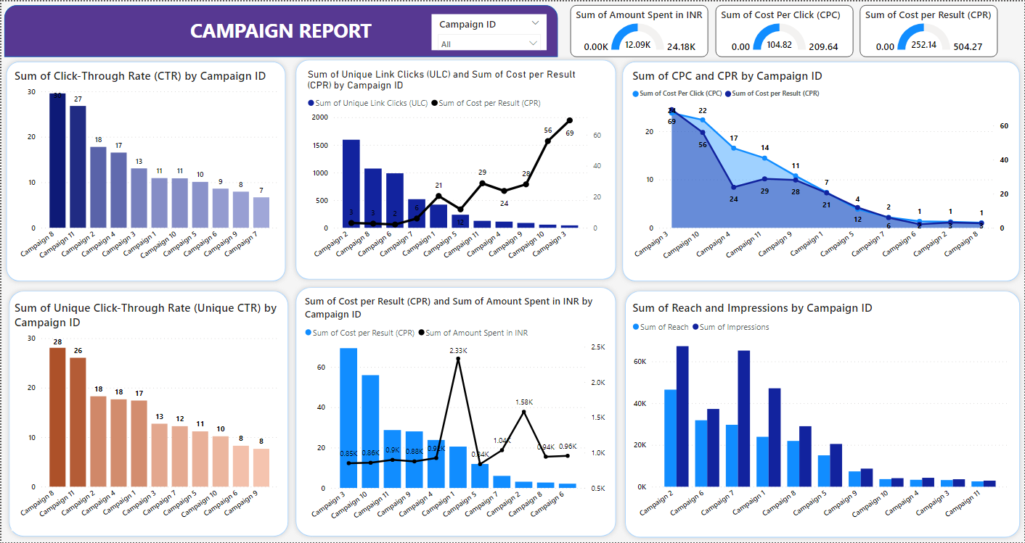

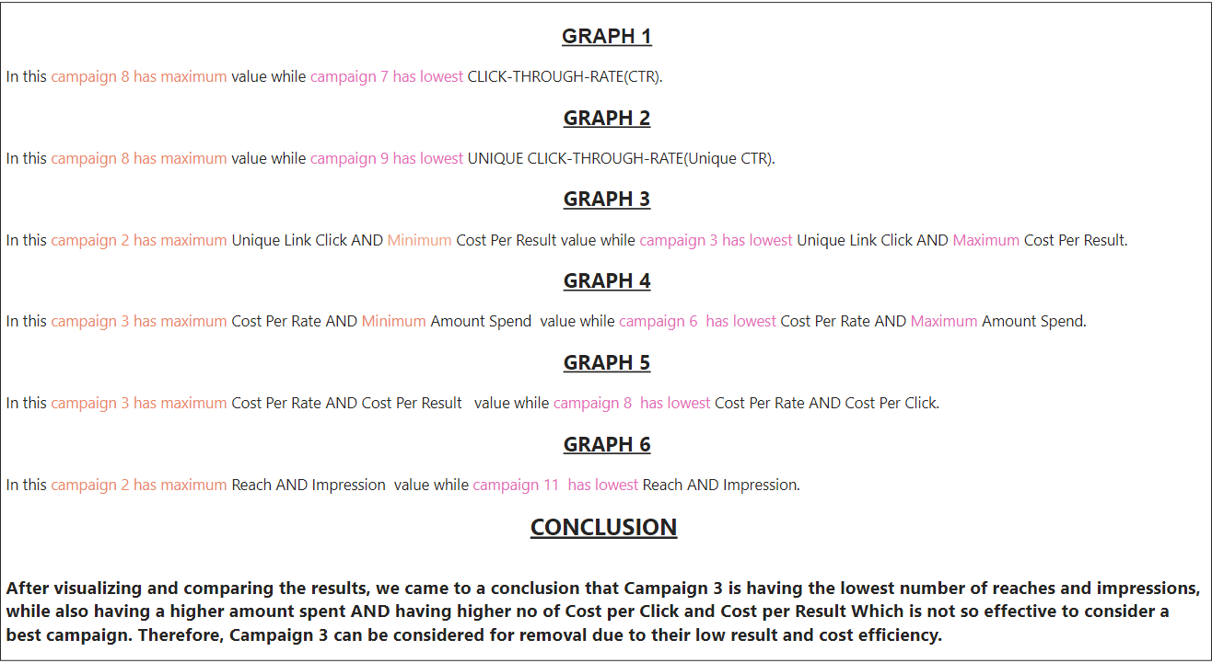

**Recommendation:**

The CPR (Cost Per Reach) and ULC (Unique Link Click) are important metric markers of success in an advertisement campaign. The CPR measures the total cost of the campaign divided by the total number of people reached. The ULC tracks a campaign's ability to generate a unique set of 'link clicks'. These metrics provide valuable insight into the efficiency and reach of an ad campaign, giving brands a better understanding of the success of their efforts. When an advertisement has low unique link clicks and a high cost per result, it is likely that the ad is not effectively reaching its target audience or resonating with them. The best course of action would be to analyze the ad's design, messaging, and delivery to understand why it is not achieving the desired results. One option would be to adjust the ad's content to be more engaging and target a more specific audience. Another option would be to try different delivery platforms and formats, such as using influencers, running carousel ads, or using video ads. It is important to understand the user's behavior in order to determine the best approach for optimizing the ad.

**Conclusion:**

After visualizing and comparing the results, we came to a conclusion that Campaign 3 is having the lowest number of reaches and impressions, while also having a higher amount spent. Therefore, **Campaign 3** can be considered for removal due to their low result and cost efficiency.