**Product Demand Analysis**

**Over all view of project**

Create a machine learning model that forecasts product demand based on historical sales and external factors, helping businesses optimize by esing data set

**Design Thinking**

Design think contain several steps

Data Collection

Data Preprocessing

Model Selection

Model Training

Evaluation efficiency

**Data collection**

Some common data collection methods include surveys, interviews, observations, focus groups, experiments, and secondary data analysis.

The data collected through these methods can then be analyzed and used to support or refute research hypotheses and draw conclusions about the study's subject matter.

**Data pre processing**

Data pre processing, a component of data preparation, describes any type of processing performed on raw data to prepare it for another data processing procedure.

1. Load data in Pandas.
2. Drop columns that aren't useful.
3. Drop rows with missing values.

Create dummy variables.

Convert the data frame to seaborn Or matplotlib

**Model selecting**

Model selection is the process of selecting the best model from all the available models .

for a particular business problem on the basis of different criterions such as robustness and model complexity.

eling is use to predict the data in accuracy & efficienc

**Model training**

A method of measuring a accuracy of the model by using XGBoost.

**Evaluating efficiency**

Evaluating the efficiency by using Root mean Squared Error(RMSE)

Performance

Efficiency

Design thinking and innovation problem solving machine learning model

Introduction

In today's dynamic business environment, the integration of design thinking and advanced forecasting

techniques is essential for fostering innovation and solving complex problems. This document explores

the synergy between design and time series forecasting, with a focus on employing methods such as

ARIMA (Auto Regressive Integrated Moving Average) or Prophet for capturing temporal patterns in

demand data.

Introduction

1. Understanding the Problem
   1. Design Thinking Approach

**Empathy**:

Begin by empathizing with the end-users and stakeholders to understand the core issues and pain points.

**Define**:

Clearly articulate the problem statement, ensuring a deep understanding of the challenges faced.

**Ideate**:

Foster a creative environment to generate diverse ideas for potential solutions.

**Prototype**:

Develop prototypes or models that can represent possible solutions, incorporating feedback from

stakeholders.

**Test**:

Test prototypes iteratively, refining them based on real-world feedback to ensure alignment with user

needs.

B. **Time Series Forecasting**

**Data Collection**:

Gather historical demand data, ensuring a comprehensive dataset for accurate forecasting.

Exploratory Data Analysis (EDA):

Analyse the data to identify trends, seasonality, and other temporal patterns.

**Model Selection:**

Choose an appropriate time series forecasting model, considering the characteristics of the data.

Example: ARIMA for capturing linear trends and seasonality, or Prophet for handling irregularities and

holidays.

**Model Training:**

Train the selected model using historical data, fine-tuning parameters for optimal performance.

**Validation and Testing:**

Validate the model's accuracy using a separate dataset not used during training.

Test the model's predictive capabilities on unseen data to ensure generalizability.

II. **Integration of Design and Forecasting**

A. **Prototyping with Forecasting Insights**

Incorporate Forecasting into Prototypes:

Embed forecasting insights into design prototypes, allowing stakeholders to visualize potential future

scenarios.

**User Testing with Forecasting Data:**

Test design prototypes with integrated forecasting data to gather feedback on the usability and

effectiveness of proposed solutions.

B. **Iterative Design-Forecasting Cycle**

**Feedback Loop:**

Establish a continuous feedback loop between design iterations and forecasting updates.

**Agile Implementation:**

Adopt an agile approach, allowing for quick adjustments based on evolving user needs and changing

demand patterns.

**Data pre processing:**

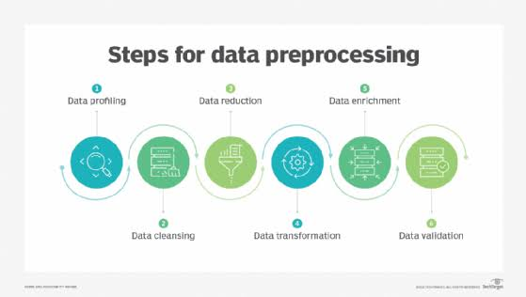Preprocessing simply refers to perform series of operations to transform or change data. It is transformation applied to our data before feeding it to algorithm. Data processing refers to perform operations on data to retrieve, transform, or change data, especially by computer.

**Data preprocessing has four steps.**

Data quality assessment.

Data cleaning.

Data transformation.

Data reduction

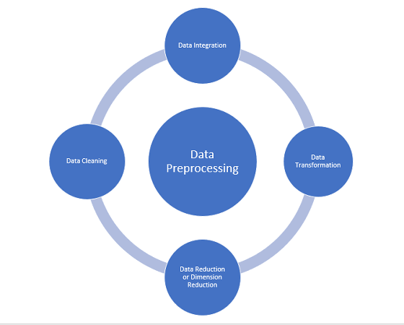

Benefits of data processing

It’s a way to reduce the complexity of dataset

Reduce the missing data

Splitting data for training the dataset efficiency

Transform data into usable form

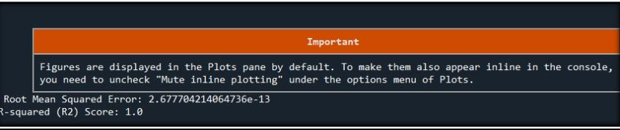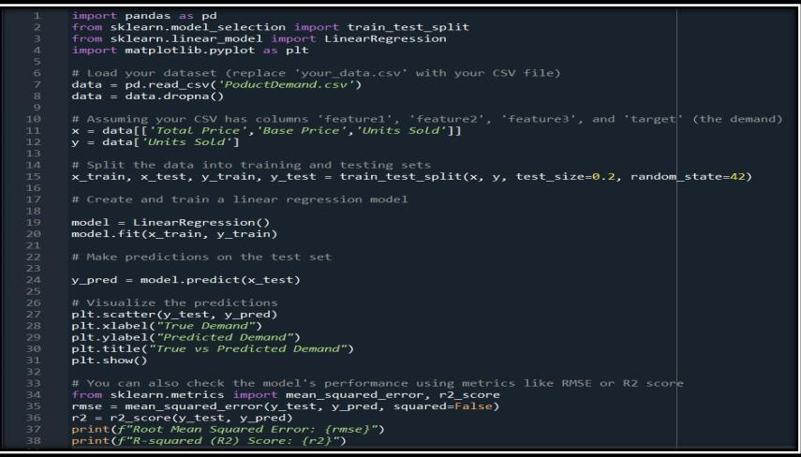

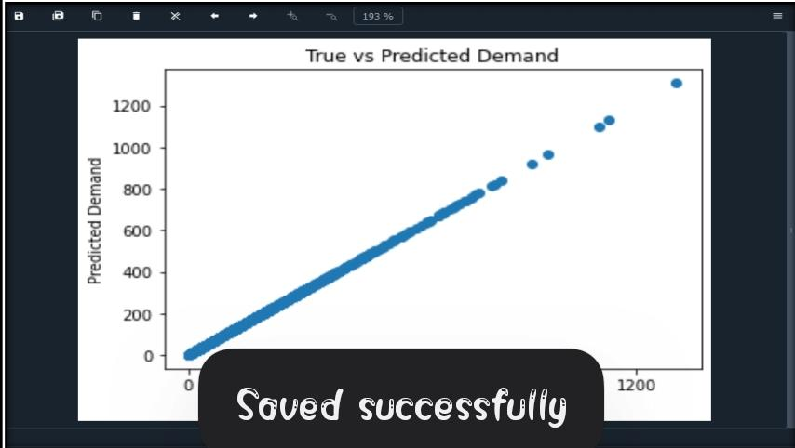

**Conclusion**:

By merging historical sales data with external factors, you create a comprehensive dataset, laying the groundwork for accurate demand predictions. The division of this data into training and testing sets is crucial for model evaluation, with time series analysis aiding in the recognition of temporal patterns and trends.

Lastly, continuous monitoring and maintenance of the model are essential to ensure it remains relevant and effective as demand patterns evolve over time.

In summary, data preprocessing and loading are the pillars upon which the demand prediction model is built, and these crucial steps lay the foundation for the accurate forecasting of product demand.