|  |  |  |  |
| --- | --- | --- | --- |
| Class: | BCS 1A | Date: | 9th Dec, 2018 |
| Subject: | Introduction to ICT | Max Marks: | 10 |

### **Mathematical functions:**

### To do some advanced mathematical functions in C, there is a header file called <math.h> that has different trigonometric and algebraic functions. Here are some frequently used functions:

|  |  |  |
| --- | --- | --- |
| **Function** | **Mathematical equivalent** | **How to use in C** |
| pow(x,y) | xy | pow(5,3) = 53 = 125 |
| sqrt(x) | (x > 0) | sqrt(4) =  = 2 |
| log(x) | ln x (x > 0) | log(5) = 1.6094 |
| log10(x) | (x > 0) | log10(5) = 0.698970 |
| exp(x) | ex | exp(2) = 7.3891 |
| sin(x) | sin x (x in radian) | sin(90) = 0.893997 |
| cos(x) | cos x (x in radian) | cos(90) = -0.448074 |
| tan(x) | tan x (x in radian) | tan(90) = -1.9952 |
| asin(x) | sin-1 x ( x in [-1,1]) | asin (0) = 0 |
| acos(x) | cos-1 x (x in [-1,1]) | acos(0) = 1.570796 |
| atan(x) | tan-1 x | atan(0) = 0 |

### **Note that you must include the header file math.h before you use any of these functions. Also, the return type of these functions is float (or double).**

**Example - 1:- This program illustrates some arithmetic properties of integer (int) variables. Trace through the program to make sure you understand the values of each variable in all stages of the program.**

# include <stdio.h>

# include <conio.h>

int main()

{

int a = 4, b, c;

printf ("a = %d. b = %d. c = %d.\n", a,b,c);

b = 69.5;

c = a + b;

printf ("a = %d. b = %d. c = %d.\n", a,b,c);

a++; //this statement is similar to a=a+1;

b -= 2; //this statement is similar to b= b-2;

--c; //this statement is similar to c=c-1;

printf ("a = %d. b = %d. c = %d.\n", a,b,c);

b *= ++a; //a=a+1;, b=b*a;

c /= a++; //c=c/a;, a=a+1;

printf ("a = %d. b = %d. c = %d.\n", a,b,c);

a = (b+c)*4; //First (b+c) then multiply the result with 4.

c = b+c*4; //First c*4 then result is added with b.

printf ("a = %d. b = %d. c = %d.\n", a,b,c);

getche();

return 0;

}

Here is the output:

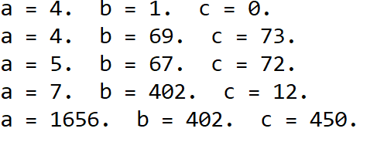

**Example – 2: There is a fifth arithmetic operator that works only with integer variables. It’s called the *remainder operator,* and is represented by %, the percent symbol. This operator (also called the *modulus operator*) finds the remainder when one number is divided by another.**

# include <stdio.h>

# include <conio.h>

int main()

{

printf("%d\n", 6 % 8); // 6

printf("%d\n", 7 % 8); // 7

printf("%d\n", 8 % 8); // 0

printf("%d\n", 9 % 8); // 1

printf("%d\n", 10 % 8); // 2

getche();

return 0;

}

**Example – 3: Write a C program to do the following:**

* 1. **Greet the user.**
  2. **Prompt the user to input two numbers.**
  3. **Check whether first number is greater than second.**
  4. **Check whether second number is greater than first.**
  5. **Print your findings.**

#include <stdio.h>

int main()

{

int a, b;

int x, y;

printf("Hello, Please input two numbers\n");

printf("a = ");

scanf("%d",&a);

printf("b = ");

scanf("%d",&b);

x = a>b;

y = b>a;

printf("is %d greater = %d\n",a,x);

printf("is %d greater = %d",b,b>y);

return 0;

}

Here is the output:

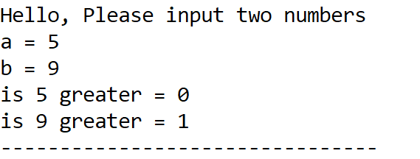

**Example – 4: Write a C program to do the following:**

* 1. **Greet the user.**
  2. **Prompt the user to input two numbers.**
  3. **Then check whether the first number is a multiple of second. (e.g. 2,4,6,8 are multiples of 2)**
  4. **Print your findings.**
  5. **Divide the first number with second number.**
  6. **Print the Quotient and Remainder.**

#include <stdio.h>

int main()

{

int a, b;

float quo;

int rem;

printf("Hello, Please input two numbers\n");

printf("a = ");

scanf("%d",&a);

printf("b = ");

scanf("%d",&b);

quo = a/b;

rem = a%b;

printf("is %d a multiple of %d = %d\n",a,b,rem==0);

printf("Quotient of %d/%d = %.2f\n",a,b,quo);

printf("Remainder of %d/%d = %d",a,b,rem);

return 0;

}

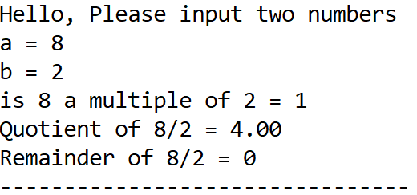Here is the output:

**Example - 5:- In this program, the library function sqrt() is used to calculate the square root of a number entered by the user.**

# include <stdio.h> //for printf, scanf.

# include<conio.h> //for getche

# include <math.h> //for sqrt

int main()

{

float number, answer; //sqrt() requires type float

printf("Enter a number: ");

scanf("%f",&number); //get the number

answer = sqrt(number); //find square root

printf("Square root of %f is %f",number, answer); //display the answer

getche();

return 0;

}

Here is the output:

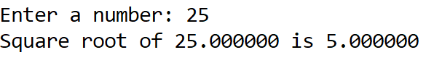

## Assignment

**Question 1:** While purchasing certain items, a discount of 10% is offered if the quantity purchased is more than 1000. If quantity and the price per item are input through keyboard, write a program that calculates the total expenses.

**Question 2:** Write a program to solve the quadratic equation using quadratic formulas:



Your Program should prompt the user for the values of *a*, *b* and *c*.