**Name of Project :** Placify Startup vibe + placement focused

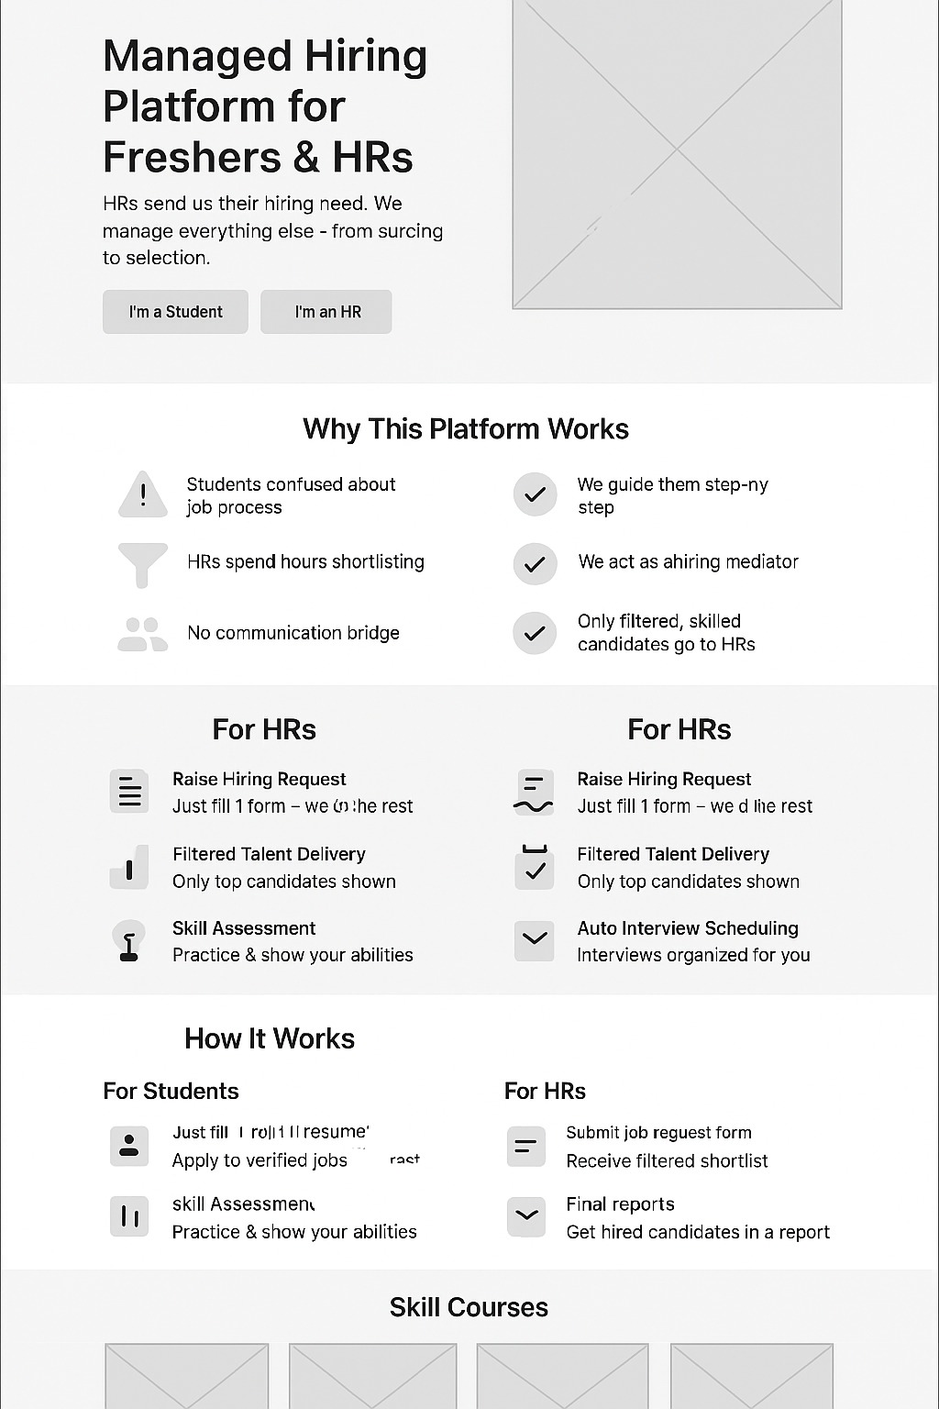

**Tools to Use While Building**

| **Task** | **Tool** |
| --- | --- |
| UI Design | Figma |
| Code Frontend | VS Code + React |
| Icons | [Heroicons](https://heroicons.com), [Feathericons](https://feathericons.com) |
| Illustrations | [unDraw.co](https://undraw.co/) |
| Hosting (Free for testing) | Vercel / Netlify |
| Backend Hosting | Render / Railway / MongoDB Atlas |

**Total Pages Required (Initial Version)**

| **Page Name** | **Purpose** |
| --- | --- |
| 1. Homepage | Overview, intro, CTAs |
| 2. Student Signup/Login | Authentication |
| 3. HR Signup/Login | Authentication |
| 4. Student Dashboard | Job browsing, applications, profile |
| 5. HR Dashboard | Post job, view applicants |
| 6. Job Details Page | Job info + apply button |
| 7. Resume Builder Page | Form to build & save resume |
| 8. Course Listing Page | All paid/free courses |
| 9. Course Details Page | Full info + buy/start |
| 10. Contact Us Page | Support/contact form |
| 11. Admin Panel (optional) | Manage users, jobs, etc. |

➡️ **Total = 10 to 11 pages (MVP version)**

## Homepage Sections (in order)

1. **Hero Section**
   * Tagline
   * Subheading
   * [I’m a Student] [I’m an HR] buttons
2. **Why This Platform Works**
   * Problems → Solutions grid
   * Use icons

| **Problem** | **Our Managed Solution** |
| --- | --- |
| Students confused about job process | We guide them step-by-step |
| HRs spend hours shortlisting | We handle screening & shortlisting |
| No communication bridge | We act as a hiring mediator |
| Random applications | Only filtered, skilled candidates go to HR |

1. **Student Features**

| **Feature** | **Description** |
| --- | --- |
| 📄 Resume Builder | Build modern resume in minutes |
| 📊 Application Tracker | Track job applications easily |
| 🧪 Skill Assessment | Practice & show your abilities |
| 🧑‍💼 Interview Preparation | Curated questions, tips, and videos |
| 🚫 *Removed:* HR Direct Chat | (Because platform handles it) |

1. **How It Works**
   * For Students → 3 steps
   * For HRs → 3 steps
2. **Skill Courses Section**
   * Show 4–6 course cards
   * Button: [View All Courses]
3. **Testimonials**
   * From students and HRs

Instead of:

“I connected with an HR…”

Use:

“I got shortlisted within 7 days without even contacting any HR myself!”

1. **FAQs**
   * About jobs, safety, refunds, etc.

Replace:  
❌ “Can I chat with the HR directly?”

With:  
✅ “How will I know if I’m shortlisted?”  
✅ “Who handles the interview process?”  
✅ “What happens after I apply to a job?”  
✅ “How do you send my profile to companies?”

1. **Footer**
   * Contact, Terms, Privacy Policy, Social Links

## Student Dashboard Pages & Sections

| **Page** | **Sections** |
| --- | --- |
| Dashboard | Recent jobs, application status |
| Profile | Basic info, resume, skills |
| Jobs | Browse + Apply |
| Courses | Browse courses |
| My Applications | Track job status |
| Resume Builder | Form-based resume generator |

### HR Dashboard Pages & Sections

| **Page** | **purpose** |
| --- | --- |
| **1. Dashboard** | Summary: Total requests, hires done, pending roles |
| **2. Raise a Hiring Request** | (New name for “Post Job”) |
| Form to give: |  |

* Job Title
* Number of candidates needed
* Skills required
* Deadline to hire
* Salary range
* Location/remote
* Preferred candidate type (fresher/experienced)  
  **Submit button** → Sends request to your team  
  |  
  | **3. Requests Overview** | Table:
* Job Role
* Requested On
* No. of candidates required
* Status (In Progress / Completed / Paused)  
  |  
  | **4. Messages (Optional)** | Chat with platform manager if needed  
  |  
  | **5. Final Reports** | After hiring complete → platform will show:
* Candidates selected
* Interview ratings
* Hiring time
* Resume access (PDFs or summary)  
  |

### What You Will Manage (as Platform Admin)

* Create job post (based on HR's request)
* Promote job to students
* Shortlist best candidates (auto + manual)
* Schedule interviews (Google Meet/Zoom/Offline)
* Notify HR only at final shortlist stage
* Give final report with selected candidates.

**Flow Summary:**

**HR’s Task:**

1. Login
2. Fill “Hiring Request” form
3. Sit back

**Your Platform’s Task:**

1. Create job post
2. Accept student applications
3. Shortlist best-fit
4. Schedule interviews
5. Submit final selected candidates to HR
6. Send offer letters if needed

**What Makes This Model Special?**

HRs ka workload **zero**  
 Students ke liye **clear process**  
 Tumhara platform **value add karta hai both sides pe**