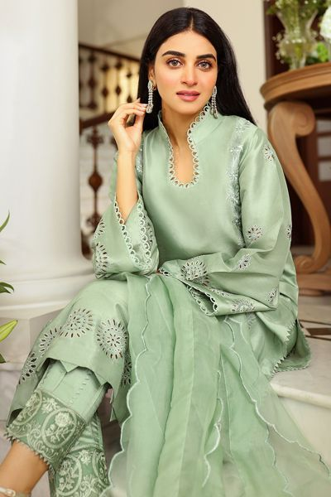Dkjbfidiweifhrinfiruhg

**𝙎𝘼𝙉𝘼 𝙎𝘼𝙁𝙄𝙉𝘼𝙕**

Asim Jofa's Silk Collection is another esteemed line by the Pakistani fashion designer, renowned for its opulence and elegance. Silk, known for its luxurious feel and lustrous appearance, serves as the primary fabric for this collection. Asim Jofa infuses his distinctive design aesthetic into the Silk Collection, creating pieces that exude sophistication and grace.

The Silk Collection typically comprises a range of traditional and contemporary ensembles, including silk suits, sarees, and dresses. These garments often feature intricate embroidery, embellishments, and unique design elements that showcase the designer's mastery of craftsmanship.

Asim Jofa's Silk Collection is popular among those who appreciate fine fabrics and exquisite detailing. The collection caters to various occasions, from formal events like weddings and parties to more casual gatherings, offering versatility and timeless elegance. With its luxurious appeal and impeccable quality, the Silk Collection by Asim Jofa continues to captivate fashion enthusiasts both in Pakistan and internationally.

Asim Jofa's silk collection transcends trends and seasons, offering timeless pieces that exude grace and opulence.

Top of Form

**𝓔𝓘𝓓 𝓒𝓞𝓛𝓛𝓔𝓒𝓣𝓘𝓞𝓝**

Whether its delicate floral motifs cascading down a silk organza saree or geometric patterns adorning a silk kurta, Jofa's embroidery elevates each piece to a work of art. The interplay of thread and fabric creates a symphony of texture and color, capturing the imagination and evoking a sense of wonder.

But it's not just the craftsmanship that sets Asim Jofa's silk collection apart; it's also his keen understanding of silhouette and design. Each garment is expertly tailored to flatter the female form, with meticulous attention to detail and fit.

From flowing gowns that skim the floor to sleek, tailored separates, Jofa's designs cater to women of all ages and body types. His silhouettes are modern yet timeless, offering a perfect balance of tradition and innovation.

The color palette of Asim Jofa's silk collection is equally exquisite, ranging from soft pastels to rich jewel tones. Whether it's a blush pink saree adorned with pearls or a midnight blue Anarkali embellished with gold, every hue is carefully chosen to complement the fabric and enhance the overall aesthetic.

But perhaps the most remarkable thing about Asim Jofa's silk collection is its versatility. Each piece can be dressed up or down, making it suitable for a variety of occasions, from weddings and parties to festive celebrations and formal events.

Whether you're looking for a show-stopping bridal ensemble or an elegant evening gown, Asim Jofa's silk collection has something for everyone. With its timeless beauty, impeccable craftsmanship, and effortless sophistication, it's no wonder that Jofa's designs are coveted by women around the world.

In conclusion, Asim Jofa's silk collection is a testament to the enduring allure of silk and the artistry of couture. With its exquisite fabrics, intricate embroidery, flattering silhouettes, and timeless elegance, it's a celebration of femininity, style, and luxury.

At the heart of Jofa's designs is a deep reverence for heritage and craftsmanship. Inspired by the rich cultural tapestry of his native land, Pakistan, Jofa infuses his silk collection with motifs and patterns that pay homage to centuries-old artisanal techniques.

From the intricate threadwork of zardozi to the delicate embellishments of gota Patti, Jofa's designs celebrate the craftsmanship of generations past while infusing a contemporary sensibility.

Moreover, Asim Jofa's silk collection serves as a celebration of femininity in all its forms. Each piece is designed to empower and inspire, embracing the diversity of women and celebrating their individuality.

Whether it's a flowing silk saree that drapes gracefully around the body or a structured silk jacket that exudes confidence and poise,

Furthermore, Asim Jofa's silk collection transcends geographical boundaries, embodying a global aesthetic that resonates with women from all walks of life. His designs effortlessly blend Eastern opulence with Western sensibility, creating a fusion that is both timeless and contemporary.

From the bustling streets of Lahore to the fashion capitals of Paris and New York, Asim Jofa's silk collection has captivated audiences around the world, earning him accolades and acclaim from critics and connoisseurs alike.

Top of Form