DOMAIN MODEL

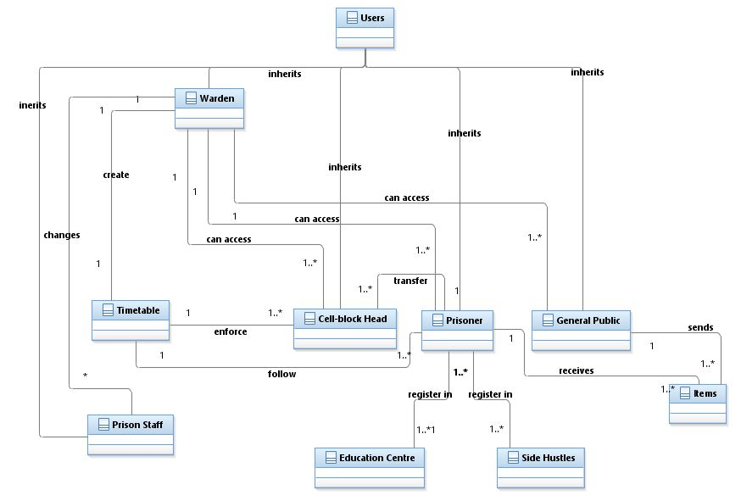

SSDs

Use case 1:

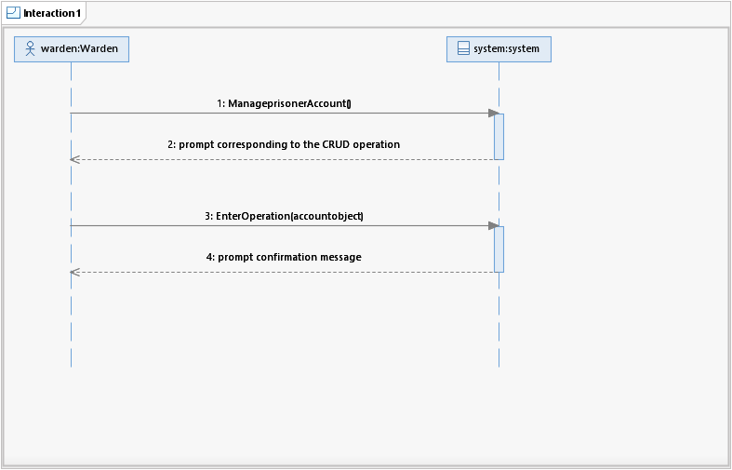Use case 2:

Use Case 3:

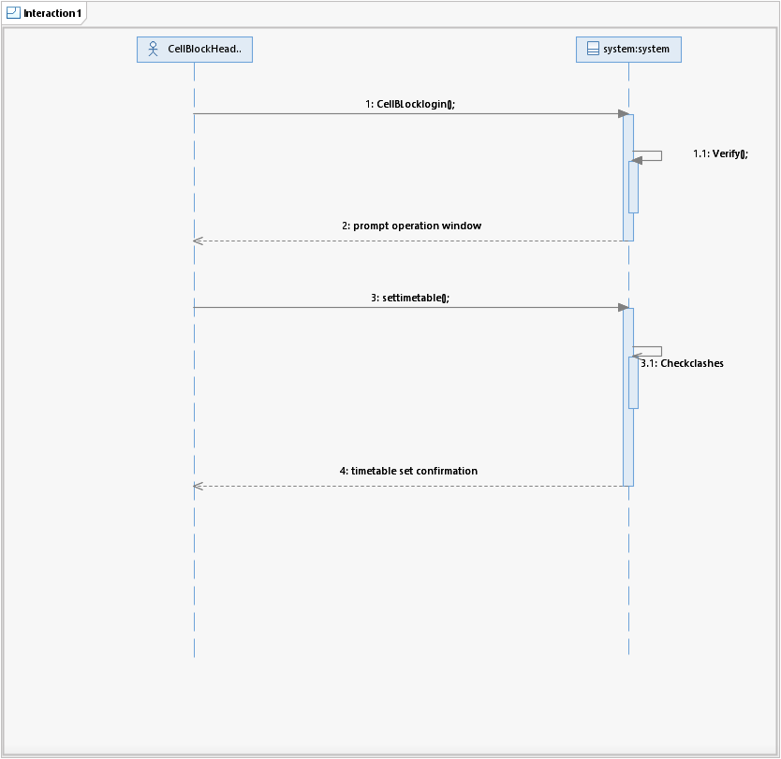

Use case 4:

Use case 5:

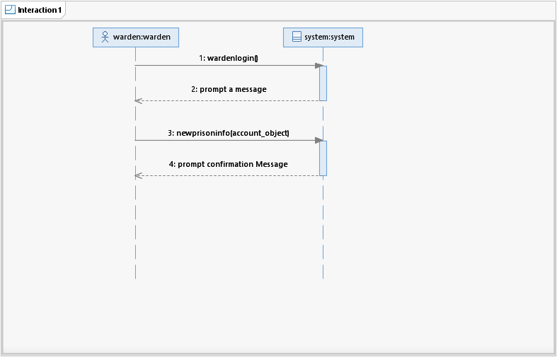

Use case 6:

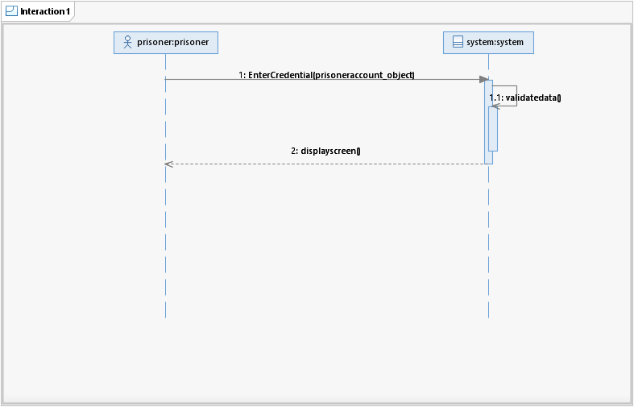

Use case 7:

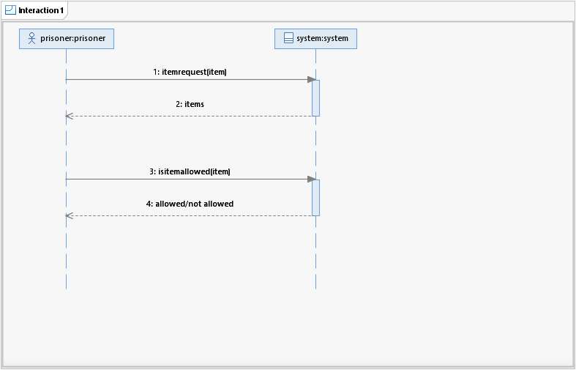

Use case 8:

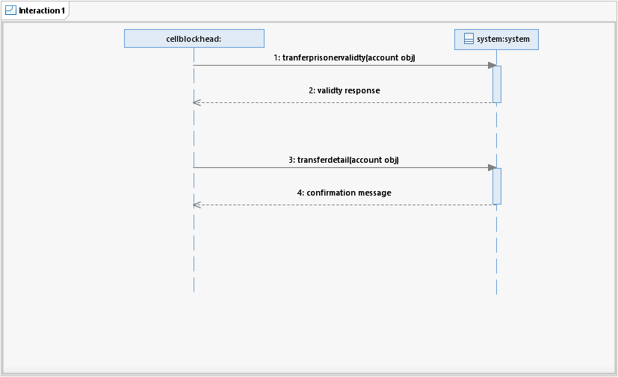

CLASS DIAGRAM

**SDs**

**Use Case 1**

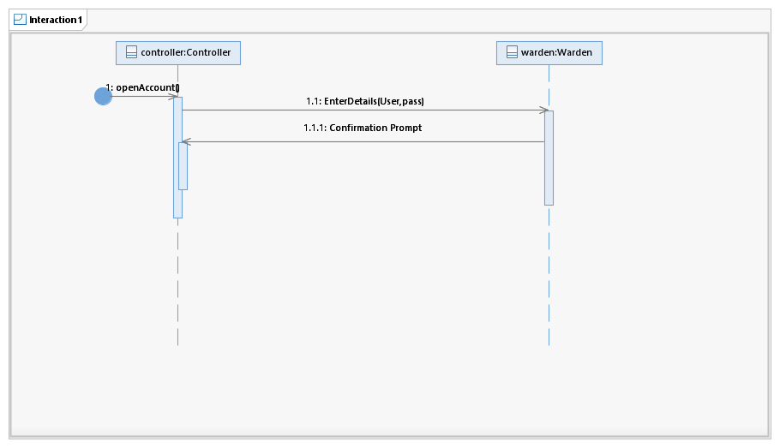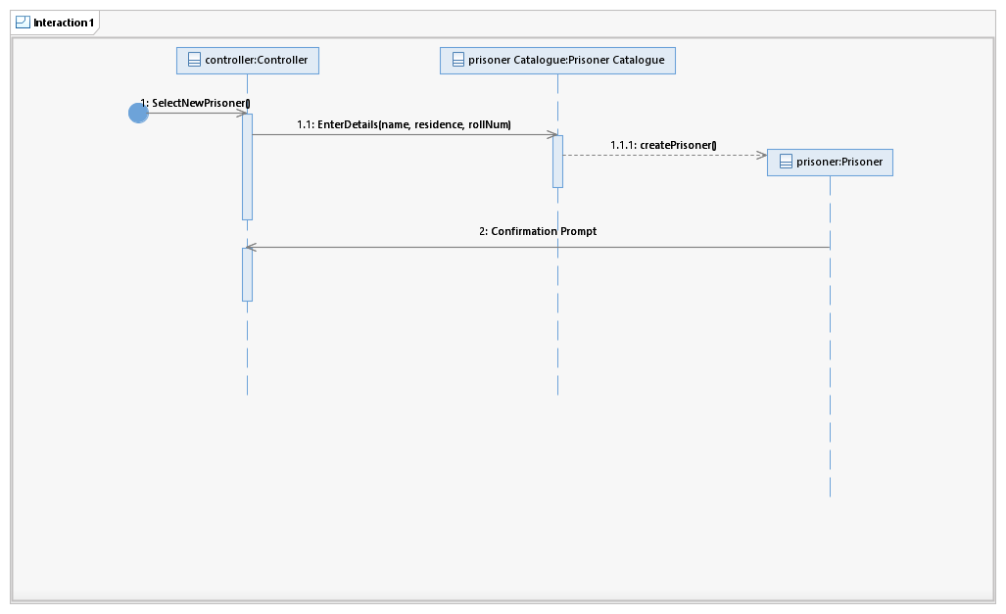

**Use Case 2**

**Use Case 3**

**Use Case 4**

**Use Case 5**

**Use Case 6**

**Use Case 7**

**Use Case 8**

