Software Requirements and Design Document
for
<Prison Management System>
Table of Contents
Table of Contents ii
1. Introduction 1
1.1 Purpose 1
1.2 Product Scope 1
1.3 Title 1
1.4 Objectives 1
1.5 Problem Statement 1
2. Overall Description 1
2.1 Product Perspective 1
2.2 Product Functions 2
2.3 List of Use Cases 2
2.4 Extended Use Cases 2
2.5 Use Case Diagram 2
3. Other Nonfunctional Requirements 2
3.1 Performance Requirements 2
3.2 Safety Requirements 2
3.3 Security Requirements 2
3.4 Software Quality Attributes 2
3.5 Business Rules 3
3.6 Operating Environment 3
3.7 User Interfaces 3
4. Domain Model 3
5. System Sequence Diagram 3
6. Sequence Diagram 3
7. Class Diagram 4
8. Package Diagram 4
9. Deployment Diagram 4

Introduction

Purpose
Helping Prisoners to become better version of themselves.

Product Scope
Prisoners would get facilitation in the district central jails. The program would improve their living standards by integrating an online prisoner management platform.

Title
Tarar-Shah Associates aims to provide ease to prisons, from registering for ide Jobs for prisons to controlling the entire prison by the Warden, we will make it all go smoother. The old prison system will finally see some automation!

Objectives
- Families of prisoners could schedule their meeting hours.
- Needs and necessities could be provided on time by highlighting it before.
- Prisoners could educate themselves from different program offering and books availability.
- Prisoners administration could easily handle and track the record of each person activity.
- Ensuring healthy and Hygienic environment to help Prisoner to reflect on their deeds.

Problem Statement
The main purpose of building prisoner’s management project is to improve the poorly administer and languid system of district jails. The problems which result due to this
incompetent system damages the core principals and values of the welfare society. Let highlight a few major issues; first when prisoners do not get suitable treatment corrupt system within
the jails prevails which includes briberies to get upper hand, uneven distribution of jails resources, gangs and fighting cultures form and most importantly person chance of forsaking and leaving his/her criminal life are reduced.
The problems could be counter if a suitable and reliable system of administration is formed. For the same purpose the prison management system would provide the online tools and state of art solutions which can improve the system as well as strengthen the core foundation of welfare society. The prison management system would provide the online platform where
prisoners could interact and avail different services. This would not fulfill their needs but also
help the administration to keep a proper check and help the system to remain transparent. The users of this platform would also be the families of prisoners which could help their loved ones to become better individuals.

Overall Description

Extended Use Cases
Use Case No: 1

Use Case Name | Process New Prisoner
Scope | Prison Management System
Level | User Goals
Primary Actor | Warden
Stakeholder & Interests | 1) Warden  Wants quick and efficient entry of prisoner’s data and allotting of rooms.
Preconditions | The prisoner must be checked, verified, and handcuffed before walking into the warden’s office.
Postconditions | The prisoner account has been created on the software, he is allotted a cellblock and room.
Main Success Scenario |  | Actor Action | System Response
Main Success Scenario |  | 1) Warden logs in using his unique credentials.
Main Success Scenario |  |  | 2) Verifies and opens the  admin account.
Main Success Scenario |  |  | 3) Displays the different operations available.
Main Success Scenario |  | 4) Selects “New Prisoner”.
Main Success Scenario |  | 5) Enters all the required data.
Main Success Scenario |  |  | 6) Checks and verifies if data entered is correct.
Main Success Scenario |  |  | 7) Updates the new verified prisoner account and its data  in the database.
Extensions | - There is a problem with the prisoner’s documents therefore, that data slot is left empty and updated later when the documents have been acquired.  - A riot breaks out while a new prisoner is being brought in, so the warden shuts down the system and locks down the prison.

Use Case No: 2

Use Case Name | Manage User Accounts
Scope | Prison Management System
Level | User Goals
Primary Actor | Warden
Stakeholder & Interests | 1) Warden  Wants fast, accurate create, read, update, and delete operations for all accounts.
Preconditions | Warden has logged in using his unique credentials.
Postconditions | The desired operation is successfully completed and recorded in the database.
Main Success Scenario |  | Actor Action | System Response
Main Success Scenario |  | 1) Warden logs into system.
Main Success Scenario |  |  | 2) Verifies and opens the  admin account.
Main Success Scenario |  | 3) Selects one of the four CRUD (Create, Read, Update, & Delete)  operations.
Main Success Scenario |  |  | 4) Opens the respective interface.
Main Success Scenario |  | 5) Enters the required data  into the designated field to perform the desired task.
Main Success Scenario |  |  | 6) If it is valid, carry out the task, and update this operation in the database if required (not required for  reading).
Extensions | - Account to be updated not found  - The database crashes. The warden updates it on his screen, but it isn’t updated in the database.

Use Case No: 3

Use Case Name | Set Weekly Timetable
Scope | Prison Management System
Level | User Goals
Primary Actor | Warden
Stakeholder & Interests | - Warden  Wants to automate actions such as moving of prisoners to and from their rooms to different parts of the prison according to the timetable that he designs.  - Cellblock Head  Is there to help the warden in case the warden needs any help or information regarding the prison.
Preconditions | The Warden and Cellblock Heads must have this option open on their  ends which allows them to communicate with each other and utilize the software’s capabilities to construct a feasible timetable.
Postconditions | A clash less timetable is constructed which is easy to manage for the  cellblock heads.
Main Success Scenario |  | Actor Action | System Response
Main Success Scenario |  | 1) Warden & Cellblock heads  login to their unique respective accounts.
Main Success Scenario |  |  | 2) Verifies the login and shows the list of operations available.
Main Success Scenario |  | 3) Everyone opens “Timetable  Management”.
Main Success Scenario |  | 4) Warden constructs a timetable.
Main Success Scenario |  |  | 5) Gives suggestions to solve  the clashes if there are any.
Main Success Scenario |  | 6) The heads check if there is any problem with the timetable that the warden has overlooked. If there is, they notify him with the inbuilt messenger programmed into this  operation.
Main Success Scenario |  |  | 7) Once everyone has confirmed the timetable, it is updated into the database  for the next week.
Main Success Scenario |  |  | 8) For the next week, the software sends out  automated announcements.

It also opens and closes doors to different parts of the prison according to the
timetable.
Extensions | - The timetable that the warden wants to construct could have unsolvable clashes because of the scarcity of resources.  - The respective Cellblock Head does not confirm the timetable; therefore, it is not implemented into the software.

Use Case No: 4

Use Case Name | Prisoners Transfer
Scope | Prison Management System
Level | User Goals
Primary Actor | Warden & Cellblock Head
Stakeholder & Interests | - Warden  Is there just to confirm if the reason stated is valid enough for the prisoner’s cellblock to be shifted.  - Cellblock Head  The two cellblock heads will be there, and the head on the receiving head will be responsible for allotting of his room. Both the heads will update the new information in the database.
Preconditions | There must be a valid reason for the transfer of the prisoner in question.
Postconditions

The prisoner is successfully shifted to the new cellblock and this new
data is updated in the database.
Main Success Scenario |  | Actor Action | System Response
Main Success Scenario |  | 1) Warden & Cellblock heads login to their unique respective  accounts.
Main Success Scenario |  |  | 2) Verifies the login and shows the list of  operations available.
Main Success Scenario |  | 3) Everyone opens “Prisoner Transfer”.
Main Success Scenario |  | 4) The old Block Head sends the prisoner details & the transfer  reason to new Block Head & the Warden.
Main Success Scenario |  | 5) The Warden checks if the transfer reason is valid and if it checks out, he gives the authorization to the new block head to change the “cell block” & “room”  fields of the prisoner in the database.
Main Success Scenario |  |  | 6) Updates the new information in the database.
Extensions | - The transfer reason is not valid, and the transfer request is denied.  - The cellblock that the prisoner is being transferred to has no rooms available.

Use Case No: 5

Use Case Name | Schedule Prisoner Meetings
Scope | Prison management system
Level | User goal

Primary Actor | Prisoner
Stakeholder & Interests | - Prisoner  Meeting schedule can be selected by the prisoner.  - Cell-block head  meeting time would be easily checked and governed.  - Relatives  they could also easily perform the meeting without delay.
Preconditions | Prisoner would enter his login credential to excess the scheduling service.
Postconditions | - the prisoner would be login into his account and can selected the available meeting schedule and book his appointment.  - Message is sent to the relatives, and they can see the meeting slot of their prisoner.  - The cell-block head can double check the prisoner meeting slots from the schedule.
Main Success Scenario |  | Actor Action | System Response
Main Success Scenario |  | 1) prisoners enter the credential into system.
Main Success Scenario |  |  | 2) system verifies the credential and log into  their account.
Main Success Scenario |  | 3) the prisoner selects the options of schedule  meeting.
Main Success Scenario |  |  | 4) schedule meeting options are open and get selected. Also, message  is sent to notify them.
Main Success Scenario |  | 5) relatives can check their  prisoner meeting time from the system.
Main Success Scenario |  |  | 6) meeting slots are shown to them.
Main Success Scenario |  | 7) The cell block head can also check the prisoner meeting time and double check it when relative arrives by entering to his own profile through  credential.
Main Success Scenario |  |  | 8) meeting slots are shown to him.

Extensions | - the credentials enter by prisoner could be incorrect.  - the time slots select is already filled by someone else or time is not available.

Use Case No: 6

Use Case Name | Change Prison Staff
Scope | prison management system
Level | user goal
Primary Actor | Warden
Stakeholder & Interests | - Cellblock Head  New staff can be checked by the cellblock head through the system.  - Warden  Warden can change the staff easily and it can be performed remotely through the system.
Preconditions | warden needs to enter the system through the credentials to change the staff.
Postconditions | warden can change the staff and the cell-block head can check the changes made to staff through the system.
Main Success Scenario |  | Actor Action | System Response
Main Success Scenario |  | 1) Warden enters the login credentials.
Main Success Scenario |  |  | 2) system check the credentials and login into his account if  credential verify.
Main Success Scenario |  | 3) the staff recruitment  information would be entered by warden.
Main Success Scenario |  |  | 4) the system stores the  information in the system and update if any changes made.
Main Success Scenario |  | 5) the cell-block head can also check the staff info through his/her account.

 |  |  | 6) The information would be shown to him.
Extensions | - the warden or cell-block head input credential could be wrong error message occur.  - the staff information isn’t complete so the data would be missing from the database of system.  - the staff isn’t eligible for the job by the rules error occur.

Use Case No: 7

Use Case Name | “Side Hustles” Registration
Scope | prison management system.
Level | user goals
Primary Actor | Prisoner
Stakeholder & Interests | - Prisoner  - The prisoner can register himself for the activities available in the prison.  - The system would count his progress in the different activities enrolled and attached into his portfolio.
Preconditions | prisoner enrolled himself into the activities available through his account
Postconditions | system would confirm his/her seat by checking availability and criteria.
Main Success Scenario |  | Actor Action | System Response
Main Success Scenario |  | 1) Enter credentials of account
Main Success Scenario |  |  | 2) After verifying display,  the option of side-hustle.
Main Success Scenario |  | 3) Choose the option of side hustle activity.
Main Success Scenario |  |  | 4) System checks availability if confirms then ask for the  information.
Main Success Scenario |  | 5) User enter the requires  info.
Main Success Scenario |  |  | 6) The system checks the criteria and if confirm

 |  |  | enrol the person into the system database.
7) The system checks the criteria and if confirm
enrol the person into the system database.
Extensions | - the information provided is not according to criteria error message occur  - the data entry of the side hustle is not updating, and progress point are not calculated.

Use Case No: 8

Use Case Name | Request Items
Scope | prison management system
Level | User goals
Primary Actor | Prisoner
Stakeholder & Interests | - Prisoner  The prisoner can ask for require items by inputting his needs into the system. The management can also be notified about the genuine required items.  - Relatives  The relatives can check the items details and provide the prisoner with them on their next meeting.
Preconditions | the prisoner would enter the items from his/her account
Postconditions | the system would store the data and sent it to the relatives and also notify the management about it.
Main Success Scenario |  | Actor Action | System Response
Main Success Scenario |  | 1) Prisoner enter his/her account through  credential
Main Success Scenario |  |  | 2) the system stores the data after verifying the  account.

3) the system would send
message to authorities about the item.
4) the cell-block head can check the item whether it allowed or not through
his account
5) notifying relative about
the item require if identified as allowed.
Extensions | - the enter item is not allowed then the system would produce error  - the system cannot send the item required message until the  cell-block head does not check it so it can be delayed or manipulated.

Use Case Diagram
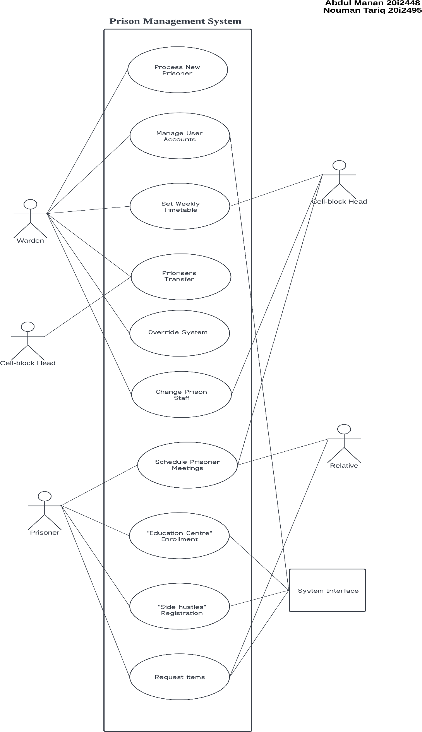

Other Nonfunctional Requirements

Performance Requirements
the window requirement is window 7 and above. It will run perfectly.

Safety Requirements
.no such safety requirement only run the code on eclipse environment also load all the files before use to run it properly/

Security Requirements
there is no security issue related to the data theft only the database needs to be secure for saving it from data loss.

Software Quality Attributes
the software is robust and can provide full functionality of maintaining the prison management system.

Business Rules
. the data and resources used here are all publicly available software on the internet. No resource we claim or illegal used.

Operating Environment
. the environment to run the code is preferably eclipse or intelliga software/

User Interfaces
.
The user interface is not available; or connected to the database properly. The code is the providing the main functionality.

