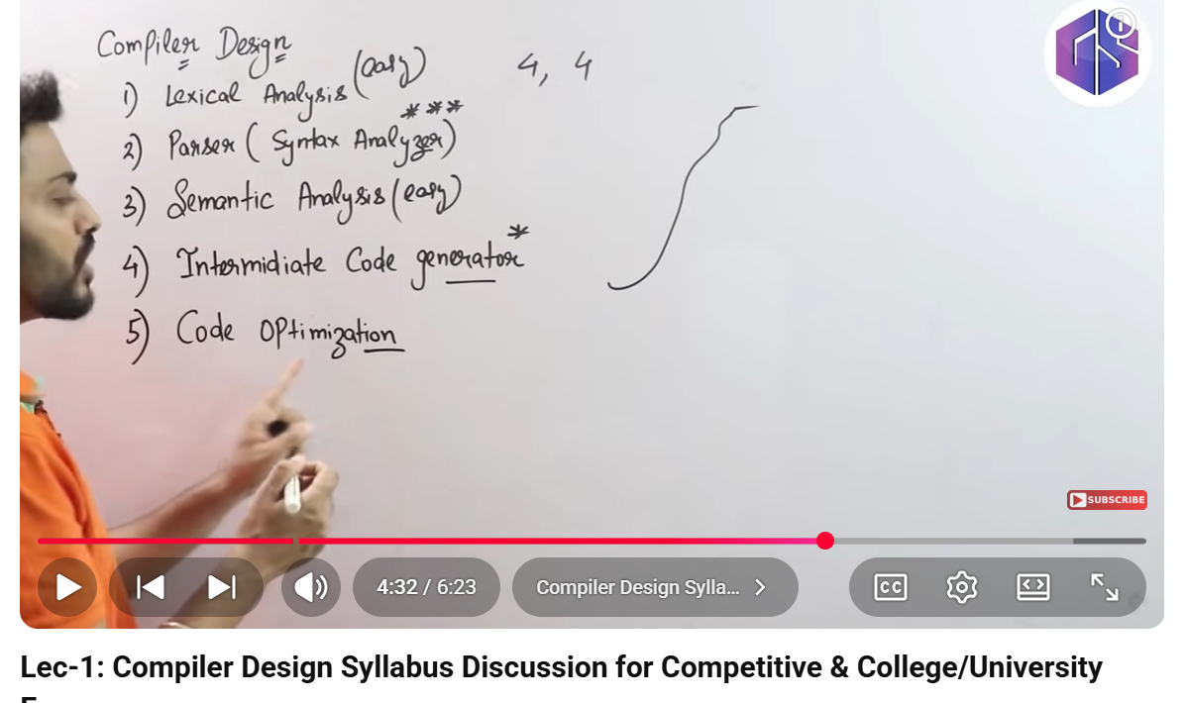

Lexical : stream of character and give stream of token ,remove whitespace ,comment like scanner tokennizer used dfa nfa to create character to token or y=2*x like it is int,x,y it stored in symbol table for later use.

Syntax : parser checks syntatically wether my token is syntactically organized or not and we can check using parsing and make parse tree wether the grammer is ambigious or not.

Semantic : logical kind of error wether the variable is properly declaered or not e.g variable not declared and type properly not mentioned.

Intermediate code genetation: 3 address code
