Open Connect RAAST Orchestration Demo
Inquiry and government bill payment flows
Paysys Labs | Implementation reference | 20 October 2026

Purpose and agreed behaviour
This document defines the demo flows for Open Connect acting as the RAAST Service Orchestration Platform (RSOP). It brings together the inquiry and bill payment sequences, diagrams and editable Mermaid source for the implementation team.
The mock government biller generates a unique inquiry identifier. RSOP stores that identifier with the amount returned in the inquiry response. The Payment Bank carries the same identifier in PACS.008, and RSOP validates the identifier and amount pair before authorising payment.
When validation fails, RSOP sends PACS.002/NAUTH. RAAST rejects the transaction and sends PACS.002/RJCT to both the Payment Bank and RSOP. When validation succeeds, RSOP sends PACS.002/AUTH. RAAST settles the transaction and sends PACS.002/ACSP to both parties. RSOP marks payment done and invokes the mock government Bill Marking service only after receiving ACSP.

Participants and boundaries
The Customer initiates inquiry and confirms payment through the Payment Bank. Inquiry requests and responses pass through the RAAST API Gateway. Open Connect routes the inquiry to the appropriate mock government institution and retains the response for subsequent payment validation.
RAAST forwards payment messages and provides the final status to both parties. The mock government biller provides Bill Inquiry and Bill Marking web services. The API Gateway is shown in the inquiry flow; the payment flow uses RAAST messaging.
Message status semantics in this document follow the agreed demo behaviour. The precise PACS.008 field for the inquiry identifier remains an implementation mapping to confirm.

Inquiry flow
The bank submits the institution and bill reference through the RAAST API Gateway. The mock biller retrieves the bill and generates a unique inquiry identifier. RSOP persists the response before returning it through the gateway, so the later payment can be checked against the original inquiry.
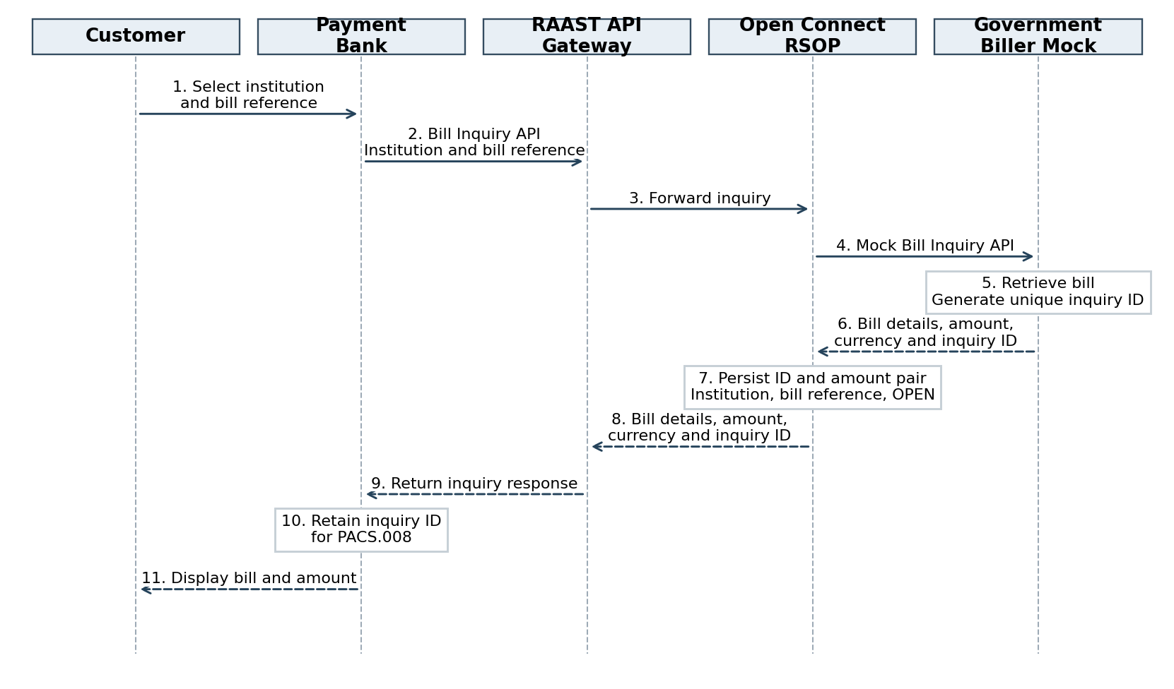
The bank retains the identifier for payment initiation and displays the bill details and amount to the customer. No payment is made and no bill is marked paid during inquiry.

Bill payment flow
RSOP validates the inquiry before AUTH. Bill marking begins only after RSOP receives ACSP.
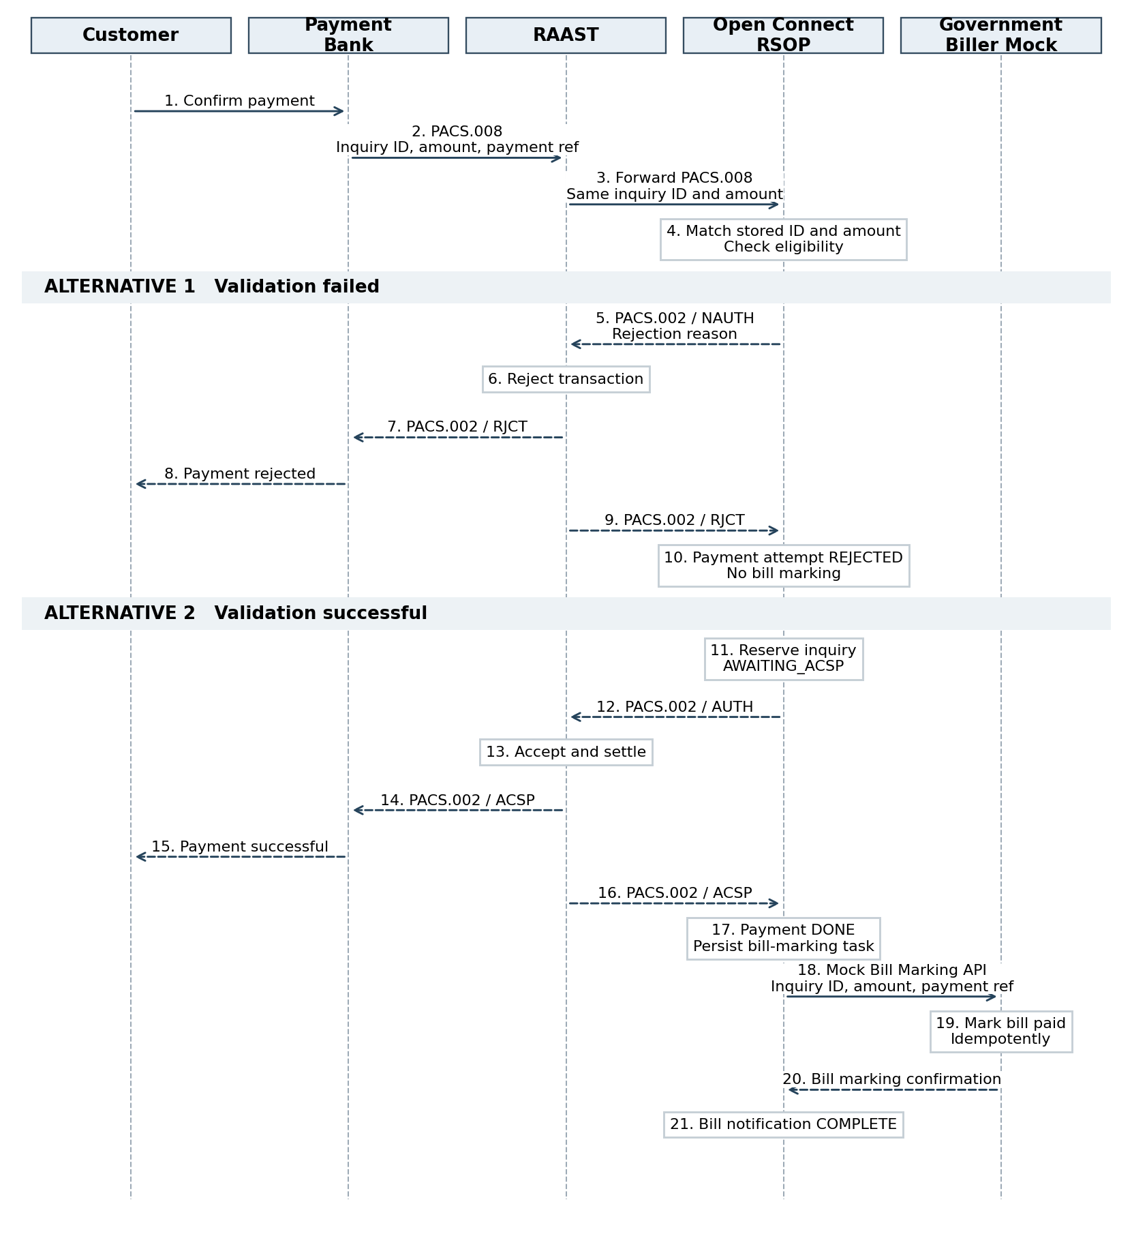
Notifications to the two parties are independent; their arrival order is not guaranteed. Mermaid source represents these notifications using parallel branches.

Implementation behaviour

Inquiry data and validation
Persist the inquiry identifier, exact payable amount, currency, institution, bill reference and inquiry status. Link each payment attempt to its payment reference. Validate that the identifier exists, the amount matches and the inquiry remains eligible for payment. Use exact decimal or minor-unit comparison for amounts.

Payment and notification state
On successful validation, atomically reserve the inquiry for the payment and retain AWAITING_ACSP before returning AUTH. On ACSP, correlate the payment reference, mark payment DONE and persist a durable Bill Marking task. Track completion of the government notification separately from the payment result.
On validation failure, return NAUTH with a reason and record the rejected payment attempt when RAAST returns RJCT. Do not call Bill Marking for a rejected attempt. A rejected attempt must not be recorded as a paid bill.

Retries and duplicate messages
Recommended demo controls: handle repeated PACS.008 and ACSP messages idempotently; prevent concurrent payments from consuming the same inquiry; and use a stable payment reference when retrying Bill Marking. A bill-marking timeout leaves the payment DONE and its notification pending for retry. If ACSP has not arrived, keep payment pending and resolve its status before attempting a new payment.

Demo checks
- Successful inquiry returns the mock-generated identifier unchanged through RSOP and the gateway.
- Matching identifier and amount produce AUTH, settlement and ACSP to both parties, followed by bill marking.
- Unknown identifier or mismatched amount produces NAUTH, then RJCT to both parties, with no bill marking.
- Duplicate final status or Bill Marking request does not apply payment twice.
- Bill Marking failure is retried without reversing a completed payment.

Mappings to confirm
Confirm the PACS.008 element carrying the inquiry identifier, message correlation fields, mock API schemas, rejection reason mapping and inquiry expiry policy. These details do not change the agreed sequence.

Inquiry Mermaid source
Copy the text below into a Mermaid editor to render the inquiry sequence.
sequenceDiagram
autonumber
actor C as Customer
participant B as Payment Bank
participant R as RAAST API Gateway
participant O as Open Connect (RSOP)
participant G as Government Biller (Mock)

C->>B: Select institution and enter bill reference
B->>R: Bill Inquiry API (institution, bill reference)
R->>O: Forward Bill Inquiry request
O->>G: Call mock Bill Inquiry web service
G->>G: Retrieve bill and generate unique inquiry identifier
G-->>O: Bill details, amount, currency, unique inquiry identifier
O->>O: Persist identifier and amount pair<br/>with institution, bill reference and status OPEN
O-->>R: Bill details, amount, currency, unique inquiry identifier
R-->>B: Return Bill Inquiry response
B->>B: Retain inquiry identifier for PACS.008 payment
B-->>C: Display bill details and payable amount

Bill payment Mermaid source
sequenceDiagram
autonumber
actor C as Customer
participant B as Payment Bank
participant R as RAAST
participant O as Open Connect (RSOP)
participant G as Government Biller (Mock)

C->>B: Confirm bill payment
B->>R: PACS.008 (inquiry identifier, amount, payment reference)
R->>O: Forward PACS.008 with same identifier and amount
O->>O: Retrieve inquiry and validate identifier and amount pair<br/>Check inquiry is eligible for payment

alt RSOP validation failed
O-->>R: PACS.002 / NAUTH (rejection reason)
R->>R: Reject transaction
par Notify Payment Bank
R-->>B: PACS.002 / RJCT
B-->>C: Payment rejected
and Notify RSOP
R-->>O: PACS.002 / RJCT
O->>O: Mark payment attempt REJECTED
end
Note over O,G: Do not call Bill Marking web service
else RSOP validation successful
O->>O: Reserve inquiry for this payment<br/>Set status AWAITING_ACSP
O-->>R: PACS.002 / AUTH
R->>R: Accept and settle transaction
par Notify Payment Bank
R-->>B: PACS.002 / ACSP
B-->>C: Payment successful
and Notify RSOP
R-->>O: PACS.002 / ACSP
O->>O: Correlate payment and mark payment DONE<br/>Persist bill-marking task
end
O->>G: Call mock Bill Marking web service<br/>(inquiry identifier, amount, payment reference)
G->>G: Mark bill paid idempotently
G-->>O: Bill marking confirmation
O->>O: Mark bill notification COMPLETE
end

