Success Story: NUST Society of Maritime Engineers (NSME)
Initially, the team started working together on different freelance design projects, team realized they needed a more structured platform to organize activities, manage projects, and represent themselves officially. This idea led to the formation of the NUST Society of Maritime Engineers (NSME) in 2021, just one year after the department was introduced.
Once the society was formed, an important question appeared: What should NSME actually do? The members began researching opportunities where they could apply their knowledge and gain exposure. During this search, they discovered the Worldwide Ferry Safety Association (WFSA) International Student Maritime Design Competition, where teams from around the world design safe and affordable ferries to solve real maritime challenges. Thus, NSME decided to participate.
NSME's 1st International Competition (2022)
NSME participated in this competition for the first time in 2022. The experience was primarily a learning opportunity to understand how international competitions work. Although the team did not secure a top position, they successfully participated and received international certificates. For a newly formed team, this was an important step to initiate. However, the journey was not easy. At that time, many people in the university did not fully understand the role of NSME. Compared to larger engineering societies, some believed that a maritime engineering society could not achieve much.
Remarks:
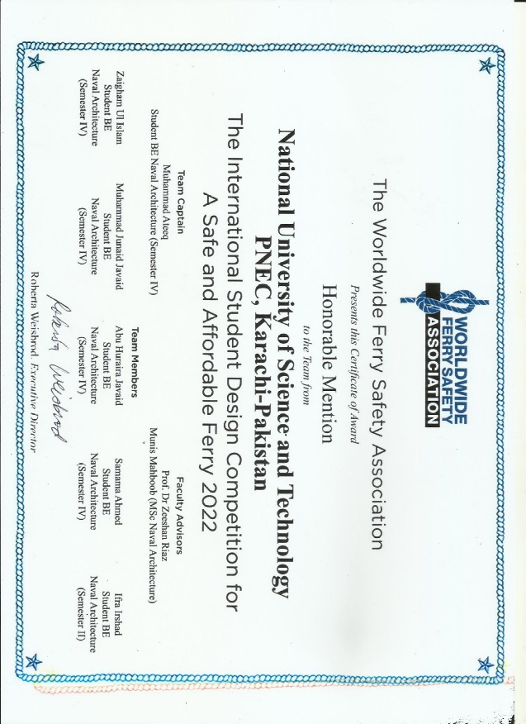
- Despite being our first competition, the team received the award of "Honorable Mention" from the judging panel.
- Judges provided constructive feedback related to areas of improvement for our design.

NSME's 2nd International Competition (2023)
Despite these challenges, the team continued working. In 2023, NSME again participated in the WFSA competition with a fully electric ROPAX ferry design for the Pasig River in the Philippines, carrying 100 passengers and 50 bicycles. This time, the team had more experience and improved their design significantly.
Remarks:
- The submission truly impressed the judges.
- The team members received the NUST High Achievers Awards for participating in an international engineering competition and representing NUST globally.
- This recognition was a commendable milestone for the society and further motivated its members to continue striving for excellence.
- The team was awarded the "Demonstrated Achievement" award by the judging panel.
- The judges also gave appreciation and positive feedback regarding the design.
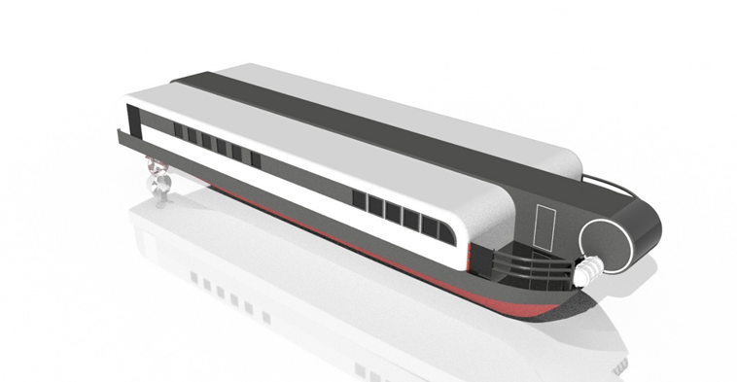
First Departmental-Level Boat Building Competition (2023)
In the same year, NSME organized its 1st Boat Building Competition at the departmental level. Students formed teams to design and build Styrofoam boats, applying real engineering concepts such as design, buoyancy calculations, and fabrication techniques.
Remarks:
- This event allowed students to learn practical skills and collaborate with other senior participants.
- The Dean appreciated the initiative - acknowledging the visible efforts showcased by the team.
- Certificates were distributed among the winning teams and participants.
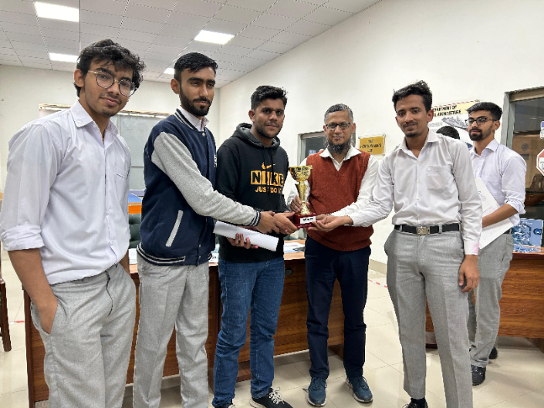
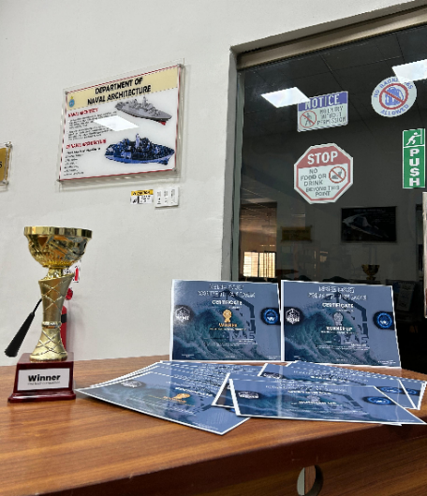
Remotely Operated Vehicle (ROV)
In 2024, the society developed the Pakistan’s first undergraduate level Observation Class Remotely Operated Vehicle (ROV) project weighing under 8 kg and measuring 0.5 meters in length.
Remarks:
- At IDEAS 2024, the team interacted with industry professionals and showcased their innovation.
- The ROV was also presented at IEEEP and Pak Industria Expo.
Industry experts appreciated the project and encouraged the team to continue developing such technologies.
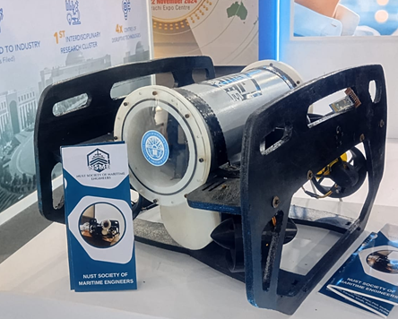
NSME's 3rd International Competition (2025)
The team continued to grow and once again participated in the WFSA competition, where they developed the E-Blue Ferry – a 32-meter fully electric catamaran ferry designed to carry 200 passengers. The ferry was specifically designed for operation in Lagos State, Nigeria - traveling from Ikorodu to CMS Terminal, covering a distance of 23 kilometers with the speed ranging 17-22 knots. It was equipped with all necessary safety equipment in compliance with international maritime standards.
Remarks:
- The team won the "Significant Achievement" award.
- Positive feedback received from the judging panel:
- Excellent breakeven period of approximately four years.
- Well-considered initiative to collaborate with LASWA and LAMATA.
- Excellent selection of materials (steel) based on local understanding.
- Effective ticketing strategy and break-even timeframe.
- Innovations acknowledged by judges:
- Battery Management Controller installed.
- Parallel middle body modified for improved hydrodynamic performance.
- Following this achievement, students began working with greater dedication and commitment, believing that their efforts could truly lead to global recognition.
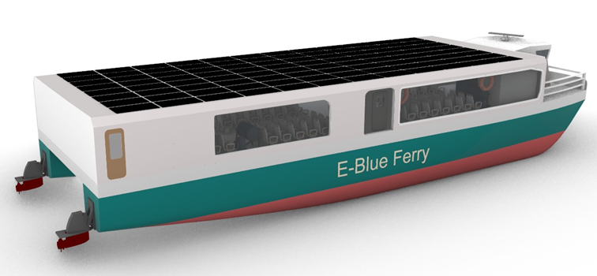
Boat Building Competition (2025)
NSME also continued organizing student activities including its 2nd Boat Building Competition, where students again designed and built Styrofoam boats while applying their engineering concepts and teamwork.
Remarks:
- The event received a positive response from the participants.
- It successfully reinforced practical engineering skills and collaborative learning.
- The continued conduct of such events demonstrated NSME's commitment to fostering hands-on maritime education.
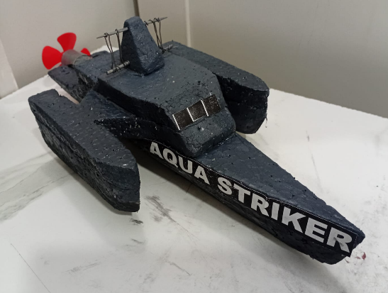
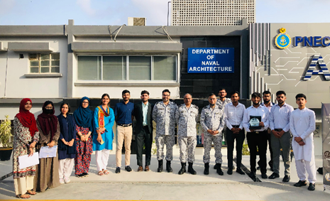
NSME's 4th International Competition (2025–2026)
The biggest milestone came during the 2025–2026 WFSA International Student Maritime Design Competition. After four years of continuous effort, NSME achieved major international success. The team designed Zaferun, a 31.5-meter double-decker hybrid catamaran diesel-electric ferry designed to carry 200 passengers plus 15 tonnes of market cargo, covering a 230 km distance in the Niger River from Lokoja terminal to trading city of Onitsha. The route also crosses four other ports beyond Lokoja and Onitsha, enabling an effective and revenue-generating journey by carrying additional passengers. The speed range of the vessel is 18–21 knots. Also, we presented our design at an online international conference named Ferry Safety and Technology Conference held by WFSA.
Remarks:
- Achievements:
- First Place in the Charles R. Cushing Award for Esthetic Design – Out of 18 international teams from different continents, NSME secured first position for the aesthetic quality of its ferry design.
- Meritorious Achievement Award – Recognizing the overall quality and engineering efforts of the project according to the given URD.
- NSME and NUST – Pakistan Navy Engineering College were featured internationally on the Marine Log global platform, bringing global recognition to our team and the university.
- NSME will be presenting Zafeurn at an online conference on 7th May 2026 organized by WFSA in front of maritime industry professionals, senior naval architects, and esteemed engineers.
- Positive Feedback & Innovations acknowledged by judges:
- Excellent choice of propulsion system.
- Waterjets use
- Oily water separator
- Hybrid material use
- Solar panels for hotel load
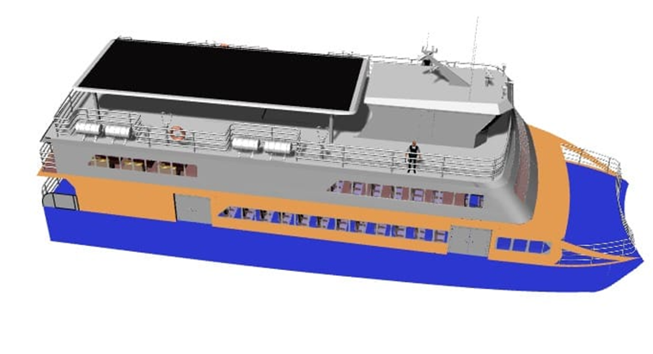
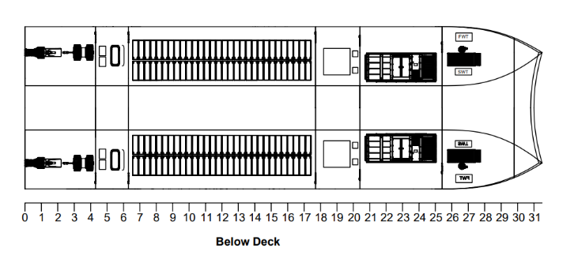
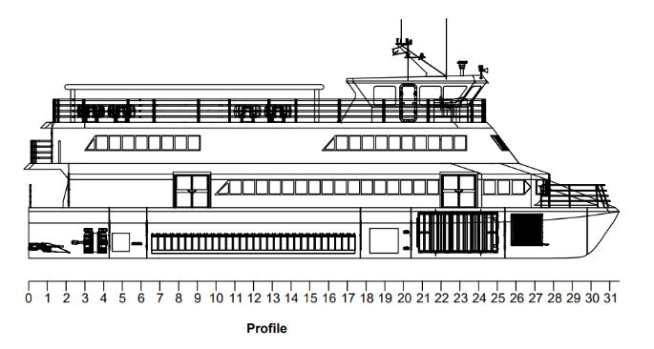
- IoT-based systems for better monitoring and control

Pipe-Framed ROV (2026)
After the success of our ferry competition, the society advanced to a physical project focused on enhancing both cost efficiency and operational effectiveness. NSME designed and fabricated an exceptionally cost-effective ROV built around a durable PVC pipe frame, incorporating a high-quality camera for superior inspection capabilities alongside an effective control system. Specifically engineered for live monitoring and inspection, this ROV is equipped with advanced cameras and sensors to enable real-time underwater data collection, while its robust pipe-frame structure ensures durability without compromising affordability, making it ideally suited for confined or challenging maritime environments.
Remarks:
- We presented this ROV at Open House '26 of our university, where companies, professionals and teachers praised the idea and also suggested working on an AUV in the near future.
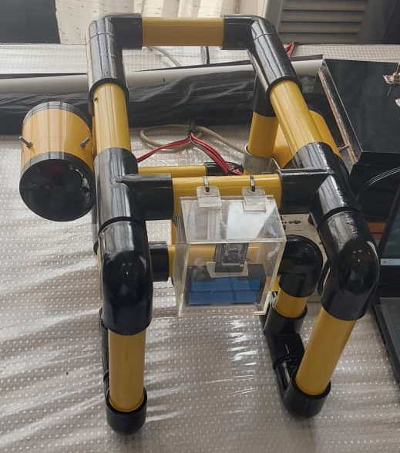
Current Projects:
Developing an Autonomous Underwater Vehicle (AUV) capable of specified area inspection, autonomous navigation and control. We are currently designing the vessel, performing different analyses on it and then will move towards its fabrication phase.
DON’T SHOW THE IMAGE OF THE AUV IN VIDEO OR PPT, SHOW IT AS A HIDDEN PROJECT.

